**DEVOPS – Final Assessment**

**SECTION - I**

**MCQs:**

1. What does WSL stand for in the context of Windows? - **Windows System for Linux**
2. What is the primary goal of continuous integration (CI) in DevOps?-  **Frequent integration of code changes**
3. In the Linux command line, what does the cd command do? - **Change the working directory**
4. Which of the following is not a Linux distribution? - **Docker**
5. What is Docker primarily used for in DevOps and containerization?- **Packaging and deploying applications in containers**
6. What is the primary purpose of Azure DevOps?- **Software development and delivery**
7. Which components are part of Azure DevOps?- **Azure Boards and Azure Pipelines**
8. How does Azure DevOps support version control in software development?- **It tracks changes in source code and manages versions.**
9. In Linux, what is the primary role of the root user? - **Administrative tasks with superuser privileges**
10. In Azure DevOps, which component is used to define, build, test, and deploy applications?- **Azure Pipelines**

**SECTION - II**

**LAB :**

**Lab 1: File and Directory Management :**

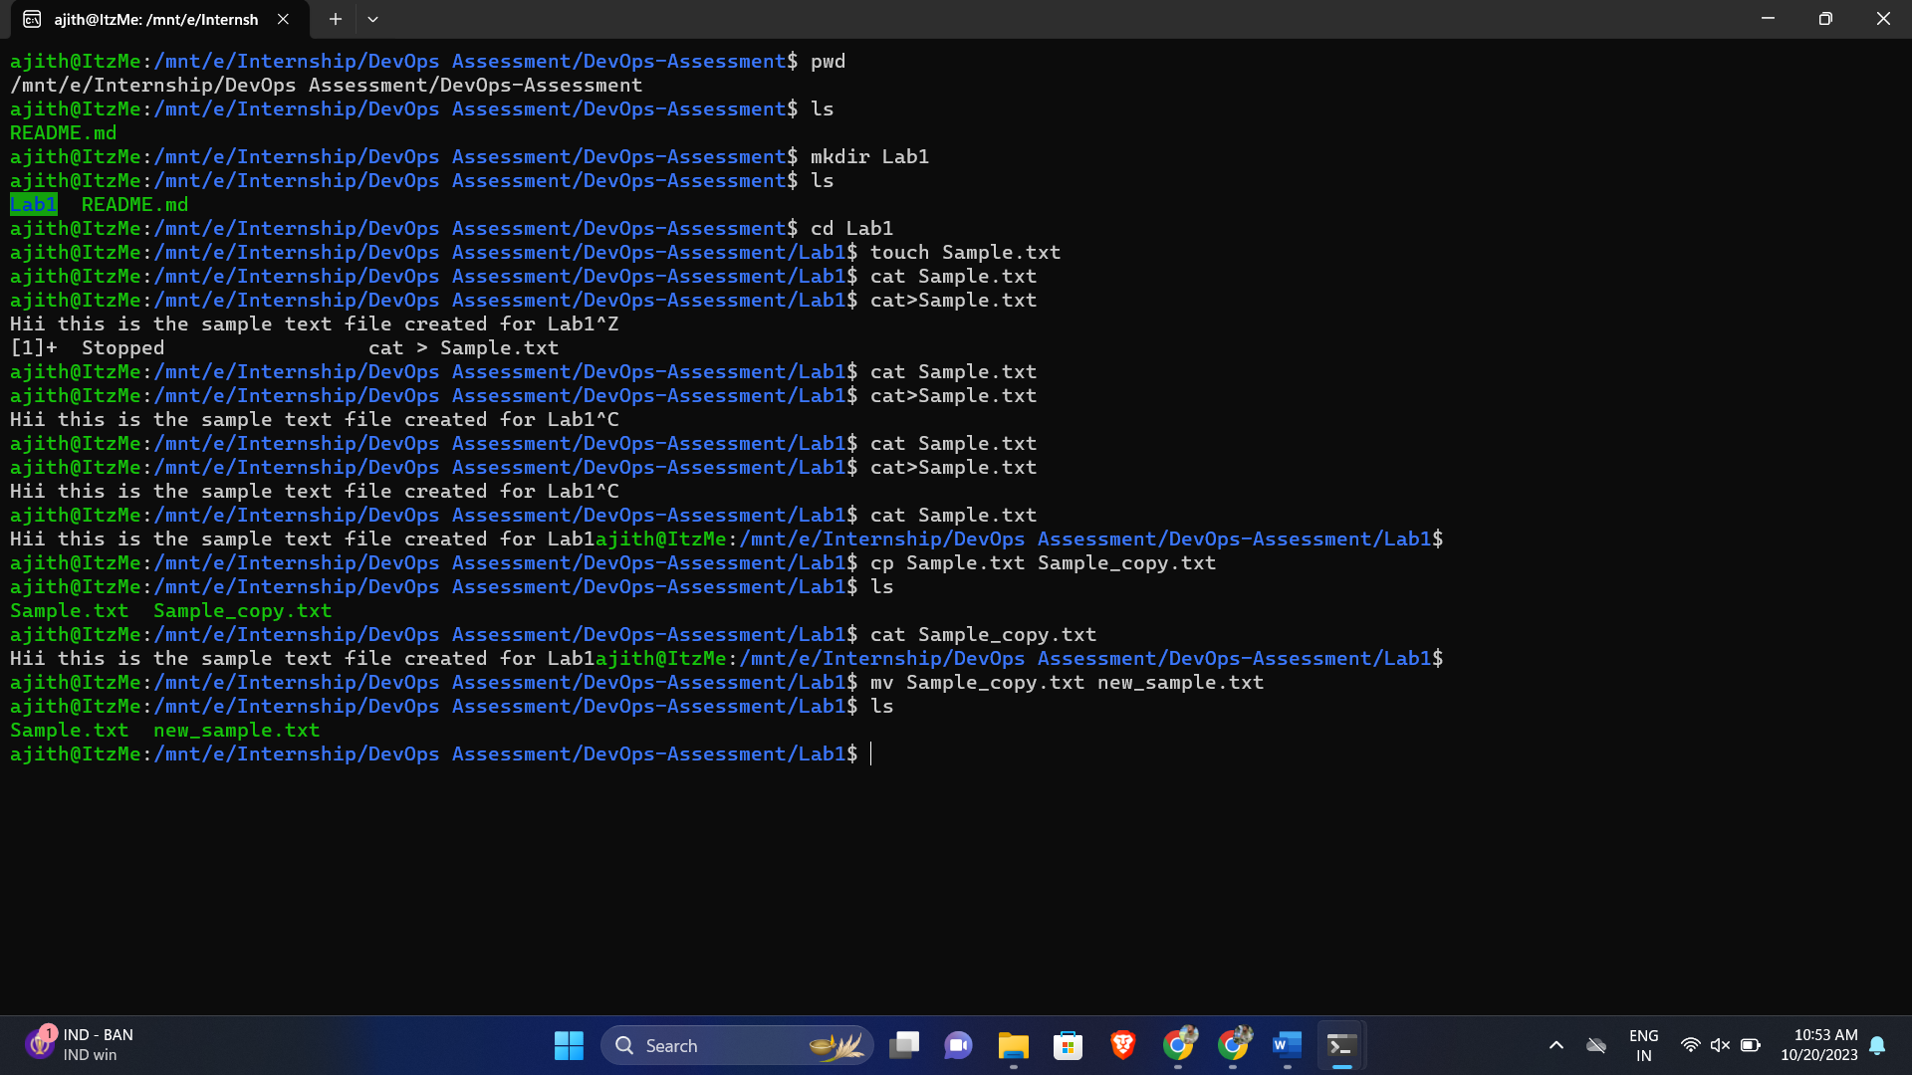

**Lab 2: Permissions and Ownership :**

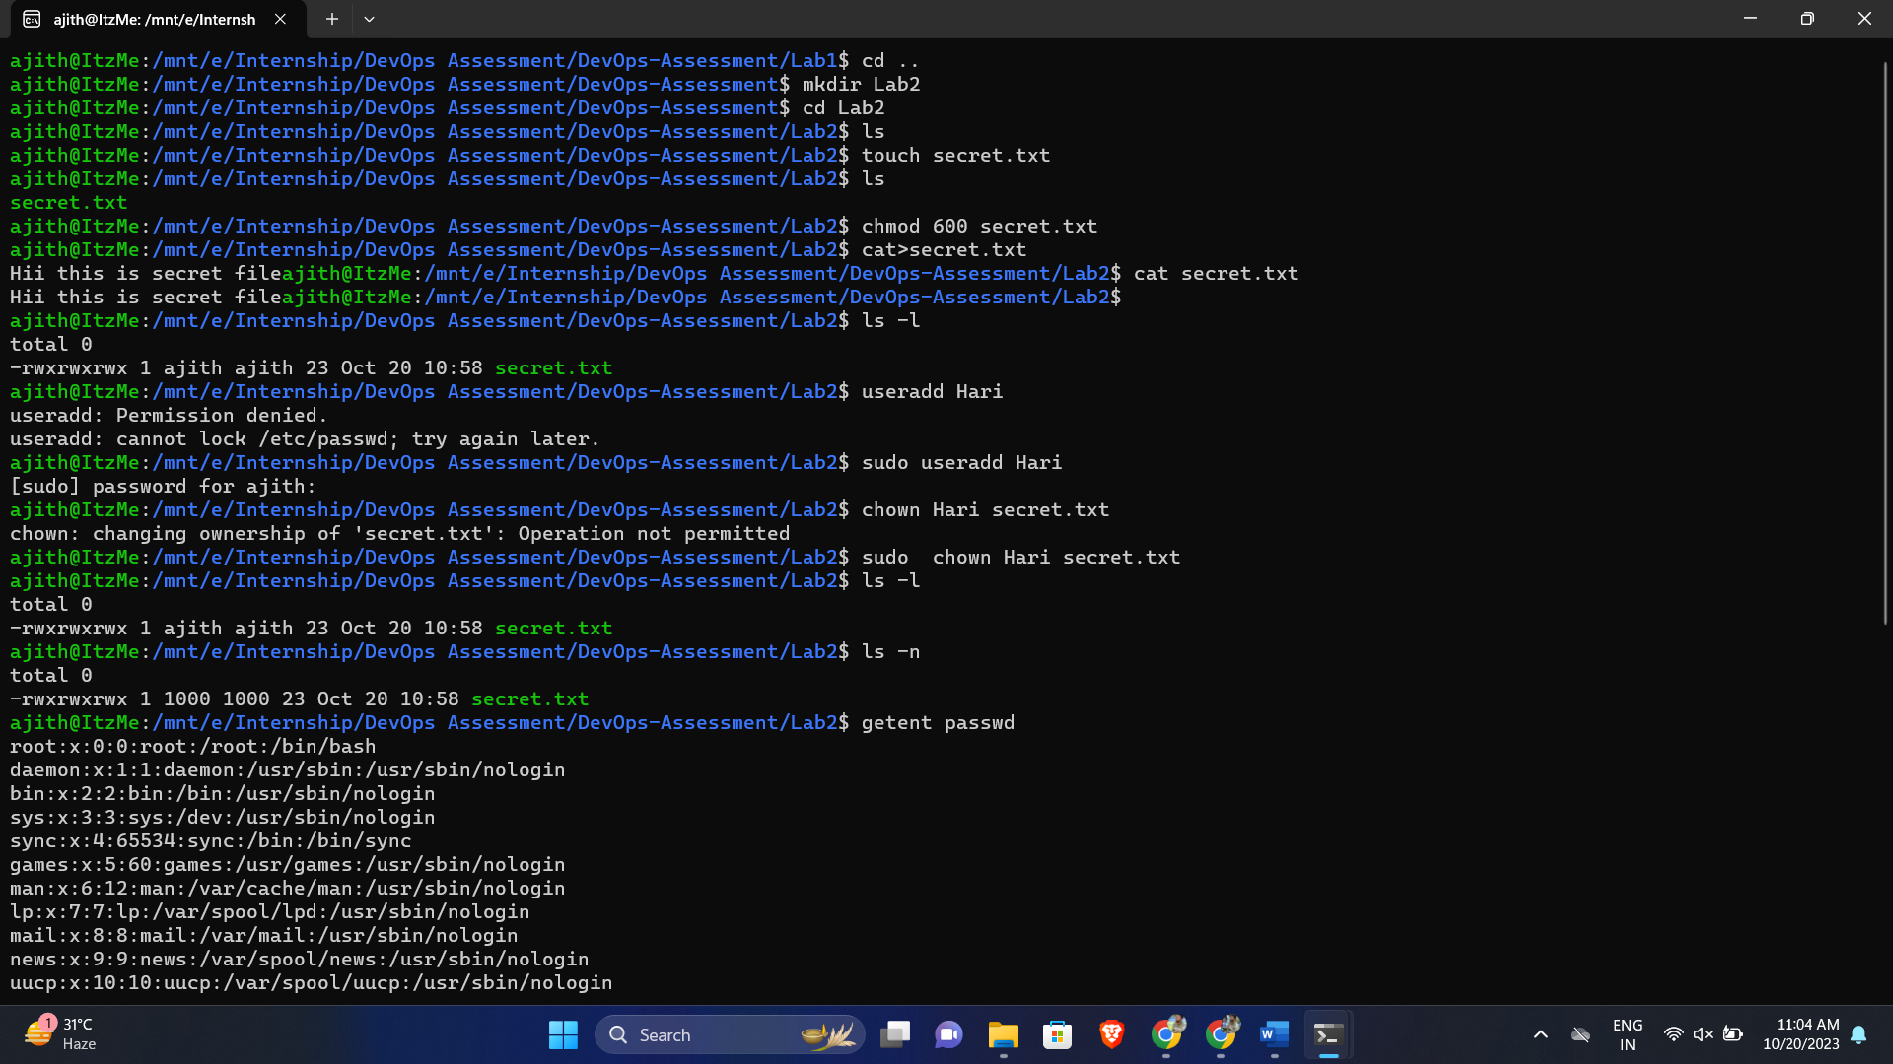

**Lab 3: Text Processing with Command Line Tools :**

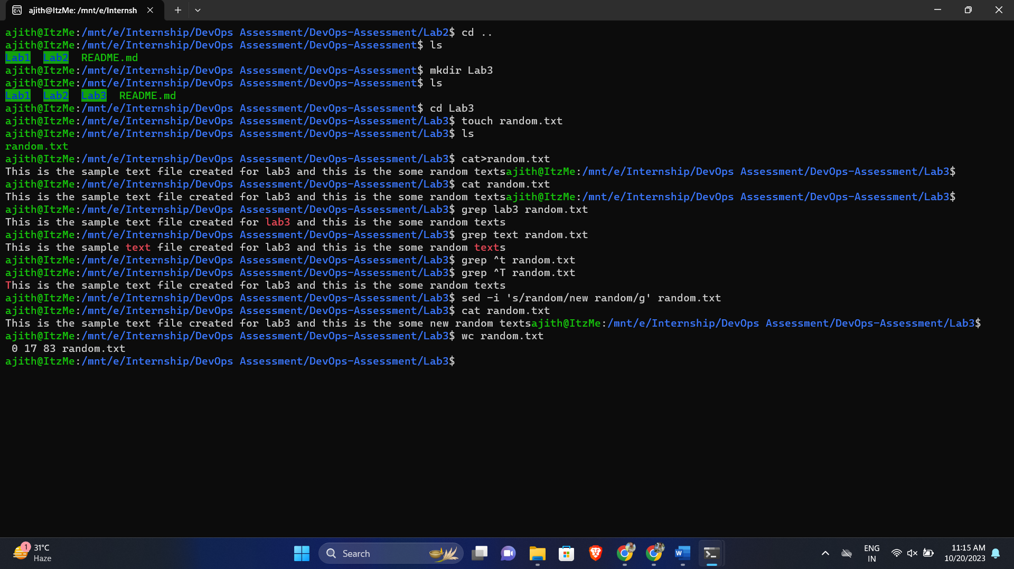

**Lab 4: Creating a Simple YAML File :**

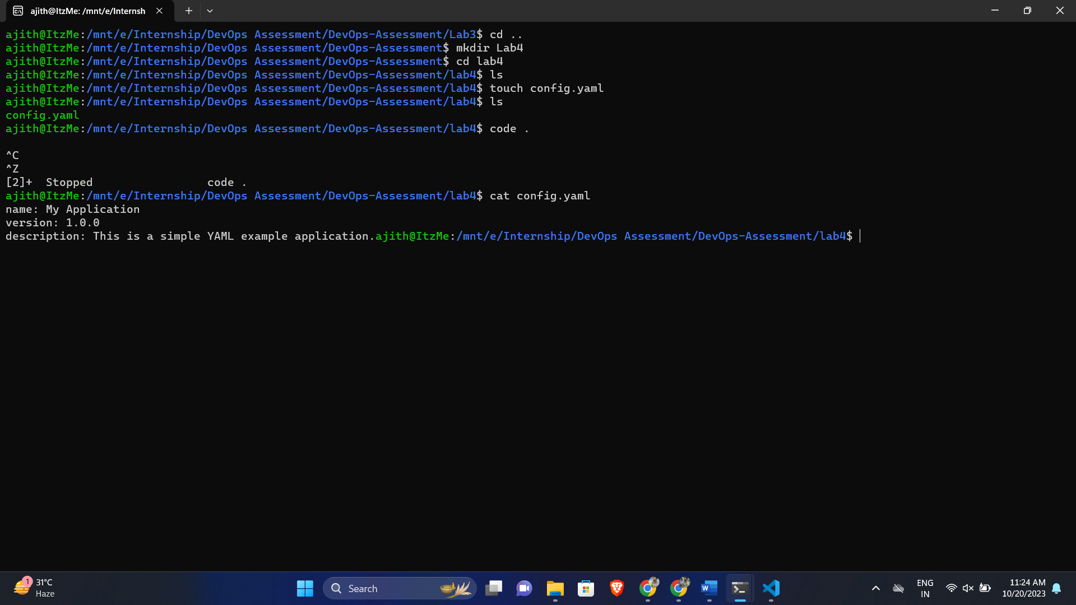

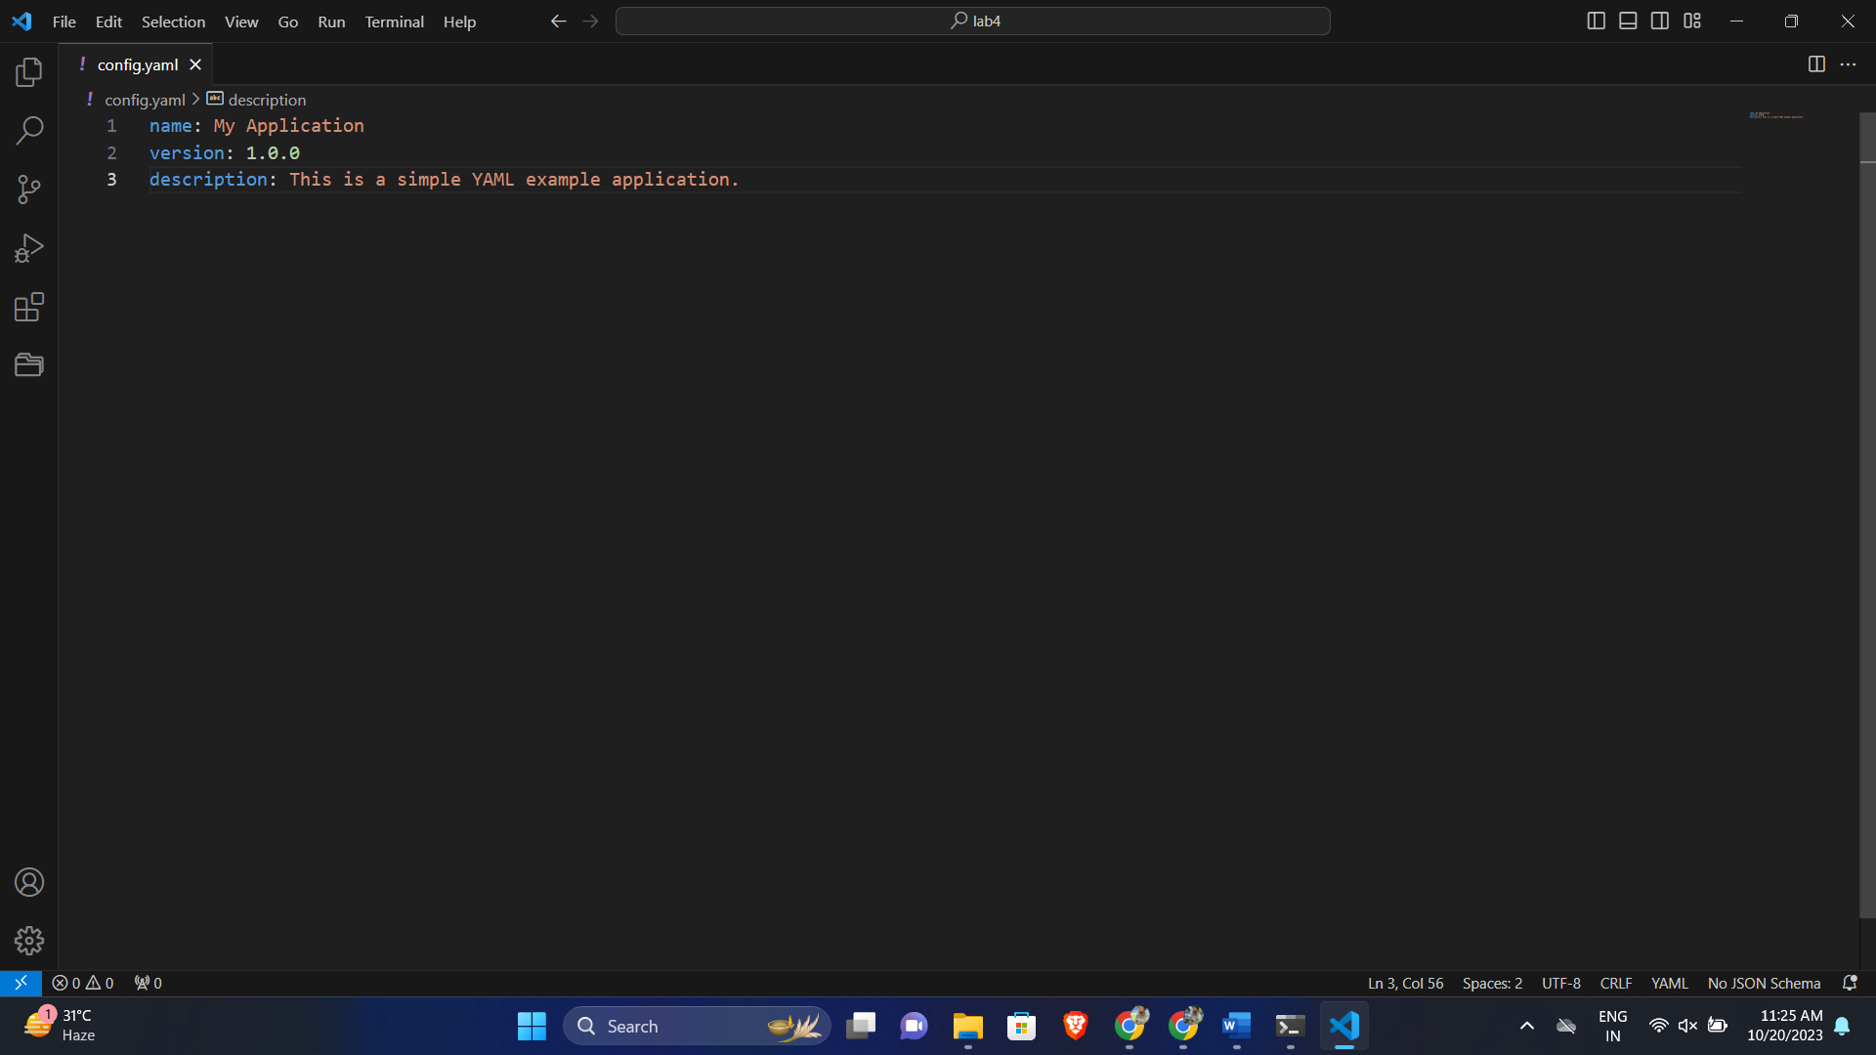

**Lab 5: Working with Lists in YAML :**

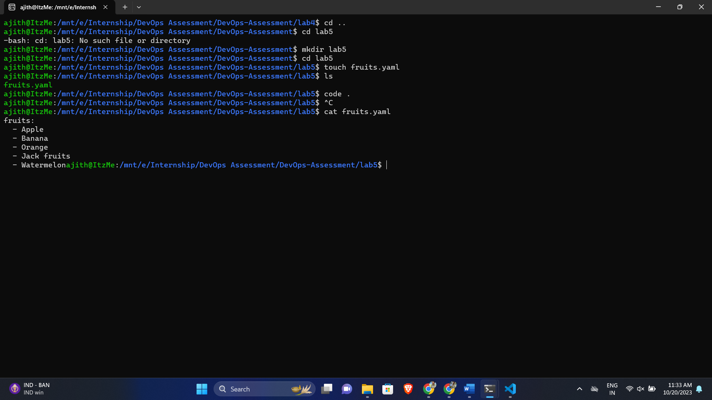

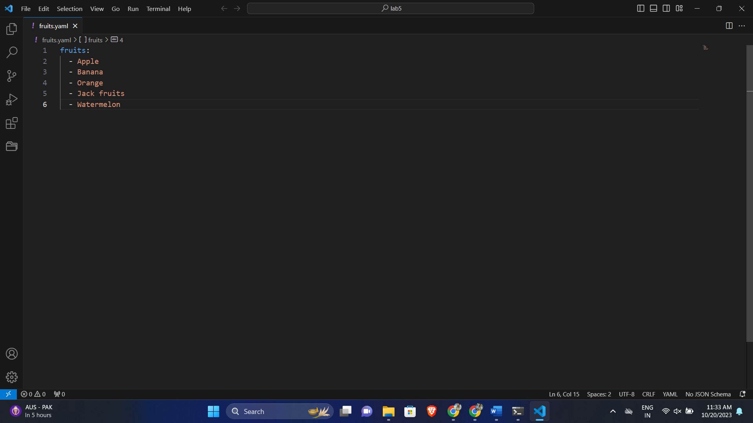

**Lab 6: Nested Structures in YAML :**

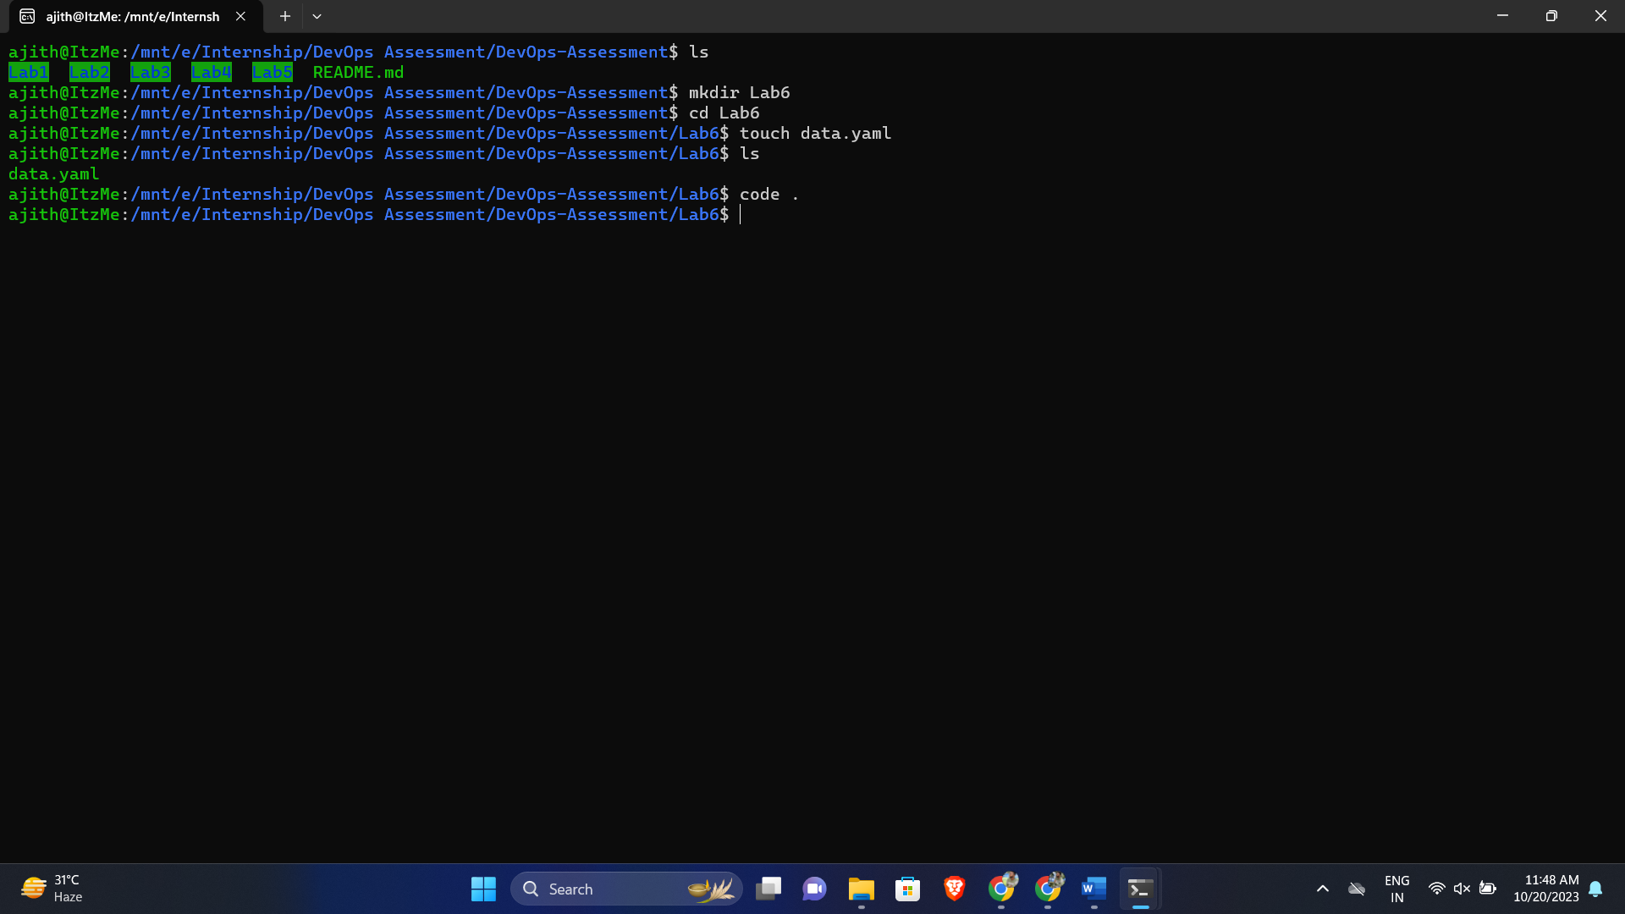

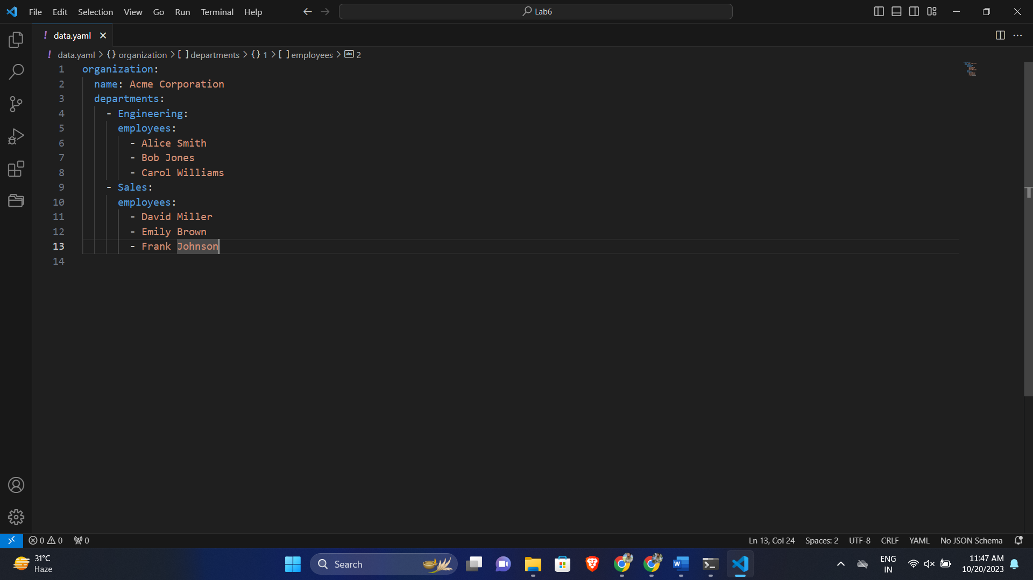

**Lab 7: Create Classic Azure CI Pipeline for Angular Application :**

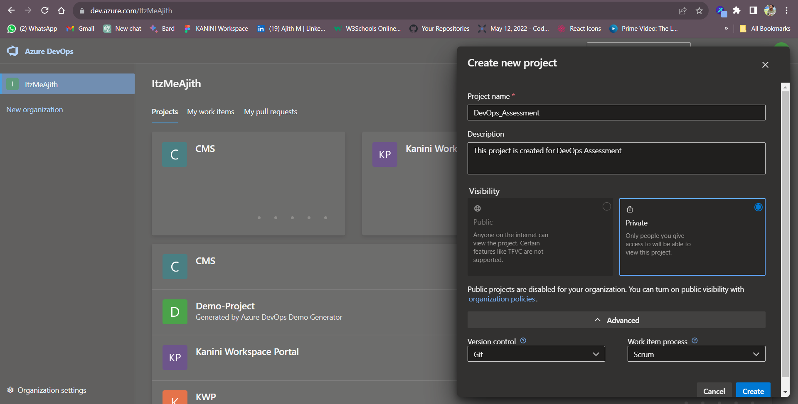

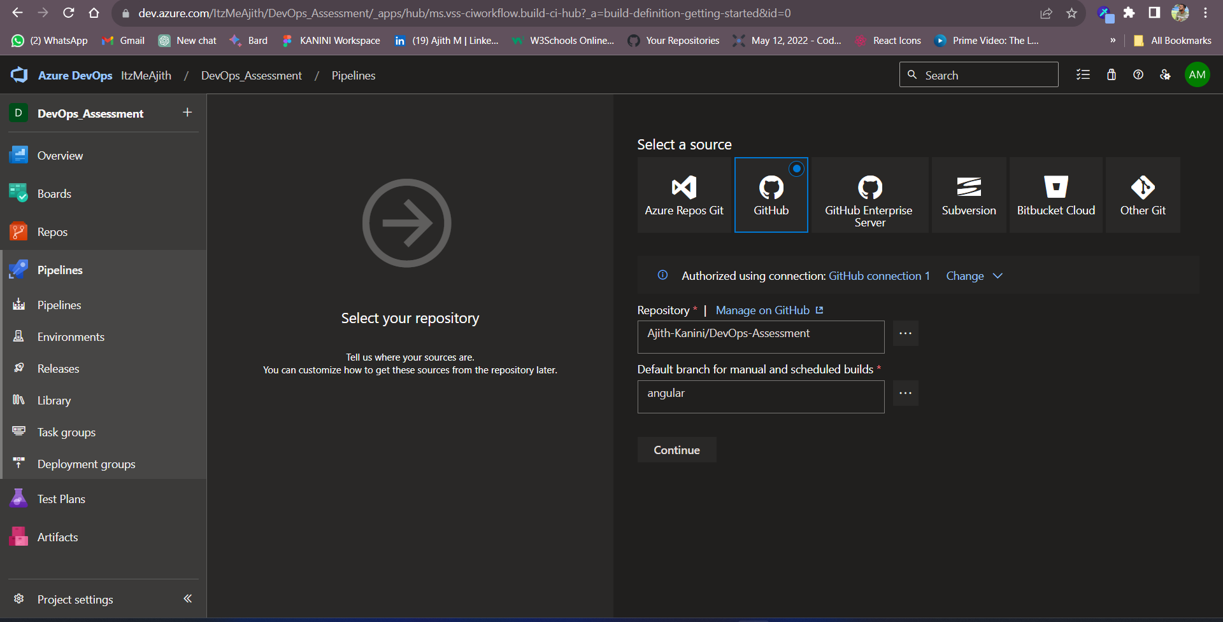

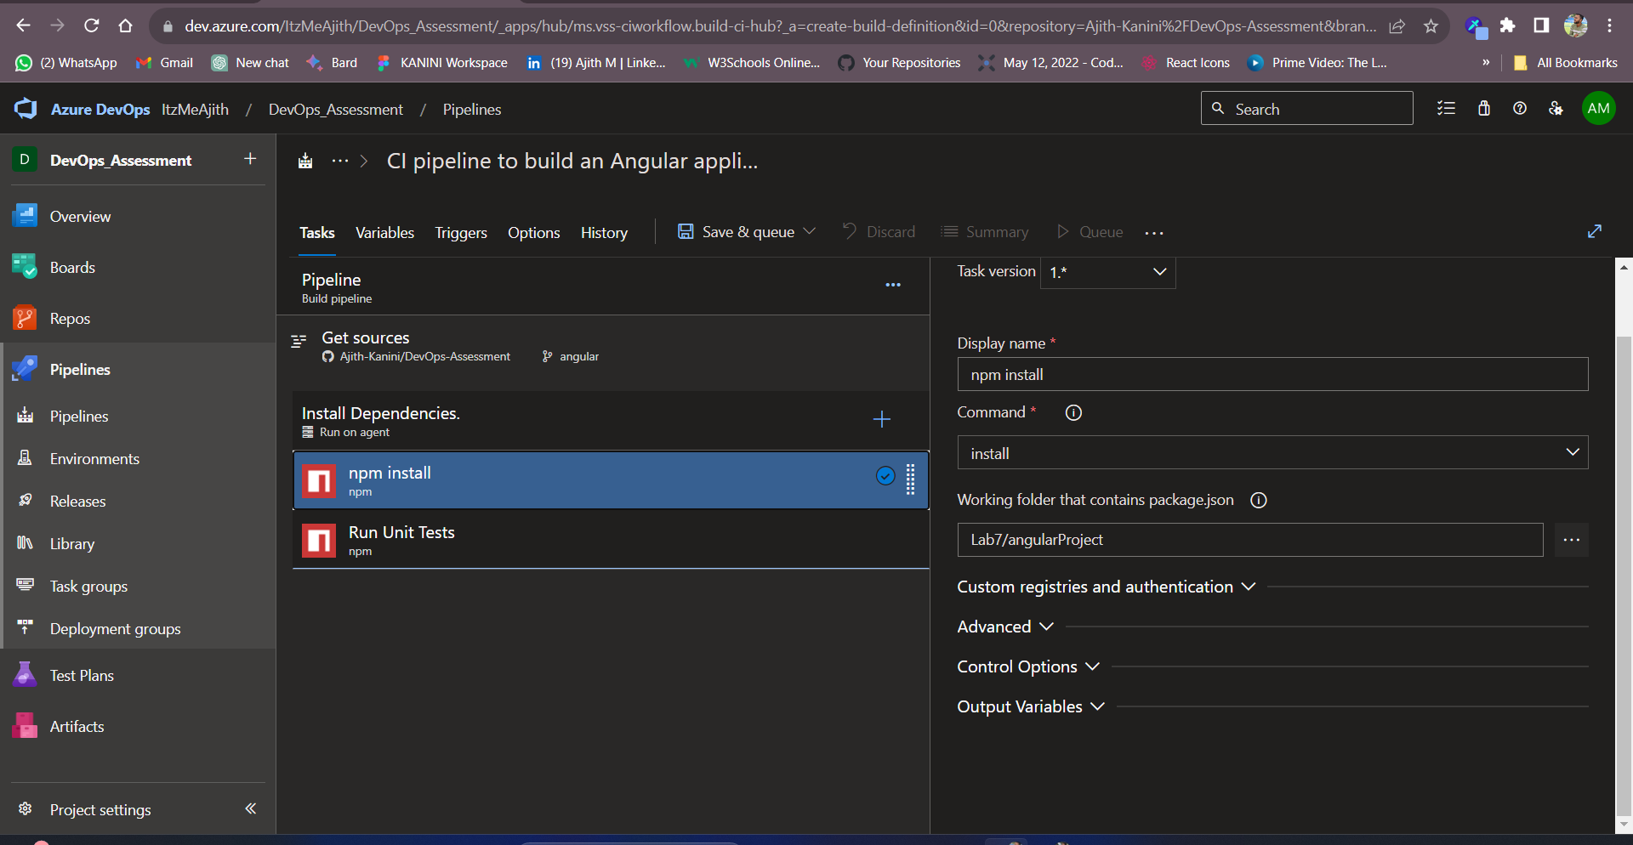

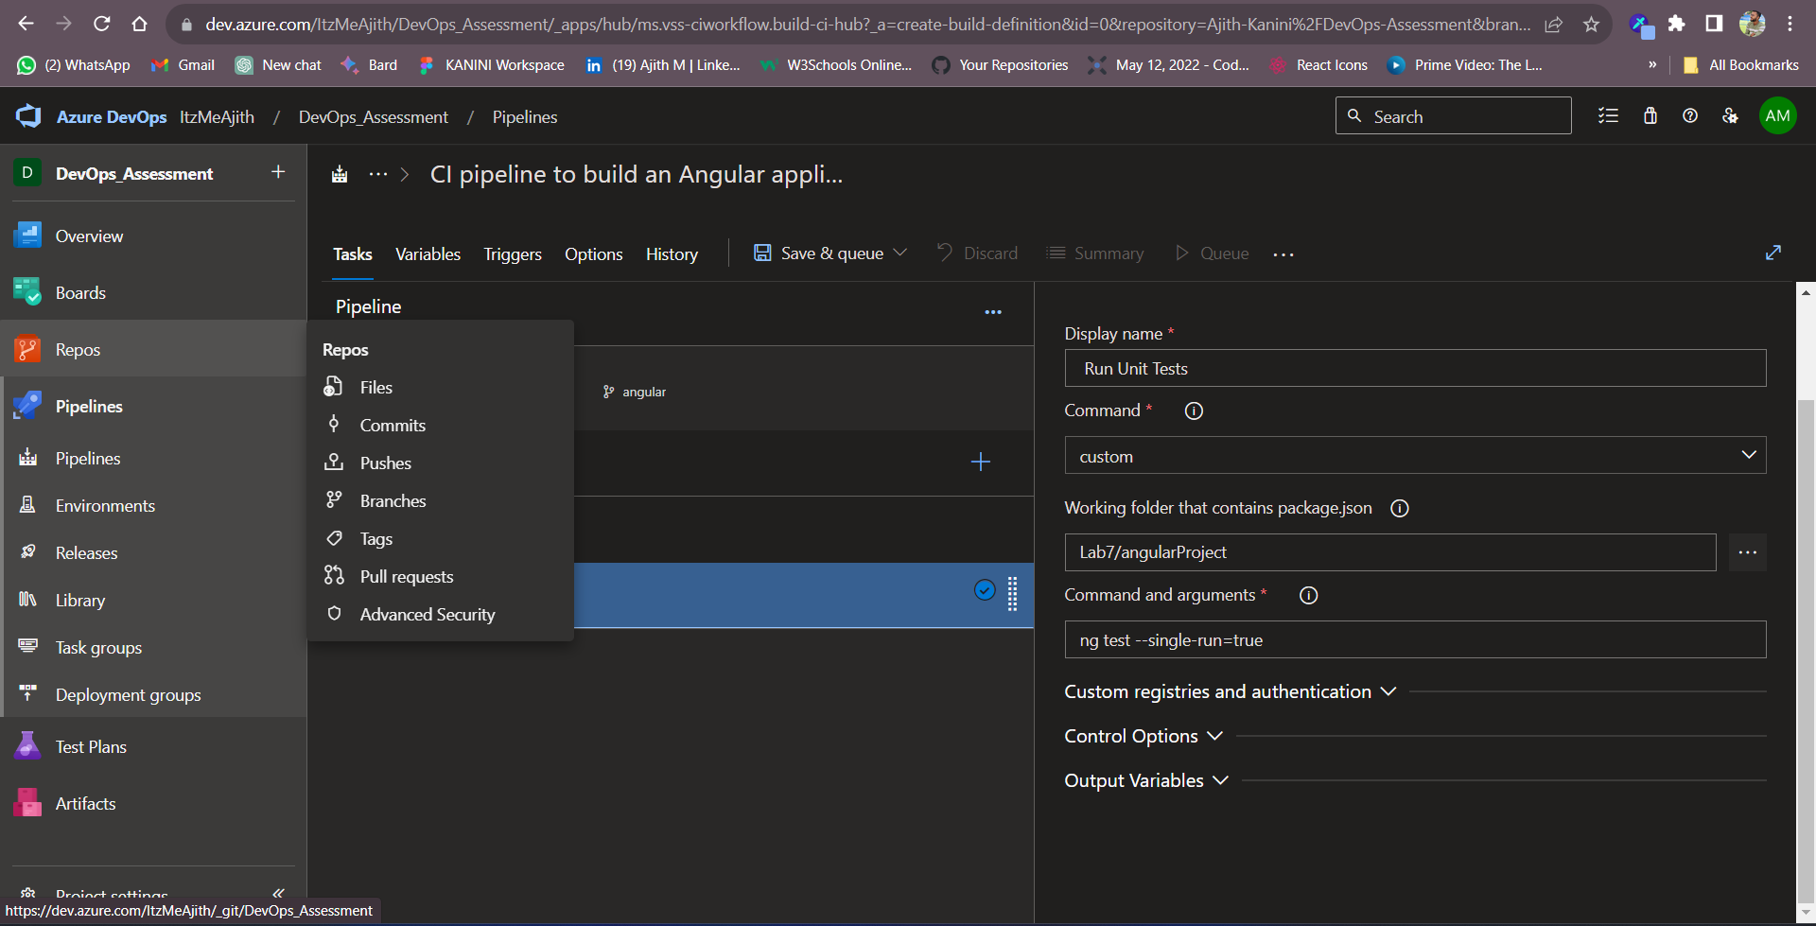

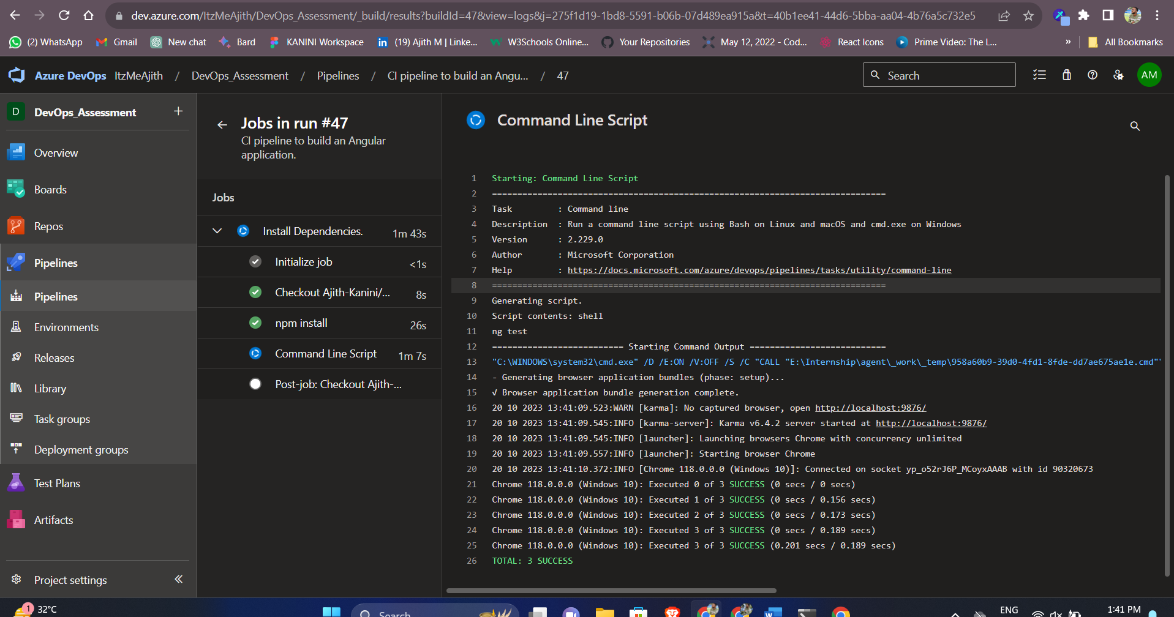

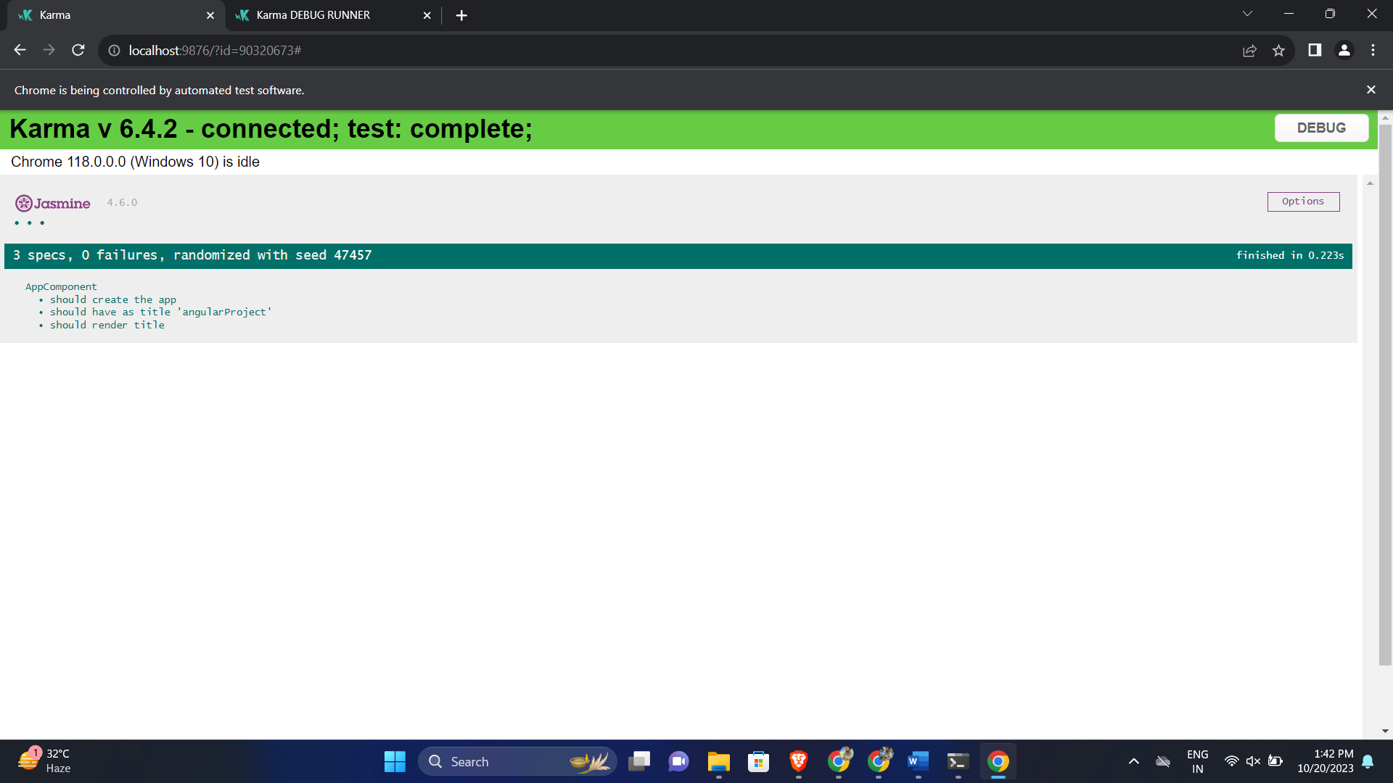

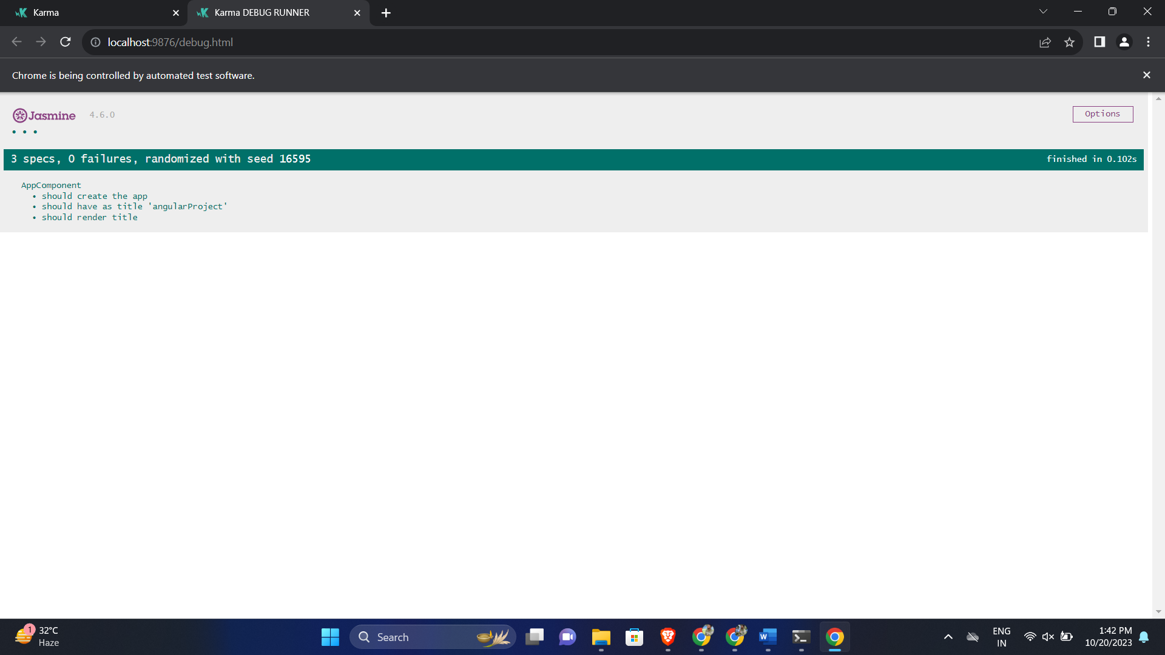

**Lab 8: Create YAML Azure CI Pipeline for React Application :**