A STUDY ON CUSTOMER SATISFACTION TOWARDS ONLINE SHOPPING WITH REFERENCE TO WONDERPICK

ABSTRACT
Consumers have learned to keep up with technology and in turn era allows them keep up with their fast-paced lifestyle. New software era, advances in Internet security, alongside the cooperation of monetary institutions are a number of the top reasons why online shopping is on the rise.
Online shopping has grown in reputation over the years, in particular due to the fact people locate it convenient and clean to bargain store from the comfort of their domestic or office. One of the most enticing components about online purchasing, specifically all through a vacation season, is it alleviates the want to attend in long traces or seek from keep to store for a selected item.

This venture has been undertaken as part of the management’s initiative to recognize the overall satisfaction level of the web purchasing clients of Wonderpick. This will help the company to personalize their services/add more functions in the destiny to cater to the particular needs of the clients.
This research turned into performed with an intention to help the employer to growth the client’s pride by means of getting their feedback. The undertaking titled “a study on customer satisfaction towards Wonderpick” conducted in Wonderpick aims to apprehend the delight degree of clients with their online buying revel in with Wonderpick. The secondary targets are to find out the reliability, assurance, complaint dealing with and product satisfaction level with of Wonderpick.

A questionnaire is used as the tool to gather the primary information from the clients of Wonderpick. The tools that are used in this mission are Percentage method, Chi-square check, Anova test and Correlation. The pattern size determined for the study is 250 respondents. Simple Random sampling is chosen for the take a look at. Based on the findings from this have a look at, suitable tips have been given to the management to enhance its customer’s satisfaction stage.

TABLE OF CONTENTS
CHAPTER NO | CHAPTERS | PAGE NO
 | ABSTRACT
I | 1.1 INTRODUCTION
 | 1.2 COMPANY PROFILE
 | 1.3 INDUSTRY PROFILE
 | 1.4 NEED FOR THE STUDY
 | 1.5 SCOPE OF THE STUDY
 | 1.6 OBJECTIVES
 | 1.7 LIMITATIONS
II | REVIEW OF LITERATURE
III | RESEARCH METHODOLOGY
 | 3.1 RESEARCH DESIGN
 | 3.2 SAMPLE SIZE
 | 3.3 DATA SOURCES
 | 3.4 RESEARCH INSTRUMENTS
 | 3.5 SAMPLING
 | 3.6 CONVENIENCE SAMPLING
 | 3.7 SAMPLE FRAME
 | 3.8 SAMPLE DESIGN
 | 3.9 ANALYTICAL TOOLS
IV | DATA ANALYSIS AND INTERPRETATION
V | 5.1 FINDINGS
 | 5.2 SUGGESTIONS
 | 5.3 CONCLUSION
 | ANNEXURE
 | BIBILIOGRAPHY
 | QUESTIONNAIRE

LIST OF TABLES

TABLE NO. | TITLE | PAGE NO
1 | GENDER
2 | AGE
3 | MARITAL STATUS
4 | OCCUPATION
5 | INFORMATION IS FOUND WITH A MINIMUM OF CLICKS
6 | LINKS ARE PROVIDED TO TRUE PAGES ON RELATED PRODUCTS
7 | EASY TO FIND RELEVANT INFORMATION
8 | IT IS EASY TO PRINT FROM THE WEB
9 | ACCESS IS FAST
10 | REGISTRATION PROCESS DETAILS ARE RETAINED SECURELY
11 | TAX AND/OR OTHER CHARGES ARE CLEARLY DETAILED
12 | DIFFERENT PAYMENT OPTIONS ARE STATED CLEARLY
13 | POTENTIALLY RANGE OF HIGH QUALITY PRODUCTS AT COMPETITIVE PRICES
14 | CREATION OF A PLEASURABLE E-SHOPPING EXPERIENCE
15 | CUSTOMER SERVICE CENTER WERE AVAILABLE AT CONVENIENT TIMES
16 | NAVIGATION IS CONSISTENT AND AVAILABLE ON EVERY PAGE
17 | HELPFUL ANSWER TO THE CLIENT’S REQUEST OF TECHNICAL INFORMATION
18 | GUARANTEES ABOUT THE PRIVACY OF PERSONAL INFORMATION
19 | EXTERNAL VALIDATION OF TRUSTWORTHINESS IS IMPORTANT
20 | QUERIES OR COMPLAINTS ARE RESOLVED WITHIN 24 HOURS
21 | RETURN POLICY IS REASONABLE
22 | EFFICIENT CONTACT CHANGES IN PRICES, PRODUCTS, DELAYS
23 | ONLINE SUPPORTS FOR AFTER-SALES SERVICE
24 | FREE OR REASONABLE DELIVERY COST
25 | FIRMS CAPACITY TO DELIVER PRODUCTS WITHOUT DAMAGE DURING THE TRANSPORT
26 | PRODUCT APPEARANCES
27 | PRODUCT PRICE
28 | PRODUCT WARRANTY
29 | PRODUCT PACKING
30 | REFERRAL PRODUCT
31 | PRODUCT QUALITY
32 | FIRMS CAPACITY TO ACCEPT THE EXACT QUANTITIES REQUESTED IN THE ORDER
33 | NOT TO HAVE DIFFICULTIES IN THE ORDER DUE TO THE LIMIT OF THE MAXI QUANTITY
34 | THE TIME BETWEEN THE ORDER AND THE DELIVERY BY THE FIRM IS REASONABLE
35 | DELIVERY STAFF IS FRIENDLY AND HELPFUL
36 | DELIVERIES NEATLY WITHOUT DELAYS
37 | EFFICIENT COMMUNICATIONS BETWEEN CUSTOMER AND TRANSPORTER
38 | SHIPMENTS RARELY CONTAIN WRONG ITEMS, LOW NUMBERS OF DEFECTS
39 | ABILITY TO MEET SCHEDULED DELIVERY DATE IS GOOD
40 | FLEXIBILITY OF DELIVERY SCHEDULE IS ACCEPTABLE
41 | ACCURACY AND COMPLETENESS OF SHIPMENTS IS SATISFACTORY
42 | QUALITY OF PACKAGING IS LESS SATISFACTORY
43 | OVERALL SATISFACTIONS WITH THE SHIPPING AND DELIVERY PROCESS IS GOOD

CHAPTER –I

1.1 INTRODUCTION
In the early years of e-commerce, clients were skeptics. Internet privacy and fraud were amongst the primary concerns. Today, the sector is moving faster than ever. The client has transitioned from skeptic shopper, worried of stepping into any Internet transaction, to a confident shopper. Some definitely committed Internet shoppers will let you know they do not ever move into a retail store. For many, the attraction is the convenience of buying from your living room. It is no longer handiest more snug, however when doing product and charge comparisons it's far optimal.
Consumers have learned to preserve up with generation and in turn era enables them maintain up with their fast paced lifestyle. New software era, advances in Internet protection, together with the cooperation of economic institutions are some of the pinnacle motives why online buying is on the rise.
The financial institutions have helped guarantee the pleasure of online shopping with their credit safety services. Customers are assured that the financial organization will help intervene within the event of an unsatisfactory transaction. Institutions have also made introduced efforts to assure their customers safety whilst the use of their credit score cards and within the prevention of identity theft.
All of these things add to the patron feeling more comfortable using credit cards for payment. Credit card transactions are usually the preferred preference of price for customer impulse purchases.
Consumers have emerge as privy to the numerous security programs they could set up in their structures to assist shield their computers. This is assisting them feel more cushty as they surf the net. The upward thrust of Secure Sockets Layer servers (SSL) provided delivered safety that also covered shopper records and shopping for online began to seem much less risky. As more buyers experience secure online buying sales upward thrust.
The retailers and webmasters are listening to their newly assured internet site visitors. Assuring customers Internet protection with transactions and conforming to protection on websites. Many outlets have made option only statistics requirements for club and order processing. The retailer is making an attempt to limit the amount of records they require the client to give.

The client is no longer obligated to join newsletters and emails. Giving the purchaser the choice to offer you with certain facts allows them to fell greater in control of their transaction. Webmasters are continuously assessing and making modifications to their web sites due to the fact they have found out to pay attention and respond to what the vacationer wishes and needs.

More cash than ever has been invested into e-trade advertising greenbacks, which has simplest helped make the world of e-trade spin. Retailers, marketers, and the state-of-the-art craze is the television industries are all shifting in rapid at the internet. Advertising dollars are following close behind.

Affiliate advertising, pay-per-clicks, and residual advantages are all aiding inside the business owners sales. This can also offer their traffic an enhanced experienced with more to offer on their internet site. Webmasters have become professionals at optimizing their agency sales pages to direct the patron’s eyes in all the proper directions.

A successful internet site leads a traveller’s eye to key products. While a visitor is shopping, additional products sold by way of the store or an affiliate are strategically positioned for superior viewing. Many buyers that buy from one website online will also buy from a website online without delay connected to the product they just purchased. This has the opportunity to promote a series of shopping events.

Convenience, time, and cash are a number of the pinnacle reasons why online purchasing is at the rise. A greater confident consumer is the usage of the Internet for increasingly more in their day by day needs. The e-commerce community is responding quickly to their consumer’s wants and needs. It is becoming easier and greater convenient to be an Internet user. There are many smaller but no much less thrilling shopping shops and shopping districts scattered around.

MARKETING OF ONLINE SHOPPING IN INDIA
Online buying concept emphasizes promoting existing products. The philosophy right here is if a product isn't promoting, extra competitive measures should be taken to promote it. Cutting price, advertising and marketing extra, or hiring greater aggressive income-people. When the railroads started out to lose commercial enterprise due to the appearance of more powerful trucks that could supply goods right to the consumer’s door.
Online shopping recognizes that the customers in the long run wants .To supply the great items and offerings to exceed the expectancies of customers. . The marketing idea, in contrast, specializes in getting consumers what they are seeking for of touring for his or her desired advantage of consumption in shopping.
The 4ps of marketing gives you the price for the client in return to that add unique attributes to the consumer in on-line shopping. In contrast, the company is faced with uncertainty from the environment
Marketing approach is a fixed of specific thoughts and movements that outline and manual selections at the best or chosen way to create, distribute, promote, and price a product once a customer is made, resources ought to be invested to preserve an ongoing, wholesome, and profitable courting with that customer.
Reaching and acquiring a new purchaser is one thing, maintaining the relationship healthy and strong over an extended time frame is the mark of the true marketing expert involved with the long-term health of the organization.
Obtaining new clients within the short-time period is a project to be sure, however maintaining relationships with those clients over the years is even more tough and is absolutely essential to the long-time survival of your business.
Over the lifetime of involvement with the customer, fee need to be created for each parties so as for the relationship to prosper. In order to assist create that cost, we should realize customers are specific and ought to be handled differently.

The extra cost you can create for your client, the extra he or she can preserve conducting enterprise with you. Some of the brilliant thinkers in marketing today name this "patron loyalty". Others call it "the propensity to re-purchase". Whatever you call it, retaining the client courting at the same time as constantly delivering cost is critical to your commercial enterprise.

INTRODUCTION TO ONLINE SHOPPING
Internet is the rapidest growing media all through the beyond decade. Especially, on-line buying is a rapidly growing e-trade area. Forrester Research forecasts that on-line retail trade could be about $217.8 billion through 2007 and account for eight% of general retail. ComScore Networks suggested that for the yr 2001, home online income totaled extra than $53 billion. This parent suggests a growth charge of approximately 20% as compared to the yr 2000.
According to Arbitron/Edison Media Research (2002), the variety of consumers who purchase on-line is developing sharply. 40% of all Americans have ever bought goods or offerings at the Web. Average amount spent on line in remaining three hundred and sixty five days was about $658 and 56% of Internet users have made a buy on line.
According to annual Internet survey of which on-line, 15% of British Internet users visit online purchasing sites most frequently and 14% frequently use Internet for online buying.
Online buying basically affords the manner customers go shopping and buy services and items with reasonable price on the Internet. For some clients, buying and purchasing on-line have become a part of their daily lives, whilst others might not even care about it. At this point, I wonder what elements have an impact on online buying conduct and give an explanation for the distinction in on line buying behavior amongst Internet users.
There are numerous blessings of online purchasing. The foremost gain of online purchasing is that it offers you an possibility to save 24 hours a day, seven days a week. Online buying has proved to be a boon for consumers who are home certain or stay in rural areas.

BENEFITS OF ONLINE SHOPPING
Online shopping gives you a giant variety of products to pick out from like gifts, wine, groceries, pharmaceuticals, clothing, luxurious items, wearing goods, art, puppy food, and so on from the comforts of your home. It additionally saves you from custom hassles in case you want to send any gift in your relative living in some other country. For instance, you stay in London and your mother has long past out on holiday in New York you can nonetheless make her day unique through sending her a bouquet by means of reserving it on line.
The different gain of on line buying is that it saves to your time. You can browse through extraordinary products with out sincerely going within the market. It also gives you the choice to compare the charges of products offered via on-line shops and make the satisfactory deal for your self and your cherished ones.
Online shopping also presents you with benefit of paying thru credit card not like some actual stores that insist on charge in cash. However, you ought to be careful whilst the usage of the credit score card for on line transactions.
In previous couple of years, on line shopping has come up as one among the maximum popular online shops in UK. Shopping specialize in digital gadgets, mobile telephones and accessories, CD's and DVD's. It is the right destination for digital merchandise that are available at virtually discounted rates. You are asked to browse through our services and make your on line purchasing experience a enjoyable one.
This collection of articles a celebration, and a call to arms. Independent, locally run agencies – the cafes, bars and shops run by means of locals who realize what their neighbourhood wants – are as vital a part of the individual of a town because the architecture that shapes it. However, there’s a recession on and throughout Glasgow and Edinburgh, little local stores are shutting down, losing out to the easy trap of the excessive avenue and to credit-crunched purchasers reducing costs.
Many Edinburgh retailers have been doubly hit, with the tram works blocking purchaser get entry to and public transport. Despite the City Council’s laudable Open for Business campaign (check them out at www.Edinburghshopper.Co.Uk), five stores have closed down on Leith Walk alone because the developments started out at the quit of 2007.
We want to stop this happening, but we want your help. Sure, that excessive street coat can be a bit less expensive than some thing hand-made by a younger Scottish designer, but you recognize deep down for your bargain-hunting heart that it’ll fall to pieces after some wears. And even as your choice to shop for CDs or books from impartial stockists won’t even be observed at Waterston’s and HMV, it is able to make all of the difference to an Avalanche or a Lost in Fiction. We want you to apply your imagination in addition to your customer power, and refuse to settle for the identical mass-manufactured merchandise as each person else.
Obviously, what follows is not completely comprehensive there are a tremendous amount of local companies out there, and we will only virtually scratch the surface. What we’ve attempted to do is select up on regions in Edinburgh and Glasgow wherein indie businesses form the network around them in some manner.
Accompanying all of this is our present day online shopping guide, which we are hoping to construct into the definitive listing source for Edinburgh and Glasgow’s indie stores. . We’re going to be usually updating.

ONLINE SHOPPING IN URBAN AREAS
Township humans mostly shop in the city at supermarkets or on their way domestic from work. Unlike suburban those who are able to shop in bulk because most get paid month-to-month and feature their personal transport, maximum township people commute through public transport, so they buy handiest what they could carry. Prices are marked up in the townships and informal settlements wherein humans should purchase in small quantities and consumers often pay substantially inflated.
There’s growing interest within the Internet as a place to store. But this sort of shopping has its personal dangers, and the rules of clever shopping are as essential within the electronic market as they're in your doorstep.
One problem is that clients have little control over what occurs to personal statistics used when buying online. Each transaction leaves an records path that may be utilized by hackers and different unauthorized individuals to assemble economic and personal profiles on you. This statistics can be bought or stolen and used for crook purposes. You have every proper to sense vulnerable when your credit card number and other economic records go crusing into cyberspace
From the stage of getting information to the stage of having loose services and fee-related offerings, we get many blessings from internet. On-line shopping is this kind of offerings. As a ways as on-line buying is concerned, handiest a handful few operate efficiently in India. Everywhere Infonaut wants to market products and services through on line purchasing first of all in Thailand and later throughout India. Everywhere Infonaut starts offevolved functioning in Tamilnadu with a mild set of services and products.
The forte of this scheme is introduction of on-line buying customized for conditions standard to India. Those, who can deal with English language to a constrained extent, those who aren't adept in computer literacy, those internet-users who are not able to get broad- band connectivity -- in such a lot of ways, we will classify internet-customers and others. E-keep of Everywhere Internet has made online buying easier, more simplified and hassle-loose for these whole group. So, the maximum feasible minimum price, the quality of the product, the rate with which the goods are introduced on the doorsteps of the customer, prompt after-sales service, trouble unfastened and less costly price procedures, the comfort of choosing the product sitting at home at your own favorable time, in a leisurely mood with out getting tormented by the attractive vagaries of the advertising environment, the selection of the articles in tension-free ambience -- all these features pertaining simplest to on-line purchasing are ensured by way of E-shop.

IMPORTANCE OF ONLINE SHOPPING

Online buying technology is a breakthrough that everybody can virtually benefit from, ought to they choose to do so. But why wouldn't they? Let’s face it, nothing is perfect and while I final checked it probably by no means could be here at least. But it is a step forward closer to some thing that may be a fantastic benefit to anybody in a few way. Customers, vendors, factories, even the economy in a few ways may be strongly affected in a positive manner.

Online purchasing creates jobs. Jobs that create a tremendous feel of protection for the future because you come back to understand that you could earn extremely massive quantities of coins in a short quantity of time.

Owning your house business in the online shopping industry or perhaps every other similarly or higher home commercial enterprise to get involved in verses working for a person else for an hourly wage though it holds little promise for the long term destiny it could offer a few immediate financial relief but not without effects of continually needing extra, dwelling week to week, social protection is even questionable anymore.

Online shopping is taking a risk however appears to be a protracted term method of desire and holds the same uncertainties that you don't even know is being entrusted with all that you need to stable your future with. We were all created for greatness! We were created to prosper and to excel! You are the driver and you manage where you are going.

Online customers desirous to shop for any items should posses the Credit Cards or ATM Cards. After deciding on the items he/she has to give the credit card numbers from which the specified money of the objects might be deducted.

ADVANTAGES OF ONLINE SHOPPING:

Easy Access and handy: This is perhaps the maximum important and vital point of all customers. One will have the limitless freedom to select by jumping on website with limitless self area available. There isn't any strain and impulse from the vendors to buy.

Timesaving: In this competitive surroundings time is obviously valuable than gold for everyone. So one can recognize how advantageous it is for whom has no time to stand and wait. The burden of going to the venders and shops is vanished by way of having access to the web sites from domestic of office, which is a matter of few minutes.

Scope to compare functions and product fees: The latest features of the final minute arrived items may be compared with the precious in formations. Displayed along side the charges and rebates. One is at his ease to head thorough from one to other.

Availability of proper merchandise:

Whatever the thing and merchandise are sold via the net purchasing real with no chance of falsification and fake.

DISADVANTAGE OF ONLINE SHOPPING

No Scope of bargaining: This is the maximum drawback of online purchasing. One has to buy the objects with charges and rebates incorporates by way of it. So the entertainment of retail purchasing with buddies or family contributors is lost.

Need of get admission to to the Internet: It leaves no scope to say that one needs to have the device and net connections.

Limited Scope: It is one in every of the incredible demerits of online buying when one is to buy a trifle items or uncommon used objects.

ONLINE SHOPPING AT SHOPPING MALLS AND DEPARTMENTAL STORES.

Online buying shops and department shops. Shoppers who like the range of shops that department shops ought to offer however can't stand combating the crowds, the apparent alternative is right at their fingertips.

Online purchasing uses pc and a connection to the World Wide Web; customers can visit many primary department shops to shop for a broad variety of merchandise and no longer even must depart the consolation in their homes.

E-Commerce & Shopping

Many purchasers avoid the hassles of in-save buying with the aid of doing the majority of their purchasing online. Articles, which includes books, clothing and residence wares, without difficulty purchased through E-Commerce websites have come to be a famous and profitable enterprise since the Internet become created. Busy lives and the need for two-parent earning have made the want for online purchasing a necessity. Find out more approximately E-Commerce and online purchasing and how they gain your life.

There is a simple way to all those matters that dampen your excursion spirit. What if you had been told there may be a manner where you could avoid parking unavailability, lengthy take a look at out queues, the never finishing hunt for the precise gift and the fatigue that it brings. This is what brings me to the brilliance that is the Internet.

ONLINE SHOPPING AT HOME

The Internet allows you to save at domestic and to save at your personal convenience and pa Why give up the thrill of going out and experiencing the interesting and crazy global that most shoppers experience. Of shopping at department stores.

Most departmental shops and apparel shops have their web sites, which makes it convenient for people to store at domestic. All you need is a credit score card and a personal laptop and you are ready to head.

The comfort of purchasing at your personal pace and at any time is what has made domestic buying so popular. Shoppers can experience some purchasing time before bed, or whilst you aren't getting sleep. You can even store before breakfast or even when you have a few spare time at work.

Benefits of home shopping
• Convenience – customers can store at domestic at their very own convenience. No more annoying about achieving the mall before it closes. You can save every time you want, in the morning, overdue at night or even in the course of your lunch hour at work.
• Variety – all the range is at your fingertips, literally! No more shuttling between shops and traveling for miles till you find that best present on your friends, own family or special someone. It is all available on the Internet. At the clicking of a button you could access shops throughout countries and continents.
• Bargains – you will be surprised with the amount of bargains you will locate on line. You can discover the entirety from free gifts, huge reductions and free shipping online. Home buying need not be stupid or expensive. In truth it is inexpensive and an entire lot more exciting.
• Quality – you can be assured of the first-class of the stuff you with the aid of on-line. You will find that maximum online shops have a special opinions column with every item; this facilitates you recognize what the others consumers have to mention about the items. And if you aren't happy through the product or high-quality you may usually return it within the stipulated time period and get your money back.
• Security – do no longer be involved about the usage of your credit score card for domestic buying. Home purchasing is perfectly secure and secure. All your personal statistics that is available thru your credit card is encrypted and completely secure. Leave all your woes about hacking and identification theft aside and revel in the thrill of buying.
Home purchasing is as easy because it gets. You want now not worry approximately complicated tactics and technical difficulties! Just connect to the website, browse items, add them to your ‘cart’ and pay the use of your credit score card. All very simple and easy. Within 21 days your item will be shipped to you. Shopping definitely can’t get better than this.

Types of online shopping shops
• Online movements
Online actions are popular places for buying and selling goods. Individuals registered as customers should buy and sale nearly some thing online. Online moves agencies are, for instances, eBay and Yahoo. The rate is generally inexpensive than market price; with "past history" functions, users can examine sale’s honesty and honest before buying; greater information is also supplied on-line, or could be responded in QnA section. However a few vender refused to ship foreign places and dangers are that venders are registered however are not authentic business, the credibility is unknown
• Portals
It is like a shopping mall gathering a number of shopping destinations collectively in a single location, but on-line however. The benefit is the range of shops, and the navigation between stores is simplified.
E-commerce
Considering the newness of the internet and World Wide Web, it is safe to say that nearly every person who has bought on line won their expertise of commerce offline. "Dirt
side" trade transactions have structural, schematic, and semantic orders that don't completely map to the special medium of the web, and it's this hole in mapping that causes the issues users experience seeking to save on line, whether the problems stem at once from usability flaws or unmet expectations.

My enjoy buying online and working on a chief on-line trade site -- Borders.Com -- has shown me that most human beings involved within the design, creation, marketing, implementation, hyping and analysis of ecommerce web sites haven't thought approximately the fundamental relationship that trade is based of Trust & Trustworthiness.

Most humans have an understanding of commerce primarily based on their revel in as customers and buyers, and they bring about this revel in with them when they begin shopping on line. In order to fulfill the user's needs, then, we have to recognize the everyday user's experience of traditional commerce.

Most issues with trade web sites are due to misunderstandings on the part of the website creators approximately how customers recognize the structure and factors of normal trade transactions. Users have fashioned schemas to apprehend commerce, however commerce sites automatically ignore these schemas.

Commerce is a communicative transaction between parties playing very familiar roles consumer and seller. Selling and buying, need to percentage a basic understanding of how the transaction is usually purported to flow. Ecommerce web web sites can not actually make products to be had to be bought, these web sites must maintain up their a part of position-playing the trade transaction.

Branding serves as a marker of corporate identity, and so has a few cost to the user, however the hubbub over branding misses a few very crucial issues that customers have.

Ecommerce internet websites have to be aware of how they talk to customers. Ecommerce web sites play their function of seller by trying to broadcast two messages to potential buyers: "buy from us" and "believe us". The impact of these specific messages, though, is often corrupted by using contradictory or distracting messages implicit inside the website's implementation of navigation flow, web page layout, visible continuity, and records space.

Ecommerce sites seem to shout the message that they're trustworthy, that users need haven't any trepidation over buying from those web sites, however trust derives not from assertions however as an alternative from revel in and judgment. People interact, and they make judgments and form expectancies of others primarily based on what they enjoy and what they surmise; it's loads simpler to determine to trust a service provider whilst you can talk to them face-to-face and shake their hand. Trusting a web web site to address you fairly and deliver your merchandise, though, well, that's harder to do whilst you recognise that every person can construct a commerce website online. Ecommerce web sites must work hard to build the impact of trustworthiness

Mall Networks continues relationships with over 500 main on-line merchants, including world-elegance merchants consisting of eBay, Expedia, Best Buy, Staples, Macy's, and Sears. Mall Networks has no longer only secured the top traders, however also has included many merchants which can be rarely or never to be had elsewhere.

Mall Networks offers best-in-magnificence service provider-funded fee prices combined with a wealthy variety of advanced gives from traders ranging from free shipping, probabilities off, unfastened items over certain fee levels, and many others.

Mall Networks is capable of secure splendid fee fees and special gives due to (1) advanced and developing buying power, now representing 25 million clients throughout a wide variety of demographics and very one of a kind loyalty and affinity programs and (2) a committed service provider control group with longstanding, strategic merchant relationships. The team at Mall Networks pioneered the normal updating of valuable offers on the website and in a previous agency changed into the first primary loyalty web page to institute a policy of clean deals every commercial enterprise day.

Consumers are offered with the most relevant merchants and offers primarily based on their profile and their purchasing history. Mall Networks self-gaining knowledge of personalization engine guarantees that all gives are centered and applicable for every user primarily based on their profile, their buying history, and based on their similarity to other shoppers. As consumers save on line, the recommendations retain to improve.

.Consumer perception towards online shopping
The have a look at of consumers helps corporations and corporations improve their marketing strategies through information problems such as how
• The psychology of how customers think, feel, reason, and pick out between one of a kind alternatives (e.G., brands, merchandise);
• The psychology of how the client is influenced by means of his or her environment (e.G., culture, family, signs, media);
• The behavior of clients even as shopping or making other marketing choices.
• Limitations in consumer knowledge or information processing talents influence decisions and advertising outcome;
• How purchaser motivation and decision strategies range between merchandise that differ of their level of significance or hobby that they entail for the consumer; and
• How entrepreneurs can adapt and enhance their advertising campaigns and advertising strategies to extra efficiently reach the purchaser.
• One "official" definition of purchaser conduct is "The look at of individuals, groups, or companies and the methods they use to pick out, secure, use, and dispose of products, services, experiences, or thoughts to fulfill needs and the affects that these techniques have on the customer and society." Although it isn't always necessary to memorize this definition, it brings up some useful points:
• Behavior takes place both for the individual, or within the context of a group (e.G., friend’s impact what styles of clothes someone wears) or an organization (people on the process make decisions as to which merchandise the organization should use).
• Consumer behavior includes the use and disposal of products in addition to the take a look at of ways they are purchased. Product use is often of terrific interest to the marketer, because this could affect how a product is excellent located or how we are able to inspire expanded consumption. Since many environmental troubles result from product disposal (e.G., motor oil being despatched into sewage structures to save the recycling fee, or garbage piling up at landfills) this is also a place of hobby.
• The impact of purchaser conduct on society is likewise of relevance. For example, aggressive advertising and marketing of excessive fat foods, or aggressive advertising and marketing of easy credit, may additionally have critical repercussions for the national fitness and economy.
• The most obvious is for marketing strategy—i.E., for making better advertising and marketing campaigns., by using know-how that purchasers are more receptive to food marketing when they're hungry, we learn to time table snack classified ads late in the afternoon.
• By expertise that new products are normally initially adopted through a few customers and simplest unfold later, and then only gradually, to the relaxation of the population.

• We analyze that corporations that introduce new merchandise must be properly financed in order that they can stay afloat till their merchandise turn out to be a commercial achievement and it is essential to please initial customers, since they may in turn influence many subsequent customers’ logo choices.
• The final benefit, reading purchaser behavior have to make us higher patron
• In practice, however, you often pay a size top class by means of buying the larger amount In this case, knowing this fact will sensitize you to the need to test the unit cost labels to decide if you are virtually getting a bargain.
There are several units in the market that can be analyzed. Our fundamental thrust in this path is the consumer. However, we can also need to analyze our own firm’s strengths and weaknesses and those of competing corporations.
Suppose that we make a product geared toward older customers, a developing segment. A competing company that objectives babies, a shrinking marketplace, is likely to recollect repositioning closer to our marketplace. To check a competing corporation’s capacity threat, we want to have a look at its assets) against pressures it faces from the marketplace.
Finally, we want to evaluate conditions (the marketing environment). For example, even though we may also have developed a product that offers great enchantment for customers, a recession can also reduce demand dramatically.

1.2 COMPANY PROFILE
Wonderpick is a main Indian brand on top of the wholesale promotional objects sector inside the southern India and one of the fastest growing organization which looks in advance and look for new markets in which taking advantage of our complementary synergies. We offer promotional & corporate gifts from various leading manufacturers throughout the globe.We provide a big range of Promotional objects and now have our very very own inhouse layout group that prepares the designs with a country of art understanding and revel in in presenting brilliant product support and also imparting a flexible provider and guaranteed high standards on all our promotional products. We, as properly as ensure implementation of a chain of strict satisfactory manipulate measure and promise fast transport time across India on most cheap price. This way, we exceed our customers expectations, producing tailor made company presents that boost personnel and consumer satisfaction, while improving your branding image . 

Why choose us for your Promotional Products?
Wonderpick is India’s most succesful promotional merchandise supplier. Our range of merchandise includes, USB drives, Training kits & Teaching aids, Drinkware, Office utilities, Business Promotional products, Eco Friendly luggage etc. None of these merchandise will disappoint even the maximum stringent of requirements. We are 100% devoted in ensuring that you get the exact product you desire. We also custom layout and produce gadgets like metal key chains, medals for carrying awards, umbrellas, pens and office stationeries.
Our Vision & Mission
we are what our customers are. Since the first actual second we have targeted our interest on our customers and their requirements to decorate their commercial enterprise promotional element as main part of our illusions, strategies and works. Just this may give an explanation for how Wonderpick has come to be a benchmark emblem on the promotional presents and advertising gadgets sector. Our achieved success encourages and leads us to arrange an agency able to help the Indian market, with the first rate values, provider inspiration and dedication towards steady improvement.
Talk to us Today…. We will assist you through the complete products & process.
We goal to deliver our clients with a way to outperform their competition within the branding field. Around India, in Chennai, Coimbatore, Mumbai, Bangalore, Hyderabad our high best promotional products and merchandise let you sell your self to customers and business companions very without difficulty indeed. Take returned the lead from your competition by getting in touch with us TODAY!!
Need assist in finding a product or maybe growing one!!
We have a huge reach in terms of sourcing promotional objects to suit a particular need, so if you cannot discover a product on our website, virtually ship us a photo of the product you are looking for – we can supply it for you and on top of that we can also design merchandise from a simple idea or a caricature and then carry it to life with our own in residence manufacturing capability – so.. talk to us about your necessities …. Our income team are satisfied to assist you..
CATEGORIES:
- Welcome / Return Gifts
- Business Promotion Products
- Trophy / Awards / Medals
- Decorative Gifts
- Decorative Wall Hanging Gifts
- Eco Friendly & Traditional Gifts
- Handicrafts Gifts
- Electronic Gadgets
- Utility Gifts
- Tech N style
1.3 INDUSTRY PROFILE
The e-commerce enterprise inside the u . S . A . is probably to be really worth USD 38 billion by means of 2016, a 67 per cent leap over the USD 23 billion revenues for 2015, as in keeping with industry body Assocham. “India’s e-commerce market was worth about USD three.eight billion in 2009, it went as much as USD 17 billion in 2014 and to USD 23 billion in 2015 and is predicted to touch whopping USD 38 billion mark with the aid of 2016,” Assocham stated in a assertion.Increasing internet and mobile penetration, developing acceptability of on-line bills and favourable demographics has furnished the e-trade region in India the unique possibility to companies hook up with their customers, it stated. There would be over a five to seven fold increase in revenue generated thru e-trade in comparison to final year with all branded apparel, accessories, jewellery, gifts, shoes are to be had at a cheaper prices and brought on the doorstep, it added.
It mentioned that the the shopping for trends in the course of 2016 will witness a giant upward movement because of aggressive on-line discounts, rising fuel fee and wider and abundant desire will hit the e-trade industry in 2016. It located mobile trade (m-commerce) is growing hastily as a stable and secure supplement to the e-trade industry.“Shopping online thru smart phones is proving to be a recreation changer, and industry leaders believe that m-commerce could make contributions as much as 70 according to cent of their overall sales,” the statement added. In India kind of 60-65 consistent with cent of the whole e-trade sales are being generated with the aid of mobile devices and tablets, increased via 50 per cent than the ultimate 12 months and also likely to hold upwards, it added.
It stated that the browsing trends, which have broadly shifted from the computer to cellular gadgets in India, online buying is also expected to observe suit, as one out of three clients currently makes transactions through mobiles in tier-1 and tier-2 cities. In 2015, seventy eight per cent of purchasing queries were made thru mobile gadgets, as compared to 46 in keeping with cent in 2013.
In 2015, the highest boom charge was seen inside the apparel phase almost 69.5 in keeping with cent over final year, followed via electronic objects by means of sixty two percent, toddler care products at 53 in step with cent, splendor and private care merchandise at 52 according to cent and domestic furniture at 49 in step with cent. It revealed that Mumbai ranks first in online purchasing observed by Delhi, Ahmedabad, Bangalore and Kolkata.
On the mode of fee, nearly 45 according to cent of online consumers reportedly desired coins on shipping mode of charge over credit score cards (16 consistent with cent) and debit cards (21 in line with cent). Only 10 according to cent opted for internet banking and a scanty 7 consistent with cent favored cash cards, cell wallets, and different such modes of payment, it stated. Among the above age segments, 18-25 years of age group has been the fastest growing age phase online with consumer boom being contributed by each male and girl segments.
The survey found out that 38 in step with cent of everyday consumers are in 18-25 age institution, 52 according to cent in 26-35, eight in line with cent in 36-45 and 2 in keeping with cent within the age institution of forty five-60. Almost 65 according to cent of on-line shoppers are male as against 35 in step with cent girl.
India had a web consumer base of about 354 million as of June 2015 and is predicted to cross 500 million in 2016. Despite being the second-biggest userbase in world, best at the back of China (650 million, 48% of population), the penetration of e-trade is low in comparison to markets just like the United States (266 million, 84%), or France (fifty four M, 81%), however is developing at an unprecedented fee, adding round 6 million new entrants each month. The enterprise consensus is that increase is at an inflection point.
In India, coins on delivery is the most favored charge method, accumulating 75% of the e-retail activities. Demand for international customer merchandise (consisting of long-tail gadgets) is growing much quicker than in-u . S . A . deliver from authorised distributors and e-commerce offerings.Largest e-commerce organizations in India are Flipkart, Snapdeal, Amazon India, Paytm.India's e-trade marketplace changed into really worth about $three.9 billion in 2009, it went as much as $12.6 billion in 2013. In 2013, the e-retail section was well worth US$2.three billion. About 70% of India's e-trade marketplace is tour related. According to Google India, there had been 35 million online shoppers in India in 2014 Q1 and is predicted to go one hundred million mark by using cease of 12 months 2016. CAGR vis-à-vis a global boom charge of eight–10%. Electronics and Apparel are the biggest categories in terms of income.By 2020, India is predicted to generate $one hundred billion on-line retail revenue out of which $35 billion will be thru fashion e-trade. Online apparel income are set to grow 4 times in coming years.

Key drivers in Indian e-commerce are:
• Large percentage of populace subscribed to broadband Internet, burgeoning 3Ginternet users, and a recent introduction of 4G across the country.
• Explosive boom of Smartphone users, soon to be world's second largest smartphone userbase.
• Rising requirements of residing as result of fast decline in poverty rate.
• Availability of a lot wider product range (along with long tail and Direct Imports) compared to what is available at brick and mortar retailers.
• Competitive charges as compared to brick and mortar retail driven by using disintermediation and reduced stock and actual property costs.
• Increased utilization of on line classified web sites, with extra purchaser shopping for and selling second-hand goods
• Evolution of Million-Dollar startups like Jabong.Com, Saavn, Makemytrip, Bookmyshow,Zomato, voonik Etc.
India's retail market is envisioned at $470 billion in 2011 and is predicted to grow to $675 Bn with the aid of 2016 and $850 billion through 2020, – anticipated CAGR of 10%. According to Forrester, the e-trade market in India is ready to grow the fastest within the Asia-Pacific Region at a CAGR of over 57 between 2012–16.As per "India Goes Digital", a report with the aid of Avendus Capital, a main Indian investment bank specializing in digital media and technology region, the Indian e-trade market is envisioned at Rs 28,500 Crore ($6.3 billion) for the yr 2011. Online travel constitutes a full-size portion (87%) of this marketplace today. Online journey marketplace in India is expected to grow at a charge of 22% over the subsequent four years and attain Rs 54,800 crore ($12.2 billion) in size with the aid of 2015. Indian e-tailing enterprise is estimated at Rs three,600 crore (US$800 million) in 2011 and predicted to grow to Rs 53,000 crore ($11.8 billion) in 2015.Overall e-trade market is predicted to reach Rs 1,07,800 crores (US$24 billion) via the 12 months 2015 with both on-line travel and e-tailing contributing equally. Another large section in e-trade is mobile/DTH recharge with almost 1 million transactions every day through operator web sites.[citation needed]New area in e-commerce is on line remedy. Company like Reckwing-India, Buyonkart, Healthkart already promoting complementary and alternative medicine where as NetMed has began promoting prescription medication online after raising fund from GIC and Steadview capital citing[16] there are no committed on-line pharmacy legal guidelines in India and it is permissible to sell prescription medicine online with a legitimate license.
Online sales of luxury products like jewellery additionally multiplied over the years. Most of the retail brands have additionally began entering into the marketplace and they expect as a minimum 20% sales thru online in next 2–three years.
Infrastructure
There are many web hosting corporations working in India however most[citation needed] of them are not suitable for eCommerce web hosting purpose, because they may be offering a great deal less stable and chance protected shared web hosting. ECommerce demand enormously secure, stable and guarded website hosting.[citation needed] Trends are changing with some of eCommerce corporations starting to offer SaaS for website hosting web shops with minimum one time costs. Many eCommerce website builder companies are selling fake dream of commencing online save in minute and for gratis which is especially confusing.There could be various strategies of ecommerce advertising which includes blog, forums, search engines like google and some online advertising and marketing websites like Google adwords and Adroll.India has were given its own model of Cyber Monday referred to as Great Online Shopping Festivalwhich started out in December 2012, whilst Google India partnered with e-trade corporations which includes Flipkart, HomeShop18, Snapdeal, Indiatimes purchasing and Makemytrip. "Cyber Monday" is a term coined within the USA for the Monday coming after Black Friday, that's the Friday after Thanksgiving Day. Most latest GOSF Great Online Shopping Festival turned into held throughout Dec 10 to 12, 2014. In early June 2013, Amazon.Com released their Amazon India marketplace without any marketing campaigns. In July, Amazon had stated it will invest $2 billion (Rs 12,000 crore) in India to enlarge business, after its largest Indian rival Flipkart introduced $1 billion in funding. Amazon has also entered grocery segment with its Kirana now in bangalore and is additionally making plans to enter in numerous other towns like Delhi, Mumbai and Chennai and faces stiff opposition with Indian startups.
Funding
Some assignment capital corporations such as Accel Partners have invested in e-trade agencies, which include enjoyment ticketing website BookMyShow.Com.
Started in 2012, Hopscotch India focuses on bringing heaps of manufacturers to mothers in India. They have raised USD 12.8 million in two rounds from 7 investors, which include Facebook co-founder Eduardo Saverin.
Flipkart.Com raised approximately USD 2.three billion. On 10 July 2013, Flipkart introduced it had received $2 hundred million from present traders Tiger Global, Naspers, Accel Partners, and ICONIQ Capital, and an additional $160 million from Dragoneer Investment Group, Morgan Stanley Wealth Management, Sofina, Vulcan Inc. And greater from Tiger Global.
In February 2014, on-line style store Myntra.Com raised $50 million from a collection of traders led through Premji Invest, the funding corporation floated by way of Azim Premji, Chairman of Wipro. May 2014 additionally witnessed an acquisition of Myntra via Flipkart reportedly for ₹2,000 crores.
In October 2014, Flintobox raised USD 300,000 from leading angels GSF Global, Globevestor (USA), AECAL (Germany), and Mauj Mobile.
In July 2015, fee evaluation service internet site MySmartPrice raised $10 million from Accel Partners and Helion Venture Partners.In September 2015, PepperTap raised $36 million from Snapdeal and others.
Niche retailers:The spread of e-commerce has led to the rise of numerous area of interest gamers who largely specialize their merchandise around a selected theme. As many as 1,06,086 websites are registered every day and extra than 25% are for area of interest businesses.During 2014, Royal Enfield sold 2 hundred motorcycles of unique collection Online.
Online garb is one of the more popular verticals, which along with computer systems and patron electronics make up 42% of the overall retail e-trade sales. Niche on line merchandising manufacturers like Headbanger's Merch, Redwolf and No Nasties partner with and even assist preserve independent musicians. Some established manufacturers like Arvind are now creating garb lines just for the e-trade markets. Some of the bigger on-line retailer like VoxPop Clothing have secured more than one rounds of funding, the remaining spherical raising $1 million from Blume Ventures in 2014.
As those niche agencies get famous, they are slowly getting received by means of the huge players. BabyOye was acquired by Mahindra Retail, a part of the $17 billion Mahindra Group. Ekstop changed into received by using the Godrej Group to complement their offline chain of Nature's Basket stores.
Online advertising is a shape of promotion that uses the Internet and World Wide Web to deliver advertising messages to attract clients. Examples of on-line advertising include contextual ads on seek engine results pages, banner commercials, blogs, Rich Media Ads, Social network advertising, interstitial ads, on line classified advertising and marketing, advertising networks and e-mail advertising and marketing, including email spam. Many of these sorts of ads are brought by way of an Ad server.

India offers massive business potential for online marketing industry with rising population, growing profits stage and changing lifestyle. With increasing number of educated human beings and migration to urban areas, increase adoption in Internet and on line advertising is being witnessed. Despite the boom, many demanding situations keep to plague the enterprise together with underdeveloped infrastructure and shortage of religion of both advertisers and audiences.- The online advertising is developing rapidly in the united states of america however a fall in advertising and marketing sales were noticed during 2009 because of the global economic system slowdown, even as overall advertising and marketing industry within the usa registered 22.00% and 12.04% increase in 2007 & 2008. The total marketing spending declined 6.80% from 2008 level because of its dependency over different industries and united states of america's financial system. Year 2010 has proven a restoration duration and advertising spending increased by means of 19.27% from 2009 figures (USD ~ billion in 2010 and USD ~ billion in 2009).
- In 2010, demand for on line advertising and marketing grew 34.14% and surpassed growth fee of other advertising and marketing formats like TV, print and radio. The elements that helped the enterprise growth were, growth in internet penetration, e-trade, social networking and population increase. The on-line advertising and marketing industry grew from USD ~ million in 2006 to USD ~ million in 2010.
- Display marketing has continually been the leading category in the online advertising and marketing market. In 2010, show advertising accounted for 48.25% of the on-line advertising; USD ~ million and 22% growth over 2009 turned into registered by way of the segment. In India, the on line display marketing spent according to consumer became INR ~ in 2009, that's low whilst as compared to other advanced countries. Also, in phrases of USD ad spent in line with user declined in 2009 compared to 2008 because of fall in USD currency charge.In terms of efficiency, the advertising enterprise is now starting to upward thrust out of its century-long infancy. The new technology of innovative marketing can be called as “the new Wanamaker generation”. John Wanamaker changed into a devoutly Christian merchant from Philadelphia, who in the 1870s not most effective invented department shops and fee tags however also became the first modern advertiser. He turned into the primary advertiser who bought area in newspapers to sell his chain of stores. He brought a far wanted revolution inside the marketing world. A few years ago, whilst the Internet hit the market, marketing industry got a new medium. And soon whole advertising world became taken by means of storm in capitalising on this media.
According to a recent marketing industry survey, it became discovered that Internet advertising could be generating $428 billion sales this year. This is a whooping quantity in comparison to the remaining year’s $220 billion. It has been now proved that about 21 percent of Internet users take into account on line marketing to be the most applicable advertising and marketing system. Internet advertising has overtaken other traditional advertising media together with newspapers, magazines, and radio.
With new systems for advertising evolving on a persistent basis, it is able to be complex to pick the right medium. By having a solid information of certain factors of Internet marketing, businesses can locate the proper media mix that works. To achieve fulfillment in Internet advertising and marketing, you should have a clear understanding of the fundamentals of Internet functioning. Additionally, you have to attempt to apprehend that some media can work for you higher than others depending on your kind of clients and the goods you offer. Internet advertising would work wonders if your purchaser base can be from any part of the sector and transaction may be handled nicely over the Internet. It additionally works well with positive sorts of services and products and additionally relies upon on certain regions. While Internet advertising and marketing can immediately relate to sales, it can have big effectiveness on sports of logo awareness, recognition and networking.
Majority business proprietors worldwide know that the Internet has now become an crucial device when it comes to running their groups successfully. However, you ought to also recognize the function played by the Internet inside the lives of their customers. You have to be capable to locate those who are using the Internet; their key interests in the time spend on the Internet and their possibilities to purchase services and products on a daily basis.
Business proprietors now have got numerous ways and websites to market it approximately their enterprise and offered services and products. Exchange4media is a main organization that supports and specialises in providing services related to Internet advertising. Exchange4media is a unmarried stop statistics platform for Internet based marketing supplying the ultra-modern news, views, analytical records, and extensive evaluation of events

1.4 NEED FOR THE STUDY
The act of purchasing products or services over the Internet. Online purchasing has grown in popularity over the years, in particular due to the fact people find it handy and easy to bargain store from the comfort of their home or office. One of the maximum enticing component about online purchasing, especially for the duration of a vacation season, is it alleviates the want to attend in long traces or search from shop to store for a selected item.
This undertaking has been undertaken as a part of the management’s initiative to understand the overall satisfaction degree of the web buying customers of Wonderpick. This will help the business enterprise to customise their services/upload more capabilities in the future to cater to the unique desires of the customers.
1.5 SCOPE OF THE STUDY

- This research was conducted with an aim to help the company to increase the customers satisfaction by getting their feedback.
- This study will help to understand the customer’s expectation towards the business needs
- The information gathered through this research can be used by the company to improve its services and become more customer-friendly. This can increase the goodwill of the company and its overall performance.

1.6 OBJECTIVES OF THE STUDY

PRIMARY OBJECTIVE:
- The main objective is to study the customer satisfaction towards Online shopping

SECONDARY OBJECTIVE:

- To determine customer’s opinion on the tangible factors of Wonderpick
- To find out the reliability of Wonderpick through various factors like payment options, tax, registration process etc

- To identify the customer’s perception towards the grievance handling procedure and guarantees for the product.

- To know the level of assurance given by Wonderpick based on return policy and delivery cost.

- To assess the satisfaction level of the customers based on the features of the product

- To provide suitable suggestions to improve the overall customer satisfaction level at Online shopping.

1.7 LIMITATIONS OF THE STUDY
Every research has its own limitation. It is not possible that a research is accomplished without having any limitations. There are always some short comings which come into the way of accomplishment of a particular research study. It is almost impossible for research to get away from it.
Following are the some limitations during the dissertation,

- Most of the customers did not spend more time in the questionnaire, so it might affect the quality of the data collected.
- The shortage of time is another constraint for the study.
- Limited number of samples of 250 has been taken for the study
- Due to shortage of time more respondents could not be met.
- Human error is unavoidable.

CHAPTER II
REVIEW OF LITERATURE

Jonathan Reynolds, (2000), eCommerce: a essential review, Offers a preliminary evaluation of digital trade. Rarely has the retail and consumer services zone been confronted with a strategic mission of such substantial complexity and uncertainty that is developing so rapidly. Suggests that the academic world is lagging at the back of the arena of exercise in terms of providing rigorous evaluation of the topic. Deals with four discrete areas of the brand new financial system as it affects retailers. Explores the quantity to which the emergence of recent digital channels to marketplace has led to one-of-a-kind manner of commercial enterprise differentiation, with unique connection with branding and pricing. Secondly, appears at how enterprise-to-enterprise companies can use digital channels to improve deliver chain and productivity requirements. Thirdly, assesses how a long way we understand some of the organisational alternate issues. Finally considers the future of eCommerce.
Francis Duffy, (2001), What e-commerce can also mean for design of corporate real property", Journal of Corporate Real Estate, Significant changes in business practice imply that the layout of the physical working environment is now getting used to add fee to enterprise performance. Businesses, inspired via the potential of statistics generation and goaded by means of international competition, are seeing corporate real estate as more than a count number of virtually accommodating themselves within the maximum efficient way. They are the usage of building projects to add fee to their center activities. They are the usage of the design process to accelerate programmes of technological and cultural alternate. Three case research are used to illustrate the brand new importance of design. The strategic implication of these experiences are that users, at all levels in commercial enterprise life, having grow to be familiar with radical changes in the layout manner, and more and more used to the responsiveness of ecommerce, are probable to come to be an increasing number of impatient with antique financial system variations of workplace design, creation, and actual estate exercise.
Amir M. Sharif, Tony Elliman, Peter E.D. Love, Atta Badii, (2004), Integrating the IS with the business enterprise: key EAI studies challenges, Enterprise software integration (EAI) technologies provide the method to integrate strategic enterprise answers within and across the element elements of organisational data gadget infrastructures. The continuing improvement of both digitally integrated commercial enterprise models, through various eCommerce and eBusiness initiatives, has intended that the importance of EAI inside company IS, has accelerated significantly. Noting that EAI incurs not simplest technological however stakeholder-degree commitments, this paper outlines the manufactured from a sustained investigation into key demanding situations inside organization IS and EAI, and gives a framework for destiny studies and investigation into this emerging and evolving area.
Dr Pauline Ratnasingam,, (2005), E-Commerce relationships: The impact of accept as true with on relationship continuity, The real property enterprise is an e-commerce anomaly. Although the overall growth of ecommerce is driven by the business-to-business quarter, the majority of real estate e-trade is derived from its retail-oriented residential zone. This look at examines the shape of residential and commercial actual estate websites, with the purpose of determining whether or not some patterns of content material might growth the great and quantity of statistics to be had to customers and dealers thereby contributing to the disparity between residential and commercial actual estate e-commerce increase. The effects of the studies show residential actual estate websites offer richer informational content than commercial actual property web sites. No giant variations are found for the person friendliness and functionality (ie ancillary offerings) supplied via residential and commercial real property websites.
Peter E.D. Love, Zahir Irani, Heng Li, Eddie W.L. Cheng, Raymond Y.C. Tse, (2001), An empirical analysis of the barriers to enforcing e-trade in small-medium sized production contractors in the kingdom of Victoria, Australia, To enhance organizational overall performance and preserve a aggressive benefit many Australian companies have started to embrace e-commerce. For example, agencies from the automotive, banking, insurance and retail industries were capable of leverage the advantages of records and communique technology. Yet, the ones from the creation enterprise have been slow, possibly even reluctant, to put into effect records and communique technologies to assist ecommerce. Thus, this paper aims to determine the boundaries that small-medium sized contractors are experiencing when confronted with the need to implement e-commerce to sustain their competitiveness. Unstructured interviews have been undertaken with managers from 20 small-medium sized contractors from the State of Victoria in Australia, which had annual turnovers ranging from $1-50 million. The financial, organizational, technical and human limitations that have been identified from findings are provided and discussed. The paper concludes by proposing strategies that small-medium sized contractors may also undertake in the event that they to leverage the advantages of e-trade.
Rajugan Rajagopalapillai, William Gardner, Professor Elizabeth Chang, Professor Tharam S. Dillon, (2005), Designing web sites with eXtensible net (xWeb) methodology, Today, eXtensible Markup Language (XML) is fast rising because the dominant standard for storing, describing, representing and interchanging facts among numerous enterprises structures and databases inside the context of complicated web enterprises facts systems (EIS). Conversely, for internet EIS (which includes ecommerce and portals) to be successful, it is crucial to use a excessive level, model driven answers and meta-facts vocabularies to layout and implementation strategies which are capable of dealing with heterogonous schemas and documents. For this, we need a methodology that provides a higher level of abstraction of the domain in question with rigorously defined standards that are to Be greater broadly understood via all stakeholders of the system. To-date, UML has confirmed itself because the language of choice for modeling EIS using OO techniques. With the advent of XML Schema, which provides wealthy centers for constraining and defining company XML content, the mixture of UML and XML technologies provide a good platform (and the flexibility) for modeling, designing and representing complex organization contents for constructing successful EIS. In this paper, we display how a layered view model coupled with a proven consumer interface analysis framework (WUiAM) is applied in providing architectural assemble and abstract website version (called eXtensible Web, xWeb), to model, layout and put in force simple, usercentred, collaborative websites at varying tiers of abstraction. The distinctiveness xWeb is that the version facts (web person interface definitions, website statistics descriptions and constraints) and the net content are captured and represented on the conceptual degree using views (one model) and may be deployed (more than one platform unique models) the usage of one or more implementation models.

Qin Hu, Xun Wu, Clement K. Wang, (2004), Lessons from Alibaba.Com: government's position in electronic contracting, Although digital trade (e-trade) can be a supply of competitive advantage, will e-commerce agencies in nations like China flourish while governments nevertheless take a “wait-and-see attitude” as to prompting, protecting, and regulating e-trade? The paper employs transaction fee economics in studying the function of government in regulating electronic contracting. Due to the transaction fees arising from e-trade, explicit contracts among parties are normally incomplete. The paper argues that those contracts must usually be backed through implicit contracts, which are determined via default guidelines in various governments. Therefore, it behoves governments urgently to fill gaps in incomplete contracts in e-trade so that it will foster a predictable legal surroundings for e-agencies, decrease legal dangers and transaction fees, and maximize economic and social advantages. The authors agree with that governments ought to also act in concert with one another on the worldwide degree to create a positive and steady commercial environment.

Mike Simpson, Anthony J. Docherty, (2004), E-commerce adoption aid and recommendation for UK SMEs, The small commercial enterprise zone of the United Kingdom economy is extremely critical and the government expends considerable resources in offering guide offerings for this quarter. This paper investigated the reasons why SMEs flow from conventional trade to e-trade, the efficacy of the guide offerings and the boundaries encountered through SMEs adopting e-commerce. The studies methodology worried literature assessment and interviews with SMEs’ owner-managers and a UK Online commercial enterprise adviser. It was discovered that as a minimum two “e-trade stars” utilized by the government to sell its assist services had in reality now not used those services. The historic relationship problems between Business Link and SMEs have been still causing troubles. Cost was not seen as an inhibitor to adopting e-trade. Some evidence turned into rising that e-trade may be capable of store failing or struggling agencies. Other unexpected results have been that e-trade had social blessings for SMEs’ proprietors in decreasing running hours yet still extended sales.

Sean Xin Xu, Xu Yan, Xiaona Zheng, (2008), Communication structures in digital commerce: a three-measurement evaluation, This study seeks to broaden a wellknown framework for comparing verbal exchange structures in e-trade, and then observe the framework to research what factors have impeded m-trade from taking off inside the unique context of China. The paper proposes a three-size framework for evaluating a verbal exchange platform in e-commerce, which functions reach, richness, and fees of communications as its salient characteristics. Grounded on the framework, a comparative evaluation is conducted using information from a survey sponsored by way of the Ministry of Commerce of China. The analysis, from the person's perspective, compares facilitators and inhibitors for the usage of verbal exchange platforms in two distinctive contexts, the mobile conversation platform in m-trade vs the fixed communication platform within the “classical” e-commerce. The examine reveals that, as compared with e-trade over the fixed verbal exchange platform, the m-commerce in China enjoys surprisingly first rate verbal exchange reach however suffers from particularly low communication richness. In the imply time, charges of communications do not seem to be a chief barrier for m-commerce growth. The three-dimension framework can function an underlying model no longer handiest to evaluate presently available communication systems for e-trade, however additionally to deal with financial calculus of blessings and expenses of rising conversation structures.

Holtjona Galanxhi-Janaqi, Fiona Fui-Hoon Nah, (2004), U-trade: rising tendencies and research issues, Ubiquitous trade or u-commerce is the aggregate of conventional e-commerce and wireless, television, voice and silent commerce. U-trade implies ubiquity, universality, forte and unison. It isn't a alternative for other types of trade, but an extension of them. While bringing many blessings, there are challenges and impediments to overcome. Research is wanted to evaluate the price of u-commerce and to address its related issues and demanding situations. Questions that want to be addressed are: What is the price of u-trade? What are the ways to maximize the advantages and cost of u-trade? Is it the proper era and what directions want to be considered? What are the privacy problems and dangers involved? What about believe and security? What are the techniques for groups in using and enforcing u-commerce? The research problems offered in this text will help create a better knowledge of u-commerce and prepare us for challenges going through it.
Sylvie Laforet, Xiaoyan Li, (2005), Consumers’ attitudes toward on line and cell banking in China, The intention of this examine is to investigate the marketplace fame for on line/mobile banking in China. With the current and forecasted high boom of Chinese electronic banking, it has the capacity to turn into a international-scale internet economic system and requires examination. The demographic, attitudinal and behavioural traits of on-line and mobile financial institution users have been examined. Respondents from six main Chinese cities participated inside the client survey. The effects showed Chinese on-line and cellular bank users were predominantly males, not always younger and tremendously educated, in comparison with the electronic financial institution users inside the West. The problem of security was found to be the maximum important element that stimulated Chinese client adoption of online banking. Main boundaries to on line banking had been the belief of risks, computer and technological capabilities and Chinese conventional cash-convey banking culture. The boundaries to cell banking adoption had been lack of knowledge and information of the benefits provided via cellular banking. This examine offers an insight into on-line/cellular banking in China, which has not previously been investigated. Distinct variations and not unusual trends between Chinese and different countries have been found with clean indication of marketing method to be deployed by way of the provider providers.
Godfred Frempong, (2009), Mobile telephone possibilities: the case of micro- and small organisations in Ghana, Emerging literature from growing countries talk volumes of modern software of cell phones to guide the financial activities of the micro and small companies (MSEs). Invariably the era is enhancing the efficiency of those operatives and boosting their competitiveness. The purpose of this paper is to analyze the contributions of cell telephones to the development of micro and small enterprises in less city and rural areas of Ghana. The technique used become essentially questionnaire management and became augmented via recognition group discussions to collect facts from MSEs in six locations in the country. The sample length became 600 organisations and the selection turned into based totally on the International Standard Industrial Code. The majority of the respondents had been superb about the impact of cellular telephones on their businesses in terms of ease of touch with clients and suppliers, reduced cost of transportation and profitability. However, there's the urgent want for the development of innovative offerings to satisfy the changing wishes of the businesses. Generally, those findings will make contributions to the emerging empirical proof of the strategic role cellular phones are playing inside the economies of growing countries.
Charles V. Trappey, Amy J.C. Trappey, (2001), Electronic commerce in Greater China, The Greater China place (China, Taiwan and Hong Kong) has more than 1.2 billion people, approximately one fifth of the world’s overall population. This incredibly massive market maintains to modernize rapidly, and during the last five years, the location has maintained a totally high economic increase fee in comparison to the rest of the world. The aggregate of marketplace size and monetary increase makes Greater China the most promising place inside the world for Internet merchandise and offerings. China, Taiwan and Hong Kong understand the opportunities and via public and private tasks are investing in the improvement of facts generation (IT) and the Internet infrastructure. This paper outlines the key electronic trade (EC) trends and events in the region. Further, the research analyzes the present day impediments to Internet commerce in China, Taiwan and Hong Kong and provides strategy and instructions for the region’s EC development.
A.C.M. Fong, S.C. Hui, (2006), A digital electronic buying and selling device for business-to-business e-trade, Until recently, only big corporations could come up with the money for to increase and hold computer structures to automate their buying and selling processes. These advert hoc answers are high-priced and preclude extensive applications because they often cope with specific problems. This paper addresses a number of these troubles via presenting a business-to-business (b2b) electronic trading framework referred to as virtual digital trading (VET).With personal computer systems and the internet, it's far now viable to comprehend a widely wide-spread electronic infrastructure for digital trading. A modular method has been adopted inside the development of VET to ensure a excessive diploma of flexibility, scalability, maintainability and upgradeability. Overall, the design intention is to make certain that the device performs efficaciously and reliably.
Amy Mahan, (2003), Regulatory peripheries: Using prepaid to extend the network, Telecom network roll-out is crucial for monetary improvement, and with the arrival of cell telephony, it is increasingly achievable. Mobile adoption in many countries has surpassed fixed line connections. This paper, however, proposes that regulators need to look past teledensity to anticipate future get right of entry to to data infrastructure. Prepaid cellular especially does not offer a stable foundation for future statistics offerings. Different levels of regulatory and network improvement decide the situations for mobile (and prepaid mobile) adoption at a national level. Likewise, access to similarly or future records offerings will be affected by the sort of network now being established and by means of regulatory situations which either understand or ignore country wide and local variations.
Gerard Bloch-Morhange, Emilio Fontela, (2003), Mobile verbal exchange from voice to data: A morphological analysis, The evaluation of characteristic dimensions of the cellular-communications gadget has been based totally in the interaction among technological performance (characteristics of the distinctive generations of mobiles), fee for the person and value-introduced. These dimensions allow for the positioning of all m-communicators offerings into a morphological cube. The evaluation of this cube shows that the vicinity of excessive value-introduced services with low pricing is yet to be developed by using the industry, if 3-G (broadband cellular telecommunications) is to develop as a successful innovation within the years to come.
Andreas Jonason, Gunnar Eliasson, (2001), Mobile Internet sales: an empirical observe of the I-mode portal, Third-generation mobile networks could be characterized by way of the convergence of the wireless, the constant Internet and the media industries. Expectations on agents’ capacity to generate revenues (and profits) inside this technological intersection are excessive and will be in addition prepared by way of the destiny broadband capacity. Previous enjoy from the fixed facet factors to problems for content material vendors to fee for their products. The clean reproducibility of content material has regularly forced its carriers to provide it loose of price. It has therefore generated little revenue. The question, however, is whether or not this pricing trouble will continue at the wireless side with the advent of mobile Internet. This paper examines the sales of I-mode for an answer and uses the idea of the experimentally organized economy and revolutionary pricing to arrive at a solution. The conclusions are supported by means of 650 interviews, 450 of which might be I-mode customers and 200 ability users of the service.
Charles M. Wood, (2004), Marketing and e-commerce as gear of development in the Asia-Pacific location: a twin path, International improvement groups claim that commercial programs of facts and conversation technology (ICT) have splendid capability to accelerate monetary growth in developing nations. This paper investigates this concept and proposes that the Internet expands the ability of advertising activities to assist developing countries pursue improvement goals along a dual path, one that includes activities that are “top-down” in nature (e.G. Infrastructure improvement), and another that involves “bottom-up” activities (e.G. Entrepreneurship). Both paths involve the enlargement of advertising and marketing efforts and represent great possibilities for business development and investment. Attention is given to the Asia-Pacific location and to the techniques and outcomes of improvement springing from bottom-up or “grassroots” approaches, and the way enhanced marketing activities can help nations reach key development goals. Finally, an interdisciplinary conceptual model is advanced regarding how a mix of top-down and bottom-up approaches may be used to inspire the diffusion of online advertising activities and to assist foster financial and social development within the rising economies within the Asia-Pacific region.
Andrew J. Rohm, Vishal Kashyap, Thomas G. Brashear, George R. Milne, (2004), The use of on-line marketplaces for aggressive advantage: a Latin American perspective, The promise of B2B e-trade had brought about an explosion in the quantity of e-marketplaces as companies followed a “release and learn” strategy. However a cash crisis and continuing losses caused superb consolidation in those marketplaces. This situation changed into reflected in Latin America too. With the growing significance of B2B e-trade worldwide, Latin American firms cannot forget about the aggressive benefits that accrue by means of employing the Internet into their strategies. This paper presents a whole lot of choice models that small and medium businesses can appoint to integrate the Internet into their business decisions and thereby remain aggressive.
Ailsa Kolsaker, Claire Payne, (2002), Engendering agree with in e-commerce: a take a look at of gender-primarily based concerns, An important element of successful e-commerce is building relationships with consumers. All relationships are based upon accept as true with and in the on-line B2C surroundings the absence of physical cues will increase the reliance upon different factors to convey integrity and engender accept as true with. Isolates and examines 3 components recognized in earlier research as areas of customer challenge. Within these parameters a number of customer characteristics doubtlessly would possibly affect believe levels; this initial exploratory look at examines whether patron accept as true with appears to vary by using gender, and it's far the authors’ intention to investigate other traits in future studies. Seeks to assess whether customer agree with is increasing or declining and whether one or different gender may potentially be greater aware of e-advertising sports. Earlier studies propose discernable variations between male and lady perceptions of online shopping; however, the present look at detects best minor (insignificant) gender-based totally variations, registering a excessive stage of difficulty overall, irrespective of gender.

CHAPTER –III
RESEARCH METHODOLOGY

Fundamental to the achievement of any formal marketing research undertaking is a sound studies layout. A good studies layout has the characteristics of problem definition, specific methods of records collection and analysis, time required for research challenge and estimate of fees to be incurred. The function of a research layout is to ensure that the require facts are gathered appropriately and economically. A studies design is solely and truly the framework or plan for an evaluation of facts. It is a blue print this is followed in completing a study. It resembles the architect`s blue-print (map) for constructing a house. It can be worthwhile to say here that a research design is nothing more than the framework for the look at guarantees that the observe will be relevant to the trouble and the examine will employ low-budget procedures.

Claire seltizetal defines Research Design as “Research design is a list of the phases and records relating to the components of a research effort. It is the arrangement of series and evaluation of data in a way that objectives to combine relevant to the studies reason with economic system in procedure”.

Three crucial about research layout are
1. The layout of investigation should stem from the problem
2. Whether the designs are efficient in a given problem setting relies upon on how imaginatively they're applied. An information of the primary layout is wanted in order that they may be modified to suit specific motive
3. The three fundamental design are as follows
i. Exploratory Research design
ii. Descriptive Research layout
iii. Casual Research layout
The Research layout used inside the examine is descriptive research design
3.1 RESEARCH DESIGN
Descriptive research layout is also called explanatory layout. This is the one that truely describes something such as demographic traits. The descriptive take a look at is generally worried with figuring out frequency with which something happens or how two variables range together.

3.2 SAMPLE SIZE
It refers to the number of elements of the population to pattern. The sample size selected for the survey is 250 online shopping clients of Wonderpick
3.three DATA SOURCES
After figuring out and defining the studies trouble and figuring out specific facts required to remedy the problem, the researcher`s project is to look the type and sources of records which may also yield the preferred results. Data sources are of two types via which statistics is accumulated.
Data sources may be categorised as
1. Primary facts
2. Secondary data
PRIMARY DATA
Primary information is the original statistics collected with the aid of the researcher first hand. It is accumulated for the first time thru discipline survey. These are the ones that are accrued specifically, for the problem at hand. The numerous assets for amassing number one records are questionnaire, observation, interview etc. The number one source used for the observe is questionnaire.
SECONDARY DATA
Secondary statistics is the statistics that's already available in published or unpublished form. When the needed facts is collected from the census of population to be had in a library method then it's miles a secondary facts. It is likewise used for accumulating historical records. The numerous sources of secondary information are books, periodicals, journals, directories, magazines, statistical records sources etc. The secondary source used for this examine is employer profile, scope, need, evaluate of literature,
4 RESEARCH INSTRUMENTS
Research instrument are the units that is used for gathering or amassing records. The instruments used in the look at are
1. Direct questions
2. Close quit questions three.
3. Dichotomous questions
4. Multiple choice questions
DIRECT QUESTIONS
Direct questions are just what their names indicate. They explicitly ask for the desired statistics. However the directness of the question additionally relates to the way a response is interpreted.
CLOSE END QUESTIONS
Such questions are additionally referred to as fixed opportunity questions they discuss with the ones questions in which the respondent is given a limited wide variety of alternative response frame which he/she is to pick one that maximum closely suits his/her opinion or attitude.
DICHOTOMOUS QUESTIONS
A dichotomous query refers to one which offers the respondent a choice among best alternatives and reduces the difficulty to its simple terms. The fixed options are of the kind, yes/no, agree/disagree, true/fake etc.
MULTIPLE CHOICE QUESTIONS
A multiple preference question refers to one which provides numerous set alternatives for its solutions. Thus, it is a middle floor among free solutions and dichotomous query.
3.5 SAMPLING
Collecting facts about each and every unit of the population is called census method. The approach, where only a few units of population under look at are taken into consideration for analysis is referred to as sampling technique. There are essential classes under which diverse sampling technique may be put.
The two categories are
1. Probability sampling
2. Non-chance sampling
The sampling approach adopted for the observe is comfort sampling underneath non-chance sampling.
NON-PROBABILITY SAMPLING
In non-opportunity sampling, the threat of any unique unit in the populace being decided on is unknown, when you consider that randomness isn't involved in the selection process. But this does not imply that the findings acquired from non-opportunity sampling are of questionable value. If well conducted their findings can be accurate as those received from opportunity sampling. The 3 frequencies used non-probability designs are
1. Judgment sampling
2. Convenience sampling three.
3.Quota sampling three.

In this technique, the pattern units are chosen mainly on the premise of the convenience to the investigator. The gadgets selected may be all people who comes across the investigator.
3.7 SAMPLE FRAME:
A Sample frame can be defined as the list of the overall additives of the person devices that comprise the described population.
3.8 SAMPLE DESIGN
Sample design is the theoretical foundation and the exercise approach through generalizing from characteristics of pretty few of the comprising populace. It is the approach by way of which the sample is selected.

3.9ANALYTICAL TOOLS

In this research the tools such as Simple percentage analysis, weighted average method
chi square, T-Test , one way Anova and correlation are used for data analysis.

ANALYSIS USING KARL PEARSON’S CORRELATION:
Correlation analysis is the statistical tool used to measure the degree to which two variables are linearly related to each other. Correlation measures the degree of association between two variables. The Pearson product-moment correlation coefficient is a measure of the strength and direction of association that exists between two variables measured on at least an interval scale. It is denoted by the symbol r.
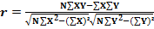
CHI- SQUARE TEST I – (Ψ²)
A chi-squared test, also referred to as chi-square test or χ2 test, is any statistical hypothesis test in which the sampling distribution of the test statistic is a chi-squared distribution when the null hypothesis is true, or any in which this is asymptotically true, meaning that the sampling distribution (if the null hypothesis is true) can be made to approximate a chi- squared distribution as closely as desired by making the sample size large enough.

The χ2 test was first used by Karl Pearson in the year 1980. The quantity χ2 describes the magnitude of the discrepancy between theory and observation.
It is calculated using:

χ² = Σ [( )2 / ]with (n - 1) degrees of freedom. Where, refers to the observed frequency & to the expected frequencies. χ² was used as a test of independence and goodness of fit.

WEIGHTED AVERAGE
Weighting is another term for sample balancing. During a survey, it is not possible to interview everyone, so only a sample of the population is interviewed. If this sample group does not accurately reflect the proportions of various groups in the total population, you can weight the survey results.

T- TEST

T Test is often called Student's T test in the name of its founder "Student". T test is used to compare two different set of values. It is generally performed on a small set of data. T test is generally applied to normal distribution which has a small set of values. This test compares the mean of two samples. T test uses means and standard deviations of two samples to make a comparison. The formula for T test is given below:

- 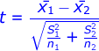
Where,
x1¯x1¯ = Mean of first set of values
x2¯x2¯ = Mean of second set of values
S1 = Standard deviation of first set of values
S2 = Standard deviation of second set of values
n1 = Total number of values in first set
n2 = Total number of values in second set.
The formula for standard deviation is given by:
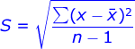
Where,
x = Values given
x¯x¯ = Mean
n = Total number of values.

ONE WAY ANOVA
The ANOVA tests the null hypothesis that samples in two or more groups are drawn from populations with the same mean values. To do this, two estimates are made of the population variance. The ANOVA produces an F-statistic, the ratio of the variance calculated among the means to the variance within the samples. If the group means are drawn from populations with the same mean values, the variance between the group means should be lower than the variance of the samples, following the central limit theorem. A higher ratio therefore implies that the samples were drawn from populations with different mean values.

CHAPTER 4: DATA ANALYSIS AND INTERPRETATION

TABLE 4.1: GENDER
GENDER | NO OF RESPONDENTS | % OF RESPONDENTS
Male | 116 | 46%
Female | 134 | 54%
Total | 250 | 100%

CHART 1
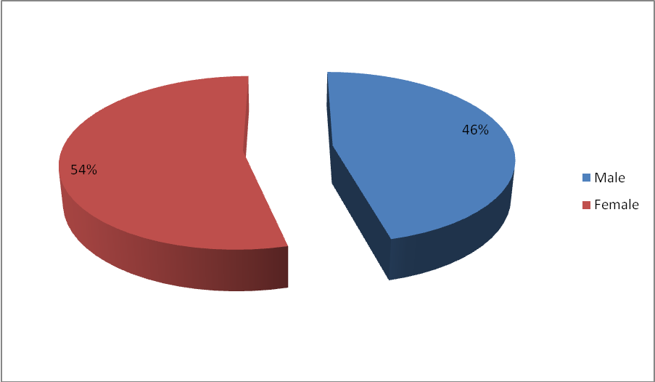
INFERENCE
From the above table it is inferred that 54% of the respondents are female,46% of the respondents are male. Most of the respondents are female.

TABLE 4.2: AGE
Age | NO OF RESPONDENTS | % OF RESPONDENTS
18-25 | 139 | 56%
26-35 | 76 | 30%
36-50 | 27 | 11%
Above | 8 | 3%
Total | 250 | 100%

CHART 2
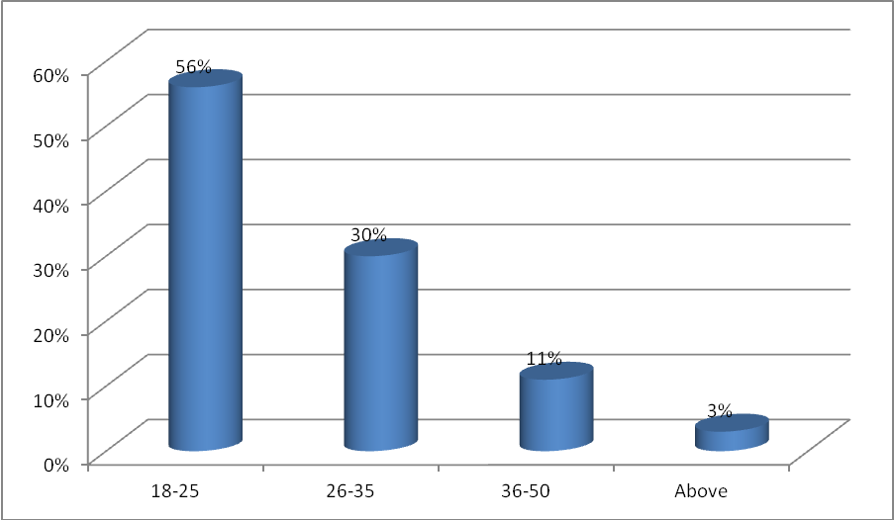
INFERENCE
From the above table it is inferred that 56% of the respondents belong to the age group of 18 – 25 yrs, 30% of the respondents belong to the age group of 26 – 35 yrs. Most of the respondents belong to the age group of 18 – 25 yrs.
TABLE 4.3: MARITAL STATUS
MARITAL STATUS | NO. OF RESPONDENTS | % OF RESPONDENTS
Single | 158 | 63%
married | 92 | 37%
Total | 250 | 100%

CHART 3
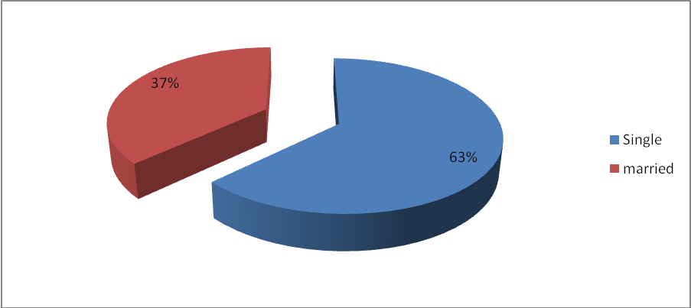

INFERENCE:
From the above table it is inferred that 63% of the respondents are Single, 37% of the respondents are Married. Most of the respondents are Single.

TABLE 4.4: OCCUPATION
OCCUPATION | NO. OF RESPONDENTS | % OF RESPONDENTS
Business | 115 | 46%
Private Employee | 31 | 12%
Government Employee | 26 | 11%
Others | 78 | 31%
Total | 250 | 100%

CHART 4
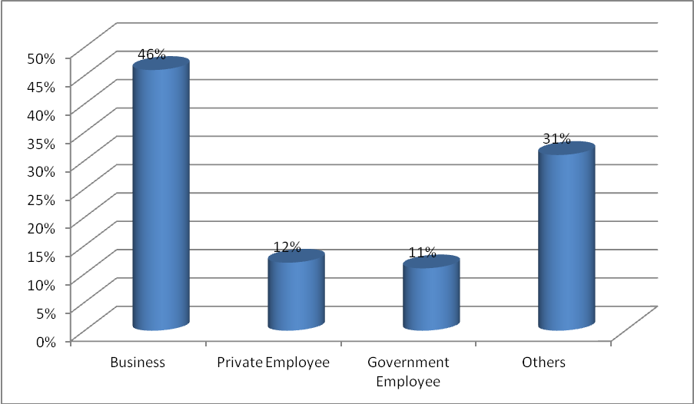

INFERENCE
From the above table it is inferred that 46% of the respondents are Business, 31% of the respondents are Others. Most of the respondents are Business.

TABLE 4.5: INFORMATION IS FOUND WITH A MINIMUM OF CLICKS
PARTICULARS | NO. OF RESPONDENTS | % OF RESPONDENTS
Strongly Disagree | 18 | 7%
Disagree | 32 | 13%
Neutral | 79 | 32%
Agree | 94 | 38%
Strongly Agree | 27 | 11%
Total | 250 | 100

CHART 5
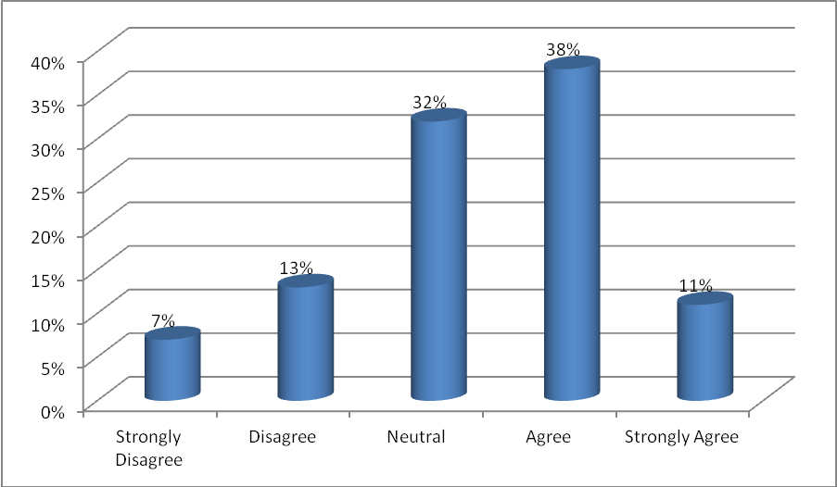

INFERENCE
From the above table it is inferred that 38% of the respondents mention agree the information is found with a minimum of clicks, 32% of the respondents mention neither agree nor disagree that the information is found with a minimum of clicks. Most of the respondents mention agree the information is found with a minimum of clicks.

TABLE 4.6: LINKS ARE PROVIDED TO TRUE PAGES ON RELATED PRODUCTS

PARTICULARS | NO. OF RESPONDENTS | % OF RESPONDENTS
Strongly Disagree | 14 | 6%
Disagree | 25 | 10%
Neutral | 71 | 28%
Agree | 102 | 41%
Strongly Agree | 38 | 15%
Total | 250 | 100%

CHART 6
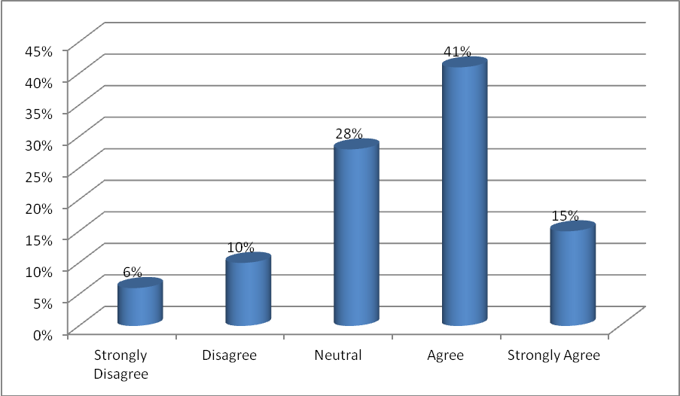
INFERENCE
From the above table it is inferred that 41% of the respondents agree the links which are provided to true pages on related products, 28% of the respondents say neither agree nor disagree the links which are provided to true pages on related products. Most of the respondents agree the links which are provided to true pages on related products.

TABLE 4.7: EASY TO FIND RELEVANT INFORMATION
PARTICULARS | NO. OF RESPONDENTS | % OF RESPONDENTS
Strongly Disagree | 12 | 5%
Disagree | 30 | 12%
Neutral | 45 | 18%
Agree | 98 | 39%
Strongly Agree | 65 | 26%
Total | 250 | 100%

CHART 7
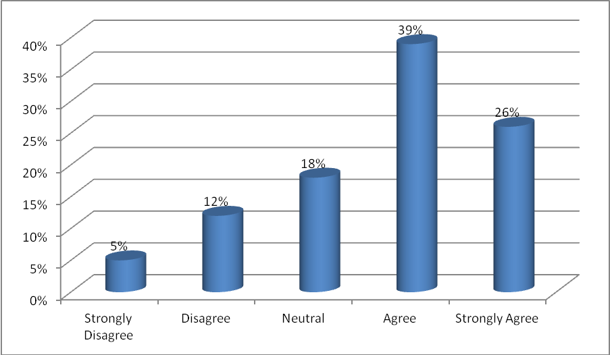

INFERENCE
From the above table it is inferred that 39% of the respondents agree the relevant information is easy to find, 26% of the respondents say strongly agree the relevant information is easy to find. Most of the respondents agree the relevant information is easy to find.

TABLE 4.8: IT IS EASY TO PRINT FROM THE WEB
PARTICULARS | NO. OF RESPONDENTS | % OF RESPONDENTS
Strongly Disagree | 3 | 1%
Disagree | 5 | 2%
Neutral | 14 | 6%
Agree | 121 | 48%
Strongly Agree | 107 | 43%
Total | 250 | 100%

CHART 8
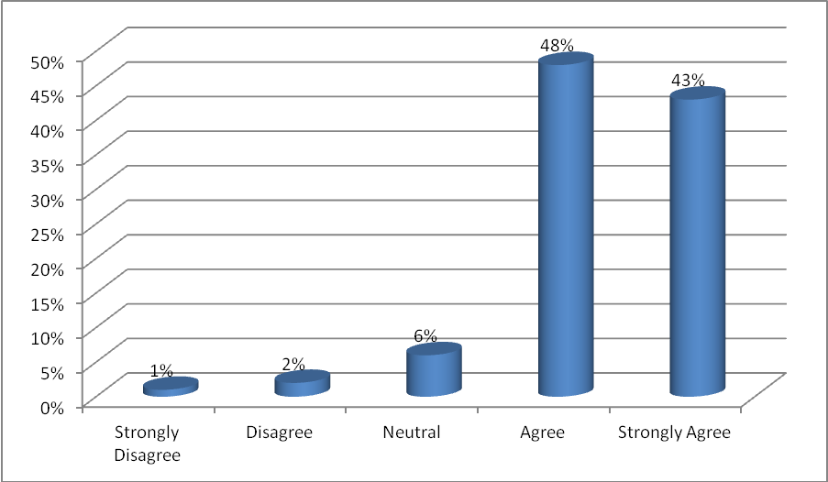

INFERENCE
From the above table it is inferred that 48% of the respondents agree to print from the web is easy, 43% of the respondents say strongly agree to print from the web is easy. Most of the respondents agree to print from the web is easy.

TABLE 4.9: ACCESS IS FAST
PARTICULARS | NO. OF RESPONDENTS | % OF RESPONDENTS
Strongly Disagree | 13 | 5%
Disagree | 19 | 8%
Neutral | 28 | 11%
Agree | 129 | 52%
Strongly Agree | 61 | 24%
Total | 250 | 100%

CHART 9
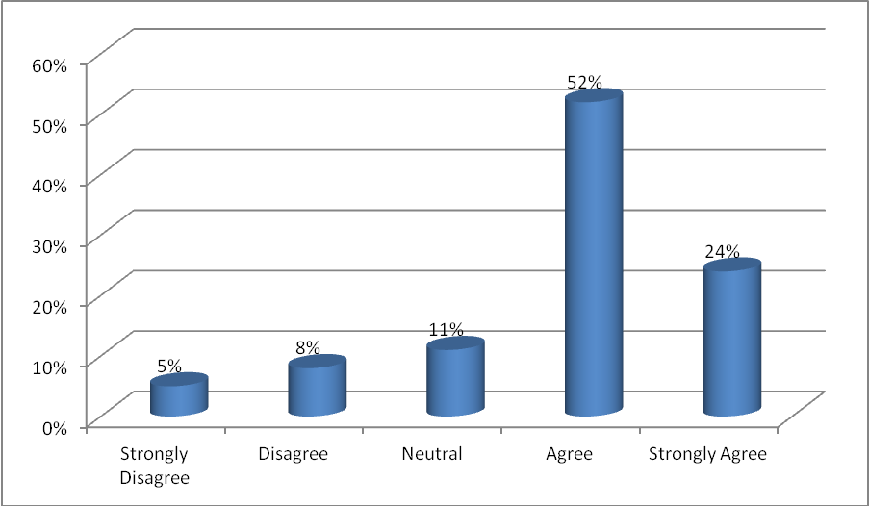

INFERENCES
From the above table it is inferred that 52% of the respondents agree that the access is fast, 24% of the respondents say strongly agree that the access is fast. Most of the respondents agree that the access is fast.
TABLE 4.10: REGISTRATION PROCESS DETAILS ARE RETAINED SECURELY

PARTICULARS | NO. OF RESPONDENTS | % OF RESPONDENTS
Strongly Disagree | 11 | 5%
Disagree | 9 | 4%
Neutral | 27 | 11%
Agree | 99 | 39%
Strongly Agree | 104 | 41%
Total | 250 | 100%

CHART 10
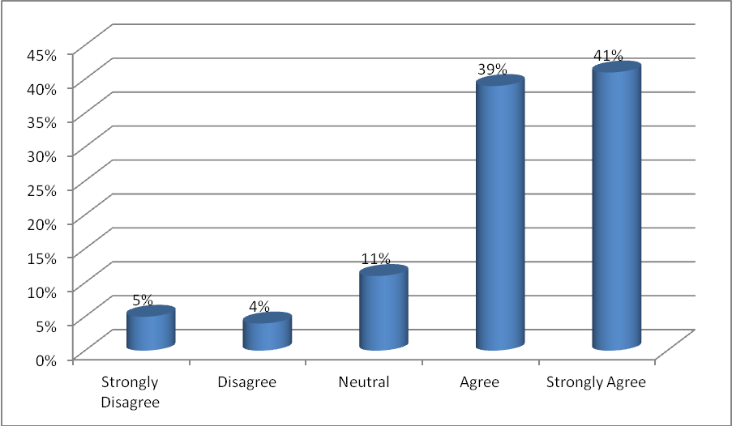
INFERENCE
From the above table it is inferred that 41% of the respondents say strongly agree the registration process details which are retained securely, 39% of the respondents say the registration process details which are retained securely. Most of the respondents say strongly agree the registration process details which are retained securely.
TABLE 4.11: TAX AND/OR OTHER CHARGES ARE CLEARLY DETAILED
PARTICULARS | NO. OF RESPONDENTS | % OF RESPONDENTS
Strongly Disagree | 17 | 7%
Disagree | 25 | 10%
Neutral | 33 | 13%
Agree | 110 | 44%
Strongly Agree | 65 | 26%
Total | 250 | 100%

CHART 11
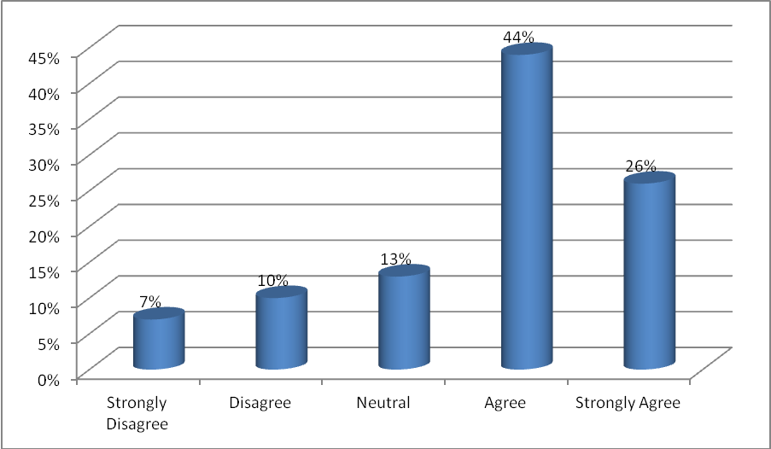

INFERENCE
From the above table it is inferred that 44% of the respondents agree the tax and/or other charges details are mentioned clearly, 26% of the respondents say strongly agree the tax and/or other charges details are mentioned clearly. Most of the respondents agree the tax and/or other charges details are mentioned clearly.
TABLE 4.12: DIFFERENT PAYMENT OPTIONS ARE STATED CLEARLY
PARTICULARS | NO. OF RESPONDENTS | % OF RESPONDENTS
Strongly Disagree | 16 | 6%
Disagree | 21 | 8%
Neutral | 31 | 12%
Agree | 124 | 51%
Strongly Agree | 58 | 23%
Total | 250 | 100%

CHART 12
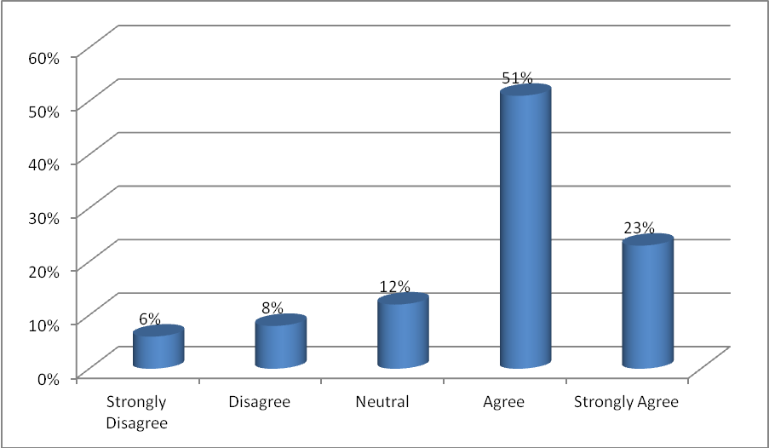
INFERENCE
From the above table it is inferred that 51% of the respondents agree the payment options are stated clearly, 23% of the respondents say strongly agree the payment options are stated clearly. Most of the respondents agree the payment options are stated clearly.

TABLE 4.13: POTENTIALLY RANGE OF HIGH QUALITY PRODUCTS AT COMPETITIVE PRICES
PARTICULARS | NO. OF RESPONDENTS | % OF RESPONDENTS
Strongly Disagree | 21 | 8%
Disagree | 32 | 13%
Neutral | 41 | 16%
Agree | 92 | 37%
Strongly Agree | 64 | 26%
Total | 250 | 100%

CHART 13
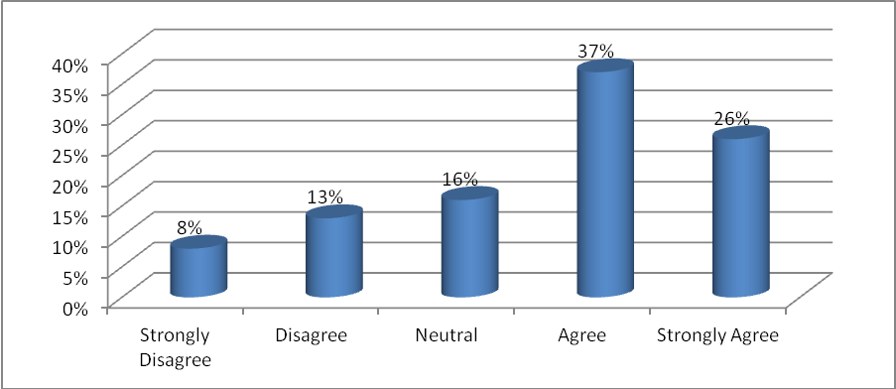
INFERENCES
From the above table it is inferred that 37% of the respondents agree the potentially range of high quality products is competitive prices, 26% of the respondents say strongly agree the potentially range of high quality products is competitive prices. Most of the respondents agree the potentially range of high quality products is competitive prices.

TABLE 4.14: CREATION OF A PLEASURABLE E-SHOPPING EXPERIENCE
PARTICULARS | NO. OF RESPONDENTS | % OF RESPONDENTS
Strongly Disagree | 9 | 3%
Disagree | 11 | 4%
Neutral | 14 | 6%
Agree | 113 | 46%
Strongly Agree | 103 | 41%
Total | 250 | 100%

CHART 14
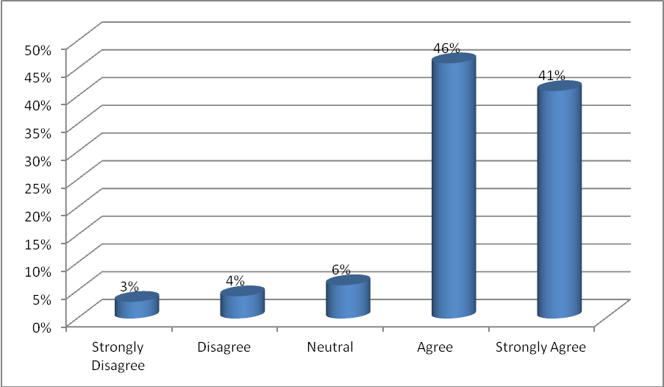
INFERENCES
From the above table it is inferred that 46% of the respondents agree for providing a pleasurable e-shopping experience, 41% of the respondents say strongly agree for providing a pleasurable e-shopping experience. Most of the respondents agree for providing a pleasurable e-shopping experience.
TABLE 4.15: CUSTOMER SERVICE CENTER WERE AVAILABLE AT CONVENIENT TIMES.
PARTICULARS | NO. OF RESPONDENTS | % OF RESPONDENTS
Strongly Disagree | 31 | 12%
Disagree | 82 | 33%
Neutral | 65 | 26%
Agree | 47 | 19%
Strongly Agree | 25 | 10%
Total | 250 | 100%

CHART 15
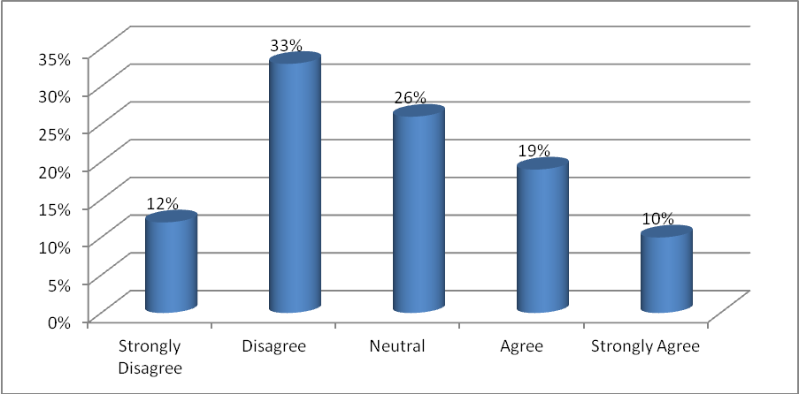
INFERENCES
From the above table it is inferred that 26% of the respondents say neither agree nor disagree with convenient time of customer service center, 41% of the respondents agree with convenient time of customer service center. Most of the respondents say neither agree nor disagree with convenient time of customer service center.
TABLE 4.16: NAVIGATION IS CONSISTENT AND AVAILABLE ON EVERY PAGE
PARTICULARS | NO. OF RESPONDENTS | % OF RESPONDENTS
Strongly Disagree | 13 | 5%
Disagree | 32 | 13%
Neutral | 67 | 27%
Agree | 94 | 37%
Strongly Agree | 44 | 18%
Total | 250 | 100%

CHART 16
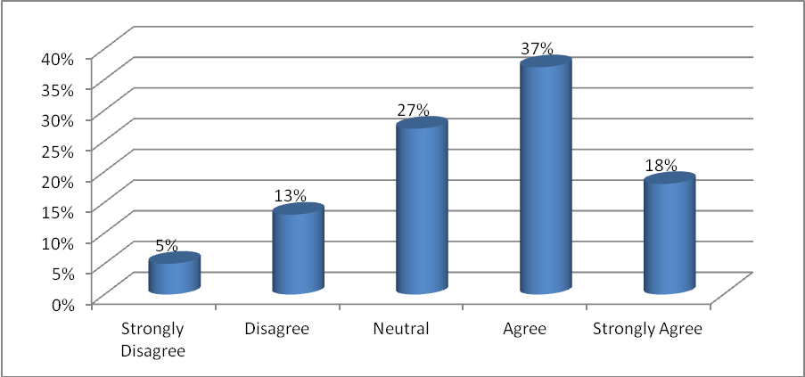
INFERENCES
From the above table it is inferred that 37% of the respondents agree the navigation is consistent and available on every page, 27% of the respondents say neither agree nor disagree the navigation is consistent and available on every page. Most of the respondents agree the navigation is consistent and available on every page.
TABLE 4.17: HELPFUL ANSWER TO THE CLIENT’S REQUEST OF TECHNICAL INFORMATION
PARTICULARS | NO. OF RESPONDENTS | % OF RESPONDENTS
Strongly Disagree | 2 | 1%
Disagree | 5 | 2%
Neutral | 10 | 4%
Agree | 89 | 35%
Strongly Agree | 144 | 58%
Total | 250 | 100%

CHART 17
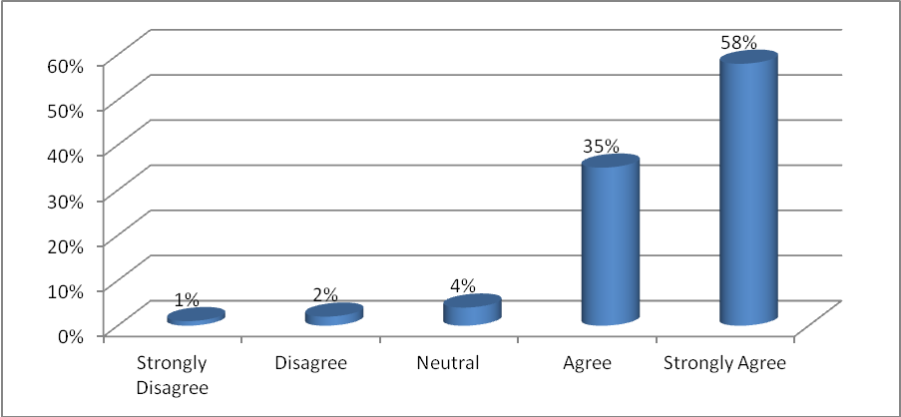
INFERENCES
From the above table it is inferred that 58% of the respondents say strongly agree to answer the client’s request of technical information, 35% of the respondents say to answer the client’s request of technical information. Most of the respondents say strongly agree to answer the client’s request of technical information.

TABLE 4.18: GUARANTEES ABOUT THE PRIVACY OF PERSONAL INFORMATION
PARTICULARS | NO. OF RESPONDENTS | % OF RESPONDENTS
Strongly Disagree | 16 | 6%
Disagree | 25 | 10%
Neutral | 48 | 19%
Agree | 109 | 44%
Strongly Agree | 52 | 21%
Total | 250 | 100%

CHART 18
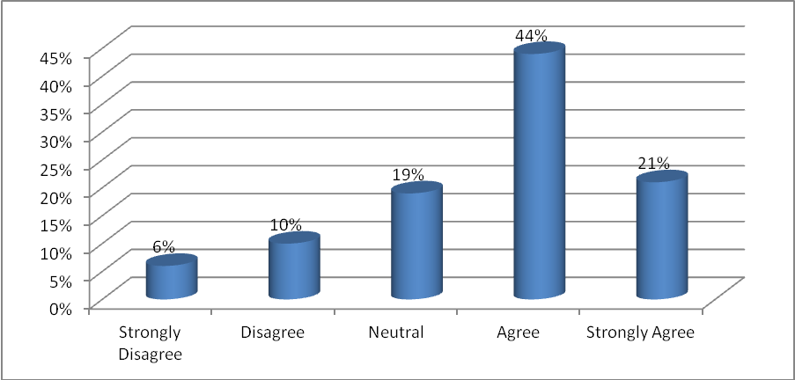
INFERENCES
From the above table it is inferred that 44% of the respondents agree about the privacy of personal information, 21% of the respondents say strongly agree about the privacy of personal information. Most of the respondents agree about the privacy of personal information.

TABLE 4.19: EXTERNAL VALIDATION OF TRUSTWORTHINESS IS IMPORTANT
PARTICULARS | NO. OF RESPONDENTS | % OF RESPONDENTS
Strongly Disagree | 11 | 4%
Disagree | 17 | 7%
Neutral | 32 | 13%
Agree | 115 | 46%
Strongly Agree | 75 | 30%
Total | 250 | 100%

CHART 19
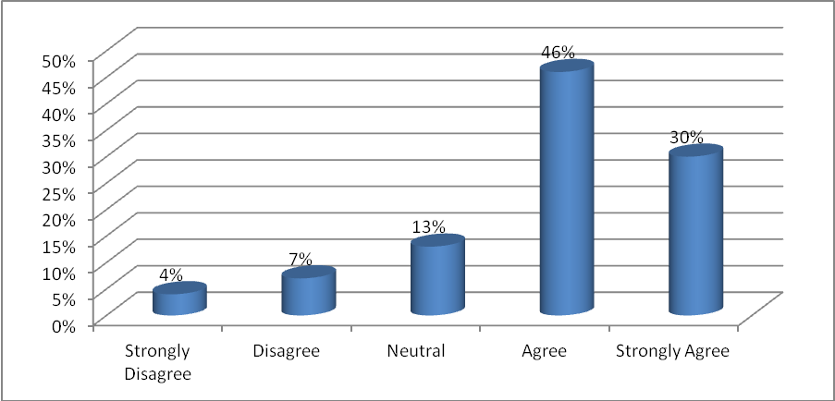
INFERENCES
From the above table it is inferred that 46% of the respondents agree about the external validation of trustworthiness is important, 30% of the respondents say strongly agree about the external validation of trustworthiness is important. Most of the respondents agree about the external validation of trustworthiness is important.
TABLE 4.20: QUERIES OR COMPLAINTS ARE RESOLVED WITHIN 24 HOURS
PARTICULARS | NO. OF RESPONDENTS | % OF RESPONDENTS
Strongly Disagree | 5 | 2%
Disagree | 9 | 3%
Neutral | 11 | 5%
Agree | 118 | 47%
Strongly Agree | 107 | 43%
Total | 250 | 100%

CHART 20
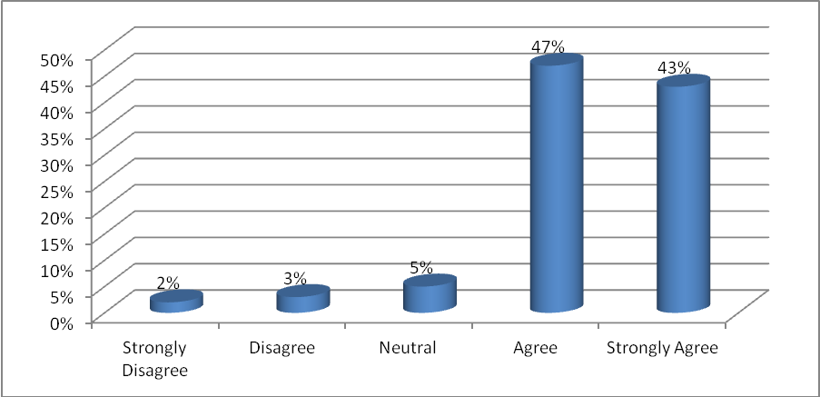
INFERENCES
From the above table it is inferred that 47% of the respondents agree with the process of getting queries or complaints are resolved within 24 hours, 43% of the respondents say strongly agree with the process of getting queries or complaints are resolved within 24 hours. Most of the respondents agree with the process of getting queries or complaints are resolved within 24 hours.

TABLE 4.21: RETURN POLICY IS REASONABLE
PARTICULARS | NO. OF RESPONDENTS | % OF RESPONDENTS
Strongly Disagree | 29 | 12%
Disagree | 69 | 28%
Neutral | 48 | 19%
Agree | 80 | 31%
Strongly Agree | 24 | 10%
Total | 250 | 100%

CHART 21
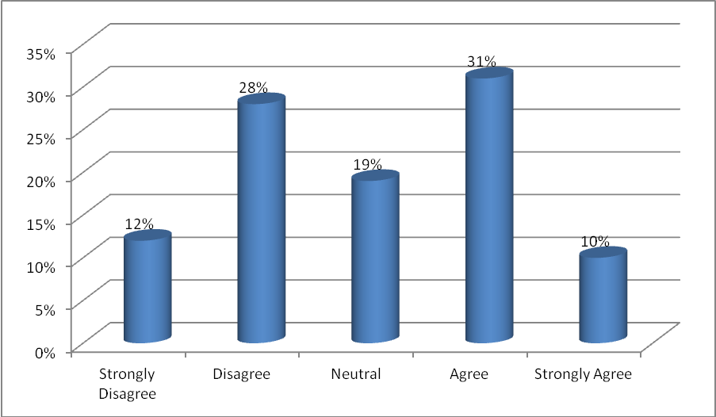
INFERENCES
From the above table it is inferred that 31% of the respondents agree with the return policy is reasonable, 28% of the respondents say disagree with the return policy is reasonable. Most of the respondents agree with the return policy is reasonable.

TABLE 4.22: EFFICIENT CONTACT CHANGES IN PRICES, PRODUCTS, DELAYS
PARTICULARS | NO. OF RESPONDENTS | % OF RESPONDENTS
Strongly Disagree | 28 | 11%
Disagree | 52 | 21%
Neutral | 61 | 24%
Agree | 74 | 30%
Strongly Agree | 35 | 14%
Total | 250 | 100%

CHART 22
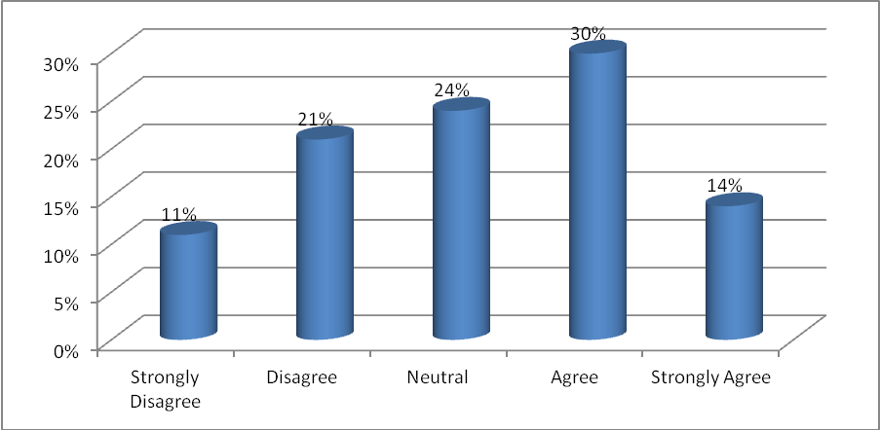
INFERENCES
From the above table it is inferred that 30% of the respondents agree the efficient contact changes in prices, products and delays, 24% of the respondents say neither agree nor disagree the efficient contact changes in prices, products and delays. Most of the respondents agree the efficient contact changes in prices, products and delays.
TABLE 4.23: ONLINE SUPPORTS FOR AFTER-SALES SERVICE
PARTICULARS | NO. OF RESPONDENTS | % OF RESPONDENTS
Strongly Disagree | 21 | 8%
Disagree | 29 | 12%
Neutral | 44 | 18%
Agree | 88 | 35%
Strongly Agree | 68 | 27%
Total | 250 | 100%

CHART 23
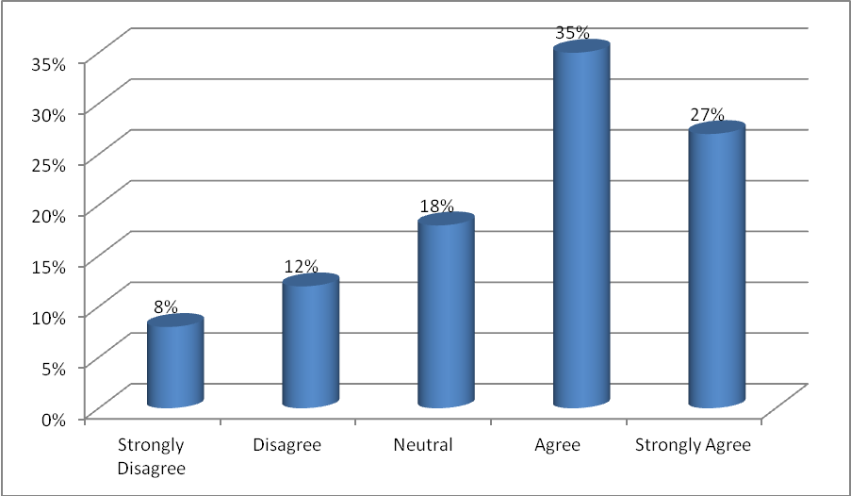
INFERENCES
From the above table it is inferred that 35% of the respondents agree with online supports for after-sales service, 27% of the respondents say strongly agree with online supports for after-sales service. Most of the respondents agree with online supports for after-sales service.
TABLE 4.24: FREE OR REASONABLE DELIVERY COST
PARTICULARS | NO. OF RESPONDENTS | % OF RESPONDENTS
Strongly Disagree | 31 | 12%
Disagree | 68 | 27%
Neutral | 51 | 21%
Agree | 62 | 25%
Strongly Agree | 38 | 15%
Total | 250 | 100%

CHART 24
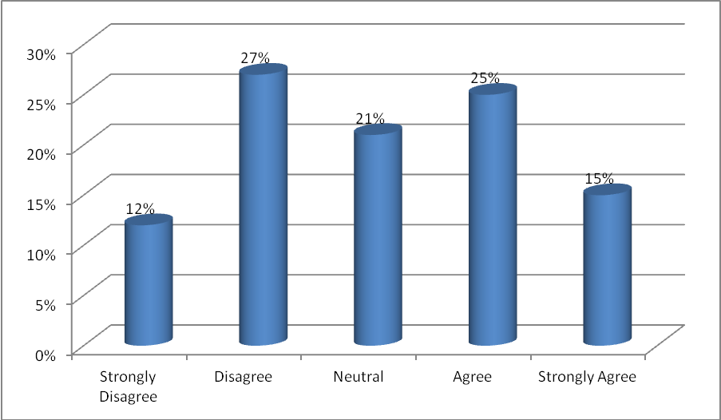
INFERENCES
From the above table it is inferred that 27% of the respondents say disagree with delivery cost, 25% of the respondents agree with delivery cost. Most of the respondents say disagree with delivery cost.

TABLE 4.25: FIRMS CAPACITY TO DELIVER PRODUCTS WITHOUT DAMAGE DURING THE TRANSPORT
PARTICULARS | NO. OF RESPONDENTS | % OF RESPONDENTS
Strongly Disagree | 19 | 8%
Disagree | 31 | 12%
Neutral | 64 | 26%
Agree | 83 | 33%
Strongly Agree | 53 | 21%
Total | 250 | 100%

CHART 25
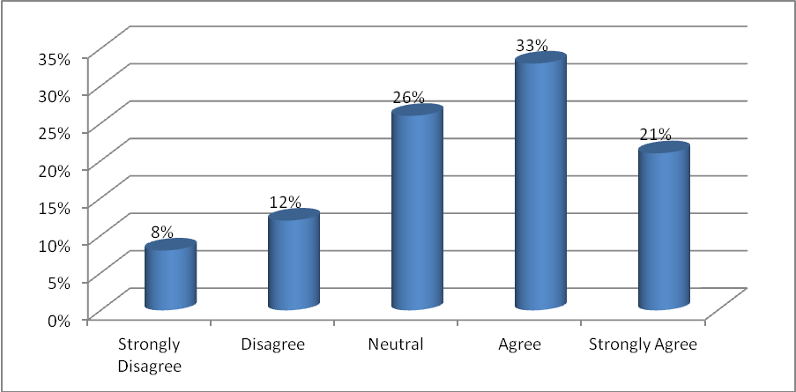
INFERENCES
From the above table it is inferred that 33% of the respondents agreed that the products are delivered without damage during the transport, 26% of the respondents say neither agree nor that the products are delivered without damage during the transport. Most of the respondents agreed that the products are delivered without damage during the transport.
TABLE 4.26: PRODUCT APPEARANCES
PARTICULARS | NO. OF RESPONDENTS | % OF RESPONDENTS
Strongly Disagree | 11 | 4%
Disagree | 60 | 24%
Neutral | 97 | 39%
Agree | 51 | 21%
Strongly Agree | 31 | 12%
Total | 250 | 100%

CHART 26
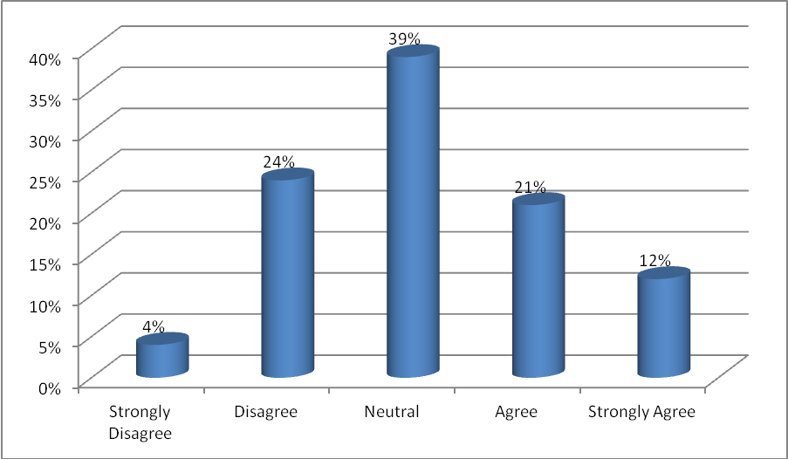
INFERENCES
From the above table it is inferred that 39% of the respondents say neither agree nor disagree with product appearances, 24% of the respondents say disagree with product appearances. Most of the respondents say neither agree nor disagree with product appearances.

TABLE 4.27: PRODUCT PRICE
PARTICULARS | NO. OF RESPONDENTS | % OF RESPONDENTS
Strongly Disagree | 12 | 5%
Disagree | 21 | 8%
Neutral | 103 | 41%
Agree | 65 | 26%
Strongly Agree | 49 | 20%
Total | 250 | 100%

CHART 27
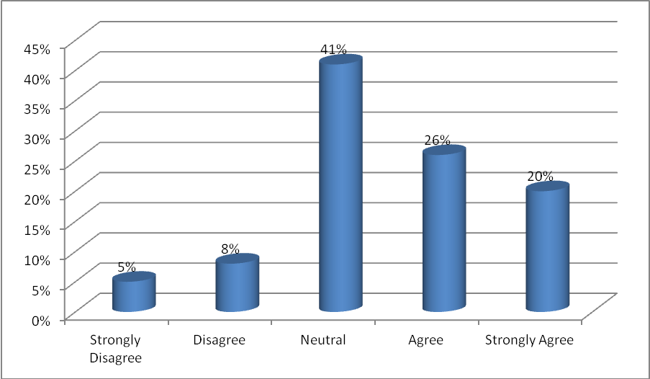
INFERENCES
From the above table it is inferred that 41% of the respondents say neither agree nor disagree with product price, 26% of the respondents agree with product price. Most of the respondents say neither agree nor disagree with product price.

TABLE 4.28: PRODUCT WARRANTY
PARTICULARS | NO. OF RESPONDENTS | % OF RESPONDENTS
Strongly Disagree | 12 | 5%
Disagree | 65 | 26%
Neutral | 81 | 33%
Agree | 71 | 28%
Strongly Agree | 21 | 8%
Total | 250 | 100%

CHART 28
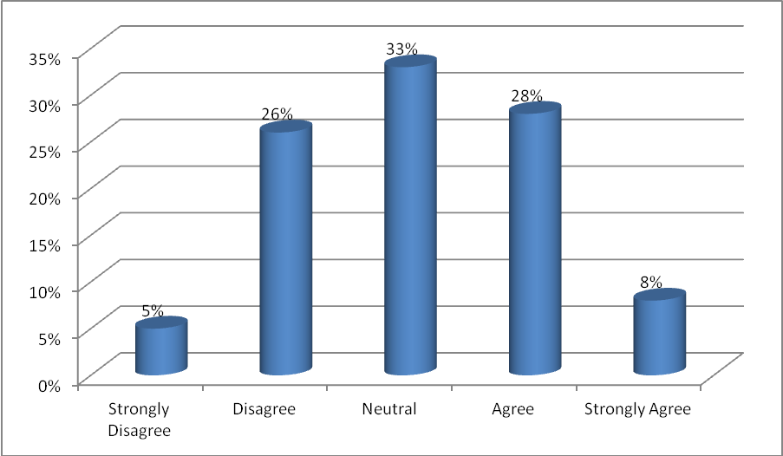
INFERENCES
From the above table it is inferred that 33% of the respondents say neither agree nor disagree with product warranty, 28% of the respondents agree with product warranty. Most of the respondents say neither agree nor disagree with product warranty.

TABLE 4.29: PRODUCT PACKING
PARTICULARS | NO. OF RESPONDENTS | % OF RESPONDENTS
Strongly Disagree | 19 | 8%
Disagree | 36 | 14%
Neutral | 76 | 30%
Agree | 72 | 29%
Strongly Agree | 47 | 19%
Total | 250 | 100%

CHART 29
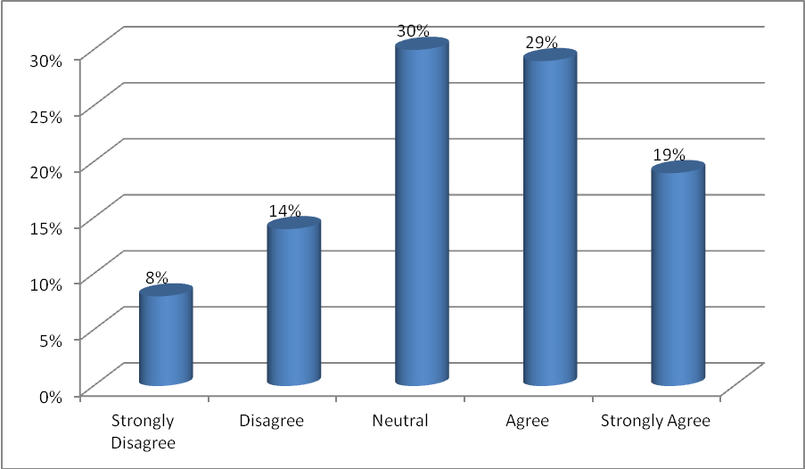
INFERENCES
From the above table it is inferred that 30% of the respondents say neither agree nor disagree with product packing, 29% of the respondents agree with product packing. Most of the respondents say neither agree nor disagree with product packing.

TABLE 4.30: REFERRAL PRODUCT
PARTICULARS | NO. OF RESPONDENTS | % OF RESPONDENTS
Strongly Disagree | 21 | 8%
Disagree | 32 | 13%
Neutral | 61 | 24%
Agree | 82 | 33%
Strongly Agree | 54 | 22%
Total | 250 | 100%

CHART 30
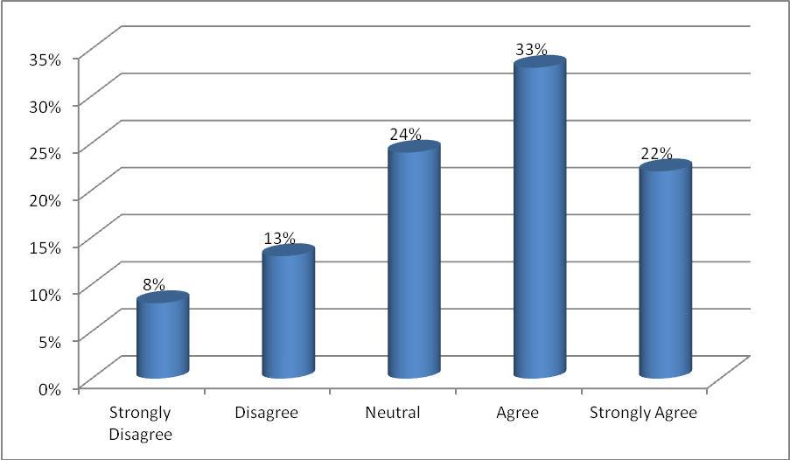
INFERENCES
From the above table it is inferred that 33% of the respondents agree with referral product, 24% of the respondents say neither agree nor disagree with referral product. Most of the respondents agree with referral product.

TABLE 4.31: PRODUCT QUALITY
PARTICULARS | NO. OF RESPONDENTS | % OF RESPONDENTS
Strongly Disagree | 14 | 6%
Disagree | 26 | 10%
Neutral | 38 | 15%
Agree | 99 | 40%
Strongly Agree | 73 | 29%
Total | 250 | 100%

CHART 31
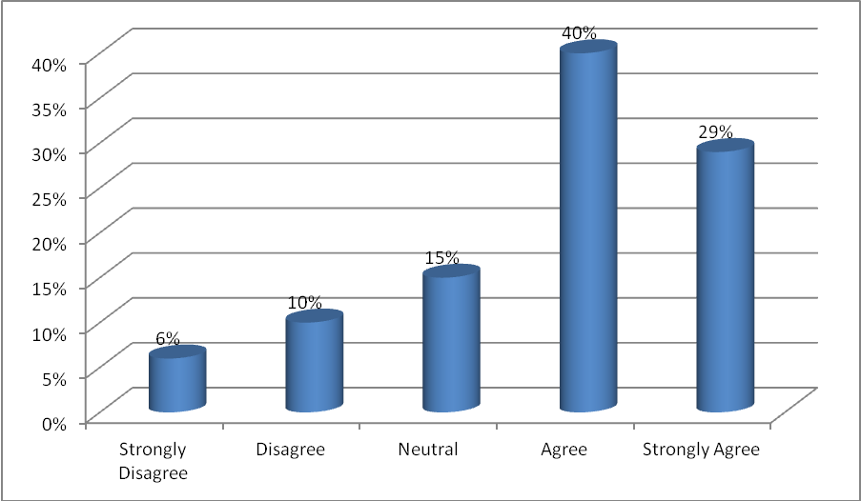
INFERENCES
From the above table it is inferred that 40% of the respondents agree with product quality, 29% of the respondents say strongly agree with product quality. Most of the respondents agree with product quality.

TABLE 4.32: FIRMS CAPACITY TO ACCEPT THE EXACT QUANTITIES REQUESTED IN THE ORDER
PARTICULARS | NO. OF RESPONDENTS | % OF RESPONDENTS
Strongly Disagree | 9 | 4%
Disagree | 54 | 22%
Neutral | 92 | 36%
Agree | 74 | 30%
Strongly Agree | 21 | 8%
Total | 250 | 100%

CHART 32
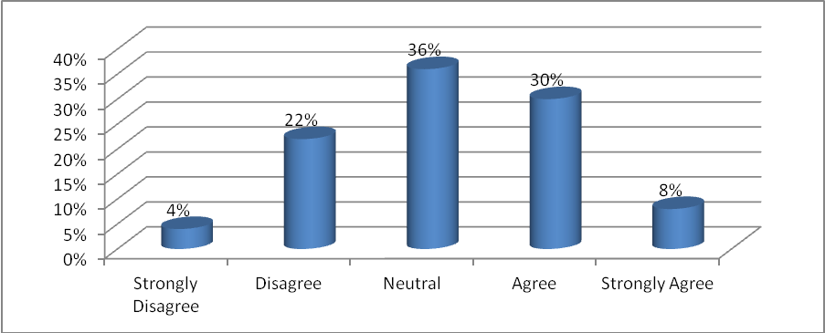
INFERENCES
From the above table it is inferred that 36% of the respondents say neither agree nor disagree to accept the quantities which requested in the order of firms capacity, 30% of the respondents agree to accept the quantities which requested in the order of firms capacity. Most of the respondents say neither agree nor disagree to accept the quantities which requested in the order of firms capacity.

TABLE 4.33: NOT TO HAVE DIFFICULTIES IN THE ORDER DUE TO THE LIMIT OF THE MAXI QUANTITY
PARTICULARS | NO. OF RESPONDENTS | % OF RESPONDENTS
Strongly Disagree | 7 | 3%
Disagree | 62 | 25%
Neutral | 98 | 39%
Agree | 65 | 26%
Strongly Agree | 18 | 7%
Total | 250 | 100%

CHART 33
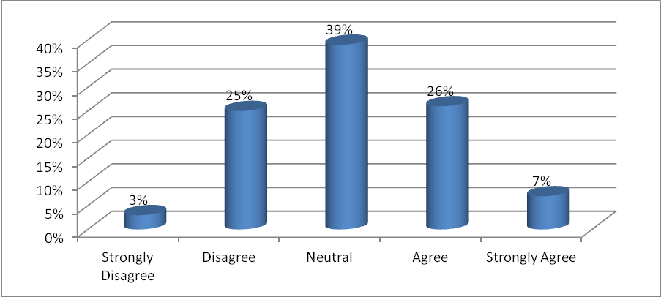
INFERENCES
From the above table it is inferred that 39% of the respondents neither agree nor disagree that they don’t have difficulties in the order due to the limit of the maxi quantity, 26% of the respondents agree that they don’t have difficulties in the order due to the limit of the maxi quantity. Most of the respondents say neither agree nor disagree that they don’t have difficulties in the order due to the limit of the maxi quantity.
TABLE 4.34: THE TIME BETWEEN THE ORDER AND THE DELIVERY BY THE FIRM IS REASONABLE
PARTICULARS | NO. OF RESPONDENTS | % OF RESPONDENTS
Strongly Disagree | 12 | 5%
Disagree | 25 | 10%
Neutral | 39 | 16%
Agree | 111 | 44%
Strongly Agree | 63 | 25%
Total | 250 | 100%

CHART 34
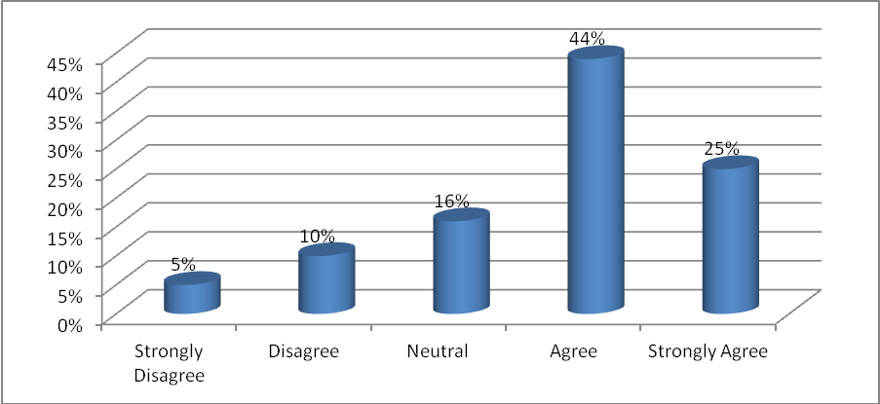
INFERENCES
From the above table it is inferred that 44% of the respondents agree with the time between order and delivery is reasonable by the frim, 25% of the respondents say strongly agree with the time between order and delivery is reasonable by the frim. Most of the respondents agree with the time between order and delivery is reasonable by the frim.

TABLE 4.35: DELIVERY STAFF IS FRIENDLY AND HELPFUL
PARTICULARS | NO. OF RESPONDENTS | % OF RESPONDENTS
Strongly Disagree | 12 | 5%
Disagree | 21 | 8%
Neutral | 42 | 17%
Agree | 99 | 40%
Strongly Agree | 76 | 30%
Total | 250 | 100%

CHART 35
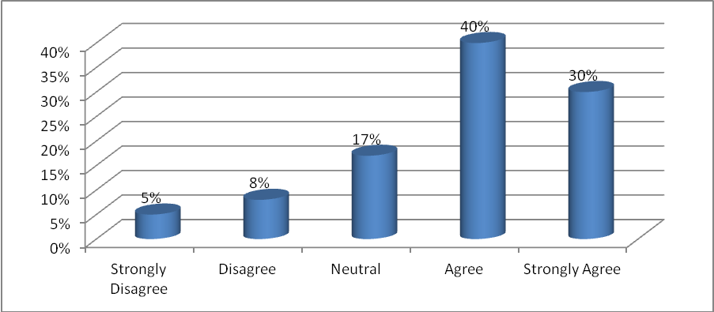
INFERENCES
From the above table it is inferred that 40% of the respondents agree that the delivery staff is friendly and helpful, 30% of the respondents say strongly agree that the delivery staff is friendly and helpful. Most of the respondents agree that the delivery staff is friendly and helpful.

TABLE 4.36: DELIVERIES NEATLY WITHOUT DELAYS
PARTICULARS | NO. OF RESPONDENTS | % OF RESPONDENTS
Strongly Disagree | 22 | 9%
Disagree | 47 | 19%
Neutral | 95 | 38%
Agree | 55 | 22%
Strongly Agree | 31 | 12%
Total | 250 | 100%

CHART 36
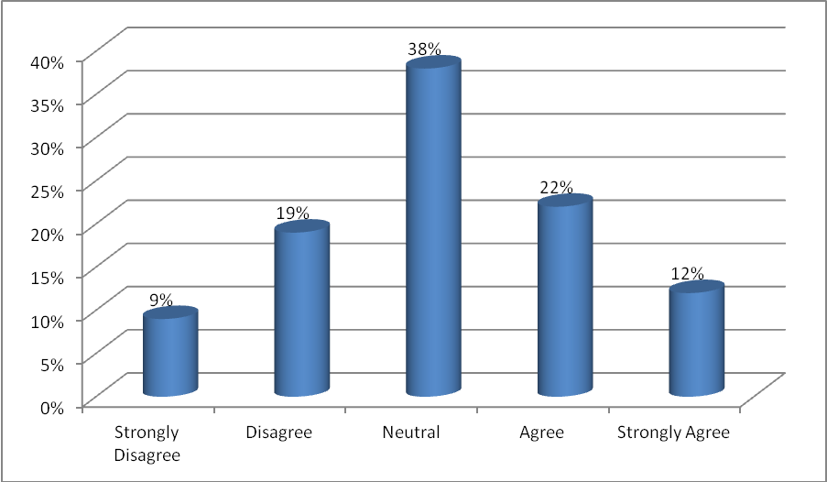
INFERENCES
From the above table it is inferred that 38% of the respondents say neither agree nor disagree that the deliveries present neatly without any delay, 22% of the respondents agree that the deliveries present neatly without any delay. Most of the respondents say neither agree nor disagree that the deliveries present neatly without any delay.
TABLE 4.37: EFFICIENT COMMUNICATIONS BETWEEN CUSTOMER AND TRANSPORTER
PARTICULARS | NO. OF RESPONDENTS | % OF RESPONDENTS
Strongly Disagree | 23 | 9%
Disagree | 35 | 14%
Neutral | 71 | 28%
Agree | 74 | 30%
Strongly Agree | 47 | 19%
Total | 250 | 100%

CHART 37
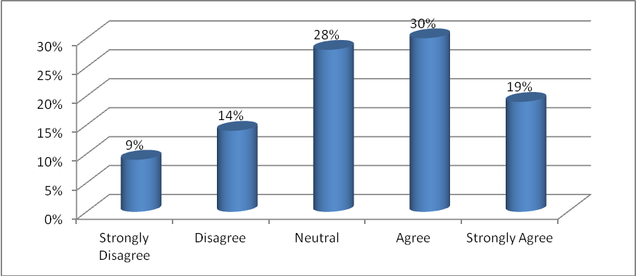
INFERENCES
From the above table it is inferred that 30% of the respondents agree with the communications between customer and transporter, 28% of the respondents say neither agree nor disagree with the communications between customer and transporter. Most of the respondents agree with the communications between customer and transporter.

TABLE 4.38: SHIPMENTS RARELY CONTAIN WRONG ITEMS, LOW NUMBERS OF DEFECTS
PARTICULARS | NO. OF RESPONDENTS | % OF RESPONDENTS
Strongly Disagree | 26 | 10%
Disagree | 21 | 8%
Neutral | 38 | 16%
Agree | 103 | 41%
Strongly Agree | 62 | 25%
Total | 250 | 100%

CHART 38
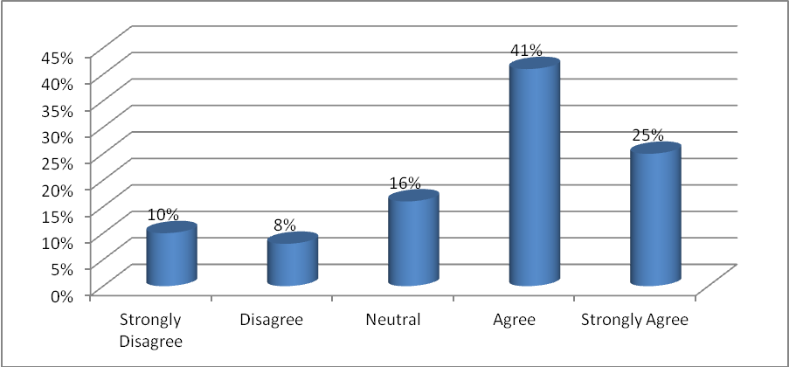
INFERENCES
From the above table it is inferred that 41% of the respondents agree the shipments contain wrong items and low numbers of defects, 25% of the respondents say strongly agree the shipments contain wrong items and low numbers of defects. Most of the respondents agree the shipments contain wrong items and low numbers of defects.

TABLE 4.39: ABILITY TO MEET SCHEDULED DELIVERY DATE IS GOOD
PARTICULARS | NO. OF RESPONDENTS | % OF RESPONDENTS
Strongly Disagree | 20 | 8%
Disagree | 25 | 10%
Neutral | 43 | 17%
Agree | 89 | 36%
Strongly Agree | 73 | 29%
Total | 250 | 100%

CHART 39
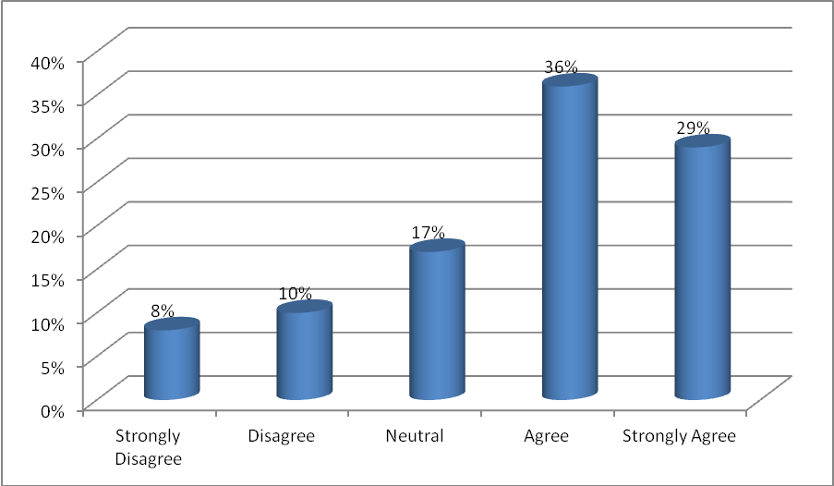
INFERENCES
From the above table it is inferred that 36% of the respondents agree to meet scheduled delivery date is good, 29% of the respondents say strongly agree to meet scheduled delivery date is good. Most of the respondents agree to meet scheduled delivery date is good.

TABLE 4.40: FLEXIBILITY OF DELIVERY SCHEDULE IS ACCEPTABLE
PARTICULARS | NO. OF RESPONDENTS | % OF RESPONDENTS
Strongly Disagree | 13 | 5%
Disagree | 27 | 11%
Neutral | 36 | 14%
Agree | 98 | 39%
Strongly Agree | 76 | 31%
Total | 250 | 100%

CHART 40
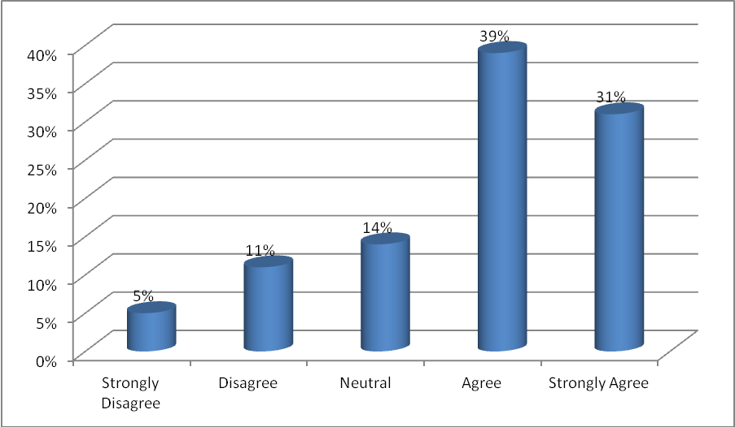
INFERENCES
From the above table it is inferred that 39% of the respondents agree that the flexibility of delivery schedule is acceptable, 31% of the respondents say strongly agree that the flexibility of delivery schedule is acceptable. Most of the respondents agree that the flexibility of delivery schedule is acceptable.
TABLE 4.41: ACCURACY AND COMPLETENESS OF SHIPMENTS IS SATISFACTORY
PARTICULARS | NO. OF RESPONDENTS | % OF RESPONDENTS
Strongly Disagree | 8 | 3%
Disagree | 12 | 5%
Neutral | 56 | 22%
Agree | 98 | 41%
Strongly Agree | 76 | 29%
Total | 250 | 100%

CHART 41
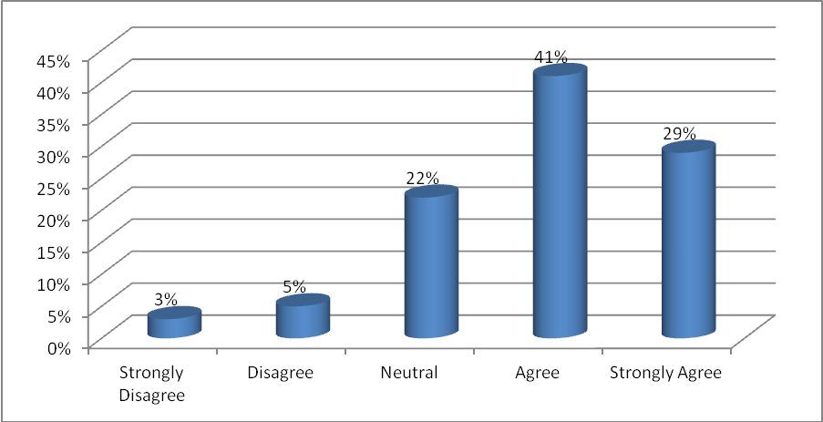
INFERENCES
From the above table it is inferred that 41% of the respondents agree with the shipments of accuracy and completeness is satisfactory, 29% of the respondents say strongly agree with the shipments of accuracy and completeness is satisfactory. Most of the respondents agree with the shipments of accuracy and completeness is satisfactory.
TABLE 4.42: QUALITY OF PACKAGING IS LESS SATISFACTORY
PARTICULARS | NO. OF RESPONDENTS | % OF RESPONDENTS
Strongly Disagree | 36 | 14%
Disagree | 83 | 33%
Neutral | 58 | 23%
Agree | 45 | 18%
Strongly Agree | 28 | 12%
Total | 250 | 100%

CHART 42
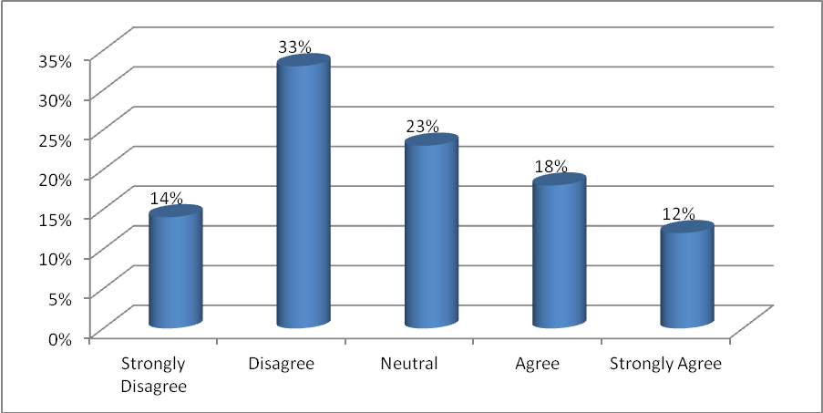
INFERENCES
From the above table it is inferred that 33% of the respondents say disagree with the quality of packaging is less satisfactory, 23% of the respondents say neither agree nor disagree with the quality of packaging is less satisfactory. Most of the respondents say disagree with the quality of packaging is less satisfactory.

TABLE 4.43: OVERALL SATISFACTIONS WITH THE SHIPPING AND DELIVERY PROCESS IS GOOD
PARTICULARS | NO. OF RESPONDENTS | % OF RESPONDENTS
Strongly Disagree | 20 | 8%
Disagree | 31 | 12%
Neutral | 45 | 18%
Agree | 69 | 28%
Strongly Agree | 85 | 34%
Total | 250 | 100%

CHART 43
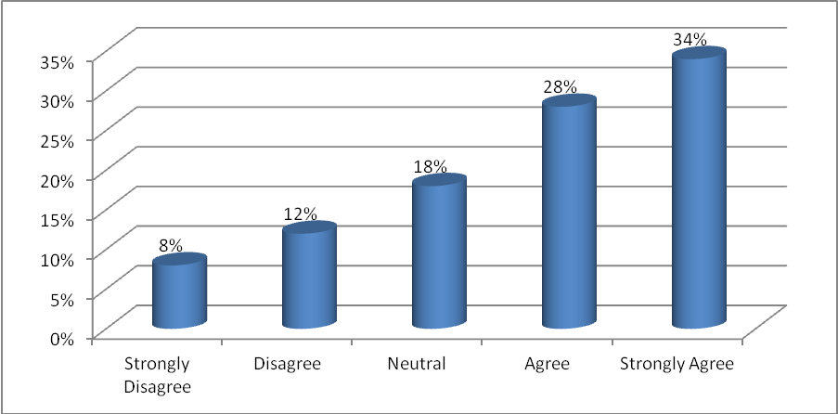
INFERENCES
From the above table it is inferred that 34% of the respondents mention strongly agree the overall satisfactions of shipment and delivery process is good, 28% of the respondents mention agree the overall satisfactions of shipment and delivery process is good. Most of the respondents mention strongly agree the overall satisfactions of shipment and delivery process is good.

STATISTICAL TOOLS AND ANALYSIS

CHI- SQUARE TEST I – (ψ²)
Chi-square is the sum of the squared difference observed (o) and the expected (e) data (or the deviation, d), divided by the expected data in all possible categories.
Null hypothesis (Ho):
There is a relationship between the easy to find relevant information and it is easy to print from the web.
Alternate hypothesis (H1):
There is no relationship between the easy to find relevant information and it is easy to print from the web.

Case Processing Summary
 | Cases
 | Valid |  | Missing |  | Total
 | N | Percent | N | Percent | N | Percent
EASY TO FIND RELEVANT INFORMATION * IT IS EASY TO PRINT FROM THE WEB | 250 | 100.0% | 0 | 0.0% | 250 | 100.0%

EASY TO FIND RELEVANT INFORMATION * IT IS EASY TO PRINT FROM THE WEB Crosstabulation
 |  |  | IT IS EASY TO PRINT FROM THE WEB |  |  |  |  | Total
 |  |  | 1 | 2 | 3 | 4 | 5 | Total
EASY TO FIND RELEVANT INFORMATION | 1 | Count | 3 | 4 | 0 | 0 | 0 | 7
EASY TO FIND RELEVANT INFORMATION | 1 | % within EASY TO FIND RELEVANT INFORMATION | 42.9% | 57.1% | 0.0% | 0.0% | 0.0% | 100.0%
EASY TO FIND RELEVANT INFORMATION | 1 | % within IT IS EASY TO PRINT FROM THE WEB | 100.0% | 80.0% | 0.0% | 0.0% | 0.0% | 2.8%
EASY TO FIND RELEVANT INFORMATION | 1 | % of Total | 1.2% | 1.6% | 0.0% | 0.0% | 0.0% | 2.8%
EASY TO FIND RELEVANT INFORMATION | 2 | Count | 0 | 1 | 8 | 0 | 0 | 9
EASY TO FIND RELEVANT INFORMATION | 2 | % within EASY TO FIND RELEVANT INFORMATION | 0.0% | 11.1% | 88.9% | 0.0% | 0.0% | 100.0%
EASY TO FIND RELEVANT INFORMATION | 2 | % within IT IS EASY TO PRINT FROM THE WEB | 0.0% | 20.0% | 57.1% | 0.0% | 0.0% | 3.6%
EASY TO FIND RELEVANT INFORMATION | 2 | % of Total | 0.0% | 0.4% | 3.2% | 0.0% | 0.0% | 3.6%
EASY TO FIND RELEVANT INFORMATION | 3 | Count | 0 | 0 | 6 | 21 | 0 | 27
EASY TO FIND RELEVANT INFORMATION | 3 | % within EASY TO FIND RELEVANT INFORMATION | 0.0% | 0.0% | 22.2% | 77.8% | 0.0% | 100.0%
EASY TO FIND RELEVANT INFORMATION | 3 | % within IT IS EASY TO PRINT FROM THE WEB | 0.0% | 0.0% | 42.9% | 17.4% | 0.0% | 10.8%
EASY TO FIND RELEVANT INFORMATION | 3 | % of Total | 0.0% | 0.0% | 2.4% | 8.4% | 0.0% | 10.8%
EASY TO FIND RELEVANT INFORMATION | 4 | Count | 0 | 0 | 0 | 93 | 0 | 93
EASY TO FIND RELEVANT INFORMATION | 4 | % within EASY TO FIND RELEVANT INFORMATION | 0.0% | 0.0% | 0.0% | 100.0% | 0.0% | 100.0%
EASY TO FIND RELEVANT INFORMATION | 4 | % within IT IS EASY TO PRINT FROM THE WEB | 0.0% | 0.0% | 0.0% | 76.9% | 0.0% | 37.2%
EASY TO FIND RELEVANT INFORMATION | 4 | % of Total | 0.0% | 0.0% | 0.0% | 37.2% | 0.0% | 37.2%
EASY TO FIND RELEVANT INFORMATION | 5 | Count | 0 | 0 | 0 | 7 | 107 | 114
EASY TO FIND RELEVANT INFORMATION | 5 | % within EASY TO FIND RELEVANT INFORMATION | 0.0% | 0.0% | 0.0% | 6.1% | 93.9% | 100.0%
EASY TO FIND RELEVANT INFORMATION | 5 | % within IT IS EASY TO PRINT FROM THE WEB | 0.0% | 0.0% | 0.0% | 5.8% | 100.0% | 45.6%
EASY TO FIND RELEVANT INFORMATION | 5 | % of Total | 0.0% | 0.0% | 0.0% | 2.8% | 42.8% | 45.6%
Total |  | Count | 3 | 5 | 14 | 121 | 107 | 250
 |  | % within EASY TO FIND RELEVANT INFORMATION | 1.2% | 2.0% | 5.6% | 48.4% | 42.8% | 100.0%
 |  | % within IT IS EASY TO PRINT FROM THE WEB | 100.0% | 100.0% | 100.0% | 100.0% | 100.0% | 100.0%
 |  | % of Total | 1.2% | 2.0% | 5.6% | 48.4% | 42.8% | 100.0%

Chi-Square Tests
 | Value | df | Asymptotic Significance (2-sided)
Pearson Chi-Square | 589.210ª | 16 | .000
Likelihood Ratio | 406.515 | 16 | .000
Linear-by-Linear Association | 212.907 | 1 | .000
N of Valid Cases | 250
a. 17 cells (68.0%) have expected count less than 5. The minimum expected count is .08.

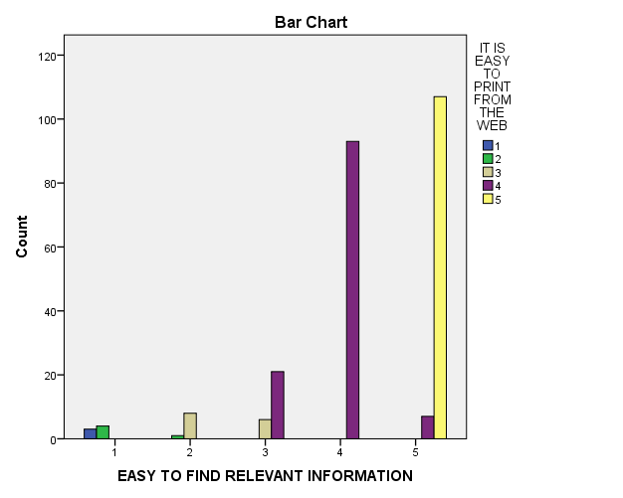
Degree of Freedom= (r-1) *(c-1)
= 4*4= 16
Calculated value = 589.210
Tabulated value = 26.296
Z = Z cal >Z tab
Z= 589.210 >26.296
Hence, the Alternate hypothesis [H1] is accepted

INFERENCE:
Since the calculated value is greater than the tabulated value, we accept the alternate hypothesis and hence there is a relationship between the easy to find relevant information and it is easy to print from the web.
ONE-WAY ANOVA CLASSIFICATION
Null hypothesis (Ho):
There is a significance difference between the queries or complaints are resolved within 24 hours and the helpful answer to the client’s request of technical information.
Alternate hypothesis (H1):
There is no significance difference between the queries or complaints are resolved within 24 hours and the helpful answer to the client’s request of technical information.
Descriptives
QUERIES OR COMPLAINTS ARE RESOLVED WITHIN 24 HOURS
 | N | Mean | Std. Deviation | Std. Error | 95% Confidence Interval for Mean |  | Minimum | Maximum
 |  |  |  |  | Lower Bound | Upper Bound | Minimum | Maximum
1 | 2 | 1.00 | .000 | .000 | 1.00 | 1.00 | 1 | 1
2 | 5 | 1.40 | .548 | .245 | .72 | 2.08 | 1 | 2
3 | 10 | 2.30 | .483 | .153 | 1.95 | 2.65 | 2 | 3
4 | 89 | 3.91 | .288 | .030 | 3.85 | 3.97 | 3 | 4
5 | 144 | 4.74 | .438 | .037 | 4.67 | 4.82 | 4 | 5
Total | 250 | 4.25 | .858 | .054 | 4.15 | 4.36 | 1 | 5

Test of Homogeneity of Variances
QUERIES OR COMPLAINTS ARE RESOLVED WITHIN 24 HOURS
Levene Statistic | df1 | df2 | Sig.
16.124 | 4 | 245 | .000

ANOVA
QUERIES OR COMPLAINTS ARE RESOLVED WITHIN 24 HOURS
 | Sum of Squares | df | Mean Square | F | Sig.
Between Groups | 145.050 | 4 | 36.263 | 233.344 | .000
Within Groups | 38.074 | 245 | .155
Total | 183.124 | 249

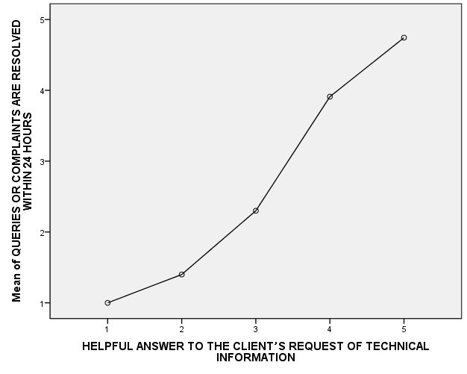

Calculated value = 233.344
Tabulated value =2.46
F = F cal >F tab F=233.344> 2.46
Hence, the Alternate hypothesis [H1] is accepted.

INFERENCE:
The calculated value of F is greater than the tabulated value. Hence, we reject the null hypothesis and conclude that there is no significance difference between the queries or complaints are resolved within 24 hours and the helpful answer to the client’s request of technical information.

ANALYSIS USING KARL PEARSON’S CORRELATION
Correlation analysis is the statistical tool used to measure the degree to which two variables are linearly related to each other. Correlation measures the degree of association between two variables.
Null hypothesis (H0):
There is positive relationship between the access is fast and the registration process details are retained securely.
Alternate hypothesis (H1):
There is negative relationship between the access is fast and the registration process details are retained securely.

Correlations
 |  | ACCESS IS FAST | REGISTRATION PROCESS DETAILS ARE RETAINED SECURELY
ACCESS IS FAST | Pearson Correlation | 1 | .906**
ACCESS IS FAST | Sig. (2-tailed) |  | .000
ACCESS IS FAST | N | 250 | 250
REGISTRATION PROCESS DETAILS ARE RETAINED SECURELY | Pearson Correlation | .906** | 1
REGISTRATION PROCESS DETAILS ARE RETAINED SECURELY | Sig. (2-tailed) | .000
REGISTRATION PROCESS DETAILS ARE RETAINED SECURELY | N | 250 | 250
**. Correlation is significant at the 0.01 level (2-tailed).

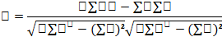
r= .906

INFERENCE:
Since r is positive, there is positive relationship between the access is fast and the registration process details are retained securely.
T-Test

Null hypothesis (Ho):
There is a significance difference between gender and Overall satisfaction with the Shipping and Delivery Process is good
Alternate hypothesis (H1):
There is no significance difference between gender and Overall satisfaction with the Shipping and Delivery Process is good

Independent Samples Test
 |  | Levene's Test for Equality of Variances |  | t-test for Equality of Means
 |  | F | Sig. | t | df | Sig.  (2-tailed) | Mean Difference | Std. Error Difference | 95% Confidence Interval of the Difference
 |  |  |  |  |  |  |  |  | Lower | Upper
GENDER | Equal variances assumed | .861 | .357 | -.448 | 64 | .656 | -.033 | .074 | -.182 | .115
GENDER | Equal variances not assumed |  |  | -1.426 | 59.000 | .159 | -.033 | .023 | -.080 | .013

Inference:
In Levene's Test for Equality of Variances significance value is 0.357 which is greater than or equal to 0.05. it means that the variability in the two conditions is about the same
Sig(2-tailed) value
Table value=.656
0.656>0.05 so there is statistically no significant difference between two conditions

WEIGHTED AVERAGE METHOD
SHIPMENTS RARELY CONTAIN WRONG ITEMS, LOW NUMBERS OF DEFECTS

Particulars | No of Respondent’s | Weightage Assigned
Strongly agree | 26 | 4 | 104
Agree | 21 | 5 | 105
Neutral | 38 | 3 | 114
Disagree | 103 | 1 | 103
Strongly Disagree | 62 | 2 | 124
Total | 250 |  | 550

Weighted Moving Average = ∑Wx1/∑X1
= 550/250
= 2.2
Inference:
From the above table, we can infer that majority of the respondents strongly disagree that shipments rarely contain wrong items, low numbers of defects

5.1 FINDINGS
- Most of the respondents are female.
- Most of the respondents belong to the age group of 18 – 25 yrs.
- Most of the respondents are Single.
- Most of the respondents are Business.
- Most of the respondents agree the information is found with a minimum of clicks.
- Most of the respondents agree the links which are provided to true pages on related products.
- Most of the respondents agree the relevant information is easy to find.
- Most of the respondents agree to print from the web is easy.
- Most of the respondents agree that the access is fast.
- Most of the respondents say strongly agree the registration process details which are retained securely.
- Most of the respondents agree the tax and/or other charges details are mentioned clearly.
- Most of the respondents agree the payment options are stated clearly.
- Most of the respondents agree the potentially range of high quality products is competitive prices.
- Most of the respondents agree for providing a pleasurable e-shopping experience.
- Most of the respondents say neither agree nor disagree with convenient time of customer service center.
- Most of the respondents agree the navigation is consistent and available on every page.
- Most of the respondents say strongly agree to answer the client’s request of technical information.
- Most of the respondents agree about the privacy of personal information.
- Most of the respondents agree about the external validation of trustworthiness is important.
- Most of the respondents agree with the process of getting queries or complaints are resolved within 24 hours.
- Most of the respondents agree with the return policy is reasonable.
- Most of the respondents agree the efficient contact changes in prices, products and delays.
- Most of the respondents agree with online supports for after-sales service.
- Most of the respondents say disagree with delivery cost.
- Most of the respondents agreed that the products are delivered without damage during the transport.
- Most of the respondents say neither agree nor disagree with product appearances.
- Most of the respondents say neither agree nor disagree with product price.
- Most of the respondents say neither agree nor disagree with product warranty.
- Most of the respondents say neither agree nor disagree with product packing.
- Most of the respondents agree with referral product.
- Most of the respondents agree with product quality.
- Most of the respondents say neither agree nor disagree to accept the quantities which requested in the order of firms capacity.
- Most of the respondents say neither agree nor disagree that they don’t have difficulties in the order due to the limit of the maxi quantity.
- Most of the respondents agree with the time between order and delivery is reasonable by the frim.
- Most of the respondents agree that the delivery staff is friendly and helpful.
- Most of the respondents say neither agree nor disagree that the deliveries present neatly without any delay.
- Most of the respondents agree with the communications between customer and transporter.
- Most of the respondents agree the shipments contain wrong items and low numbers of defects.
- Most of the respondents agree to meet scheduled delivery date is good.
- Most of the respondents agree that the flexibility of delivery schedule is acceptable.
- Most of the respondents agree with the shipments of accuracy and completeness is satisfactory.
- Most of the respondents disagree with the quality of packaging is less satisfactory.
- Most of the respondents strongly agree the overall satisfactions of shipment and delivery process is good.

5.2 SUGGESTIONS

- The organization need to give some relaxation in the price level for the existing customers.
- The organization need to improve the user friendly features.
- Advertisements in the smart phone also need to be improved.
- The organization need to give more offers in ads rather different kinds of ads for the customers so that it will increase the organization growth.

5.3 CONCLUSION

The internet has become an ongoing emerging source that tends to expand more and more. The growth of this particular medium attracts the attention of advertisers as a more productive source to bring in consumers.

This study has been conducted in Wonderpick to understand the effectiveness of the business advertisements placed in the internet. Based on the findings it can be concluded that most of the customers are satisfied with the the Wonderpick website. The price of the products can be reduced to make it more competitive. Management of Wonderpick website can improve the features of the website to attract more businesses and retain the existing customers.

BIBLIOGRAPHY

BIBLIOGRAPHY
References:
[1] Jonathan Reynolds, (2000) "eCommerce: a critical review", International Journal of Retail & Distribution Management, Vol. 28 Iss: 10, pp.417 – 444

[2] Francis Duffy, (2001) "What e-commerce may mean for design of corporate real estate", Journal of Corporate Real Estate, Vol. 3 Iss: 1, pp.56 – 61

[3] Amir M. Sharif, Tony Elliman, Peter E.D. Love, Atta Badii, (2004) "Integrating the IS with the enterprise: key EAI research challenges", Journal of Enterprise Information Management, Vol. 17 Iss: 2, pp.164 – 170

[4] Dr Pauline Ratnasingam,, (2005) "E-Commerce relationships: The impact of trust on relationship continuity", International Journal of Commerce and Management, Vol. 15 Iss: 1, pp.1 – 16

[5] Peter E.D. Love, Zahir Irani, Heng Li, Eddie W.L. Cheng, Raymond Y.C. Tse, (2001) "An empirical analysis of the barriers to implementing e-commerce in small-medium sized construction contractors in the state of Victoria, Australia", Construction Innovation: Information, Process, Management, Vol. 1 Iss: 1, pp.31 – 41

[6] Rajugan Rajagopalapillai, William Gardner, Professor Elizabeth Chang, Professor Tharam S. Dillon, (2005) "Designing websites with eXtensible web (xWeb) methodology", International Journal of Web Information Systems, Vol. 1 Iss: 3, pp.179 – 191

[7] Qin Hu, Xun Wu, Clement K. Wang, (2004) "Lessons from Alibaba.com: government's role in electronic contracting", info, Vol. 6 Iss: 5, pp.298 - 307

[8] Mike Simpson, Anthony J. Docherty, (2004) "E-commerce adoption support and advice for UK SMEs", Journal of Small Business and Enterprise Development, Vol. 11 Iss: 3, pp.315 – 328
[9] Sean Xin Xu, Xu Yan, Xiaona Zheng, (2008) "Communication platforms in electronic commerce: a three-dimension analysis", info, Vol. 10 Iss: 2, pp.47 – 56
[10] Holtjona Galanxhi-Janaqi, Fiona Fui-Hoon Nah, (2004) "U-commerce: emerging trends and research issues", Industrial Management & Data Systems, Vol. 104 Iss: 9, pp.744 – 755
[11] Sylvie Laforet, Xiaoyan Li, (2005) "Consumers’ attitudes towards online and mobile banking in China", International Journal of Bank Marketing, Vol. 23 Iss: 5, pp.362 – 380
[12] Godfred Frempong, (2009) "Mobile telephone opportunities: the case of micro- and small enterprises in Ghana", info, Vol. 11 Iss: 2, pp.79 – 94
[13] Charles V. Trappey, Amy J.C. Trappey, (2001) "Electronic commerce in Greater China", Industrial Management & Data Systems, Vol. 101 Iss: 5, pp.201 – 210
[14] A.C.M. Fong, S.C. Hui, (2006) "A virtual electronic trading system for business-to-business e-commerce", Kybernetes, Vol. 35 Iss: 6, pp.865 – 879
[15] Amy Mahan, (2003) "Regulatory peripheries: Using prepaid to extend the network", info, Vol. 5 Iss: 4, pp.37 – 44
[16] Gerard Bloch-Morhange, Emilio Fontela, (2003) "Mobile communication from voice to data: A morphological analysis", info, Vol. 5 Iss: 2, pp.24 – 33
[17] Andreas Jonason, Gunnar Eliasson, (2001) "Mobile Internet revenues: an empirical study of the I-mode portal", Internet Research, Vol. 11 Iss: 4, pp.341 – 348
[18] Charles M. Wood, (2004) "Marketing and e-commerce as tools of development in the Asia-Pacific region: a dual path", International Marketing Review, Vol. 21 Iss: 3, pp.301 – 320
[19] Andrew J. Rohm, Vishal Kashyap, Thomas G. Brashear, George R. Milne, (2004) "The use of online marketplaces for competitive advantage: a Latin American perspective", Journal of Business & Industrial Marketing, Vol. 19 Iss: 6, pp.372 – 385
[20] Ailsa Kolsaker, Claire Payne, (2002) "Engendering trust in e-commerce: a study of gender-based concerns", Marketing Intelligence & Planning, Vol. 20 Iss: 4, pp.206 – 214

BOOKS:
- Bernhard Serexhe (ud) Deregulation/Globalisation: The Loss of Cultural Diversity? This article is available on-line at : http://www.ctheory.com/ga1.10-deregulation.html [Last accessed Wednesday, 15 November 2000].

- Brain Subirana and Patricia Carvajal (2000) : Transaction Streams: theory and examples related to confidence in internet based electronic commerce, Journal of Information Technology, 15, pp: 3-16.

- Britannica (2000) Electronic commerce is available at : http://ww.britannica.com/bcom/eb/article/printable/5/0,5722,138395,00.html [Last accessed Saturday, 11 November 2000].

- CNet News.com (2000) Yahoo president predicts Net explosion : November 9, 2000. http://news.cnet.com/news/0-1005-200-3603596.html [last accessed Wednesday, November 15, 2000].

- Dan Gebler (2000) The Future of E-Commerce : August 9, 2000. http://www/ecommercetimes.com/news/articles2000/000809-2.shtml [Last accessed Wednesday, November 15, 2000].

- John Barron, Michael Shaw and Andrew Bailey (2000) : Web based E-Catalog system in B2B procurement, Communication of the ACM, 43(5), pp: 93-100.

- MSN Encarta (2000) Learning and research : Internet: is available at : http://encarta.msn.com/find/concise.asp?mod=1&ti=761579729 [Last accessed Saturday, 11 November 2000].

- Patrick McKeown and Richard Watson (1997) Metamorphosis : A guide to the world wide web and electronic commerce. New York : John Wiley & Sons Inc.

- Peter Cohan (2000) E-Profits, High Pay off strategies for capturing the e-commerce edge. New York : American Management Association.

- Richard Watson, George Zinkhan and Leyland Pitt (2000) Integrated Internet Marketing Communication of the ACM, 43(6), pp : 97-102.

- United Nations Development Programme1 (2000) : Electronic Commerce (e-commerce) and its Implications for Development : This article is available online : http://www.undp.org/info21/e-com/e1.html

- United Nations Development Program2, (2000) : The advantages of e-commerce for companies in developing countries http://www.undp.org/info21/e-com/e8.html [Last accesses Wednesday, November 15, 2000].

QUESTIONNAIRE

Personal Details:
- Name :
- Gender : Male Female
3.Age : 18-25 26-35 36-50 Above
4.Martial status : Single Married
5.Occupation : Business Private Employee Government Employee Other_____
1 = Strongly Disagree 2 = Disagree 3 = Neutral 4 = Agree 5 = Strongly agree
 | Tangible | 1 | 2 | 3 | 4 | 5
6 | Information is found with a minimum of clicks
7 | Links are provided to true pages on related products
8 | Easy to find relevant information
9 | It is easy to print from the Web

 | Reliability
10 | Access is fast
11 | Registration process details are retained securely
12 | Tax and/or other charges are clearly detailed
13 | Different payment options are stated clearly
14 | Potentially range of high quality products at competitive prices
15 | Creation of a pleasurable e-shopping experience
16 | Customer service center were available at convenient times.

 | Empathy | 1 | 2 | 3 | 4 | 5
17 | Navigation is consistent and available on every page
18 | Helpful answer to the client’s request of technical information
19 | Guarantees about the privacy of personal information
20 | External validation of trustworthiness is important
21 | Queries or complaints are resolved within 24 hours

 | Assurance .
22 | Return policy is reasonable
23 | Efficient contact changes in prices, products, delays
24 | Online support for after-sales service
25 | Free or reasonable delivery cost
26 | Firms capacity to deliver products without damage during the transport

 | Product satisfaction | 1 | 2 | 3 | 4 | 5
27 | Product appearance
28 | Product price
29 | Product warranty
30 | Product packing
31 | Referral product
32 | Product quality

 | Responsiveness
33 | Firms capacity to accept the exact quantities requested in the order
34 | Not to have difficulties in the order due to the limit of the maxi quantity
35 | The time between the order and the delivery by the firm is reasonable
36 | Delivery staff is friendly and helpful
37 | Deliveries neatly without delays
38 | Efficient communication between customer and transporter
39 | Shipments rarely contain wrong items, low numbers of defects

 | Customer satisfaction | 1 | 2 | 3 | 4 | 5
40 | Ability to meet scheduled delivery date is good
41 | Flexibility of delivery schedule is acceptable
42 | Accuracy and completeness of shipments is satisfactory
43 | Quality of packaging is less satisfactory
44 | Overall satisfaction with the Shipping and Delivery Process is good

