**ANTI SLEEP ALARM FOR DRIVER USING ARDUINO NANO**

**Project Report**

**Submitted in partial fulfilment of the requirements for Anti Sleep Alarm for Drivers using Arduino Nano**

**B Tech**

**Presidency University**

**Carried out at**

**Presidency University**

**Bangalore**

**By**

**A S Nitesh Kumar (20191CSE0001)**

**Abdur Rahman (20191CSE0004)**

**Arjun Singh (20191CSE0041)**

**Ajith Kumar (20191CSE0015)**

**Aishwarya Raikar (20191CSE0013)**



**Department of Computer Science and Engineering**

**Bengaluru**



**Certificate**

This is to certify that the project entitled “ Anti Sleep Alarm for Driver Using Arduino Nano” has been successfully completed by Mr A S Nitesh Kumar, Mr Abdur Rahman, Mr Arjun Singh, Mr Ajith Kumar and Ms Aishwarya Raikar of sixth semester B tech at Presidency University, Bengaluru,as the Internet of Things project in partial fulfilment for the award of B Tech degree course conducted by the Presidency University. The Project Report presented here is the Bonafide work of the student.

Guide : Head of the Department

Prof. Afroz Pasha Dr. Jacob Augustine

Group Members:

|  |  |
| --- | --- |
| ID | NAME |
| 20191CSE0001 | A S Nitesh Kumar |
| 20191CSE0004 | Abdur Rahman |
| 20191CSE0041 | Arjun Singh |
| 20191CSE0015 | Ajith Kumar |
| 20191CSE0013 | Aishwarya Raikar |

**Acknowledgement**

While performing our project, we had to take the help and guidelines of some respected persons who deserve our greatest gratitude. The completion of this project gave us immense pleasure.

We are highly indebted to Dr. Jacob Augustine, Mr. Afroz Pasha sir, for their guidance, constant supervision and for their support in completing our project.

We would like to express our gratitude to our parents for their kind cooperation and encouragement.

**ABSTRACT**

Feeling sleepy while driving could cause a hazardous traffic accident. However, when driving alone on the highway or driving over a long period of time, drivers are inclined to feel bored and sleepy, or even fall asleep.

There is a high demand for cheap and efficient driver sleep detection. Therefore, we came up with an idea and successfully developed an Anti Sleep Alarm for Driver, which could effectively meet this demand.

This system alerts the user if he/she falls asleep at the wheel thereby, avoiding accidents and saving lives. This system is useful especially for people who travel long distances and people who are driving late at night.

**Table of Contents**

*Acknowledgement*

*Abstract*

1. Components Required 06

2. Features of Components Used 07

3. Pinout Diagram 10

4. Manual Connection of the Project 11

5. Code 12

6. Read Me 13

7. Conclusion 14

**COMPONENTS USED**

1. Arduino Nano

2. Eye Blink Sensor

3. Active Buzzer

4. Coin Vibration Motor

5. SPST Switch

6. Jumper Wires

7. 9V Battery

**FEATURE OF COMPONENTS USED**

**1. Arduino Nano**

Arduino Nano is a small, compatible open-source electronic development board based on an 8-bit AVR microcontroller.

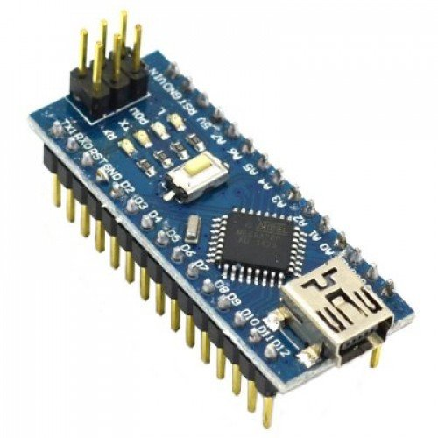

**2. Eye Blink Sensor**

The eye blink sensor is an infrared sensor which illuminates the eye with infrared light and monitors the changes in the reflected light.

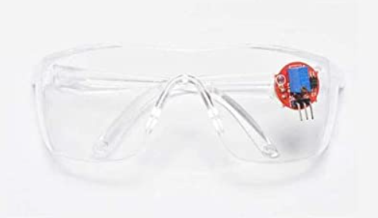

**3. Active Buzzer**

An active buzzer has a built-in oscillating source, so it will make sounds when electrified.

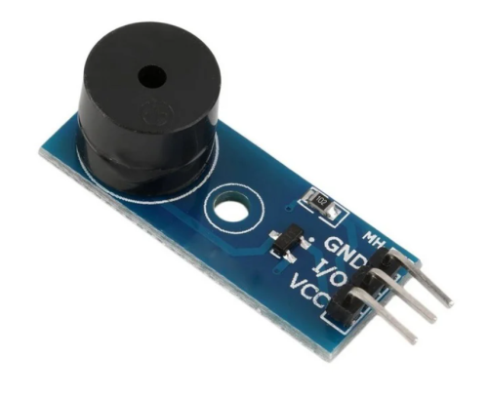

**4. Coin Vibration Motor**

Coin vibration motor is a typical ERM (eccentric rotating mass) actuators. It provides customer with haptic feedback

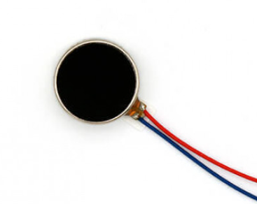

**5. SPST Switch**

SPST switch stands for “Single Pole Single Throw” which includes a single input and a single output.

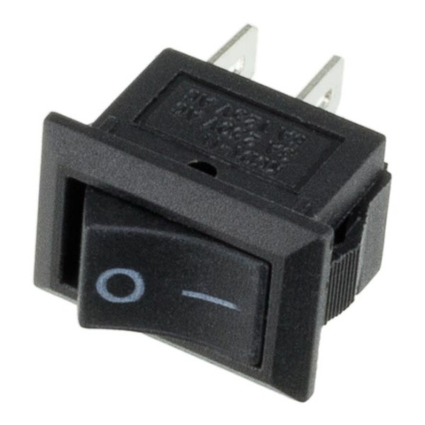

**6. Jumper Wires**

Jumper wires are simply wires that have connector pins at each end, allowing them to be used to connect two points to each other without soldering.

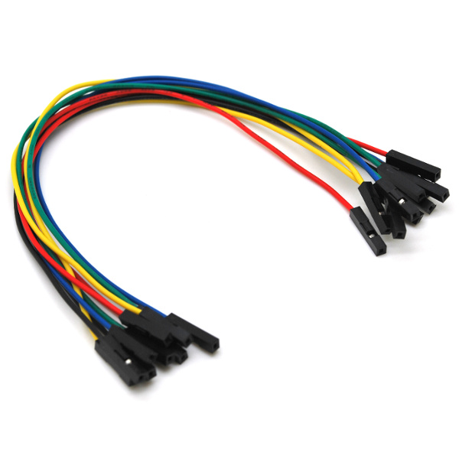

**7. 9V Battery**

It is an electric battery that supplies a nominal voltage of 9 Volts

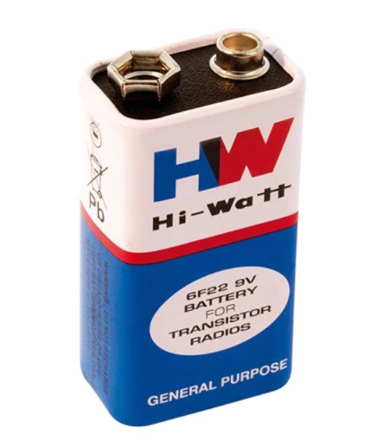

**PINOUT DIAGRAM**

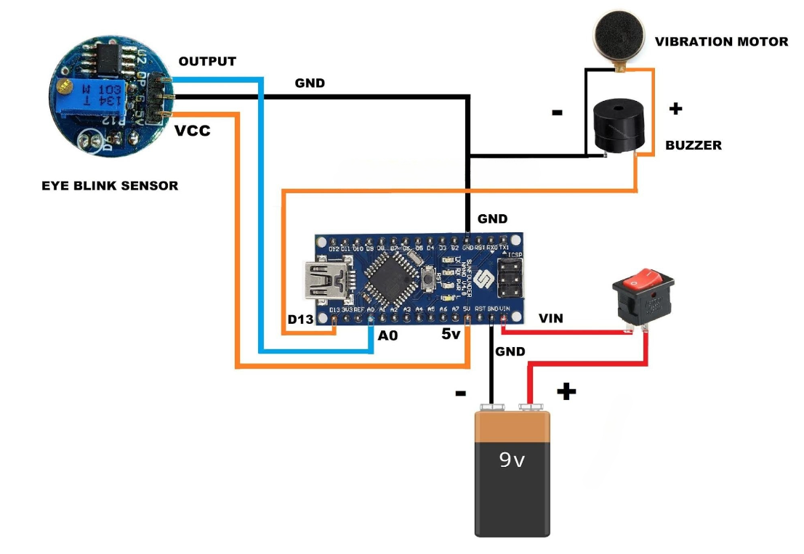

**MANUAL CONNECTION OF THE PROJECT**

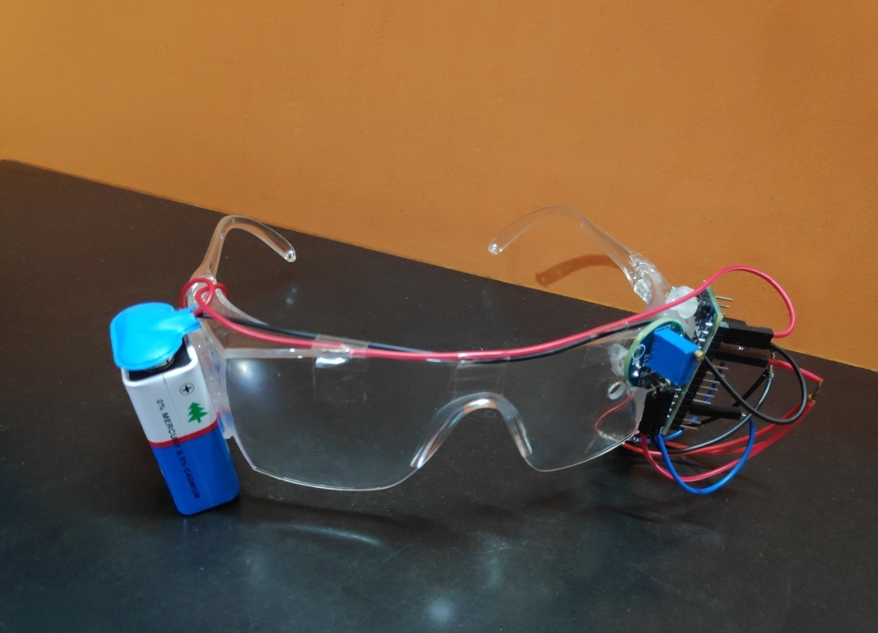

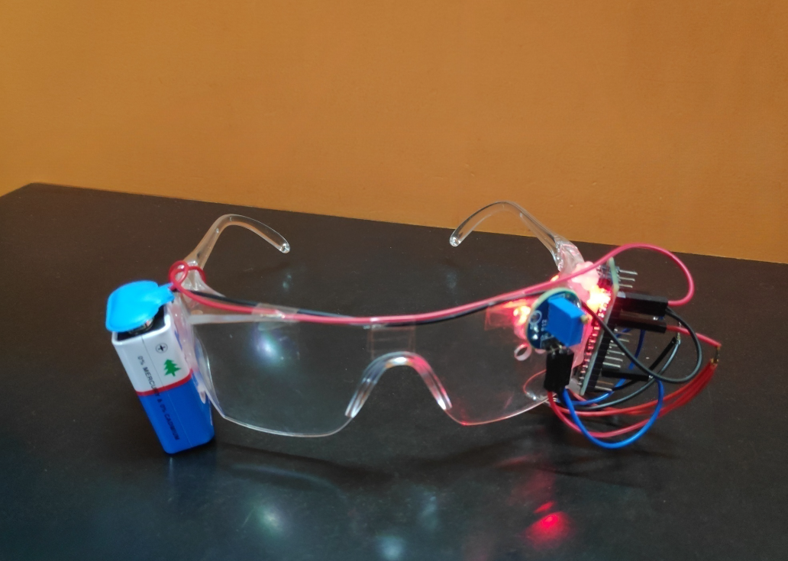

**CODE**

#define SENSE A0

void setup() {

pinMode(SENSE, INPUT);

pinMode(2, OUTPUT);

}

void loop() {

if(digitalRead(SENSE))

{

digitalWrite(2, LOW);

}

else

{

delay (2000);

if(digitalRead(SENSE))

{

digitalWrite(2, LOW);

}

else

digitalWrite(2, HIGH);

}

}

**READ ME**

The whole structure is made on an eye frame or an eyeglass

It consists of an eye blink sensor, arduino nano, active buzzer, coin vibration motor, 9 volt battery and spst switch

We have one sensor that is eye blink sensor and two actuators that are active buzzer and coin vibration motor

Everything is connected to arduino nano using jumper wires as per the circuit diagram

The eye glasses are worn by the driver during the long drive it detects the dizziness of the driver leading to the activation of active buzzer and coin vibration motors and makes the driver awake

**CONCLUSION**

Through this project we came across various components which gave us more insight about the subject “Internet Of Things”. Our project was about Anti Sleep Alarm for Driver Using Arduino Nano

The main objective of our project is to prevent accidents and provide efficient drive for the driver.