MiniProject
S/19/803
2025-05-25
#Load Data set
practice <- read.csv("F:/4th year Semester_1st/STA4053/Project/athletic.csv")
#head(practice )
#Find a Missing Values
sum(is.na(practice))
## [1] 0
#column Names
names(practice)
## [1] "Age" "B.0..G.1." "MealPlan" "Weight" "Height"
## [6] "X100m.s." "L_Jumb.m." "H_Jumb.m." "Pracice.H." "fee"
#number of row * number of columns
dim(practice)
## [1] 635 10
#mean
apply(practice, 2, mean)
## Age B.0..G.1. MealPlan Weight Height X100m.s.
## 1.240787e+01 4.913386e-01 2.127443e+02 6.164252e+01 1.426238e+02 1.097132e+01
## L_Jumb.m. H_Jumb.m. Pracice.H. fee
## 3.753134e+00 3.120000e+00 5.575197e+00 6.129055e+04
#variance
apply(practice,2,var)
## Age B.0..G.1. MealPlan Weight Height X100m.s.
## 8.440632e+00 2.503192e-01 9.017996e+03 3.046496e+02 4.626427e+02 2.738464e+00
## L_Jumb.m. H_Jumb.m. Pracice.H. fee
## 3.201600e-01 7.145994e-01 6.541320e+00 5.522676e+08
#corr_matrix
cor(practice, method = "spearman")
## Age B.0..G.1. MealPlan Weight Height
## Age 1.0000000000 -0.041504203 0.002785978 -0.011606141 0.042263287
## B.0..G.1. -0.0415042031 1.000000000 0.009598595 0.001628390 -0.021799222
## MealPlan 0.0027859781 0.009598595 1.000000000 0.018170953 0.003540792
## Weight -0.0116061409 0.001628390 0.018170953 1.000000000 0.005541275
## Height 0.0422632872 -0.021799222 0.003540792 0.005541275 1.000000000
## X100m.s. 0.0424558342 -0.021395785 0.003628088 0.005446075 0.999980772
## L_Jumb.m. 0.0427071587 -0.021285043 0.003777802 0.005533705 0.999935565
## H_Jumb.m. -0.0220642379 0.003491604 -0.022149214 0.055125970 0.009818228
## Pracice.H. -0.0186854535 0.007545983 -0.033832934 -0.010068014 -0.002716904
## fee 0.0002921154 0.044674972 -0.032303538 0.050664110 -0.001055744
## X100m.s. L_Jumb.m. H_Jumb.m. Pracice.H. fee
## Age 0.042455834 0.042707159 -0.022064238 -0.018685453 0.0002921154
## B.0..G.1. -0.021395785 -0.021285043 0.003491604 0.007545983 0.0446749722
## MealPlan 0.003628088 0.003777802 -0.022149214 -0.033832934 -0.0323035382
## Weight 0.005446075 0.005533705 0.055125970 -0.010068014 0.0506641095
## Height 0.999980772 0.999935565 0.009818228 -0.002716904 -0.0010557443
## X100m.s. 1.000000000 0.999945359 0.009939598 -0.002915671 -0.0011595048
## L_Jumb.m. 0.999945359 1.000000000 0.010050774 -0.002497046 -0.0017791557
## H_Jumb.m. 0.009939598 0.010050774 1.000000000 0.009988576 0.1689148380
## Pracice.H. -0.002915671 -0.002497046 0.009988576 1.000000000 0.2164073623
## fee -0.001159505 -0.001779156 0.168914838 0.216407362 1.0000000000
#Standardizing each variable
scaled_df <- apply(practice, 2, scale)
head(scaled_df)
## Age B.0..G.1. MealPlan Weight Height X100m.s.
## [1,] -0.4845921 -0.9820505 -0.4693712 -1.4691305 1.87525837 1.87250430
## [2,] 1.2364145 -0.9820505 -0.8320214 0.6507013 1.46617629 1.46762899
## [3,] 0.2038105 -0.9820505 -0.4749902 -0.3232755 -0.57788583 -0.58091923
## [4,] 1.5806158 1.0166740 -1.0950561 -0.5524465 -0.03360536 -0.03101395
## [5,] -1.5171960 -0.9820505 -1.3147635 1.8538491 1.30038624 1.29842737
## [6,] -1.1729947 -0.9820505 0.6421497 1.1663361 0.02460248 0.02337228
## L_Jumb.m. H_Jumb.m. Pracice.H. fee
## [1,] 1.86782603 -1.4432066 -1.0264296 -0.8421377
## [2,] 1.46134127 -1.0883198 -0.9482313 -0.7570327
## [3,] -0.57108257 -0.8517285 -0.8700330 -0.6719277
## [4,] -0.04088505 -0.4968416 -0.7918347 -0.5868226
## [5,] 1.30228201 -0.2602504 -0.7136364 -0.5017176
## [6,] 0.02980796 0.0946365 -0.6354381 -0.4166126
# Checking the variable type
numerical_sale <- practice[1:16,]
# normalizing data
data_normalized <- scale(numerical_sale)
## Correlation matrix
cor_matrix <- cor(data_normalized)
data.pca <- princomp(cor_matrix)
summary(data.pca)
## Importance of components:
## Comp.1 Comp.2 Comp.3 Comp.4 Comp.5
## Standard deviation 1.0677328 0.6121405 0.4691672 0.27704500 0.22505909
## Proportion of Variance 0.6049485 0.1988362 0.1168015 0.04072807 0.02687734
## Cumulative Proportion 0.6049485 0.8037847 0.9205862 0.96131431 0.98819165
## Comp.6 Comp.7 Comp.8 Comp.9
## Standard deviation 0.14917555 1.688019e-04 1.525960e-06 5.969618e-09
## Proportion of Variance 0.01180833 1.511986e-08 1.235604e-12 1.890977e-17
## Cumulative Proportion 0.99999998 1.000000e+00 1.000000e+00 1.000000e+00
## Comp.10
## Standard deviation 0
## Proportion of Variance 0
## Cumulative Proportion 1
e <- eigen(cor_matrix)
library(factoextra)
## Warning: package 'factoextra' was built under R version 4.4.2
## Loading required package: ggplot2
## Warning: package 'ggplot2' was built under R version 4.4.2
## Welcome! Want to learn more? See two factoextra-related books at https://goo.gl/ve3WBa
pca_result<-prcomp(cor_matrix,center = TRUE,scale = TRUE)
fviz_eig(pca_result, addlabels = TRUE, ylim = c(0, 50))
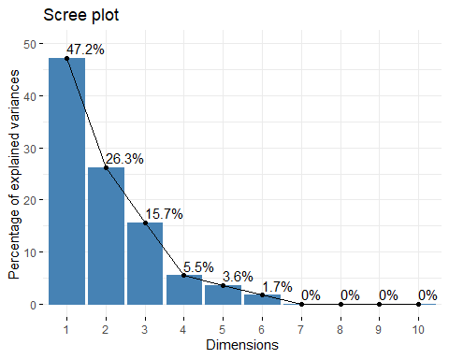
#install.packages("ggcorrplot")
library(ggcorrplot)
## Warning: package 'ggcorrplot' was built under R version 4.4.3
# normalizing data
data_normalized <- scale(practice)
## Correlation matrix
cor_matrix <- cor(data_normalized)
## Graphical view of Correlation Matrix
ggcorrplot(cor_matrix)
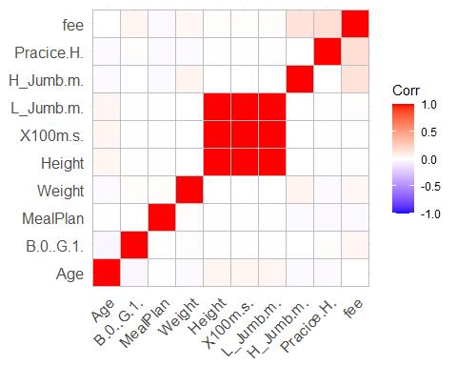
#Principal Component Analysis (PCA)
pca_result <- prcomp(practice, scale = TRUE)
names(pca_result)
## [1] "sdev" "rotation" "center" "scale" "x"
## means
pca_result$cente
## Age B.0..G.1. MealPlan Weight Height X100m.s.
## 1.240787e+01 4.913386e-01 2.127443e+02 6.164252e+01 1.426238e+02 1.097132e+01
## L_Jumb.m. H_Jumb.m. Pracice.H. fee
## 3.753134e+00 3.120000e+00 5.575197e+00 6.129055e+04
# standard deviations
pca_result$scale
## Age B.0..G.1. MealPlan Weight Height X100m.s.
## 2.905277e+00 5.003191e-01 9.496313e+01 1.745421e+01 2.150913e+01 1.654830e+00
## L_Jumb.m. H_Jumb.m. Pracice.H. fee
## 5.658269e-01 8.453398e-01 2.557600e+00 2.350037e+04
scaled_data <- scale(practice)
pca_result <- prcomp(scaled_data, center = TRUE, scale. = TRUE)
summary(pca_result)
## Importance of components:
## PC1 PC2 PC3 PC4 PC5 PC6 PC7
## Standard deviation 1.7333 1.1199 1.0309 1.0151 0.99182 0.98245 0.96993
## Proportion of Variance 0.3004 0.1254 0.1063 0.1030 0.09837 0.09652 0.09408
## Cumulative Proportion 0.3004 0.4258 0.5321 0.6352 0.73354 0.83006 0.92413
## PC8 PC9 PC10
## Standard deviation 0.87100 0.004209 0.001169
## Proportion of Variance 0.07586 0.000000 0.000000
## Cumulative Proportion 1.00000 1.000000 1.000000
biplot(pca_result, scale = 0.1, cex = 0.9, col = c("blue", "red"))
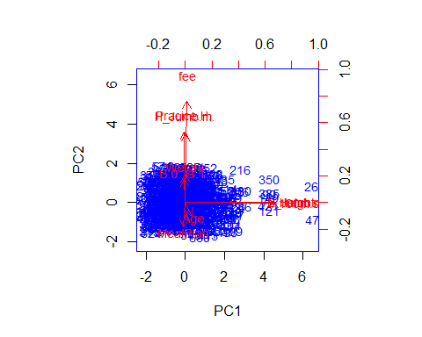
#install.packages("ggfortify")
library(ggfortify)
## Warning: package 'ggfortify' was built under R version 4.4.3
autoplot(pca_result, loadings = TRUE, loadings.label = TRUE)
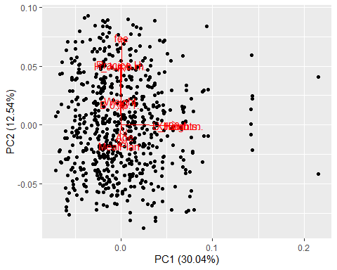
# biplot of the variables
fviz_pca_var(data.pca, col.var = "black")
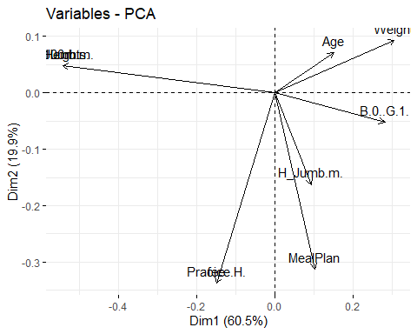
#Interpretation using illustrative
# Scree plot to choose number of components
screeplot(pca_result, type = "lines")
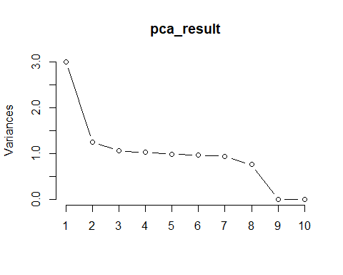
## Contribution of each Variable
fviz_cos2(data.pca, choice = "var", axes = 1:4)
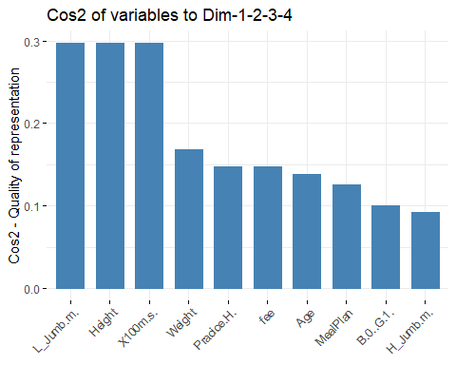
#Factor Analysis
#install.packages(c("psych", "readxl", "GPArotation"))
library(psych)
## Warning: package 'psych' was built under R version 4.4.3
##
## Attaching package: 'psych'
## The following objects are masked from 'package:ggplot2':
##
## %+%, alpha
library(readxl)
## Warning: package 'readxl' was built under R version 4.4.3
library(GPArotation)
##
## Attaching package: 'GPArotation'
## The following objects are masked from 'package:psych':
##
## equamax, varimin
# Select only numeric variables for FA
fa_data <- practice[, c("Age", "B.0..G.1.", "MealPlan", "Weight", "Height",
"X100m.s.", "L_Jumb.m.", "H_Jumb.m.", "Pracice.H.", "fee")]
# Check suitability for factor analysis
KMO(fa_data)
## Kaiser-Meyer-Olkin factor adequacy
## Call: KMO(r = fa_data)
## Overall MSA = 0.74
## MSA for each item =
## Age B.0..G.1. MealPlan Weight Height X100m.s. L_Jumb.m.
## 0.54 0.30 0.41 0.40 0.67 0.69 0.95
## H_Jumb.m. Pracice.H. fee
## 0.49 0.48 0.48
cortest.bartlett(fa_data)
## R was not square, finding R from data
## $chisq
## [1] 14748.15
##
## $p.value
## [1] 0
##
## $df
## [1] 45
# Perform factor analysis (change nfactors as needed)
fa_result <- fa(fa_data, nfactors = 3, rotate = "varimax", fm = "ml")
# View factor loadings
print(fa_result$loadings, cutoff = 0.3)
##
## Loadings:
## ML1 ML2 ML3
## Age
## B.0..G.1.
## MealPlan
## Weight
## Height 0.999
## X100m.s. 0.999
## L_Jumb.m. 0.999
## H_Jumb.m.
## Pracice.H.
## fee 0.841 0.536
##
## ML1 ML2 ML3
## SS loadings 2.994 0.767 0.413
## Proportion Var 0.299 0.077 0.041
## Cumulative Var 0.299 0.376 0.417
# Visualize factor structure
fa.diagram(fa_result)
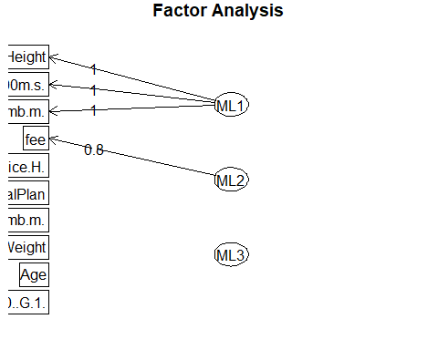
# Optional: Visualize with factoextra (for PCA-style biplot)
fviz_pca_var(prcomp(practice, scale. = TRUE),
col.var = "contrib",
repel = TRUE,
title = "Variable Loadings (PCA approximation)")
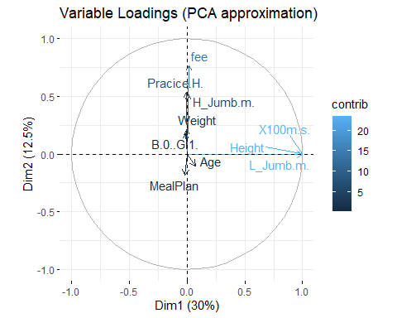
# Load libraries
library(lavaan)
## Warning: package 'lavaan' was built under R version 4.4.3
## This is lavaan 0.6-19
## lavaan is FREE software! Please report any bugs.
##
## Attaching package: 'lavaan'
## The following object is masked from 'package:psych':
##
## cor2cov
library(semPlot)
## Warning: package 'semPlot' was built under R version 4.4.3
library(readxl)
# Define SEM model
sem_model <- '
Physical =~ X100m.s. + L_Jumb.m. + H_Jumb.m.
Body =~ Weight + Height
Training =~ Pracice.H. + fee
Physical ~ Training + Body
'
# Fit the model
fit <- sem(sem_model, data = practice)
## Warning: lavaan->lav_data_full():
## some observed variances are (at least) a factor 1000 times larger than
## others; use varTable(fit) to investigate
## Warning: lavaan->lav_data_full():
## some observed variances are larger than 1000000 use varTable(fit) to
## investigate
## Warning: lavaan->lav_lavaan_step11_estoptim():
## Model estimation FAILED! Returning starting values.
## Warning: lavaan->lav_model_vcov():
## Could not compute standard errors! The information matrix could not be
## inverted. This may be a symptom that the model is not identified.
# Summary of fit
summary(fit, fit.measures = TRUE, standardized = TRUE)
## Warning: lavaan->lav_object_summary():
## fit measures not available if model did not converge
## lavaan 0.6-19 did NOT end normally after 4683 iterations
## ** WARNING ** Estimates below are most likely unreliable
##
## Estimator ML
## Optimization method NLMINB
## Number of model parameters 17
##
## Number of observations 635
##
##
## Parameter Estimates:
##
## Standard errors Standard
## Information Expected
## Information saturated (h1) model Structured
##
## Latent Variables:
## Estimate Std.Err z-value P(>|z|) Std.lv
## Physical =~
## X100m.s. 1.000 1.647
## L_Jumb.m. 0.342 NA 0.563
## H_Jumb.m. 0.002 NA 0.004
## Body =~
## Weight 1.000 0.031
## Height 712.154 NA 22.058
## Training =~
## Pracice.H. 1.000 0.000
## fee 118878409.113 NA 25181.164
## Std.all
##
## 1.000
## 1.000
## 0.005
##
## 0.002
## 1.030
##
## 0.000
## 1.073
##
## Regressions:
## Estimate Std.Err z-value P(>|z|) Std.lv
## Physical ~
## Training -9.984 NA -0.001
## Body 51.635 NA 0.971
## Std.all
##
## -0.001
## 0.971
##
## Covariances:
## Estimate Std.Err z-value P(>|z|) Std.lv
## Body ~~
## Training -0.000 NA -0.021
## Std.all
##
## -0.021
##
## Variances:
## Estimate Std.Err z-value P(>|z|) Std.lv
## .X100m.s. 0.000 NA 0.000
## .L_Jumb.m. 0.000 NA 0.000
## .H_Jumb.m. 0.713 NA 0.713
## .Weight 308.341 NA 308.341
## .Height -28.009 NA -28.009
## .Pracice.H. 6.531 NA 6.531
## .fee -83177569.257 NA -83177569.257
## .Physical 0.156 NA 0.058
## Body 0.001 NA 1.000
## Training 0.000 NA 1.000
## Std.all
## 0.000
## 0.000
## 1.000
## 1.000
## -0.061
## 1.000
## -0.151
## 0.058
## 1.000
## 1.000
# 🔍 Plot the SEM diagram
semPaths(fit,
what = "std", # Standardized estimates
layout = "tree", # Layout style
edge.label.cex = 1, # Label size
curvePivot = TRUE,
fade = FALSE,
sizeMan = 6,
sizeLat = 8,
nCharNodes = 0) # Show full variable names
