1. **PROFIT & LOSS**

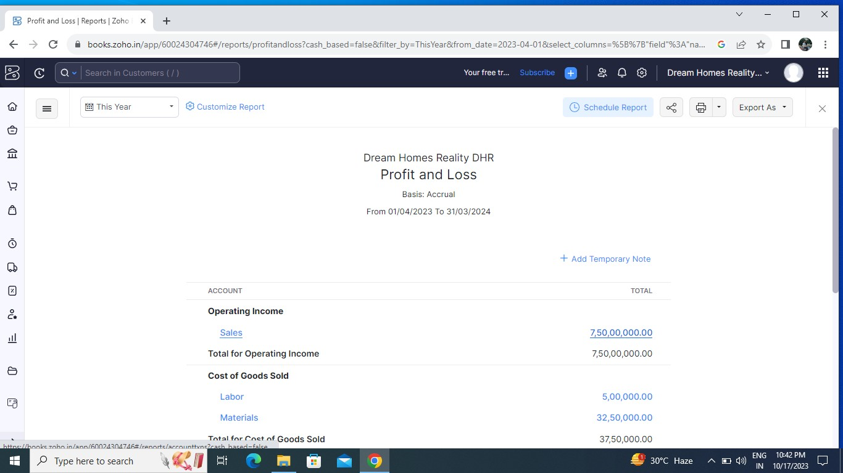

1. **BALANCE SHEET**

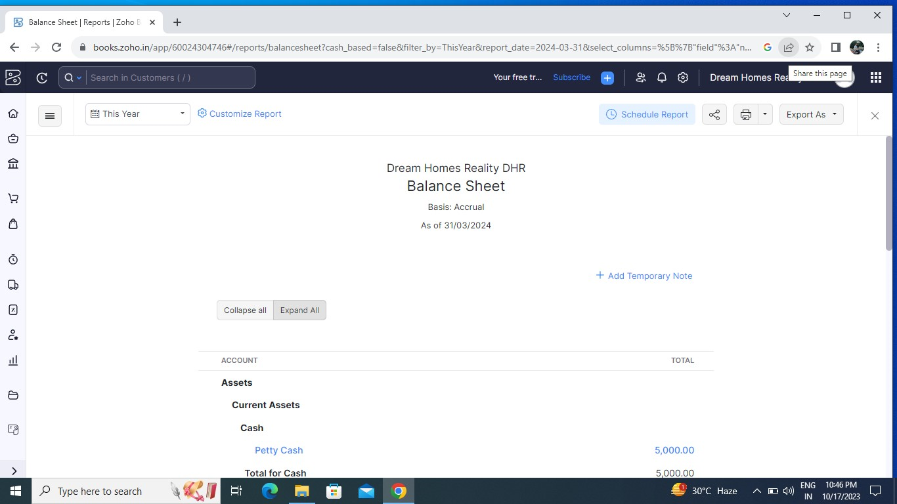

1. **GST REPORTS**

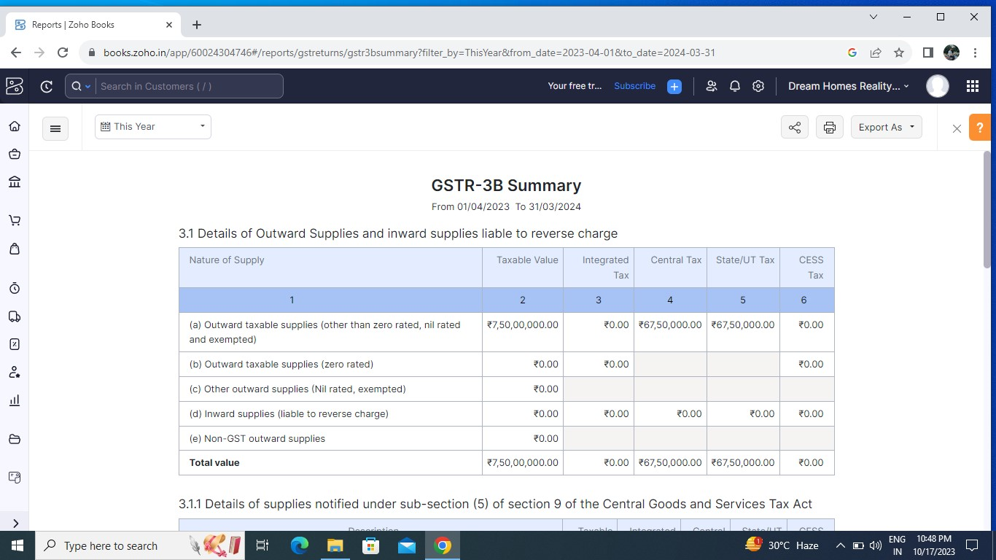

**TAX RETURN**

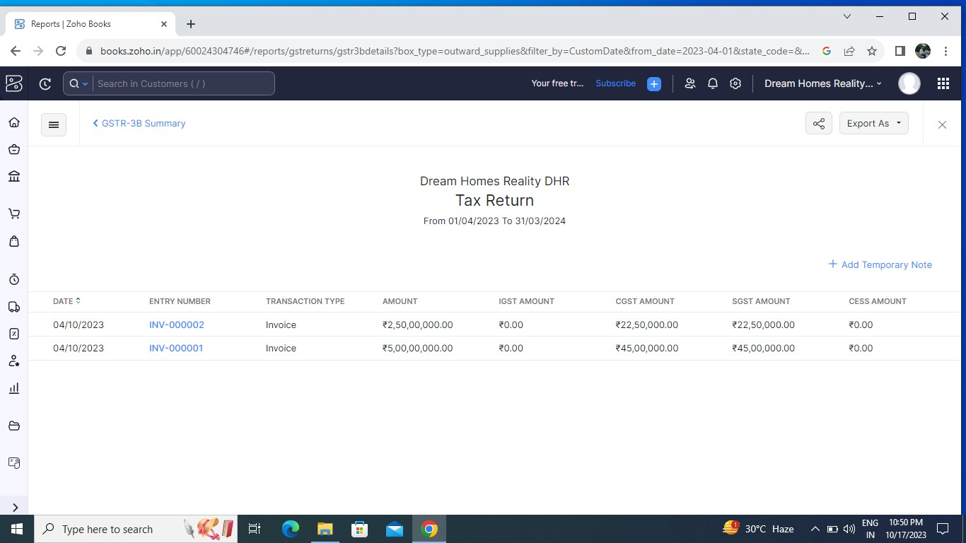

1. **JOURNAL REPORTS**

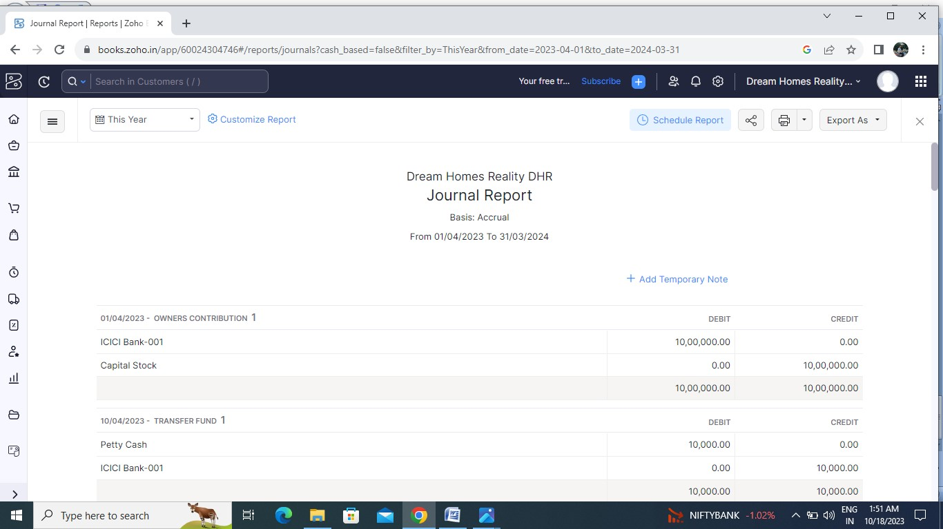

**5. ACCOUNTS RECEIVABLE AGING DETAILS**

