**NON INVASIVE HEARING AID USING THE NATURAL AMPLIFICATION OF EAR THROUGH BONE CONDUCTION**

**1**

**INTRODUCTION**

Communication is a major part of life. But deaf people are restricted from the normal form of communication and deafness is third most common disability in the world. This can be rectified by using various medical surgical treatments which are quite costlier. The human auditory system consists of outer, middle and inner ear. The eardrum converts the sound waves which are actually the vibrations in the air to different vibrations and transmits into cochlea which is connected to the auditory nerve system. Sometimes the sound waves directly goes into inner ear bypassing the eardrum, this happens through bone conduction. This is one of the way to hear our own voice. Whales hear through bone conduction.

In 18th century a famous composer Ludwig van Beethoven, discovered Bone Conduction, he was completely deaf. To listen to the sound of piano with the help his jaws, Beethoven attached a rod to the piano and clenched the rod in his teeth as vibrations were transferred from the piano to his jaw He received perception of the sound or vibrations. This proved that sound could reach our auditory system or the inner ear through another medium.

.

**2**

**LITERATURE SURVEY**

SWAAAAMMMMYYYYYNAATTTHHHHAAAAAAAA

3

**EXISTING SYSTEM**

Several hearing devices were found for outer drum problem only. Inner drum problem is usually a permanent condition which impairs one’s ability to tell the direction a sound is coming from. It can also be responsible for difficulty in understanding speech or conversations on the deaf ear side, particularly in a noisy environment. Some medical treatments has been proposed but it requires surgery. Due to the surgery it might lead to additional problems.

**4**

**PROPOSED SYSTEM**

This hearing device is designed to use the natural amplification of your ear. Any sound that is coming from GSM Modem , it uses a digital processor (PIC16F877A) to transmit to the sound to a piezoelectric actuator which needs very little power to generate the vibrations that travel through bone, which in turn sends those sound vibrations into your cochlea through your teeth. This way, the sound is transported from your impaired ear directly to your hearing ear.

**4.1 INVASIVE XYZ TITLE**

Deafness is defined as partial or complete hearing loss. Deaf and hard of hearing people can experience anything from a very mild to a total loss of hearing. Elderly adults who frequently experience a loss of hearing, and as a result can potentially experience social isolation, relationship breakdowns and an increase in mental health related issues.

According to the Australian Bureau of Statistics in 1993 there were 93,600 people in WA with some form of hearing loss and 1,200 of those people use Auslan (Australian sign language) as their main mode of communication.95 per cent of deaf babies are born to non-deaf families.

Most of the deaf people have inner-drum problems. The major issue with this is that you require surgery to try and cure such an issue. But even then success rate is quite low. Our aim is to overcome this lower success rate and to help them recover from this deafness without the need of surgery.

**4.2 REQUIREMENTS**

HARDWARE:

* PIC Microcontroller(PIC16F877A)
* GSM Modem (SIM800A)
* Playback Module
* Relay system
* UART Module
* Audio Amplifier

SOFTWARE:

* MP LAB IDE

**4.3 PIC MICRO CONTROLLER**

4.3.1 Introduction to PIC Micro controller

A computer-on-a-chip is a variation of a microprocessor which combines the processor core (CPU), some memory, and I/O (input/output) lines, all on one chip. The computer-on-a-chip is called the microcomputer whose proper meaning is a computer using a (number of) microprocessor(s) as its CPUs, while the concept of the microcomputer is known to be a microcontroller. A microcontroller can be viewed as a set of digital logic circuits integrated on a single silicon chip. This chip is used for only specific applications.

Along with microcontrollers getting faster, smaller and more power efficient they are also getting more and more features. Often, the first version of microcontroller will just have memory and digital I/O, but as the device family matures, more and more pat numbers with varying features will be available.

In this project we used PIC 16f877A microcontroller. For most applications, we will be able to find a device within the family that meets our specifications with a minimum of external devices, or an external but which will make attaching external devices easier, both in terms of wiring and programming.

For many microcontrollers, programmers can built very cheaply, or even built in to the final application circuit eliminating the need for a separate circuit. Also simplifying this requirement is the availability of micro-controllers wit SRAM and EEPROM for control store, which will allow program development without having to remove the micro controller for the application circuit.

4.3.2 **PIC MICROCONTROLLER CORE FEATURES:**

* High-performance RISC CPU.
* Only 35 single word instructions to learn.
* All single cycle instructions except for program branches which are two cycle.
* Operating speed: DC - 20 MHz clock input DC - 200 ns instruction cycle.
* Up to 8K x 14 words of FLASH Program Memory, Up to 368 x 8 bytes of Data Memory (RAM) Up to 256 x 8 bytes of EEPROM data memory.
* Pin out compatible to the PIC16C73B/74B/76/77
* Interrupt capability (up to 14 sources)
* Eight level deep hardware stack
* Direct, indirect and relative addressing modes.
* Power-on Reset (POR).
* Power-up Timer (PWRT) and Oscillator Start-up Timer (OST).
* Watchdog Timer (WDT) with its own on-chip RC oscillator for reliable operation.
* Programmable code-protection.
* Power saving SLEEP mode.
* Selectable oscillator options.
* Low-power, high-speed CMOS FLASH/EEPROM technology.
* Fully static design.
* In-Circuit Serial Programming  (ICSP)  .
* Single 5V In-Circuit Serial Programming capability.
* In-Circuit Debugging via two pins.
* Processor read/write access to program memory.
* Wide operating voltage range: 2.0V to 5.5V.
* High Sink/Source Current: 25 mA.
* Commercial and Industrial temperature ranges.
* Low-power consumption.

In this project we used PIC 16f877A microcontroller. PIC means Peripheral Interface Controller. The PIC family having different series. The series are 12- Series, 14- Series, 16- Series, 18- Series, and 24- Series. We used 16 Series PIC microcontrollers.

4.3.2 **ADVANTAGES OF USING A PIC MICROCONTROLLER OVER MICROPROCESSOR AND OTHER EMBEDDED CIRCUITS:**

* Gather input from various sensors
* Process this input into a set of actions
* Use the output mechanisms on the Microcontroller to do something useful
* RAM and ROM are inbuilt in the MC.
* Cheap compared to MP.
* Multi machine control is possible simultaneously.

4.3.3 **pin diagram pic 16 f874a/877a:**

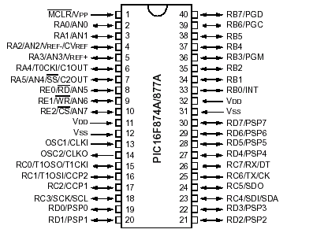

**INTERNAL BLOCK DIAGRAM**

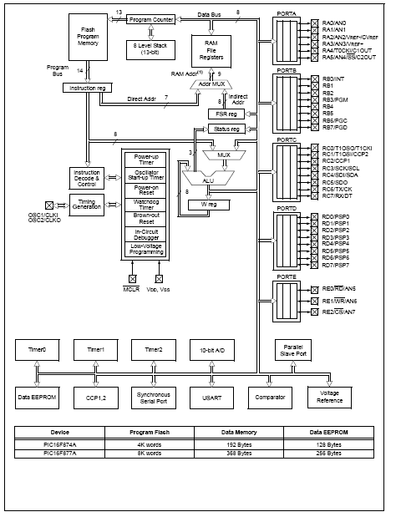

**PIC CONTROLLER SPECIFICATIONS:**

|  |  |
| --- | --- |
| Power requirements | 4.8 to 5.5Vdc @ 3Ma |
| User connector | 5-pin header; 0.025" posts on 0.10" centers |
| Connector pinout | +5V GND SERIAL GND +5V |
| Serial Input | RS-232 or inverted TTL, 2400/9600, N81 |
| Operating Temperature | 0° to 50° C |
| Initialization | switches LCD power; performs soft init |
| Instruction prefix | ASCII 254 (0FE hex) |
| LCD type | Supertwist (STN), yellow-green |

**4.4 GSM MODEM**

**4.4.1 INTRODUCTION**

This GSM Modem can work with any GSM network operator SIM card just like a mobile phone with its own unique phone number. Advantage of using this modem will be that its RS232 port can be used to communicate and develop embedded applications. Applications like SMS Control, data transfer, remote control and logging can be developed easily using this.

The modem can either be connected to PC serial port directly or to any microcontroller through MAX232. It can be used to send/receive SMS and make/receive voice calls. It can also be used in GPRS mode to connect to internet and run many applications for data logging and control. In GPRS mode you can also connect to any remote FTP server and upload files for data logging.

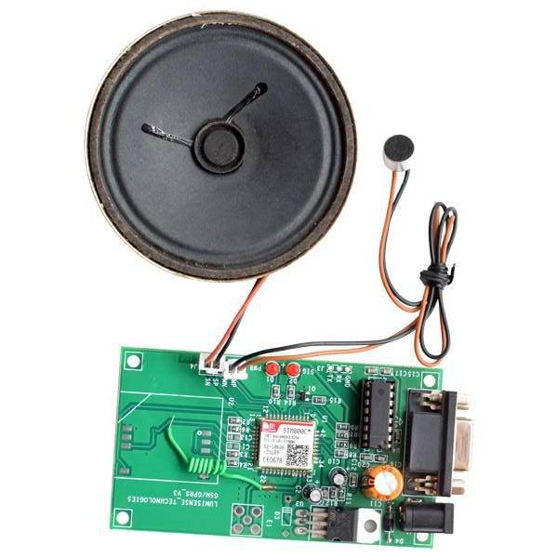

**4.4.2 FEATURES**

* High Quality Product
* RS232 interface @ RMC Connector for direct communication with computer or MCU kit
* Configurable baud rate
* SMA connector with GSM Antenna.
* SIM Card holder.
* Built in Network Status LED
* Inbuilt Powerful TCP/IP protocol stack for internet data transfer over GPRS.
* Audio interface Connector
* Normal operation temperature: -20 °C to +55 °C
* Input Voltage: 4.5V-12V DC

**CIRCUIT DIAGRAM USING GSM MODEM**

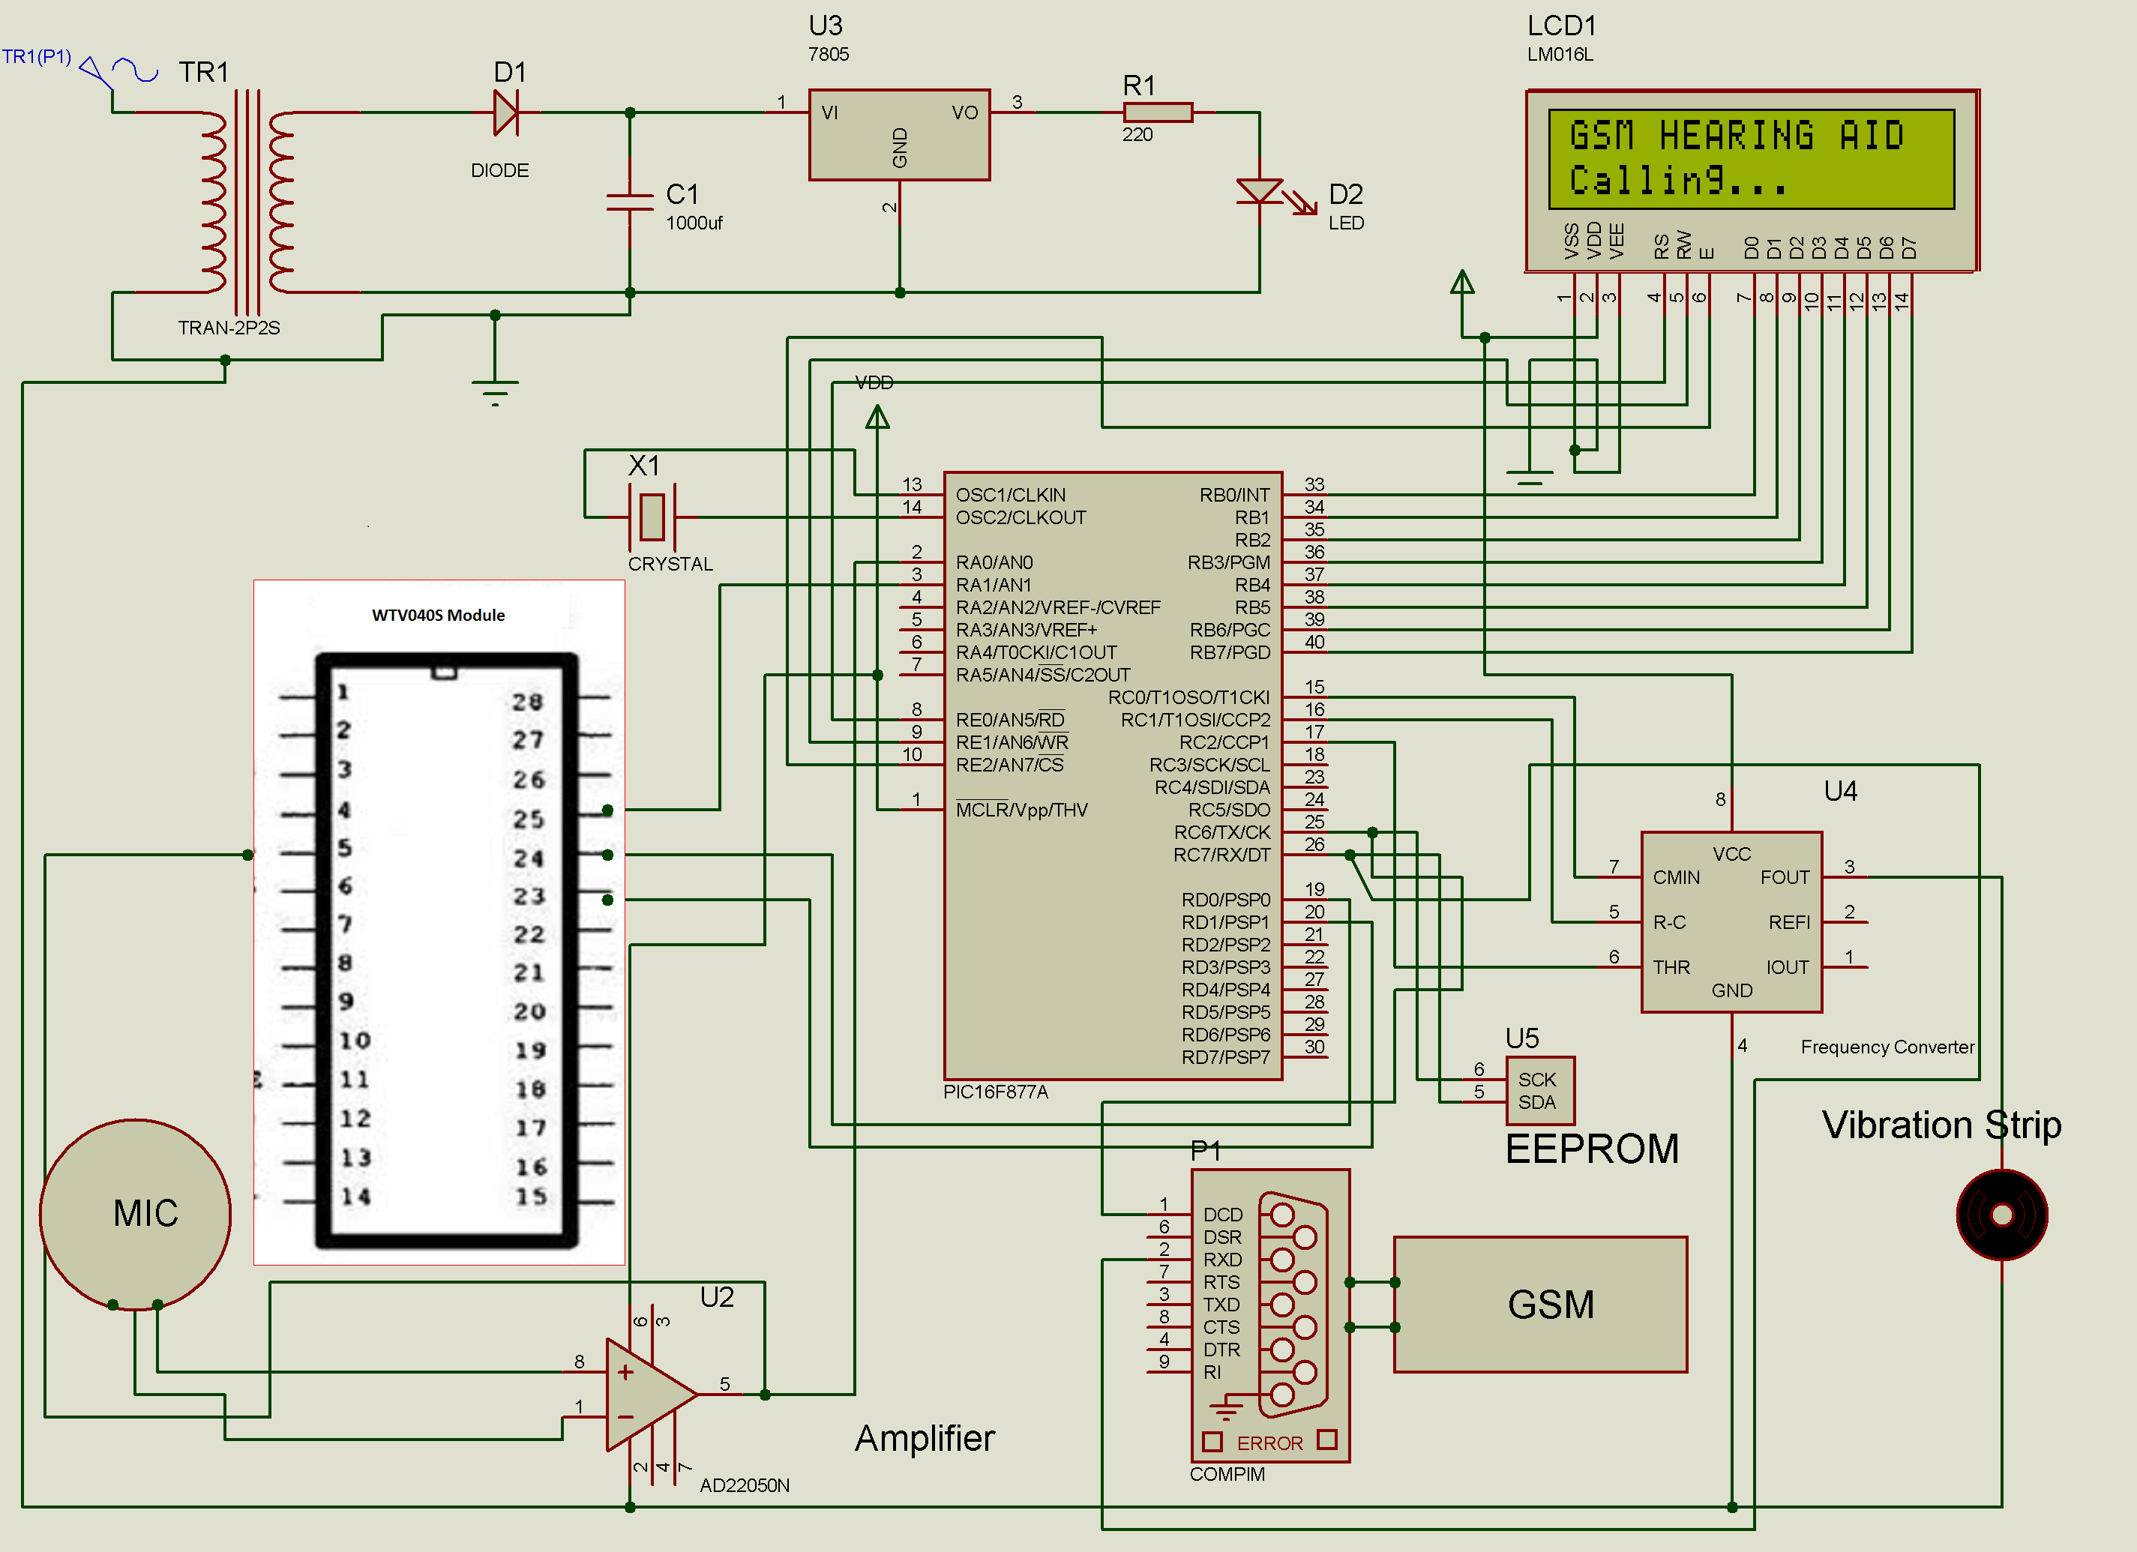

**4.5 VOICE RECORD/PLAY BACK MODULE**

**4.5.1 INTRODUCTION**

WTV-SR is one of the members of recording serial products. WTV-SR module can record as well as fixed voice playback, recording content uploaded and a variety of control modes can be chosen. With the master chip and plug-in SPI-FLASH, it has a great advantage in the duration time of recording and cost performance.

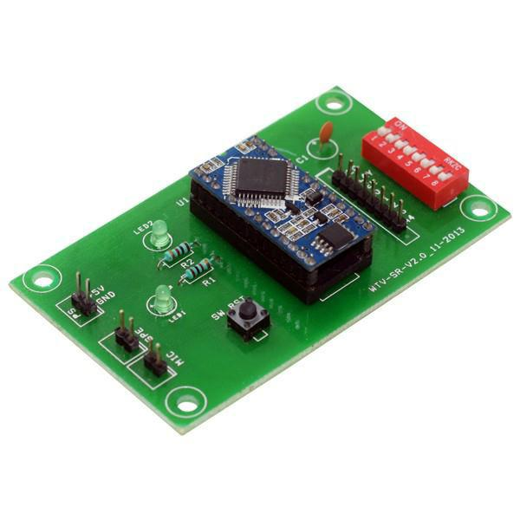

WTV-SR is provided with mp3 mode, Key control one by one, parallel interface, one-line serial interface, three-line serial interface. Therefore, WTV-SR module is suit for many occasions. It can be changed different control modes by setting I/O, which on the bottom of WTV-SR. It gives a Flexible power supply by either supply module or supply solution, so it is a effective recording solution.

The recorded voice can be uploaded to the system. It also supports download voice from PC and play recorded voice with high quality. It can record up to 252 segment voice (including fixed voice) and recording time up to 1600 seconds. It supports audio recording at 10 KHz or 14 KHz sample rate.

**4.5.2 FEATURES**

* Operating voltage: 3.3v DC
* Recording Time: 12 minutes
* 8-level adjustable volume
* Support MIC & LINE-IN recording
* Support USB with programmer
* With power down memory to retain

**4.6 RELAY SYSTEM**

A relay is an electromechanical switch which is powered by electric current. A single relay board arrangement contains driver circuit, power supply circuit and isolation circuit. Relay is assembled with the circuit and the driver contains transistors for switching operations. An isolation circuit prevents reverse voltage from the relay which protects the controller and the transistor from damage. The input pulse for switching the transistor is given from the microcontroller.

**4.7 CONVERTER**

**4.7.1 INTRODUCTION**

There are a lot of devices out there that still communicate over RS232 but we bet your new laptop isn’t one of them. Don’t worry, though, we’ve got you covered. This 6ft converter plugs into your computer’s USB port and provides you with a DB-9 RSR232 connection. After installing the drivers onto your Windows, Mac or Red Hat Linux system, the FTDI chipset inside the cable will enumerate as a COM port with a baud rate adjustable to whatever setup you want to connect to RS232. We were curious what made this cable work, so we tore one open and found that it’s simply an FTDI FT232 paired with a Zywyn, ZT213 RS232 Transceiver.

The USB_RS232 cables are a family of USB to RS232 levels serial UART converter cables incorporating FTDI’s [FT232RQ](http://www.ftdichip.com/Products/ICs/FT232R.htm) USB to serial UART interface IC device which handles all the USB signaling and protocols. The cables provide a fast, simple way to connect devices with a RS232 level serial UART interface to USB. Each USB-RS232 cable contains a small internal electronic circuit board, utilizing the [FT232R,](http://www.ftdichip.com/Products/ICs/FT232R.htm) which is encapsulated into the USB connector end of the cable. The integrated electronics also include the RS232 level shifter plus Tx and Rx. LEDs which give a visual indication of traffic on the cable.

**4.7.2 FEATURES**

* USB Chip: CH340
* Connector: DB9 Male - all signals
* Cable Length: 0.8 meters
* Wire: Shielded
* Body: Dust Proof fully molded enclosure

**SOFTWARE**

**SOUND SENSOR**

**WORKING**

**CODE**

**CONCLUSION**

**FUTURE SCOPE**

**REFERENCE**