AUGMENTED REALITY IN ARCHITECTURE AND INTERIOR DESIGN

Abstarct:

This paper presents an application of Augmented Reality technology for Architecture and Interior design..Along with the dramatic progress in digtal technology,virtual information technologies are also required for architectural projects.As we all know agreeing upon a presented interior design by an architecture and later realising that this was not the design that we orignally had in mind is a common problem indeed.But through Augmented reality each every Architect’s design and what their client envisioned can be be exactly realised. Here, Augmented Reality environment is exploited as the new working environment for architects in architectural design works, and then they can do their work conveniently . Finally, this paper proposes a new method for applying AR technology to interior design work, where a user can view virtual furniture and communicate with 3D Object data using a dynamic and flexible user interface.

Introduction:

Creating an interior design for any open space is a difficult task on its own,but creating an augmented vesion of the same is task too complicated without the propeer tools necessary. Augmented Reality is a technology which provides a live direct or indirect view of a physical, real-world environment whose elements are augmented(or supplemented) by computer-generated sensory input such as sound, video, graphics or GPS data. It is related to a more general concept called mediated reality, in which a view of reality is modified (possibly even diminished rather than augmented) by a computer.

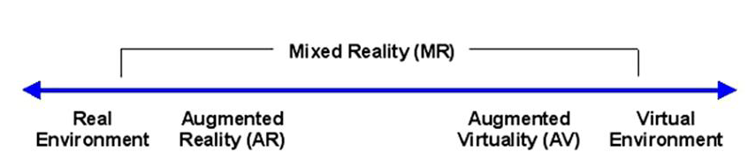

As a result, the technology functions by enhancing one’s current perception of reality.This technology will provide the necessary tools for any architect to provide their clients with the an augmented version of what they expect and help the clients realsie what’s feasible and what’s not.Every augmented object is completely reprented in 3-D to provide a full view on how everything may appear in reality. Accordingly, this paper presents on how augmented reality is used for designing/educating/presenting interior design projects using overlaid virtual furniture in a physical environment .

Fig: Augment reality flowchart

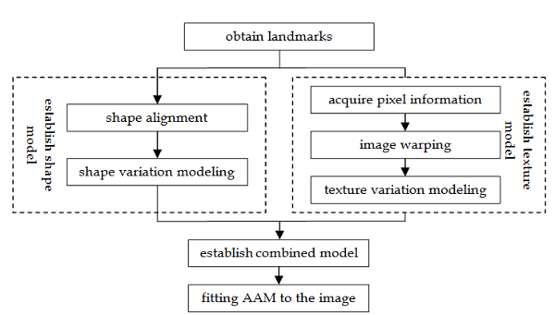

Technology at hand:

### Hardware:

### Hardware components for augmented reality are: processor, display, sensors and input devices. Modern mobile computing devices like smartphones and tablet computers contain these elements which often include a camera and MEMS sensors such as accelometer,GPS and solid state compass, making them suitable AR platforms.

#### Display:

#### Various technologies are used in Augmented Reality rendering including optical projection systems, monitors, hand held devices, and display systems worn on the human body.

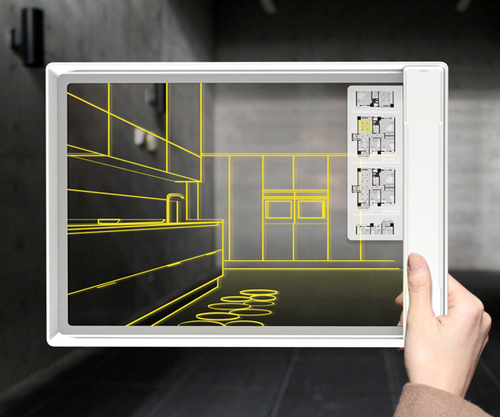

Head mounted :

Head mounted display (HMD) is a display device paired to a headset such as a harness or helmet. HMDs place images of both the physical world and virtual objects over the user's field of view. Modern HMDs often employ sensors for six degrees of freedom monitoring that allow the system to align virtual information to the physical world and adjust accordingly with the user's head movements.HMDs can provide users immersive, mobile and collaborative AR experiences.[]](https://en.wikipedia.org/wiki/Augmented_reality#cite_note-hmdcollab-15) display (HMD) is a display device paired to a headset such as a harness or helmet. HMDs place images of both the physical world and virtual objects over the user's field of view. Modern HMDs often employ sensors for six degrees of freedom monitoring that allow the system to align virtual information to the physical world and adjust accordingly with the user's head movements.HMDs can provide users immersive, mobile and collaborative AR experiences.

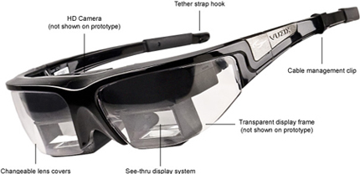

##### Handheld**:**

Handheld displays employ a small display that fits in a user's hand. All handheld AR solutions to date opt for video see-through. Initially handheld AR employed fiducial markers, and later GPS units and MEMS sensors such as digital compasses and six degrees of freedom accelerometer–gyroscope. Today SLAM markerless trackers such as PTAM are starting to come into use. Handheld display AR promises to be the first commercial success for AR technologies. The two main advantages of handheld AR is the portable nature of handheld devices and ubiquitous nature of camera phones. The disadvantages are the physical constraints of the user having to hold the handheld device out in front of them at all times as well as distorting effect of classically wide-angled mobile phone cameras when compared to the real world as viewed through the eye.

#### Input devices:

Techniques include speech recognition systems that translate a user's spoken words into computer instructions and gesture recognition systems that can interpret a user's body movements by visual detection or from sensors embedded in a peripheral device such as a wand, stylus, pointer, glove or other body wear

### Software and algorithms:

A key measure of AR systems is how realistically they integrate augmentations with the real world. The software must derive real world coordinates, independent from the camera, from camera images. That process is called image registration which uses different methods of computer vision, mostly related to video tracking. Many computer vision methods of augmented reality are inherited from visual odometry. Usually those methods consist of two parts.

First detect intest points, or fiducial markers, or optical flow in the camera images. First stage can use feature detection methods like corner detection, blob detection, edge detection or thresholding and/or other image processingg methods. The second stage restores a real world coordinate system from the data obtained in the first stage. Some methods assume objects with known geometry (or fiducial markers) present in the scene. In some of those cases the scene 3D structure should be precalculated beforehand. If part of the scene is unknown simultaneous localization and mapping (SLAM) can map relative positions. If no information about scene geometry is available, structure from motion methods like bundle adjustment are used. Mathematical methods used in the second stage include projective (epipolar) geometry, geometric algebra, rotation representation with exponential map, kalman and particle filters, nonlinear optimization, robust statistics.

Augmented Reality Markup Language(ARML) is a data standard developed within the Open Geospatial Consortium(OGC), which consists of an XML grammar to describe the location and appearance of virtual objects in the scene, as well as ECMA Script bindings to allow dynamic access to properties of virtual objects.

To enable rapid development of Augmented Reality Application, some software development kits (SDK) have emerged. A few SDK such as CloudRidAR  leverage cloud computing for performance improvement. Some of the well known AR SDKs are offered by Vuforia, ARToolKit, Catchoom CraftAR, Mobinett AR,[]](https://en.wikipedia.org/wiki/Augmented_reality#cite_note-60) Wikitude, Blippar and Layar.

Augmented Reality in Architecture and Interior designing:

Recently, AR technology is also being considered as a new design approach for architecture.As a result,a lot of AR experiments and research have been directed towards architectural design process.For example, the illustration down below depicts how augmented reality can be used to present the design of a building to in 3D environment.

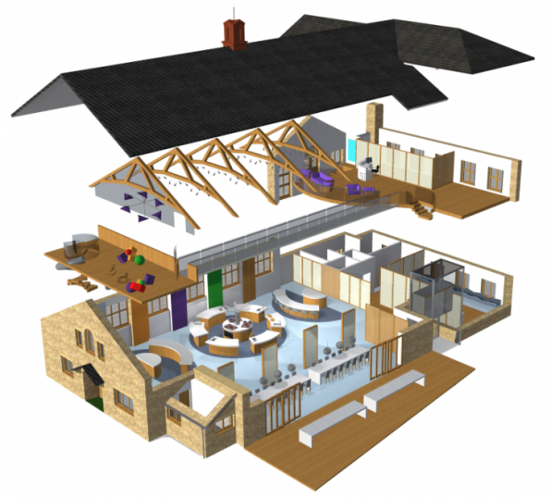

Augmented reality can overlay a real site with a virtual design at full-scale. A growing number of AR developers and visualisation providers now offer AR platforms that enable ‘walking tours’ of a virtual building, from early design through to construction. Those from backgrounds outside the construction industry often struggle to decode technical planning documents, or interpret 2-D drawings to understand their 3D implications. Augmented reality applications promise to bypass such ‘coding’ and ‘translation’ models of spatial communication, and more intuitively convey the intended appearance, scale, and features of a proposed design.

As mentioned above augmented reality can be used to for a wide variety of architectural and interior design projects.The ease of development of any augmented reality depends upon the user interface which plays a vital role.Most user interfaces available in market provides the neccesary tools, but the need for a more interactive user interface is ever growing to meet the growing demands of the interior designing market.

Revolutionary interface:

A new Experimental project known as Studierstube is being developed for augmented reality in the belief that,it has a better chance of becoming a viable user interface for applications requiring manipulation of complex three-dimensional information as a daily routine. At the heart of the Studierstube system, collaborative augmented reality is used to embed computer-generated images into the real work environment.

The user interface of the initial Studierstube system, in particular the implementation of collaborative augmented reality, and the Personal Interaction Panel, a two-handed interface for interaction with the system was not well optimised for the growing demands of the industry and hence a new system was established which is an extended Studierstube system based on a heterogeneous distributed architecture. This system allows the user to combine multiple approaches— augmented reality, projection displays,and ubiquitous computing—to the interface as needed.

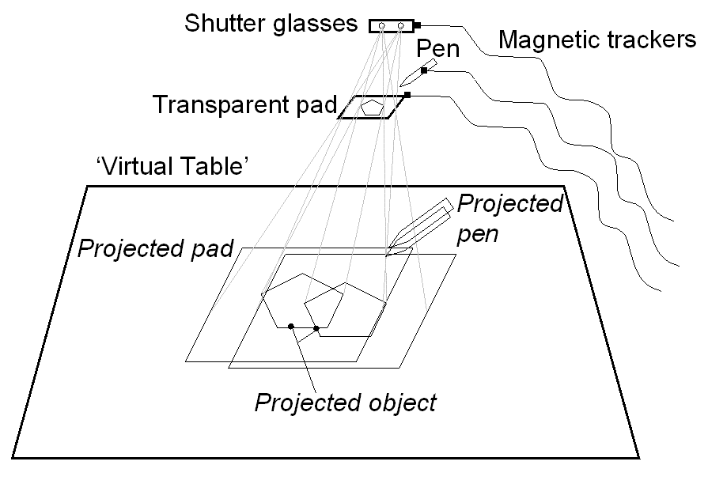

The environment is controlled by the Personal Interaction Panel, a twohanded, pen-and-pad interface that has versatile uses for interacting with the virtual environment. Studierstube also borrows elements from the desktop, such as multitasking and multi-windowing. The resulting software architecture is a user interface management system for complex augmented reality applications.