INTERNET OF THINGS AND MACHINE LEARNING IN VERTICAL FARMING

Ajith Panneerselvam#1, Gowtham Genupur#2

*# 2nd Year Student, Computer Science and Engineering, R.M.K Engineering College, Chennai, India.* 1 ajith.ark1@gmail.com 2 gowtham.gourov@gamil.com

***Abstract: The cutting edge of the agriculture is vertical farming. This paper’s centric goal is to give a different dimension to vertical farming and carry it to the next level by the touch of the state-of-the-art technology – MACHINE LEARNING AND INTERNET OF THINGS (IOT). In the past few decades, the apocalyptic deeds by the humans to the nature pushed the agriculture to a critical stage to practice farming in the concealed environment (closed room, godown, etc.). As the plants are grown in an artificial environment, utmost care and monitoring should be taken to grow them, as if they are grown in the fresh nature. Internet of things contributes a lot in this hypothesis and it will be discussed deeply. Machine learning is going to be the game changer in vertical farming. Machine learning is the heart of the farm and would have a complete control over the plants growth in atomic level. The future of mankind needs agriculture to be sustained by joining hands with the neo-technologies.***

**Keywords – Vertical Farming, Internet of Things, Machine Learning.**

1. INTRODUCTION

The world of automation and various data technologies have left some field untouched. One such field is agriculture. This paper is going to automate the entire vertical farm powered by intelligent machines. Internet of Things (IOT) is going to sense the plants in 360 degree and hoard the data in the cloud space for performing data analysis. Machine learning endeavors to ease the owner’s nightmares of monitoring the plants growth in the concealed space. Machine learning is the decision maker of this farm, any decisions drafted by the computer is highly reliable. Henceforth, using this regal technologies (Machine Learning and IOT), we nullify the uncertainties and produce the best productivity.

1. VERTICAL FARMING

Vertical farming as the name suggests farming is performed vertically by growing the crops one above the other on stacks. It is a part of urban agriculture, in which natural process occurs under controlled environment. As the plants are grown breaking the terms of conventional farming techniques, utmost care should be taken to avert any new diseases as this space is completely foreign for the plants.

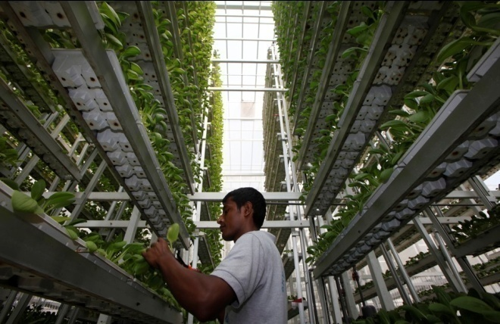

Fig. 1 Vertical Farming

The technology incorporated Vertical Farming uses Controlled Environment Agriculture (CEA) technique where temperature, humidity, sunlight and soil nutrient are controlled using machines. Vertical farms can be of any type, from small scale farms for community use to large scale farms for commercial purpose. By replacing traditional farming with Vertical Farming, productivity can be increased tremendously with the available land itself. Also it will eliminate the use of insecticides, pesticides etc. to produce fresh organic food at cheaper rates.

1. NEED FOR VERTICAL FARMING

Over time, changes pave their own way. By 2050, it is predicted that 80% of the globe will turn to be an urban area, also the population will become three times. With huge population and less area, Vertical Farming finds itself the most suitable solution to the deficit of food productivity. It is an all-time farming method that proliferate the productivity by a factor of 4-6 depending on the crop. It reduces transportation costs, fresh green vegetables will reach people just after the harvest unlike traditional farming. In today's world we have so many problems such as pollution, drought, global warming etc. due to anthropogenic activities. So, agriculture is in serious need for help from technology.

1. INTERNET OF THINGS

Internet of Things (IOT) is the network of sensors connected to the Internet, transferring data sensed by the sensors to the cloud storage, or any other preferred storage medium. In vertical farming, we are prone to use manifold sensors to monitor the plant thoroughly, without the human’s support. The data from the sensors are stored in the cloud space for analyzing the data and taking appropriate actions to the farm based upon the analyzed results.

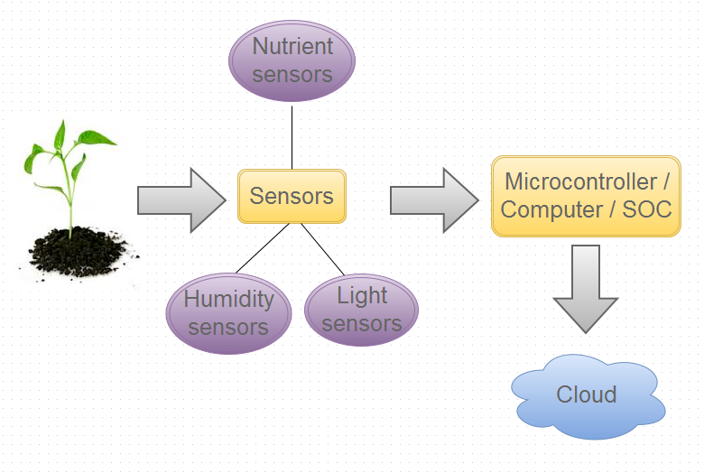

Fig. 2 Basic layout of IOT in Vertical Farming

The various sensors used in vertical farming to build an IOT automated farm are as follows:

* Humidity sensor
* Nutrient sensor
* Light sensor

*A. Humidity sensors*

Humidity sensors senses, measures and reports relative humidity of the air in the farm. Temperatures of 65-75°F are best for most plants. These temperatures is liable to change based upon the plants grown. Growing leafy plants in water will eventually increase the humidity of the room. In case of vertical farming, the plants are grown in preponderance, which will apparently result in astronomical increase in the humidity of the room. The data obtained from the sensors, will be compared with the prescribed humidity which is defined earlier.

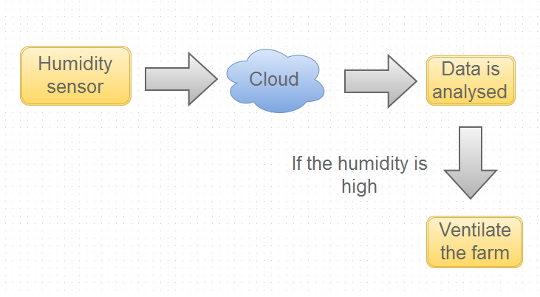

Fig. 3 The flow of data from humidity sensor

If the humidity of the farm failed to match the defined humidity value, the microcontroller will trigger the ventilation system (ventilation fan).

*B. Nutrient sensors*

Nutrients are the key components in deciding the growth rate of the plants. Nutrient sensors sense the composition of the nutrients (Sodium, Potassium, Nitrate, and Calcium) in the soil and feed it to the database, where it computes to check whether the nutrient obtained by the plants is sufficient for the plants growth in that stage.

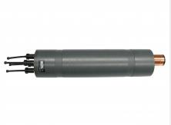

Fig. 4 Nutrient sensor

When the microcontroller realizes that the nutrient for a particular stack is not sufficient, it triggers the nutrient reservoir placed in non-plant rooms to the desired stack of plants.

*C. Light sensors*

Since the plants are grown in the concealed environment, they are not exposed to the natural UV light from the sun. As light is the key entity in the process of photosynthesis, incandescent lights / fluorescent lights are set to perform the role of sun.

Light penetration is a primary influence on correct pruning.



Fig. 5 Impact of light penetration in the shape of plants

Light quality refers to the color or wavelength reaching the plant's surface. Red and blue have the greatest impact on plant growth. Green light is least effective (the reflection of green light gives the green color to plants). Blue light is primarily responsible for vegetative leaf growth. Red light, when combined with blue light, encourages flowering. The more sunlight a plant receives, to a degree, the higher the photosynthetic rate will be. Even slight decrease in the light intensity can turn out to be a disastrous effect in the growth of the plants.

Since we are constrained in emitting appropriate light intensity, the light sensors should act in an intelligent manner, by giving off light to the plants based upon the plant species, the growth stage of the plant, the shape of the plant. Henceforth, the light sensors will be controlled by the microcontroller or a computer, by analyzing the given set of data obtained from the other sensors. The microcontroller undergoes image processing to find the shape, height of the plants. Based upon these inference, the

1. MACHINE LEARING

The age of feeding data to the computers manually for analyzing the data and expecting productive decisions after data analysis bids farewell to us by the dawn of machine learning. Machine learning is the action of the computers or any intelligent machines to learn stuffs on its own by pre-written machine learning algorithm.

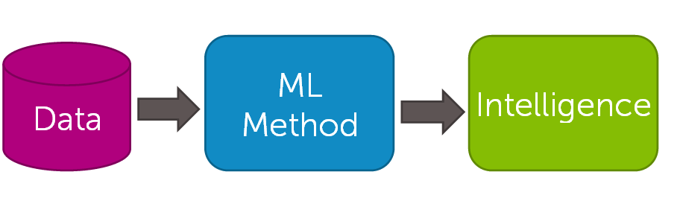

Fig. 6 Basic pipeline of machine learning

The data fed to the machine algorithm is obtained from the sensors, which forms the base of the Internet of Things. In our case, sensor’s contribution is significant in both IOT and Machine learning.

The two primary concepts of machine learning are to be imported in vertical farming. They are Classification and Deep learning.

*A. Classification:*

In machine learning and statistics, classification is the problem of identifying to which of a set of categories a new observation belongs, on the basis of a training of data containing observations (or instances) whose category membership is known.

In our application i.e. Vertical farming, classification can be implemented by fetching data (nutrients, light intensity) from the sensors and feeding it to the machine learning algorithm (Classification).The Classification algorithm will parse the entire data it obtained and segregate them into collection of related data sets.

For instance, let us take we obtained light intensity of 100 candelas, which is an advised light intensity for growing plants in a room or closed environment. Also, the nutrient value obtained from the nutrient sensor is also accurate. Then as a result of the classification process, the machine will process all the values obtained from different sensors with respect to constraints of vertical farming and store them in the related data sets. In this case, the machine (computer) will store this result in the optimistic data set of the plants growth in the cloud space.

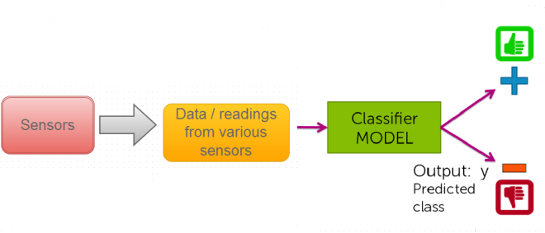

Fig. 7 Classification process

This vital data can be used for multiple purposes. By end of the day, with the help of this completely analyzed data, we can notify the owner or in-charge of the farm with the simple notification to their mobile through mail or any standard mode of notification.

VI*.* COMMERCIAL PURPOSE

Vertical Farm mobile application can be developed for commercial purpose. People can be encouraged to keep their own farm area in their house itself. Using this application they can feed their crops' information into the database and get technical assistance. The app will instruct the person when to water the plants, when to use nutrient solution. From the images of the plants, their growth rate, chlorophyll content, harvest time everything can found by using Machine learning enabled image processing. Furthermore, nutrient testing device can be used to test the soil nutrient content. User’s Smartphone can be connected to the device through Bluetooth to fetch the information which could be used for analysis and to get assistance.

1. ADVANTAGES

* Human assistance in farming can be neglected.
* Errors committed by humans can be avoided, as every single process in farming is automated.
* Machine Learning in agriculture, will definitely be productive in vertical farming
* Employment of Data scientist
* New diseases suffered by the plants can be detected by Advance Machine Learning.
* One time investment, because the same technology can be used for any types of crops and any number of cultivation cycles, as the farm is powered by machine learning.

1. DISADVANTAGES

* Requires lot of research work and initially have to face some losses to find the best possible method.
* Highly investment, due to the use of advanced technology and sophisticated equipments.
* The conventional farmers cannot be adapted to this technology as involves recent technologies and high investment.

VIII. CONCLUSION

Progress with sensor and Machine Learning will boost Vertical Farming, as functionality like indoor farming and greater context awareness requiring more ubiquitous connectivity and sensing capabilities. Internet of Things and Machine Learning promises to revolutionize Vertical Farming by bringing together silicon-based microelectronics and data analytics. The agriculture industry needs more efficient technology in automation and high-end data processing, which will definitely catapult agriculture to high trajectory in the days to come.

REFERENCES

*[1] ThingWorx Website. [Online]. Available:* [*http://www.thingworx.com/*](http://www.thingworx.com/)

*[2] Stephen R. Garner, Craig G. Nevill-Manning, Ian H. Witten, “Applying Machine Learning to Agriculture Data,”*

*[3]* *Anshal Savla, Himtanaya Bhadada, Parul Dhawan, Vatsa Joshim “Application of Machine Learning Techniques for Yield Prediction on Delineated Zones in Precision Agriculture,” International Journal of New* *Computer Architectures and their Applications, 2015*

*[4] A.Paventhan, “Internet of Things based approach to Agriculture Monitoring,” Asia-Pacific Advanced Network (APAN) 36TH Meeting, Aug.20, 2013.*