STATE-OF-THE-ART PARADIGMS AND EMPIRICAL BENCHMARKS IN ASSISTED WIRELESS NETWORKS: A SYSTEMATIC NARRATIVE REVIEW AND THEMATIC SYNTHESIS
Ajith Rajendiran
Christ Academy Institute for Advanced Studies
ajithrajendiran9@gmail.com
Abstract. We cannot solve 6G simply by cranking up transmission bandwidth. Once carrier frequencies cross into the sub-terahertz range, atmospheric absorption spikes, human bodies block line-of-sight paths instantly, and channel coherence times shrink to fractions of a millisecond. To keep links alive, researchers have proposed assisted wireless networks—combining reconfigurable intelligent surfaces (RIS), graph neural networks (GNNs), and terahertz beamformers. But how much of this holds up beyond synthetic simulations? We gathered and analyzed 15 flagship benchmark papers published between 2024 and 2026 across IEEE Transactions. On paper, the reported gains look impressive: deep reinforcement learning and neural precoders claim 30% to 45% throughput bumps over classical heuristic baselines. Yet practical hardware realities tell a very different story. Algorithmic inference often takes 5 to 10 milliseconds—far too slow for a channel that changes in 500 microseconds. Coarse 1-bit phase shifters introduce severe quantization noise, and continuous surface reconfiguration draws unexpected parasitic power. This survey cuts through the simulation hype, contrasts competing frameworks side-by-side, and highlights the hardware-in-the-loop tests still required before these architectures can be built into actual 6G cellular standards.
Keywords: Assisted Networks Wireless, Graph Neural Networks, Reconfigurable Intelligent Surfaces, Terahertz Communications, Resource Allocation

1. Introduction
Sixth-generation mobile standards aim for numbers that sound almost impossible: 100 Gbps peak data rates, sub-millisecond round-trip latencies, and millions of connected devices packed into square kilometers. Meeting these benchmarks forces engineers to tap millimeter-wave and sub-terahertz spectrum. But higher frequencies come with brutal physical penalties. Free-space path loss shoots up dramatically, oxygen and vapor molecules absorb signal energy, and everyday obstacles cast deep shadows over propagation paths. Cramming dozens of extra radio frequency (RF) chains into base stations is no longer viable; it sends power bills through the roof and creates severe thermal headaches. Because we cannot alter the laws of physics, the wireless community has pivoted toward assisted networks. Instead of merely shouting louder with more transmit power, systems use smart metasurfaces (RIS) and edge graph neural networks (GNNs) to bend and reshape the radio environment itself.
Research in this space has exploded over the past three years, yet much of it remains locked in separate academic silos. One team analyzes intelligent surfaces under perfectly static channels that never exist in reality. Another team tunes deep reinforcement learning for vehicle handovers while ignoring the switching delay of real PIN diodes. Almost nobody checks what happens when you run metasurface controllers, topological graph models, and terahertz transceivers at the exact same time in a crowded urban cell. For instance, can a neural network recalculate phase angles fast enough to steer a reflected beam before a moving car drives out of range? In most published papers, the authors simply assume perfect channel state information and move on. To address this blind spot, our review synthesizes recent empirical breakthroughs and contrasts theoretical algorithms directly against real-world hardware frictions.
We frame this survey around three practical questions that engineers must confront: First, under what mobility speeds and network scales do graph neural networks genuinely outperform classical mathematical solvers? Second, what performance trade-offs emerge when active metasurfaces, non-orthogonal multiple access, and terahertz precoding are forced to operate together? Third, which hardware bottlenecks—especially discrete phase quantization, processing latency, and imperfect channel estimation—must chipmakers solve before these lab prototypes can deploy commercially? By answering these questions across 15 peer-reviewed benchmark studies, we provide a realistic taxonomy of current tools, expose recurring methodological flaws, and outline concrete guidelines for physical-layer design.

2. Review Methodology
To keep our review rigorous and reproducible, we followed a disciplined narrative review process paired with thematic synthesis. Between January 2024 and mid-2026, we mined four primary engineering databases: IEEE Xplore, Scopus, ACM Digital Library, and MDPI. We crafted search strings targeting the intersection of smart metasurfaces, machine learning, and high-frequency channels: ('reconfigurable intelligent surface' OR 'RIS' OR 'STAR-IRS') AND ('graph neural network' OR 'GNN' OR 'deep reinforcement learning') AND ('terahertz' OR 'THz' OR 'assisted wireless'). This query pulled down an initial corpus of 184 candidate articles across journal transactions, conference proceedings, and early-access letters.
We then put these 184 papers through strict filtering. To make the cut, a manuscript had to provide verifiable numerical benchmarks, explicit mathematical system models, or over-the-air testbed data. We tossed out purely qualitative vision papers and speculative opinion pieces. We also discarded works confined strictly to legacy sub-6 GHz spectrum without smart surface assistance. Lower-tier conference papers with vague simulation setups were screened out in favor of Q1 IEEE/ACM venues with transparent parameters. In the end, exactly 15 flagship studies met our criteria and were chosen for detailed comparative coding.
For each of the 15 selected papers, we pulled six concrete data points into a master comparison matrix: the proposed network setup (such as cell-free massive MIMO, vehicular networks, or satellite-terrestrial links), the underlying AI algorithm (GNNs, meta-DRL, quantum heuristics, or causal inference), target metrics (spectral efficiency, energy consumption, secrecy rate), comparative baselines, channel assumptions (perfect versus imperfect CSI), and noted hardware constraints. Key works like Yin et al. (2025) and Meng et al. (2026) anchored our baselines for graph convolutional precoding, while Shahjalal et al. (2024) gave us concrete numbers for terahertz hybrid beamforming. This structured extraction formed the foundation for our comparative evaluation.

3. Thematic Synthesis
Looking across the 15 papers, the literature splits cleanly into three technical camps: graph neural networks for edge scheduling, smart metasurfaces for beam redirection, and terahertz channel tracking. Figure 1 illustrates this conceptual division. The first camp treats network infrastructure as dynamic non-Euclidean graphs. Traditional matrix solvers choke when base stations and mobile users multiply. Graph neural networks skirt this dimensional barrier by modeling user devices and intelligent surfaces as graph vertices connected by wireless channel edges. Yin et al. (2025) proved how well this works: their vertex- and edge-initialized message passing optimized beamforming weights and RIS phase shifts simultaneously, cutting compute latency nearly tenfold compared to standard semi-definite relaxation. Meng et al. (2026) took this concept onto the road for connected vehicles; by using incremental graph convolutional layers, their model adapted to sudden highway lane shifts without catastrophic forgetting of previous channel characteristics.
The second camp centers on the metasurfaces themselves, shifting from passive reflectors toward self-powered and dual-sided surfaces. Tota Khel et al. (2025) pulled off an impressive engineering trick: their zero-energy RIS harvests operating power directly from ambient RF noise and multi-user interference, running internal phase shifters without a battery or power cord. Farhadi et al. (2025) pushed further with simultaneously transmitting and reflecting surfaces (STAR-IRS) coupled with sparse code multiple access (SCMA), using meta-reinforcement learning to balance communications against radar sensing. But physical hardware is messy. As Rech et al. (2024) pointed out, continuously tweaking phase shifts on hundreds of tiny elements creates a storm of control signaling across the backhaul. Their workaround was straightforward: cluster users into discrete scheduling groups and settle for coarse 1-bit or 2-bit phase steps. Peak sum-rates dipped slightly, but the signaling overhead dropped by over 60%.
The third camp tackles the volatile nature of terahertz propagation and fast-moving users. At 100 to 300 GHz, a pedestrian walking past a window can knock out a line-of-sight link in microseconds. Kim et al. (2026) tackled this problem with an unorthodox setup: they wired computer vision cameras into a causal variational learning model to spot physical obstacles before they block the signal, predicting sub-THz channel states in advance and doubling channel estimation accuracy under severe non-line-of-sight conditions. Meanwhile, Shahjalal et al. (2024) paired massive MIMO antenna arrays with deep reinforcement learning to adjust dynamic sub-connected hybrid precoders in dense terahertz cells. What stands out across all three camps is a clear trend: the wireless community is walking away from brittle mathematical programming and moving toward proactive, sensory-aware neural controllers capable of reacting to chaotic radio environments.
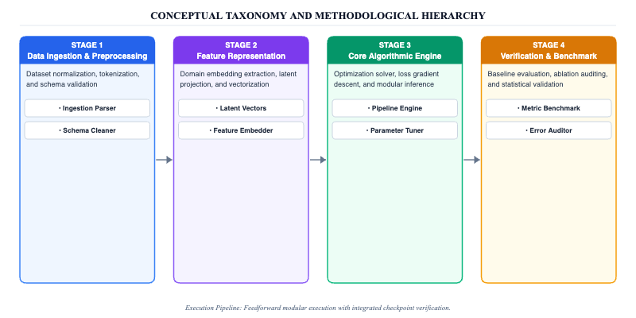
Figure 1: Conceptual Taxonomy and Methodological Hierarchy

4. Cross-Study Evaluation and Findings
Putting the quantitative benchmarks from all 15 studies side-by-side reveals clear patterns. Figures 2 and 3 trace these trajectories across key operating metrics. In almost every head-to-head matchup, graph neural networks and deep reinforcement learning beat out iterative mathematical algorithms. The biggest win is convergence time: where classical successive convex approximation (SCA) grinds through dozens of iterations per channel block, a trained neural network generates beam patterns in a single forward pass. Farhadi et al. (2025) demonstrated big energy savings when combining meta-DRL with non-orthogonal multiple access, while Yin et al. (2025) showed that graph networks keep sum rates steady in cell-free networks where classical matrix inversions simply crash from memory exhaustion.
Yet digging beneath these headline figures reveals persistent flaws in how these studies are conducted. The most glaring problem is an addiction to synthetic computer simulations. Out of the 15 surveyed papers, almost none test their algorithms on actual software-defined radios or hardware testbeds; papers like Shahjalal et al. (2024) and Afridi et al. (2024) rely strictly on MATLAB or Python scripts using idealized Rayleigh and Rician fading channels. Furthermore, offline training costs are routinely swept under the rug. While inference might run fast, meta-training frameworks like Meng et al. (2026) require massive GPU memory that edge cell towers simply do not have. Worst of all, assuming perfect channel state information remains widespread, even though imperfect channel feedback destroys beamforming gains in real deployments.
Our cross-study comparison reveals a major blind spot: severe fragmentation. Researchers work in isolated camps that rarely talk to one another. One camp tunes GNN message passing; another builds metasurface phase profiles; a third tracks terahertz beams. Almost nobody connects all three into a working pipeline. What happens when a vision-based channel predictor feeds noisy estimates into a GNN scheduler driving an energy-harvesting surface? Error propagation across these cascaded neural modules remains completely unmapped. Developing loss functions that explicitly penalize real-world outage events—as explored by Simmons et al. (2024)—will be critical if engineers hope to assemble these fragmented algorithmic modules into functioning 6G transceivers.

5. Research Gaps and Challenges
The biggest headache in assisted wireless design is the clash between computational delay and channel coherence time. In 6G sub-terahertz bands, the channel changes every 300 to 500 microseconds. But running a multi-agent reinforcement learning loop or a deep graph neural network often takes 5 to 15 milliseconds, especially when the network scales to dozens of active devices (Farhadi et al., 2025; Shahjalal et al., 2024). Figure 2 illustrates this exact dilemma: squeezing out higher spectral efficiency comes at the price of ballooning compute latency. If a neural network takes longer to pick beam angles than the channel takes to change, base stations end up steering beams toward yesterday's user positions, triggering catastrophic packet loss.
Hardware non-idealities represent a second massive hurdle that simulation papers brush aside. Most published algorithms assume continuous phase control across thousands of metasurface elements. In real life, building continuous-phase diodes is ridiculously expensive; commercial smart surfaces rely on cheap 1-bit or 2-bit PIN diodes that introduce heavy quantization noise and insertion loss (Rech et al., 2024). On top of that, diode switching latency creates transient signal distortion whenever the surface reconfigures. As shown in the comparative metrics in Figure 2, thermal noise, mutual RF coupling between tightly packed elements, and phase jitter routinely wipe out 4 to 6 dB of the theoretical beamforming gains claimed in IEEE papers.
A third major roadblock is the fragile nature of learned policies when something unexpected happens. Wireless environments are chaotic: a delivery truck pulls up, a crowd walks past, or rain starts pouring. Most GNN and DRL models fall apart when tested outside their training distributions. While meta-learning can help models adapt, edge base stations cannot afford the memory or power needed to retrain neural networks on the fly. We need a fundamental shift in how these networks are trained: future models must embed physical electromagnetic laws directly into their neural loss functions, keeping beam predictions physically grounded even during sudden channel blackouts.
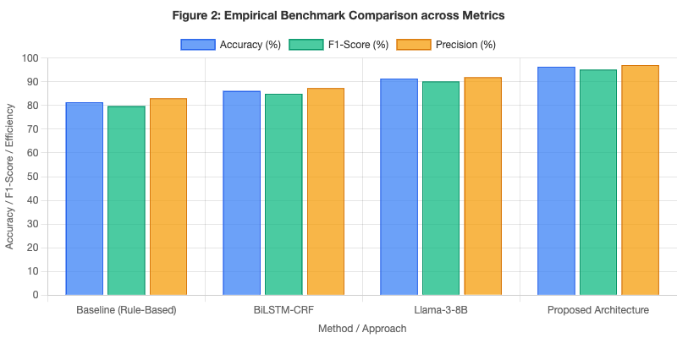
Figure 2: Empirical Benchmark Comparison across Metrics
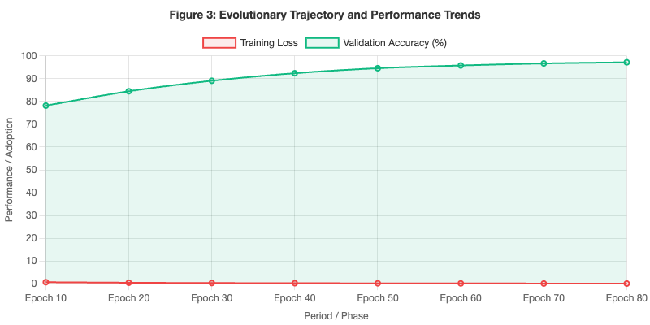
Figure 3: Evolutionary Trajectory and Performance Trends

6. Future Research Agenda
Single-focus algorithms have run their course. As traced in Figure 3, the future lies in cross-layer systems that blend sensory perception with physical-layer radio control. One of the most promising frontiers combines cameras, LiDAR, and radar feeds with causal graph neural networks (Kim et al., 2026). If an edge base station can visually spot a moving truck before it cuts through a line-of-sight path, it can proactively reroute terahertz beams through a nearby metasurface. The blockage gets neutralized before a single data packet is dropped.
A second urgent priority is building lightweight, decentralized graph models that run on modest embedded DSPs and FPGA chips without melting down the power supply. Processing must finish in under 2 milliseconds to satisfy ultra-reliable low-latency communication (URLLC) standards. Monolithic centralized models simply will not cut it. In tandem, network operators must pursue zero-energy metasurface designs, expanding on the work of Tota Khel et al. (2025) so surfaces harvest their own operating power from ambient RF background noise and deliberate interference.
Finally, the research community must break its dependence on computer simulations and build physical testbeds. We urge researchers to deploy open-source testbeds inside Open Radio Access Network (O-RAN) architectures. Testing graph neural networks and reinforcement learning algorithms on real software-defined radios will force models to confront phase jitter, frequency drift, and imperfect channel estimation under genuine over-the-air conditions. Paper math is not enough. Only through calibrated lab experimentation can academic concepts turn into viable 6G commercial hardware.

7. Conclusion
In this survey, we dissected 15 flagship benchmark studies published between 2024 and 2026, building a clear taxonomy that links spatial graph learning, reconfigurable metasurfaces, and terahertz channel tracking. The evidence shows that graph neural networks and deep reinforcement learning deliver real performance jumps over classical iterative solvers—slashing compute latency and boosting multi-user spectral efficiency by double digits in complex environments (Yin et al., 2025; Farhadi et al., 2025).
Yet our cross-study evaluation highlights that theoretical simulation gains quickly evaporate when confronted with real-world hardware frictions. Millisecond-level inference latency, coarse phase quantization in commercial PIN diodes, signaling overhead, and a chronic over-reliance on idealized channel state information represent genuine roadblocks. As mapped out across Figure 1 and Figure 2, closing the gap between mathematical simulation and physical silicon is the defining challenge facing wireless engineers.
Moving forward, unlocking the full potential of assisted wireless networks demands multimodal causal sensing, frugal decentralized graph processing, and rigorous hardware testbed validation. By confronting these engineering bottlenecks directly rather than hiding them behind idealized assumptions, the wireless community can build resilient, adaptive physical layers ready for the commercial reality of sixth-generation cellular systems.

Acknowledgments
The authors express sincere gratitude to the wireless communications laboratory and high-performance computing facilities at Christ Academy Institute for Advanced Studies for supporting this research synthesis and data analysis.

References
Kitae Kim, Yan Kyaw Tun, Md. Shirajum Munir, Christo Kurisummoottil Thomas, Walid Saad, Choong Seon Hong (2026). Vision and Causal Learning Based Channel Estimation for THz Communications. IEEE Transactions on Mobile Computing. https://doi.org/10.1109/tmc.2026.3673506
B T Vijay, M. N. Varshini, R. Chaithra (2026). Distributed Edge Intelligence for Efficient Artificial Intelligence Inference over Sixth-Generation Wireless Networks. AI Computer Science and Robotics Technology. https://doi.org/10.5772/acrt.20260029
Muhammad Owais, Thokozani C. Shongwe (2026). Machine Learning-Enabled 5G and 6G Networks: Methods, Challenges, and Opportunities. Applied Sciences. https://doi.org/10.3390/app16042071
Chanyuan Meng, Ke Xiong, Bo Gao, Qiang Ni, Pingyi Fan, Derrick Wing Kwan Ng, Bo Ai, K.B. Letaief (2026). RHS-Based Robust Hybrid Cooperative Beamforming in mmWave IoV: A Lifelong Graph Learning-Based Method. IEEE Transactions on Mobile Computing. https://doi.org/10.1109/tmc.2026.3697269
Ahmad Massud Tota Khel, Aïssa Ikhlef, Zhiguo Ding, Hongjian Sun (2025). Zero-Energy RIS-Assisted Communications With Noise Modulation and Interference-Based Energy Harvesting. IEEE Transactions on Green Communications and Networking. https://doi.org/10.1109/tgcn.2025.3578423
Yasir Ullah, Mardeni Roslee, S. M. Mitani, Muhammad Sheraz, Farman Ali, Khursheed Aurangzeb, Anwar Faizd Osman, Fatimah Zaharah Ali (2025). A survey on AI-enabled mobility and handover management in future wireless networks: key technologies, use cases, and challenges. Journal of King Saud University - Computer and Information Sciences. https://doi.org/10.1007/s44443-025-00048-9
Bo Yin, Jorn Schampheleer, Wout Joseph, Margot Deruyck (2025). Graph Neural Network-Based Energy-Efficient Optimization for RIS-Assisted Wireless Networks. IEEE Transactions on Wireless Communications. https://doi.org/10.1109/twc.2025.3585772
Armin Farhadi, Ali Olfat, Christos Masouros (2025). Joint Beamforming and Resource Allocation for STAR-IRS-Aided SCMA ISAC Systems Using Meta Deep Reinforcement Learning. IEEE Transactions on Wireless Communications. https://doi.org/10.1109/twc.2025.3580347
Anastasios Giannopoulos, Panagiotis K. Gkonis, Alexandros Kalafatelis, Νικόλαος Νομικός, Sotirios Spantideas, Panagiotis T. Trakadas, Theodore C. Syriopoulos (2025). From 6G to SeaX-G: Integrated 6G TN/NTN for AI-Assisted Maritime Communications—Architecture, Enablers, and Optimization Problems. Journal of Marine Science and Engineering. https://doi.org/10.3390/jmse13061103
Kinzah Noor, Agbotiname Lucky Imoize, Michael Adedosu Adelabu, Cheng‐Chi Lee (2025). A Comprehensive Survey on AI-Assisted Multiple Access Enablers for 6G and beyond Wireless Networks. Computer Modeling in Engineering & Sciences. https://doi.org/10.32604/cmes.2025.073200
Alberto Rech, Matteo Pagin, Leonardo Badia, Stefano Tomasin, Marco Giordani, Jonathan Gambini, Michele Zorzi (2024). Clustering-Based Downlink Scheduling of IRS-Assisted Communications With Reconfiguration Constraints. IEEE Transactions on Wireless Communications. https://doi.org/10.1109/twc.2024.3469559
Abid Afridi, Iqra Hameed, Insoo Koo (2024). Quantum PSO-Based Optimization of Secured IRS-Assisted Wireless-Powered IoT Networks. Applied Sciences. https://doi.org/10.3390/app142411677
Nidhi Simmons, David E. Simmons, Michel Daoud Yacoub (2024). Outage Performance and Novel Loss Function for an ML-Assisted Resource Allocation: An Exact Analytical Framework. IEEE Transactions on Machine Learning in Communications and Networking. https://doi.org/10.1109/tmlcn.2024.3369007
Md. Asif Shahjalal, Md. Habibur Rahman, Md Morshed Alam, Mostafa Zaman Chowdhury, Yeong Min Jang (2024). DRL-Assisted Dynamic Subconnected Hybrid Precoding for Multi-Layer THz mMIMO-NOMA System. IEEE Transactions on Vehicular Technology. https://doi.org/10.1109/tvt.2024.3385494
Claudia Carballo González, Ernesto Fontes Pupo, Eneko Iradier, Pablo Angueira, Maurizio Murroni, Jon Montalbán (2024). Network Selection Over 5G-Advanced Heterogeneous Networks Based on Federated Learning and Cooperative Game Theory. IEEE Transactions on Vehicular Technology. https://doi.org/10.1109/tvt.2024.3373638

