🧠 What is this app?
DykScribe is like a smart digital notebook for Van Dyk engineers.
It helps techs easily record and submit:
- Equipment info
- Notes
- Q&A responses (typed or spoken)
Everything gets stored in a secure database.
You can just talk — and the app writes it for you!
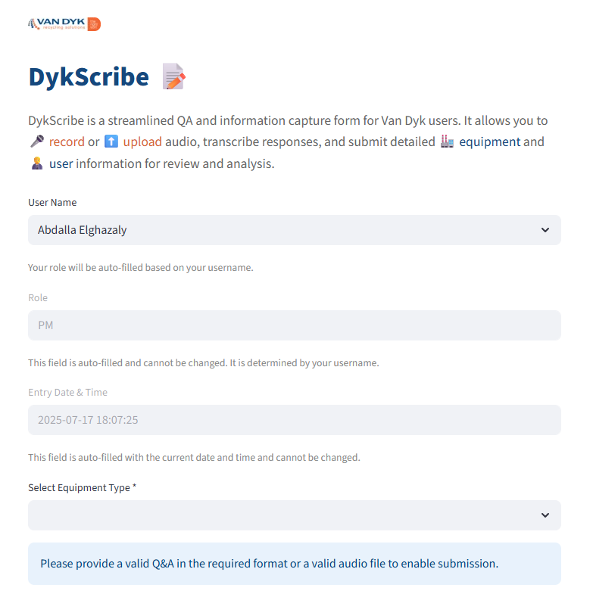

🧩 What are the pieces inside?
The app uses 4 main files:
- app.py → The main brain (this is the app you run)
- db_engine.py → Helps the app talk to the database 💬📦
- app_secrets.py → Holds secret info like passwords 🔐
- requirements.txt → Tells Python which tools to install 🧰

🚀 Step-by-Step: What Happens When You Use It?
1. App Starts
- It shows a logo and title: "DykScribe 📝"
- It gets ready to connect to:
  - A database (like a big digital filing cabinet)
  - OpenAI (to help with writing stuff nicely)

2. User Fills the Form
You (the user) choose:
- Your name (your role shows up automatically)
- Date & time (it fills this in for you)
- What kind of equipment you worked on
- What brand it is
- The model of that equipment
- Two details like the machine’s size or power (called Specs)
- Notes (any extra thoughts)
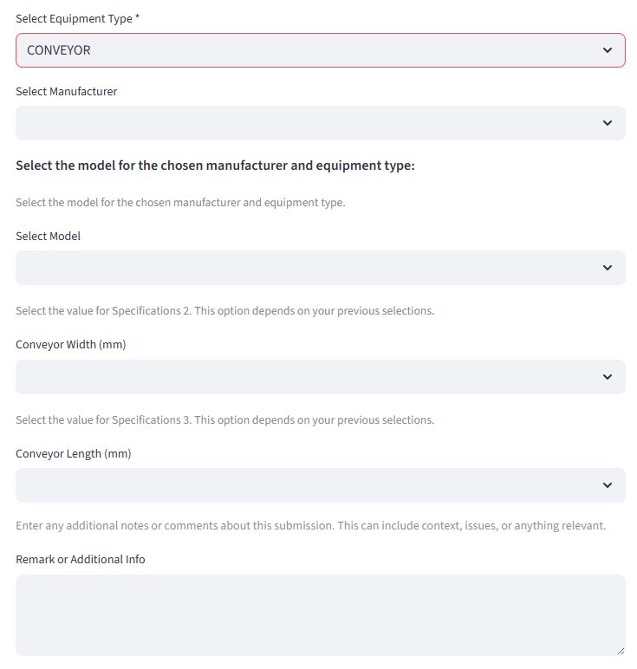

3. Choose ONE Way to Give Q&A
You now choose one way to give your questions and answers:

Option A: 📢 Audio
You either:
- Record your voice right in the browser
- Or upload a sound file (.mp3 or .wav)
The app will:
- Listen to your voice
- Use Whisper (by OpenAI) to write down what you said
- Use ChatGPT to change that into Q&A like this:
makefile
CopyEdit
Q1: What machine did you fix?
A1: I fixed the Air Booster.
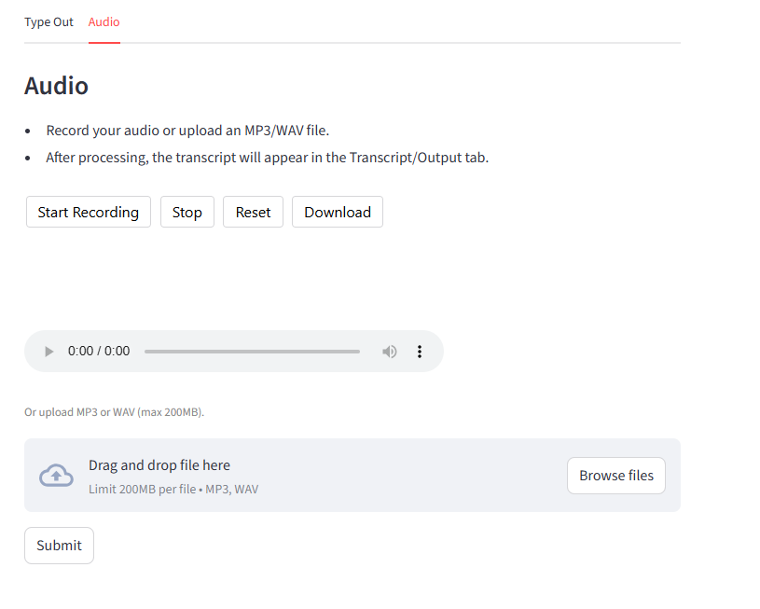

Option B: ✍️ Type It Out
You just type your Qs and As into a box like this:
vbnet
CopyEdit
Q1: What did you do?
A1: I cleaned the conveyor.
The app checks to make sure it looks like real Q&A.
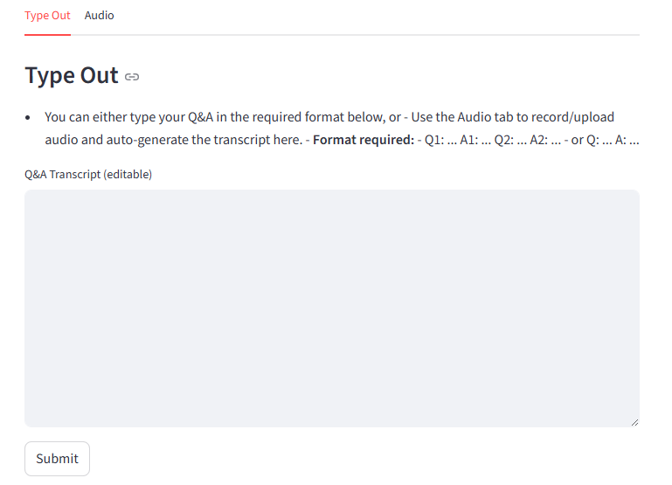

4. 📤 You Click Submit
Once you're done:
- If you gave valid audio, it works
- If you typed valid Q&A, it works
(But not both! Pick just one)

5. The App Does Some Magic
- Counts how many Qs and As you gave
- Gives you points (1 point per question)
- Saves all this in memory (like a locker)
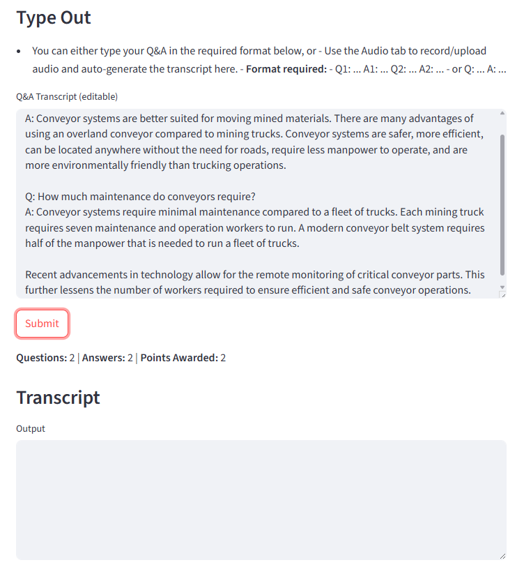

6. 📦 Final Step: Submit to Database
When you click “Submit to Database”:
- All your answers
- Your notes
- Your name, time, and specs
- Even your audio recording
➡️ All of this goes into a special SQL Server database.

💾 Behind-the-Scenes
- The app connects to a secure cloud database
- It uses OpenAI Whisper to listen
- It uses ChatGPT to organize your answers
- It only works with:
  - Either typed Q&A
  - Or voice recording
(Not both together)

✅ Why It’s Cool
- No need to write things twice
- You can just talk, and the app handles it
- Clean, simple way to save machine data
- Easy for team leads to review later
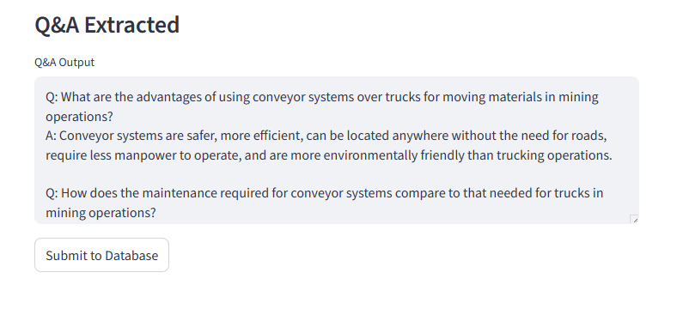

📘 About This App
App Name: DykScribe 📝
Author: Ajith Srikanth
Made For: Van Dyk Recycling Service Engineers
Built With: Python using Cursor
Hosted On: Streamlit

