ROW Application

User Guide

Infra Build – Jio Digital Life

A step-by-step guide for ROW Executives to create, manage,
merge, and submit ROW Applications using the K2 and GIS systems.

Table of Contents
1. Overview
2. Workflow Summary
3. Accessing the ROW Application
4. Searching and Selecting Span Details
5. Creating a ROW Application
6. SPAN Split and Update Authority
7. Saving the Split Span
8. Updating Authority for Split Spans
9. Generating Application After Split
10. Merging Applications
11. Application Acknowledgement & Submission
12. Capture Joint Survey Details
13. Capture Application Processing Fee

1. Overview
The ROW (Right of Way) Application is a web-based module within the Infra Build platform (Jio Digital Life) that enables ROW Executives to create, manage, and submit Right of Way applications for fiber optic network deployments. The application integrates with K2 workflow engine and GIS (Geographic Information System) for geographic span management.
This document provides a comprehensive step-by-step guide covering the complete lifecycle of a ROW Application — from initial creation through span management, application merging, submission, joint survey, and processing fee capture.
Key Capabilities:
- Create ROW Draft Applications for Intercity & Intracity networks
- View and select SPAN, CROSSING, and POLE details from GIS
- Split spans and update authority information
- Merge multiple draft applications into a single application
- Submit application acknowledgement with supporting documents
- Capture Joint Survey findings
- Capture and approve Application Processing Fee (multi-level approval)

2. Workflow Summary
The following table summarizes the key tasks in the ROW Application workflow:
Workflow | Task Name | System | App Type | Role | Location
ROW Application | Create ROW Application | K2, GIS | Web | ROW Executive | SHQ
ROW Application | Application Acknowledgement | K2, GIS | Web | ROW Executive | SHQ
ROW Application | Capture Joint Survey Details | K2, GIS | Web | ROW Executive | SHQ
ROW Application | Capture Application Processing Fee | K2, GIS | Web | ROW Executive | SHQ
ROW Application | Processing Fee – Approval L1 | K2, GIS | Web | SCO | SHQ
ROW Application | Processing Fee – Approval L2 | K2, GIS | Web | State FC&A | SHQ

3. Accessing the ROW Application
To begin working with ROW Applications, you must first access the FTTX Home screen on the K2 platform.
Step 1: Log in to the K2 platform and navigate to the FTTX Home screen.
Step 2: On the FTTX Home screen, locate the "PUBLIC ROW" tile on the left side of the screen.
Step 3: Click on "Manage Draft Application (Intercity & Intracity)" under the PUBLIC ROW section.
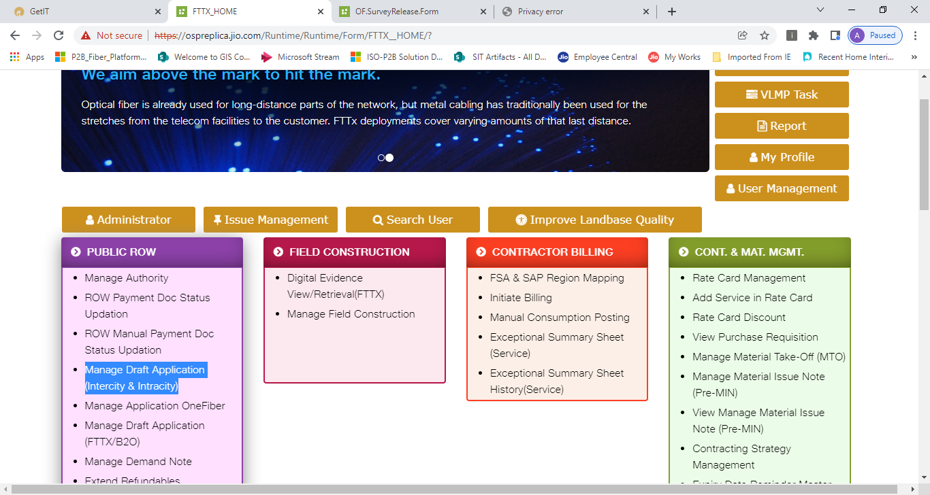
Figure 1: FTTX Home Screen – Click 'Manage Draft Application (Intercity & Intracity)' under PUBLIC ROW
Note: The PUBLIC ROW tile contains several options including Manage Authority, ROW Payment Doc Status Updation, ROW Manual Payment Doc Status Updation, Manage Application OneFiber, Manage Draft Application (FTTX/B2O), Manage Demand Note, and Extend Refundables.

4. Searching and Selecting Span Details
After accessing the application, you will be directed to the 'Application Generation One Fiber' screen where you can search for span details.
Step 1: Select "NON DIT Draft Application" as the application type.
Step 2: Fill in the search filters:
- Phase – Select the applicable phase
- Jio State – e.g., Chhattisgarh
- Political State – e.g., Chhattisgarh
- MP (Maintenance Point) – e.g., INCGJGDP01 - Jagdalpur
- Authority Category – e.g., NHAI
- Authority – e.g., CG NHAI
- Network Category – Select as applicable
- Network Type – e.g., INTERCITY
Step 3: Click the "Search" button to retrieve the link/route details.
Step 4: In the LINKS/SPANS section, select the Link/Route from the dropdown (e.g., CG_CG_CGMADIORUMTESPR002_BU).
Step 5: Click "Get Span" to retrieve span details. You can also click "Get Pole" or "Get Crossing" to get pole and crossing details.
Step 6: SPAN, CROSSING, and POLE details eligible for ROW will be displayed in a table showing Feature ID, Length, UOM, Construction Type, and Construction Methodology.
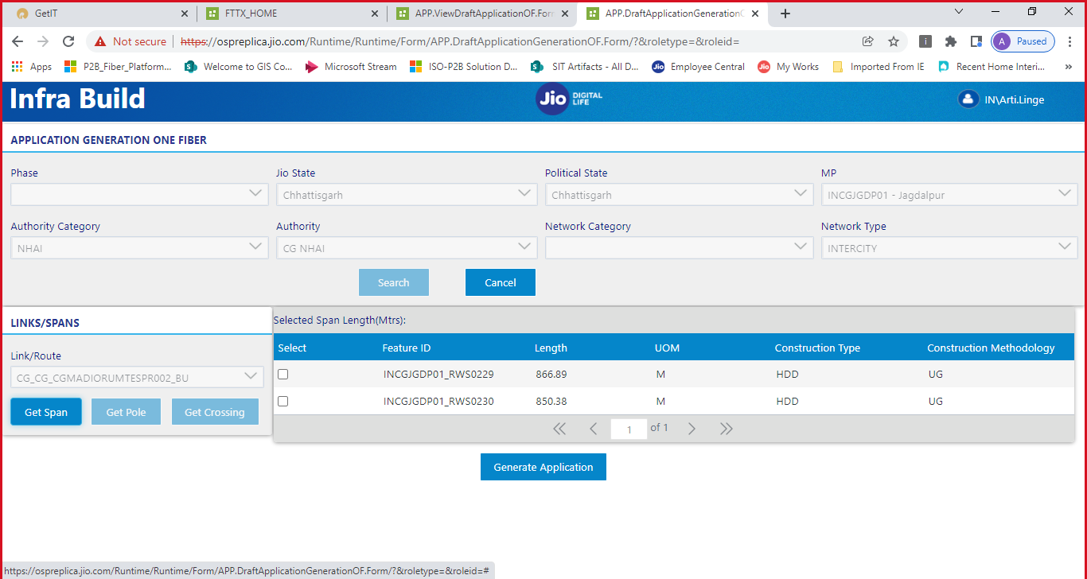
Figure 2: Application Generation One Fiber – Search filters and SPAN details

5. Creating a ROW Application
Once you have retrieved the span details, you can select the desired spans and generate a ROW application.
Step 1: Select the desired SPAN segment(s) by checking the checkbox next to the Feature ID.
Step 2: The "Selected Span Length (Mtrs)" field will automatically update to reflect the total length of selected spans.
Step 3: Click the "Generate Application" button at the bottom of the page.
Step 4: A success message will appear confirming the application has been created, displaying the Application Reference Number (e.g., NLD-CG-CG-2022034154204843).
Step 5: Click "OK" to dismiss the success dialog.
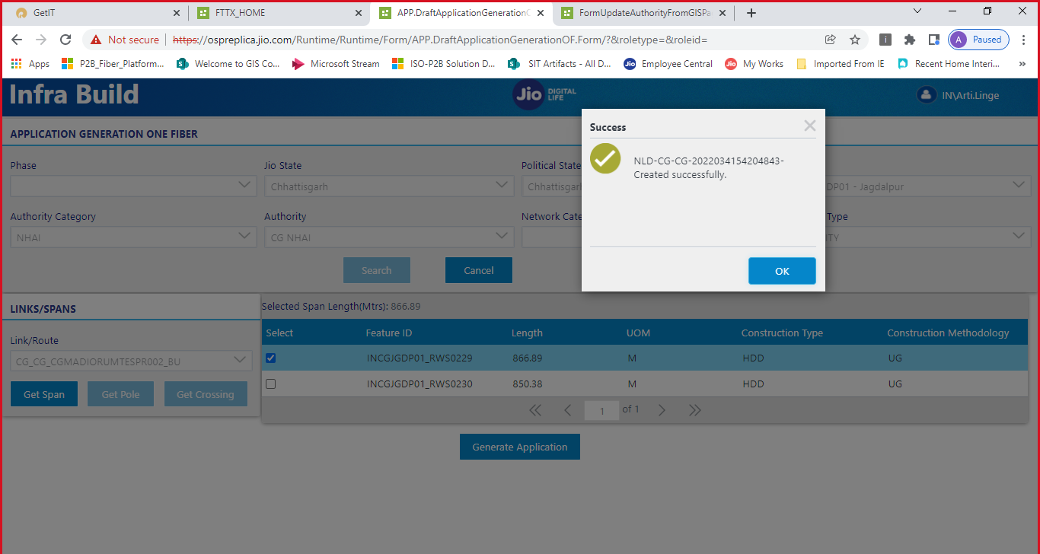
Figure 3: Application Created Successfully – Application Reference Number displayed

6. SPAN Split and Update Authority
Before application creation, users can split spans and update the authority information. This is done through the Update Authority page integrated with GIS mapping.

6.1 Viewing Authority Details
You can view and manage all registered authorities from the Authority Details page.
Step 1: Navigate to the Authority Details page in Infra Build.
Step 2: The page displays a list of all authorities with their Category, Name, Type, Number of Circles, MPs, JPs, and Address.
Step 3: Use the toolbar options: Add Authority, Edit Authority, Manage Authority Cost, Manage Authority Vendor Contract Type Mapping, or Update ROW Authority (GIS).
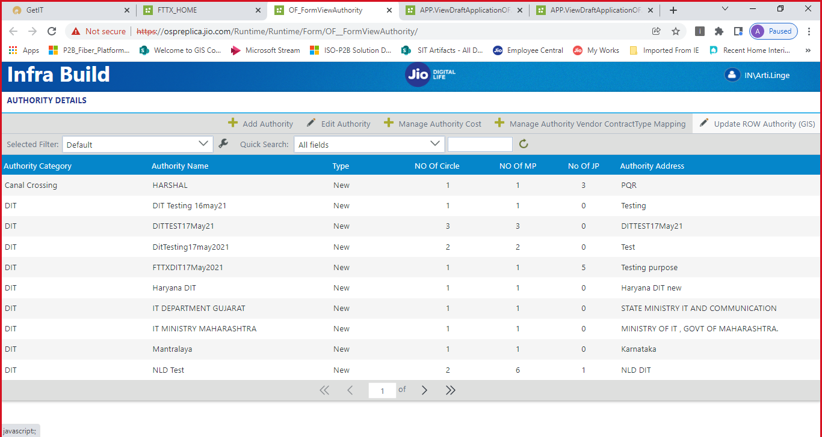
Figure 4: Authority Details – List of all registered authorities

6.2 Adding/Updating Authority
If the authority for a span is not registered, you can add a new authority.
Step 1: Select the Authority Type: "Existing" or "New".
Step 2: For a new (unregistered) authority, fill in:
- Authority Category – e.g., PWD
- Authority Name – e.g., CG PWD
- Authority Address – e.g., CG PWD MAIN LANE CG
Step 3: Configure the JIO State Mapping (Circle and MP Name).
Step 4: Click "Save Authority" to save the new authority.
Step 5: A confirmation dialog will appear: "Are you sure you want to add/update authority with below mapping?" Click "OK".
Step 6: A success message will confirm: "Authority Saved Successfully."
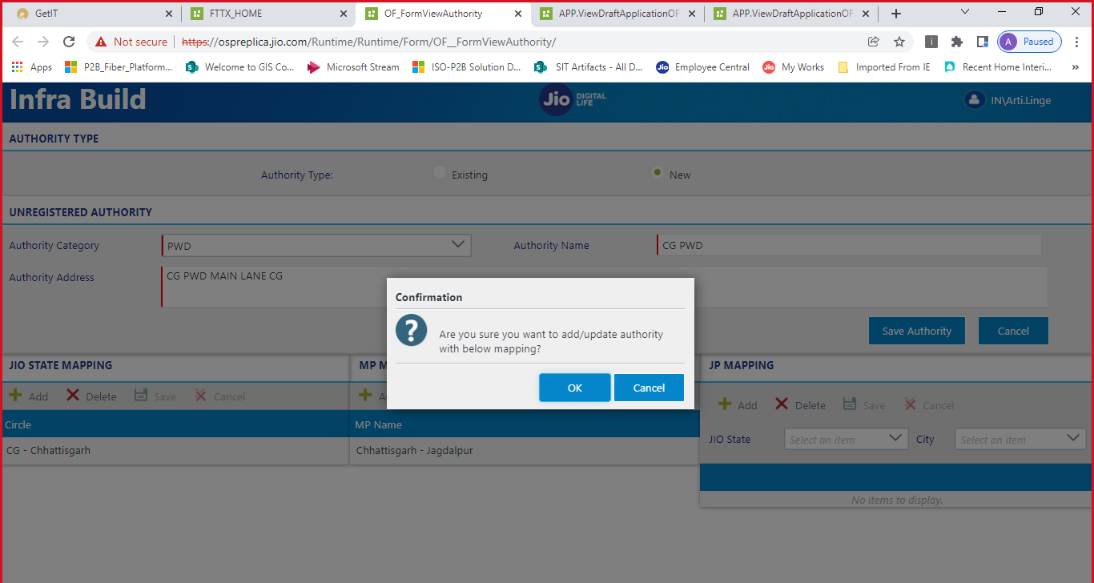
Figure 5: Add New Authority – Authority Type, Category, Name, and State Mapping
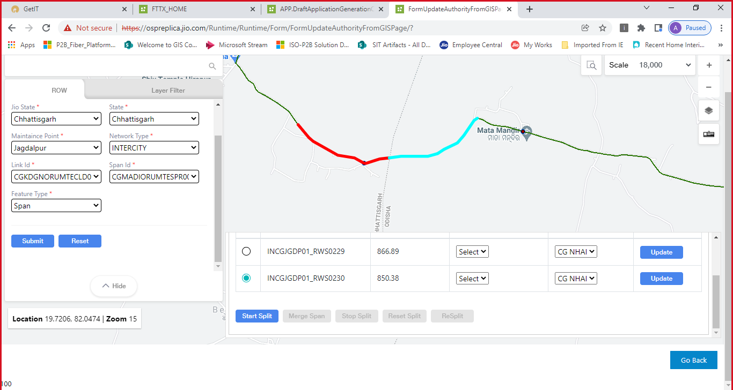
Figure 6: Authority Saved Successfully

6.3 Using GIS Map for Span Management
The Update Authority from GIS Page provides an interactive map view where you can visualize fiber spans and perform split/merge operations.
Step 1: On the GIS page, fill in the filter fields:
- Jio State and State – e.g., Chhattisgarh
- Maintenance Point – e.g., Jagdalpur
- Network Type – e.g., INTERCITY
- Link Id and Span Id – Select from dropdowns
- Feature Type – e.g., Span
Step 2: Click "Submit" to load the span on the GIS map.
Step 3: The map will display the fiber route with color-coded spans. The span details (RWS Id, Length, Authority Category, Authority Name) are shown in the table below the map.
Step 4: Use the action buttons to manage spans:
- Start Split – Begin splitting a selected span into multiple segments
- Merge Span – Merge two or more span segments
- Stop Split – Stop the current split operation
- Reset Split – Reset the split to the original state
- ReSplit – Re-split a previously split span
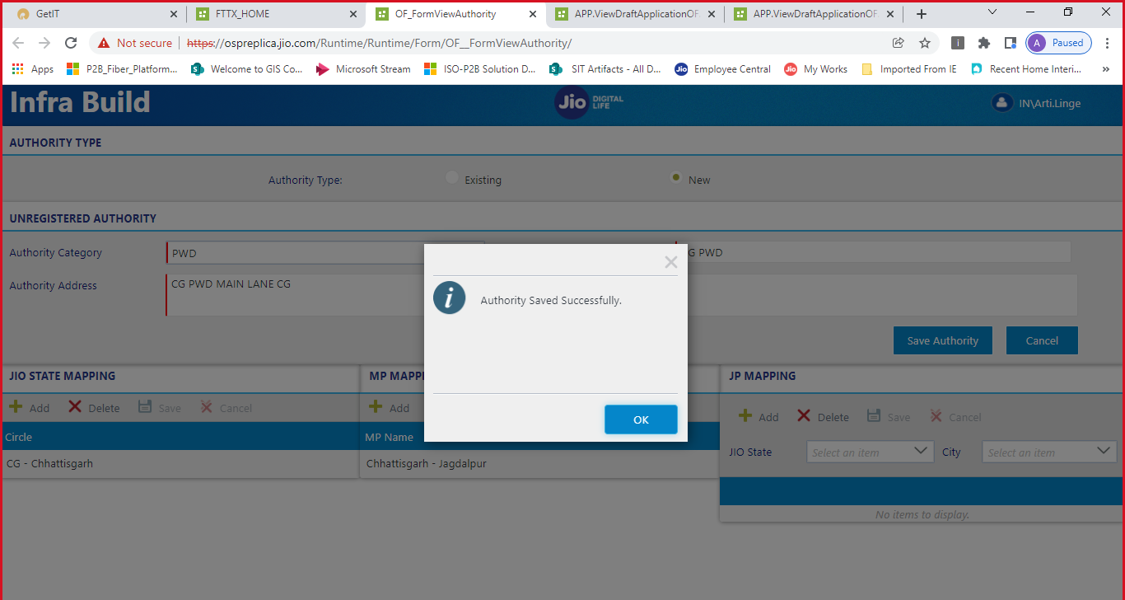
Figure 7: GIS Map View – Span segments with color-coded routes and action buttons

7. Saving the Split Span
After splitting a span on the GIS map, you need to save the split data.
Step 1: After performing the split operation on the map, the split spans will appear in the table with updated RWS IDs and lengths.
Step 2: Verify the split span details (RWS Id, Length in Mtrs, Authority Category, Authority Name).
Step 3: Click the "Save Split" button to save the split data.
Step 4: A success message will confirm: "Split span data saved successfully." Click "OK".
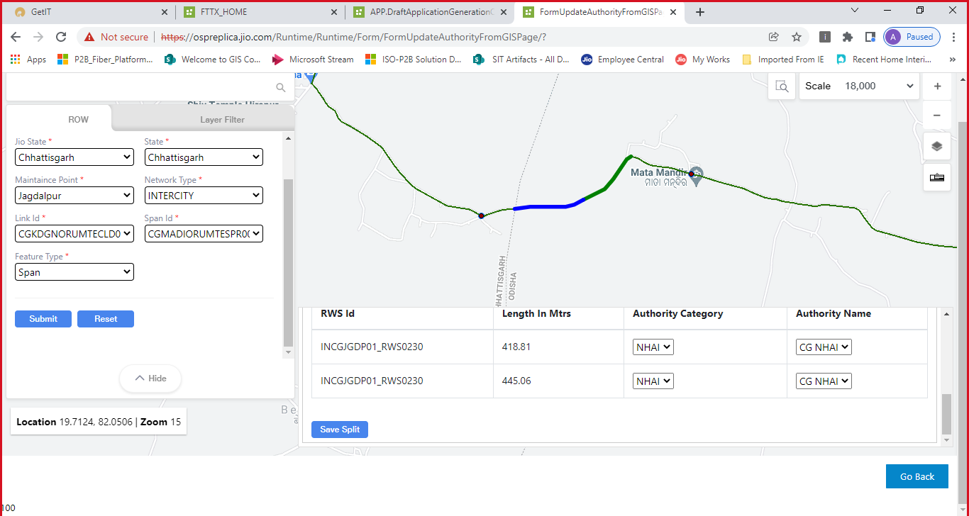
Figure 8: Split Span on Map – RWS IDs and lengths of split segments
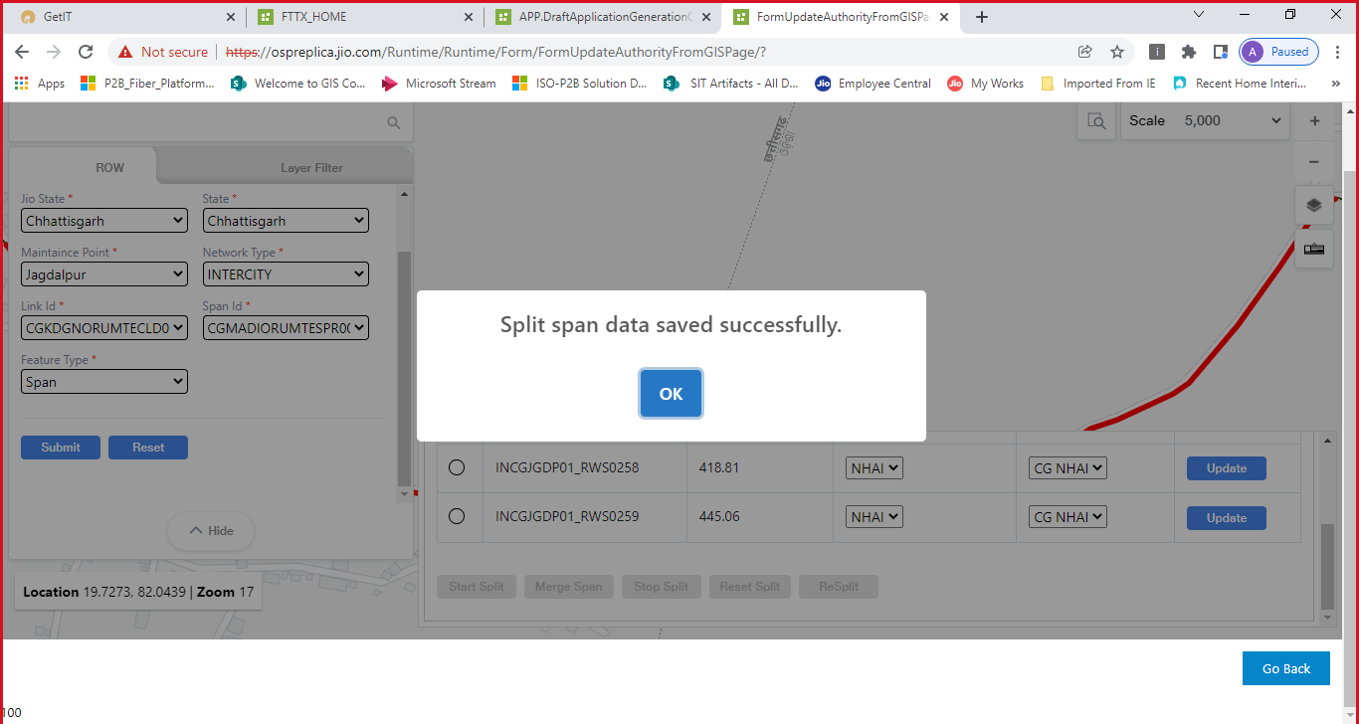
Figure 9: Split Span Data Saved Successfully

8. Updating Authority for Split Spans
After splitting a span, you may need to update the authority for individual split segments.
Step 1: On the GIS map page, locate the split span segments in the table.
Step 2: For each span segment, select the appropriate Authority Category (e.g., NHAI, PWD) from the dropdown.
Step 3: Select the corresponding Authority Name (e.g., CG NHAI, CG PWD).
Step 4: Click the "Update" button next to the span segment to save the authority change.
Step 5: A success message will confirm: "Span data updated successfully." Click "OK".
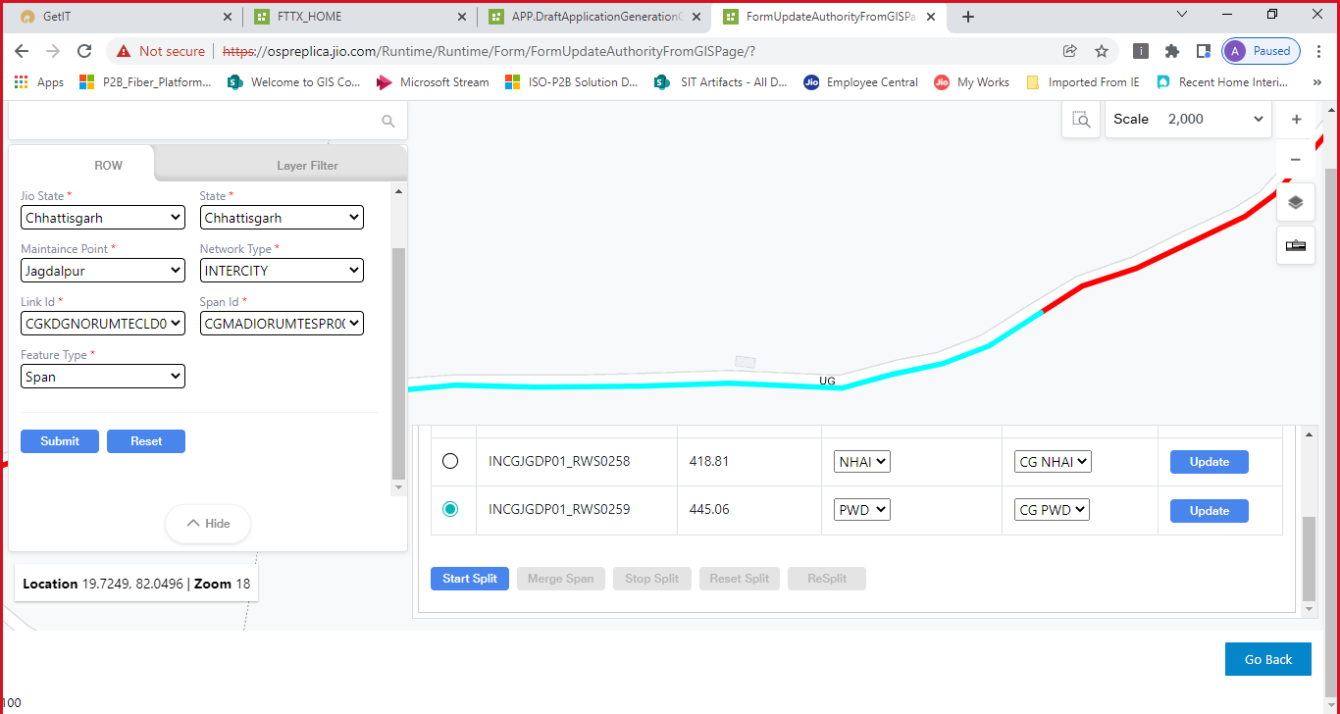
Figure 10: Update Authority – Select Authority Category and Name for each split span
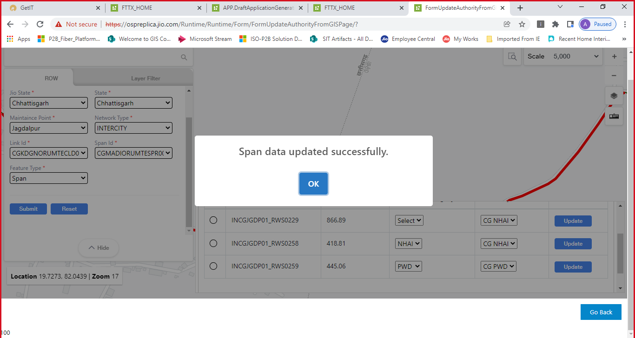
Figure 11: Span Data Updated Successfully

9. Generating Application After Split
After splitting spans and updating authorities, you can return to the Application Generation screen to create a new application with the updated span details.
Step 1: Navigate back to the "Application Generation One Fiber" screen.
Step 2: Search for spans using the same filters. You will now see the split span segments (e.g., INCGJGDP01_RWS0229 – 866.89 M, INCGJGDP01_RWS0258 – 418.81 M, INCGJGDP01_RWS0259 – 445.06 M).
Step 3: Select the desired span segments by checking the checkboxes.
Step 4: Click "Generate Application" to create the application.
Step 5: A success message will display the new Application Reference Number (e.g., NLD-CG-CG-2022034155725720). Click "OK".
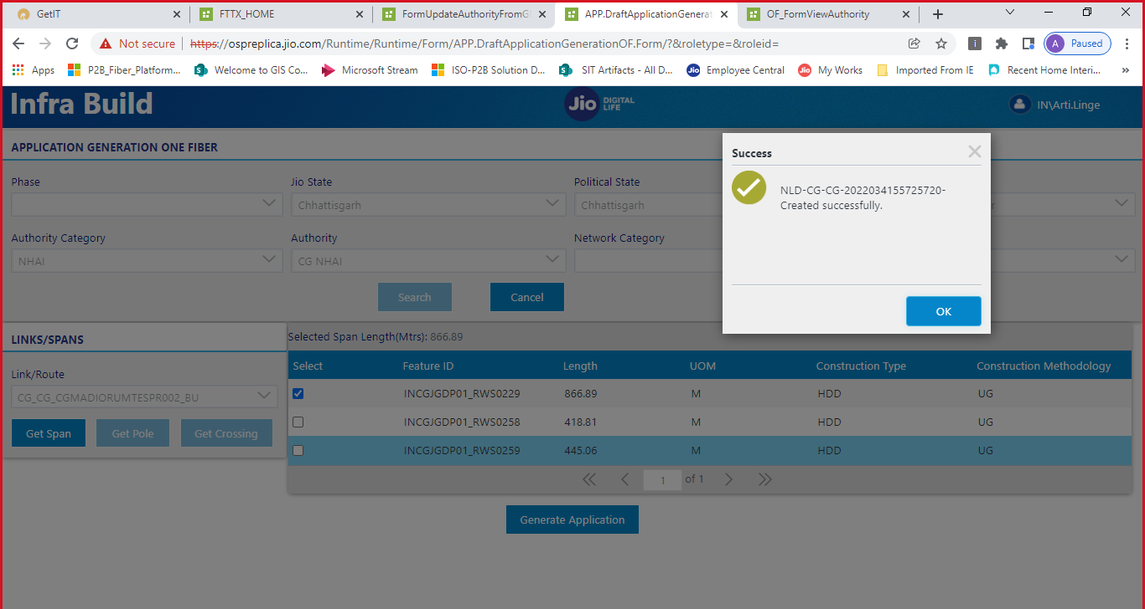
Figure 12: Application Generation – Select split spans and generate application
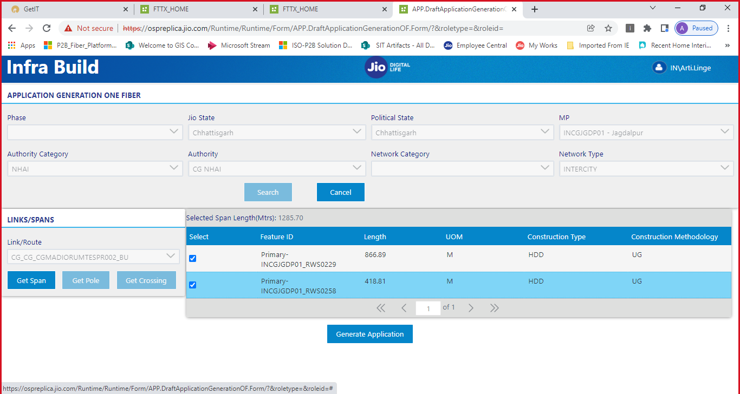
Figure 13: Second Application Created Successfully after Span Split

10. Merging Applications
Users can merge multiple draft applications into a single application. This is useful when multiple span segments under the same authority need to be submitted as one combined application.
Step 1: Navigate to the "Manage Application OneFiber" option on the FTTX Home screen under PUBLIC ROW.
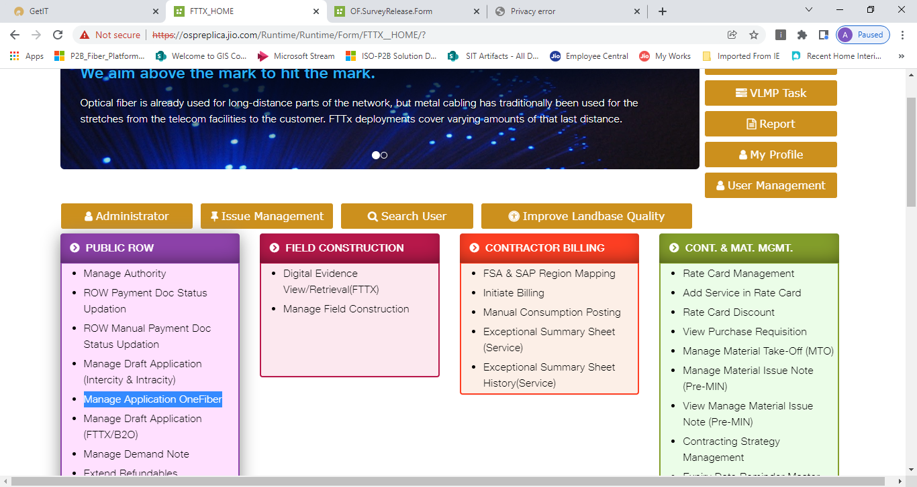
Figure 14: FTTX Home – Click 'Manage Application OneFiber'
Step 2: On the Merge Application screen, select the Network Type (e.g., INTERCITY).
Step 3: Fill in the Search Application filters (JIO State, Political State, MP, Authority Category, Authority).
Step 4: Click "Search" to retrieve draft applications.
Step 5: In the DRAFT APPLICATION section, select the application(s) to merge by checking the checkboxes.
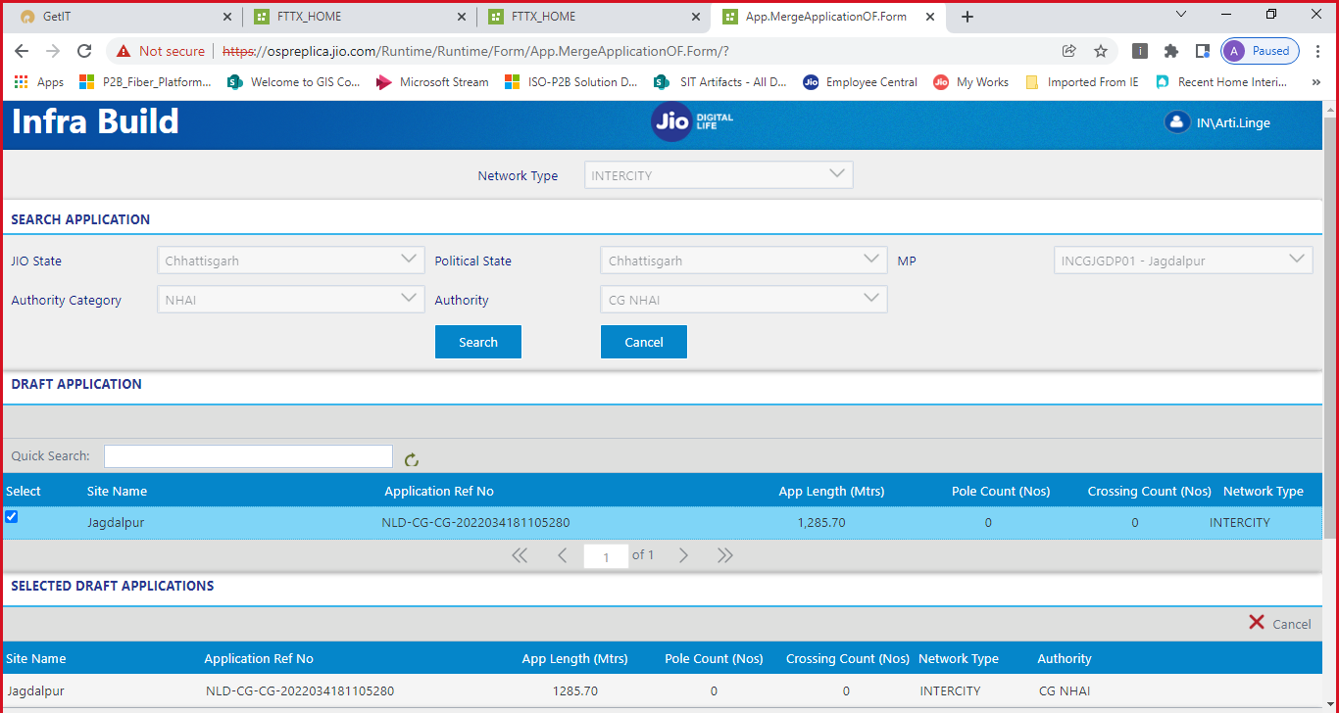
Figure 15: Merge Application – Search and select draft applications
Step 6: The SELECTED DRAFT APPLICATIONS section will display the chosen applications with details including Site Name, Application Ref No, App Length, Pole Count, Crossing Count, Network Type, and Authority.
Step 7: Review the following details:
- Selected App Length (Mtrs) – Total combined length
- Row Processing Fee Applicable – Select Yes/No
- App Pole (Nos) – Total pole count
- App Crossing (Nos) – Total crossing count
- Remarks – Add any remarks if needed
Step 8: Click "Generate Merged Application" to create the merged application.
Step 9: A success message will confirm: "Merge Application (CG22034181336766) Generated successfully." Click "OK".
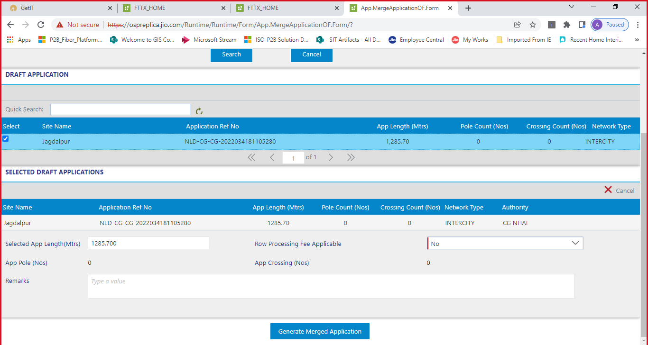
Figure 16: Merge Application – Review details and generate merged application
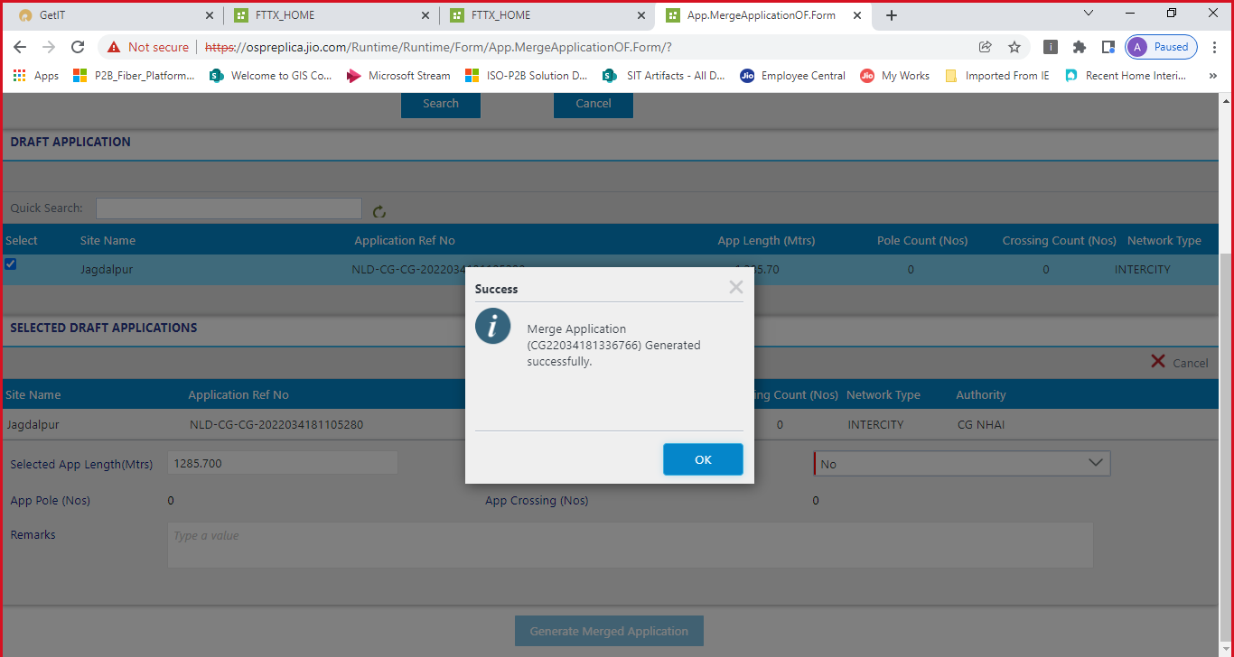
Figure 17: Merge Application Generated Successfully

11. Application Acknowledgement & Submission
After the application is generated, a task will be assigned to the user for application submission. The user must complete the acknowledgement process.
Step 1: Navigate to the Task List in Infra Build (FTTXTaskList).
Step 2: In the Task List, locate the task "Submit App Acknowledgement Details" under the ROW - Application process.
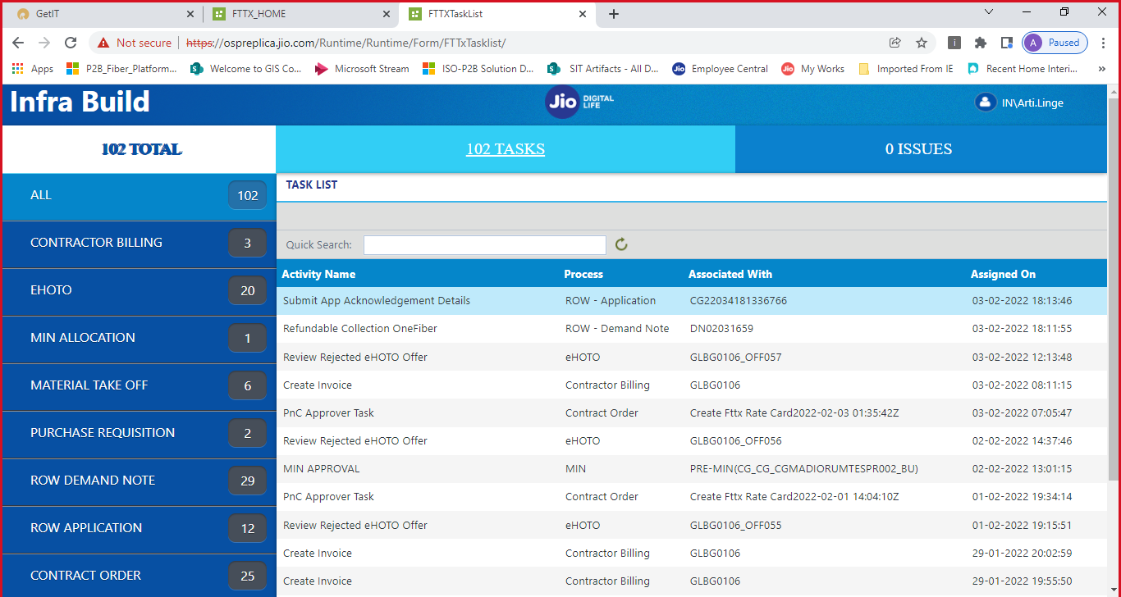
Figure 18: Task List – 'Submit App Acknowledgement Details' task assigned
Step 3: Click on the task to open the Submit Application Acknowledgement Details form.
Step 4: On the form, review the application details:
- App. Ref. No. – Application reference number
- Acknowledgement ID – Will be assigned after submission
- Authority Name – e.g., CG NHAI
- Application Length (Mtrs) – e.g., 1285.70
- Application Pole (Nos) – Count of poles
- Application Crossing (Nos) – Count of crossings
- Submitted Date – Date of submission
- Submitted By – Name of the submitter
Step 5: Upload the acknowledged copy of the submitted application (PDF format).
Step 6: Attach any Other Documents if needed.
Step 7: Enter Processing Fee (Rs.) if applicable.
Step 8: Select Payment Type and enter Payment Instrument No.
Step 9: Upload Processing Fee Scanned Copy if applicable.
Step 10: Click "Submit" to submit the application.
Step 11: A success message will confirm: "Application submitted." Click "OK".
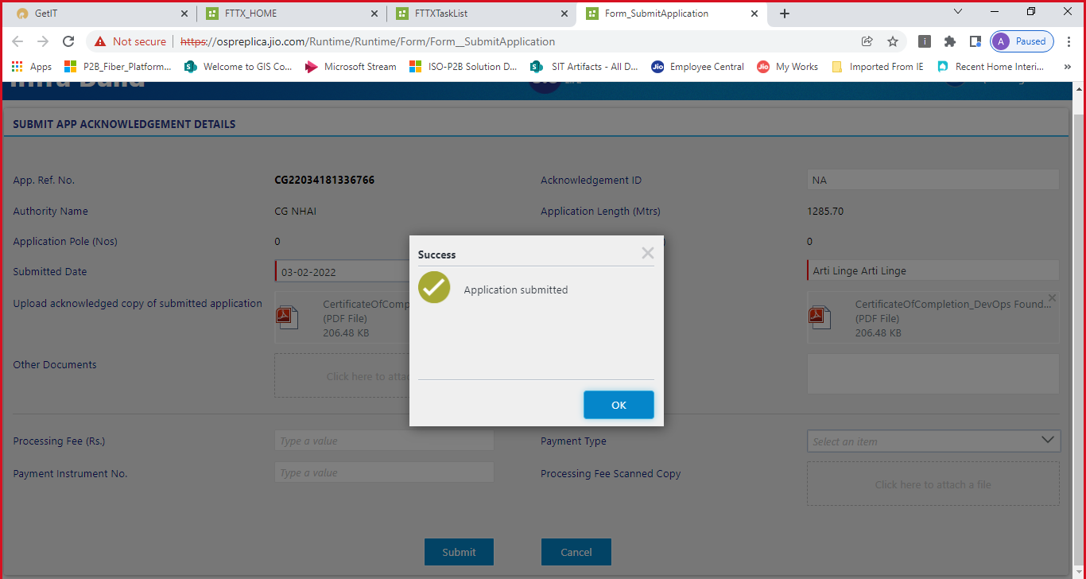
Figure 19: Submit Application Acknowledgement – Application Submitted Successfully

12. Capture Joint Survey Details
After the application is submitted, a task for capturing Joint Survey findings will be assigned.
Step 1: Navigate to the Task List and locate the task "Submit Joint Survey Findings" under ROW - Application.
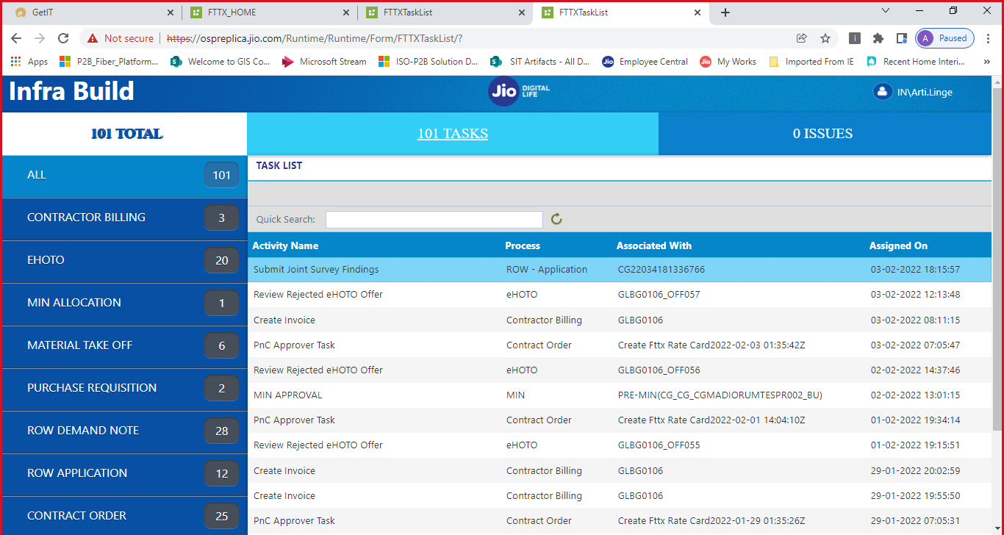
Figure 20: Task List – 'Submit Joint Survey Findings' task assigned
Step 2: Click the task to open the Joint Survey Findings form.
Step 3: On the form, review the application details:
- App. Ref. No. – Application reference number (e.g., CG22034181336766)
- Authority Name – e.g., CG NHAI
- App. Length (Mtrs) – e.g., 1285.70
- App. Crossing (Nos) – Count of crossings
- App. Pole (Nos) – Count of poles
Step 4: Enter the Date of Joint Survey.
Step 5: Upload the Survey Finding Document (e.g., Certificate of Completion PDF).
Step 6: Add Comments (e.g., "Joint survey done").
Step 7: Click "Submit" to submit the joint survey findings. You can also click "Not Applicable" if the survey is not required.
Step 8: A success message will confirm: "Joint Survey Findings Submitted." Click "OK".
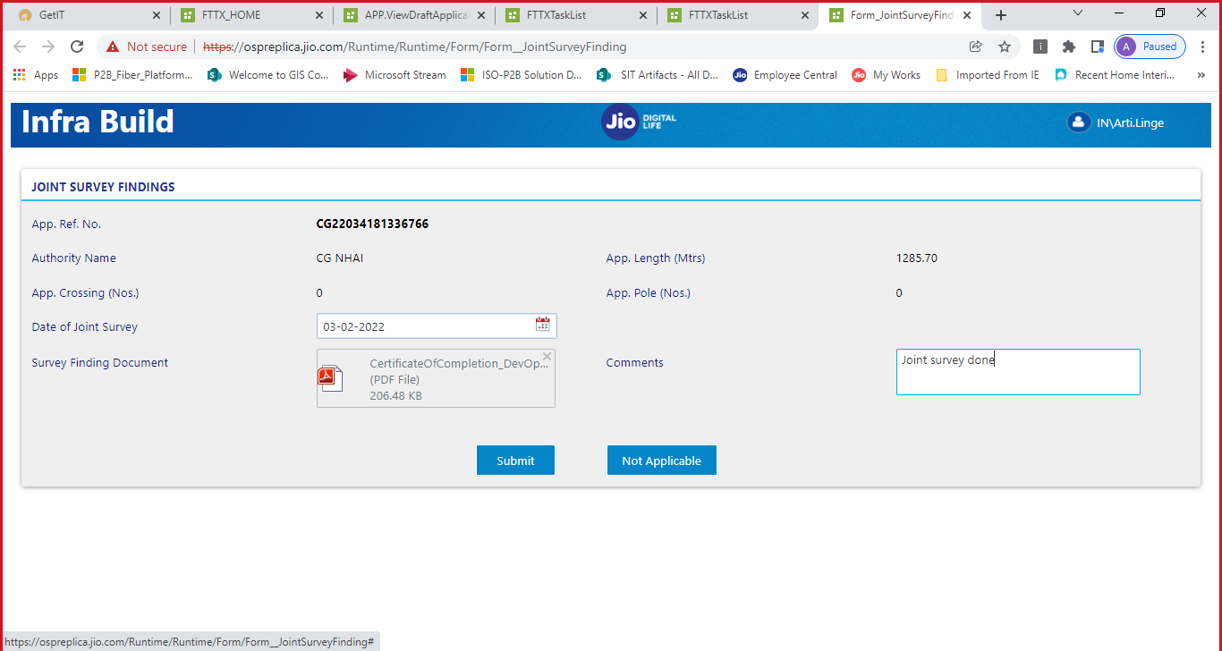
Figure 21: Joint Survey Findings Form – Enter survey details and upload documents
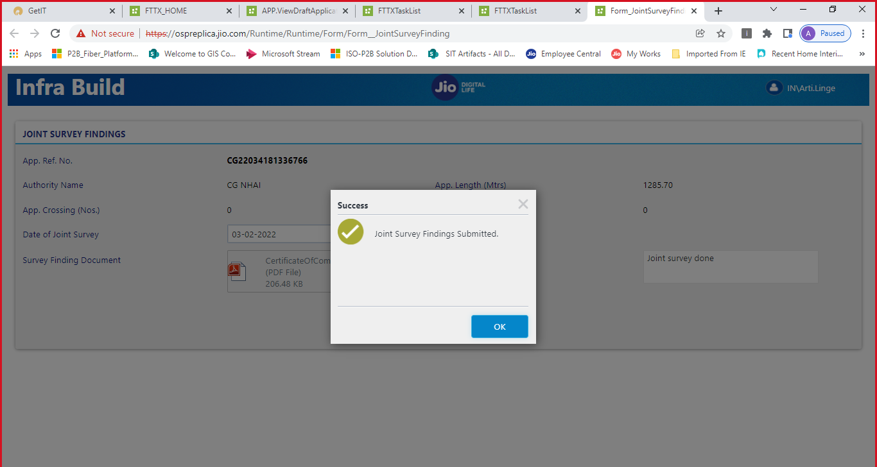
Figure 22: Joint Survey Findings Submitted Successfully

13. Capture Application Processing Fee
The final step in the ROW Application workflow is capturing the Application Processing Fee. This task involves a multi-level approval process.
Approval Workflow:
Workflow | Task Name | System | App Type | Role | Location
ROW Application | Capture Application Processing Fee | K2, GIS | Web | ROW Executive | SHQ
ROW Application | Processing Fee – Approval L1 | K2, GIS | Web | SCO | SHQ
ROW Application | Processing Fee – Approval L2 | K2, GIS | Web | State FC&A | SHQ

Step 1: The ROW Executive captures the Application Processing Fee details.
Step 2: The fee is then sent for Level 1 (L1) Approval to the SCO (State Circle Office).
Step 3: After L1 approval, the fee goes for Level 2 (L2) Approval to the State FC&A (Finance, Costing & Accounts).
Step 4: Once both levels of approval are completed, the processing fee is finalized.
Note: The processing fee approval follows a hierarchical workflow. The ROW Executive initiates the fee capture, the SCO reviews and approves at L1, and the State FC&A provides final approval at L2.

Appendix

A. Glossary
Abbreviation | Description
ROW | Right of Way – Permission required to lay fiber optic cables along public roads/highways
K2 | Workflow management platform used for task routing and approvals
GIS | Geographic Information System – Used for mapping and managing geographic span data
FTTX | Fiber to the X – Generic term for fiber optic network architecture
SPAN | A segment of fiber optic cable between two points
RWS | ROW Span – Unique identifier for span segments
NHAI | National Highways Authority of India
PWD | Public Works Department
DIT | Department of Information Technology
SCO | State Circle Office
FC&A | Finance, Costing & Accounts
MP | Maintenance Point
HDD | Horizontal Directional Drilling – A construction method
UG | Underground – Construction methodology
SHQ | State Headquarters
NLD | National Long Distance – Network type prefix

B. Key System URLs
FTTX Home: https://ospreplica.jio.com/Runtime/Runtime/Form/FTTX__HOME/?
Task List: https://ospreplica.jio.com/Runtime/Runtime/Form/FTTXTaskList/

