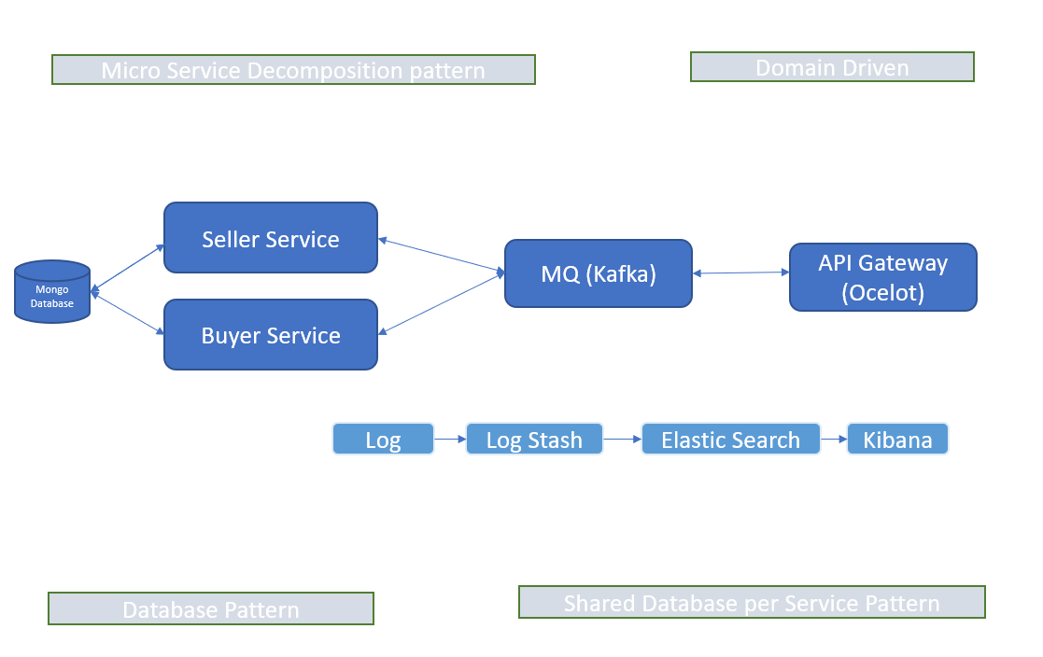
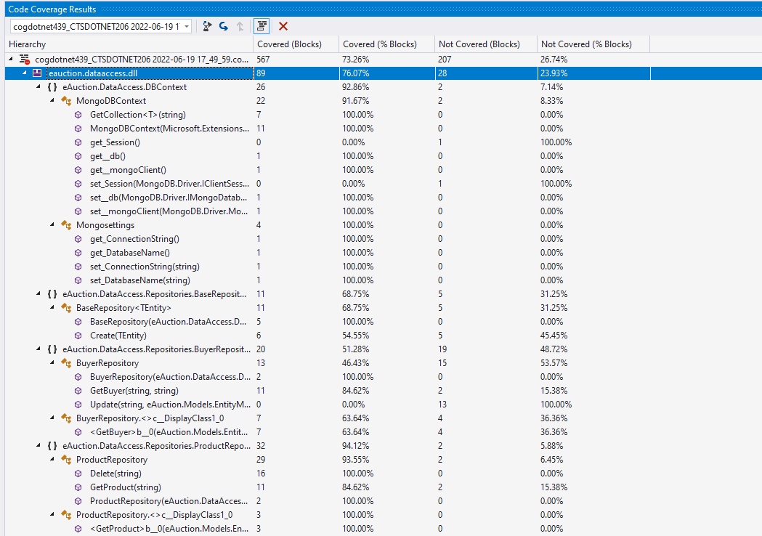
e-Auction Design Document
- Architecture Diagram:

- Rest API Documentation:

- Method: Get
Url: https://localhost:44308/e-auction/api/v1/seller/show-bids/4e6e37e8-6a6f-47f2-9041-673c0d7a04ac?pageNumber=1&pageSize=3&sortBy=BuyerFirstName&FilterBy=100
Response: [
{
"shortDescription": "Diamond Ornament desc",
"detailedDescription": "Diamond Ornament detailed desc",
"category": "Ornament",
"startingPrice": 100,
"bidEndDate": "2022-06-25T04:24:41.297Z",
"bidAmount": 1000,
"buyerFirstName": "Ashaa",
"buyerLastName": "Gangineni",
"city": "Chicago"
},
{
"shortDescription": "Diamond Ornament desc",
"detailedDescription": "Diamond Ornament detailed desc",
"category": "Ornament",
"startingPrice": 100,
"bidEndDate": "2022-06-25T04:24:41.297Z",
"bidAmount": 700,
"buyerFirstName": "Gopi Kiran",
"buyerLastName": "Nuthalapati",
"city": "Dallas"
}
]

- Method: Post
Url: https://localhost:44308/e-auction/api/v1/seller/add-product
Request:
{
"productName": "Oil Painting",
"shortDescription": "Painting desc",
"detailedDescription": "Painting detailed desc",
"category": "Painting",
"startingPrice": 100,
"bidEndDate": "2022-06-27T04:24:41.297Z",
"firstName": "Ajitha",
"lastName": "Gangineni",
"address": "Elden street",
"city": "Toronto",
"state": "ON",
"pin": "L5M6N6",
"phone": "5436783421",
"email": "aj@gmail.com"
}
Response:Product created successfully!!

- Method: Delete
Url: https://localhost:44308/e-auction/api/v1/seller/delete/530c0e62-6161-4148-abff-b9697a1266d0
Response: Deleted Successfully!!

- Method: Post
Url: https://localhost:44308/e-auction/api/v1/buyer/place-bid
Request:
{
"firstName": "Gopi Kiran",
"lastName": "Nuthalapati",
"address": "Yong Street",
"city": "Dallas",
"state": "TX",
"pin": "50080",
"phone": "4235212353",
"email": "gk@gmail.com",
"productId": "4e6e37e8-6a6f-47f2-9041-673c0d7a04ac",
"bidAmount": 700
}
Response: Bid data is processing.

- Method: Post
Url: https://localhost:44308/e-auction/api/v1/buyer/update-bid/4e6e37e8-6a6f-47f2-9041-673c0d7a04ac/an@gmail.com/1000
Response:Bid Data updated Successfully!!

- Code Coverage Report:

