**Cognizant Deep Skilling - Digital Nurture 4.0**

**9. ReactJS-HOL**

**Open Command Prompt**

npx create-react-app cricketapp

cd cricketapp

npm start

**ListofPlayers.js**

import React from 'react';

const ListofPlayers = () => {

  const players = [

    { name: 'Virat', score: 80 },

    { name: 'Rohit', score: 65 },

    { name: 'Rahul', score: 90 },

    { name: 'Dhoni', score: 50 },

    { name: 'Hardik', score: 75 },

    { name: 'Shami', score: 60 },

    { name: 'Bumrah', score: 85 },

    { name: 'Jadeja', score: 70 },

    { name: 'Ashwin', score: 55 },

    { name: 'Pant', score: 45 },

    { name: 'Gill', score: 95 },

  ];

  const playerList = players.map((player, index) => (

    <li key={index}>{player.name} - {player.score}</li>

  ));

  const below70 = players.filter(player => player.score < 70);

  return (

    <div>

      <h2>All Players</h2>

      <ul>{playerList}</ul>

      <h2>Players with Score below 70</h2>

      <ul>

        {below70.map((player, index) => (

          <li key={index}>{player.name} - {player.score}</li>

        ))}

      </ul>

    </div>

  );

};

export default ListofPlayers;

**IndianPlayers.js**

import React from 'react';

const IndianPlayers = () => {

  const oddTeam = ['Virat', 'Rahul', 'Hardik', 'Jadeja', 'Gill'];

  const evenTeam = ['Rohit', 'Dhoni', 'Shami', 'Bumrah', 'Pant', 'Ashwin'];

  const [captain, viceCaptain, ...restOdd] = oddTeam;

  const [keeper, bowler, ...restEven] = evenTeam;

  const T20players = ['Kohli', 'Rohit'];

  const RanjiTrophy = ['Prithvi', 'Pujara'];

  const mergedPlayers = [...T20players, ...RanjiTrophy];

  return (

    <div>

      <h2>Odd Team</h2>

      <p>Captain: {captain}</p>

      <p>Vice Captain: {viceCaptain}</p>

      <ul>{restOdd.map((p, i) => <li key={i}>{p}</li>)}</ul>

      <h2>Even Team</h2>

      <p>Keeper: {keeper}</p>

      <p>Bowler: {bowler}</p>

      <ul>{restEven.map((p, i) => <li key={i}>{p}</li>)}</ul>

      <h2>Merged Players</h2>

      <ul>{mergedPlayers.map((p, i) => <li key={i}>{p}</li>)}</ul>

    </div>

  );

};

export default IndianPlayers;

**App.js**

import React from 'react';

import ListofPlayers from './ListofPlayers';

import IndianPlayers from './IndianPlayers';

function App() {

  const flag = false;

  return (

    <div className="App">

      <h1>Cricket App</h1>

      {flag ? <ListofPlayers /> : <IndianPlayers />}

    </div>

  );

}

export default App;

Output

**When flage=true**

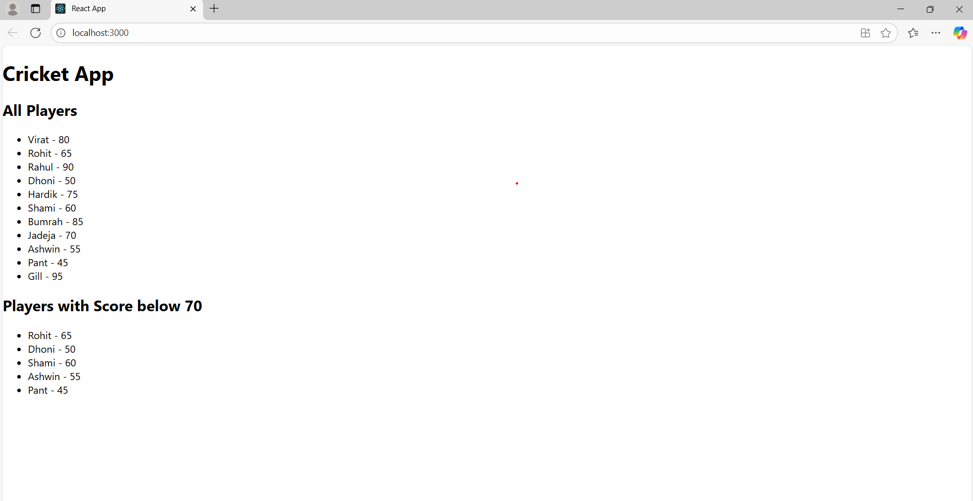

**When flag=false**

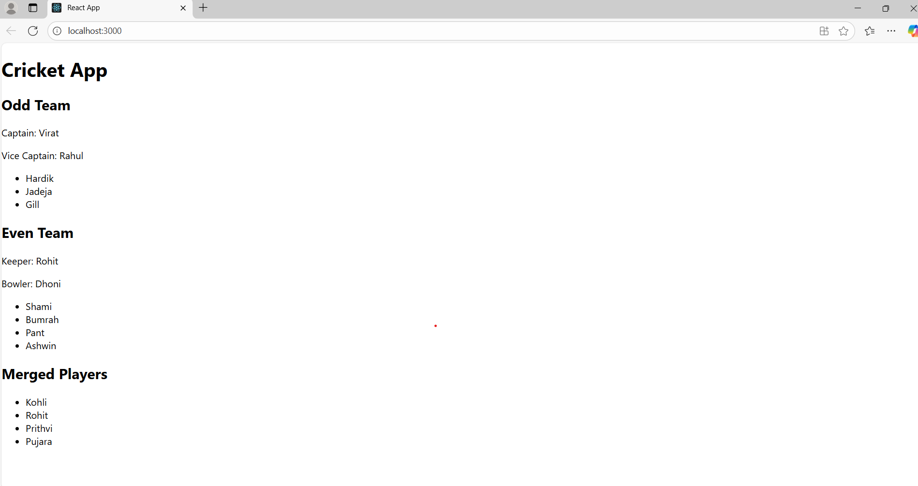

**10. ReactJS-HOL**

**Open Command Prompt**

npx create-react-app officespacerentalapp

cd officespacerentalapp

npm start

**App.js**

import React from 'react';

import officeImage from './office1.jpg';

function App() {

  const heading = <h1>Office Space Rental Listings</h1>;

 const office1 = {

    name: 'Skyline Workspace',

    rent: 55000,

    address: '100 MG Road, Chennai',

  };

  const officeList = [

    { name: 'Skyline Workspace', rent: 55000, address: 'MG Road, Chennai' },

    { name: 'Green Office Hub', rent: 62000, address: 'Anna Nagar, Chennai' },

    { name: 'TechSpace', rent: 58000, address: 'T Nagar, Chennai' },

    { name: 'Elite Tower', rent: 75000, address: 'Adyar, Chennai' },

  ];

  const rentStyle = (rent) => ({

    color: rent < 60000 ? 'red' : 'green',

    fontWeight: 'bold',

  });

  return (

    <div style={{ textAlign: 'center', fontFamily: 'Arial' }}>

      {heading}

      <img src={officeImage} alt="Office Space" style={{ width: '400px', margin: '20px auto' }} />

      <div style={{ marginTop: '20px' }}>

        <h2>{office1.name}</h2>

        <p style={rentStyle(office1.rent)}>Rent: ₹{office1.rent}</p>

        <p>Address: {office1.address}</p>

      </div>

      <h2>Available Offices</h2>

      {officeList.map((office, index) => (

        <div key={index} style={{ border: '1px solid gray', margin: '10px', padding: '10px' }}>

          <h3>{office.name}</h3>

          <p style={rentStyle(office.rent)}>Rent: ₹{office.rent}</p>

          <p>Address: {office.address}</p>

        </div>

      ))}

    </div>

  );

}

export default App;

**Output:**

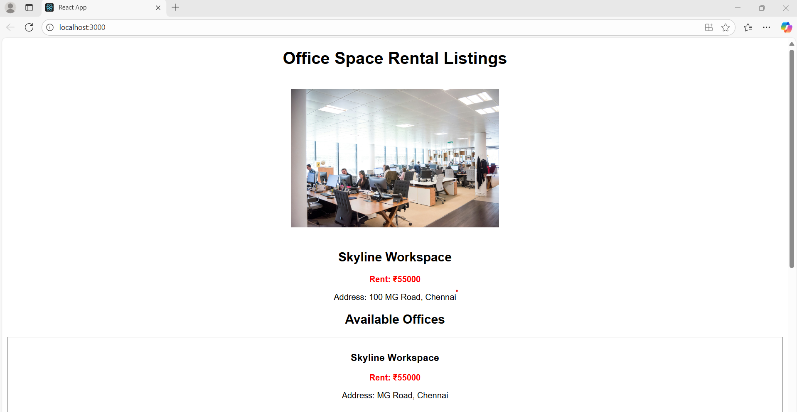

**11. ReactJS-HOL**

**Open Command Prompt:**

npx create-react-app eventexamplesapp

cd eventexamplesapp

npm start

**App.js**

import React, { Component } from 'react';

import CurrencyConvertor from './CurrencyConvertor';

class App extends Component {

  constructor(props) {

    super(props);

    this.state = {

      count: 0,

    };

  }

  increment = () => {

    this.setState(prevState => ({ count: prevState.count + 1 }));

  };

  sayHello = () => {

    alert("Hello! This is a static message.");

  };

  handleIncrease = () => {

    this.increment();

    this.sayHello();

  };

  decrement = () => {

    this.setState(prevState => ({ count: prevState.count - 1 }));

  };

  sayWelcome = (msg) => {

    alert(msg);

  };

  handleClick = (e) => {

    alert("I was clicked");

    console.log("Synthetic Event:", e);

  };

  render() {

    return (

      <div style={{ textAlign: 'center', fontFamily: 'Arial' }}>

        <h1>React Event Handling Examples</h1>

        <h2>Counter: {this.state.count}</h2>

        <button onClick={this.handleIncrease}>Increment</button>

        <button onClick={this.decrement}>Decrement</button>

        <br /><br />

        <button onClick={() => this.sayWelcome("Welcome to React Events!")}>Say Welcome</button>

        <br /><br />

        <button onClick={this.handleClick}>OnPress (Synthetic Event)</button>

        <br /><br />

        <CurrencyConvertor />

      </div>

    );

  }

}

export default App;

**CurrencyConvertor.js**

import React, { Component } from 'react';

class CurrencyConvertor extends Component {

  constructor(props) {

    super(props);

    this.state = {

      inr: '',

      euro: '',

    };

  }

  handleChange = (event) => {

    this.setState({ inr: event.target.value });

  };

  handleSubmit = () => {

    const inr = parseFloat(this.state.inr);

    const euro = (inr / 90).toFixed(2);

    this.setState({ euro });

  };

  render() {

    return (

      <div style={{ marginTop: '30px' }}>

        <h2>Currency Convertor (INR → Euro)</h2>

        <input

          type="number"

          placeholder="Enter amount in INR"

          value={this.state.inr}

          onChange={this.handleChange}

        />

        <button onClick={this.handleSubmit}>Convert</button>

        {this.state.euro && (

          <p>{this.state.inr} INR = {this.state.euro} Euro</p>

        )}

      </div>

    );

  }

}

export default CurrencyConvertor;

**Output**

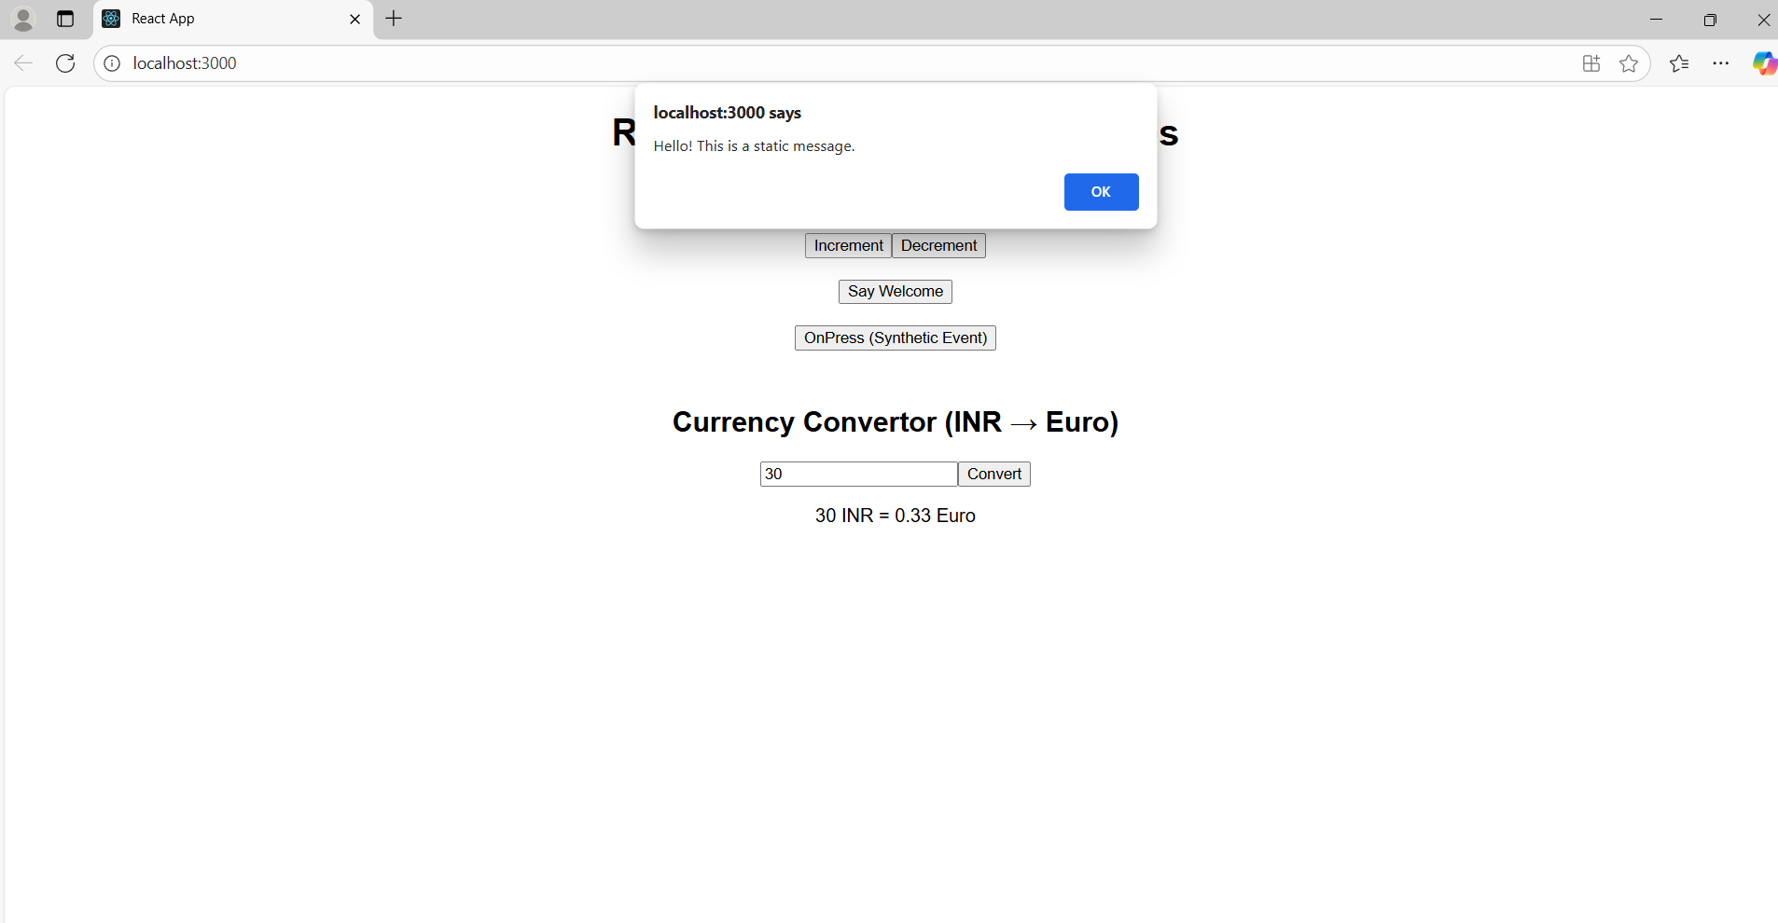

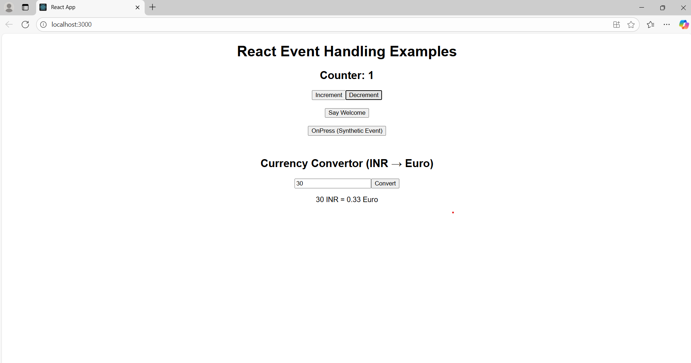

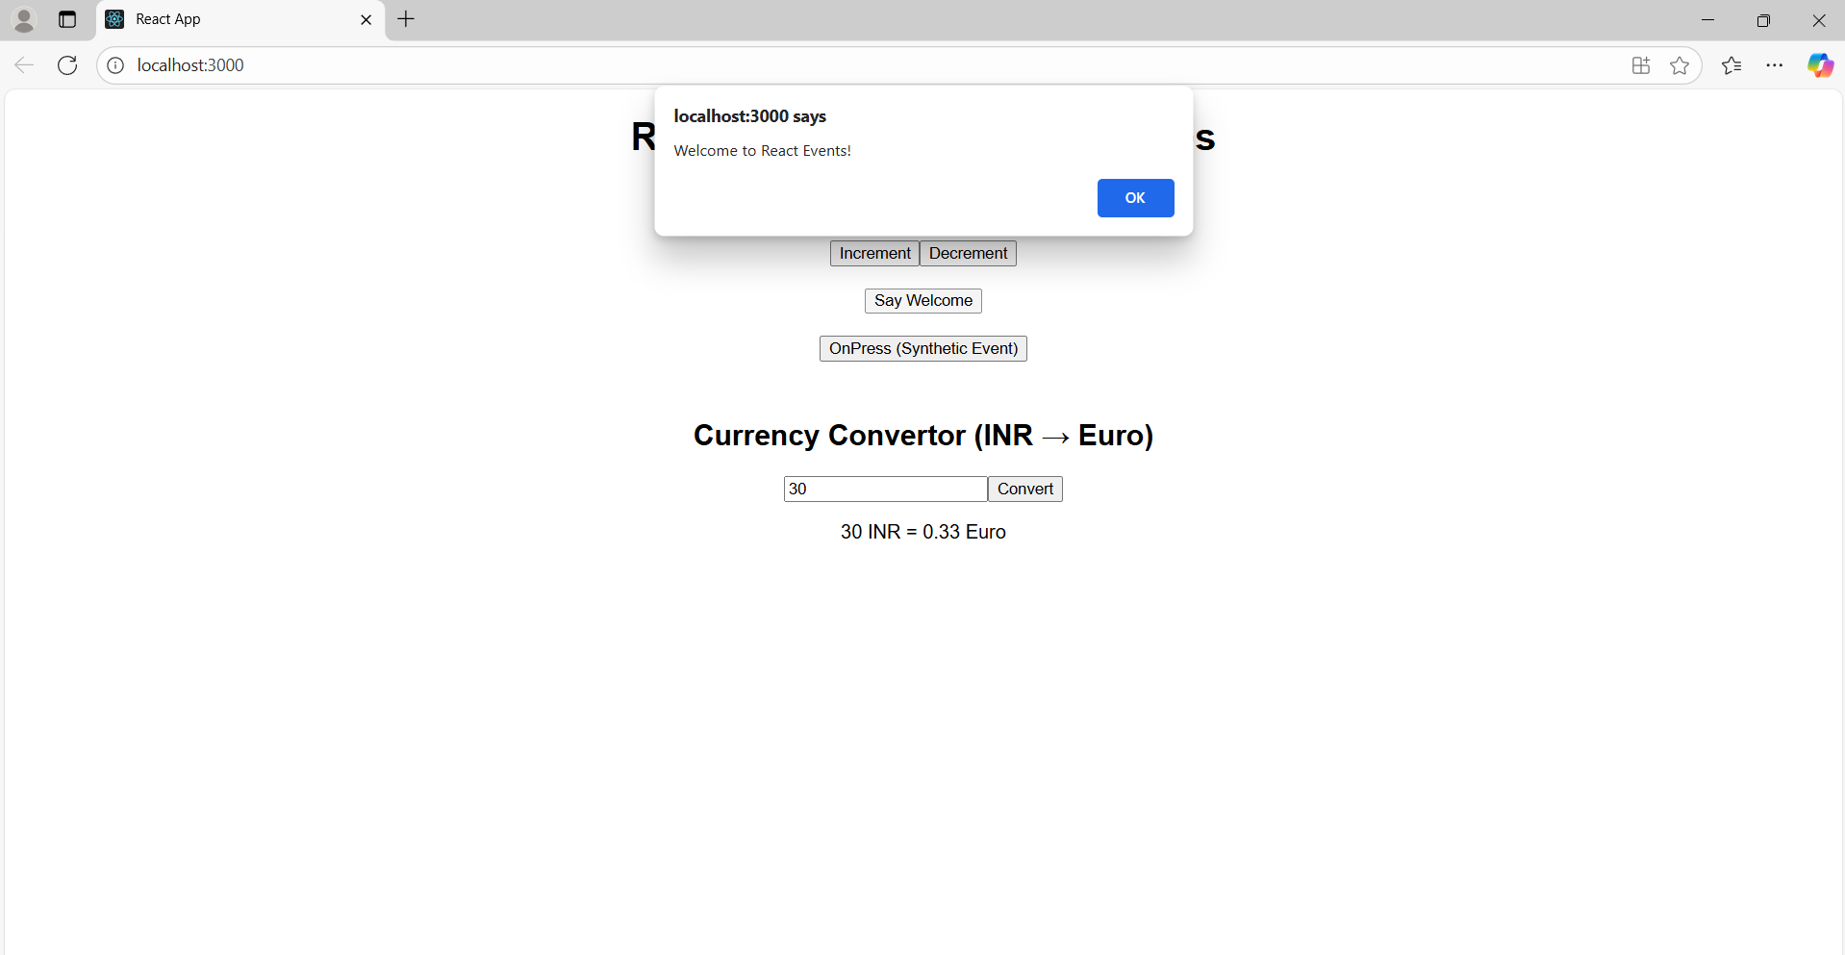

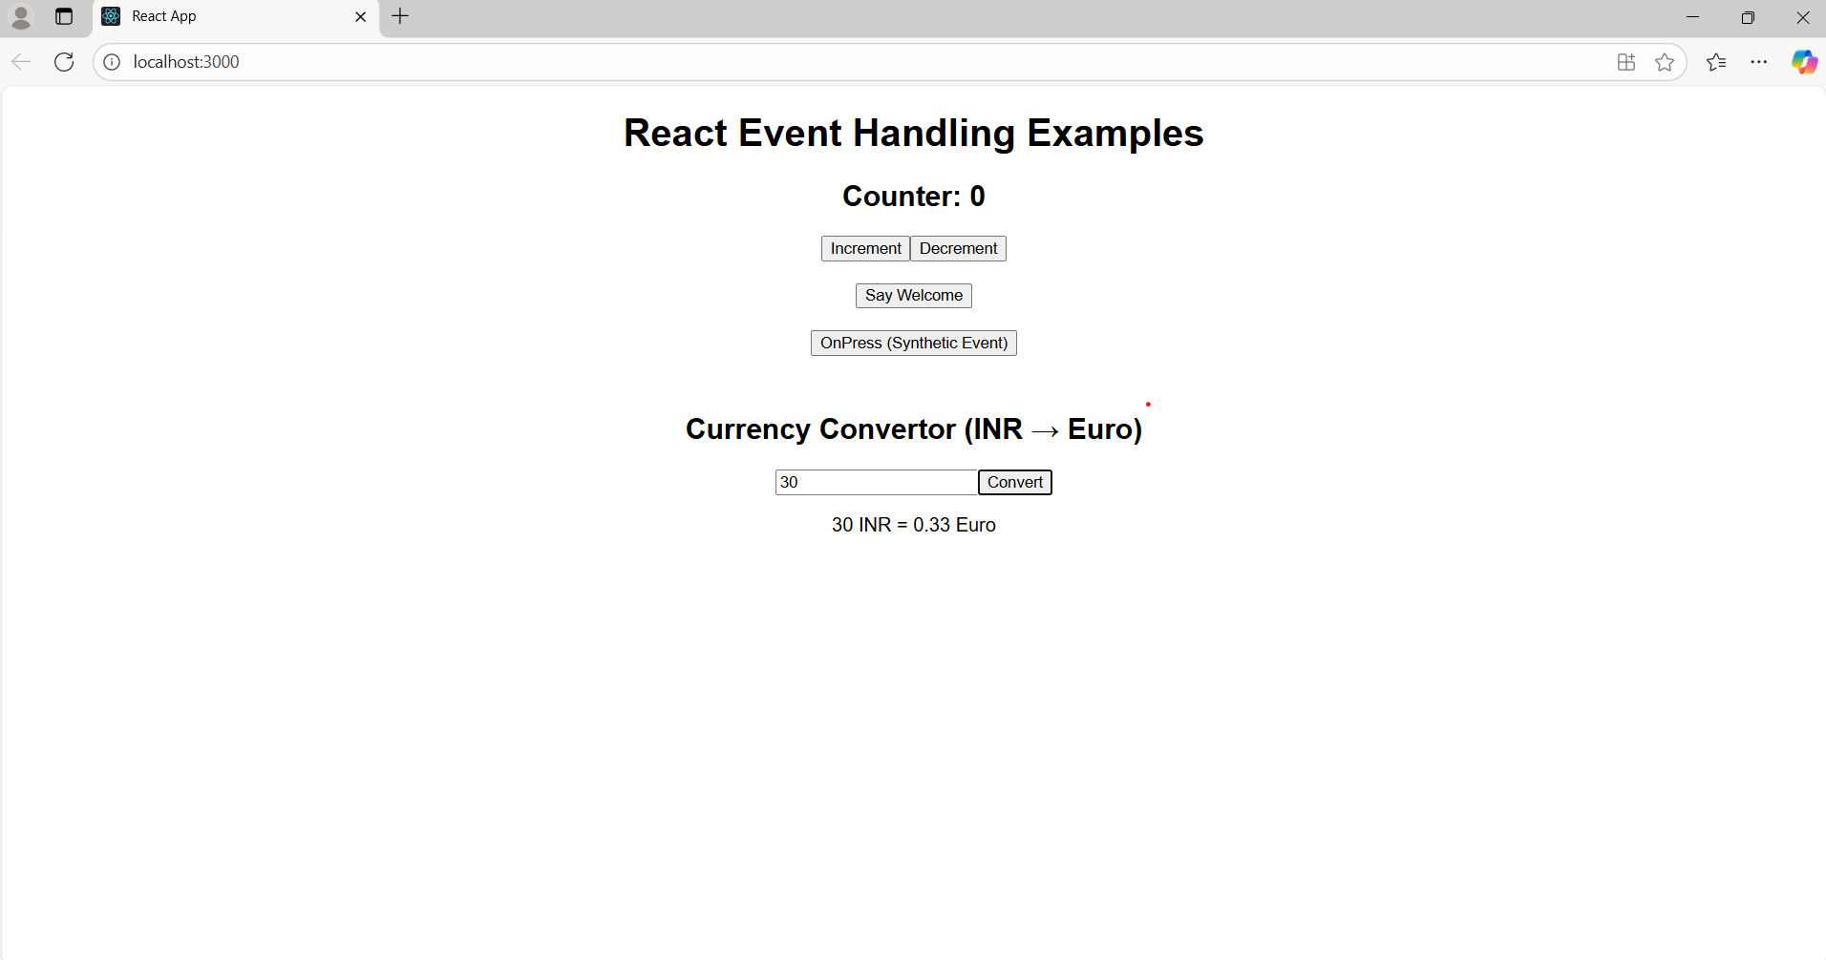

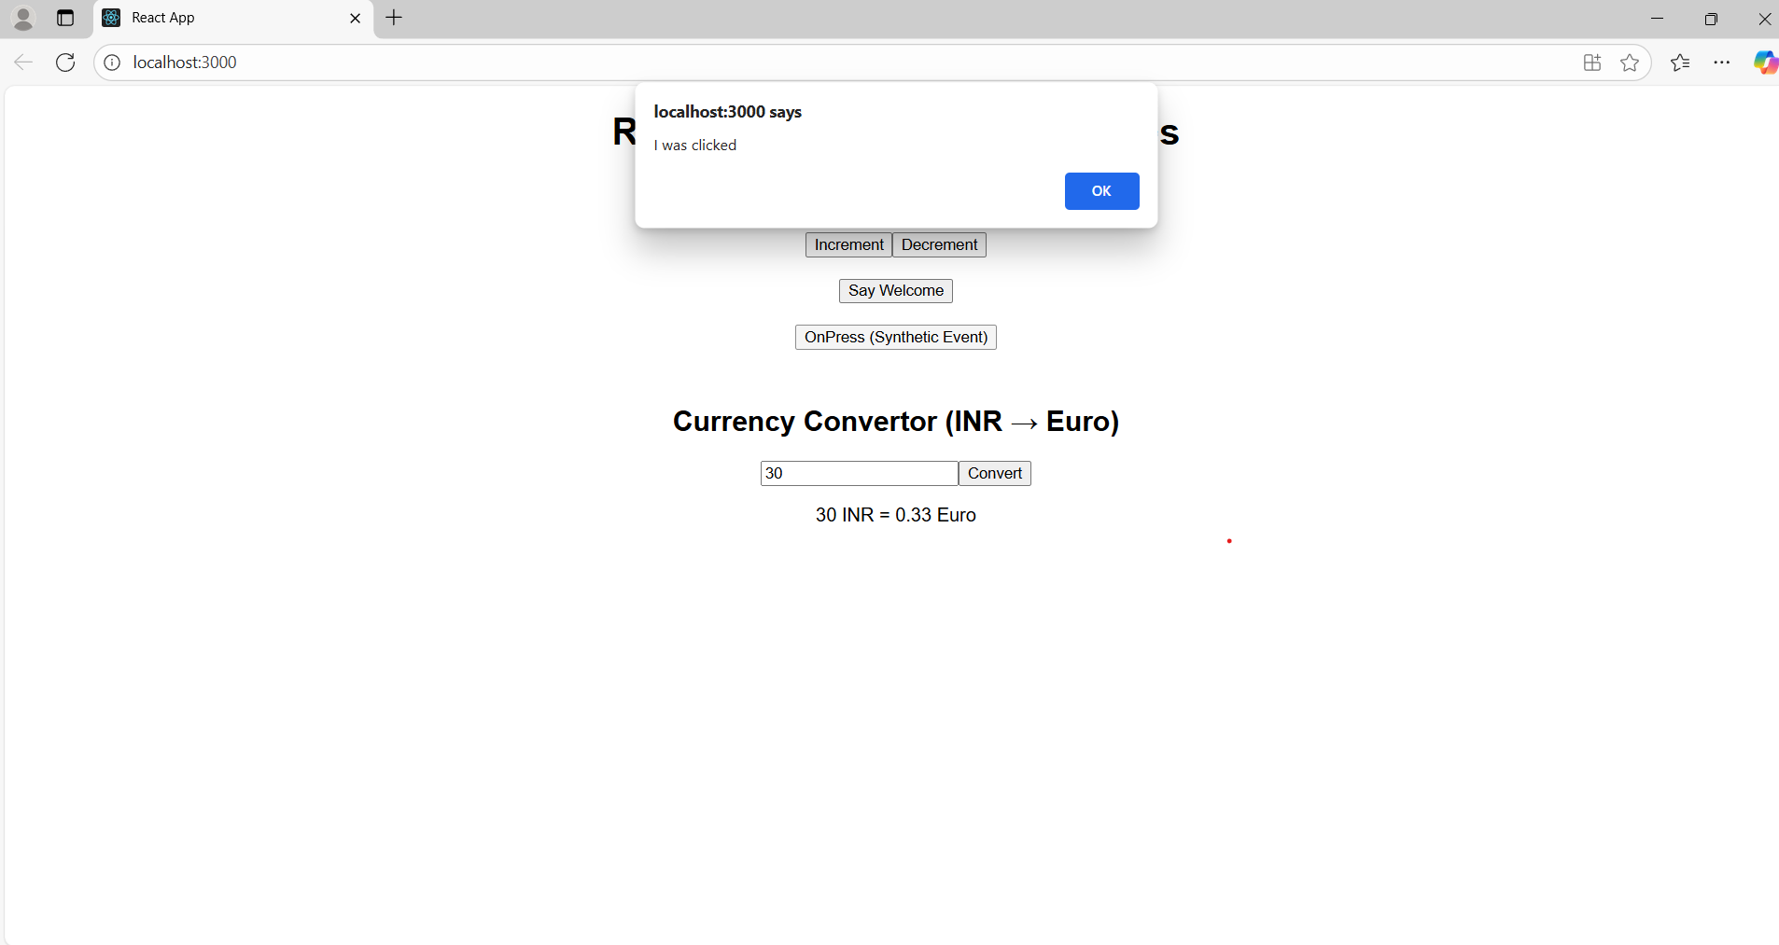

**12. ReactJS-HOL**

**Open Command Prompt:**

npx create-react-app ticketbookingapp

cd ticketbookingapp

npm start

**GuestPage.js**

import React from 'react';

const GuestPage = () => {

return (

<div className="page guest">

<h2>Welcome Guest</h2>

<p>You can browse available flights below:</p>

</div>

);

};

export default GuestPage;

**UserPage.js**

import React from 'react';

const UserPage = () => {

return (

<div className="page user">

<h2>Welcome User</h2>

<p>You can book your flight now!</p>

<button className="book-btn">Book Ticket</button>

</div>

);

};

export default UserPage;

**FlightDetails.js**

import React from 'react';

const FlightDetails = () => {

return (

<div className="flight-details">

<h3>Available Flights</h3>

<ul>

<li> Chennai ➜ Delhi — ₹4500</li>

<li> Bangalore ➜ Mumbai — ₹3900</li>

<li>Coimbatore ➜ Hyderabad — ₹3500</li>

</ul>

</div>

);

};

export default FlightDetails;

**Output:**

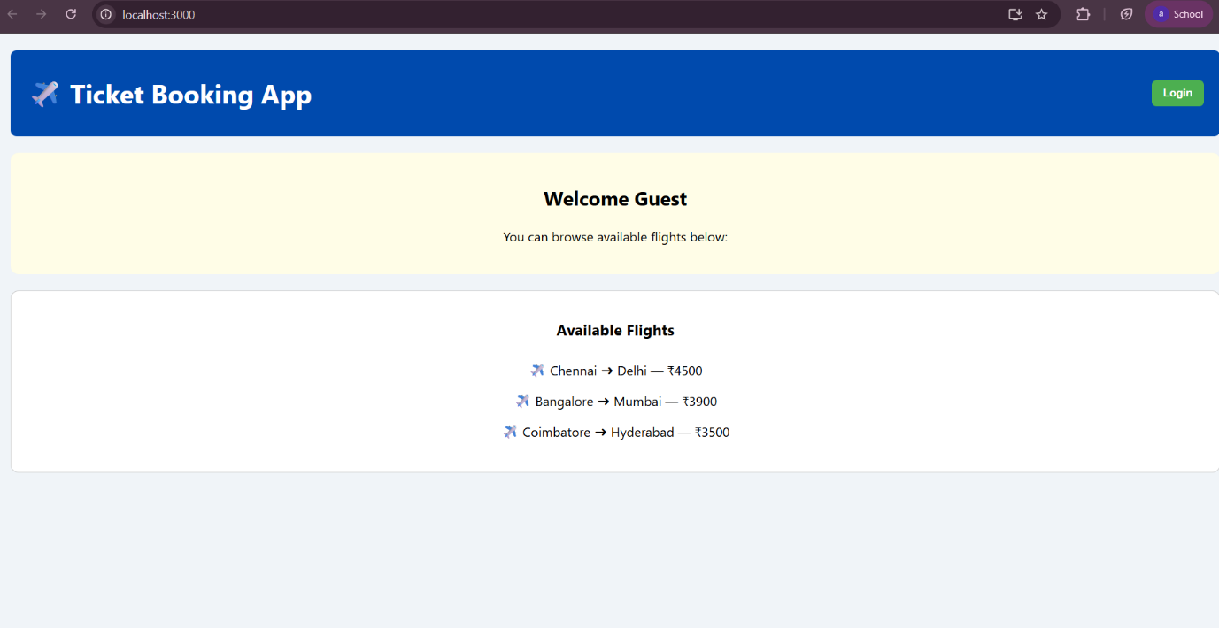

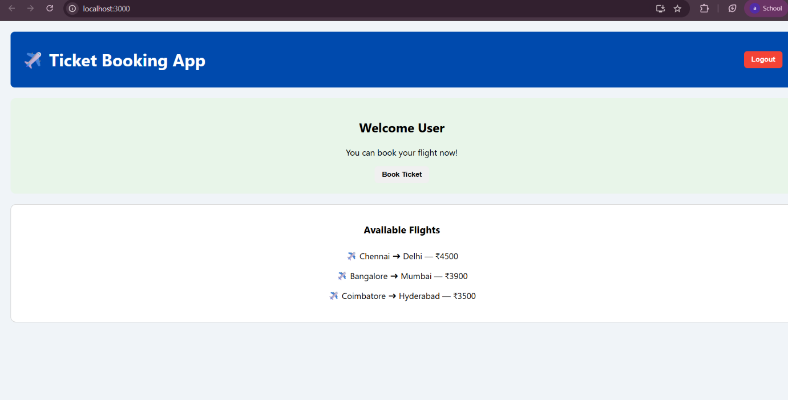

**13.ReactJS-HOL**

**Open Command Prompt:**

npx create-react-app bloggerapp

cd bloggerapp

npm start

**BookDetails.js**

import React from "react";

function BookDetails({ books }) {

return (

<div>

<h2>📚Book Details</h2>

<ul>

{books.map((book, index) => (

<li key={index}>

<b>{book.title}</b> by {book.author}

</li>

))}

</ul>

</div>

);

}

export default BookDetails;

**BlogDetails.js**

import React from "react";

function BlogDetails({ blogs }) {

return (

<div>

<h2> 📝Blog Details</h2>

<ul>

{blogs.map((blog, index) => (

<li key={index}>

<b>{blog.title}</b> - {blog.category}

</li>

))}

</ul>

</div>

);

}

export default BlogDetails;

**CourseDetails.js**

import React from "react";

function CourseDetails({ courses }) {

return (

<div>

<h2>🎓 Course Details</h2>

<ul>

{courses.map((course, index) => (

<li key={index}>

<b>{course.name}</b> - {course.duration}

</li>

))}

</ul>

</div>

);

}

export default CourseDetails;

**App.js**

import React, { useState } from "react";

import BookDetails from "./ BookDetails";

import BlogDetails from "./ BlogDetails";

import CourseDetails from ". /CourseDetails";

function App() {

const [view, setView] = useState("book");

const books = [

{ title: "React Explained", author: "Zac Gordon" },

{ title: "Learning React", author: "Alex Banks" },

];

const blogs = [

{ title: "React Performance", category: "Tech" },

{ title: "JSX Deep Dive", category: "Programming" },

];

const courses = [

{ name: "React Basics", duration: "4 weeks" },

{ name: "Advanced React", duration: "6 weeks" },

];

return (

<div style={{ textAlign: "center", padding: "30px" }}>

<h1>Blogger App</h1>

<div>

<button onClick={() => setView("book")}>Book View</button>

<button onClick={() => setView("blog")}>Blog View</button>

<button onClick={() => setView("course")}>Course View</button>

</div>

<hr />

{view === "book" ? (

<BookDetails books={books} />

) : view === "blog" ? (

<BlogDetails blogs={blogs} />

) : (

<CourseDetails courses={courses} />

)}

{/* {view === "book" && <BookDetails books={books} />} */}

</div>

);

}

export default App;

**Output:**

