**Exercise No 5**: **Information gathering using theHarvester Aim:** To demonstrate information gathering using theHarvester

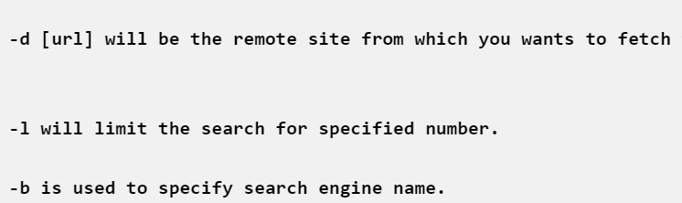Procedure:

STEP 1: Open Terminal in the kali linux STEP 2: Run the following command

**Command: theHarvester -d** arms.sse.saveetha.com**-l 300 -b all**

S.Ajith kumar 192011004

Step 4: run this command “theHarvester -d arms.sse.saveetha.com -l 300 -b all -f test” and hit enter to export the result as html file and xml file

Step 5: now close the terminal and navigate the home folder and search

OUTPUT

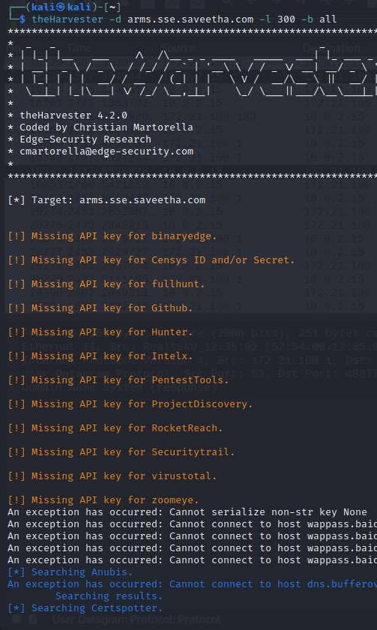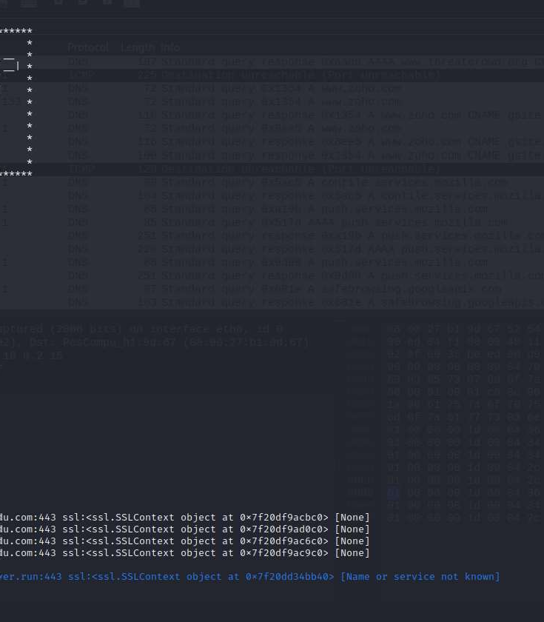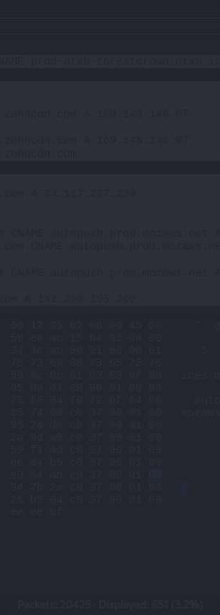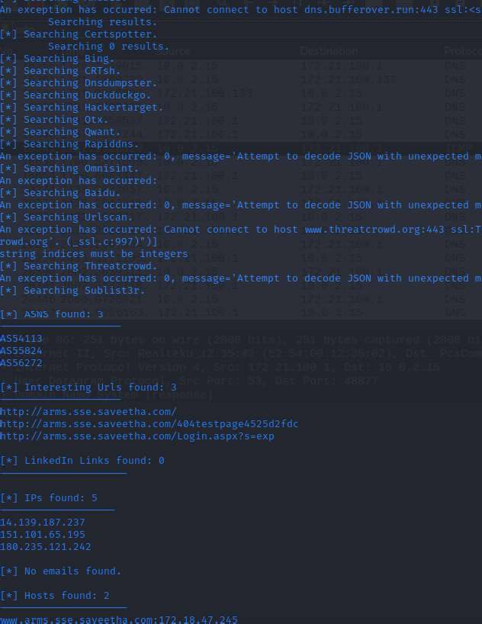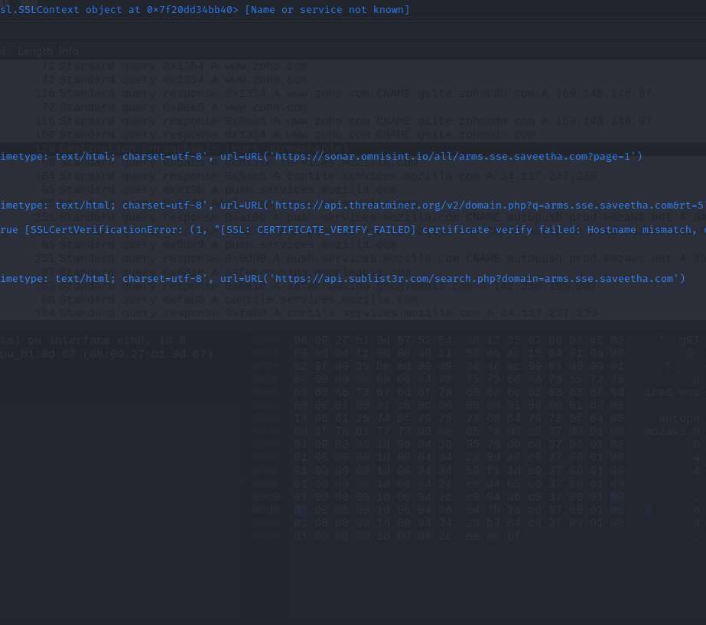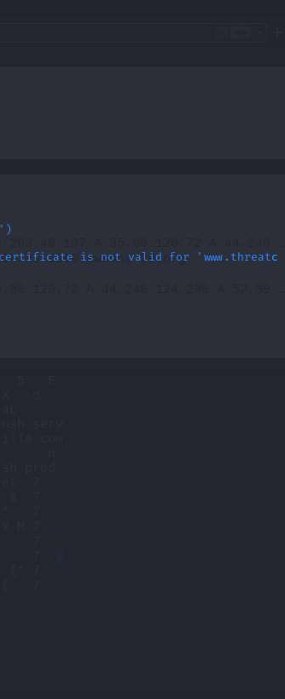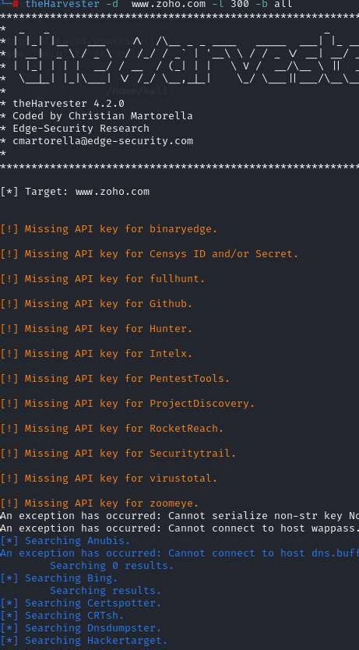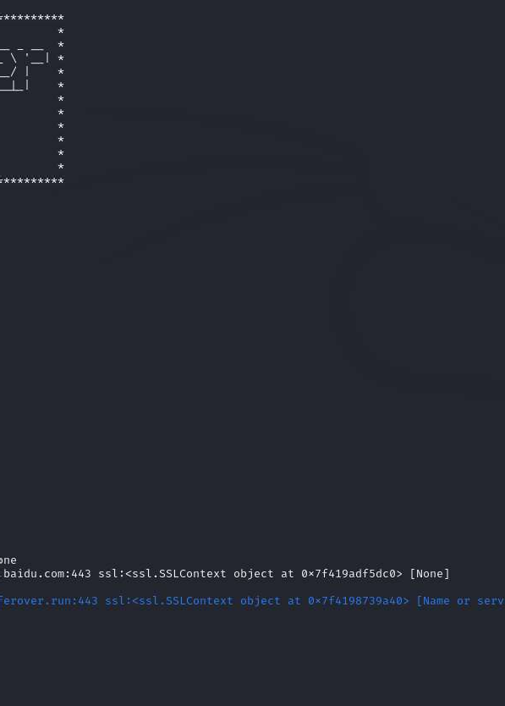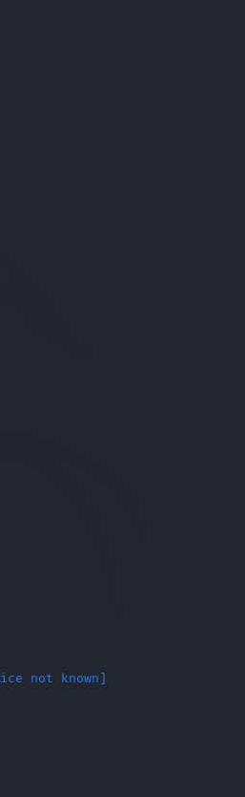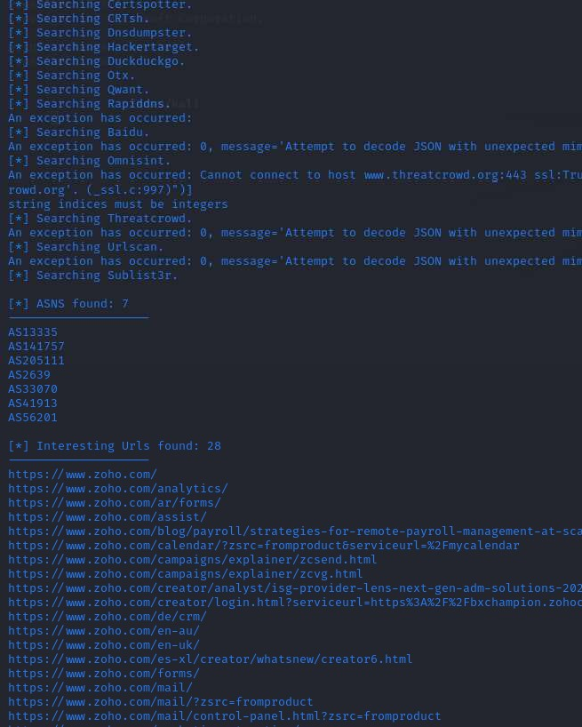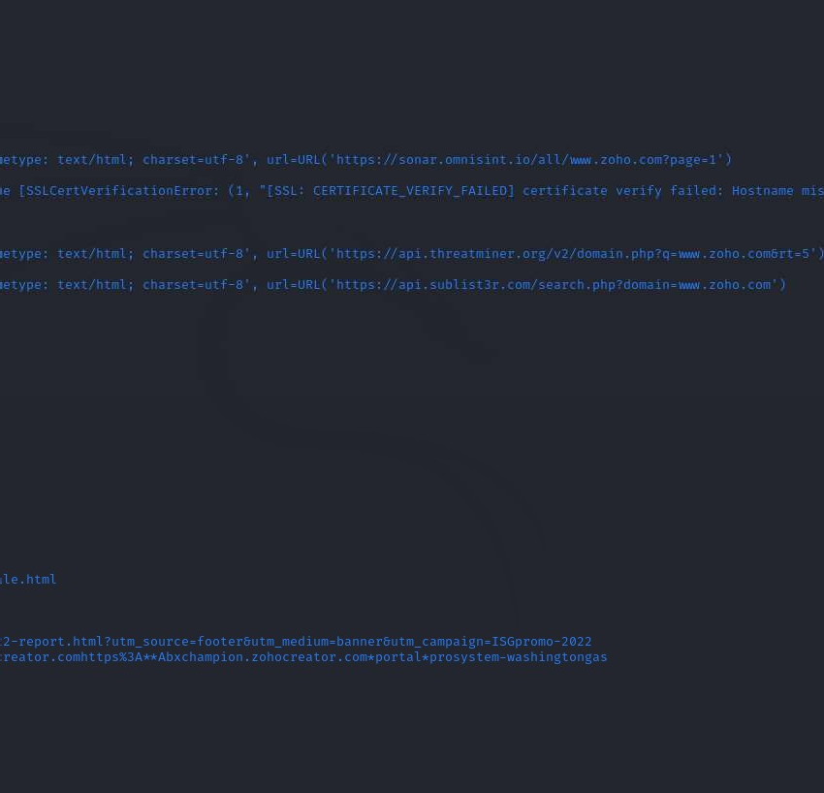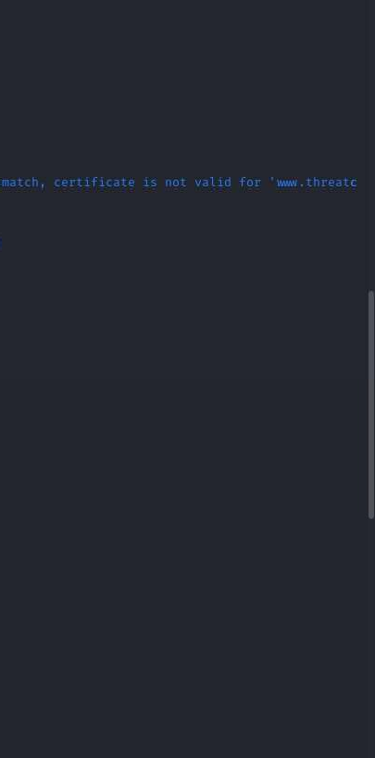

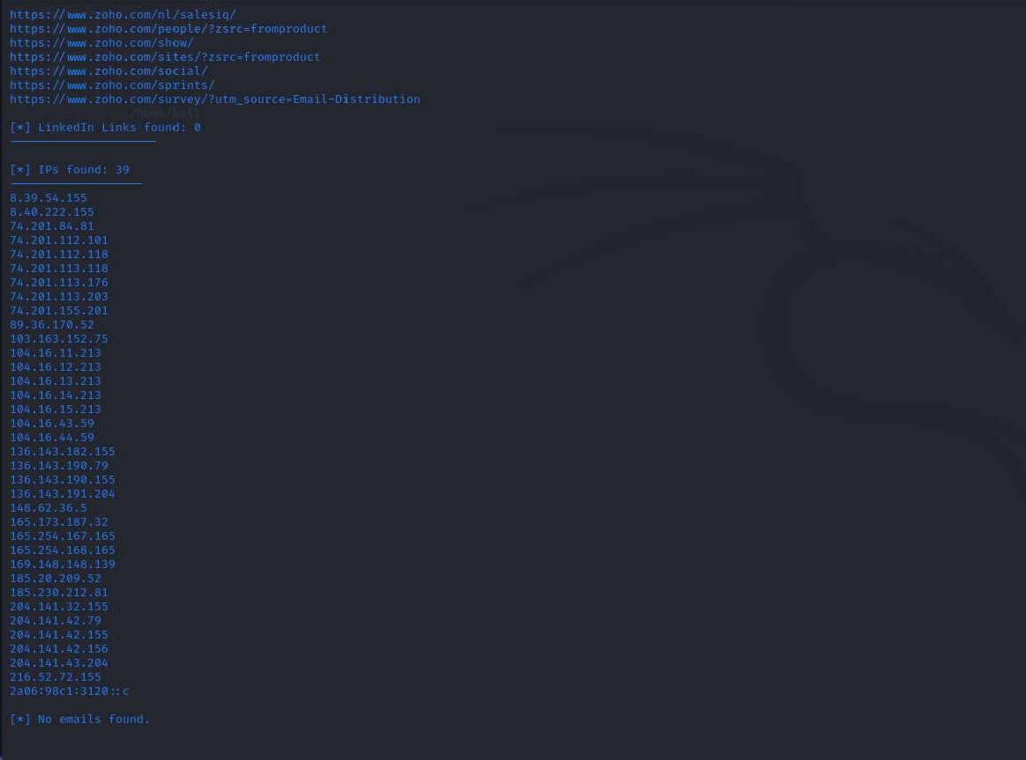

**Result**

Information gathering using theHarvester is performed successfully.