SIMATS ENGINEERING
ASSESSMENT TOOL 3 – Assignment 2

COURSE NAME: STATISTICS WITH R PROGRAMMING COURSE CODE: ITA04

COURSE OUTCOME COVERED

CO3: Construct and manipulate data frames using reshaping, merging, and file I/O operations in R to prepare structured datasets for analysis.. (BL3, BL5)

Assessment Tool Weightage: 20%

QUESTIONS: 5 Total Marks: 100

Annexure

Assignment 2

Code of Conduct:

I AJITH KUMAR V/192421049_ (Name / Reg No) certify that this submission is my original work and that I have adhered to the guidelines specified for this assessment.
I understand that any violation of academic integrity rules will result in disciplinary action.

Signature of the student:

Assignment 2:
- Generate 5 Questions for your Capstone Project module
- Apply the formulae and use the relevant graph to visualize it
- Upload the file in Github link
- Save the 5 Questions and Gihub link in the Excell sheet
Smart Electricity Consumption Analysis and Prediction Using R
Module 1: Data Collection and Preprocessing - Questions, Formulas and R Code

Dataset Used
The project uses hourly electricity consumption data stored in the file electricity_consumption_data.csv (smart meter data from 1 January 2025 onward). The figures below are taken from the Module 1 slides and are used in all five questions.
Item | Value
Rows in raw file | 8,775
Duplicate rows | 15
Records collected (8,775 - 15) | 8,760
Missing values | 214
Incorrect values | 37
Clean records | 8,509

Packages and setup used in RStudio for all the graphs:
install.packages(c("ggplot2", "scales")) # run once
library(ggplot2)
library(scales)

df <- read.csv("electricity_consumption_data.csv") # dataset file

Question 1
Question: How many missing values were there in each column before cleaning, and how many remained after cleaning?

Formulas used
Missing values in a column = sum(is.na(column))
Total missing values = 120 + 54 + 25 + 10 + 5 = 214
Missing values after cleaning = 0 (rows with NA removed using na.omit)

R code
# number of missing values in every column of the raw data
colSums(is.na(df))

# values used in the graph
cols <- c("Units (kWh)", "Voltage", "Time", "Date", "Meter ID")
q1 <- data.frame(
Column = factor(rep(cols, 2), levels = cols),
Stage = factor(rep(c("Before cleaning", "After cleaning"), each = 5),
levels = c("Before cleaning", "After cleaning")),
Missing = c(120, 54, 25, 10, 5, 0, 0, 0, 0, 0)
)

ggplot(q1, aes(x = Column, y = Missing, fill = Stage)) +
geom_col(position = position_dodge(width = 0.8), width = 0.7, colour = "black") +
geom_text(aes(label = Missing), position = position_dodge(width = 0.8), vjust = -0.5) +
scale_fill_manual(values = c("Before cleaning" = "grey35", "After cleaning" = "white")) +
scale_y_continuous(limits = c(0, 140)) +
labs(title = "Missing values by column: before and after cleaning",
x = NULL, y = "Missing values") +
theme_classic(base_size = 12) +
theme(legend.title = element_blank())

Graph
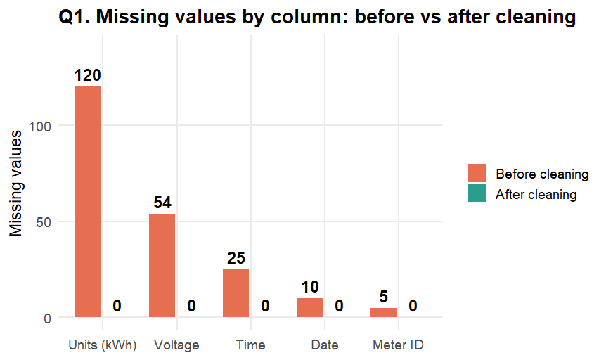
Figure 1: Missing values by column before and after cleaning

Question 2
Question: What share of the 8,760 records came from each data source?

Formulas used
Share of a source (%) = (records from that source / total records) x 100
Smart meter = 4,818 / 8,760 x 100 = 55%
Utility billing = 2,190 / 8,760 x 100 = 25%
Public CSV = 1,752 / 8,760 x 100 = 20%

R code
# percentage share of each source
source_count <- c(4818, 2190, 1752)
source_pct <- source_count / sum(source_count) * 100
round(source_pct, 1)

q2 <- data.frame(
Source = c("Smart meter readings", "Utility billing records", "Public CSV dataset"),
Records = source_count
)
q2$Label <- paste0(q2$Source, ": ", comma(q2$Records))
q2$Label <- factor(q2$Label, levels = q2$Label)

ggplot(q2, aes(x = 2, y = Records, fill = Label)) +
geom_col(width = 1, colour = "black") +
geom_text(aes(label = paste0(round(Records / sum(Records) * 100), "%")),
position = position_stack(vjust = 0.5),
colour = c("white", "black", "black"), size = 5) +
coord_polar(theta = "y") +
xlim(0.5, 2.5) +
annotate("text", x = 0.5, y = 0, label = "8,760\nrecords", size = 5) +
scale_fill_manual(values = c("grey25", "grey60", "grey88")) +
labs(title = "Share of records by data source") +
theme_void(base_size = 12) +
theme(legend.title = element_blank(), legend.position = "bottom",
legend.direction = "vertical")

Graph
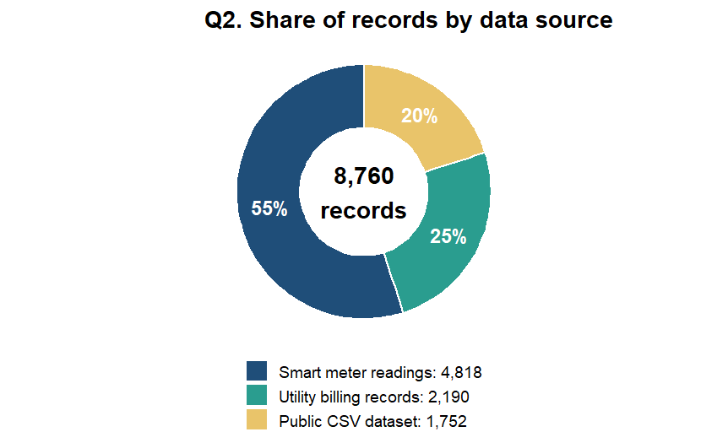
Figure 2: Share of records by data source

Question 3
Question: Which columns account for most of the missing values?

Formulas used
Share of a column (%) = (missing in that column / total missing) x 100
Cumulative % = running total of the shares, columns arranged from largest to smallest
Units (kWh) = 120 / 214 x 100 = 56.07%
Voltage = 54 / 214 x 100 = 25.23% (cumulative 81.31%)
Time = 25 / 214 x 100 = 11.68% (cumulative 92.99%)
Date = 10 / 214 x 100 = 4.67% (cumulative 97.66%)
Meter ID = 5 / 214 x 100 = 2.34% (cumulative 100%)

R code
# share and cumulative share of missing values
cols <- c("Units (kWh)", "Voltage", "Time", "Date", "Meter ID")
missing <- c(120, 54, 25, 10, 5)

share <- missing / sum(missing) * 100
cumpct <- cumsum(share)
round(share, 2)
round(cumpct, 2)

q3 <- data.frame(Column = factor(cols, levels = cols),
Missing = missing, CumPct = cumpct)
k <- max(q3$Missing) / 100 # scale factor for the second axis

ggplot(q3, aes(x = Column)) +
geom_col(aes(y = Missing), fill = "grey60", colour = "black", width = 0.7) +
geom_text(aes(y = Missing, label = Missing), vjust = -0.5) +
geom_line(aes(y = CumPct * k, group = 1), colour = "black", linewidth = 1) +
geom_point(aes(y = CumPct * k), colour = "black", size = 2.5) +
geom_text(aes(y = CumPct * k, label = paste0(round(CumPct), "%")), vjust = -1) +
scale_y_continuous(name = "Missing values", limits = c(0, 140),
sec.axis = sec_axis(~ . / k, name = "Cumulative % of missing values")) +
labs(title = "Pareto chart of missing values", x = NULL) +
theme_classic(base_size = 12)

Graph
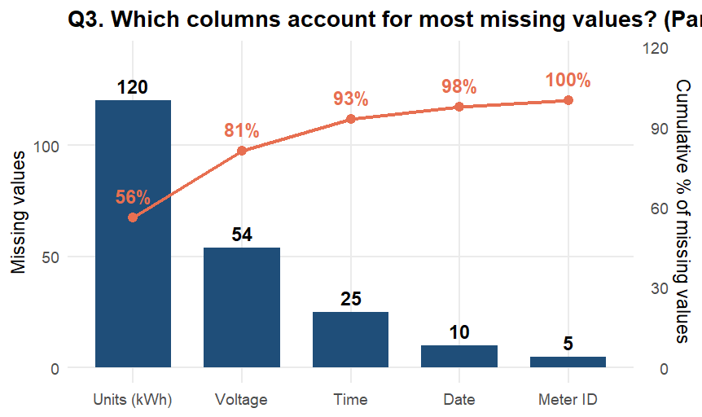
Figure 3: Pareto chart of missing values by column

Question 4
Question: How many records remain after moving from the raw data to the clean dataset?

Formulas used
Records collected = raw rows - duplicate rows = 8,775 - 15 = 8,760
Clean records = records collected - missing - incorrect = 8,760 - 214 - 37 = 8,509
Retention (%) = clean records / records collected x 100 = 8,509 / 8,760 x 100 = 97.13%
Data lost (%) = 100 - 97.13 = 2.87%

R code
# record count at each stage
raw <- 8775
duplicates <- 15
missing <- 214
incorrect <- 37

collected <- raw - duplicates # 8760
clean <- collected - missing - incorrect # 8509
retention <- clean / collected * 100 # 97.13
loss <- 100 - retention # 2.87

steps <- c("Raw rows", "Duplicates\nremoved", "Records\ncollected",
"Missing\nvalues", "Incorrect\nvalues", "Clean\nrecords")
q4 <- data.frame(
id = 1:6,
start = c(8300, raw, 8300, collected, collected - missing, 8300),
end = c(raw, collected, collected, collected - missing, clean, clean),
value = c(raw, -duplicates, collected, -missing, -incorrect, clean),
type = c("total", "drop", "total", "drop", "drop", "final")
)

ggplot(q4) +
geom_rect(aes(xmin = id - 0.35, xmax = id + 0.35,
ymin = pmin(start, end), ymax = pmax(start, end), fill = type),
colour = "black") +
geom_text(aes(x = id, y = pmax(start, end) + 12, label = comma(value))) +
scale_x_continuous(breaks = 1:6, labels = steps) +
scale_fill_manual(values = c(total = "grey35", drop = "white", final = "grey75"),
guide = "none") +
coord_cartesian(ylim = c(8300, 8850)) +
labs(title = "Records from raw data to clean dataset",
x = NULL, y = "Number of records (axis starts at 8,300)") +
theme_classic(base_size = 12)

Graph
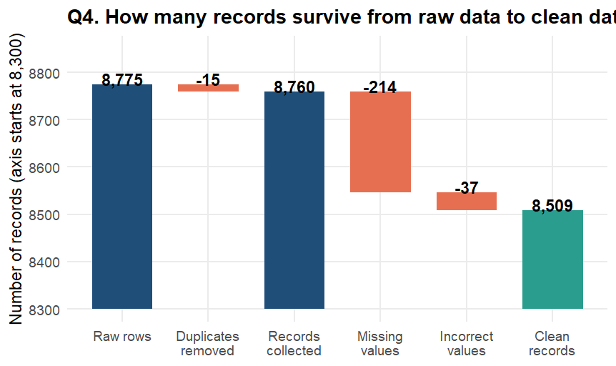
Figure 4: Number of records at each stage of cleaning

Question 5
Question: Which data quality issue is the most common in the raw dataset?

Formulas used
Issue (%) = (count of the issue / raw rows) x 100
Missing values = 214 / 8,775 x 100 = 2.44%
Incorrect values = 37 / 8,775 x 100 = 0.42%
Duplicate rows = 15 / 8,775 x 100 = 0.17%

R code
# each issue as a percentage of the raw rows
raw <- 8775
count <- c(214, 37, 15)
pct <- count / raw * 100
round(pct, 2)

q5 <- data.frame(
Issue = factor(c("Missing values", "Incorrect values", "Duplicate rows"),
levels = c("Duplicate rows", "Incorrect values", "Missing values")),
Count = count,
Label = paste0(count, " (", sprintf("%.2f", pct), "% of 8,775 rows)")
)

ggplot(q5, aes(x = Issue, y = Count)) +
geom_col(fill = "grey55", colour = "black", width = 0.6) +
geom_text(aes(label = Label), hjust = -0.05) +
coord_flip() +
scale_y_continuous(limits = c(0, 340)) +
labs(title = "Data quality issues in the raw dataset", x = NULL, y = "Count") +
theme_classic(base_size = 12)

Graph
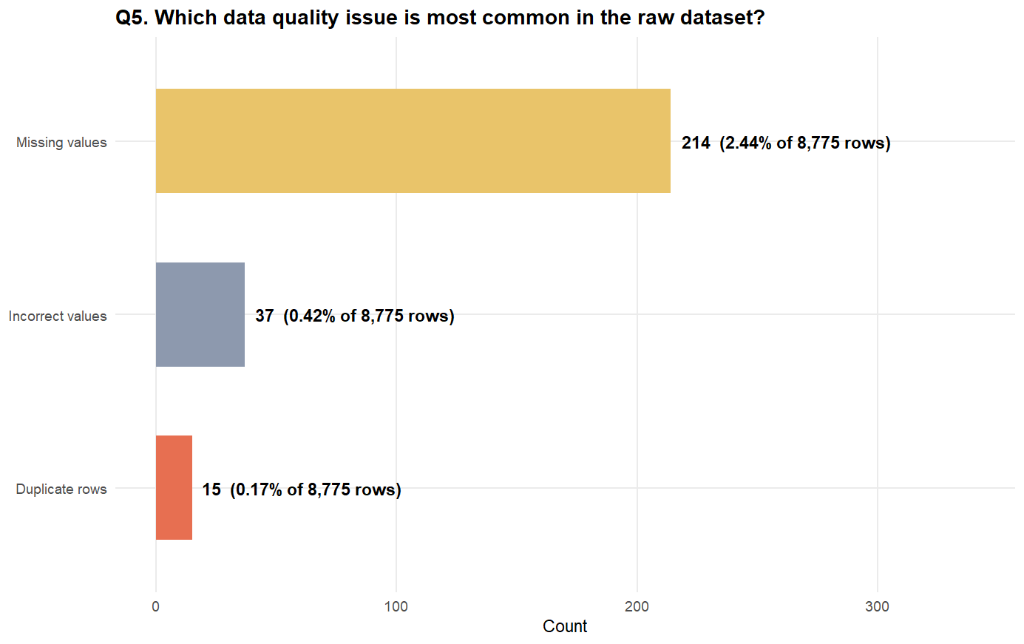
Figure 5: Data quality issues in the raw dataset

