# 📊 Global YouTube Statistics - Power BI Project

## 📌 Project Overview

This project analyzes **Global YouTube Statistics** using **Power BI** to uncover insights about content trends, engagement, and audience behavior across different countries and categories.

The dashboard provides interactive visualizations to explore:

- Top performing YouTube channels globally 🌍

- Video categories with the highest engagement 🎥

- Country-wise analysis of views, likes, comments, and subscriber counts 📈

- Growth patterns and correlations across multiple metrics 🔍

---

## 🗂️ Files Included

- **Global YouTube Statistics.csv** → Dataset used for analysis (raw data).

- **Global YouTube Statistics.pbix** → Power BI dashboard file.

---

## ⚡ Features of the Dashboard

- Interactive slicers for **country**, **category**, and **time period**

- KPI cards summarizing **total views, likes, comments, and subscribers**

- Visual comparisons of **top channels by country and category**

- Drill-down analysis for deeper insights into performance

- Trend analysis to identify growth opportunities

---

## 🛠️ Tools & Technologies

- **Power BI Desktop** (for dashboard creation)

- **CSV Dataset** (for raw data source)

- **DAX (Data Analysis Expressions)** for custom measures

---

## 🚀 How to Use

1. Download the repository files.

2. Open the `.pbix` file in **Power BI Desktop**.

3. Explore the interactive dashboard using slicers and filters.

4. Use the CSV file for custom queries or additional analysis.

---

## 📌 Key Insights

- Certain **categories dominate views and engagement** across all regions.

- A small percentage of channels generate the **majority of global traffic**.

- **Country-specific trends** reveal differences in content preferences.

---

## 📷 Dashboard Preview

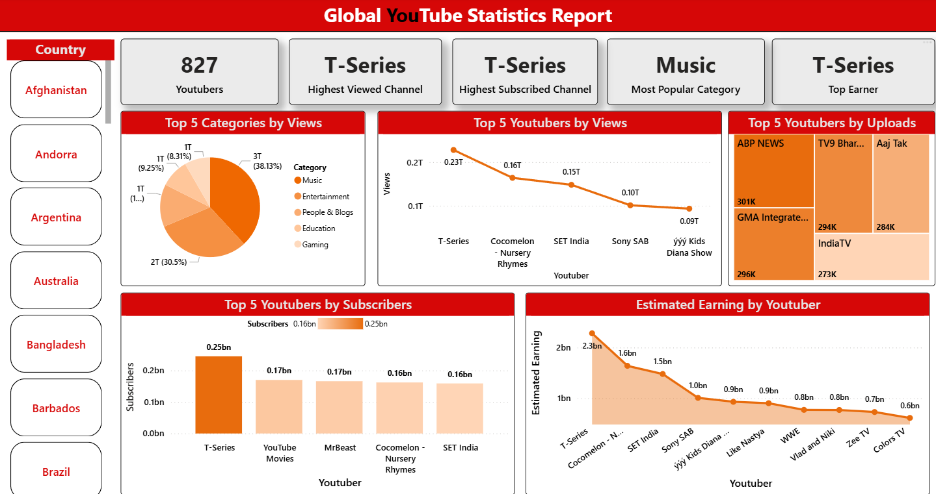

## 🤝 Contribution

Contributions are welcome! Feel free to fork the repo and improve the dashboard.