PSNA College of Engineering and Technology
Department of Computer Science and Engineering
Regulation 2017

A Ready Nutshell

CS 8391 Data Structures

Unit | Title | Page No
I | LINEAR DATA STRUCTURES – LIST | 5
II | LINEAR DATA STRUCTURES – STACKS, QUEUES | 23
III | NON LINEAR DATA STRUCTURES – TREES | 40
IV | NON LINEAR DATA STRUCTURES – GRAPHS | 72
V | SEARCHING, SORTING AND HASHING TECHNIQUES | 92
 | UNIVERSITY QUESTIONS | 104

Vision Statement of the Department:
To be centre of excellence in the field of Computer Science and Engineering education, producing globally competent professionals with social responsibilities.
Mission Statements of the Department:
- Sustain an environment conducive to quality education in engineering and research.
- Provide a learning ambience to enhance problem solving skills, leadership qualities and team spirit with ethical responsibilities.
- Evolve with the recent trends in industry to develop inter-disciplinary innovative systems and entrepreneurship.
Programme Educational Objectives(PEOs)
The Program Educational Objectives (PEOs) which describes expected accomplishments of our graduates of the B.E. CSE program are:
- Graduates will accomplish professional skills with necessary technical knowledge in Computer Science and Engineering and be successful in their career or higher studies, engaging in lifelong learning.
- Graduates will demonstrate problem solving and design skills to solve engineering problems and compete successfully on multi-disciplinary teams.
- Graduates will have the ability to adapt with contemporary technologies and undertake research effectively with good ethical standards.
Program Outcomes (POs)

Computer Science and Engineering Graduates will be able to:

PO1: Engineering knowledge: Apply the knowledge of mathematics, science, engineering fundamentals, and an engineering specialization to the solution of complex engineering problems.

PO2: Problem analysis: Identify, formulate, review research literature, and analyze complex engineering problems reaching substantiated conclusions using first principles of mathematics, natural sciences, and engineering sciences.

PO3: Design/development of solutions: Design solutions for complex engineering problems and design system components or processes that meet the specified needs with appropriate consideration for the public health and safety, and the cultural, societal, and environmental considerations.

PO4: Conduct investigations of complex problems: Use research-based knowledge and research methods including design of experiments, analysis and interpretation of data, and synthesis of the information to provide valid conclusions.

PO5: Modern tool usage: Create, select, and apply appropriate techniques, resources, and modern engineering and IT tools including prediction and modeling to complex engineering activities with an understanding of the limitations.

PO6: The engineer and society: Apply reasoning informed by the contextual knowledge to assess societal, health, safety, legal and cultural issues and the consequent responsibilities relevant to the professional engineering practice.

PO7: Environment and sustainability: Understand the impact of the professional engineering solutions in societal and environmental contexts, and demonstrate the knowledge of, and need for sustainable development.

PO8: Ethics: Apply ethical principles and commit to professional ethics and responsibilities and norms of the engineering practice.

PO9: Individual and team work: Function effectively as an individual, and as a member or leader in diverse teams, and in multidisciplinary settings.

PO10: Communication: Communicate effectively on complex engineering activities with the engineering community and with society at large, such as, being able to comprehend and write effective reports and design documentation, make effective presentations, and give and receive clear instructions.

PO11: Project management and finance: Demonstrate knowledge and understanding of the engineering and management principles and apply these to one’s own work, as a member and leader in a team, to manage projects and in multidisciplinary environments.

PO12: Life-long learning: Recognize the need for, and have the preparation and ability to engage in independent and life-long learning in the broadest context of technological change.
Programme Specific Outcome(PSOs) (Regulation 2017)
PSO1: Analyze, design and develop computing solutions by applying foundational concepts of computer science and engineering.
PSO2: Apply software engineering principles and practices for developing quality software for scientific and business applications.
PSO3: Adapt to emerging information and communication technologies (ICT) to innovate ideas and solutions to existing/novel problems.
Course Outcomes :
CO1: Create abstract data types for Linked list data structures
CO2: Write algorithms to solve problems using stack and queue data structures
CO3: Design algorithms using tree structure and apply them to problem solution.
CO4: Apply graph data structure to solve real-life problems.
CO5: Analyse various sorting, searching and hashing algorithms.
Syllabus

UNIT I LINEAR DATA STRUCTURES – LIST
Abstract Data Types (ADTs) – List ADT – array-based implementation – linked list implementation ––singly linked lists- circularly linked lists- doubly-linked lists – applications of lists –Polynomial Manipulation – All operations (Insertion, Deletion, Merge, Traversal).

UNIT II LINEAR DATA STRUCTURES – STACKS, QUEUES
Stack ADT – Operations – Applications – Evaluating arithmetic expressions- Conversion of Infix to postfix expression – Queue ADT – Operations – Circular Queue – Priority Queue – deQueue – applications of queues.

UNIT III NON LINEAR DATA STRUCTURES – TREES
Tree ADT – tree traversals – Binary Tree ADT – expression trees – applications of trees – binary search tree ADT –Threaded Binary Trees- AVL Trees – B-Tree – B+ Tree – Heap – Applications of heap.

UNIT IV NON LINEAR DATA STRUCTURES – GRAPHS
Definition – Representation of Graph – Types of graph – Breadth-first traversal – Depth-first traversal – Topological Sort – Bi-connectivity – Cut vertex – Euler circuits – Applications of graphs.

UNIT V SEARCHING, SORTING AND HASHING TECHNIQUES
Searching- Linear Search – Binary Search. Sorting – Bubble sort – Selection sort – Insertion sort – Shell sort – Radix sort. Hashing- Hash Functions – Separate Chaining – Open Addressing – Rehashing – Extendible Hashing.
TEXT BOOKS:
1. Mark Allen Weiss, ―Data Structures and Algorithm Analysis in C‖, 2nd Edition, Pearson Education,1997.
2. Reema Thareja, ―Data Structures Using C‖, Second Edition , Oxford University Press, 2011
REFERENCES:
1. Thomas H. Cormen, Charles E. Leiserson, Ronald L.Rivest, Clifford Stein, ―Introduction to Algorithms", Second Edition, Mcgraw Hill, 2002.
2. Aho, Hopcroft and Ullman, ―Data Structures and Algorithms‖, Pearson Education,1983.
3. Stephen G. Kochan, ―Programming in C‖, 3rd edition, Pearson Education.
4. Ellis Horowitz, Sartaj Sahni, Susan Anderson-Freed, ―Fundamentals of Data Structures in C‖, Second Edition, University Press, 2008

UNIT I LINEAR DATA STRUCTURES
Abstract Data Types (ADTs) – List ADT – array-based implementation – linked list implementation ––singly linked lists- circularly linked lists- doubly-linked lists – applications of lists –Polynomial Manipulation – All operations (Insertion, Deletion, Merge, Traversal)

Data structures
The way of organizing large amount of data in order to represent the logical relationship between each data item is called data structure.
Types:
(1) Linear Data Structure | (2) Non linear Data Structure
Data is arranged in linear sequence. | Data is not arranged in sequence.
Every item is related to its previous and next item. | Every item is attached with many other items.
Data items can be traversed in a single run. | Data cannot be traversed in a single run.
Examples: Array, Stack, Queue, Linked List. | Examples: Tree | Graph.
Array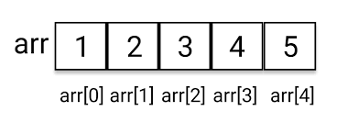

Modular Programming
Module is a logical unit and does a specific job
Advantages:
(1) It is much easier to debug (2) It allow simultaneous usage; (3) Making changes easier.

ADT (Abstract Data Type)
- A mathematical model for data types, it consists of data types and set of operations.
- It is a useful tool for specifying the logical property of a data type.
- It is an extension of modular programming.
- It does not show the detailed implementation of the operations (Abstraction).
- The implementation of ADT is written once and called several times.

List ADT
List : Sequence of element is called list
Ex: List E1,E2,E3,..En
The operations associated with list ADT are,
- PrintList , MakeEmpty , Find , Insert , Delete , Next, Previous

The List ADT can be implemented in two ways
(1) Array implementation (2) Linked list implementation

Array implementation of List ADT:

Array: A derived data type, the elements should be in same type and the elements are stored in consecutive memory location, and the size of the array is fixed.

Ex: int a[5]={10,20,30,40,50};
Memory location | Array index | Value
2000 | 0 | 10
2002 | 1 | 20
2004 | 2 | 30
2006 | 3 | 40
2008 | 4 | 50

Advantage:
- Easy to implement
- Fast searching
Disadvantage:
- Array size is static, therefore we need to estimate very maximum size (Lead to wastage of memory)
- Array need to single contiguous memory block. (it not possible always – OS need to do additional process)
- Insertion and deletion are time consuming (O(n)) and the list size must be known in advance.

Insert 15 at the position 2
Before insertion | During insertion | After insertion
Currentsize=3  Maxsize=5 | Currentsize=3  Maxsize=5 | Currentsize=4  Maxsize=5
  Index | Value
  0 | 10
  1 | 20
  2 | 30
  3
  4
  Index | Value
  0 | 10
  1
  2 | 20
  3 | 30
  4
  Index | Value
  0 | 10
  1 | 15
  2 | 20
  3 | 30
  4
Delete 10
Before deletion | During deletion | After deletion
Currentsize=4  Maxsize=5 | Currentsize=4  Maxsize=5 | Currentsize=3  Maxsize=5
  Index | Value
  0 | 10
  1 | 15
  2 | 20
  3 | 30
  4
  Index | Value
  0 | 15
  1 | 20
  2 | 30
  3
  4
  Index | Value
  0 | 15
  1 | 20
  2 | 30
  3
  4

Array implementation of list ADT.
#include <stdio.h>
int a[10];
int currentsize=0;
void insert(int,int);
void del(int);
int find(int);
void printlist();
int main()
{
int choice=0,p,x;
while(choice<=4)
{
clrscr();
printf("1.insert \n2.delete \n3.find \n4.display \n5.exit\nEnter your choice");
scanf("%d",&choice);
switch(choice)
{
case 1: printf("Enter the possition and value ");
scanf("%d %d",&p,&x);
insert(p,x);
break;
case 2: printf("Enter the Element to delete");
scanf("%d",&x);
del(x);
break;
case 3: printf("Enter the Element to find");
scanf("%d",&x);
p=find(x);
printf("Element found at %d",p);
break;
case 4: printlist();
break;
}
getch();
}
}
void insert(int po,int x)
{
int i=currentsize;
while(po<=i)
{
a[i]=a[i-1];
i--;
}
a[i]=x;
currentsize=currentsize+1;
}
void del(int x)
{
int i,po;
po=find(x);
if(po!=-1)
{
i=po;
while(i<currentsize)
{
a[i-1]=a[i];
i++;
}
currentsize=currentsize-1;
}
else
printf("Element not found");
}

int find(int x)
{
int i=0;
while(i<currentsize && a[i]!=x)
{i=i+1;}
if(i==currentsize)
{return -1;}
else
{return (i+1);}
}

void printlist()
{ int i;
for(i=0;i<currentsize;i++)
printf("%d\n",a[i]);
}

Array vs Linked List

 | Array | Linked List
Basic | fixed number of data items. | variable number of data items.
Size | Specified during declaration. | No need to specify; grow and shrink during execution.
Storage Allocation | Element location is allocated during compile time. | Element position is assigned during run time.
Order of the elements | Stored consecutively 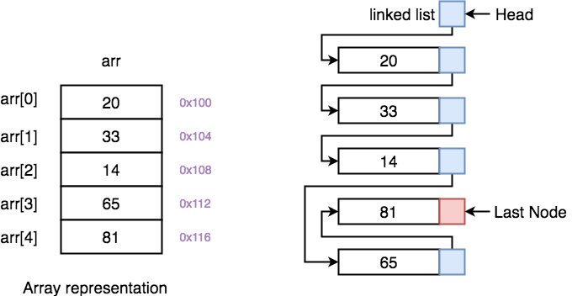 | Stored randomly
Accessing the element | Direct or randomly accessed, i.e., Specify the array index or subscript. | Sequentially accessed, i.e., Traverse starting from the first node in the list by the pointer.
Insertion and deletion of element | Slow relatively as shifting is required. | Easier, fast and efficient.
Searching | Binary search and linear search | linear search
Memory required | less | More
Memory Utilization | Ineffective | Efficient

Linked List implementation of list
- A linked list is a series of connected nodes but the nodes need not to stored in consecutive location
- The size of the list is dynamic
  - Each node contains at least A piece of data (any type) and Pointer to the next node in the list
- Advantages over arrays
1) Dynamic size
2) Ease of insertion/deletion
- Drawbacks:
1) Random access is not allowed. We have to access elements sequentially starting from the first node. So we cannot do binary search with linked lists.
2) Extra memory space for a pointer is required with each element of the list.
- Node Structure
struct node
{
int element;
node *next;
}
- Applications of Linked Lists
  - Linked lists are used to implement stacks, queues, graphs, etc.
  - Polynomial operations
  - Multilist used for maintain a database.

- Types of Linked Lists
- There are 3 different implementations of Linked List available, they are:

1. Singly Linked List
- Can’t traverse backwards, only forward movements.
- Can’t access the previous node.
- A node can’t be deleted if the pointer to that node is given.
- Can’t move to the previous node.
- To access a particular node, traverse from the first node.
Ex: 1
struct node
{
int element;
struct node *next;
}
Ex: 2
struct student
{
int rno;
char name[30];
struct student *next;
}

2. Doubly Linked List
Node Structure:
struct node
{
int element;
struct node *next;
struct node *prev;
}

  - Merits:
  - List can be traversed forward and backwards.
  - Easy to delete a node given with that pointer.

  - Demerits:
  - More space needed for two pointers forward & backward

3. Circular Linked List
Circular linked list is a linked list where all nodes are connected to form a circle. There is no NULL at the end. A circular linked list can be a singly circular linked list or doubly circular linked list.
  - The last node of the list point the first node of the list
  - The previous node can be accessed by traversing in the loop.
Advantage:
- Any node can be a starting point. We can traverse the whole list by starting from any point. We just need to stop when the first visited node is visited again
- Useful for implementation of queue
- Circular Doubly Linked Lists are used for implementation of advanced data structures like Fibonacci Heap
  - Singly circular linked list

- Doubly circular linked list

- Operations in linked List
Ex: Linked list consist of 3 elements

  - The last node points to NULL
  - List uses only as much space as is needed for the elements currently on the list
  - but requires space for the pointers in each cell
Linked list after inserting the newnode at 3rd position
- Steps for insert a node
  - Locate 2nd node
  - Allocate memory for the new node
  - Point the new node to its successor(3rd node)
  - Point the new node’s predecessor(2nd node) to the new node

- Steps for delete the node 2
  - Find the previous node (1st node)
  - Release the memory occupied by the found node (2nd node)
  - Set the pointer of the predecessor (1st node) to the successor (3rd node)
Before deleting node 20.

During deletion

After deletion

Linked List Implementation of List ADT

#include<stdio.h>
#include<conio.h>
// Linked list ADT
struct node
{
int element;
struct node *next;
};
typedef struct node* list;
list head=NULL,ptr=NULL;
void insert(int,int);
void del(int);
list find(int);
list findprevious(int);
void print();

void main()
{
list l=NULL,t=NULL;
int val,pos,choice=0;
while(choice<5)
{
clrscr(); printf("\n1.Insert\n2.delete\n3.find\n4.Printlist\n5.Exit\nEnter your choice");
scanf("%d",&choice);
switch(choice)
{
case 1:
printf("Enter position and element");
scanf("%d%d",&pos,&val);
insert(pos,val);
break;
case 2:
printf("Enter element to delete");
scanf("%d",&val);
del(val);
break;
case 3:
printf("Enter element to find");
scanf("%d",&val);
t=find(val);
if(t!=NULL)
printf("Element Found%d",t->element);
else
printf("Element Not Found");
getch();
break;
case 4:
print(ptr);
getch();
break;
}
}
}
void insert(int pos,int v)  {  list newnode;  int i;  ptr=head->next;  newnode=malloc(sizeof(struct node));  newnode->element=v;  newnode->next=NULL;  if(pos==1) // Insert element at first position  { newnode->next=head->next;  head->next=newnode;  }  else // Insert element at other places  {  for(i=1;i<pos-1&&ptr->next!=NULL;i++)  { ptr=ptr->next; }  newnode->next=ptr->next;  ptr->next=newnode;  }  } | void del(int v)  {  list fp;  ptr=head->next;  if(ptr->element==v) // Delete first position  {  head->next=head->next->next;  free(ptr);  }  else // Delete element at other places  {  fp=findprevious(v);  if(fp!=NULL)  { ptr=fp->next;  fp->next=fp->next->next;  free(ptr);  }  }  }
list find(int v)  {  ptr=head->next;  while(ptr!=NULL)  { if(ptr->element==v)  return ptr;  ptr=ptr->next;  }  return NULL;  } | list findprevious(int v)  {  ptr=head->next;  while(ptr->next!=NULL)  { if(ptr->next->element==v)  return ptr;  ptr=ptr->next;  }  return NULL;  }
void print()
{ ptr=head->next;
while(ptr!=NULL)
{ printf("%d->",ptr->element);
ptr=ptr->next;
}
}

Reversing a list | Merging of two sorted list
Procedure:  - If list ==NULL return NULL.  - Else,  - Copy first node of list to first node of reverse list  - Then copy the next node of list to first node if reverse list.  Continue, until the list is not equal to NULL  - Return reverse list.  list reverse(list l)  {  list revlist,temp;  if(l==NULL)  return NULL;  revlist->next=NULL;  while(l!=NULL)  {  temp=l;  temp->next=revlist;  l=l->next;  revlist=temp;  }  return revlist;  }  Ex:  List :  Revlist : | Procedure:  While both list1and list2 not NULL  - If list1<list2 copy node of list1 to merged list and increment list1 and mergedlist  - Else copy node of list2 to mergedlist and increment list2 and mergedlist.  If list1=NULL, copy list2 to mergedlist  Else copy list1 to mergedlist.  Return mergedlist.  list merge(list l1,list l2)  {  list mergelist,l3,temp;  mergedlist->next=l3;  while(l1!=NULL && l2!=NULL)  {  if(l1->element<l2->element)  {  temp=l1;  l1=l1->next;  }  else  {  temp=l2;  l2=l2->next;  }  temp->next=NULL;  l3->next=temp;  l3=temp;  }  if(l1==NULL) l3->next=l2;  else l3->next=l1;  return mergedlist;  }  List1  List2  Mergedlist

Intersection of two sorted list | Union of two sorted list
list intersection (list l1,list l2)  {  l2=l2start;  list intersection=l3=NULL;  while(l1!=NULL)  {  l2=l2start;  while(l2!=NULL)  {  if(l1->element==l2->element)  {  temp=l1;  temp->next=NULL;  l3->next=temp;  l3=temp;  break;  }  else  l2=l2->next;  }  l1=l1->next;  }  return intersection;  }  List 1  List 2  Intersection | void union(list l1,list l2)  {  list union=l3=NULL;  while(1)  {  if(l1->element==l2->element)  { temp=l1;  temp->next=NULL;  l3->next=temp;  l3=temp;  l1=l1->next;  l2=l2->next;  }  else if(l1->element <l2->element)  { while(l1->element<l2->element)  { temp=l1;  temp->next=NULL;  l3->next=temp;  l3=temp;  l1=l1->next;  }  }  else if(l1->element >l2->element)  { while(l1->element>l2->element)  { temp=l2;  temp->next=NULL;  l3->next=temp;  l3=temp;  l2=l2->next;  }  }  if(l1==NULL || l2==NULL) break;  }  if(l1==NULL) l3->next=l2;  else l3->next=l1;  return union;  }  List 1  List 2  Union
Doubly Linked List variation from Singly linked list

struct node
{
int element;
struct node *next;
struct node *prev;
};

void insert(int pos,int v)  {  list newnode;  int i;  ptr=head->next;  newnode=malloc(sizeof(struct node));  newnode->element=v;  newnode->next=NULL;  newnode->prev=NULL;  if(pos==1) // Insert element at first position  {  newnode->next=head->next;  head->next->prev=newnode;  head->next=newnode;  }  else // Insert element at other places  {  for(i=1;i<pos-1&&ptr->next!=NULL;i++)  {  ptr=ptr->next;  }  newnode->next=ptr->next;  ptr->next->prev=newnode;  ptr->next=newnode;  newnode->prev=ptr;  }  } | void del(int v)  {  list fp;  ptr=head->next;  if(ptr->element==v) // Delete first position  {  head->next=head->next->next;  head->next->next->prev=NULL;  free(ptr);  }  else // Delete element at other places  {  fp=findprevious(v);  if(fp!=NULL)  {  ptr=fp->next;  fp->next=fp->next->next;  fp->next->next->prev=fp;  free(ptr);  }  }  }

Circular Linked List Variation from Singly linked list
void insert(int pos,int v)  {  list newnode;  int i;  ptr=head->next;  newnode=malloc(sizeof(struct node));  newnode->element=v;  newnode->next=newnode;  if(pos==1) // Insert Element at first position  {  if(head->next==NULL) // List is Empty  head->next=newnode;  else // List is not empty  {  while(ptr->next!=head->next)  ptr=ptr->next;  ptr->next=newnode;  newnode->next=head->next;  head->next=newnode;  }  }  else // Insert Element at other position  {  for(i=1;i<pos-1&&ptr->next!=NULL;i++)  { ptr=ptr->next; }  newnode->next=ptr->next;  ptr->next=newnode;  }  } | void del(int v)  {  list fp;  ptr=head->next;  if(ptr->element==v) // Delete first position  {  if(ptr->next==ptr) // list empty after delete  { head->next=NULL;  free(ptr);  }  else // list not empty after delete  {  while(ptr->next!=head->next)  ptr=ptr->next;  ptr->next=head->next->next;  ptr=head->next;  head->next=head->next->next;  free(ptr);  }  }  else // Delete element at first position  {  fp=findprevious(v);  if(fp!=NULL)  { ptr=fp->next;  fp->next=fp->next->next;  free(ptr);  }  }  }
list find(int v)  {  ptr=head->next;  do  { if(ptr->element==v)  return ptr;  ptr=ptr->next;  }while(ptr!=head->next);  return NULL;  } | void print()  { ptr=head->next;  do  {  if(ptr)  printf("%d->",ptr->element);  ptr=ptr->next;  }while(ptr!=head->next);  }

Polynomial Addition and Multiplication

Polynomial representation

Node Structure
struct node
{
int coef;
int exp;
struct node *next;
};

Ex:
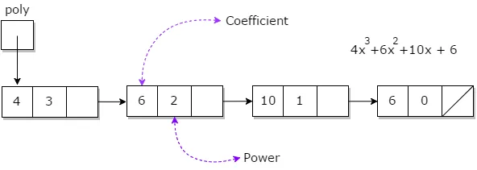
Polynomial Addition
Input:  1st number = 5x² + 4x¹ + 2x⁰  2nd number = 5x¹ + 5x⁰  Output:  5x²+9x¹⁺7x⁰ | 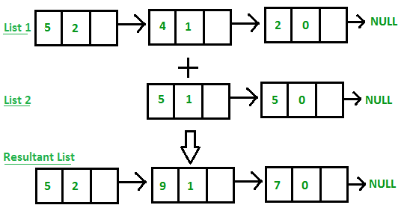

Approach

- If list1 and list2 not equal to NULL
  - If exponent of list1 > exponent of list2, list 1 node copied to result and move list 1
  - If exponent of list2 > exponent of list1, list 2 node copied to result and move list 2
  - If exponent of list1 = exponent of list2, add coefficient of list 1 and list 2 – add new node to the result with added coefficient and the exponent. Then move list 1 and list 2
- If list 1 is NULL, add the remaining nodes of list 2 to result
- If list 2 is NULL, add the remaining nodes of list 1 to result
#include<stdio.h>  #include<conio.h>  struct node  {  int coef;  int exp;  struct node *next;  };  typedef struct node* list;  list create(list);  list add(list,list,list);  list mul(list,list,list);  void printlist(list);  void main()  {  list p1,p2,p3,p4;  int coef,exp;  p1=create(p1);  p2=create(p2);  printf("\nPolinomial one :");  printlist(p1);  printf("\nPolinomial two :");  printlist(p2);  p3=add(p3,p1,p2);  printf("\nSum of polinomial:");  printlist(p3);  p4=mul(p4,p1,p2);  printf("\nMul of polinomial:");  printlist(p4);  getch();  } | list create(list l1)  {  int i=0,c,e,n;  list newnode,l2;  printf("Enter no of node ");  scanf("%d",&n);  while(i<n)  { printf("Enter Coef and exp");  scanf("%d %d",&c,&e);  newnode=malloc(sizeof(struct node));  newnode->coef=c;  newnode->exp=e;  newnode->next=NULL;  if(i==0)  { l1=newnode;  l2=newnode;  }  else  { l1->next=newnode;  l1=newnode;  }  i++;  }  return l2;  }  void printlist(list l1)  {  while(l1!=NULL)  {  printf("%d %d ->",l1->coef,l1->exp);  l1=l1->next;  }  }

list add(list l,list l1,list l2)
{
list l3,newnode;
int i=0;
while(l1!=NULL && l2!=NULL)
{
newnode=malloc(sizeof(struct node));
newnode->next=NULL;
if(l1->exp>l2->exp)
{
newnode=l1;
l1=l1->next;
}
else if(l2->exp>l1->exp)
{
newnode=l2;
l2=l2->next;
}
else
{
newnode->coef=l1->coef+l2->coef;
newnode->exp=l1->exp;
l1=l1->next;
l2=l2->next;
}

if(i==0)
{ l=newnode;
l3=l;
i++;
}
else
{ l->next=newnode;
l=newnode;
}
}
if(l1!=NULL) l->next=l1;
if(l2!=NULL) l->next=l2;
return l3;
}

Polynomial Multiplication
Input:
Poly1: 3x^2 + 5x^1 + 6,
Poly2: 6x^1 + 8

Output: 18x^3 + 54x^2 + 76x^1 + 48
On multiplying each element of 1st polynomial with elements of 2nd polynomial, we get
18x^3 + 24x^2 + 30x^2 + 40x^1 + 36x^1 + 48

On adding values with same power of x,
18x^3 + 54x^2 + 76x^1 + 48
Approach:
- In this approach we will multiply the 2nd polynomial with each term of 1st polynomial.
- Store the multiplied value in a new linked list.
- Then we will add the coefficients of elements having the same power in resultant polynomial.

list mul(list l, list l1, list l2)
{
list l3,newnode,l2start=l2,temp;
int i=0;
while(l1!=NULL)
{
l2=l2start;
while(l2!=NULL)
{
newnode=malloc(sizeof(struct node));
newnode->next=NULL;
newnode->coef=l1->coef*l2->coef;
newnode->exp=l1->exp+l2->exp;

if(i==0)
{
l=newnode;
l3=l;
i++;
}
else
{
l->next=newnode;
l=newnode;
}
l2=l2->next;
}
l1=l1->next;
}
return l3;
}
UNIT II LINEAR DATA STRUCTURES – STACKS, QUEUES
Stack ADT – Operations - Applications - Evaluating arithmetic expressions- Conversion of Infix to postfix expression - Queue ADT – Operations - Circular Queue – Priority Queue - deQueue – applications of queues.

List | Stack | Queue
 | 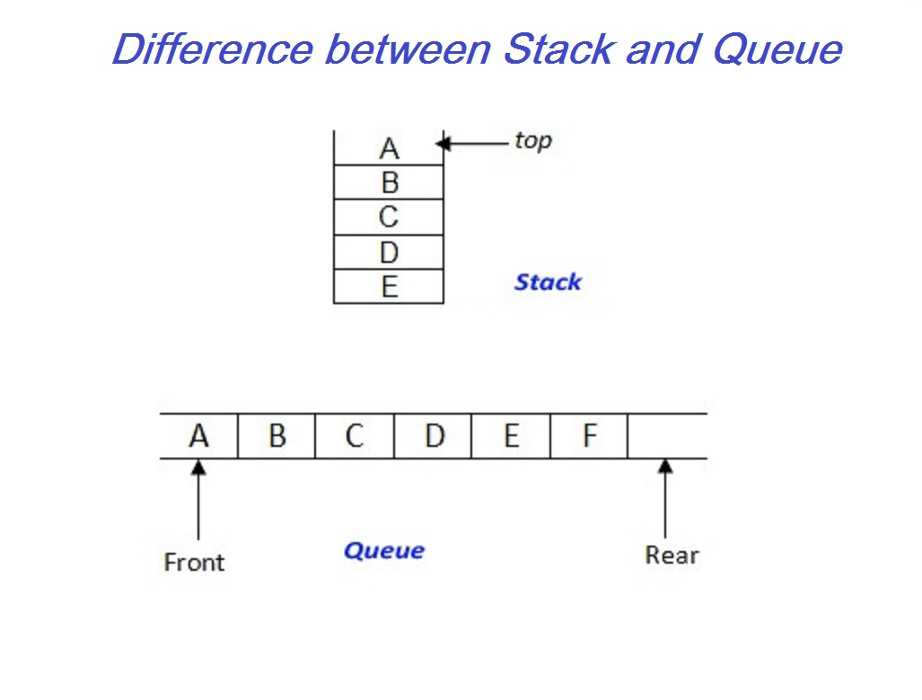
   | A
   | B
  → | C
   | D
   | E
Linear DS | Linear DS | Linear DS
Insert, Delete, Search at any point | Insert, Delete, Search at TOP only | Insert at one end(Rear) and Delete at another end(Front)
Any element can be out at any time | LIFO (Last In First Out) | FIFO (Firs In First Out)
Can be implemented using array/ linked list | Can be implemented using array/ linked list | Can be implemented using array/ linked list

STACK
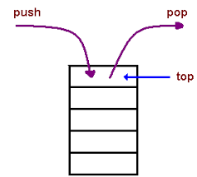
A stack is a list with the restriction
that insertions and deletions can only be performed at the top of the list
The other end is called bottom
Stacks are less flexible but are more efficient and easy to implement
Stacks are known as LIFO (Last In, First Out) lists.
The last element inserted will be the first to be retrieved
Operations of Stack
- IsEmpty: return true if stack is empty, return false otherwise
- IsFull: return true if stack is full, return false otherwise
- Top: return the element at the top of stack
- Push: add an element to the top of stack
- Pop: delete the element at the top of stack
- DisplayStack: print all the data in the stack

Implementations of stacks
- Array Implementation of Stack
- Linked List Implementation of Stack
Array implementation:
ADT:
- The array declared with the size 3 (maxsize)
- The stack pointer (sp) initialized with -1.
- Operations are, PUSH,POP,PRINT

PUSH: Push(insert) the Element at the top of the stack
Check, whether the STACK is FULL,
if stack is not full, increment stack pointer and assign the value
else print “stack full”

POP: Pop(delete) the Element at the top of the stack
Check, whether the STACK is EMPTY,
If stack is not empty, assign the value and decrement stack pointer
Else print “stack empty”

PRINT: List all the elements of the stack from first element to last element (0 to stack pointer)
TOP : stack[sp] return the top of the stack

#include <stdio.h>
#define maxsize 3
int stack[maxsize];
int sp=-1;
void push(int);
int pop();
void print();

int main()
{
int choice=0,p,x;
while(choice<4)
{
clrscr();
printf("1.push \n2.pop \n3.Print \n4.Exit\nEnter your choice");
scanf("%d",&choice);
switch(choice)
{
case 1: printf("Enter the value ");
scanf("%d",&x);
push(x);
break;
case 2: x=pop();
if(x!=NULL)
printf("The popped element is %d",x);
break;
case 3: print();
break;
}
getch();
}
}

void print()
{ int i;
for(i=0;i<=sp;i++)
printf("%d\n",stack[i]);
}

Code | Initial | Push(10) | Push(20) | Push(30)
void push(int x)  {  if(sp<maxsize-1)  stack[++sp]=x;  else  {  printf("Stack Full");  getch();  }  } | SP
  SP | 10
  SP | 20
   | 10
  SP | 30
   | 20
   | 10
 | SP=-1 | SP=0 | SP=1 | SP=2
 | Stack Empty |  |  | Stack Full

Code | Initial | Pop() | Pop() | Pop()
int pop()  { int x;  if(sp!=-1)  {  x=stack[sp--];  return x;  }  else  {  printf("Stack Empty");  return NULL;  }  } |  |  |  | SP
  SP | 30
   | 20
   | 10
  SP | 20
   | 10
  SP | 10
 | SP=2 | SP=1 | SP=0 | SP=-1
 | Stack Full |  |  | Stack Empty

Linked List implementation of Stack
#include<stdio.h>
#include<conio.h>
struct node
{
int element;
struct node *next;
};

typedef struct node* list;
list head=NULL,ptr=NULL;
void push(int);
list pop();
void print();

void main()
{
int val,choice=0;
while(choice<4)
{
clrscr(); printf("\n1.Push\n2.Pop\n3.Print\n4.Exit\nEnter your choice");
scanf("%d",&choice);
switch(choice)
{
case 1:
printf("Enter element");
scanf("%d",&val);
push(val);
break;
case 2:
ptr=pop();
if(ptr!=NULL)
{printf("The Popped Element %d",ptr->element);
free(ptr);
}
getch();
break;
case 3:
print();
getch();
break;
}
}
}

Procedure | Code
- Since it is a linked list implementation, need not to check Full condition  - Create a newnode with element  - Insert the newnode at first position | void push(int v)  {  list newnode;  int i;  newnode=malloc(sizeof(struct node));  newnode->element=v;  newnode->next=head->next;  head->next=newnode;  }

Initial

Stack Empty
push(10)
push(20)
push(30)
pop()
pop()
pop()
Stack Empty

Procedure | Code
- Check for Stack empty, if it is empty return NULL  - Otherwise,  - return first node of the stack  - Make second node as first node | list pop()  {  if(head->next==NULL)  { printf("Stack Empty");  return NULL;  }  else  {  ptr=head->next;  head->next=head->next->next;  return(ptr);  }  }

void print()
{
ptr=head->next;
while(ptr!=NULL)
{
printf("%d->",ptr->element);
ptr=ptr->next;
}
}
Application of Stack :: Check for Balancing parenthesis
#include <stdio.h>  #define maxsize 10  int stack[maxsize];  int sp=-1;  void push(int);  int pop();  int main()  {  int i;  char expr[20];  clrscr();  printf("Enter the expression : ");  gets(expr);  for(i=0;i<strlen(expr);i++)  {  if(expr[i]=='(' || expr[i]=='[' || expr[i]=='{')  push(expr[i]);  else if(expr[i]==')' && pop()=='(');  else if(expr[i]==']' && pop()=='[');  else if(expr[i]=='}' && pop()=='{');  else if(expr[i]!=')' && expr[i]!=']' && expr[i]!='}')  {}  else  {  printf("Unbalanced ");  getch();  exit(0);  }  }  if(sp == -1)  printf("Balanced");  else  printf("Unbalanced");  getch();  } | Balanced Symbol Examples:  - a+b  - ()  - {()}  - ((a+b) * (a-b))  - void main() {}  Unbalanced Examples:  - (()  - ())  - {(})  - ((a+b)*(a-b)  Procedure:  - If any open brackets, PUSH into the stack  - If any close brackets, POP stack and compare with the closed brackets, both are not in same family “UNBALANCED”  - Other than brackets do nothing  - Finally if input and stack empty, BALANCED  otherwise UNBALANCED

Application of Stack :: Infix to postfix conversion
#include <stdio.h>  #define maxsize 10  int stack[maxsize];  int sp=-1;  void push(int);  char pop();  int priority(char);  void main()  {  char expr[20],t;  int x,i;  printf("Enter infix expression :: ");  scanf("%s",expr);  for(i=0;i<strlen(expr);i++)  {  if(isdigit(expr[i]))  printf("%c",expr[i]);  else if(expr[i]=='(')  push(expr[i]);  else if(expr[i]==')')  { while(stack[sp]!='(')  {printf("%c",pop());}  t=pop();  }  else  {  while(priority(stack[sp]) >= priority(expr[i]))  printf("%c",pop());  push(expr[i]);  }  }  while(sp != -1)  {  printf("%c",pop());  }  getch();  } | int priority(char x)  {  if(x == '=')  return 1;  if(x == '+' || x == '-')  return 2;  if(x == '*' || x == '/')  return 3;  }  Examples:  Procedure:  - Read infix expression  - If alphanumeric PRINT  - If it is Open bracket PUSH  - If it is Close bracket POP stack till the Open bracket  - If it is Operator and > top of the stack PUSH.  - If it is Operator and <= top of the stack POP till the operator is > top of stack.  - Push the operator  - Pop the stack and print
  Infix | Postfix
  a+b | ab+
  a+b*c | abc*+
  a=b+c*d | abcd*+=
  c=(a+b)*(a-b) | cab+ab-*=

Infix | Case | PRINT | Stack
c=(a+b)*(a-b) | c  Operand  PRINT | c
=(a+b)*(a-b) | =  Operator,  >top, PUSH | c
  =
(a+b)*(a-b) | (  Open bracket,  PUSH | c
  (
  =
a+b)*(a-b) | a  Operand  PRINT | ca
  (
  =
+b)*(a-b) | +  Operator,  >top, PUSH | ca
  +
  (
  =
b)*(a-b) | b  Operand  PRINT | cab
  +
  (
  =
)*(a-b) | )  Close bracket,  POP and print till ( | cab+
  =
*(a-b) | *  Operator,  >top, PUSH | cab+
  *
  =
(a-b) | (  Open bracket,  PUSH | cab+
  (
  *
  =
a-b) | a  Operand  PRINT | cab+a
  (
  *
  =
-b) | -  Operator,  >top,  PUSH | cab+a
  -
  (
  *
  =
b) | b  Operand  PRINT | cab+ab
  -
  (
  *
  =
) | )  Close bracket,  POP and print till ( | cab+ab-
  *
  =
 | Pop remaining from stack and PRINT | cab+ab-*=
Application of Stack :: Postfix Evaluation
#include <stdio.h>  #define maxsize 10  int stack[maxsize];  int sp=-1;  void push(int);  int pop();  void main()  {  char expr[20];  int i,a,b;  printf("Enter post fix expression :: ");  scanf("%s",expr);  for(i=0;i<strlen(expr);i++)  {  if(isdigit(expr[i]))  push(expr[i]-48);  else  { b=pop();  a=pop();  switch(expr[i])  {  case '+':  push(a+b);  break;  case '-':  push(a-b);  break;  case '*':  push(a*b);  break;  case '/':  push(a/b);  break;  }  }  }  printf("%d",pop());  getch();  } | Examples  Procedure:  - If digit PUSH in to the stack  - Else (Operator), POP top two, do the operation and PUSH the result to the stack  - POP the final answer.
  Infix | Postfix | Answer
  2+1 | 21+ | 3
  (2+1)*(2-1) | 21+21-* | 3
  2+1*3 | 213*+ | 5
  Postfix | Case | Stack
  21+21-* | Digit, PUSH
    2
  1+21-* | Digit, PUSH
    1
    2
  +21-* | Operator,  POP top two,  Do the operation,  PUSH the result
    3
  21-* | Digit, PUSH
    2
    3
  1-* | Digit, PUSH
    1
    2
    3
  -* | Operator,  POP top two,  Do the operation,  PUSH the result
    1
    3
  * | Operator,  POP top two,  Do the operation,  PUSH the result
    3
   | POP the result  3
    3

Queue
- Queue is a list with the restriction
- Insertion done at one end (Rear) and the deletion done at other end( Front)
- Queue are less flexible but are more efficient and easy to implement
- Queue are known as FIFO (First In, First Out) lists.
- The first element inserted will be the first to be retrieved

Operations of Queue
- IsEmpty: return true if stack is empty, return false otherwise
- IsFull: return true if stack is full, return false otherwise
- Enqueue: add an element at the end of the queue
- Dequeue: delete the element at the beginning of the queue
- Print: print all the data in the stack
Implementations of Queue
- Array Implementation of Linear Queue
- Array Implementation of Circular Queue
- Linked List Implementation of Queue
- Array Implementation of Double ended Queue
- Array implementation of priority queue
Array implementation:
ADT:
- The array declared with the size 3 (maxsize)
- The front and rear initialized with -1.
- Operations are, Enqueue, Dequeue, Print

Enqueue: Insert the Element at the End of the Queue
Check, whether the Queue is FULL,
if Queue not full, increment rear pointer and assign the value
else print “Queue full”

Dequeue: Delete the Element at the Front of the Queue
Check, whether the Queue is EMPTY,
If Queue is not empty, assign the value and Increment front
Else print “Queue empty”
PRINT: List all the elements of the Queue from first element to last element (front to rear pointer)

Array implementation of Linear Queue
#include <stdio.h>  #define maxsize 3  int queue[maxsize];  int front=-1;  int rear=-1;  void enqueue(int);  int dequeue();  void printqueue();  int main()  { int choice=0,p,x;  while(choice<4)  {clrscr();  printf("1.Enqueue \n2.Dequeue \n3.Print \n4.exit\nEnter your choice");  scanf("%d",&choice);  switch(choice)  {  case 1: printf("Enter the value ");  scanf("%d",&x);  enqueue(x);  break;  case 2: x=dequeue();  if(x!=NULL)  printf("The dequeued element is  %d",x);  break;  case 3: printqueue();  break;  }getch();  }  } | void enqueue(int x)  {  if(rear<maxsize-1)  { rear=rear+1;  queue[rear]=x;  if(front==-1)  front=0;  }  else  printf("Queue Full");  }  int dequeue()  { int x;  if(front>-1 && front<=rear)  {  x=queue[front];  front=front+1;  return x;  }  else  {  printf("Queue Empty");  return NULL;  }  }  void printqueue()  { int i;  for(i=front;i<=rear;i++)  printf("%d\n",queue[i]);  }

Linear Queue | Circular Queue
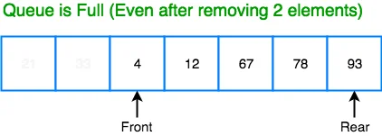 | 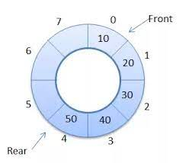
Rear and Front can move in forward direction, therfore if it reach the maxsize, It does not allow Enqueue | Rear and Front can move in circular direction, therfore if it reach the maxsize, then it move to the first posistion and allow Enqueue.
Array implementation of Circular Queue

#include <stdio.h>  #define maxsize 3  int queue[maxsize];  int front=-1;  int rear=-1;  int count=0;  void enqueue(int);  int dequeue();  void printqueue();  int main()  {  int choice=0,p,x;  while(choice<4)  {  clrscr();  printf("1.Enqueue \n2.Dequeue \n3.Print \n4.exit\nEnter your choice");  scanf("%d",&choice);  switch(choice)  {  case 1: printf("Enter the value ");  scanf("%d",&x);  enqueue(x);  break;  case 2: x=dequeue();  if(x!=NULL)  printf("The deleted element is %d",x);  break;  case 3: printqueue();  break;  }  getch();  }  } | void enqueue(int x)  {  if(count<maxsize)  { rear=(rear+1)%maxsize;  queue[rear]=x;  count++;  if(front==-1)  front=0;  }  else  {  printf("Queue Full");  }  }  int dequeue()  { int x;  if(count>0)  {  x=queue[front];  count--;  front=(front+1)%maxsize;  return x;  }  else  {  printf("Queue Empty");  return NULL;  }  }  void printqueue()  { int i,j;  i=front;  j=0;  while(j<count)  {printf("%d\n",queue[i]);  i=(i+1)%maxsize;  j++;}  }

Linked List implementation of Queue
#include<stdio.h>  #include<conio.h>  struct node  {  int element;  struct node *next;  };  typedef struct node* list;  list head=NULL,ptr=NULL;  void enqueue(int);  list dequeue();  void print();  int main()  { int choice=0,p,x;  while(choice<=3)  {  clrscr();  printf("1.Enqueue \n2.Dequeue \n3.Print \n4.exit\nEnter your choice");  scanf("%d",&choice);  switch(choice)  {  case 1: printf("Enter the value ");  scanf("%d",&x);  enqueue(x);  break;  case 2: ptr=dequeue();  if(ptr==NULL)  printf("Queue Empty");  else  {  printf("The dequeued ELement %d",ptr->element);  free(ptr);  }  break;  case 3: print();  break;  }  getch();  }  } | void enqueue(int v)  {  list newnode;  ptr=head->next;  newnode=malloc(sizeof(struct node));  newnode->element=v;  newnode->next=NULL;  if(head->next==NULL)  head->next=newnode;  else  {  while(ptr->next!=NULL)  ptr=ptr->next;  ptr->next=newnode;  }  }  list dequeue()  {  if(head->next!=NULL)  { ptr=head->next;  head->next=head->next->next;  return ptr;  }  else  return NULL;  }  void print()  { ptr=head->next;  while(ptr!=NULL)  { printf("%d->",ptr->element);  ptr=ptr->next;  }  }

Double Ended Queue
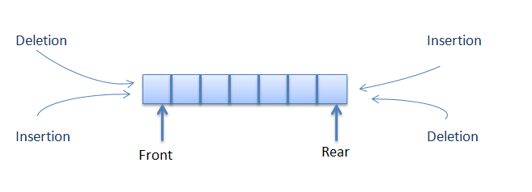 A deque, also known as a double-ended queue.
It allows to do Enqueue/Dequeue both end of the Queue.
This structure provides all the capabilities of stacks and queues in a single data structure.
Dequeue ADT
Array with Maxsize
Set front=rear=-1
Set count=0
Enqueuef(v) : Enqueue element at front
Enqueuer(v) : Enqueue element at Rear
Dequeuef() : Delete from front
Dequeuer() : Delete from rear
Printqueue() : Print the elements of the queue

#include <stdio.h>
#define maxsize 5
int queue[maxsize];
int front=-1;
int rear=-1;
int count=0;
void enqueuef(int);
void enqueuer(int);
int dequeuef();
int dequeuer();
void printqueue();

int main()
{
int choice=0,p,x;
while(choice<6)
{
clrscr();
printf("1.Enqueue at Front\n 2. Enqueue at Rear\n3.Dequeue at Front \n4.Dequeue at Rear\n5.Print \n6.exit\nEnter your choice");
scanf("%d",&choice);
switch(choice)
{
case 1: printf("Enter the value ");
scanf("%d",&x);
enqueuef(x);
break;
case 2: printf("Enter the value ");
scanf("%d",&x);
enqueuer(x);
break;

case 3: x=dequeuef();
if(x!=NULL)
printf("The deleted element is %d",x);
break;
case 4: x=dequeuer();
if(x!=NULL)
printf("The deleted element is %d",x);
break;

case 5: printqueue();
break;
}
getch();
}
}

void printqueue()
{ int i,j;
i=front;
j=0;
while(j<count)
{printf("%d\n",queue[i]);
i=(i+1)%maxsize;
j++;}
}

void enqueuef(int x)  {  if(count<maxsize)  {  if(front==-1)  {front=0;  rear=0;}  else if(front==0)  front=maxsize-1;  else  front=front-1;  queue[front]=x;  count++;  }  else  {  printf("Queue Full");  }  } | void enqueuer(int x)  {  if(count<maxsize)  {  if(front==-1)  {front=0;  rear=0;}  else if(rear==maxsize-1)  rear=0;  else  rear=rear+1;  queue[rear]=x;  count++;  }  else  {  printf("Queue Full");  }  }
int dequeuef()  {  int x;  if(count>0)  {  x=queue[front];  count--;  if (front==maxsize)  front=0;  else  front=front+1;  return x;  }  else  {  printf("Queue Empty");  return NULL;  }  } | int dequeuer()  {  int x;  if(count>0)  {  x=queue[rear];  count--;  if (rear==0)  rear=maxsize-1;  else  rear=rear-1;  return x;  }  else  {  printf("Queue Empty");  return NULL;  }  }

UNIT III NON LINEAR DATA STRUCTURES – TREES

Tree ADT – tree traversals – Binary Tree ADT – expression trees – applications of trees – binary search tree ADT – Threaded Binary Trees- AVL Trees – B-Tree – B+ Tree – Heap – Applications of heap.

Tree

Tree is a non linear data structure.
It is a hierarchical data structure defined as a collection of nodes. Nodes represent value and nodes are connected by edges.
Trees provide an efficient insertion and searching.

Tree Terminology

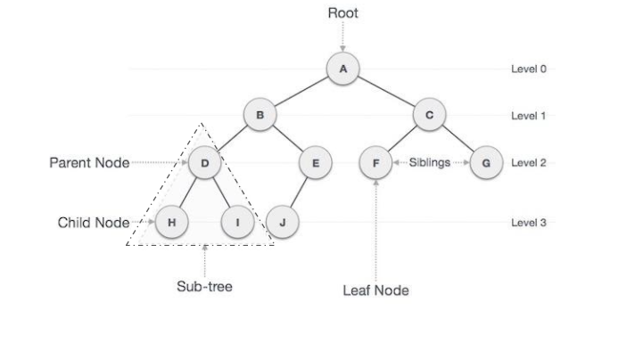
Root
The first node is called root, in which indegree of root is zero. Root node is A
Subtree
It is the connected structure below any node.
Leaf
Leaf is any node in which outdegree of the node is zero. Leaf nodes are H,I,J, F, and G
Parent
A node is parent if it has successor nodes. Parent nodes are B, C, D, and E
Child
The node is a child if it has a one predecessor. H and I are the Child nodes of D.
Siblings
Two or more nodes with same parent. F and G are siblings
Ancestor
It is any node in the path from root to that node. The ancestors of node D are B and A

Descendant
All the nodes in the path from a given node to a leaf node. The descendents of node B are E and J

Path
It is a sequence of nodes in which each node is adjacent to the next one. For reaching D, AB and BD these two branches should be added. Path is ABD

Degree
The number of children’s of the node. Degree of node B = 3

Level
It is a distance from root node is that root node is at level 0, its next child is at level 1, and its grandchild is at level 2 and so on.
Level 0 node A
Level 1 nodes B and C
Level 2 nodes D, E , F and G
Level 3 nodes H , I and J
Length of the path
It is the number of edges on that path. The length of the path from A to F is 2
Height of the tree
The height of the tree is the path length from the leaf.
The height of the tree is the maximum path length =>3
Depth
The depth of the node is the path length from root to that specific node. The depth of node G is 2
Height of the node
The height of the node is the longest path from that node to leaf. The height of node C is 2
Types of Tree
- General Tree
- Forest Tree
- Binary Tree
- Binary Search Tree
- Expression Tree
- AVL Tree
- Red Black Tree
- Splay Tree
- B Tree
- B+Tree
- Heap Tree

General Tree
In the data structure, General tree is a tree in which each node can have either zero or many child nodes. General trees are used to model applications such as file systems.

Representation

- Linked list representation

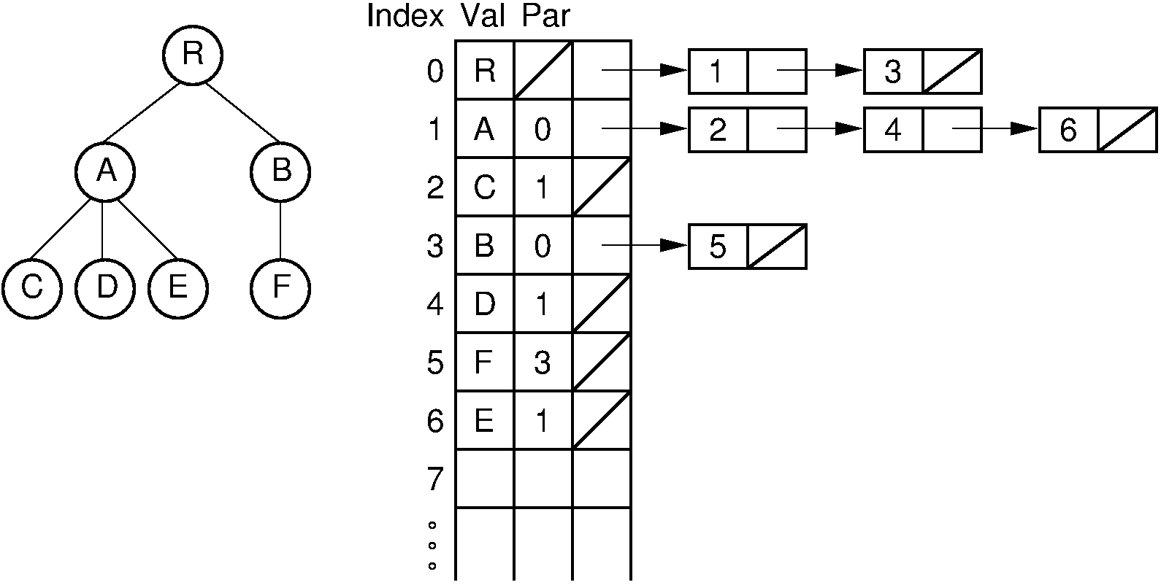
- First child / next sibiling

Since each node in a tree can have an arbitrary number of children, and that number is not known in advance, the general tree can be implemented using a first child/next sibling method

General tree to binary tree conversion

General Tree | Binary Tree – Linked list | Binary Tree

Binary tree
A tree in which each node has at most two children generally referred as left child and right child. It can be implemented using doubly linked list.
Node structure
struct node
{
int element;
struct node *left;
struct node *right;
};
Binary Tree | Doubly linked list representation
Types of Binary Tree
Full/ proper/ strict Binary tree  Every node in the tree has either 0 or 2 children. | 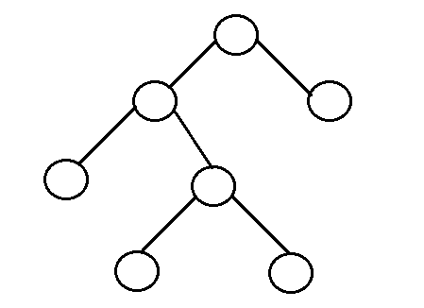
Perfect binary tree:  A tree is a perfect binary tree if all the internal nodes have 2 children, and all the leaf nodes are at the same level. | 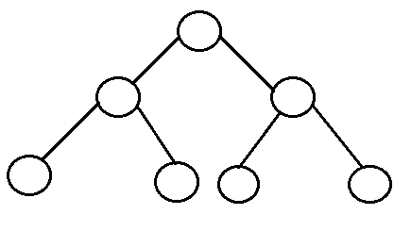
Complete binary tree:  All the nodes are completely filled except the last level.  The last level is filled from left to right of the tree. | 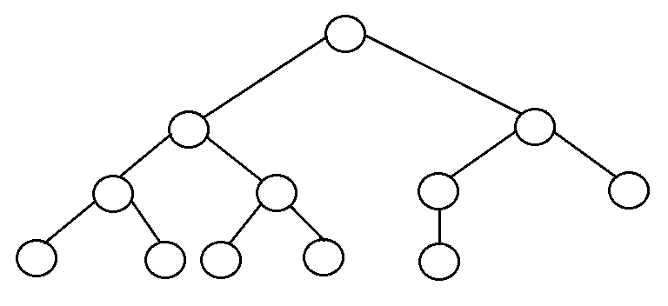
Balanced binary tree:  The height of the left and the right sub trees of each node should vary by at most one.  Ex: AVL Tree and a Red-Black Tree are some common examples | 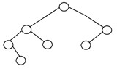

Tree Traversal
Visiting of each node of a tree is called traversal. Linear data structures like Stack, Queue, and linked list have only one way for traversing, whereas the tree has various ways to traverse or visit each node.

Algorithm for binary tree traversal
Inorder(root)  - Traverse the left sub-tree, (recursively call inorder(root -> left).  - Visit and print the root node.  - Traverse the right sub-tree, (recursively call inorder(root -> right). |  | void inorder(tree root)  {  if(root == NULL)  return;  inorder(root->left);  printf("%d ->", root->data);  inorder(root->right);  }
Preorder(root)  - Visit and print the root node.  - Traverse the left sub-tree, (recursively call inorder(root -> left).  - Traverse the right sub-tree, (recursively call inorder(root -> right). |  | void preorder(tree root)  {  if(root == NULL)  return;  printf("%d ->", root->data);  inorder(root->left);  inorder(root->right);  }
Postorder(root)  - Traverse the left sub-tree, (recursively call inorder(root -> left).  - Traverse the right sub-tree, (recursively call inorder(root -> right).  - Visit and print the root node. |  | Void postorder(tree root)  {  if(root == NULL)  return;  inorder(root->left);  inorder(root->right);  printf("%d ->", root->data);  }
 | Inorder  L N R |  | D B E A F G C
 | Preorder  N L R |  | A B D E C F G
 | Postorder  L R N |  | D E B G F C A
 | Inorder  L N R |  | 1 2 3 4 5 6 7
 | Preorder  N L R |  | 4 2 1 3 6 5 7
 | Postorder  L R N |  | 1 3 2 5 7 6 4

Construction of Expression tree
(a+b)*(c*(d+e)) => ab+ cde+**
Procedure: If operand PUSH, If operator POP top two, add operator as parent, PUSH into the stack.
a b + c d e + * * | + c d e + * * |  | c d e + * *
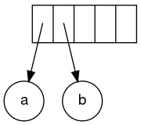 | 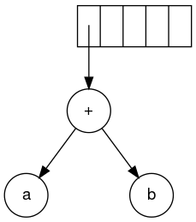 |  | 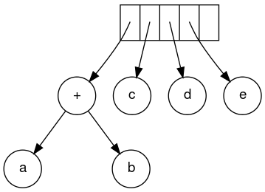
+ * * |  | * *
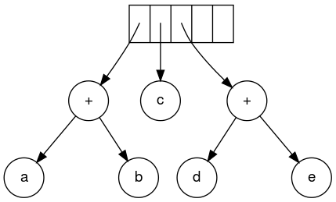 |  | 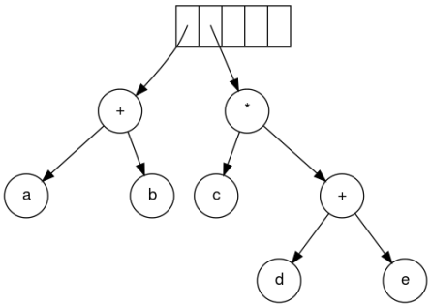
*
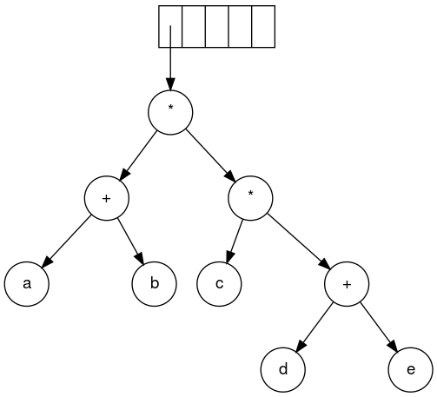
Binary Search Tree
Binary Search tree can be defined as a class of binary trees, in which the nodes are arranged in a specific order. This is also called ordered binary tree.
- In BST, the value of all the nodes in the left sub-tree is less than the value of the root.
- Similarly, value of all the nodes in the right sub-tree is greater than to the value of the root.
- This rule will be recursively applied to all the left and right sub-trees of the root.

Advantages of using binary search tree
- Searching become very efficient in a binary search tree since, we get a hint at each step, about which sub-tree contains the desired element.
- The binary search tree is considered as efficient data structure in compare to arrays and linked lists. In searching process, it removes half sub-tree at every step. Searching for an element in a binary search tree takes o(log₂n) time. In worst case, the time it takes to search an element is 0(n).
- It also speed up the insertion and deletion operations as compare to that in array and linked list.
Insert:
If the newnode is less than the node, insert at left subtree
Else, the newnode is greater than the node, insert at right subtree.
10,2,8,20,35,13,1,23
Insert 10 | Insert 2 | Insert 8
Insert 20 | Insert 35 | Insert 13
Insert 1 | Insert 23

Find Min/Max
=> The leftmost Node – Minimum
=> The rightmost Node - Maximum
Find Minimum | Find Maximum

Find
If the element less than the node, find in the left subtree
Else, find in the right subtree

Find 13
Delete Leaf Node (Delete 1) => Delete the node
Delete Node with 1 child (Delete 35) => Make the child as node

Delete Node with 2 child (Delete 10)
Find right minimum, Copy right minimum to the node, Delete right minimum

#include<stdio.h>
#include<stdlib.h>

struct node
{
int data;
struct node* left;
struct node* right;
};
typedef struct node * tree;
tree createnode(int);
tree insert(tree,int);
tree find(tree,int);
tree findmin(tree);
tree findmax(tree);
tree deletenode(tree,int);
void inorder(tree);

int main()
{ tree root = NULL;
tree temp;
int ch,element;
clrscr();
while(ch<7)
{
clrscr();
printf("1. Insert\n2. Display\n3. Find\n4. Findmin\n5. Findmax\n6. Delete\n7.Exit");
printf("\nEnter your choice :");
scanf("%d",&ch);
switch(ch)
{
case 1:
printf("Enter element to insert ");
scanf("%d",&element);
root=insert(root,element);
break;
case 2:
printf("List of element:");
inorder(root);
break;
case 3:
printf("Enter element to find ");
scanf("%d",&element);
temp=find(root,element);
if(temp!=NULL)
printf("\nThe element is = %d",temp->data);
else
printf("\nElement not found");
break;
case 4:
temp=findmin(root);
printf("the minimum element is : %d",temp->data);
break;
case 5:
temp=findmax(root);
printf("the maximum element is : %d",temp->data);
break;
case 6:
printf("Enter the element to delete ");
scanf("%d",&element);
root=deletenode(root,element);
break;
}
getch();
}
}

tree createnode(int value){  tree newNode = malloc(sizeof(struct node));  newNode->data = value;  newNode->left = NULL;  newNode->right = NULL;  return newNode;  }  tree insert(tree root, int data)  {  if (root == NULL) return createnode(data);  if (data < root->data)  root->left = insert(root->left, data);  else if (data > root->data)  root->right = insert(root->right, data);  return root;  }  void inorder(tree root){  if(root == NULL) return;  inorder(root->left);  printf("%d ->", root->data);  inorder(root->right);  }  tree findmin(tree t)  {  tree minnode= t;  while (minnode->left != NULL)  minnode= minnode->left;  return minnode;  }  tree findmax(tree t)  {  tree maxnode= t;  while (maxnode->right != NULL)  maxnode= maxnode->right;  return maxnode;  } | tree find(tree t,int key)  {  tree temp=t;  if(t==NULL)  return NULL;  if(key<t->data)  temp=find(t->left,key);  else if(key>t->data)  temp=find(t->right,key);  return temp;  }  tree deletenode(tree root, int key)  { tree temp;  if (root == NULL) return root;  if (key < root->data)  root->left = deletenode(root->left, key);  else if (key > root->data)  root->right = deletenode(root->right, key);  else  {  // node with only one child or no child  if (root->left == NULL)  {  tree temp = root->right;  free(root);  return temp;  }  else if (root->right == NULL)  {  tree temp = root->left;  free(root);  return temp;  }  //node with two children:  temp = findmin(root->right);  root->data = temp->data;  root->right = deletenode(root->right, temp->data);  }  return root;  }

Threaded Binary Tree
- Binary trees have a lot of wasted space: the leaf nodes each have 2 null pointers. We can use these pointers to help us in inorder traversals.

Inorder traversal of a Binary tree can either be done using recursion or with the use of a auxiliary stack. The idea of threaded binary trees is to make inorder traversal faster and do it without stack and without recursion.

A binary tree is threaded by making all right child pointers that would normally be null point to the inorder successor of the node (if it exists), and all left child pointers that would normally be null point to the inorder predecessor of the node.

Types of threaded binary trees:
- Single Threaded: each node is threaded towards either the in-order predecessor or successor (left orright) means all right null pointers will point to inorder successor OR all left null pointers will point to inorder predecessor.
- Double threaded: each node is threaded towards both the in-order predecessor and successor (left andright) means all right null pointers will point to inorder successor AND all left null pointers will point to inorder predecessor.

Single Threaded | Double Threaded

AVL trees (Adelson, Velski & Landis Tree )
What if the input to binary search tree comes in a sorted (ascending or descending) manner? It will then look like this –
Left Skewed | Right Skewed
It is observed that BST's worst-case performance is closest to linear search algorithms, that is Ο(n). In real-time data, we cannot predict data pattern and their frequencies. So, a need arises to balance out the existing BST.
AVL tree checks the height of the left and the right sub-trees and assures that the difference is not more than 1. This difference is called the Balance Factor.
Here we see that the first tree is balanced and the next two trees are not balanced −
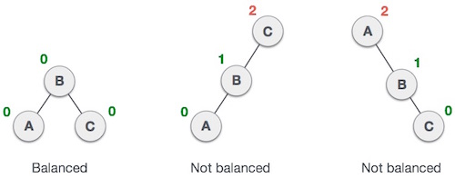
In the second tree, the left subtree of C has height 2 and the right subtree has height 0, so the difference is 2. In the third tree, the right subtree of A has height 2 and the left is missing, so it is 0, and the difference is 2 again. AVL tree permits difference (balance factor) to be only 1.
BalanceFactor = height(left-subtree) − height(right-subtree)
If the difference in the height of left and right sub-trees is more than 1, the tree is balanced using some rotation techniques.

AVL Rotations
To balance itself, an AVL tree may perform the following four kinds of rotations −
- Left rotation (Single Rotation)
- Right rotation (Single Rotation)
- Left-Right rotation (Double Rotation)
- Right-Left rotation (Double Rotation)

Left Rotation
If a tree becomes unbalanced, when a node is inserted into the right subtree of the right subtree, then we perform a single left rotation −
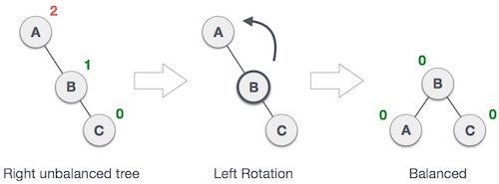
In our example, node A has become unbalanced as a node is inserted in the right subtree of A's right subtree. We perform the left rotation by making A the left-subtree of B.

Right Rotation
AVL tree may become unbalanced, if a node is inserted in the left subtree of the left subtree. The tree then needs a right rotation.
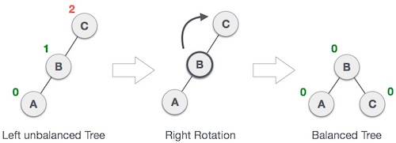
As depicted, the unbalanced node becomes the right child of its left child by performing a right rotation.

Left-Right Rotation
Double rotations are slightly complex version of already explained versions of rotations. To understand them better, we should take note of each action performed while rotation. Let's first check how to perform Left-Right rotation. A left-right rotation is a combination of left rotation followed by right rotation.
State | Action
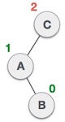 | A node has been inserted into the right subtree of the left subtree. This makes C an unbalanced node. These scenarios cause AVL tree to perform left-right rotation.
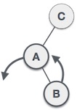 | We first perform the left rotation on the left subtree of C. This makes A, the left subtree of B.
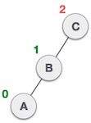 | Node C is still unbalanced, however now, it is because of the left-subtree of the left-subtree.
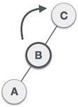 | We shall now right-rotate the tree, making B the new root node of this subtree. C now becomes the right subtree of its own left subtree.
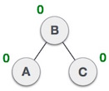 | The tree is now balanced.

Right-Left Rotation
The second type of double rotation is Right-Left Rotation. It is a combination of right rotation followed by left rotation.
State | Action
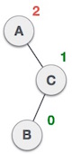 | A node has been inserted into the left subtree of the right subtree. This makes A, an unbalanced node with balance factor 2.
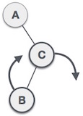 | First, we perform the right rotation along C node, making C the right subtree of its own left subtree B. Now, B becomes the right subtree of A.
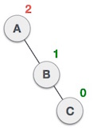 | Node A is still unbalanced because of the right subtree of its right subtree and requires a left rotation.
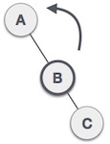 | A left rotation is performed by making B the new root node of the subtree. A becomes the left subtree of its right subtree B.
 | The tree is now balanced.
#include<stdio.h>  typedef struct node  {  int data;  struct node *left,*right;  int ht;  }node;  node *insert(node *,int);  node *Delete(node *,int);  void preorder(node *);  void inorder(node *);  int height( node *);  node *rotateright(node *);  node *rotateleft(node *);  node *RR(node *);  node *LL(node *);  node *LR(node *);  node *RL(node *);  int BF(node *);  int main()  {  node *root=NULL;  int x,n,i,op;  do  {  printf("\n1)Create:");  printf("\n2)Insert:");  printf("\n3)Delete:");  printf("\n4)Print:");  printf("\n5)Quit:");  printf("\n\nEnter Your Choice:");  scanf("%d",&op);  switch(op)  {  case 1: printf("\nEnter no. of elements:");  scanf("%d",&n);  printf("\nEnter tree data:");  root=NULL;  for(i=0;i<n;i++)  {  scanf("%d",&x);  root=insert(root,x);  }  break;  case 2: printf("\nEnter a data:");  scanf("%d",&x);  root=insert(root,x);  node * Delete(node *T,int x)  {  node *p;  if(T==NULL)  {  return NULL;  }  else if(x > T->data) // Delete in right subtree  {  T->right=Delete(T->right,x);  if(BF(T)==2)  if(BF(T->left)>=0)  T=LL(T);  else  T=LR(T);  }  else if(x<T->data) // Delete in left subtree  {  T->left=Delete(T->left,x);  if(BF(T)==-2) //Rebalance during windup  if(BF(T->right)<=0)  T=RR(T);  else  T=RL(T);  }  else//data to be deleted is found  {  if(T->right!=NULL) //delete its inorder succesor  { p=T->right;  while(p->left!= NULL)  p=p->left;  T->data=p->data;  T->right=Delete(T->right,p->data);  if(BF(T)==2)//Rebalance during windup  if(BF(T->left)>=0)  T=LL(T);  else  T=LR(T);\  }  else  return(T->left);  }  T->ht=height(T);  return(T);  }  int height(node *T)  {  int lh,rh;  if(T==NULL)  return(0);  if(T->left==NULL)  lh=0;  else  lh=1+T->left->ht;  if(T->right==NULL)  rh=0;  else  rh=1+T->right->ht;  if(lh>rh)  return(lh);  return(rh);  }  int BF(node *T)  {  int lh,rh;  if(T==NULL)  return(0);  if(T->left==NULL)  lh=0;  else  lh=1+T->left->ht;  if(T->right==NULL)  rh=0;  else  rh=1+T->right->ht;  return(lh-rh);  } | break;  case 3: printf("\nEnter a data:");  scanf("%d",&x);  root=Delete(root,x);  break;  case 4: printf("\nPreorder sequence:\n");  preorder(root);  printf("\n\nInorder sequence:\n");  inorder(root);  printf("\n");  break;  }  }while(op!=5);  return 0;  }  node * insert(node *T,int x)  {  if(T==NULL)  {  T=(node*)malloc(sizeof(node));  T->data=x;  T->left=NULL;  T->right=NULL;  }  else if(x > T->data) // insert in right subtree  {  T->right=insert(T->right,x);  if(BF(T)==-2)  if(x>T->right->data)  T=RR(T);  else  T=RL(T);  }  else if(x<T->data)  {  T->left=insert(T->left,x);  if(BF(T)==2)  if(x < T->left->data)  T=LL(T);  else  T=LR(T);  }  T->ht=height(T);  return(T);  }  node * rotateright(node *x)  {  node *y;  y=x->left;  x->left=y->right;  y->right=x;  x->ht=height(x);  y->ht=height(y);  return(y);  }  node * rotateleft(node *x)  {  node *y;  y=x->right;  x->right=y->left;  y->left=x;  x->ht=height(x);  y->ht=height(y);  return(y);  }  node * RR(node *T)  {  T=rotateleft(T);  return(T);  }  node * LL(node *T)  {  T=rotateright(T);  return(T);  }  node * LR(node *T)  {  T->left=rotateleft(T->left);  T=rotateright(T);  return(T);  }  node * RL(node *T)  {  T->right=rotateright(T->right);  T=rotateleft(T);  return(T);  }  void preorder(node *T)  {  if(T!=NULL)  {  printf("%d(Bf=%d)",T->data,BF(T));  preorder(T->left);  preorder(T->right);  }  }  void inorder(node *T)  {  if(T!=NULL)  {  inorder(T->left);  printf("%d(Bf=%d)",T->data,BF(T));  inorder(T->right);  }  }

Inert 10 | Insert 12 | Insert 24
Inert 8 |  | Insert 6
Insert 1 |  |  | Insert 7
Insert 5
Insert 3
Insert 4

Heap Tree
Heap data structure is a complete binary tree that satisfies the heap property.
Max Heap Property : All nodes are greater than the child
Min Heap Property : All nodes are lesser than the child

Max Heap | Min Heap
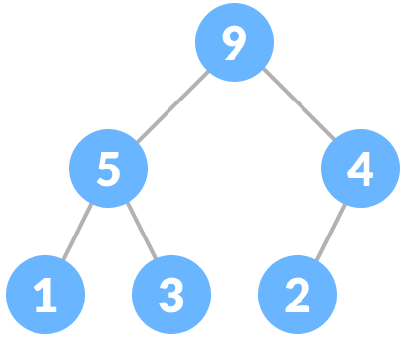 | 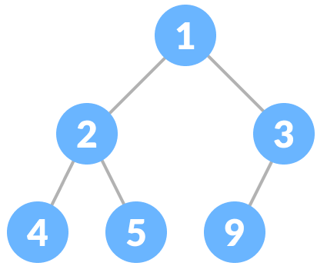

Heap tree construction
Input the array | Create complete Binary tree
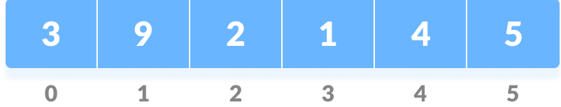 | 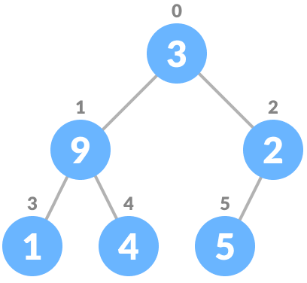

Heapify the complete binary tree
Heapify is the process of creating a heap data structure from a binary tree.
- Start from the first index of non-leaf node whose index is given by n/2 - 1.  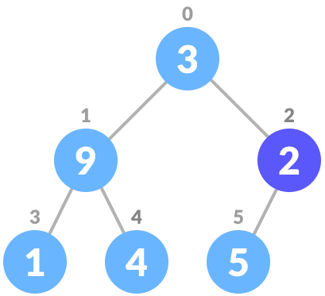 | - Set current element i as largest.  - The index of left child is given by 2i + 1  and the right child is given by 2i + 2.  - If leftChild is greater than currentElement , set leftChildIndex as largest.  - If rightChild is greater than currentElement , set rightChildIndex as largest | - Swap largest with the current element  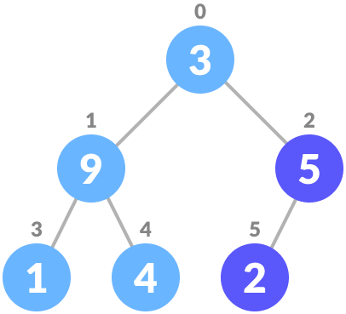  - i=i-1, Repeat steps till i=0.

Insert Operation
Insert the new element at the end of the array | Heapify the tree
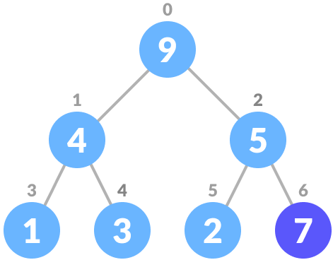 | 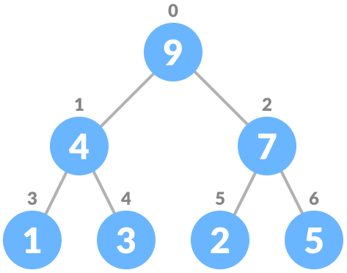

Delete Operation
Select the element 3 to delete | Swap it with the last element | Remove the last element | Heapify the tree
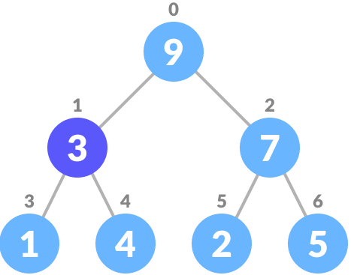 | 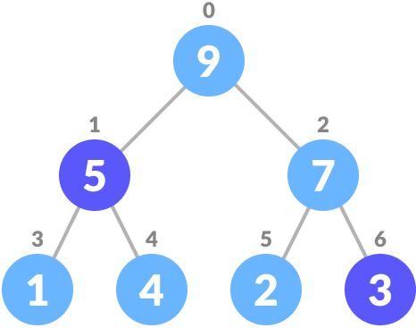 | 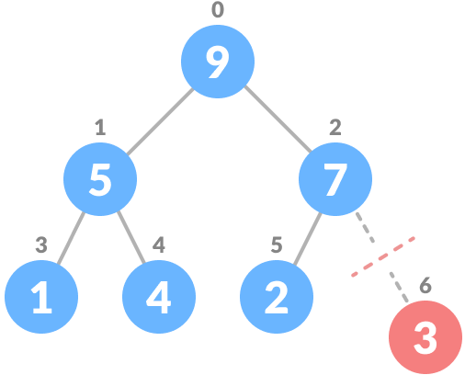 | 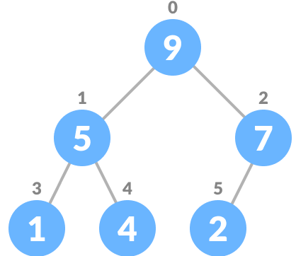

Applications of Heaps:

- Heap Sort: Heap Sort uses Binary Heap to sort an array in O(nLogn) time.
- Priority Queue: Priority queues can be efficiently implemented using Binary Heap because it supports insert(), delete() and extractmax(), decreaseKey() operations in O(logn) time. Binomoial Heap and Fibonacci Heap are variations of Binary Heap. These variations perform union also efficiently.
- Graph Algorithms: The priority queues are especially used in Graph Algorithms like Dijkstra’s Shortest Path and Prim’s Minimum Spanning Tree.
- Many problems can be efficiently solved using Heaps. See following for example.
a) K’th Largest Element in an array.
b) Sort an almost sorted array/
c) Merge K Sorted Arrays.

Operations on Min Heap:
- getMini(): It returns the root element of Min Heap. Time Complexity of this operation is O(1).
- extractMin(): Removes the minimum element from MinHeap. Time Complexity of this Operation is O(Logn) as this operation needs to maintain the heap property (by calling heapify()) after removing root.
- decreaseKey(): Decreases value of key. The time complexity of this operation is O(Logn). If the decreases key value of a node is greater than the parent of the node, then we don’t need to do anything. Otherwise, we need to traverse up to fix the violated heap property.
- insert(): Inserting a new key takes O(Logn) time. We add a new key at the end of the tree. IF new key is greater than its parent, then we don’t need to do anything. Otherwise, we need to traverse up to fix the violated heap property.
- delete(): Deleting a key also takes O(Logn) time. We replace the key to be deleted with minum infinite by calling decreaseKey(). After decreaseKey(), the minus infinite value must reach root, so we call extractMin() to remove the key.

#include <stdio.h>
int size = 0;
void swap(int *a, int *b)
{
int temp = *b;
*b = *a;
*a = temp;
}
void heapify(int array[], int size, int i)
{
if (size == 1)
{
printf("Single element in the heap");
}
else
{
int largest = i;
int l = 2 * i + 1;
int r = 2 * i + 2;
if (l < size && array[l] > array[largest])
largest = l;
if (r < size && array[r] > array[largest])
largest = r;
if (largest != i)
{
swap(&array[i], &array[largest]);
heapify(array, size, largest);
}
}
}
void insert(int array[], int newNum)
{
if (size == 0)
{
array[0] = newNum;
size += 1;
}
else
{
array[size] = newNum;
size += 1;
for (int i = size / 2 - 1; i >= 0; i--)
{
heapify(array, size, i);
}
}
}
void deleteRoot(int array[], int num)
{
int i;
for (i = 0; i < size; i++)
{
if (num == array[i])
break;
}

swap(&array[i], &array[size - 1]);
size -= 1;
for (int i = size / 2 - 1; i >= 0; i--)
{
heapify(array, size, i);
}
}
void printArray(int array[], int size)
{
for (int i = 0; i < size; ++i)
printf("%d ", array[i]);
printf("\n");
}
int main()
{
int array[10];

insert(array, 3);
insert(array, 4);
insert(array, 9);
insert(array, 5);
insert(array, 2);

printf("Max-Heap array: ");
printArray(array, size);

deleteRoot(array, 4);

printf("After deleting an element: ");

printArray(array, size);
}

B- Tree
A M way search tree, used to handle large dataset in disk.

Limitations of Search trees:
It is a two way (binary) tree, therefore it allow maximum of two child per node.
- Lead to deapest tree and take more time for search
But B-Tree contains more than one value (key) and more than two children. B-Tree was developed in the year 1972 by Bayer and McCreight with the name Height Balanced m-way Search Tree. Later it was named as B-Tree.

B-Tree of Order m has the following properties...
- Maximum of m child per node
- Minimum of m/2 child
- All leaf nodes are in same level
- The root node has atleast two child
- All nodes except root must have at least [m/2]-1 keys and maximum of m-1 keys.
- All non leaf nodes except root must have at least m/2 children
- All key values in a node must be in ascending order

Node structure
P₁ | K₁ | P₂ | K₂ | P₃ | K₃ | …….. | K_{m-1} | P_{m}

M – order of the tree
P_{1 …} P_{m} - Pointer to child
K_{1 …} K_{m-1} - Keys

Ex :
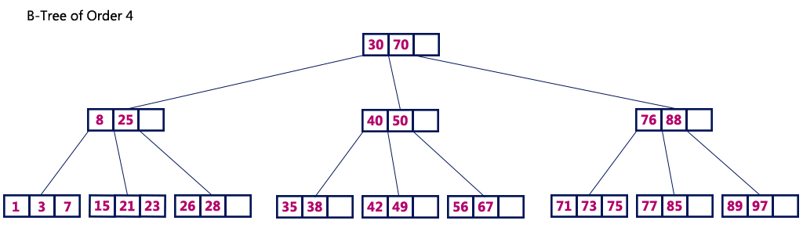

Operations on a B-Tree
The following operations are performed on a B-Tree...
- Search
- Insertion
- Deletion

Search Operation in B-Tree
The search operation in B-Tree is similar to the search operation in Binary Search Tree. In B-Tree also search process starts from the root node but here we make an n-way decision every time.
- Step 1 - Read the search element from the user.
- Step 2 - Compare the search element with first key value of root node in the tree.
- Step 3 - If both are matched, then display "Given node is found!!!" and terminate the function
- Step 4 - If both are not matched, then check whether search element is smaller or larger than that key value.
- Step 5 - If search element is smaller, then continue the search process in left subtree.
- Step 6 - If search element is larger, then compare the search element with next key value in the same node and repeate steps 3, 4, 5 and 6 until we find the exact match or until the search element is compared with last key value in the leaf node.
- Step 7 - If the last key value in the leaf node is also not matched then display "Element is not found" and terminate the function.

Insertion Operation in B-Tree
In a B-Tree, a new element must be added only at the leaf node. That means, the new keyValue is always attached to the leaf node only. The insertion operation is performed as follows...
- Step 1 - Check whether tree is Empty.
- Step 2 - If tree is Empty, then create a new node with new key value and insert it into the tree as a root node.
- Step 3 - If tree is Not Empty, then find the suitable leaf node to which the new key value is added using Binary Search Tree logic.
- Step 4 - If that leaf node has empty position, add the new key value to that leaf node in ascending order of key value within the node.
- Step 5 - If that leaf node is already full, split that leaf node by sending middle value to its parent node. Repeat the same until the sending value is fixed into a node.
- Step 6 - If the spilting is performed at root node then the middle value becomes new root node for the tree and the height of the tree is increased by one.

Insert the following element to a Btree (Order 3)
10,20,30,15,12,17,18,8,6,5,11
Insert 10 |  | Insert 20
Insert 30
Insert 15
Insert 12
Insert 17
Insert 18
Insert 8
Insert 6
Insert 5,11

Delete Operation in B-Tree

Identify the node which has been delteted
If the node has more than m/2 key then delete the key
If the node does not contain m/2 keys,
- If the left sibiling contain more than m/2 key,
Move the right most key of left to parent and move down the parent to node
- Else if the right sibiling contain more than m/2 key,
Move the left most key of right sibiling to parent and move down the parent to node.
- Else, [left and right sibiling does not contain excess]
Merge the left,right and parent nodes, which reduces the tree height by one.
Application of B-tree : Used to maintain database in disk.
 | Delete 6
Delete 15 | Delete 12
Delete 30

B+ Tree:
A variant of B-Tree.
Allow efficient insertion and search
The data are stored only in the leaf node
The intermediate node contain only key
The leaf nodes are connected by linked list.

 | B-Tree | B+ Tree
1 | All internal and leaf nodes have data pointers | Only leaf nodes have data pointers
2 | Since all keys are not available at leaf, search often takes more time. | All keys are at leaf nodes, hence search is faster and accurate..
3 | No duplicate of keys is maintained in the tree. | Duplicate of keys are maintained and all nodes are present at leaf.
4 | Insertion takes more time and it is not predictable sometimes. | Insertion is easier and the results are always the same.
5 | Deletion of internal node is very complex and tree has to undergo lot of transformations. | Deletion of any node is easy because all node are found at leaf.
6 | Leaf nodes are not stored as structural linked list. | Leaf nodes are stored as structural linked list.
7 | No redundant search keys are present.. | Redundant search keys may be present..
8 | All nodes are having key and data | Intermediate node having key, leaf nodes having data

UNIT IV NON LINEAR DATA STRUCTURES - GRAPHS
Definition – Representation of Graph – Types of graph - Breadth-first traversal - Depth-first traversal – Topological Sort – Bi-connectivity – Cut vertex – Euler circuits – Applications of graphs.

- A graph G is defined as follows:
G=(V,E)
V(G): a finite, nonempty set of vertices
E(G): a set of edges (pairs of vertices)

- When the edges in a graph have no direction, the graph is called undirected

- When the edges in a graph have a direction, the graph is called directed (or digraph)
- A cycle is a simple path in which the first and the last vertices are the same
- A directed graph is strongly connected if there is a directed path from vi to vj and also from vj to vi.

- the in-degree of a vertex v is the number of edges that have v as the head
- the out-degree of a vertex v is the number of edges that have v as the tail

Strongly connected component:
- A strongly connected component of a digraph G is a maximal strongly connected subgraph of G.

Ex: There are 2 SCC in this graph
- Complete graph: a graph in which every vertex is directly connected to every other vertex
- Adjacent nodes: two nodes are adjacent if they are connected by an edge
- Path: a sequence of vertices that connect two nodes in a graph
- What is the number of edges in a complete undirected graph with N vertices?
N * (N-1) / 2
- What is the number of edges in a complete directed graph with N vertices?
N * (N-1)

- A simple path is a path in which all vertices, except possibly the first and the last, are distinct

Ex: There are 2 simple path between 1 and 4

Path 1: 1->3->4
Path 2: 1->4
Weighted graph:
A graph in which each edge carries a value

Graph Representation

Adjacency matrix |  | Adjacency List
Good for dense graphs --|E|~O(|V|²)  Memory requirements: O(|V| + |E| ) = O(|V|² )  Connectivity between two vertices can be tested quickly |  | Good for sparse graphs -- |E|~O(|V|)  Memory requirements: O(|V| + |E|)=O(|V|)  Vertices adjacent to another vertex can be found quickly
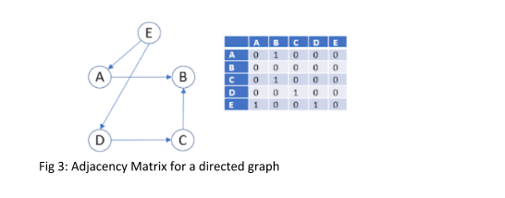 | Directed Graph
   | A | B | C | D | E
  A | 0 | 1 | 0 | 0 | 0
  B | 0 | 0 | 0 | 0 | 0
  C | 0 | 1 | 0 | 0 | 0
  D | 0 | 0 | 1 | 0 | 0
  E | 1 | 0 | 0 | 1 | 0
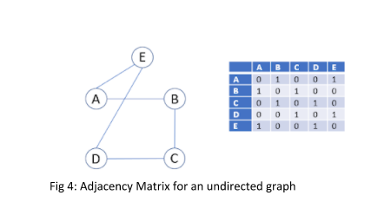 | Undirected Graph
   | A | B | C | D | E
  A | 0 | 1 | 0 | 0 | 1
  B | 1 | 0 | 1 | 0 | 0
  C | 0 | 1 | 0 | 1 | 0
  D | 0 | 0 | 1 | 0 | 1
  E | 1 | 0 | 0 | 1 | 0
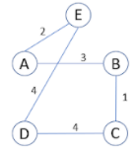 | Weighted undirected graph
   | A | B | C | D | E
  A | 0 | 3 | 0 | 0 | 2
  B | 3 | 0 | 1 | 0 | 0
  C | 0 | 1 | 0 | 4 | 0
  D | 0 | 0 | 4 | 0 | 4
  E | 2 | 0 | 0 | 4 | 0

Graph traversal
Graph traversal is a technique used for searching a vertex in a graph. The graph traversal is also used to decide the order of vertices is visited in the search process.
Traversal of a graph produces a spanning tree as final result. Spanning Tree is a graph without loops.
There are two graph traversal techniques.
- DFS (Depth First Search)
- BFS (Breadth First Search)

DFS (Depth First Search)
DFS implemented using Stack data structure with maximum size of total number of vertices in the graph.

We use the following steps to implement DFS traversal...
- Step 1 - Define a Stack of size total number of vertices in the graph.
- Step 2 - Select any vertex as starting point for traversal. Visit that vertex and push it on to the Stack.
- Step 3 - Visit any one of the non-visited adjacent vertices of a vertex which is at the top of stack and push it on to the stack.
- Step 4 - Repeat step 3 until there is no new vertex to be visited from the vertex which is at the top of the stack.
- Step 5 - When there is no new vertex to visit then use back tracking and pop one vertex from the stack.
- Step 6 - Repeat steps 3, 4 and 5 until stack becomes Empty.
- Step 7 - When stack becomes Empty, then produce final spanning tree by removing unused edges from the graph

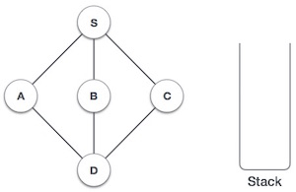 | DFS  Initialize the stack.
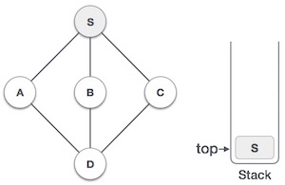 | Mark S as visited and put it onto the stack. Explore any unvisited adjacent node from S. We have three nodes and we can pick any of them. For this example, we shall take the node in an alphabetical order.
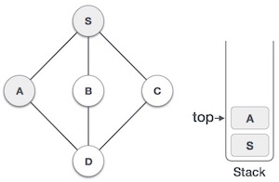 | Mark A as visited and put it onto the stack. Explore any unvisited adjacent node from A. Both Sand D are adjacent to A but we are concerned for unvisited nodes only.
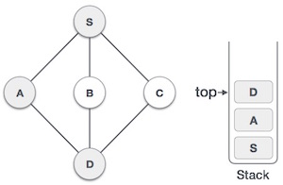 | Visit D and mark it as visited and put onto the stack. Here, we have B and C nodes, which are adjacent to D and both are unvisited. However, we shall again choose in an alphabetical order.
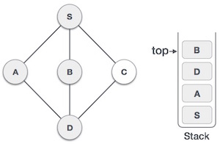 | We choose B, mark it as visited and put onto the stack. Here Bdoes not have any unvisited adjacent node. So, we pop Bfrom the stack.
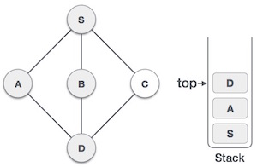 | We check the stack top for return to the previous node and check if it has any unvisited nodes. Here, we find D to be on the top of the stack.
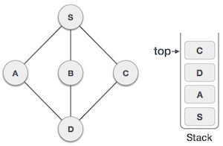 | Only unvisited adjacent node is from D is C now. So we visit C, mark it as visited and put it onto the stack.
For C nod unvisited node POP
For D nod unvisited node POP
For A nod unvisited node POP
For S nod unvisited node POP

 | S A D B C

BFS (Breadth First Search)
BFS implemented using Queue data structure with maximum size of total number of vertices in the graph.
We use the following steps to implement BFS traversal...
- Step 1 - Define a Queue of size total number of vertices in the graph.
- Step 2 - Select any vertex as starting point for traversal. Visit that vertex and insert it into the Queue.
- Step 3 - Visit all the non-visited adjacent vertices of the vertex which is at front of the Queue and insert them into the Queue.
- Step 4 - When there is no new vertex to be visited from the vertex which is at front of the Queue then delete that vertex.
- Step 5 - Repeat steps 3 and 4 until queue becomes empty.
- Step 6 - When queue becomes empty, then produce final spanning tree by removing unused edges from the graph
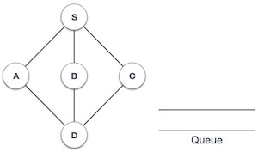 | BFS  Initialize the queue.  Enqueue the starting node (S)
  S
  F R
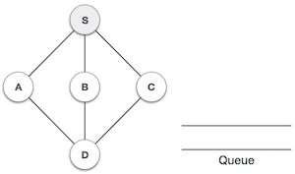 | Enqueue the adjacent and unvisited node(A,B,C) of S in ascending order, and Dequeue S from the Queue.
   | A | B | C
   | F |  | R
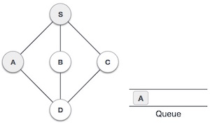 | Enqueue the adjacent and unvisited node(D) of A, and Dequeue A from the Queue.
   |  | B | C | D
   |  | F |  | R
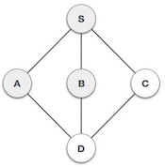 | No adjacent and unvisited node for B, Dequeue B
   |  |  | C | D
   |  |  | F | R
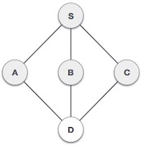 | No adjacent and unvisited node for C, Dequeue C
  D
  F R
 | No adjacent and unvisited node for D, Dequeue D
  D
  F R
 | No adjacent and unvisited node for D, Dequeue D
 | S A B C D

BFS | DFS
/* Graph Traversal – BFS */  #include <stdio.h>  #include <stdlib.h>  #define MAX 100  #define initial 1  #define waiting 2  #define visited 3  int n;  int adj[MAX][MAX];  int state[MAX];  void create_graph();  void BFS();  int queue[MAX], front = -1,rear = -1;  void insert_queue(int vertex);  int delete_queue();  int isEmpty_queue();  int main()  {  create_graph();  BFS();  return 0;  }  void BFS()  {  int i,v;  for(i=0; i<n; i++)  state[i] = initial;  printf("Enter Start Vertex for BFS: ");  scanf("%d", &v);  insert_queue(v);  state[v] = waiting;  printf("BFS Traversal : ");  while(!isEmpty_queue())  {  v = delete_queue( );  printf("%d ", v);  state[v] = visited;  for(i=0; i<n; i++)  {  if(adj[v][i] == 1 && state[i] == initial)  {  insert_queue(i);  state[i] = waiting;  }  }  }  printf("\n");  }  void insert_queue(int vertex)  {  if(rear == MAX-1)  printf("Queue Overflow\n");  else  {  if(front == -1)  front = 0;  rear = rear+1;  queue[rear] = vertex ;  }  }  int isEmpty_queue()  {  if(front == -1 || front > rear)  return 1;  else  return 0;  }  int delete_queue()  {  int delete_item;  if(front == -1 || front > rear)  {  printf("Queue Underflow\n");  exit(1);  }  delete_item = queue[front];  front = front+1;  return delete_item;  }  void create_graph()  {  int count,max_edge,origin,destin;  printf("Enter number of vertices : ");  scanf("%d", &n);  max_edge = n * (n-1);  for(count=1; count<=max_edge; count++)  {  printf("Enter edge %d( -1 -1 to quit ) : ",count);  scanf("%d %d", &origin, &destin);  if((origin == -1) && (destin == -1))  break;  if(origin>=n || destin>=n || origin<0 || destin<0)  {  printf("Invalid edge!\n");  count--;  }  else  adj[origin][destin] = 1;  }  } | /* Graph Traversal – DFS */  #include <stdio.h>  #include <stdlib.h>  #define MAX 100  #define initial 1  #define waiting 2  #define visited 3  int n;  int adj[MAX][MAX];  int state[MAX];  void create_graph();  void DFS();  int stack[MAX],top=-1;  void push_stack();  void pop_stack();  int peek_stack();  int isEmpty_stack();  int main()  {  create_graph();  DFS();  return 0;  }  void DFS()  {  int i,v;  for(i=0; i<n; i++)  state[i] = initial;  printf("Enter Start Vertex for DFS: ");  scanf("%d", &v);  printf("DFS Traversal : ");  push_stack(v);  state[v] = visited;  printf("%d ", v);  while(!isEmpty_stack())  {  v = peek_stack();  for(i=0; i<n; i++)  {  if(adj[v][i] == 1 && state[i] == initial)  {  push_stack(i);  state[i] = visited;  printf("%d ", i);  break;  }  }  if(i==n) pop_stack();  }  printf("\n");  }  void push_stack(int item)  {  stack[++top] = item;  }  void pop_stack()  {  top--;  }  int peek_stack()  {  return stack[top];  }  int isEmpty_stack()  {  return top == -1;  }  void create_graph()  {  int count,max_edge,origin,destin;  printf("Enter number of vertices : ");  scanf("%d", &n);  max_edge = n * (n-1);  for(count=1; count<=max_edge; count++)  {  printf("Enter edge %d( -1 -1 to quit ) : ",count);  scanf("%d %d", &origin, &destin);  if((origin == -1) && (destin == -1))  break;  if(origin>=n || destin>=n || origin<0 || destin<0)  {  printf("Invalid edge!\n");  count--;  }  else  adj[origin][destin] = 1;  }  }

Topological Sort for Acyclic Graph
Topological sorting for Directed Acyclic Graph (DAG) is a linear ordering of vertices such that for every directed edge u v, vertex u comes before v in the ordering. Topological Sorting for a graph is not possible if the graph is not a DAG.
int counter;
int v,w;
Q=createqueue();
counter=0;

for(v=0;v<n;v++)
{
if(indegree[v]==0)
enqueue(Q,v);
}

while(!isemptyqueue(Q))
{
v=dequeue(Q);
topologicalorder[v]=++counter;
for each w to adjacent to v
if(--indegree[w]==0)
{
enqueue(Q,w);
}
}

 | In degree before Dequeue
Vertex | 1 | 2 | 3 | 4 | 5 | 6 | 7
V₁ | 0 | 0 | 0 | 0 | 0 | 0 | 0
V₂ | 1 | 0 | 0 | 0 | 0 | 0 | 0
V₃ | 2 | 1 | 1 | 1 | 0 | 0 | 0
V₄ | 3 | 2 | 1 | 0 | 0 | 0 | 0
V₅ | 1 | 1 | 0 | 0 | 0 | 0 | 0
V₆ | 3 | 3 | 3 | 3 | 2 | 1 | 0
V₇ | 2 | 2 | 2 | 1 | 0 | 0 | 0
Enqueue | V₁ | V₂ | V₅ | V₄ | V_{3,} V₇ |  | V₆
Dequeue | V₁ | V₂ | V₅ | V₄ | V₃ | V₇ | V₆

Bi-connectivity – Cut vertex – Euler circuits
A graph is said to be Biconnected if:
1) It is connected, i.e. it is possible to reach every vertex from every other vertex, by a simple path.
2) Even after removing any vertex the graph remains connected.
Biconnected Graph | Not Biconnected graph
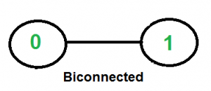 | 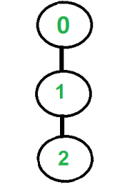

A connected graph is Biconnected if it is connected and doesn’t have any Articulation Point. We mainly need to check two things in a graph.
1) The graph is connected.
2) There is not articulation point in graph.

Articulation point (Cut vertex) – A vertex whose removal disconnect the graph.

Algorithm for check the graph is Bi-connected::
We start from any vertex and do DFS traversal. In DFS traversal, we check if there is any articulation point. If we don’t find any articulation point, then the graph is Biconnected. Finally, we need to check whether all vertices were reachable in DFS or not.
The idea is to use DFS (Depth First Search). In DFS, we follow vertices in tree form called DFS tree. In DFS tree, a vertex u is parent of another vertex v, if v is discovered by u (obviously v is an adjacent of u in graph). In DFS tree, a vertex u is articulation point if one of the following two conditions is true.
1) u is root of DFS tree and it has at least two children.
2) u is not root of DFS tree and it has a child v such that no vertex in subtree rooted with v has a back edge to one of the ancestors (in DFS tree) of u.

Graph | DFS | Articulation Point
Condition for AP,
If L[v] >= D[u]

L[v] – Least vertex can be reached.

D[v] – DFS vertex no

(i)
u=2 ; v=4
L[v] = 1 ; D[u]=2
L[v]<D[u]
therefore node 2 is not an AP

(ii)
u=4 ; v=7
L[v] = 3 ; D[u]=3
L[v]>=D[u]
therefore node 4 is AP

(iii)
u=5 ; v=6
L[v] = 3 ; D[u]=3
L[v]>=D[u]
therefore node 4 is AP

(i)
u=0 ; v=2
L[v] = 1 ; D[u]=2
L[v]<D[u]
therefore node 2 is not an AP

(ii)
u=0 ; v=3
L[v] = 4 ; D[u]=2
L[v]>=D[u]
therefore node 0 is AP

(iii)
u=3 ; v=4
L[v] = 4 ; D[u]=4
L[v]>=D[u]
therefore node 3 is AP

Euler Circuit
If there exists a walk in the connected graph that starts and ends at the same vertex and visits every edge of the graph exactly once with or without repeating the vertices, then such a walk is called as an Euler circuit.
Euler Graph | Not an Euler Graph
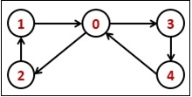 | 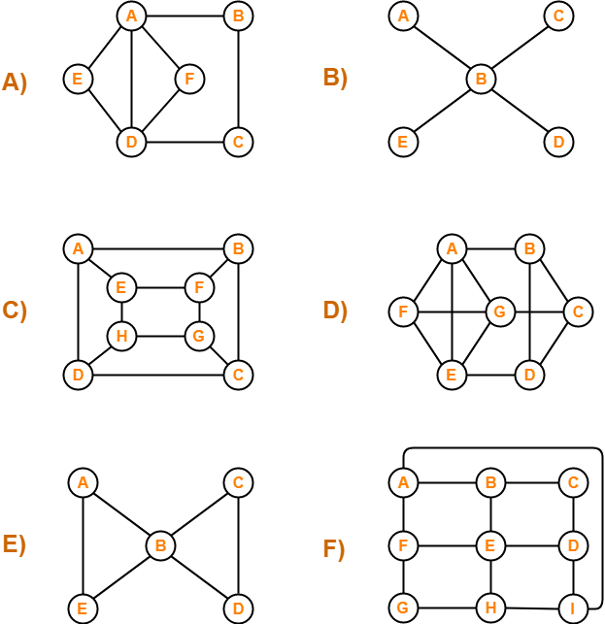

To check whether a graph is Eulerian or not, we have to check two conditions −
- The graph must be connected.
- For directed graph - The in-degree and out-degree of each vertex must be the same .
- For Undirected graph - The degree of each vertex must be EVEN.

Minimum spanning tree – Kruskal’s Algorithm
Minimum Spanning Tree is a set of edges in an undirected weighted graph that connects all the vertices with no cycles and minimum total edge weight.
When number of edges to vertices is low, kruskal’s algorithm is preferred.

Edge | Weight | Action
(V₁,V₄) | 1 | Accepted
(V₆,V₇) | 1 | Accepted
(V₁,V₂) | 2 | Accepted
(V₃,V₄) | 2 | Accepted
(V₂,V₄) | 3 | Rejected
(V₁,V₃) | 4 | Rejected
(V₄,V₇) | 4 | Accepted
(V₃,V₆) | 5 | Rejected
(V₅,V₇) | 6 | Accepted

Minimum spanning tree - Prim’s Algorithm
When number of edges to vertices is high, Prims’s algorithm is preferred.
V | Known | D_{v} | P_{v}
V₁ | F | 0 | 0
V₂ | F | ∞ | 0
V₃ | F | ∞ | 0
V₄ | F | ∞ | 0
V₅ | F | ∞ | 0
V₆ | F | ∞ | 0
V₇ | F | ∞ | 0

V | Known | D_{v} | P_{v}
V₁ | T | 0 | 0
V₂ | F | 2 | V₁
V₃ | F | 4 | V₁
V₄ | F | 1 | V₁
V₅ | F | ∞ | 0
V₆ | F | ∞ | 0
V₇ | F | ∞ | 0

V | Known | D_{v} | P_{v}
V₁ | T | 0 | 0
V₂ | F | 2 | V₁
V₃ | F | 2 | V₄
V₄ | T | 1 | V₁
V₅ | F | 7 | V₄
V₆ | F | 8 | V₄
V₇ | F | 4 | V₄

V | Known | D_{v} | P_{v}
V₁ | T | 0 | 0
V₂ | T | 2 | V₁
V₃ | F | 2 | V₄
V₄ | T | 1 | V₁
V₅ | F | 7 | V₄
V₆ | F | 8 | V₄
V₇ | F | 4 | V₄

V | Known | D_{v} | P_{v}
V₁ | T | 0 | 0
V₂ | T | 2 | V₁
V₃ | T | 2 | V₄
V₄ | T | 1 | V₁
V₅ | F | 7 | V₄
V₆ | F | 5 | V₃
V₇ | F | 4 | V₄

V | Known | D_{v} | P_{v}
V₁ | T | 0 | 0
V₂ | T | 2 | V₁
V₃ | T | 2 | V₄
V₄ | T | 1 | V₁
V₅ | F | 6 | V₇
V₆ | F | 1 | V₇
V₇ | T | 4 | V₄

V | Known | D_{v} | P_{v}
V₁ | T | 0 | 0
V₂ | T | 2 | V₁
V₃ | T | 2 | V₄
V₄ | T | 1 | V₁
V₅ | F | 6 | V₇
V₆ | T | 1 | V₇
V₇ | T | 4 | V₄

V | Known | D_{v} | P_{v}
V₁ | T | 0 | 0
V₂ | T | 2 | V₁
V₃ | T | 2 | V₄
V₄ | T | 1 | V₁
V₅ | T | 6 | V₇
V₆ | T | 1 | V₇
V₇ | T | 4 | V₄

Single Source Shortest Path Algorithm – Dijikstr’s
An algorithm that is used for finding the shortest distance, or path, from starting node to target node in a weighted graph is known as Dijkstra's Algorithm. This algorithm makes a tree of the shortest path from the starting node, to all other nodes in the graph

V | Known | D_{v} | P_{v}
V₁ | F | 0 | 0
V₂ | F | ∞ | 0
V₃ | F | ∞ | 0
V₄ | F | ∞ | 0
V₅ | F | ∞ | 0
V₆ | F | ∞ | 0
V₇ | F | ∞ | 0
Initial
V | Known | D_{v} | P_{v}
V₁ | T | 0 | 0
V₂ | F | 2 | V₁
V₃ | F | ∞ | 0
V₄ | F | 1 | V₁
V₅ | F | ∞ | 0
V₆ | F | ∞ | 0
V₇ | F | ∞ | 0
v1
declared known
V | Known | D_{v} | P_{v}
V₁ | T | 0 | 0
V₂ | F | 2 | V₁
V₃ | F | 3 | V₄
V₄ | T | 1 | V₁
V₅ | F | 3 | V₄
V₆ | F | 9 | V₄
V₇ | F | 5 | V₄
v4
declared known
V | Known | D_{v} | P_{v}
V₁ | T | 0 | 0
V₂ | T | 2 | V₁
V₃ | F | 3 | V₄
V₄ | T | 1 | V₁
V₅ | F | 3 | V₄
V₆ | F | 9 | V₄
V₇ | F | 5 | V₄
v2
declared known
V | Known | D_{v} | P_{v}
V₁ | T | 0 | 0
V₂ | T | 2 | V₁
V₃ | T | 3 | V₄
V₄ | T | 1 | V₁
V₅ | F | 3 | V₄
V₆ | F | 9 | V₄
V₇ | F | 5 | V₄
v3
declared known
V | Known | D_{v} | P_{v}
V₁ | T | 0 | 0
V₂ | T | 2 | V₁
V₃ | T | 3 | V₄
V₄ | T | 1 | V₁
V₅ | T | 3 | V₄
V₆ | F | 8 | V₄
V₇ | F | 5 | V₄
v5
declared known
V | Known | D_{v} | P_{v}
V₁ | T | 0 | 0
V₂ | T | 2 | V₁
V₃ | T | 3 | V₄
V₄ | T | 1 | V₁
V₅ | T | 3 | V₄
V₆ | F | 6 | V₄
V₇ | T | 5 | V₄
v7
declared known
V | Known | D_{v} | P_{v}
V₁ | T | 0 | 0
V₂ | T | 2 | V₁
V₃ | T | 3 | V₄
V₄ | T | 1 | V₁
V₅ | T | 3 | V₄
V₆ | T | 6 | V₇
V₇ | T | 5 | V₄
v6
declared known

V1->v2 = 2
V1->v4->v3=3
V1->v4=1
V1->v4->v5=3
V1->v4->v7->v6=6
V1->v4->v7=5

UNIT V SEARCHING, SORTING AND HASHING TECHNIQUES
Searching- Linear Search - Binary Search. Sorting - Bubble sort - Selection sort - Insertion sort - Shell sort – Radix sort. Hashing- Hash Functions – Separate Chaining – Open Addressing – Rehashing – Extendible Hashing.

Insertion Sort :
Following are the steps involved in insertion sort:
- We start by making the second element of the given array (index 1)
- The key element here is the new card that we need to add to our existing sorted set of cards.
- We compare the key element with the element(s) before it, in this case, element at index 0:
  - If the key element is less than the first element, we insert the key element before the first element.
  - If the key element is greater than the first element, then we insert it after the first element.
- Then, we make the third element of the array as key and will compare it with elements to it's left and insert it at the right position.
- And we go on repeating this, until the array is sorted.

Let's consider an array with values {5, 1, 6, 2, 4, 3}
Below, we have a pictorial representation of how Insertion sort will sort the given array.
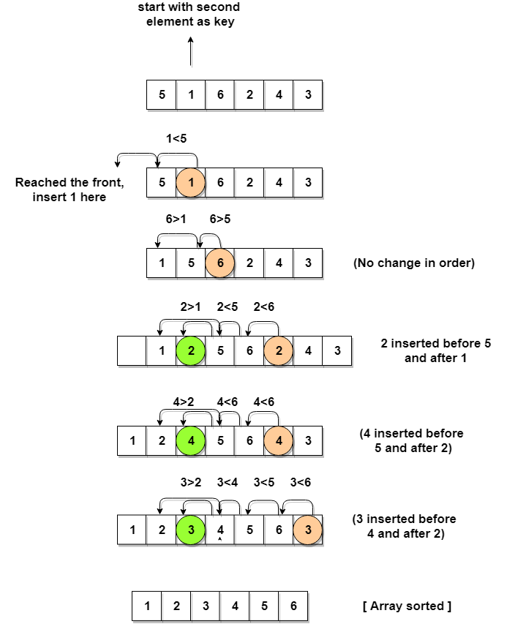 | void insertion(int array[],int n)  {  for (c = 1 ; c <= n - 1; c++)  {  d = c;  while ( d > 0 && array[d-1]  > array[d])  {  t = array[d];  array[d] = array[d-1];  array[d-1] = t;  d--;  }  }  }
We continue to move towards left if the elements are greater than the key element and stop when we find the element which is less than the key element.
And, insert the key element after the element which is less than the key element.

Bubble Sort
Following are the steps involved in bubble sort(for sorting a given array in ascending order):
- Starting with the first element(index = 0), compare the current element with the next element of the array.
- If the current element is greater than the next element of the array, swap them.
- If the current element is less than the next element, move to the next element. Repeat Step 1.

void bubble(int array[],int n)
{
for (c = 0 ; c < n - 1; c++)
{
for (d = 0 ; d < n - c - 1; d++)
{
if (array[d] > array[d+1])
{
swap = array[d];
array[d] = array[d+1];
array[d+1] = swap;
}
}
}
}
Let's consider an array with values {5, 1, 6, 2, 4, 3}
Below, we have a pictorial representation of how bubble sort will sort the given array.
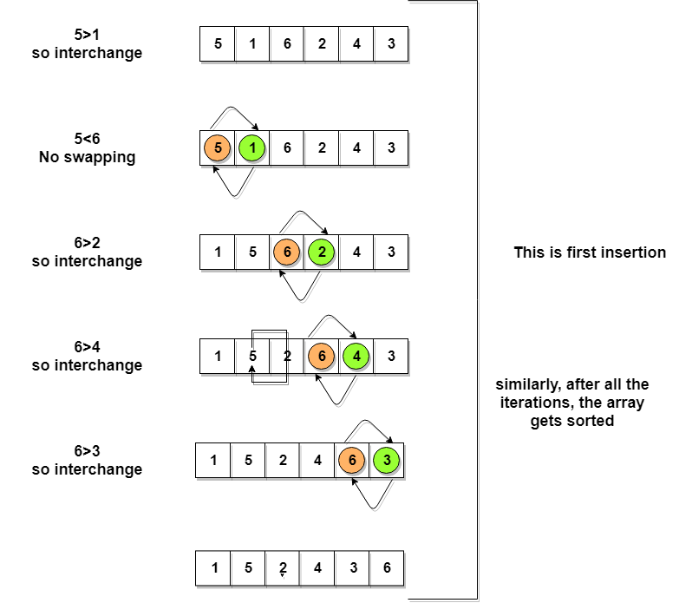 | After the first iteration, 6 is placed at the last index, which is the correct position for it.  Similarly after the second iteration, 5 will be at the second last index, and so on.

Selection Sort :
Following are the steps involved in selection sort(for sorting a given array in ascending order):
- Starting from the first element, we search the smallest element in the array, and replace it with the element in the first position.
- We then move on to the second position, and look for smallest element present in the subarray, starting from index 1, till the last index.
- We replace the element at the second position in the original array, with the second smallest element.
- This is repeated, until the array is completely sorted.

void selection(int array[],int n)
{
for ( c = 0 ; c < ( n - 1 ) ; c++ )
{ position = c;
for ( d = c + 1 ; d < n ; d++ )
if ( array[position] > array[d] )
position = d;
if ( position != c )
{swap = array[c];
array[c] = array[position];
array[position] = swap;
}
}
}
Let's consider an array with values {3, 6, 1, 8, 4, 5}
Below, we have a pictorial representation of how selection sort will sort the given array.
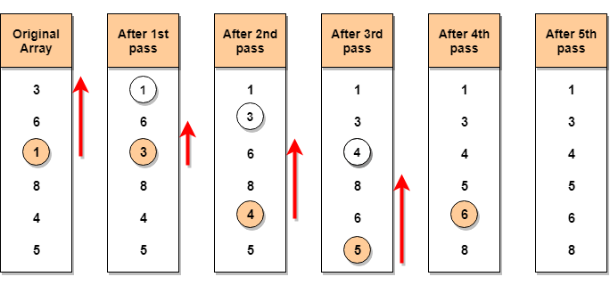
In the first pass, the smallest element will be 1, so it will be placed at the first position.
Then leaving the first element, next smallest element will be searched, from the remaining elements. We will get 3 as the smallest, so it will be then placed at the second position.
Then leaving 1 and 3(because they are at the correct position), we will search for the next smallest element from the rest of the elements and put it at third position and keep doing this until array is sorted.

Shell Sort:
Let us consider the following example to have an idea of how shell sort works.
we take the interval of 4 (n/2). Make a virtual sub-list of all values located at the interval of 4 positions. Here these values are {35, 14}, {33, 19}, {42, 27} and {10, 44}
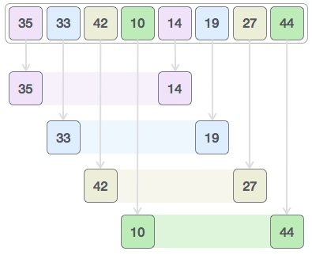  We compare values in each sub-list and swap them (if necessary) in the original array.  After this step, the new array should look like this −  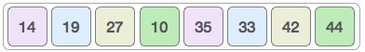  Then, we take interval of 2 and this gap generates two sub-lists - {14, 27, 35, 42}, {19, 10, 33, 44}  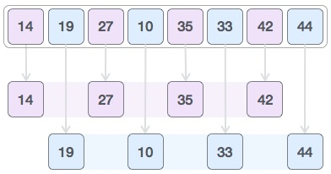  We compare and swap the values, if required, in the original array. After this step, the array should look like this –  Finally, we sort the rest of the array using interval of value 1. Shell sort uses insertion sort to sort the array. | void shellsort(int arr[], int num)  {  int i, j, k, tmp;  for (i = num / 2; i > 0; i = i / 2)  {  for (j = i; j < num; j++)  {  for(k = j - i; k >= 0; k = k - i)  {  if (arr[k+i] >= arr[k])  break;  else  {  tmp = arr[k];  arr[k] = arr[k+i];  arr[k+i] = tmp;  }  }  }  }  }
  14 | 10 | 27 | 19 | 35 | 33 | 42 | 44
  10 | 14 | 19 | 27 | 33 | 35 | 42 | 44

Radix Sort :
The bin sorting approach can be generalised in a technique that is known as radix sorting.

Example:
Assume that we have n integers in the range (0,n²) to be sorted. (For a bin sort, m = n², and we would have an O(n+m) = O(n²) algorithm.) Sort them in two phases:
- Using n bins, place a_{i} into bin a_{i} mod n,
- Repeat the process using n bins, placing a_{i} into bin floor(a_{i}/n), being careful to append to the end of each bin.
This results in a sorted list.
As an example, consider the list of integers: 36 9 0 25 1 49 64 16 81 4
n is 10 and the numbers all lie in (0,99). After the first phase, we will have:
Bin | 0 | 1 | 2 | 3 | 4 | 5 | 6 | 7 | 8 | 9
Content | 0 | 1  81 | - | - | 64  4 | 25 | 36  16 | - | - | 9  49
Note that in this phase, we placed each item in a bin indexed by the least significant decimal digit.
Repeating the process, will produce:
Bin | 0 | 1 | 2 | 3 | 4 | 5 | 6 | 7 | 8 | 9
Content | 0  1  4  9 | 16 | 25 | 36 | 49 | - | 64 | - | 81 | -

Bin | 0 | 1 | 2 | 3 | 4 | 5 | 6 | 7 | 8 | 9
Content | 0  1  4  9  16  25  36  49  64  81 | - | - | - | - | - | - | - | - | -
In this second phase, we used the leading decimal digit to allocate items to bins, being careful to add each item to the end of the bin.
We can apply this process to numbers of any size expressed to any suitable base or radix.

Linear Search
Linear search is a very basic and simple search algorithm. In Linear search, we search an element or value in a given array by traversing the array from the starting, till the desired element or value is found.
The time complexity of Linear search algorithm is O(n),

Implementing Linear Search
Following are the steps of implementation that we will be following:
- Traverse the array using a for loop.
- In every iteration, compare the target value with the current value of the array.
  - If the values match, return the current index of the array.
  - If the values do not match, move on to the next array element.
- If no match is found, return -1.

void linearsearch(int array[],int n){
for (c = 0; c < n; c++)
{
if (array[c] == search) {
{printf("%d is present at location %d.\n", search, c+1);
break;}
}
}
if (c == n)
printf("%d isn't present in the array.\n", search);
}

Binary Search
Binary Search is applied on the sorted array or list of large size. It's time complexity of O(log n) makes it very fast as compared to other sorting algorithms. The only limitation is that the array or list of elements must be sorted for the binary search algorithm to work on it.

Implementing Binary Search Algorithm
- Start with the middle element:
  - If the target value is equal to the middle element of the array, then return the index of the middle element.
  - If not, then compare the middle element with the target value,
    - If the target value is greater than the number in the middle index, then pick the elements to the right of the middle index, and start with Step 1.
    - If the target value is less than the number in the middle index, then pick the elements to the left of the middle index, and start with Step 1.
- When a match is found, return the index of the element matched.
- If no match is found, then return -1

void binarysearch(int array[],int n)
{
first = 0; last = n - 1; middle = (first+last)/2;
while (first <= last) {
if (array[middle] < search)
first = middle + 1;
else if (array[middle] == search) {
printf("%d found at location %d.\n", search, middle+1);
break;
}
else
last = middle - 1;
middle = (first + last)/2;
}
if (first > last)
printf("Not found! %d isn't present in the list.\n", search);
}

Element to search 42

Element | 10 | 15 | 18 | 25 | 30 | 42 | 55 | 87 | 98
Index | 0 | 1 | 2 | 3 | 4 | 5 | 6 | 7 | 8
Ptr | first |  |  |  | middle |  |  |  | last

middle = (first+last)/2 = (0+8)/2 = 4
a[middle] < search [30<42]
first=middle+1 = 4+1 = 5

Element | 10 | 15 | 18 | 25 | 30 | 42 | 55 | 87 | 98
Index | 0 | 1 | 2 | 3 | 4 | 5 | 6 | 7 | 8
Ptr |  |  |  |  |  | first | middle |  | last

middle = (first+last)/2 = (5+8)/2 = 13/2=6
a[middle] > search [55>42]
last=middle-1 = 6-1 = 5

Element | 10 | 15 | 18 | 25 | 30 | 42 | 55 | 87 | 98
Index | 0 | 1 | 2 | 3 | 4 | 5 | 6 | 7 | 8
Ptr |  |  |  |  |  | first last middle

middle = (first+last)/2 = (5+5)/2 = 5
a[middle] == search [42==42]
42 found at location 6

Hashing
- Hashing is a technique to convert a range of key values into a range of indexes of an array.
- The idea is to use hash function that converts a given phone number or any other key to a smaller number and uses the small number as index in a table called hash table.
- Hashing is the solution that can be used in almost all such situations and performs extremely well compared to other data structures like Array, Linked List and AVL.
With hashing we get O(1) search time on average and O(n) in worst case.
Hash Function: A function that maps a big number to a small integer that can be used as index in hash table.
A good hash function should have following properties
1) Efficiently computable.
2) Should uniformly distribute the keys

Hash Table: An array that stores pointers to records corresponding to a given phone number.

Collision: The situation where a newly inserted key maps to an already occupied slot in hash table is called collision and must be handled using some collision handling technique.

How to handle Collisions?
There are mainly two methods to handle collision:
1) Separate Chaining
2) Open Addressing
1)Separate Chaining:
The idea is to make each cell of hash table point to a linked list of records that have same hash function value.
Let us consider a simple hash function as “key mod 7” and sequence of keys as 50, 700, 76, 85, 92, 73, 101.
Advantages:
1) Simple to implement.
2) Hash table never fills up, we can always add more elements to chain.
3) Less sensitive to the hash function or load factors.
4) It is mostly used when it is unknown how many and how frequently keys may be inserted or deleted.
Disadvantages:
1) Cache performance of chaining is not good as keys are stored using linked list. Open addressing provides better cache performance as everything is stored in same table.
2) Wastage of Space (Some Parts of hash table are never used)
3) If the chain becomes long, then search time can become O(n) in worst case.
4) Uses extra space for links.

2)Open Addressing
In Open Addressing, all elements are stored in the hash table itself. So at any point, size of the table must be greater than or equal to the total number of keys
Insert(k): Keep probing until an empty slot is found. Once an empty slot is found, insert k.
Search(k): Keep probing until slot’s key doesn’t become equal to k or an empty slot is reached.
Delete(k): Delete operation is interesting. If we simply delete a key, then search may fail. So slots of deleted keys are marked specially as “deleted”.
Insert can insert an item in a deleted slot, but the search doesn’t stop at a deleted slot.
- Linear Probing: In linear probing, we linearly probe for next slot. For example, typical gap between two probes is 1 as taken in below example also.
let hash(x) be the slot index computed using hash function and S be the table size

If slot hash(x) % S is full, then we try (hash(x) + 1) % S
If (hash(x) + 1) % S is also full, then we try (hash(x) + 2) % S
If (hash(x) + 2) % S is also full, then we try (hash(x) + 3) % S
..................................................
Let us hash function as “key mod 7” and sequence of keys as 50, 700, 76, 85, 92, 73, 101.
Index | After 50 | After  700 | After 76 | After 85 | After  85 | After  92 | After 92 | After  73 | After  73 | After 101 | After 101
0 |  | 700 | 700 | 700 | 700 | 700 | 700 | 700 | 700 | 700 | 700
1 | 50 | 50 | 50 | 50 / 85 | 50 | 50/92 | 50 | 50 | 50 | 50 | 50
2 |  |  |  |  | 85 | 85 | 85 | 85 | 85 | 85 | 85
3 |  |  |  |  |  |  | 92 | 92/73 | 92 | 92/101 | 92
4 |  |  |  |  |  |  |  |  | 73 | 73 | 73
5 |  |  |  |  |  |  |  |  |  |  | 101
6 |  |  | 76 | 76 | 76 | 76 | 76 | 76 | 76 | 76 | 76

Clustering: The main problem with linear probing is clustering, many consecutive elements form groups and it starts taking time to find a free slot or to search an element.

b) Quadratic Probing We look for i²‘th slot in i’th iteration.
let hash(x) be the slot index computed using hash function.
If slot hash(x) % S is full, then we try (hash(x) + 1*1) % S
If (hash(x) + 1*1) % S is also full, then we try (hash(x) + 2*2) % S
If (hash(x) + 2*2) % S is also full, then we try (hash(x) + 3*3) % S
..................................................
Let us hash function as “key mod 7” and sequence of keys as 50, 700, 76, 85, 92, 73, 101.
Index | After 50 | After  700 | After 76 | After 85 | After  85 | After  92 | After 92 | After  73 | After  101 | After 101
0 |  | 700 |  | 700 | 700 | 700 | 700 | 700 | 700 | 700
1 | 50 |  |  | 50 / 85 | 50 | 50/92 | 50 | 50 | 50 | 50
2 |  |  |  |  | 85 | 85 | 85 | 85 | 85 | 85
3 |  |  |  |  |  |  |  | 73 | 73/101 | 73
4 |  |  |  |  |  |  |  |  |  | 101
5 |  |  |  |  |  |  | 92 | 92 | 92 | 92
6 |  |  | 76 | 76 | 76 | 76 | 76 | 76 | 76 | 76

c) Double Hashing We use another hash function hash2(x) and look for i*hash2(x) slot in i’th rotation.
let hash(x) be the slot index computed using hash function.
If slot hash(x) % S is full, then we try (hash(x) + 1*hash2(x)) % S
If (hash(x) + 1*hash2(x)) % S is also full, then we try (hash(x) + 2*hash2(x)) % S
If (hash(x) + 2*hash2(x)) % S is also full, then we try (hash(x) + 3*hash2(x)) % S
..................................................
..................................................

First hash function is typically hash1(key) = key % TABLE_SIZE
A popular second hash function is : hash2(key) = PRIME – (key % PRIME) where PRIME is a prime smaller than the TABLE_SIZE.
A good second Hash function is:
- It must never evaluate to zero
- Must make sure that all cells can be probed

Let us hash function as “key mod 7” and sequence of keys as 50, 700, 76, 85, 92, 73, 101.

Index | After 50 | After  700 | After 76 | After 85 | After  85 | After  92 | After 92 | After  73 | After 101 | After 101
0 |  | 700 |  | 700 | 700 | 700 | 700 | 700 | 700 | 700
1 | 50 |  |  | 50 / 85 | 50 | 50/92 | 50 | 50 | 50 | 50
2 |  |  |  |  |  |  |  |  |  | 101
3 |  |  |  |  |  |  |  | 73 | 73/101 | 73
4 |  |  |  |  |  |  | 92 | 92 | 92 | 92
5 |  |  |  |  | 85 | 85 | 85 | 85 | 85 | 85
6 |  |  | 76 | 76 | 76 | 76 | 76 | 76 | 76 | 76

Comparison of above three:
- Linear probing has the best cache performance but suffers from clustering. One more advantage of linear probing is easy to compute.
- Quadratic probing lies between the two in terms of cache performance and clustering.
- Double hashing has poor cache performance but no clustering. Double hashing requires more computation time as two hash functions need to be computed.

Sno | Separate Chaining | Open Addressing
1 | Chaining is Simpler to implement | Open Addressing requires more computation
2 | In chaining, Hash table never fills up, we can always add more elements to chain | In open addressing, table may become full
3 | Chaining is Less sensitive to the hash function or load factors | Open addressing requires extra care for to avoid clustering and load factor
4 | Chaining is mostly used when it is unknown how many and how frequently keys may be inserted or deleted | Open addressing is used when the frequency and number of keys is known
5 | Cache performance of chaining is not good as keys are stored using linked list | Open addressing provides better cache performance as everything is stored in the same table.
6 | Wastage of Space (Some Parts of hash table in chaining are never used). | In Open addressing, a slot can be used even if an input doesn’t map to it
7 | Chaining uses extra space for links | No links in Open addressing

Rehashing
If the table is close to full, the search time grows and may become equal to the table size.
When the load factor exceeds a certain value (e.g. greater than 0.5) we do rehashing :
Build a second table twice as large as the original and rehash all the keys of the original table.
Before rehasing | After rehasing
  Index | Key
  0 | 700
  1 | 50
  2 | 101
  3 | 73
  4 | 92
  5 | 85
  6 | 76
  Index | key
  0
  1 | 92
  2
  3
  4
  5
  6
  7 | 85
  8 | 73
  9
  10 | 101
  11 | 700
  12 | 50
  13 | 76
Rehashing is expensive operation, with running time O(N)
However, once done, the new hash table will have good performance.
Extendible hashing
Used when the amount of data is too large to fit in main memory and external storage is used.
N records in total to store, M records in one disk block
The problem: in ordinary hashing several disk blocks may be examined to find an element -
a time consuming process.
Extendible hashing: no more than two blocks are examined.
Idea:
Keys are grouped according to the first m bits in their code.
Each group is stored in one disk block.
If the block becomes full and no more records can be inserted, each group is split into two,
and m+1 bits are considered to determine the location of a record.
Example: lets' say we have 4 groups of keys according to the first two bits:

00 | 01 | 10 | 11
00010 | 01001 | 10001 | 11000
00100 | 01010 | 10100 | 11010
 | 01100
Each disk block in the example can contain 3 records only, 4 blocks are needed to store the above keys
New key to be inserted: 01011.
Block2 is full, so we start considering 3 bits:
After inserting 01011 :: Block 2 is full | Extendible hashing
  00 | 01 | 10 | 11
  00010 | 01001 | 10001 | 11000
  00100 | 01010 | 10100 | 11010
   | 01100
   | 01011
  000 | 001 | 010 | 011 | 100 | 101 | 110 | 111
  00010  00100 |  | 01001 | 01100 | 10001  10100 |  | 11000  11010
   |  | 01010
   |  | 01011
The second group of keys is split onto two disk blocks - one for keys staring with 010,
and one for keys starting with 011.
A directory is maintained in main memory with pointers to the disk blocks for each bit pattern.
The size of the directory is 2D = O(N(1+1/M)/M), where
D - number of bits considered
N - number of records
M - number of disk blocks.

