JAVA SCRIPT-INTRODUCTION

A scripting language is used to write scripts.These contain a series of commands that are interpreted one by one at runtime.

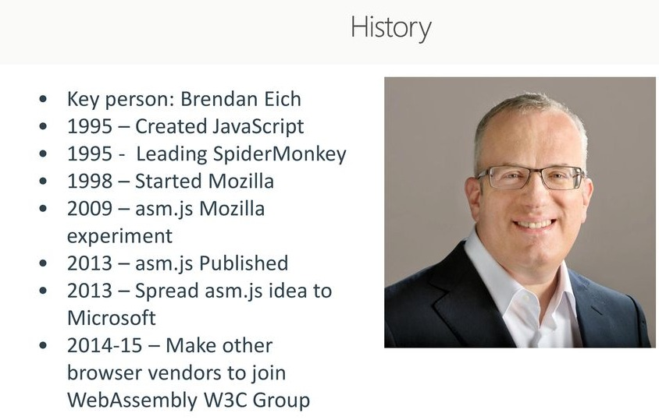

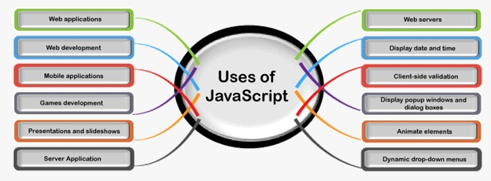

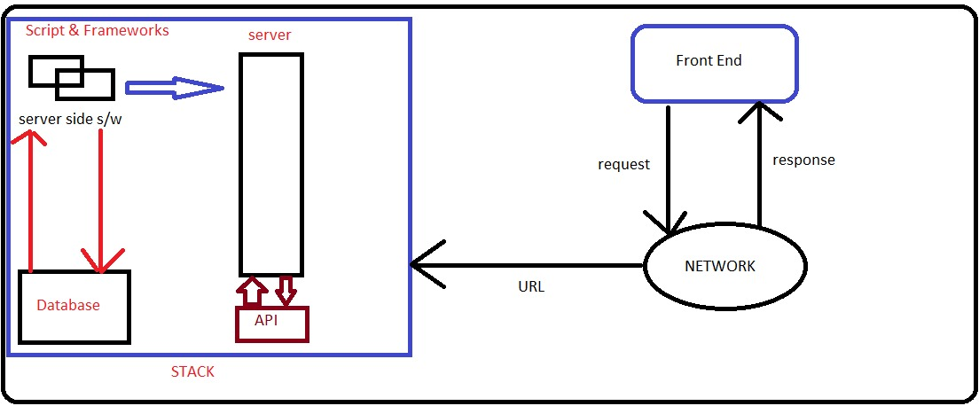

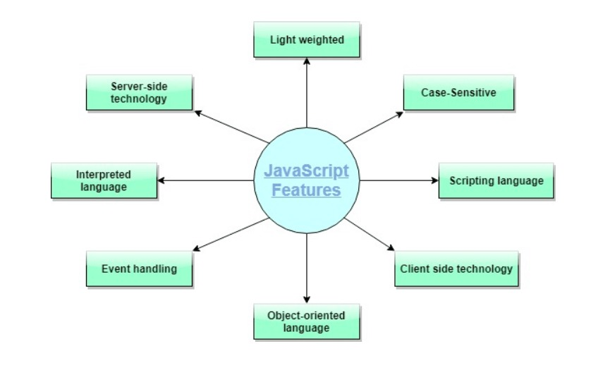

JS=server side technology +client side technology=Full-fledged programming lang

Purpose is to add functionality to the HTML

Usually we use java script at front end and node.js at back end.

Java script developer’s console:To test our javascript code,not recommended for main coding

Browser🡪right click🡪Inspect🡪console or ctrl+shift+j

Primitive Data Types In Javascript

1.number: 20,25,24.5,-23-🡪“number”,10+2,10-2,10\*\*2,10\*2,10/2,10%3

10+20\*3=70 10\*(2+3)=20

typeof(10.2) 🡺'number'

2.string: ‘pentagon’ or “pentagon”,+🡺concatenation

"hello"+"pentagon"🡺'hellopentagon'

Esc chars🡪\t \n

Ex: "pentagon".length🡺8

"pentagon"[2]🡺'n' index of first char is 0

"pentagon"[100]🡪undefined

3.boolean 🡪only allowed values are true or false

JAVASCRIPT VARIABLES

var name=”shreenath”

var age=20

var isGraduated=false

javascript is also a dynamically typed language.

null and undefined:

If variables are declared but not initialized,such variables are considered as undefined.

var a

typeof a🡪undefined

null🡪the variable is not pointing to any object.

Methods to read and write data

alert()🡪To display alert msg to end user.alert(“msg”)

console.log()🡪To display message to the console

prompt()🡪To get input from end user.

Writing js code in a separate file and connect to html

Create a javascript file 1.js

alert("hello pentagon")

Create an html file 1.html and connect js file

<html>

<head>

<script type="text/javascript" src="1.js"></script>

</head>

<body>

<h1>First example</h1>

</body>

</html>

<html>

<head>

<script>

alert("hello world")

</script>

</head>

<body>

<h1>First example</h1>

</body>

</html>

The values are read in the form string

1.html

<html>

<head>

<script type="text/javascript" src="1.js"></script>

</head>

<body>

<h1>second example</h1>

</body>

</html>

1.js

var name=prompt("Enter your name")

var x=prompt("enter 1st value")

var y=prompt("enter 2nd value")

var z=x+y

alert(name) //shreenath

alert(z) //1020

Operators such as Arithmetic operators,Comparison operators

Difference b/w == and ===

==🡪Normal equality operator In which values are important but not the datatype

===🡪Strict equality operator in which both values and datatypes are important

alert(10==10)🡪true

alert(10===10)🡪true

alert(10==”10”)🡪true

alert(10==”10”)🡪false

true=="1"🡪true

false===”0”🡪false

NaN(Not a number)

If the result of an operation is undefined then we get NaN

0/0

Logical operators🡺&&[logical and] ,||[logical or],![logical not]

Zero value🡺false,non-zero🡪true

Empty string🡪false, non-empty string🡺true

null ,undefined, NaN🡺false

Conditional statements

if(cond)

{

Body

}

else if

{

body

}

else

{

Body

}

1.js

var num=Number(prompt("Enter a num")) //str to number

if(num%2==0)

{

console.log("even")

}

else

{

console.log("odd")

}

1.html

<html>

<head>

<script type="text/javascript" src="1.js"></script>

</head>

<body>

<h1>Conditional stmt example</h1>

</body>

</html>

<html>

<head>

<script>

var num=Number(prompt("Enter a num"))

if(num>0)

{

console.log("+ve num")

}

else if(num<0)

{

console.log("-ve num")

}

else

{

console.log("zero")

}

</script>

</head>

<body>

<h1>Conditional stmt example</h1>

</body>

</html>

<html>

<head>

<script>

var num1=Number(prompt("Enter 1st num"))

var num2=Number(prompt("Enter 2nd num"))

var num3=num1+num2

alert(num3)

</script>

</head>

<body>

<h1>Conditional stmt example</h1>

</body>

</html>