**Javascript Objects**

**Javascript objects store information in the form of key-value pairs.**

**var var_name={key1:value1,key2:value2…..}**

**var emp={**

**name:”Mahendr”,**

**eid:100,**

**place:”Blore”**

**}**

**To access the values:emp[“name”] or emp.name**

**🡪var emp={} or var emp=new Object()**

**🡪emp[“name”]=”Einstein”**

**<script>**

**var emp={}**

**emp["name"]="Einstein"**

**emp["id"]=100**

**emp["place"]="Blore"**

**//alert(emp[name])//undefined**

**alert(emp["name"])//Einstein**

**</script>**

**<script>**

**var emp=new Object()**

**emp["name"]="Einstein"**

**emp["id"]=100**

**emp["place"]="Blore"**

**//alert(emp[name])//undefined**

**alert(emp["name"])**

**alert(emp["id"])**

**</script>**

**Updating the values**

**<script>**

**var emp=new Object()**

**emp["name"]="Einstein"**

**emp["id"]=100**

**emp["place"]="Blore"**

**//alert(emp[name])//undefined**

**alert(emp["name"])**

**alert(emp["id"])**

**emp["id"]=999**

**alert(emp["id"])**

**</script>**

**For loop to display key-value pairs**

**<script>**

**var emp={"name":"shreenath","eid":100,"place":"Blore"}**

**//alert(emp[name])//undefined**

**for(key in emp)**

**{**

**alert(key+":"+emp[key]) //key elements**

**}**

**</script>**

**Objects inside an array**

**<script>**

**var emp=[**

**{"name":"shreenath","eid":100,"place":"Blore"},**

**{"name":"shreenidhi","eid":102,"place":"Mysore"}**

**]**

**alert(emp[0]["name"])//shreenath**

**alert(emp[1]["place"])//Mysore**

**</script>**

**Object method**

**<script>**

**var emp={"A":"Apple",**

**"B":"Ball",**

**m:function(){alert("object method")}**

**}**

**emp.m()**

**</script>**

**this keyword:Inside the object method if we want to access object properties then we should use this keyword.**

**<script>**

**var stud={**

**"id":100,**

**"name":"anu",**

**"marks":92,**

**fun:function()//obejct method**

**{**

**alert("Student id="+this.id)**

**alert("Student name="+this.name)**

**alert("Student marks="+this.marks)**

**}**

**}**

**stud.fun()**

**</script>**

**DOCUMENT OBJECT MODEL**

**Dom is an interface b/w javascript html and css.**

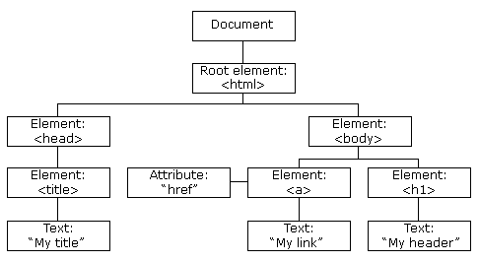

**We can access HTML elements through DOM**

**1.document.URL🡺This is original URL of the website**

**2.document.body🡪This returns everything inside body**

**3.document.head🡪This returns head of the page**

**4.documet.links🡪This returns list of all links of the page**

**5.document.getElementById()🡪Returns element with specified id**

**6.document.getElementByClassName()🡪Returns list of elements of specific clas**

**7.document.getElementByTagName()🡪Returns list of elements of specific tag**

**8.document.querySelector()🡪Returns the first object matching css style selector**

**9.document.querySelctorAll()🡪Returns all objects matches css selector**

**<html>**

**<head>**

**<title>Example1</title>**

**</head>**

**<body>**

**<h1>DOM Example</h1>**

**<p>**

**Pentagon Space would be the focal point for the people who want to master the future with niche technologies and the clients who are in search of resources can be deployed from the first day of work.**

**</p>**

**<h2>Favourite subjects</h2>**

**<ul>**

**<li>Java</li>**

**<li>Python</li>**

**<li>C#</li>**

**<li id="id-one">Javascript</li>**

**</ul>**

**<h2>Favorite games</h2>**

**<ul>**

**<li class="class-one">Cricket</li>**

**<li>Football</li>**

**<li>Tennis</li>**

**</ul>**

**<a href="https://pentagonspace.in/about-us">Pentagon space</a>**

**</body>**

**<script>**

**</script>**

**</html>**

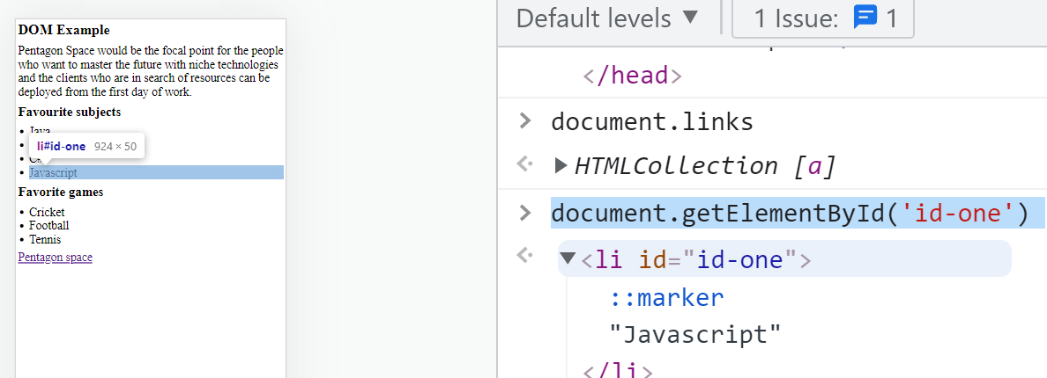

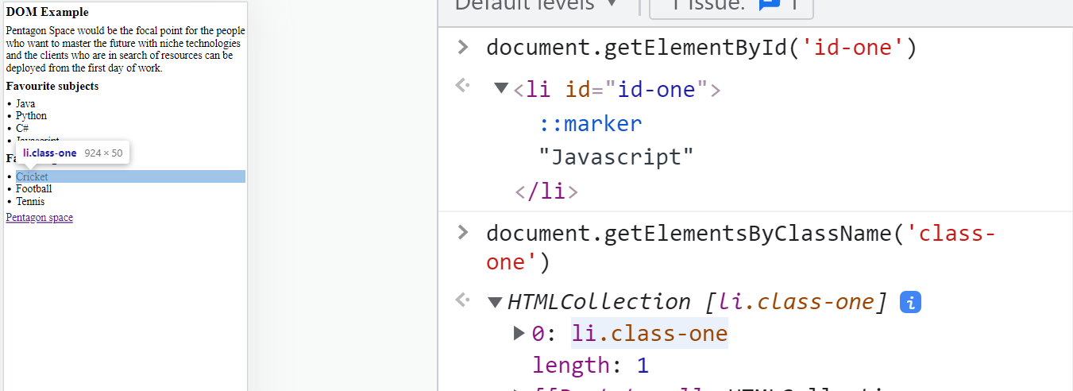

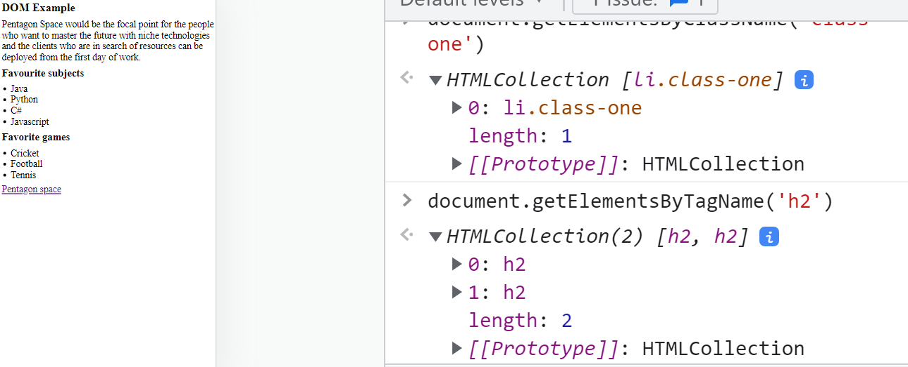

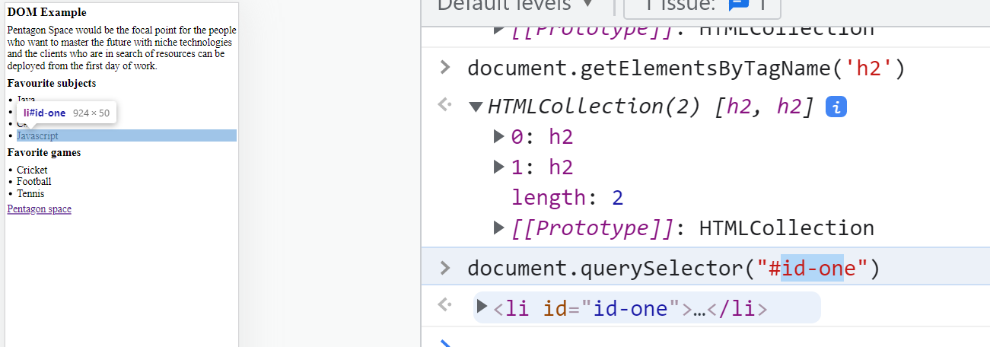

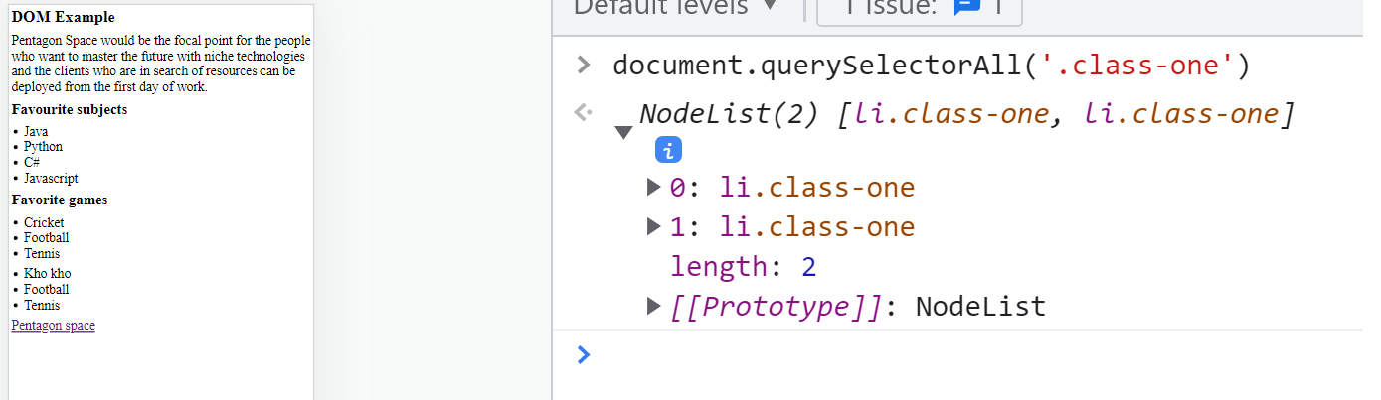

**querySelector() querySelectorAll()**

**If the specific CSS maps with only one html element then we should use querySelector().If multiple html elements match,then querySelector() returns only first matched element.**

**We use querySelectorAll() to access all matched html elements.If multiple html elements are there, then we use this method**

**Dom based javascript to change color of h1 tag**

**var myh1=document.querySelector(‘h1’)**

**myh1.style.color=”red”**