Music Playlist & Listening-Stats Manager
Title
Music Playlist & Listening-Stats Manager

Abstract
The Music Playlist & Listening-Stats Manager is a Java-based application designed to manage music playlists and track listening statistics. It allows users to add songs, view the playlist, search for songs, calculate total playlist duration, record the number of times songs are played, and display listening statistics.
The project combines three Course Outcomes: CO 1 (Foundations), covering variables, data types, input/output, and problem-solving; CO 2 (Control Flow), covering conditional statements and loops; and CO 3 (Methods & Arrays), covering user-defined methods, recursion, and one-dimensional and two-dimensional arrays.

Advantages
Simplifies music playlist management.
Tracks the number of times each song is played.
Calculates total playlist duration automatically.
Provides a search facility to find songs.
Uses arrays to store and organize music information.
Demonstrates multiple Java programming concepts in one application.

CODE:
import java.util.Scanner;

public class MusicPlaylistManager {

static final int MAX = 50;

static String[] songs = new String[MAX];
static String[] artists = new String[MAX];

// 2-D array: duration and number of plays
static int[][] stats = new int[MAX][2];

static int count = 0;

// Method to add a song
static void addSong(Scanner sc) {
if (count >= MAX) {
System.out.println("Playlist is full!");
return;
}

System.out.print("Enter song name: ");
songs[count] = sc.nextLine();

System.out.print("Enter artist name: ");
artists[count] = sc.nextLine();

System.out.print("Enter duration in seconds: ");
stats[count][0] = sc.nextInt();

System.out.print("Enter number of plays: ");
stats[count][1] = sc.nextInt();
sc.nextLine();

count++;

System.out.println("Song added successfully!");
}

// Method to display all songs
static void displayPlaylist() {
if (count == 0) {
System.out.println("Playlist is empty.");
return;
}

System.out.println("\n--- Music Playlist ---");

for (int i = 0; i < count; i++) {
System.out.println((i + 1) + ". " + songs[i]
+ " | Artist: " + artists[i]
+ " | Duration: " + stats[i][0] + " sec"
+ " | Plays: " + stats[i][1]);
}
}

// Method to search for a song
static void searchSong(Scanner sc) {
System.out.print("Enter song name to search: ");
String search = sc.nextLine();

boolean found = false;

for (int i = 0; i < count; i++) {
if (songs[i].equalsIgnoreCase(search)) {
System.out.println("Song found: " + songs[i]);
System.out.println("Artist: " + artists[i]);
System.out.println("Duration: "
+ stats[i][0] + " seconds");
found = true;
break;
}
}

if (!found) {
System.out.println("Song not found.");
}
}

// Recursive method to calculate total plays
static int totalPlays(int index) {
if (index == count) {
return 0;
}

return stats[index][1] + totalPlays(index + 1);
}

// Method to calculate total playlist duration
static int totalDuration() {
int total = 0;

for (int i = 0; i < count; i++) {
total += stats[i][0];
}

return total;
}

// Method to record a new play
static void playSong(Scanner sc) {
System.out.print("Enter song name to play: ");
String search = sc.nextLine();

for (int i = 0; i < count; i++) {
if (songs[i].equalsIgnoreCase(search)) {
stats[i][1]++;

System.out.println("Now playing: " + songs[i]);
System.out.println("Total plays: "
+ stats[i][1]);
return;
}
}

System.out.println("Song not found.");
}

// Method to display listening statistics
static void showStatistics() {
System.out.println("\n--- Listening Statistics ---");
System.out.println("Total songs: " + count);
System.out.println("Total playlist duration: "
+ totalDuration() + " seconds");
System.out.println("Total number of plays: "
+ totalPlays(0));

if (count > 0) {
int mostPlayed = 0;

for (int i = 1; i < count; i++) {
if (stats[i][1] > stats[mostPlayed][1]) {
mostPlayed = i;
}
}

System.out.println("Most played song: "
+ songs[mostPlayed]);
}
}

public static void main(String[] args) {
Scanner sc = new Scanner(System.in);
int choice;

do {
System.out.println("\n===== MUSIC PLAYLIST MANAGER =====");
System.out.println("1. Add Song");
System.out.println("2. Display Playlist");
System.out.println("3. Search Song");
System.out.println("4. Play Song");
System.out.println("5. Listening Statistics");
System.out.println("6. Exit");
System.out.print("Enter your choice: ");

choice = sc.nextInt();
sc.nextLine();

switch (choice) {
case 1:
addSong(sc);
break;

case 2:
displayPlaylist();
break;

case 3:
searchSong(sc);
break;

case 4:
playSong(sc);
break;

case 5:
showStatistics();
break;

case 6:
System.out.println("Thank you for using "
+ "Music Playlist Manager!");
break;

default:
System.out.println("Invalid choice. Try again.");
}

} while (choice != 6);

sc.close();
}
}
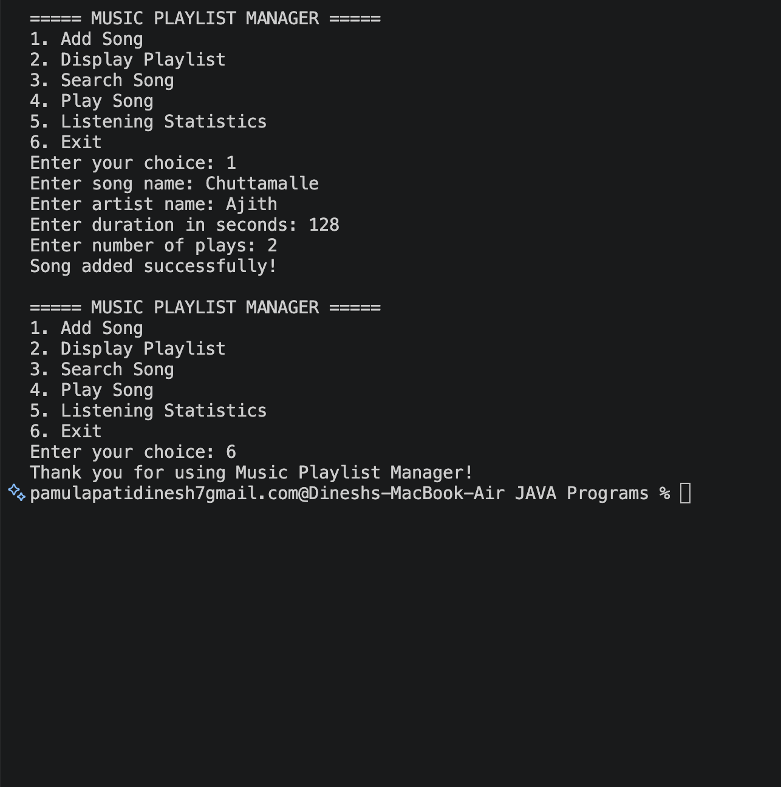

Conclusion:
The Music Playlist & Listening-Stats Manager successfully demonstrates the application of fundamental Java programming concepts in a practical project. The system provides essential features such as adding songs, displaying playlists, searching for songs, tracking listening counts, and calculating playlist statistics. By combining foundations, control flow, methods, recursion, and arrays, the project achieves the objectives of all three Course Outcomes. It also improves problem-solving, logical thinking, and programming skills while demonstrating the usefulness of Java in developing real-world applications.

