**Assignment 3**

**1. Create customers table with customer_id, username, email, phone, address. Declar customer_id as primary key.**

CREATE TABLE customers (

customer_id INT PRIMARY KEY,

username VARCHAR(255),

email VARCHAR(255),

phone VARCHAR(20),

address VARCHAR(255)

);

DESC customers;

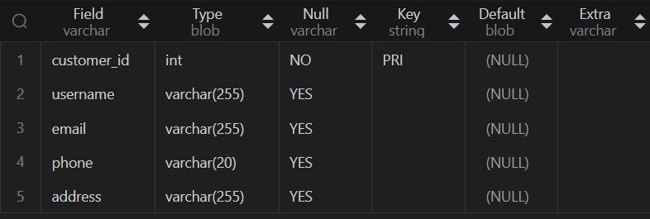

**2.Create orders table with order_id, order_date, amount_pai, customer_id . declar order_id as primary key and customer_id as foreign key. here customers is master table and orders is child table.**

CREATE TABLE orders (

order_id INT AUTO_INCREMENT PRIMARY KEY,

order_date DATE,

amount_paid DECIMAL(10,2),

customer_id INT,

FOREIGN KEY (customer_id) REFERENCES customers(customer_id)

);

DESC orders;

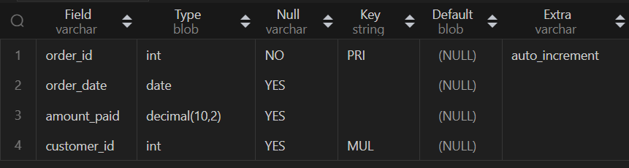

**3. Create products table with product_id, product_name, price, description columns. Declare product_id as primary key.**

CREATE TABLE products (

product_id INT PRIMARY KEY,

product_name VARCHAR(255),

price DECIMAL(10,2),

description TEXT

);

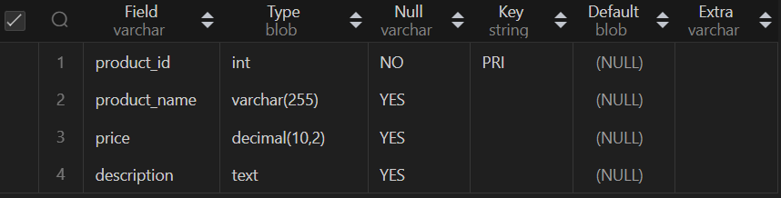DESC products**;**

**4. Create orders_product table with id, order_id, product_id, quantity columns. Declare order_id and product_id as foreign key and id as primary key.**

CREATE TABLE orders_product (

id INT AUTO_INCREMENT PRIMARY KEY,

order_id INT,

product_id INT,

quantity INT,

FOREIGN KEY (order_id) REFERENCES orders(order_id),

FOREIGN KEY (product_id) REFERENCES products(product_id)

);

DESC orders_product;

