**Index Page:**

Navbar:

* The navbar has company logo, and anchor tags o the separate pages.
  1. Company Logo
  2. Home page
  3. About
  4. Service
  5. Products
  6. Contact
* Career
* On Scroll it will be fixed to the top.
* On every page the navbar will be same.
* Ser can navigate between the pages with the anchor tags.
* In product there are again three products type.
  1. PC – Based
  2. Real Time Simulator
  3. Custom Electronic Devices
* The anchor tag has some styling like on hover changes text colour to yellow.
* The navbar is responsible with the device screen width.





About:

* In about section user will see the company profile and history.
* There are two sections for the information and one for the image.
* On the left section user will see the company profile and vision.
* The company profile information and vision are taken from the current website and manuals.
* In the right section there will be an image.
* The About is responsible with the device screen width.

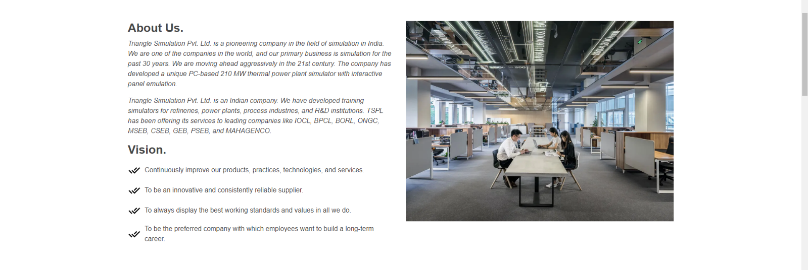

Client:

* In this section the client company or organisation logos carousel will be running.
* When user moves the cursor over the carousel the logos carousel will stop moving.
* The carousel is responsible with the device screen width.



* Below the carousel client list will be displayed.
* The clients are divided in to the two types
  1. Industries
  2. Institutional
* The both type of clients are displayed in same line with their full name and short form.
* The client section responsible with the device screen width.

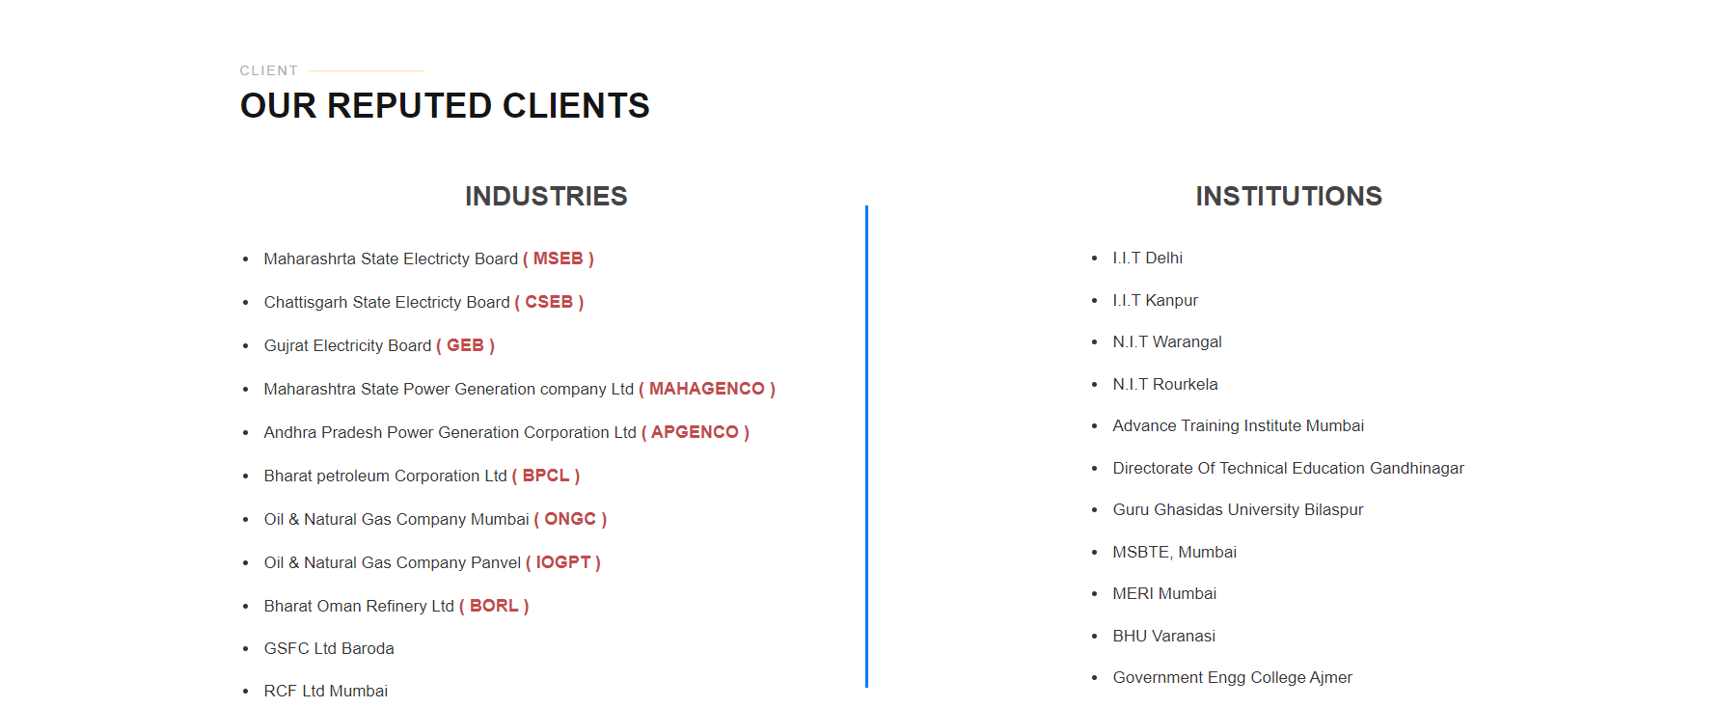

Testimonial:

* In the testimonial section the review submitted by the clients will be shown.
* The reviews will be shown in one row.
* User will have right and left arrow to see the next and previous review.
* The review contains the respective clients.
* The Testimonial section is responsible with the width.

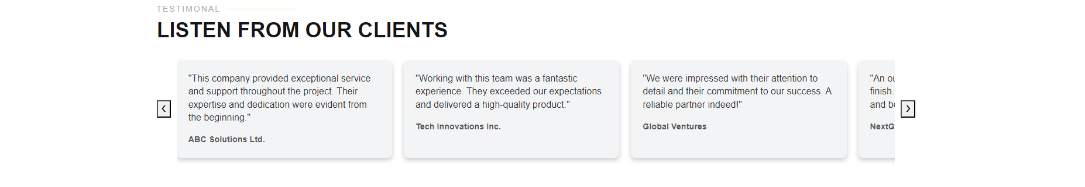

Footer:

* The footer will be of every page bottom.
* The footer will have TSPL office address, useful links and social medial links.
* User can navigate trough the pages with the help of footer useful links.
* Social media links will be provided in the footer.
* The footer will be responsible with screen width.

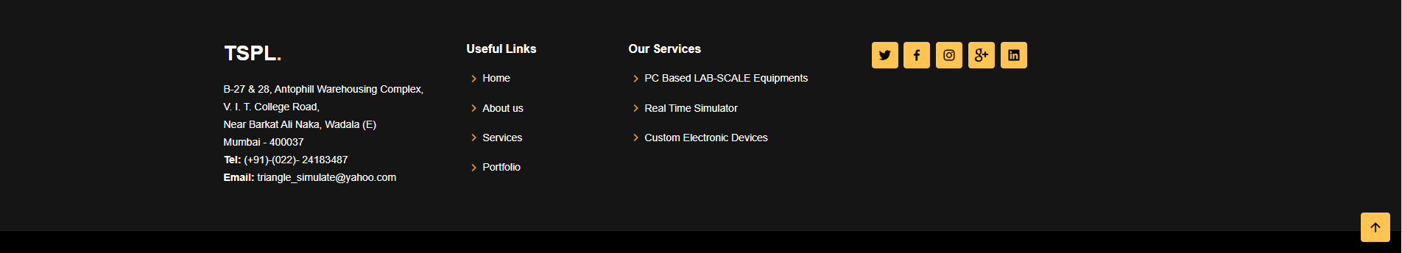

Products:

* There are three types of products:
  1. PC – Based
  2. Real Time Simulator
  3. Custom Electronic Devices



* With the help of navigation bar user can go to the any product page or the page he wants.
* This navigation bar is responsible to the screen width.

PC – Based Lab Scale Equipment’s:

User can go to the PC-Based lab scale Equipment’s using the navbar anchor tag.

Google Map:

* In the index page above the footer there will be an google map of tspl office.

