PlanFlow workload planning through user experience and iterative development
Member 1 Ajiton Estibeiro
CPU4106-20C Group Project
Allocated focus Scrum coordination and user experience

Abstract
PlanFlow is a local web application supporting daily workload and staffing comparisons in a warehouse planning context. This article examines the project through user experience design and iterative coordination. The prototype brings together forecast demand, staffing, productivity and labour costs within five main pages. A fictional October to December dataset supports demonstration without using confidential workplace information. The discussion considers task-based requirements, planned Penpot prototyping, usability evaluation and the evidence needed to establish Scrum practice. Earlier recorded automated tests provide initial technical evidence, while interviews and usability findings remain outstanding. MySQL support is implemented, although the verified demonstration uses SQLite. The project connects with Sustainable Development Goal 8 through its focus on technology-supported productivity. Its main contribution is a testable decision-support prototype whose practical value requires further evaluation with planners.
Keywords: workload planning staffing decision support warehouse operations SDG 8.

1 Introduction
Warehouse planning matches forecast demand with staff and productive time. Absence, changing volumes and dispatch deadlines complicate this task. PlanFlow brings workload records, staffing calculations, scenarios and reports into a local browser application. Planning experience in retail distribution informed its context, but the prototype is an educational system rather than an authorised workplace product.
The research question is how a browser application can support understandable and consistent staffing decisions. Objectives are to centralise inputs, reveal departmental shortages, compare responses and retain records. This article connects formative planning, methodological appraisal and system modelling with the documented prototype and weekly reflections [4]-[7].

2 Problem and sustainable development
Spreadsheet planning is flexible, but manually maintained files can require repeated calculations and separate comparisons when forecasts or staff availability change. Inconsistent formulas and outdated entries are possible sources of error. These concerns establish the initial problem definition; they are not findings from a completed workplace survey. Interviews and observation are needed to establish their frequency and significance in the intended setting.
SDG 8 Target 8.2 links productivity with technological upgrading and innovation [1]. PlanFlow explores this relationship through resource comparisons. Appropriate breaks, realistic workloads and employee wellbeing remain relevant: greater calculated capacity alone does not demonstrate decent work. No measured organisational improvement or official SDG indicator is claimed.

3 Method and project organisation
The project follows iterative development across requirements, design, implementation and evaluation. Formative F1 allocated Scrum coordination and UX to Ajiton, front end development to Newton, Python calculations to Ioan-Dragos, and requirements, MySQL, reports and testing to Marcos [4]. Its Gantt plan placed requirements in Week 1, design in Week 2 and validation in Week 5. These are planned responsibilities and milestones; attendance records, commits and review notes are needed to establish actual contributions. Scrum provides an inspection and adaptation framework [2].
Formative F2 examined consistent evaluation, separation of development and testing, and limits to generalisation [5]. The methodological lesson for PlanFlow is to define repeatable checks before interpreting results. Repeated demonstrations on fictional data cannot establish workplace effectiveness. Interviews and task observations should complement technical tests, while independent examples should check calculations. Weekly reflections document progress and outstanding research rather than substituting for participant findings [7].
Formative F3 distinguishes user goals from internal functions [6]. The use case model connects planner tasks with workload, staffing, scenarios and reports. The context DFD places the application and SQL database inside one boundary, showing external inputs and outputs. Planner and administrator describe functional roles, not implemented separate accounts. Appendix A reproduces these models alongside the role-specific interface evidence.

4 System and dataset
The interface uses HTML, CSS and JavaScript, while Python and Flask handle application requests. Chart.js provides local visualisations. Interface code, database access and calculation logic are separated so that changes can be reviewed and tested independently. Five main pages cover overview, workload, staffing, scenarios and reports. A settings page manages the database connection and displays recent changes.
The fictional dataset expanded from October to December 2026. The reporting evidence covers 92 dates, two shifts and three departments: 552 plans [7]. Earlier October-only references to 186 plans describe the previous sample. Simulated actuals, including future planning dates, support demonstration rather than business performance claims. Sample records were prepared in Excel with AI assistance and converted into SQL.
PlanFlow's recorded demonstration uses SQLite, with MySQL support awaiting a separate integration check. On 23 October, the registration lab successfully used PHP and MariaDB on port 3307 [8]. This verifies local database availability for that exercise, not PlanFlow migration. Switching database engines does not automatically copy edits.

5 Planning model
Available staff equal scheduled staff minus absences. Per-person capacity equals the productivity rate multiplied by productive hours plus applicable overtime hours. Required headcount is forecast workload divided by per-person capacity, rounded upwards. Each department is assessed separately because spare capacity is not assumed to transfer freely between departments.
The reference day shift shows 12,000 forecast cases, 17 available staff and capacity of 10,200 cases, leaving a 1,800-case shortage and requiring 20 staff. In the saved scenario evidence, proposed coverage reaches 12,000 cases while three deadline risks remain [7]. Thus volume coverage and dispatch readiness require separate interpretation.
Scenarios preserve baseline and proposed values without applying the proposed changes to the current plan. Labour costs are illustrative estimates based on available staffing, paid hours and overtime rates. They exclude the complexities of payroll and should not be interpreted as accounting outputs.

6 User experience design
The UX focus is to make the planner's next action clear. A user who discovers a shortage should be able to identify the relevant department, inspect the underlying assumptions and compare a response without navigating through unrelated records. This suggests a task sequence from overview to detail and then to scenario comparison. Shared date and shift filters support continuity across pages.
Human-centred design places the user, task and context of use within the design process [3]. For this project, short interviews should explore how forecasts arrive, which decisions are time-sensitive and how shortages are communicated. A questionnaire can broaden feedback, but it should not substitute for understanding actual tasks. Recruitment should include participants with relevant planning experience and use consent where workplace research is involved.
Penpot was selected for flows, wireframes and a clickable prototype. The planned design evaluation should ask participants to enter a forecast, record absence, identify a shortage and compare an alternative. Observations should record errors, uncertainty and completion time. Leading questions such as whether the dashboard is easy should be replaced with tasks that reveal difficulties. Completed participant results are not available, so interface decisions remain hypotheses rather than validated preferences.

7 Coordination and critical discussion
The allocated coordination role connects the backlog with what can realistically be delivered. Useful backlog items describe an observable outcome, such as a planner seeing a shortage after recording an absence. Acceptance criteria should specify the expected calculation and persistence behaviour. This gives the interface and Python work a shared target and makes sprint review more concrete.
Scrum evidence should show how inspection changed the product [2]. For example, a review might reveal confusion between volume coverage and deadline readiness, leading to clearer separate warnings. This is a proposed review example, not an event claimed to have occurred. Trello records and meeting notes should preserve genuine decisions, while GitHub history can support discussion of implementation progress.
The main evaluation risk is mistaking attractive screens for a useful workflow. Charts may help users recognise an imbalance, but unclear labels can still cause incorrect decisions. Future reviews should examine contrast, keyboard access and understandable validation alongside task success. The coordinator should prioritise confirmed user difficulties and record why a change was accepted, deferred or rejected. This creates a reasoned development account without inventing personal experience.

8 Evaluation and limitations
The earlier article records 19 passing automated tests covering calculations, validation, persistence, scenarios and exports. This is historical verification evidence, not a newly rerun suite. The Week 3 records additionally report successful read requests and rejection of an invalid date [7]. The database member's report evidence shows 552 rows, 1,902,400 forecast cases and 2,056,250 planned capacity. These are fictional demonstration totals.
The separate registration practical produced a success response and stored Alex Student and Jamie Student in registration_db.registrations. A request with an invalid email, short name and future birth date was rejected. Apache served the page, PHP validated and inserted through a prepared statement, MariaDB stored rows, and phpMyAdmin displayed them [8]. Appendix B shows both success and storage evidence.
These checks support the cases exercised, not production reliability. Stable productivity assumptions simplify queues and dependencies. PlanFlow still needs verified MySQL integration, individual accounts, deployment controls and user evaluation. The registration exercise cannot establish those capabilities.

Ethical use and evidence
Fictional data avoids exposing employee information. Future research requires appropriate permission, consent and confidential handling of responses. Staffing recommendations should support responsible human decisions. Shared screenshots establish system behaviour, while personal contribution claims require corroborating records. No completed participant study or measured reduction in planning time is claimed.
For a future UX study, participants could first locate the department with a shortage and then explain whether the proposed scenario resolves dispatch risk. Recording incorrect interpretations would reveal whether the distinction between capacity and deadlines is understood. A before-and-after comparison using the same task instructions could evaluate a revised label or warning. The coordinator should document recruitment, consent, task conditions and reasons for design changes. Small convenience samples would provide formative feedback rather than representative estimates. This keeps evaluation proportionate to the prototype and connects backlog priorities to observed difficulties instead of assumed user preferences.

9 Conclusion
PlanFlow connects a defined planning problem with inspectable calculations, interfaces and reporting. Formative planning, appraisal and modelling strengthen the explanation of its development. Weekly evidence demonstrates a working SQLite prototype; the separate PHP exercise confirms local database learning. Further work should prioritise user research, independent calculation checks and PlanFlow-specific MySQL verification before operational benefits are asserted.

References
[1] United Nations, "Goal 8 Decent work and economic growth." [Online]. Available: https://sdgs.un.org/goals/goal8. Accessed: Oct. 23, 2026.
[2] K. Schwaber and J. Sutherland, The Scrum Guide, Nov. 2020. [Online]. Available: https://scrumguides.org/docs/scrumguide/v2020/2020-Scrum-Guide-US.pdf. Accessed: Oct. 23, 2026.
[3] International Organization for Standardization, Ergonomics of human-system interaction Part 210 Human-centred design for interactive systems, ISO 9241-210:2019, 2019. [Online]. Available: https://www.iso.org/standard/77520.html. Accessed: Oct. 23, 2026.
[4] PlanFlow group, Formative F1 Group Reflection and Planning, Week 1, CPU4106-20C, 2026. Shared group submission and named Gantt plan.
[5] A. Estibeiro, Critical Appraisal of Research Methodology, Formative F2, Week 2, CPU4106-20C, 2026. Methodological learning from the supplied regression study; no replication is claimed.
[6] PlanFlow group, PlanFlow system modelling, Formative F3, individual member versions, 22 Oct. 2026. UML use case and context DFD.
[7] PlanFlow group, Week 3 learning and project reflection, Summative S2, individual member versions, 22-23 Oct. 2026; A. Estibeiro, Week 2 learning and project reflection, 16 Oct. 2026. Shared fictional project evidence.
[8] GBS, Web Development Practical Workbook, Lab W3S2 1.docx, Practical 2, 2026; local registration test and screenshots, 23 Oct. 2026.

Appendix A Project interface evidence
Overview dashboard and the planner journey. Reproduced from the member's Week 3 portfolio [7]. The screenshot uses fictional data and is not a new capture of PlanFlow.
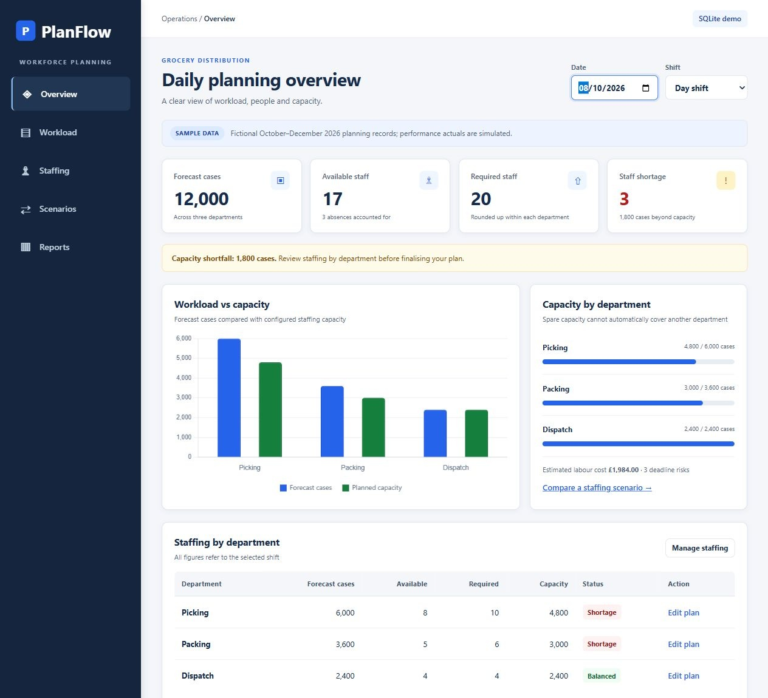
Figure A1 PlanFlow overview for 8 October 2026, Day shift: 12,000 forecast cases, 17 available staff and 20 required staff. The dashboard exposes departmental shortages.

Appendix A System models
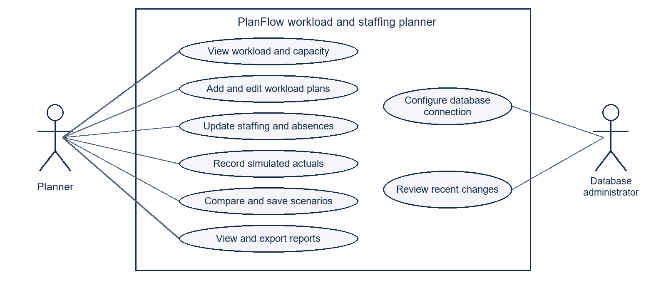
Figure A2 Shared UML use case diagram from Formative F3 [6]. Actors connect to goals within the system boundary; these roles do not establish implemented account permissions.
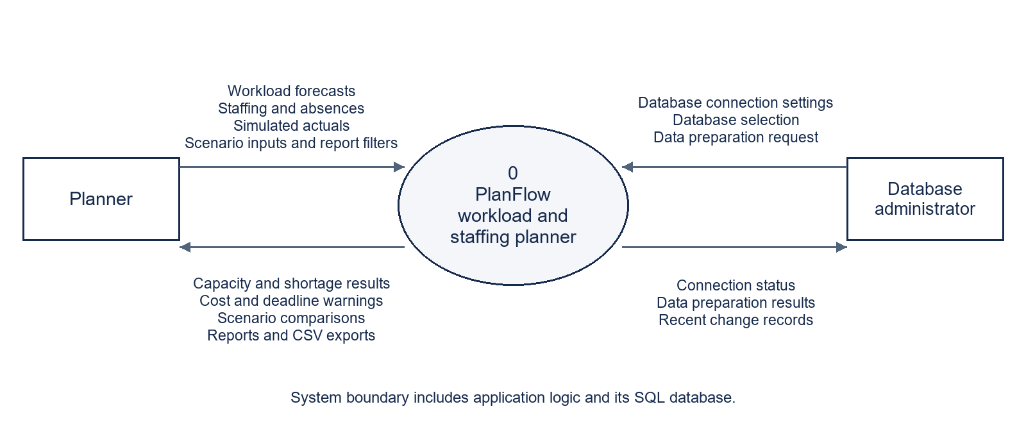
Figure A3 Shared context DFD from Formative F3 [6]. One process represents PlanFlow and its SQL database; labelled arrows describe external exchanges.

Appendix B PHP and database lab evidence
Separate registration practical captured on 23 October 2026 [8]. This shared evidence demonstrates local PHP and MariaDB operation on port 3307. It does not establish a PlanFlow MySQL connection or independent completion by every member.
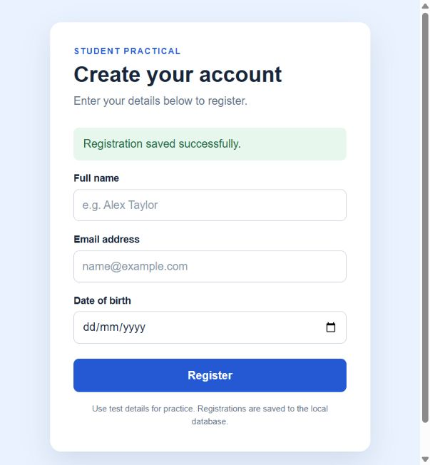
Figure B1 Registration form at localhost/registration/index.php showing a successful save after submitting fictional details.
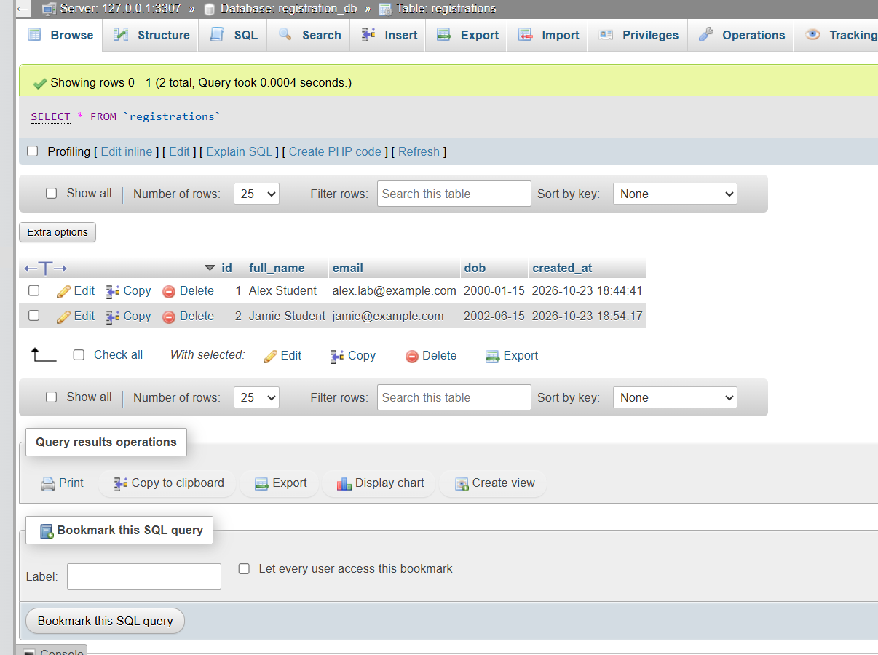
Figure B2 phpMyAdmin Browse view of registration_db.registrations showing the saved Alex Student and Jamie Student records.

