LAPORAN PRAKTIKUM

POSTTEST 2

ALGORITMA PEMROGRAMAN LANJUT


Disusun oleh:

Ajiva Alank Setiandra (2409106017)

Kelas (A1 ‘24)

PROGRAM STUDI INFORMATIKA

UNIVERSITAS MULAWARMAN

SAMARINDA

2025

1. Flowchart
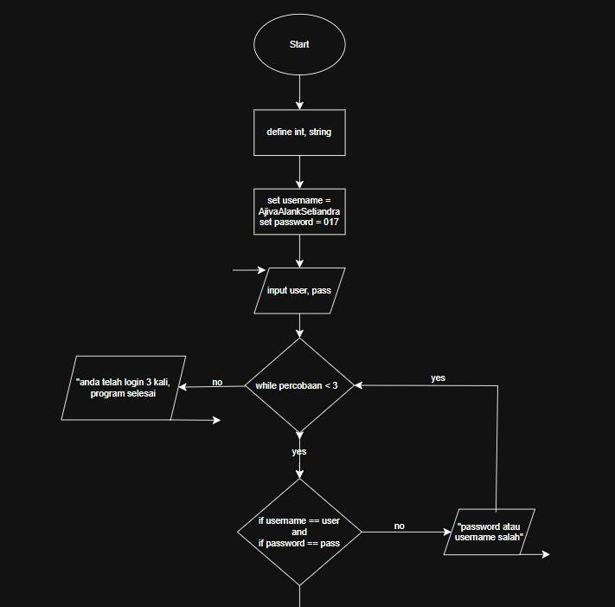

Gambar 1.1 flowchart bagian 1

1

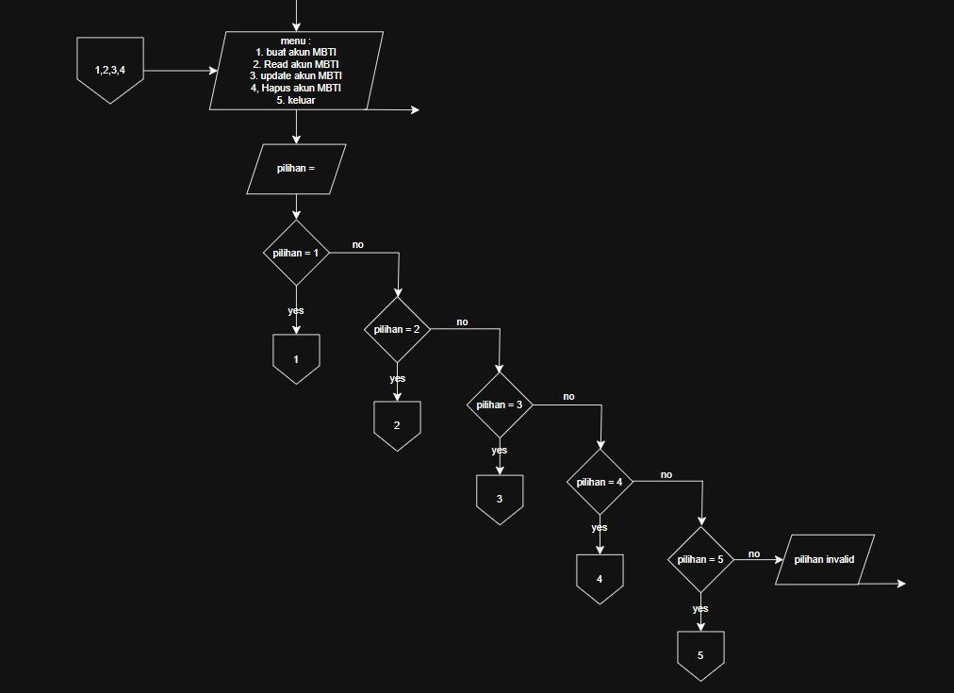

Gambar 1.2 flowchart bagian 2
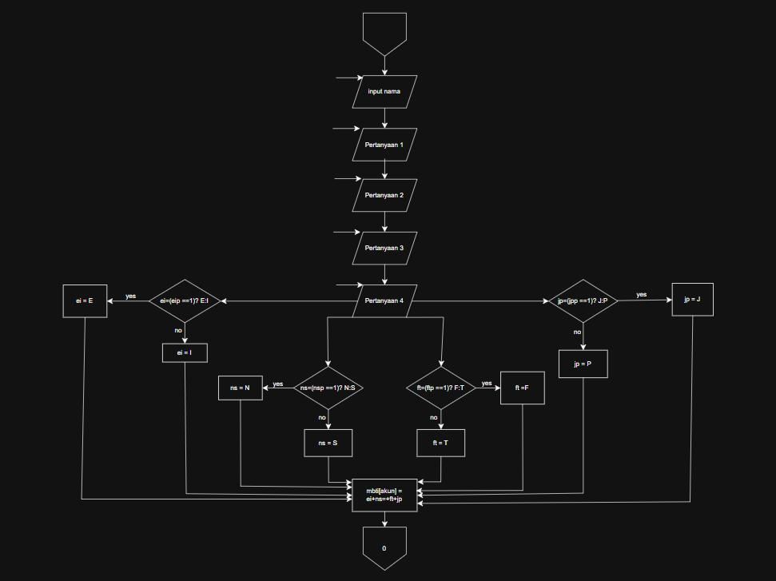

Gambar 1.3 flowchart fitur create

2

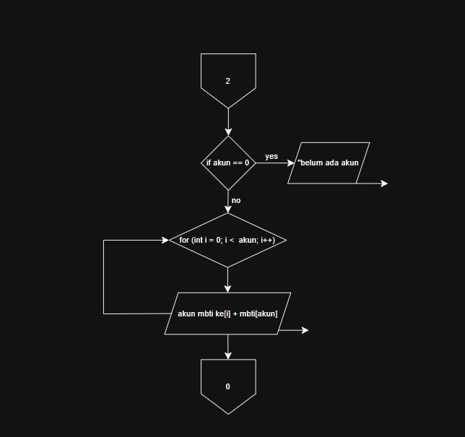

Gambar 1.4 flowchart fitur read

3

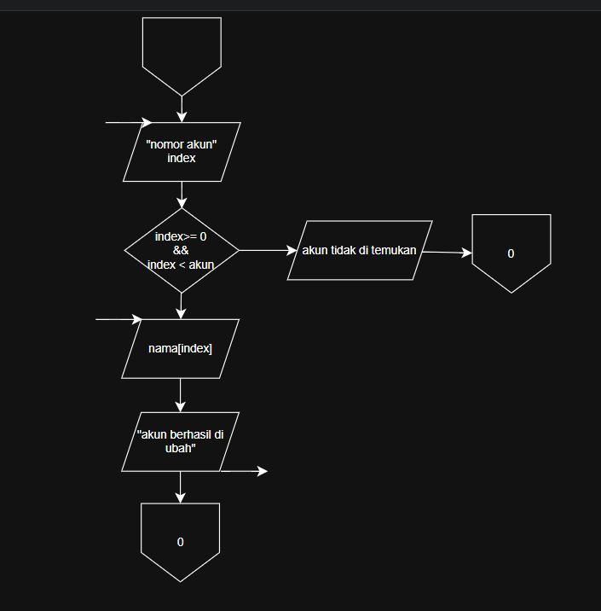

Gambar 1.5 flowchart fitur update
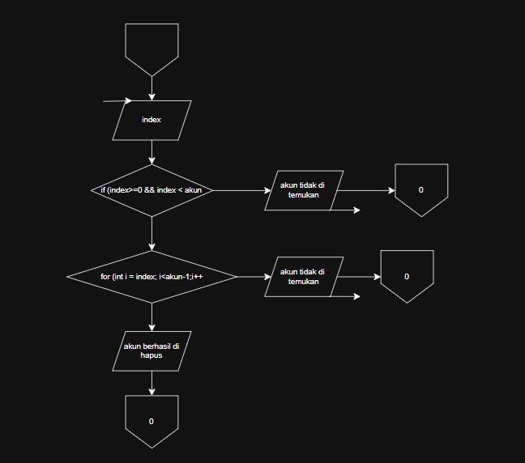

Gambar 1.6 flowchart fitur delete

4

