**Performance Evaluation Of Machine Learning Algorithms For Disease Prediction**

**Software requirements**

**• Programming Language : Python, Jupyter Notebook**

**• Packages : Numpy,Matplotlib, SKLearn, Pandas, Flask Framework**

**• Tool : Python 3.7**

**Disease prediction dataset details:**

We are collected dataset contains 97 colums and 84 records. Out of 97 columns 96 columns all are features and last column contains disease type.

**Itching, skin_rash, nodal_skin_eruptions, continuous_sneezing, shivering, chills, joint_pain, stomach_pain, acidity, ulcers_on_tongue, muscle_wasting, vomiting, burning_micturition, spotting_ urination, fatigue, weight_gain, anxiety, cold_hands_and_feets, mood_swings, weight_loss, restlessness, lethargy, patches_in_throat, irregular_sugar_level, cough, high_fever, sunken_eyes, breathlessness, sweating, dehydration, indigestion, headache, yellowish_skin, dark_urine, Nausea, loss_of_appetite, pain_behind_the_eyes, back_pain, constipation, abdominal_pain, diarrhea, mild_fever, yellow_urine, yellowing_of_eyes, acute_liver_failure, fluid_overload, swelling_of_stomach, swelled_lymph_nodes, malaise, blurred_and_distorted_vision, phlegm, throat_irritation, redness_of_eyes, sinus_pressure, runny_nose, congestion, chest_pain, weakness_in_limbs, fast_heart_rate, ____, prognosis**

1, 1,1, 0, 0, 0, 0, 0, 0, 0, 0, 0, 0, 0, 0, 0, 0, 0, 0, 0, 0, 0, 0, 0, 1, 0, 1, 0, 1, 0, 0, 1, 0, 0, 0, 0, 1, 0, 0, 0, 0, 0, 0,1, 0, 1,0,1, 1, Fungal infection

0,1,1,0,0,0,0,1,1,1,,0,0,0,1,0,1,0,1,1,1,1,0,0,0,0,1,1,0,0,1,0,0,0,0,0,0,0,0,0,0,0,0,0,0,0,0,0,0,0,0,0,0,0,,0,

Drug Reaction

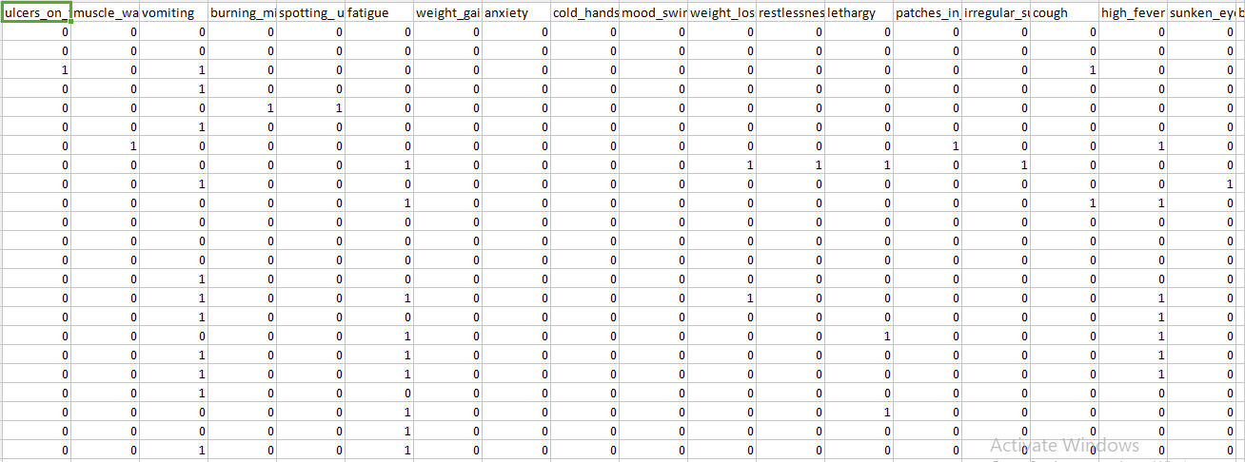

**Import required package and downloading & extracting the dataset**

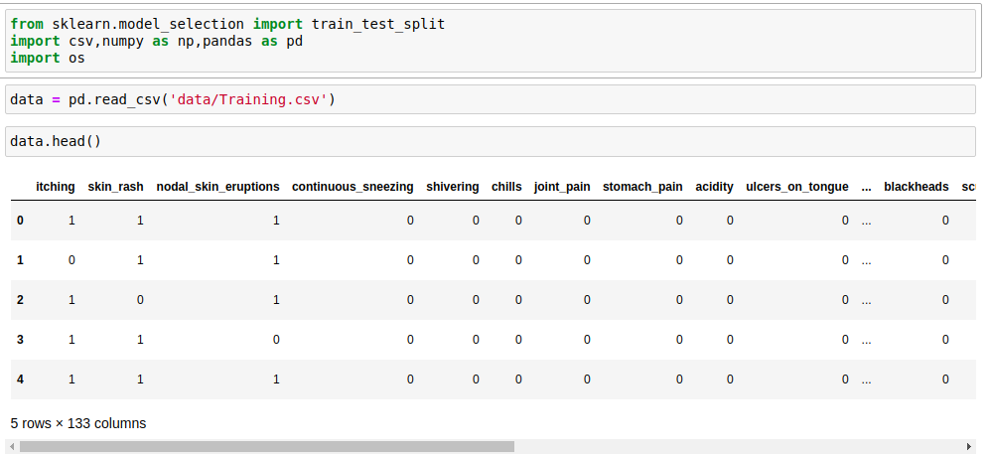

**Data Processing**

**Outcome Visualization**

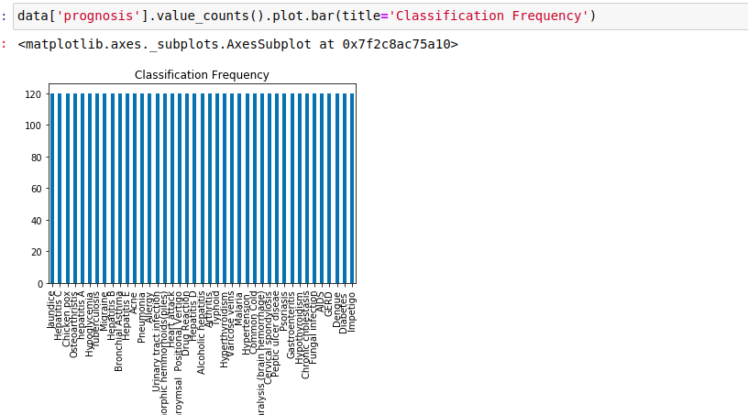

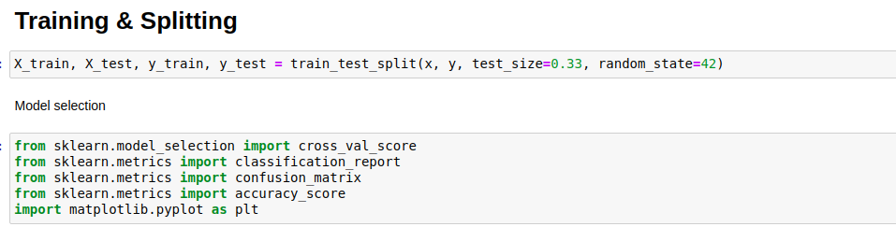

**Training and splitting the data**

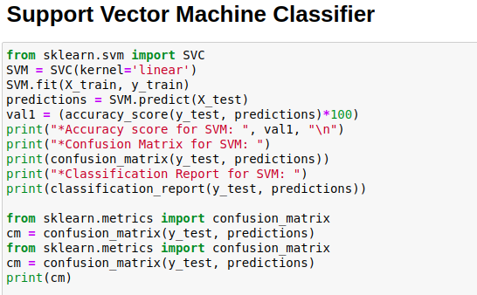

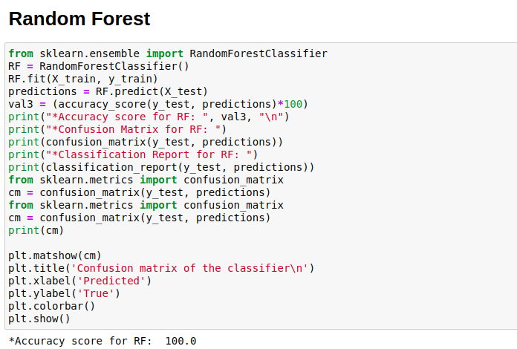

**Model Comparison**

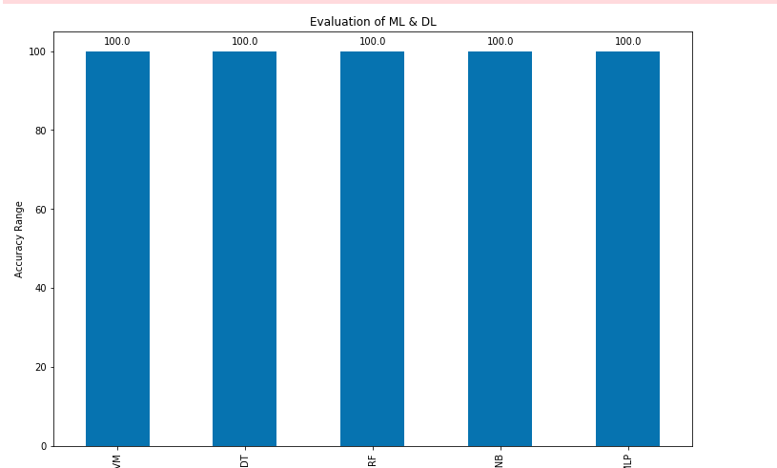

**From the above the all are giving better accuracy for prediction**

**Framework**

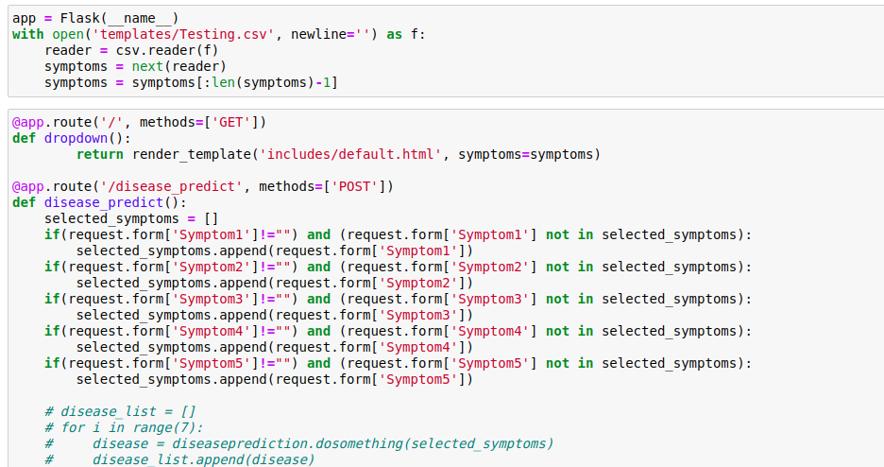

**SO we are implementing the flask framework for user base disease detection with svm classifier**

