Employee Class

using System;

using System.Collections.Generic;

using System.Linq;

using System.Web;

namespace WebApplication10.Models

{

public class Emplyee

{

public int id { get; set; }

public string name { get; set; }

public string city { get; set; }

public string country { get; set; }

public string gender { get; set; }

}

}

Home Controller

using System.Collections.Generic;

using System.Web.Mvc;

using WebApplication10.Models;

namespace WebApplication10.Controllers

{

public class HomeController : Controller

{

public ActionResult Index()

{

return View();

}

public ActionResult About()

{

ViewBag.Message = "Your application description page.";

return View();

}

public ActionResult Contact()

{

ViewBag.Message = "Your contact page.";

return View();

}

public ActionResult ViewEmployee(Emplyee ep1)

{

List<Emplyee> employees = new List<Emplyee> { ep1 };

return View(employees);

}

public ActionResult AddEmployee()

{

return View();

}

[HttpPost]

public ActionResult AddEmployee(Emplyee ep)

{

return RedirectToAction("ViewEmployee", "Home", ep);

}

}

}

Add Employee View

@model WebApplication10.Models.Emplyee

@{

ViewBag.Title = "AddEmployee";

Layout = "~/Views/Shared/_Layout.cshtml";

}

<h2>AddEmployee</h2>

@using (Html.BeginForm("AddEmployee", "Home", FormMethod.Post))

{

@Html.AntiForgeryToken()

<div class="form-horizontal">

<h4>Emplyee</h4>

<hr />

@Html.ValidationSummary(true, "", new { @class = "text-danger" })

<div class="form-group">

@Html.LabelFor(model => model.id, htmlAttributes: new { @class = "control-label col-md-2" })

<div class="col-md-10">

@Html.EditorFor(model => model.id, new { htmlAttributes = new { @class = "form-control" } })

@Html.ValidationMessageFor(model => model.id, "", new { @class = "text-danger" })

</div>

</div>

<div class="form-group">

@Html.LabelFor(model => model.name, htmlAttributes: new { @class = "control-label col-md-2" })

<div class="col-md-10">

@Html.EditorFor(model => model.name, new { htmlAttributes = new { @class = "form-control" } })

@Html.ValidationMessageFor(model => model.name, "", new { @class = "text-danger" })

</div>

</div>

<div class="form-group">

@Html.LabelFor(model => model.city, htmlAttributes: new { @class = "control-label col-md-2" })

<div class="col-md-10">

@Html.EditorFor(model => model.city, new { htmlAttributes = new { @class = "form-control" } })

@Html.ValidationMessageFor(model => model.city, "", new { @class = "text-danger" })

</div>

</div>

<div class="form-group">

@Html.LabelFor(model => model.country, htmlAttributes: new { @class = "control-label col-md-2" })

<div class="col-md-10">

@Html.EditorFor(model => model.country, new { htmlAttributes = new { @class = "form-control" } })

@Html.ValidationMessageFor(model => model.country, "", new { @class = "text-danger" })

</div>

</div>

<div class="form-group">

@Html.LabelFor(model => model.gender, htmlAttributes: new { @class = "control-label col-md-2" })

<div class="col-md-10">

@Html.EditorFor(model => model.gender, new { htmlAttributes = new { @class = "form-control" } })

@Html.ValidationMessageFor(model => model.gender, "", new { @class = "text-danger" })

</div>

</div>

<div class="form-group">

<div class="col-md-offset-2 col-md-10">

<input type="submit" value="Create" class="btn btn-default" />

</div>

</div>

</div>

}

<div>

@Html.ActionLink("Back to List", "ViewEmployee")

</div>

@section Scripts {

@Scripts.Render("~/bundles/jqueryval")

}

View Employee View

@model IEnumerable<WebApplication10.Models.Emplyee>

@{

ViewBag.Title = "ViewEmployee";

Layout = "~/Views/Shared/_Layout.cshtml";

}

<h2>ViewEmployee</h2>

<p>

@Html.ActionLink("Create New", "AddEmployee")

</p>

<table class="table">

<tr>

<th>

ID

</th>

<th>

Name

</th>

<th>

City

</th>

<th>

Country

</th>

<th>

Gender

</th>

</tr>

@foreach (var emp in Model)

{

<tr>

<td>

@Html.DisplayFor(modelItem => emp.id)

</td>

<td>

@Html.DisplayFor(modelItem => emp.name)

</td>

<td>

@Html.DisplayFor(modelItem => emp.city)

</td>

<td>

@Html.DisplayFor(modelItem => emp.country)

</td>

<td>

@Html.DisplayFor(modelItem => emp.gender)

</td>

<td>

@Html.ActionLink("Edit", "Edit", new { id = emp.id }) |

@Html.ActionLink("Details", "Details", new { id = emp.id }) |

@Html.ActionLink("Delete", "Delete", new { id = emp.id })

</td>

</tr>

}

</table>

Add Employee Output

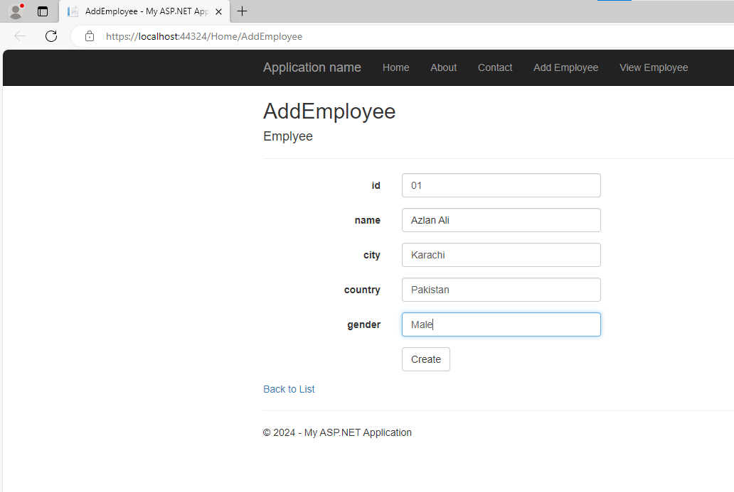

View Employee Output

