**Let’s Quizzzzzzzz**

Department of Engineering, Sciences and Humanities (DESH)

*Abstract*— Our project is to create a funny way of learning which can achieved by an simple APP i.e.. an QIZZES APP which will teach you as well as entertain you too.

Keywords ---_Python , Tkinter , Classes , functions,

modules ,Pillow (PIL)..

# Introduction

An desktop App will be consisits of multiple domains at it’s first window such as Biology ,Physics , Chemistry,G.K.. etcs,. From which user’s choice will be taken and quizz test will get start as user clicks on start button which will be fun as well as easy way to gain knowledge.

# Implementation details

All the code required for doing various stuff in program wii be basically done with the help of ***PYHON 3.8.2*** version.

Python has many libraries and built in modules. Out of them most commonly used ***“ tkinter ”*** module will be used for GUI i.e.. Graphical User Interface of our app.

Basic idea of app is such ; that we’ll ask user to choose his domain in which he wants to gain knowledge i.e.. take quiz. Selected domain will take user to a new page on which he will get a single question with 4 options for each question. Every domain will consists of 10 to 15 questions while for each question user will get 60 sec to answer the question otherwise next question will automatically pop up with previous question remaining unsolved. To make this quiz solving more intense we be using negative scoring system i.e.. every correct answer will give user +5 marks while every negative answer will give user -1 mark so that user will find qizzes as exam questions.

Our module named **“SAMPLE”** has been used in program which consists of various functions. Based on user’s choice of domain these functions will return the list of questions and answers along with options to display to the user .

To make app more attractive so that students may not find it boring different backgrounds and foregoround were make made by using in buit module ***“ PILLOW ”*** generally refer as ***“ PIL*** ”.

All the rules such as negative scoring , time bounding , etc are listed in a new tab named as “RULES” which is places just below at right of domain page from which user can get aware of himself for those .

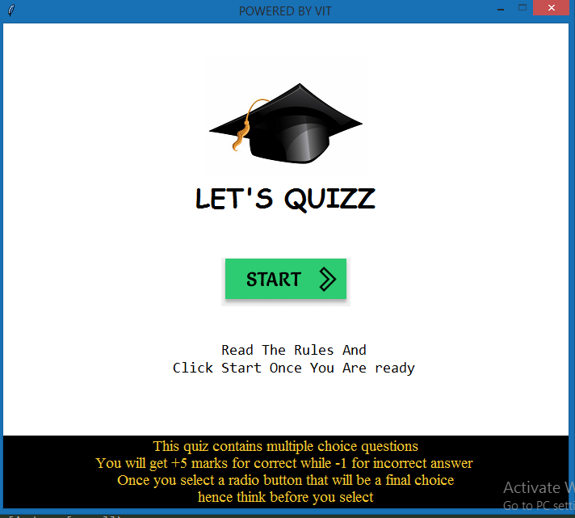

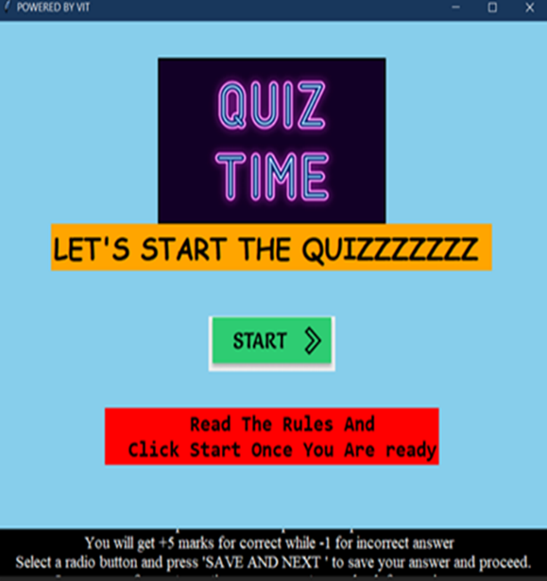

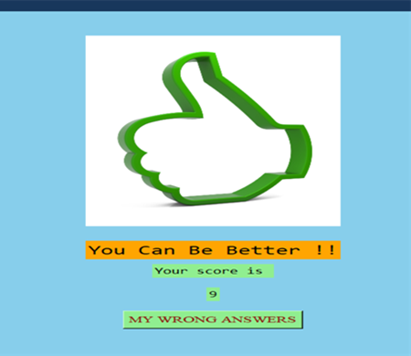

# Results and discussion

App is working very smoothly . As soon as you enter the app it’s asking to start quiz and as you hit “start quiz” button new page is being loaded to display you no. of options of domain you want to take a quiz. Just as you select domain and proceeds your quiz gets started and it gives you 60sec to solve you each questions.

# Conclusion and Future Scope

Same App can be updated by adding new domain i.e.. “ENTRANCE EXAM SECTION “ like NEET , JEE, CET,which will be consist of whole previous years question papers so that they can be available for each and every student at his convenient place with free of cost.

V . APENDEXTURE

def selected(value_2):

global radiovar , user_answer , repeations , cp_answers_choice , gk_answers_choice , bio_answers_choice

global lblQuestion , r1 , r2 , r3 , r4 , ques

x = radiovar.get()

user_answer.append(x)

radiovar.set(-1)

if (value_2==0):

answers_choice_select=cp_answers_choice

elif (value_2==1):

answers_choice_select=bio_answers_choice

elif (value_2==2):

answers_choice_select=gk_answers_choice

if ques < repeations:

lblQuestion.config(text = question_select[indexes[ques]])

r1['text'] = answers_choice_select[indexes[ques]][0]

r2['text'] = answers_choice_select[indexes[ques]][1]

r3['text'] = answers_choice_select[indexes[ques]][2]

r4['text'] = answers_choice_select[indexes[ques]][3]

ques += 1

else:

calc(value_2)

def startquiz(value_1):

global lblQuestion,r1,r2,r3,r4,save_btn,question_select,cp_questions,gk_questions,cp_answers_choice,gk_answers_choice, bio_questions,bio_answers_choice

if ( value_1==0 ) :

question_select = cp_questions

answers_choice_select=cp_answers_choice

elif ( value_1==1 ) :

question_select = bio_questions

answers_choice_select = bio_answers_choice

elif ( value_1==2 ) :

question_select = gk_questions

answers_choice_select = gk_answers_choice

lblQuestion = Label(root,font = ("Consolas", 16),width = 500, justify = "center", wraplength = 400,bg = "white",

text = question_select[indexes[0]])

lblQuestion.pack(pady=(100,30))

global radiovar

radiovar = IntVar()

radiovar.set(-1)

r1 = Radiobutton(root,font = ("Times", 12), value = 0, variable = radiovar,bg = "white",

text = answers_choice_select[indexes[0]][0],)

r1.pack(pady=5)

r2 = Radiobutton(root,font = ("Times", 12), value = 1, variable = radiovar,bg = "white",

text = answers_choice_select[indexes[0]][1],)

r2.pack(pady=5)

r3 = Radiobutton(root,font = ("Times", 12), value = 2, variable = radiovar,bg = "white",

text = answers_choice_select[indexes[0]][2])

r3.pack(pady=5)

r4 = Radiobutton(root,font = ("Times", 12), value = 3, variable = radiovar,bg = "white",

text = answers_choice_select[indexes[0]][3],)

r4.pack(pady=5)

save_btn.configure(text="SAVE AND NEXT",font=("times",13),command=lambda:selected(value_1),justify="center",bg="light green",fg="dark red")

save_btn.pack(pady=(50,0))

##### References

List of all the books, research papers, websites, etc. that were reffered while developing this project and report are as

1. A_Practical_Introduction_to_Python_Programming_Heinold *(reference 141 onwards)*
2. https://stackoverflow.com/questions/48554463/python-multiple-choice-quiz-scoring-using-tkinter

Ayush kagane

Div:-B roll no:-38\

Prof.shaiwalli ballal