School of Computing and Information Technology
University of Technology, Jamaica
237 Old Hope Road

Agreement re PRJ4020, Major Project
I intend to do my best, to collaborate with my group members, and to communicate in a timely fashion with all team members. Timely attendance at all meetings is required and expected.
I agree to acknowledge receipt of emails from the supervisor, and to copy all group members on all emails about the major project. UTech emails should be used.
I agree to attend all group meetings with the supervisor (online and face-to-face), or to indicate why I cannot attend (with appropriate documentation such as medical certification and/or work obligations).
I (along with my group) will keep written records of the major project group meetings.
I promise to send documents (labeled appropriately with a short title related to your research topic) at least 48 hours prior to a scheduled meeting. Each email you have a clear title, including the major project number.
When asked, I will document my contribution to major project (PRJ4020) and to honestly evaluate the contribution of others in my group.
I agree to participate in journal or conference publications related to this project, or that I would only be mentioned in the acknowledgements, depending on my contributions. Authors of an article must do at least two of the following three tasks:
- Contribute to the project ideation and proposal
- Data collection and analysis
- Writing of the article
I agree to discuss any problems with major projects with the supervisor before reaching out to the major project coordinator or other academic staff.
I understand that I should be involved in each chapter of the written project and the oral presentations (mini viva and final viva). If there is an artifact, I should either be involved in requirements analysis, development, and/or testing. Finally, I understand that the grades for PRJ4020 will be assigned according to contribution of each group member.

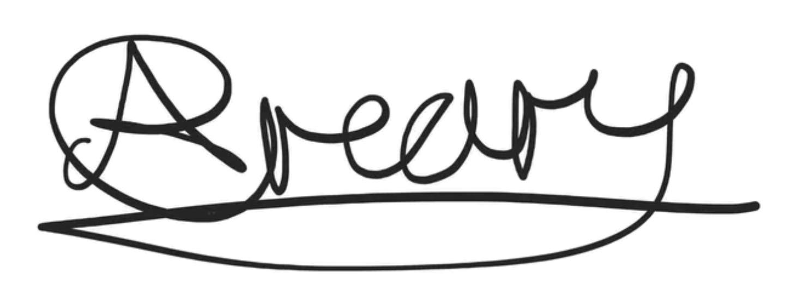
Name: __Akeem Creary__

Signature ________________________ Date: _November 4, 2026__

