* Navigate to “app” directory

* Activate venv “fastAPIVenv” provided in project

* install requirements.txt

* run command – “uvicorn main:app --reload --port 8000”

* go to URL <http://127.0.0.1:8000/docs>

* refer below mentioned details for APIs and their sample responses  
  
1] “/register” – Register user

* click on “Try it out”  
 * edit user and password for registration  
 * click on “Execute”  
 * refer response body section for the response of API  
 * note: if user is registered already then duplicate not allowed

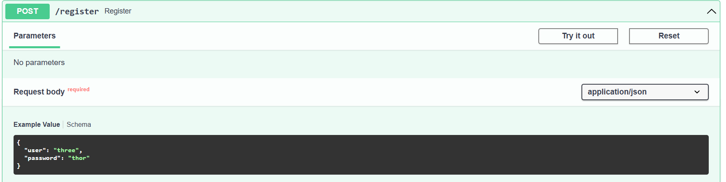  
  
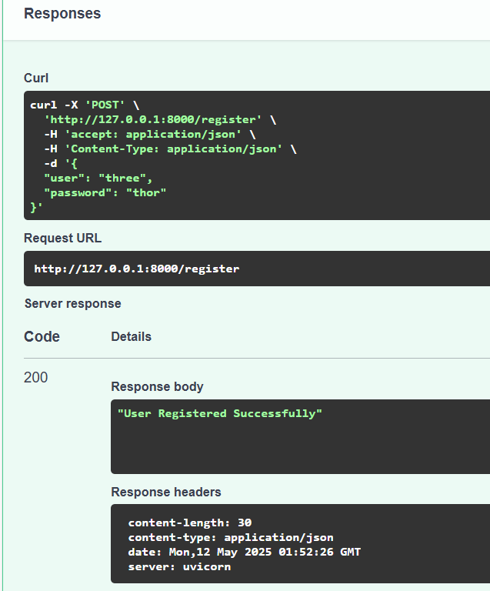

2] “/login” - login with registred user

* click on “Try it out”  
 * edit with registered user and password for login  
 * click on “execute”  
 * upon successful verification of user credential, token will be returned in response  
 * copy the token and provide it in Autorization at the top of screen  
 * paste token in “value” in JWTBearer section only and click on “Authorize”  
 * now the token is passed to the application and user can access all API

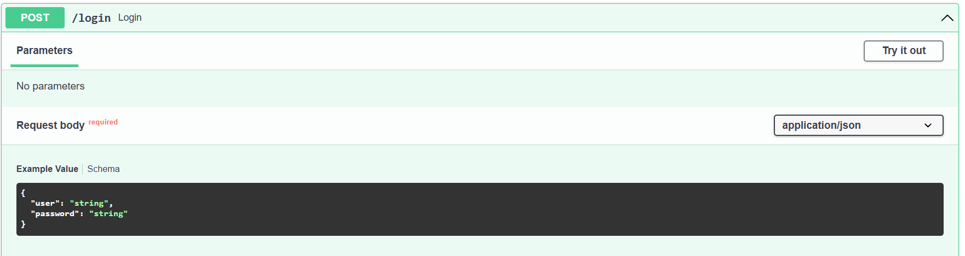

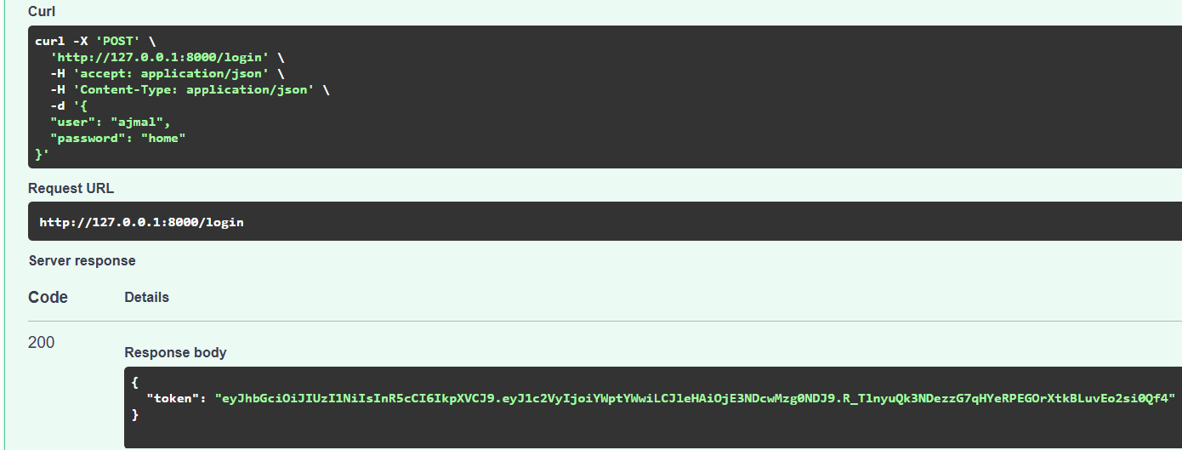

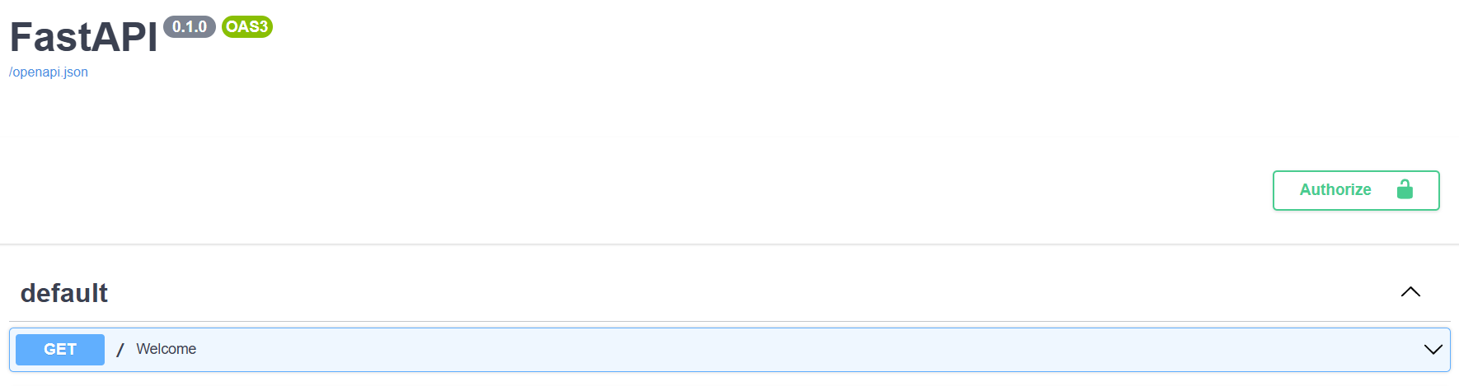

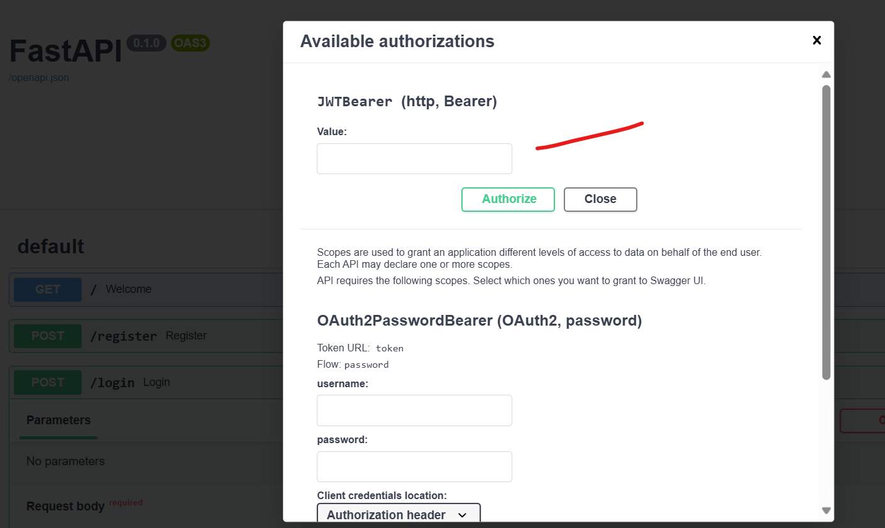

3] “/fund-families” - Get All list of Mutual Funds

* Click on “Try it out”
* Click on “Execute”
* List of all mutual funds will show in response
* Note: response is too long, hence it will take some time to load

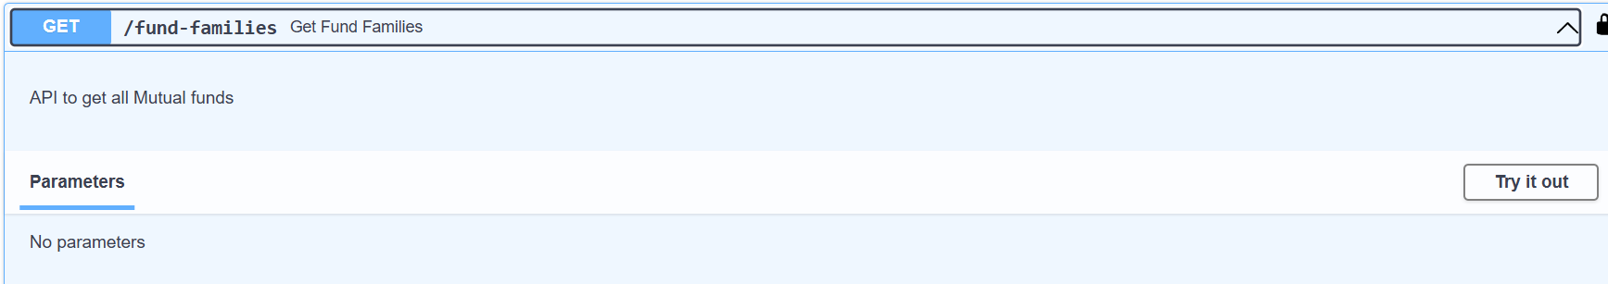

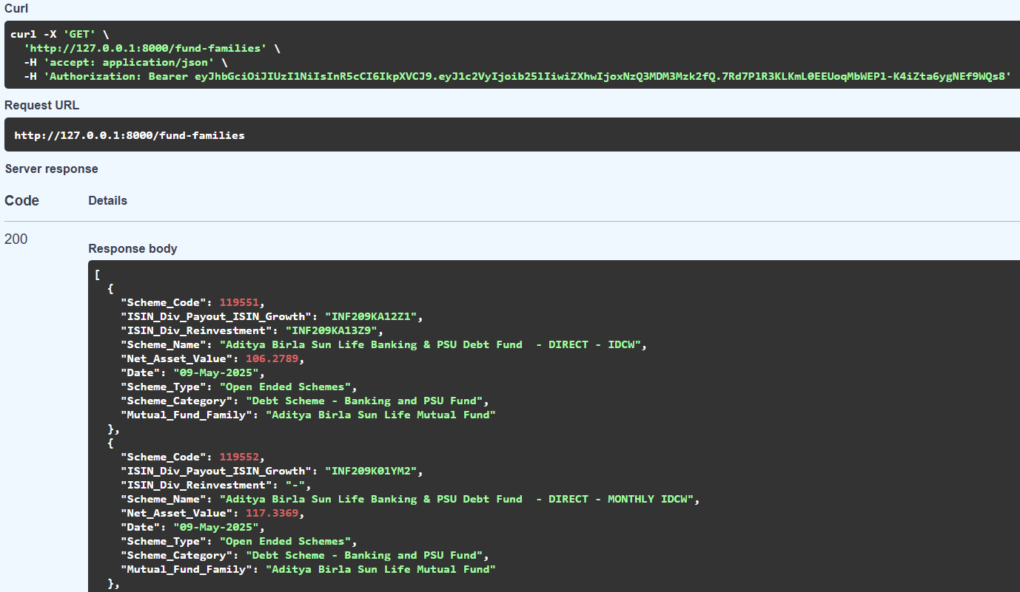

4] “/get-fund-details” - get details of fund based on “scheme_code”

* click on “Try it out”  
* provide “scheme_code” and click on “execute”

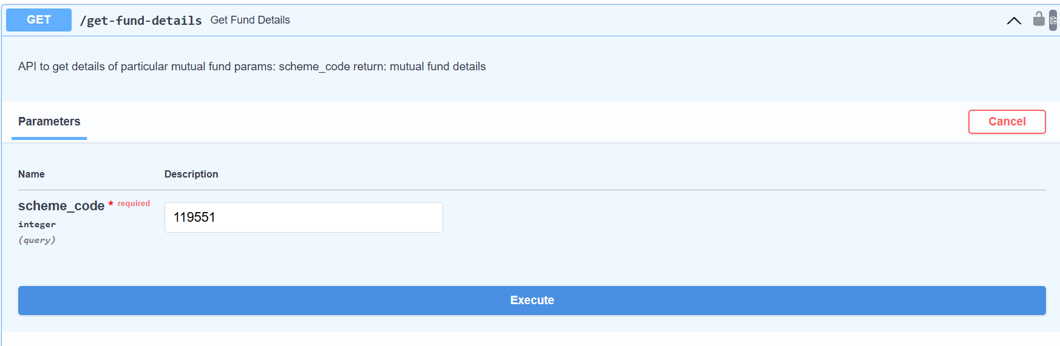

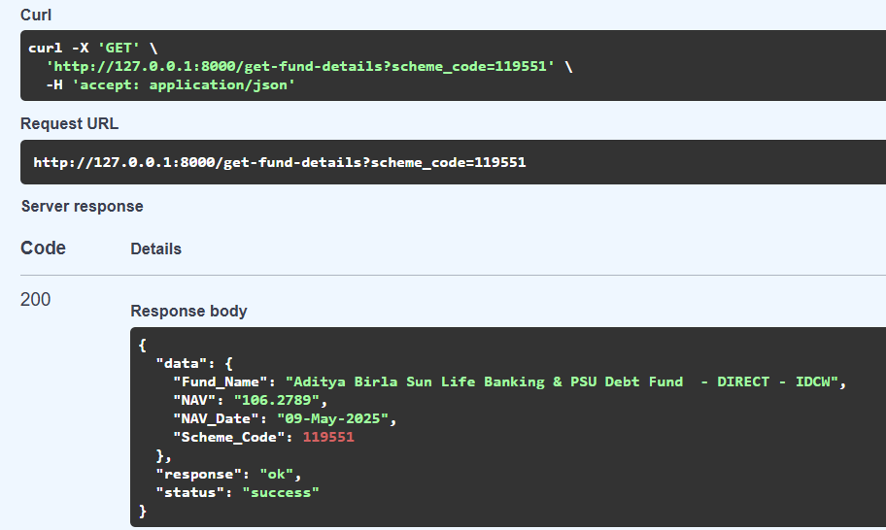

5] “/invest” - API to invest amount under particular scheme

* click on “Try it out”  
* provide amount & scheme_code to invest  
* note: If investment already exits then new amount will be added to existing amount to make total invenstment

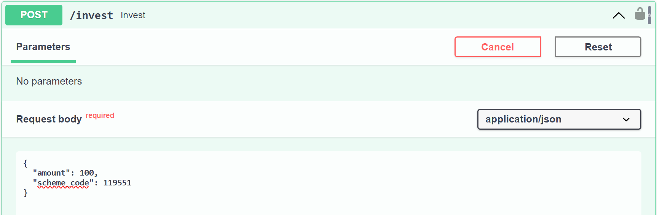

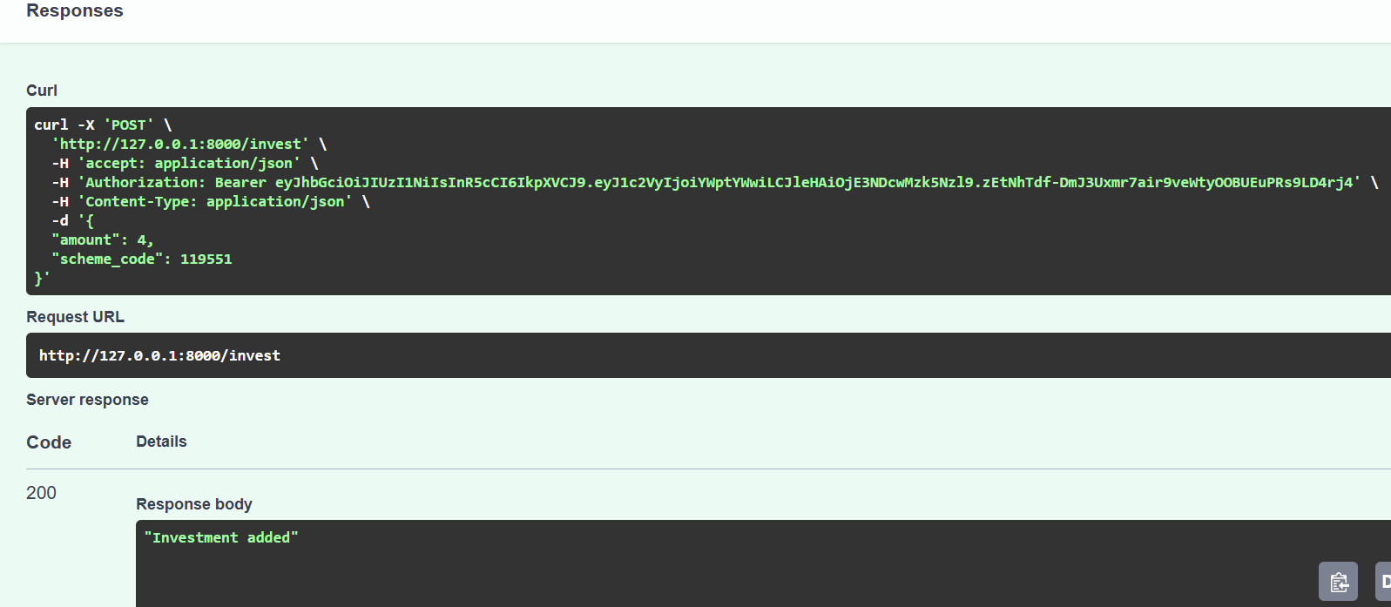

6] “/portfolio” - API to get portfolio of current user

* click on “Try it out”  
 * click on “Execute”  
 * API will return portfolio of user

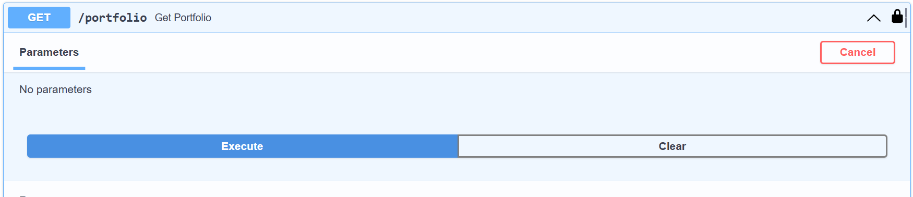

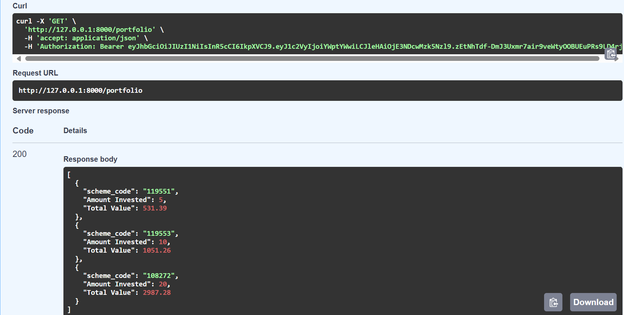

# Note –

If API with Authentication mandatory tried to access without providing token then it will show error response “Not Authenticated”

