BRAVO DRINKING WATER

Lab Analysis - Water Quality Report  Physical and Chemical Test  Microbiology  Comments: WATER IS FIT FOR DRINKING  Lab Chemist: Muhammad Bilal  Signature: _________________ | 25 Oct 2026  Pure Hydration, Delivered.  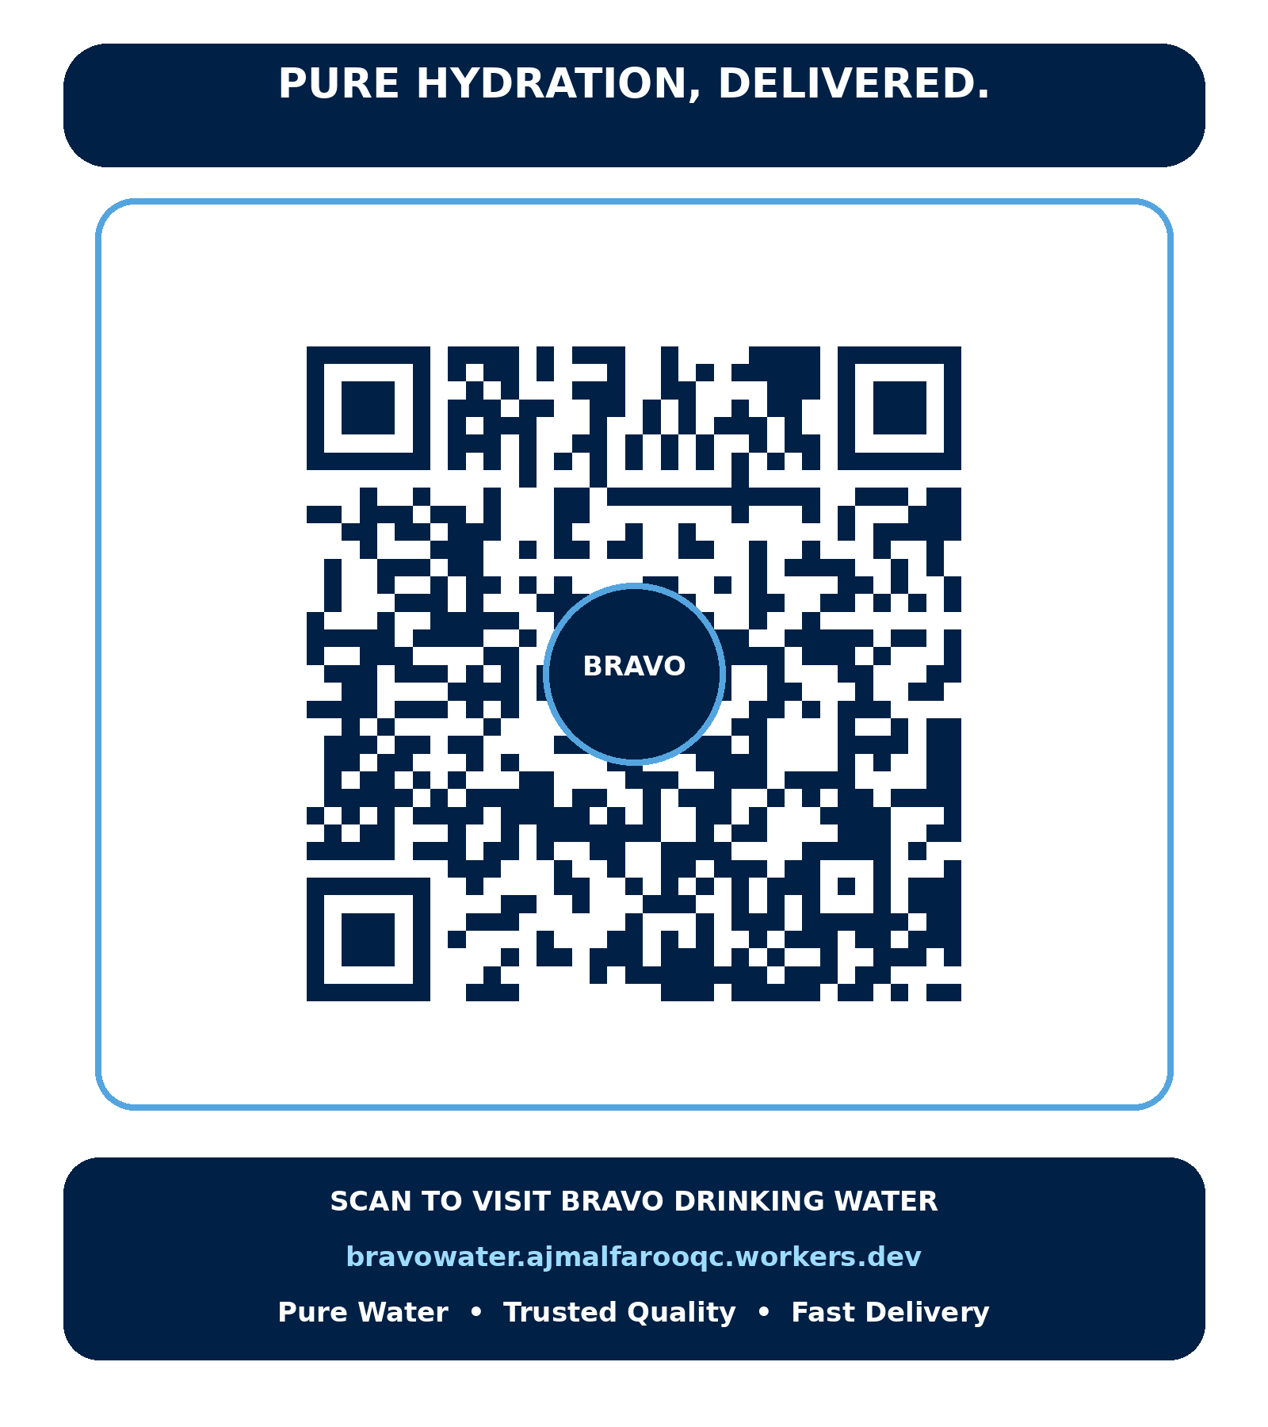  SCAN TO VISIT BRAVO DRINKING WATER  bravowater.ajmalfarooqc.workers.dev  Pure Water • Trusted Quality • Fast Delivery
  # | Parameter | Limit | Result
  1 | Appearance | Clear, free from foreign matter | Cleared
  2 | Taste/Test | Smoot Un-objectionable | Normal
  3 | Odour | Odourless | Odourless
  4 | Colour | Colourless | Colourless
  5 | Turbidity (NTU) | 0.5 (max) | BDL
  6 | pH | 6.5 - 8.5 | 6.9
  7 | TDS (ppm) | 500 (max) | 160
  8 | Total Hardness (ppm) | 200 | 100
  9 | Calcium - Ca (ppm) | 100 | 30
  10 | Magnesium - Mg (ppm) | 50 | 4
  11 | Sodium - Na (ppm) | 50 | 16
  12 | Potassium - K (ppm) | 10 | BDL
  13 | Sulphate - SO4 (ppm) | 250 | 32
  14 | Nitrite (ppm) | 1 | 0.2
  15 | Chloride - Cl (ppm) | 250 | 56
  16 | Chlorine (ppm) | 0.1 | NIL
  # | Microbial Analysis | Limit | Result
  1 | Total Coliform | <1 CFU/250ml | NEGATIVE
  2 | E.coli | <1 CFU/250ml | NEGATIVE
  3 | Fecal Enterococci | ..CFU/ml | NEGATIVE
  4 | Pseudomonas aeruginosa | <1 CFU/ml | NEGATIVE

