GIT

We are using Git to maintain and manage the versioning

- What is version control system and why it is popular?

It address two problems
- Sharin of code
- Versioning

VC
Cvs and svn is centralized
GIT -> distributed

GIT

- Source code management or software configuration management

Source code - the devolepers write codes

- Source code management
- Centralized version control system
- Distributed version control system

Centralized version control system (cvcs)
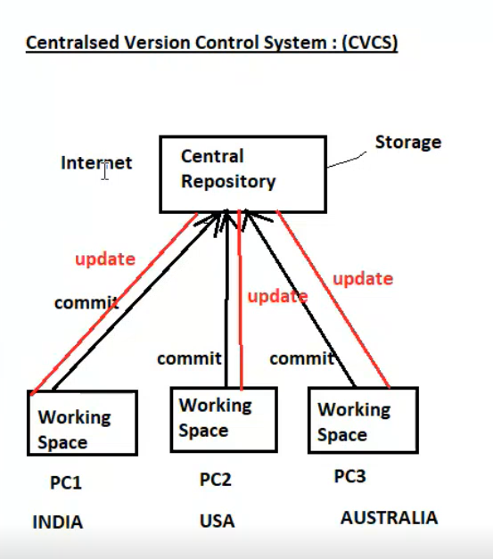
Push : commit
Pull : update

- Here developers are in different location but same project
- Internet is required to connect with central repo
- All code is stored in central repo
- Developer commits directly to the central repo
- Commit: pushinf the code from personal computer(work space) to central server or repo

Explained notes of centralized vcs

- Centralized Version Control Systems (CVCS) rely on a single central repository where all code versions are stored
- Developers connect to this repository to commit changes or update their local copies
- Working on branches is difficult in cvcs, developers often face merge conflict’
- Cvcs require internet ,it do not provide offline access
- In cvcs server is donw ,developers cannot work

Drawback of cvs
- Depends on internet ( so process might be delay because of huge traffic)
- There is no copies, if the central repo fail all datas will get lose

Distributed version control system (DVCS)

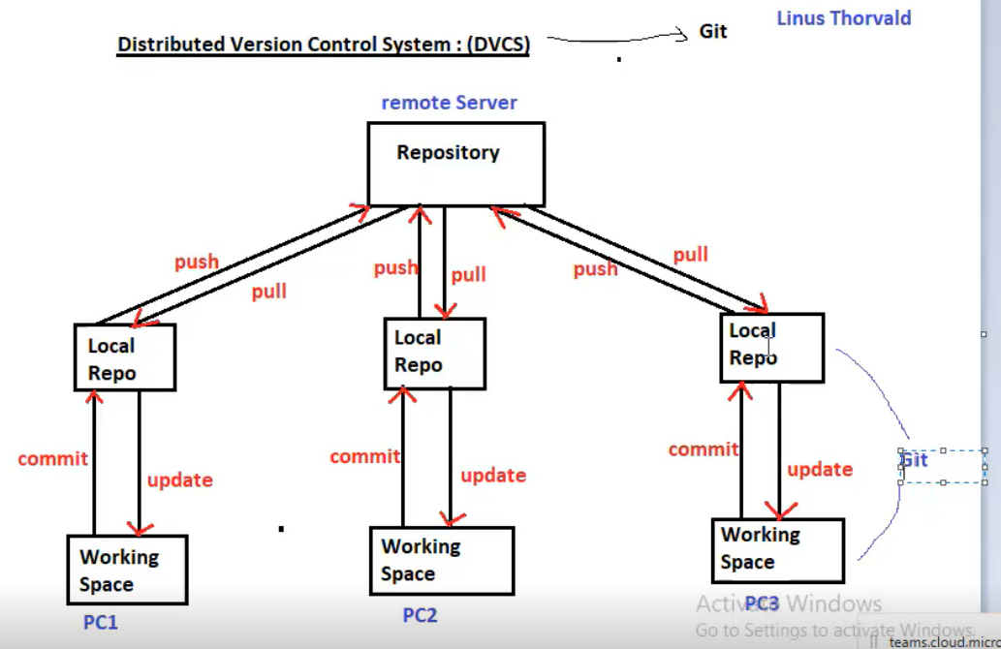

- Git is DVCS
- The moment we installed a git, a repo will create in local machine called local repository
- Every developer as a complete copy of the repo

Explained notes

- In DVCS ,each client can have a local branch as well and have a complete history on it,client need to push the change to the branch, which will then be pushed to server repository
- Working on branches is easier is dvcs,developers face less conflict
- Dvcs systems are working fine on offline mode as a client copies the entire repository on their location machine
- In dvcs server is down , developers can work use the copies in the local repo
- Dvcs Is faster as mostly user deal with local lopy without hitting server everytime

Workflow of Git / stages of Git

- Workin directory/working space
- Stagging area
- Local repository

- git install – to install
- git init – to initiate the git and create a new Git repository

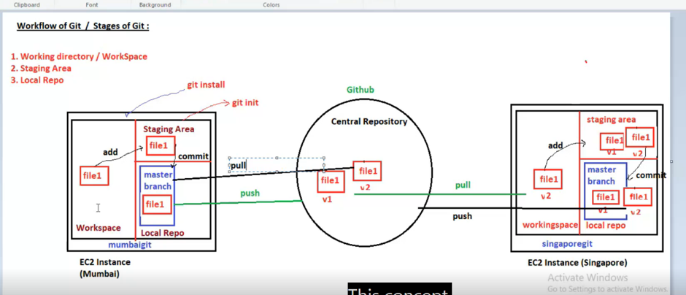

- in local repo by default one branch will create called master branch
- work space -- deveoloper are working in the working space. It’s a local folder where developers create and modify files before stagging and commitin to git.
- Developers will write and create files in working space

Git add – to store the files to staggin area
Git commit – to push the file from staggin area to local repo (default branch, master branch

Stagging area
- Stagging area is a intermediate area between working area and git repository. It allows developers to select and review specific changes before creating a commit using git commit
- From the local repo we push the file to central repo called GIT HUB

Repository
- Repository is a place where you have all your codes or kind of folder on server
- It is a kind of folder related to one product
- Changes are personal to that partical repo

LAB for install,create,initaiate GIT

- Launch a instance first
- Yum update -y
- Yum install git -y ( to install git)
- git -v ( to check the git version )
- mkdir folder ( after installing Git need to create a directory.it will act as a repository)
Q. how do you set a global username and email in git?
- git config –global user.name “ajmal”
- git config –global user.mail “ajmalmhd531@gmail.com” ( every commit you make on the system will be tagged with your name and mail)
- git config --global –list ( to check the username and mail)
- cd folder
Q: How do you initialize a new Git repository?
- Git init
- Git status ( to check the status)
- Create a empty file – touch blearn
Q: How do you add all files to the staging area?
- git add . (all files)
- git add blearn (specific files)
- git commit -m "First commit( create a commit with a message?)
- git log –oneline (view commit history in one line?) git log for detailed commit history
Q. How do you list all branches?
- # git branch
Q: How do you create a new branch?
- git branch branch1
Q: How do you switch to another branch?
- git checkout branch1 or git switch branch1
Q: How do you view details of a specific commit?
- git show <commit-id>

Branch

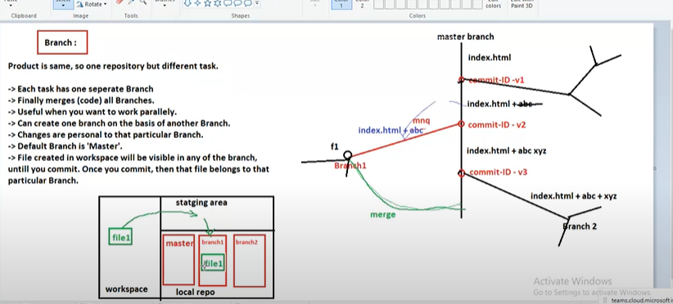

Advantage of git

- free and open source
- fast and small – as most of the operations are perform locally there it is fast ( it means there is no internet connection required so it should be fast)
- security – git users a common cryptographic hash function called secure hash function sha1 (secute hash). To name and identify object with int its database
- no need of powerfull hardware
- easier branchin – if we create a new branch, it will copy all the codes to new branch

git reset . # Staging Area -> Workspace
git reset --soft HEAD~1 # Commit -> Staging Area
git reset HEAD~1 # Commit -> Workspace

Git conflict
- when some files having different content in different branches, if you do merge conflict occurs ( resolve conflict then add and cpmmit)
- conflict occurs when you mere branches

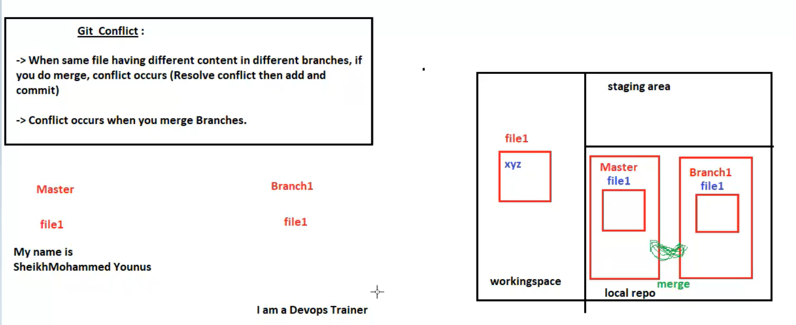

Q)Create two branches, make conflicting changes to the same file in each branch, merge the branches, and resolve the merge conflict.”
1. Create a repository (git init)
2. Commit files on master
3. Create Branch1
4. Make different changes in both master and Branch1
5. Switch back to master
6. Run git merge Branch1
7. Conflict occurs in younusfile
8. Edit the file (vi younusfile) to resolve the conflict
9. Stage the resolved file (git add .)
10. Commit the resolution (git commit -m "Resolve Conflict")

Git stashing
- suppose you are implementing a new feature for you product, your code is in progress and suddenly a customer escalation comes because of this, you have to keep aside your new feature work for few hours
- you cannot commit your partial code and also cannot throw away your chanes,so you need temporary storage, when you can store your particular changes and later on commit it
- to stash an item ( only applies modified file not new file)
- git stash temporarily saves your uncommited changes . so you can swtich branch or working something else,without commiting incomplete work

Git stash | Saves your current changes and revert your working directory to match the last commit
Git stash list | Shows all stashed entried
Git shash apply | Re-applies most recent stash but keeps it in stash list
Git stash pop | Re-applies most recent stash nd remove it in stash list
Git stash drop | Delete a specific stash without applying it
Girt stash clear | Delete stashes

