CHAPTER 1

INTRODUCTION

A Live Civilians Emergency Response System is a comprehensive platform designed to enhance public safety by providing real-time emergency management tools. The system integrates several crucial components aimed at streamlining emergency responses and improving communication between authorities and civilians during crises. This system serves as a bridge between civilians and emergency responders, providing essential tools for real-time communication, safe routing, and predictive capabilities, ultimately ensuring a faster and more coordinated response during emergencies.

1.1 CONTEXT

Live Civilians Emergency Response System is a coordinated framework designed to provide real-time assistance to civilians during emergencies like natural disasters, terrorist attacks, or accidents. The system integrates communication technologies, such as emergency hotlines, mobile apps, and geo-location services, to quickly connect civilians with first responders. It involves multi-agency coordination between police, fire departments, medical teams, and emergency services to ensure rapid action and efficient resource deployment. This include real-time alerts to civilians, GPS tracking for monitoring evacuations, and medical triage. Increasingly, civilians contribute through apps that allow them to report emergencies, share live updates, and request help. Technology like drones and AI-driven data analysis improves situational awareness, while government and private-sector collaboration enhances the system's overall effectiveness.

1.2 VISION

This system is to create a seamless, real-time network that ensures rapid and coordinated responses during any crisis. It aims to integrate advanced technologies like AI, geolocation, and communication platforms to enhance the speed and efficiency of emergency interventions. This system envisions empowering civilians with tools to report emergencies and receive live updates, improving their safety and awareness. It seeks to unify all emergency response agencies to work collaboratively, reducing delays and confusion during critical moments. Ultimately, the goal is to save lives, minimize damage, and create resilient communities prepared for any emergency.

1.3 OBJECTIVES

- Rapid Response: To ensure immediate and efficient deployment of emergency services during crises, minimizing response time.

- Real-Time Communication: Facilitate instant communication between civilians, emergency responders, and agencies through integrated platforms like mobile apps, hotlines, and social media.

- Civilians' Safety: Provide civilians with timely alerts, safety instructions, and live updates to protect them during emergencies.

- Multi-Agency Coordination: Enhance collaboration between police, fire, medical, and other response units to ensure seamless action in emergency situations.

- Technological Integration: Use cutting-edge technology, including AI, GPS, and drones, to improve situational awareness and optimize resource allocation.

- Crisis Mitigation: Minimize the impact of disasters by enabling swift evacuation, medical aid, and resource management to protect lives and property.

CHAPTER 2

LITERATURE SURVEY

2.1. Flood Forecasting System Based on Integrated Big and Crowdsource Data by Using Machine Learning Techniques

Authors: Supattra Puttinaovarat, Paramate Horkaew

Year: 2020

Literature Survey: The study addresses limitations in traditional flood forecasting, which rely on sparse and outdated meteorological and hydrological data. It integrates big data, geospatial analytics, and machine learning techniques like Decision Trees, Random Forest, ANN, and SVM to enhance prediction accuracy. Crowdsourced data further improve real-time updates. By combining multiple data sources through APIs, the proposed system achieves 97.93% accuracy with MLP ANN, enhancing disaster preparedness and response.

2.2. A Hybrid Machine Learning Pipeline for Automated Mapping of Events and Locations From Social Media in Disasters

Authors: Chao Fan, Fangsheng Wu, and Ali Mostafavi

Year: 2020

Literature Survey: The study explores the use of social media for disaster management, focusing on event detection and geolocation inference using machine learning. While existing methods like Naïve Bayes, CNNs, and GANs aid crisis response, challenges such as low geotag availability and credibility persist. Current platforms lack fine-grained location mapping. To address this, the paper introduces a hybrid machine learning pipeline integrating Named Entity Recognition, geolocation fusion, a fine-tuned BERT classifier, and graph-based clustering. Tested on Hurricane Harvey Twitter data, the approach enhances situational awareness and disaster response.

2.3. Automated Machine Learning Approaches for Emergency Response and Coordination via Social Media in the Aftermath of a Disaster: A Review

Authors: Lokabhiram Dwarakanath, Amirrudin Kamsin, Rasheed Abubakar Rasheed, Anitha Anandhan, Liyana Shuib

Year: 2021

Literature Survey: This paper reviews the role of social media in disaster response and the use of machine learning for extracting actionable information. Prior research is categorized into three phases: early warning, post-disaster coordination, and damage assessment. Various machine learning techniques, including traditional classifiers and deep learning, have been applied to filter relevant data from social media. Key challenges include multilingual support, data integration, and real-world validation. The study emphasizes the need for improved automation and scalability in machine learning for effective disaster response.

2.4. Machine Learning-based Classification of Online News Data for Disaster Management

Authors: Lakshmi S Gopal, Rekha Prabha, Divya Pullarkatt, Maneesha Vinodini Ramesh

Year: 2020

Literature survey: Discusses web crawling and supervised learning for disaster-related news classification. It highlights challenges in extracting relevant information, the importance of politeness policies in web scraping, and the effectiveness of machine learning models like Naïve Bayes and SVM. The study emphasizes data preprocessing techniques and the role of structured news data in improving disaster management efforts. Additionally, it explores the necessity of filtering non-relevant content using exclusion conditions and ontology-based keyword matching. It also reviews various text classification approaches and their limitations, emphasizing the need for improved data collection and model training to enhance classification accuracy.

2.5. Integrating Machine Learning and Remote Sensing in Disaster Management: A Decadal Review of Post-Disaster Building Damage Assessment

Authors: Sultan Al Shafian and Da Hu

Year: 2024

Literature Survey: The paper reviews the integration of remote sensing and machine learning for post-disaster building damage assessment by analyzing 370 articles from 2014 to 2024. It highlights key advancements in UAV technology, AI-driven analysis, and real-time processing while addressing challenges such as data fusion and model adaptability. The study emphasizes the need for AI-driven strategies to boost accuracy and efficiency, and it advocates for future research on multi-modal AI models, real-time data processing, and improved disaster response training.

2.5.Integrating Machine Learning and Remote Sensing in Disaster Management: A Decadal Review of Post-Disaster Building Damage Assessment

Authors: Sultan Al Shafian and Da Hu

Year: 2024

Literature Survey: The paper reviews the integration of remote sensing and machine learning for post-disaster building damage assessment by analyzing 370 articles from 2014 to 2024. It highlights key advancements in UAV technology, AI-driven analysis, and real-time processing while addressing challenges such as data fusion and model adaptability. The study emphasizes the need for AI-driven strategies to boost accuracy and efficiency, and it advocates for future research on multi-modal AI models, real-time data processing, and improved disaster response training.

2.6.Geographical Distribution, Disease Association, and Diversity of Klebsiella pneumoniae K/L and O Antigens in India: Roadmap for Vaccine Development

Authors: Varun Shamanna et al.

Year: 2024

Literature Survey: The study analyzes 1,072 Klebsiella pneumoniae isolates in India to assess serotype diversity, antimicrobial resistance, and distribution. Whole-genome sequencing identifies 78 KL and 13 O types, with KL64, KL51, and KL2 being the most common, and O1/O2v1 and O1/O2v2 as dominant O serotypes. Though no link to disease severity was found, virulence factors like yersiniabactin and aerobactin correlated with specific KL types. A vaccine covering ~20 KL or four O types could protect against 85% of carbapenemase-producing strains, emphasizing the need for targeted surveillance and intervention. Additionally, the study underscores the role of AI-driven strategies in disease monitoring, integrating machine learning and real-time data processing to improve vaccine development and public health responses.

CHAPTER 3

EXISTING SYSTEM
In the realm of disaster management, several established systems and frameworks have been developed to enhance response capabilities and safeguard civilian lives. Here are some noteworthy existing
4.1 FEMA’S INTEGRATED PUBLIC ALERT AND WARNING SYSTEM (IPAWS)
- Description: A system that enables local, state, tribal, and federal authorities to send emergency alerts to the public
- Key Features:
  - Multi-channel communication (TV, radio, mobile devices).
  - Capability to issue alerts based on specific geographic areas.
  - Integration with the Emergency Alert System (EAS).
3.2 GLOBAL DISASTER ALERT AND COORDINATION SYSTEM (GDACS)
- Description: A web-based platform that provides real-time alerts about natural disasters worldwide.
- Key Features:
  - Automated alerts based on earthquake and cyclone monitoring.
  - Coordination support for humanitarian response.
  - Access to satellite imagery and mapping tools.
3.3 CRISIS RESPONSE PLATFORMS (E.G., USHAHIDI)
- Description: A crowd-sourced platform that facilitates information sharing during crises.
- Key Features:
  - Users can report incidents and share updates.
  - Integration of mapping tools to visualize reported data.
  - Enables community engagement and coordination.

3.4 PREDICTIVE ANALYTICS TOOLS (E.G., IBM WEATHER COMPANY)
- Description: Tools that leverage big data to provide weather forecasting and disaster predictions.
- Key Features:
  - Advanced analytics to predict severe weather events.
  - Historical data analysis for better preparedness.
  - Integration with local emergency management agencies.
3.5 GEOGRAPHIC INFORMATION SYSTEMS (GIS)
- Description: Tools used for mapping and analyzing disaster-prone areas.
- Key Features:
  - Visualization of risk zones and vulnerable populations.
  - Route planning based on real-time data.
  - Support for emergency response planning and execution.
3.6 COMMUNITY COMMUNICATION PLATFORMS (E.G., NEXTDOOR, FACEBOOK GROUPS)
- Description: Social media and community apps that allow for local information sharing.
- Key Features:
  - Facilitate communication among residents during emergencies.
  - Enable the sharing of resources and support networks..
3.7 MOBILE APPS FOR DISASTER MANAGEMENT (E.G., RED CROSS EMERGENCY APP)
- Description: Mobile applications designed to provide disaster information and resources to civilians.
- Key Features:
  - Real-time alerts

CHAPTER 4

PROPOSED SYSTEM
The "Civilian Emergency Response System" (CERS) is designed to provide a comprehensive, technology-driven approach to disaster management, effectively safeguarding civilian lives through its four key components: disaster prediction, route planning, alert systems, and community communication. Below is a detailed overview of the proposed system, highlighting its functionality, architecture, and benefits.
4.1 SYSTEM OVERVIEW
The CERS integrates advanced technologies and data analytics to enhance the preparedness, response, and recovery phases of disaster management. Its modular design allows for seamless integration with existing systems and platforms, ensuring efficient operation during emergencies.
4.2 KEY COMPONENTS
4.2.1. DISASTER PREDICTION
- Functionality: Utilizes machine learning algorithms and big data analytics to analyze historical and real-time data, such as weather patterns, geological data, and environmental conditions.
- Benefits:
  - Provides early warnings for potential disasters, allowing authorities and civilians to take preventive measures.
  - Facilitates timely evacuations and the implementation of safety protocols to minimize casualties and property damage.
4.2.2. ROUTE PLANNING
- Functionality: Generates dynamic, real-time route maps that guide civilians from disaster-affected areas to safe zones, takingintoaccount current environmental conditions and hazards.
- Benefits:
  - Ensures efficient and safe evacuations by avoiding hazardous zones.
  - Continuously updates evacuation routes based on changing conditions to provide the safest paths.
4.2.3. ALERT SYSTEMS
- Functionality: Sends color-coded alerts (e.g., orange, red) to inform civilians about impending disasters and the severity of threats through multiple communication channels (mobile notifications, SMS, etc.).
- Benefits:
  - Ensures timely dissemination of critical information to all civilians, including vulnerable populations.
  - Increases awareness and preparedness among communities.
4.2.4. COMMUNITY COMMUNICATION
- Functionality: Provides a platform for individuals in disaster-affected areas to share information, request help, and coordinate with others through a community chat system.
- Benefits:
  - Fosters a sense of community and mutual support during emergencies.
  - Enhances information flow, especially when traditional communication channels are disrupted.
4.3 SYSTEM ARCHITECHTURE
The architecture of the CERS is designed for scalability, reliability, and user accessibility. Key layers include:
- Data Layer: Integrates data from various sources (weather APIs, historical databases, IoT sensors).
- Application Layer: Comprises the four main components (disaster prediction, route planning, alert systems, community communication).
- Interface Layer: Provides user interfaces (mobile app, web dashboard) for civilians and emergency responders.
- Integration Layer: APIs for data integration with external systems and existing emergency response frameworks.
- Infrastructure Layer: Cloud-based services for data storage and processing, ensuring robust security measures.

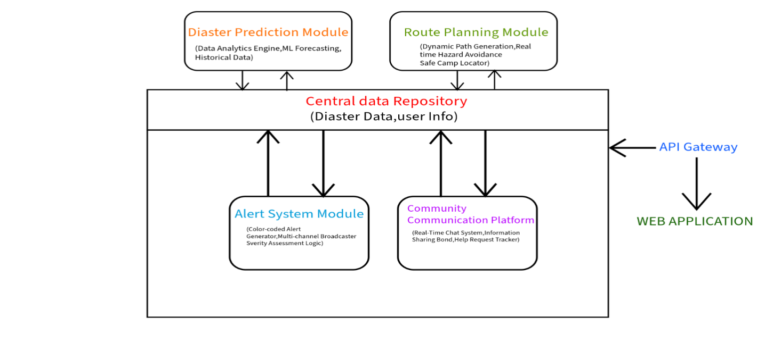
Fig no: 4.3 System Architechture
4.4 IMPLEMENTATION STRATEGY
- Phase 1: Development: Build the core components of the system using agile methodologies, ensuring flexibility to adapt to changing requirements.
- Phase 2: Pilot Testing: Implement the system in selected high-risk areas to gather data and feedback, making necessary adjustments.
- Phase 3: Deployment: Roll out the system to broader regions, ensuring proper training for users and emergency responders.
- Phase 4: Continuous Improvement: Monitor system performance, update algorithms, and enhance features based on user feedback and technological advancements.
4.5 EXPECTED OUTCOMES
- Enhanced safety and preparedness of civilian populations during natural disasters.
- Reduction in casualty rates and property damage through effective prediction and response strategies.
- Strengthened community resilience and support networks during emergencies.

CHAPTER 5

SYSTEM REQUIREMENTS
5.1 Disaster Prediction Component
5.1.1 Functional Requirements:
- Data Collection: The system should gather historical disaster data, weather data (temperature, wind speed, rainfall, etc.), seismic data, and environmental information.
- Predictive Analytics: The system should apply machine learning algorithms and data analytics to forecast potential natural disasters (e.g., floods, earthquakes, hurricanes).
- Real-Time Data Processing: It must handle real-time data streams from weather stations, sensors, satellites, etc.
- Accuracy: The predictions should be accurate within a predefined margin of error, with the ability to continuously improve prediction models through learning.
5.1.2 Non-Functional Requirements:
- Scalability: Should be able to process large volumes of historical and real-time data.
- Reliability: The system must provide timely predictions and warnings to ensure preemptive actions.
- Speed: Predictions should be generated and updated in real-time as new data becomes available.
5.1.3 Technical Specifications:
- Use of Big Data Analytics platforms (e.g., Apache Hadoop, Spark) for handling large-scale data.
- Machine Learning libraries (e.g., TensorFlow, Scikit-learn, Keras) for prediction models.
- Integration with third-party APIs like NOAA, USGS, and Global Disaster Databases.
- Cloud-based storage (e.g., AWS S3, Google Cloud Storage) for managing historical and real-time data.
5.2 Route Planning Component
5.2.1 Functional Requirements:
- Route Generation: The system must generate dynamic, real-time evacuation routes based on disaster scenarios, road closures, traffic conditions, and topography.
- Safety Assurance: Routes should avoid hazardous zones and ensure safe passage for civilians, considering the current state of the environment (e.g., flood-prone areas, unstable structures).
- Dynamic Updates: As the disaster unfolds, the system should continuously update routes based on real-time data from sensors, traffic reports, or field agents.
- Integration with Emergency Services: Coordination with local authorities and emergency services to ensure the designated safe routes are accessible.
5.2.2 Non-Functional Requirements:
- Latency: The system must update route information in near real-time (sub-second or few seconds delay).
- Redundancy: Multiple route options should be available in case of unexpected changes or blockages.
- Usability: Routes should be presented in a user-friendly format on mobile or web interfaces.
5.3 Alert System
5.3.1 Functional Requirements:
- Multi-Channel Alerts: The system must support alerts via mobile notifications, SMS, emails, radio, TV, and social media channels.
- Alert Severity Levels: Clear categorization of alerts (e.g., color-coded alerts: yellow, orange, red) based on the severity of the threat.
- Personalized Alerts: Alerts should be customized to users based on location, disaster type, and severity.
- Preemptive Alerts: Ability to send early warnings, ideally several hours or days in advance, for disasters like hurricanes or floods.
5.3.2 Non-Functional Requirements:
- Reachability: Must ensure alerts reach all civilians, including vulnerable groups (elderly, disabled, etc.).
- Accuracy: Alerts must be precise and context-specific to avoid panic and misinformation.
- Real-Time Delivery: Alerts should be delivered immediately upon detection of a potential disaster or escalation.
5.4 Community Communication System
5.4.1 Functional Requirements:
- Real-Time Messaging: The system should allow users to send and receive real-time messages, including text, images, and voice notes.
- User Interaction: Ability for users to communicate directly with emergency services or other civilians.
- Data Sharing: Users should be able to share their locations, request help, or report hazardous conditions.
- Moderation and Security: The platform should ensure that conversations are monitored for misinformation or harmful content.
- Multilingual Support: The system should provide multilingual support for diverse populations.
5.4.2 Non-Functional Requirements:
- Scalability: Should support thousands or millions of simultaneous users in a disaster.
- Security: End-to-end encryption of messages for user privacy.
- Offline Functionality: The platform should offer limited functionality even when internet access is interrupted (e.g., SMS-based communication).
5.5 User and Access Management
5.5.1 Functional Requirements:
- User Authentication: The system must support user authentication via standard protocols like OAuth2, Open ID, or two-factor authentication (2FA).
- Role-based Access Control (RBAC): Different access levels should be granted based on user roles (e.g., civilians, responders, admins).
- User Profiles: Store basic user details (name, contact, emergency information) and preferences for alerts and communications.
5.5.2 Non-Functional Requirements:
- Security: Strong security measures to prevent unauthorized access and protect sensitive data.
- Usability: Simple user interface for profile management and setting preferences.
5.5.3 Technical Specifications:
- Authentication Services: Use of Auth0, Firebase Authentication, or custom-built OAuth2 solutions.
- Access Control: Implementation of RBAC using services like Keycloak, Amazon Cognito, or custom middleware.
- Database: Store user data in secure databases such as PostgreSQL, MongoDB, or MySQL.

CHAPTER 6

SYSTEM DESIGN

The increasing frequency and intensity of natural disasters underscore the critical need for innovative solutions to protect civilian lives. The Civilian Emergency Response System (CERS) is a comprehensive, technology-driven framework designed to enhance disaster management. This report outlines the system's four key components: disaster prediction, route planning, alert systems, and community communication, detailing how each element contributes to improved civilian safety and resilience.It incorporates multiple layers, including data collection, processing, communication, and user interfaces.The user interface is designed with simplicity, accessibility, and ease of use in mind.

6.1 HOME PAGE DESIGN
The Home Page serves as the main dashboard for users to access the system's features
and updates.
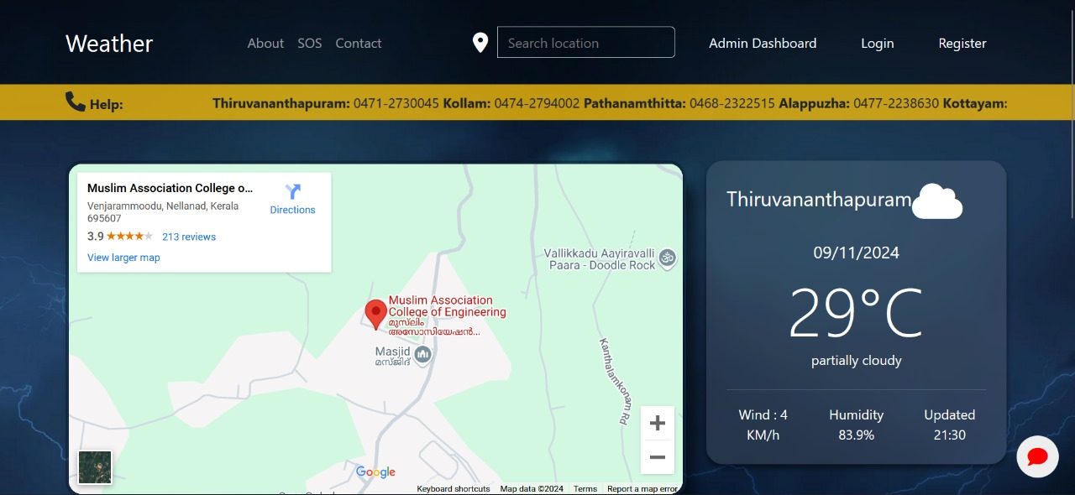

Fig no: 6.1 Home Page
- User-Friendly Layout: The form is organized in a simple, linear structure, making it easy for users to follow and fill out each field in sequence. Labels for each input field (Name, Email ID, Phone, Password, Confirm Password) are clearly visible.
- Aesthetic Design: The dark, stormy cloud background with subtle lighting effects adds a modern and dramatic look to the form. The semi-transparent input fields blend with the background, giving the form a sleek, professional feel.

- Validation and Error Handling: A validation message ("Please fill out this field") appears to prompt users when required fields are not filled out.

- Password Confirmation: The form includes both a Password and Confirm Password field, which helps users confirm their password to avoid errors.This is a standard security feature to ensure the accuracy of password entry.

- Mobile-Friendly Structure: The simple, single-column layout is likely responsive, meaning it would adapt well to different screen sizes, including mobile devices.

- Interactive Elements: A "Sign Up" button allows users to submit the form after completing all fields. A "Login Here" link beneath the form directs existing users to the login page, improving user navigation and accessibility.

- Country Code Selection for Phone Number: The Phone field starts with a country code (+91), which could be configurable to support different regions, enhancing global usability.

- Readable Typography:The font style is clear and readable, with blue-colored text matching the dark theme, enhancing visual appeal and legibility.

6.2 LOGIN PAGE DESIGN
The Login Page allows users to securely sign in to the system.
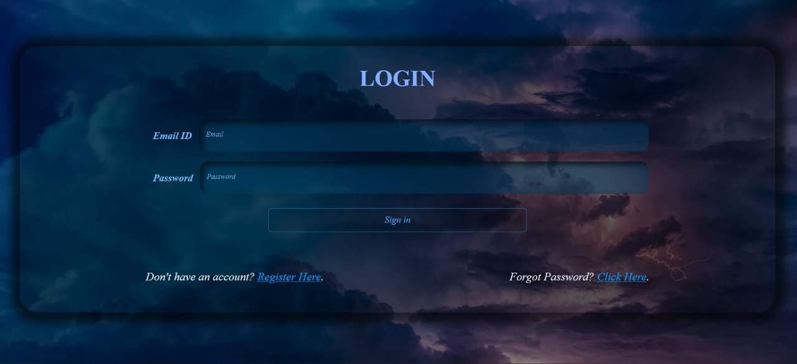

Fig no : 6.2 Login Page
- Username and Password Fields: For user authentication.
- Two-Factor Authentication (2FA): Optional for higher security.
- Login Button: To submit credentials and access the system.
- Forgot Password Link: For users who need to recover their account credentials.
- Sign-Up Link: For new users who want to register for the system.
6.3 RESET PASSWORD PAGE
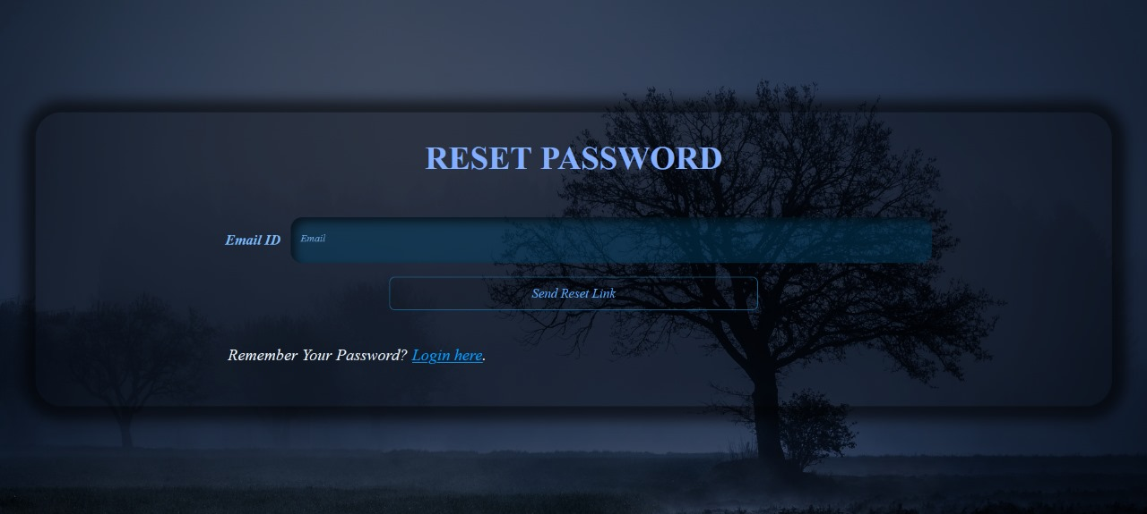

Fig no: 6.3 Reset Password
It contains :
- Input field for email.
- A button labeled "Send Reset Link."
- A navigational link to return to the login page.

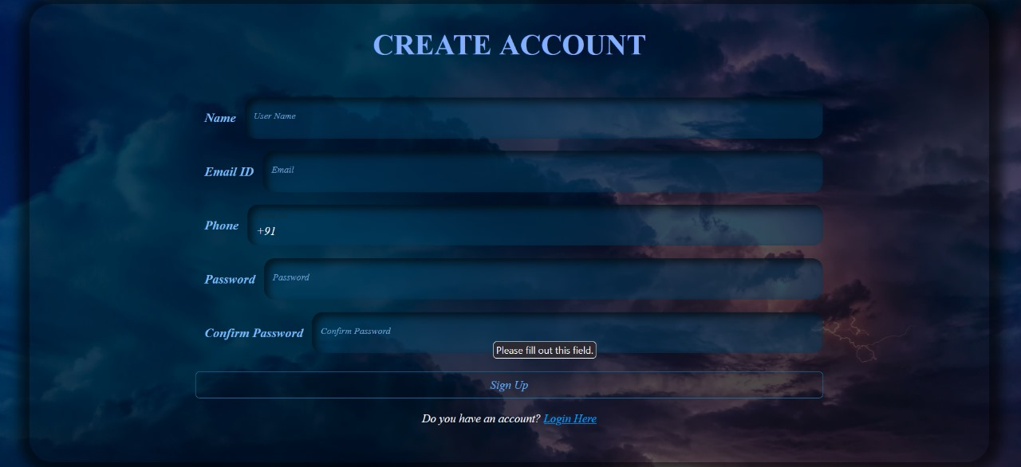
6.4 CREATE ACCOUNT PAGE

Fig no: 6.4 Create Account

Enables new users to register for the system by providing personal details and setting up a secure password and Key Elements are:
- Input fields for name, email ID, phone number, password, and confirm password.
- Validation to ensure proper data entry (e.g., "Please fill out this field").
- A "Sign Up" button and a navigational link for existing users to log in.

6.5 DISASTER PREDICTION MODULE
- Data Collection: Collects environmental data (weather patterns, seismic activity, historical data, etc.) from various sources like satellites, weather stations, and sensors.
- Data Processing: Uses machine learning models and predictive analytics to analyze the data and predict the likelihood of upcoming disasters.
- User Interaction: Provides real-time disaster alerts to authorities and civilians. Civilian users will be notified about potential threats via the alert system and be given recommendations for evacuation or safety measures.
6.6 ROUTE PLANNING MODULE

- Dynamic Route Generation: This feature generates real-time maps showing evacuation routes, safe zones, and danger areas. Routes are updated based on real-time environmental conditions (e.g., floods, fires, earthquakes).
- GPS Integration: The system utilizes GPS data from users’ devices to provide the most accurate and personalized route for evacuation.
- Safety Optimizations: The system continually assesses traffic, roadblock data, and other variables to provide the safest, most efficient paths for evacuation.

6.7 ALERT SYSTEM
- Alerts: The alert system uses a color-coded system (e.g., green, orange, red) to indicate the severity of the impending disaster.
  - Red Alert: Imminent or ongoing disaster, immediate action required (evacuation).
  - Orange Alert: Disaster is likely or in the process of occurring, prepare to takeaction.
  - Green Alert: No immediate threat, but monitoring continues.

6.8 DATABASE DESIGN
To support the functionality of the Civilian Emergency Response System, a relational database will be used to store and manage data. Key tables include:
- Users Table: Stores user credentials, profiles, and preferences.
- Disaster Events Table: Stores information about predicted and ongoing disasters.
- Route Maps Table: Stores data about dynamic evacuation routes, safe zones, and hazardous areas.
- Alert History Table: Tracks all issued alerts with timestamps and relevant details.
- Community Chat Table: Stores chat messages, user interactions, and group memberships.
- Emergency Contact Table: Stores local authorities, hospitals, and rescue team contact details.

6.9 SECURITY AND PRIVACY CONSIDERATIONS
- Encryption: All sensitive data (e.g., user credentials, personal information) will be encrypted using modern encryption algorithms.
- Access Control: Role-based access control (RBAC) will ensure that only authorized personnel (e.g., disaster management authorities) can access critical systems and data.
- Privacy: The system will comply with relevant data privacy regulations (e.g., GDPR, CCPA) and ensure users’ data is protected.

CHAPTER 7

SYSTEM IMPLEMENTATION

The methodology for developing the "Civilian Emergency Response System" (CERS) follows a structured approach to ensure that each component is effectively integrated and functional. This methodology comprises several phases: Research and Analysis, Design, Development, Testing, Deployment, and Maintenance. Below is a detailed breakdown of each phase.
7.1.RESEARCH AND ANALYSIS
Objective: To gather relevant information and define the requirements for the system.
- Literature Review: Analyze existing disaster management systems, identifying strengths and weaknesses to inform the design of CERS.
- Stakeholder Engagement: Conduct interviews and focus groups with emergency responders, local authorities, and community members to understand their needs and expectations.
- Needs Assessment: Identify key challenges faced during natural disasters and determine the functionalities required to address these challenges effectively.
7.2 .DESIGN
Objective: To create a comprehensive design for the system, detailing each component's functionality and user interfaces.
- System Architecture: Develop a high-level architecture diagram to visualize the interaction between the various components (disaster prediction, route planning, alert systems, community communication).
- User Experience (UX) Design: Create wireframes and prototypes for the mobile app and web dashboard, focusing on user accessibility and ease of use.
- Database Design: Plan the database structure to efficiently store and manage data related to predictions, routes, alerts, and community interactions.

7.3.DEVELOPMENT
Objective: To build the system according to the established design specifications.
- Agile Development: Implement an iterative development approach, allowing for flexibility and continuous feedback. Break the project into manageable sprints focusing on individual components.
- Component Development:
  - Disaster Prediction Module: Utilize machine learning algorithms to analyze data and provide predictions.
  - Route Planning Module: Implement real-time mapping and routing features using GIS technology.
  - Alert System Module: Develop the notification system for disseminating alerts across multiple channels.
  - Community Communication Module: Create the chat platform for users to connect and share information.
7.4.TESTING
Objective: To ensure the system functions correctly and meets user requirements.
- Unit Testing: Test individual components for functionality and performance.
- Integration Testing: Assess the interaction between components to ensure seamless operation.
- User Acceptance Testing (UAT): Involve stakeholders in testing the system in real-world scenarios, gathering feedback for improvements.
- Load Testing: Evaluate system performance under high-stress conditions to ensure reliability during disasters.
7.5.DEPLOYMENT
Objective: To roll out the system to target areas and ensure user readiness.
- Pilot Program: Launch the system in select high-risk areas for a trial period, gathering data and feedback on its performance.
- Training Sessions: Conduct workshops for emergency responders and community members to familiarize them with the system’s features and functionalities.
- Launch: Officially deploy the system to all targeted regions, ensuring all components are fully operational.
7.6.MAINTENANCE AND CONTINUOUS IMPROVEMENT
Objective: To ensure the system remains effective and up-to-date.
- Monitoring: Continuously monitor system performance, user engagement, and feedback to identify areas for improvement.
- Updates and Enhancements: Regularly update software and algorithms based on technological advancements and user feedback.
- Community Engagement: Foster ongoing communication with users to address emerging needs and improve the system’s functionality.

CHAPTER 8

SYSTEM TESTING

CHAPTER 9

RESULTS AND DISCUSSION

9.1 HOME PAGE

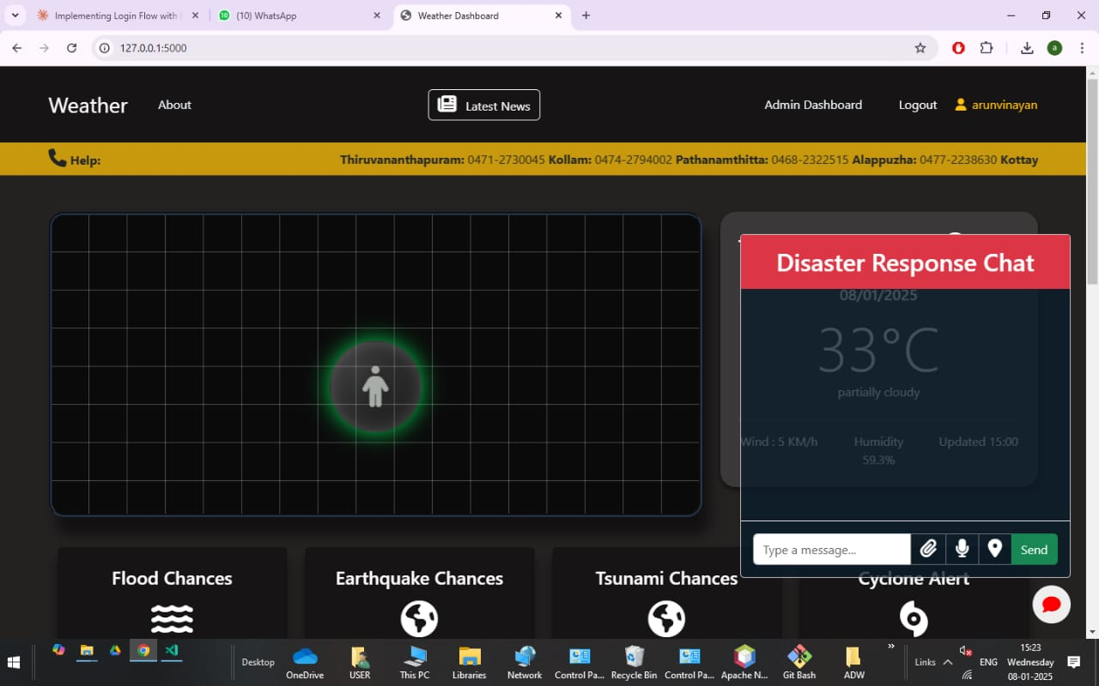
Fig no:9.1:Home Page

The home page consists of the Admin Dashboard, login logout section and the user icons. The interface also provides a facility to see the current location of the user. It also includes the chatting icon which enables the user to share their emotions, resources etc.The home page includes various disaster prediction mechanisms for the events such as:
- Flood
- Tsunami
- Cyclone
- Earthquake
- Rainfall
- Tornado etc.

9.2 EMERGENCY SOS

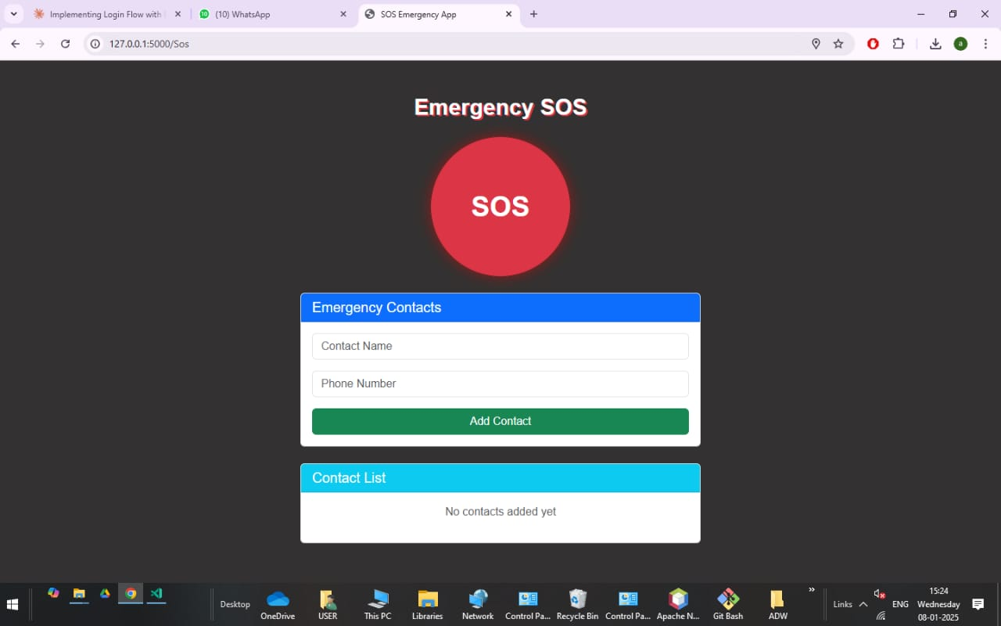
Fig no:9.2: Emergency SOS

Emergency SOS features in disaster management applications are designed to provide users with immediate assistance during emergencies

- Instant Alerts: Users can quickly send distress signals to emergency contacts or authorities, often by pressing a designated button or performing a specific action on their device.
- Real-Time Location Sharing: The application transmits the user's precise location to responders, enabling swift assistance.
- Satellite Communication: Some modern smartphones, such as iPhone models 14, 15, and 16, can connect to satellites, allowing users to contact emergency services even without cellular or Wi-Fi coverage.
- Community Reporting: Certain apps enable users to report incidents anonymously, contributing to community safety and awareness.

Examples of Emergency SOS Features:

- Pulse Point: This app alerts CPR-trained individuals about nearby cardiac emergencies, allowing them to provide assistance before professional help arrives.
- Citizen COP: This application offers features like incident reporting, SOS alerts, and real-time location sharing to enhance personal safety and assist law enforcement.

Incorporating Emergency SOS features into disaster management apps significantly enhances users' ability to seek immediate help, share critical information, and receive timely assistance during emergencies, thereby improving overall safety and response outcomes.

9.3 DISASTER PREDICTION MODULE

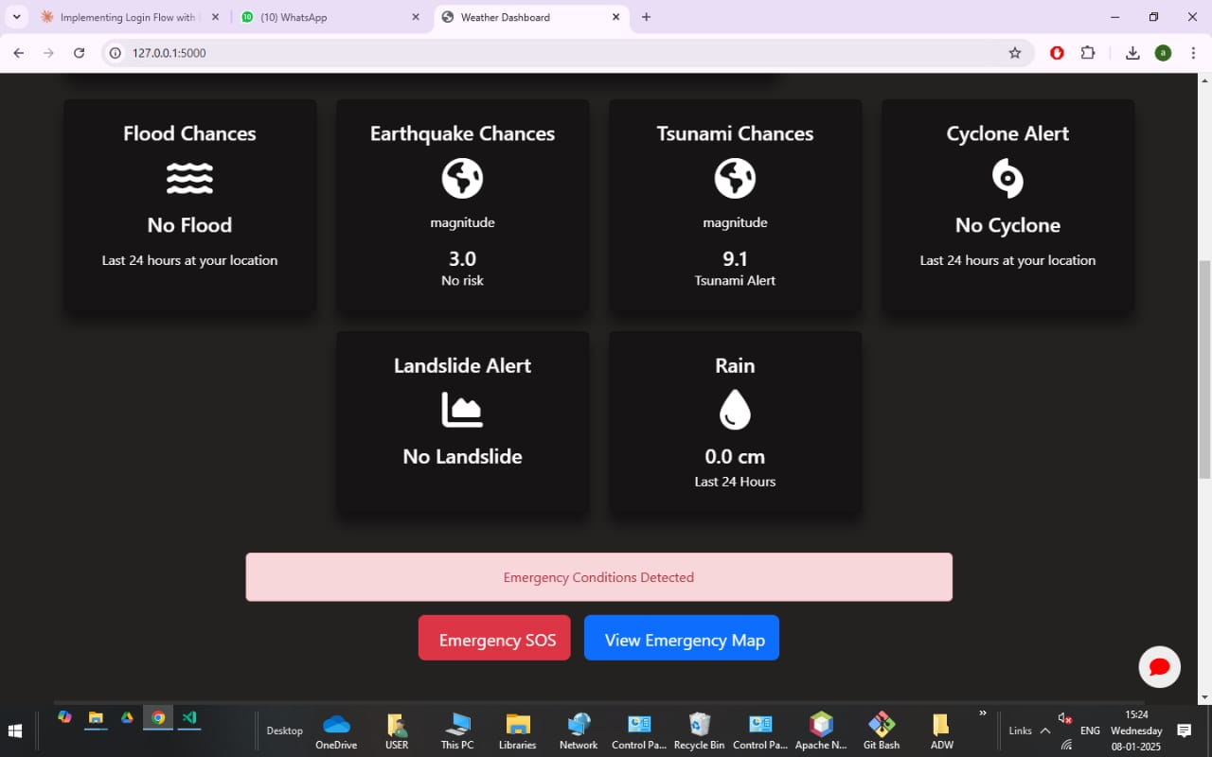

Fig no:9.3.Disater prediction module

Disaster management applications equipped with disaster prediction capabilities utilize advanced technologies to anticipate natural hazards, thereby enhancing preparedness and mitigating potential impacts. These applications integrate various data sources and employ sophisticated algorithms to forecast events such as earthquakes, floods, hurricanes, and wildfires such as Random Forest Classification and Random Forest Regression

- Data Integration: These applications aggregate data from diverse sources, including satellite imagery, weather stations, seismic sensors, and historical records, to monitor environmental conditions continuously.
- Artificial Intelligence (AI) and Machine Learning (ML): By analyzing patterns and anomalies within vast datasets, AI and ML models can predict the likelihood, timing, and severity of potential disasters. For instance, AI-enhanced forecasting systems have improved weather predictions by analyzing historical data, aiding in anticipating extreme weather events.
- Real-Time Monitoring: Continuous data analysis enables the detection of early warning signs, facilitating prompt alerts to users. For example, AI analysis of satellite images can provide rapid post-disaster assessments, aiding in real-time disaster response.

  - ROUTE MAPPING MODULE

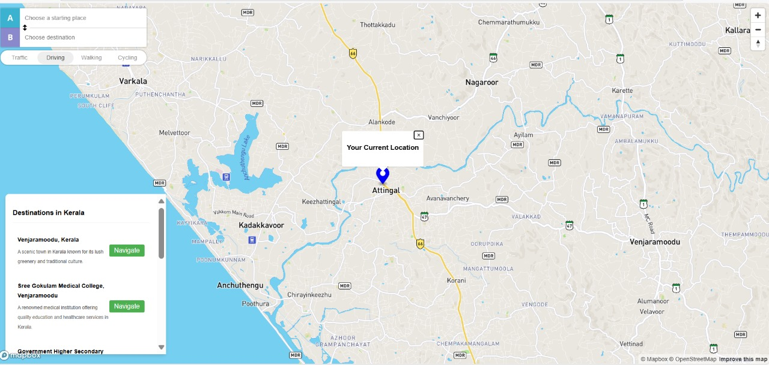
Fig no:9.4 Route Mapping Module
In disaster management applications, route mapping is a critical feature that assists individuals and emergency responders in navigating safely and efficiently during emergencies. This functionality leverages real-time data and geospatial technologies to provide optimal paths, considering factors such as road closures, hazards, and traffic conditions.

- Real-Time Data Integration: By aggregating information from various sources—including user reports, official alerts, and sensor data—these applications offer up-to-date navigation guidance

- Geospatial Analysis: Advanced mapping technologies analyze geographic information to identify safe zones, evacuation routes, and resource locations. The Sahana Software Foundation developed tools like the Community Resilience Mapping Tool, which helps communities collect data on vulnerabilities and resources, facilitating effective planning and response during disasters.
- Crowdsourced Reporting: User-generated reports enhance situational awareness by providing real-time insights into on-ground conditions. Applications such as Ushahidi allow individuals to submit reports via mobile devices or the internet, creating a comprehensive map of events with geographic and time-date information. This collective intelligence supports informed decision-making during crises.

CHAPTER 10

CONCLUSION

The Civilian Emergency Response System (CERS) represents a transformative advancement in disaster management, leveraging cutting-edge technology to safeguard civilian lives and minimize the impact of natural disasters. By integrating four critical components are disaster prediction, route planning, alert systems, and community communication. CERS creates a comprehensive, responsive, and proactive framework for managing emergencies. Through advanced data analytics and machine learning, CERS enhances disaster prediction, enabling authorities and civilians to act with greater foresight and precision. The real-time route planning functionality ensures safe and efficient evacuations, even in the most hazardous conditions. The multi-channel alert system delivers timely, clear, and actionable information, ensuring widespread awareness and swift action. Meanwhile, the community chat system fosters communication and mutual support, allowing individuals to coordinate and share vital information during crises. Together, these components form an integrated ecosystem that improves preparedness, optimizes response efforts, and accelerates recovery. With scalable and resilient infrastructure, CERS ensures that disaster management can adapt to the scale of the event and the needs of diverse populations. Ultimately, the system not only saves lives and reduces damage but also strengthens the collective ability of communities to withstand and recover from natural disasters. In conclusion, CERS is a groundbreaking tool in disaster management, advancing both the effectiveness and efficiency of emergency response while empowering individuals and communities to act in unison toward safety and recovery. Its implementation will play a pivotal role in shaping the future of disaster preparedness and response.

CHAPTER 11

FUTURE ENHANCEMENTS

11.1 Disaster Prediction
- Advanced Data Analytics & Machine Learning: Use of historical disaster data, weather patterns, seismic activity, and other environmental factors to predict upcoming natural disasters (e.g., hurricanes, earthquakes, floods).Predictive models that generate early warnings, allowing for preemptive actions such as evacuations and safety protocols.
- Real-Time Data Integration: The ability to integrate and process real-time data from multiple sources (e.g., weather stations, satellite feeds, IoT sensors) to continuously update disaster forecasts.
- Prediction Accuracy and Updates: Regular updates to predictions based on the latest data, ensuring the system remains current and reliable.
- Predict disasters across different types (floods, hurricanes, wildfires, earthquakes, etc.).
- Provide a lead time for authorities and civilians to act, ranging from hours to days depending on the disaster type.

11.2 Route Planning
- Real-Time Dynamic Routing: Generation of real-time evacuation routes based on the current state of the disaster (e.g., flooded roads, blocked routes, unsafe areas).Use of geospatial data to determine the safest and fastest paths to designated shelters or safe zones.
- Integration with Traffic and Environmental Data: Continuous updates to evacuation routes based on environmental changes (e.g., flooding, road damage, traffic congestion).Consideration of road conditions, traffic patterns, and alternative paths to ensure efficient evacuations.
- Optimization for Multiple Users: Ability to create multiple evacuation routes based on real-time conditions to accommodate large numbers of people, especially in high-risk areas. Provide evacuation routes in real-time, taking into account hazardous areas, traffic conditions, and road closures.

11.3 Alert System
- Multi-Channel Notification Delivery: Alerts sent through multiple channels such as mobile notifications, SMS, emails, TV/radio broadcasts, and social media to ensure broad reach.
- Color-Coded Alert Levels: Clear and easily understandable alert system with color-coded severity levels (e.g., yellow, orange, red) indicating the urgency and type of disaster.Alerts can be customized based on user location, disaster type, and user preferences.
- Localized Alerts: Ability to send alerts to specific regions or user groups, ensuring that individuals receive relevant warnings based on their exact location.
- Preemptive Alerts: Alerts sent well in advance of the disaster event, allowing time for preparation (e.g., evacuations, securing property).
- Support multiple forms of communication to reach the widest possible audience.
- Allow authorities to issue targeted alerts based on geographical regions and disaster severity.
- Provide clear, actionable information on safety measures to be taken based on alert severity.

11.4 Community Communication
- Real-Time Chat System: A community chat platform where users can exchange information, request help, and coordinate with emergency responders or other civilians during disasters.
- Geolocation Integration: Users can share their location and status to help responders locate them and offer assistance as needed.
- Coordination of Support: Enable civilians to coordinate mutual aid efforts (e.g., sharing resources, organizing transport to shelters) or to report local conditions .
- Multilingual Support: The system should support multiple languages, ensuring accessibility to diverse populations during a disaster.
- Integration with Emergency Services: The platform should allow for direct communication with emergency services or government agencies to streamline resource requests and coordination.
- Facilitate communication between affected individuals, communities, and responders.
- Ensure the platform is user-friendly and accessible to a wide range of users, including vulnerable groups like the elderly or disabled.

11.5 User and Access Management
- User Profiles: Creation of individual profiles with essential details like contact information, emergency contacts, and medical history for use during evacuation or rescue.
- Role-Based Access Control: Different access levels for users (e.g., civilians, emergency responders, government agencies) to ensure proper information distribution and resource management.
- Authentication and Privacy: Secure user authentication mechanisms, such as OAuth2, two-factor authentication (2FA), to protect user data and privacy. Ensure that civilians can easily update their profiles with vital information, while ensuring that only authorized users (e.g., emergency responders) have access to sensitive data. Support a centralized management system to handle user access and ensure smooth coordination among different stakeholders.

  - Scalable and Resilient Infrastructure

- Cloud-Based Architecture: The system should be built on a cloud infrastructure (e.g., AWS, Google Cloud) to ensure scalability and redundancy.
- Real-Time Data Handling: Ability to process massive volumes of real-time data from various sources, including weather data, GPS data, sensor data, and user-generated inputs.
- Fault Tolerance and Redundance: The system should be designed to handle disruptions (e.g., network outages, infrastructure damage) during a disaster and ensure continuous operation.
- High Availability: Ensure the system remains available under heavy loads, particularly during peak disaster events, where demand for data and communication can surge.Design the system to handle large-scale data processing and user interaction, even during widespread, high-stress disaster events. Ensure global accessibility and high availability across regions, especially in areas with limited infrastructure.

CHAPTER 12

SCREENSHOTS

REFERENCES

[1] “Machine Learning based Classification of Online News Data for Disaster Management”, Lakshmi S Gopal 2020 IEEE Global Humanitarian Technology Conference (GHTC) | 978-1-7281-7388-7/20/$31.00 ©2020 IEEE | DOI: 10.1109/GHTC46280.2020.9342921 Center for Wireless Networks & Applications (WNA) Amrita Vishwa Vidyapeetham Amritapuri, India lakshmisgopal@am.amrita.edu Divya Pullarkatt Center for Wireless Networks & Applications (WNA) Amrita Vishwa Vidyapeetham Amritapuri, India divyap@am.amrita.edu

[2] “Automated Machine Learning Approaches for Emergency Response and Coordination via Social Media in the Aftermath of a Disaster”: A Review LOKABHIRAM DWARAKANATH RASHEED ABUBAKAR RASHEED 1,AMIRRUDIN KAMSIN 1, 1,ANITHA ANANDHAN AND LIYANA SHUIB 2 2, 1Department of Computer System and Technology, Faculty of Computer Science and Information Technology, University of Malaya, Kuala Lumpur 50603, Malaysia 2Department of Information Systems, Faculty of Computer Science and Information Technology, University of Malaya, Kuala Lumpur 50603, Malaysia Corresponding author: Amirrudin Kamsin (amir@um.edu.my) This work was supported in part by the Postgraduate Research Grant (PPP) through the University of Malaya, Malaysia, under Grant PG028-2015B, and in part by the Interdisciplinary Research Program Grant (IIRG) under Project IIRG031B-2019.

[3] “A Hybrid Machine Learning Pipeline for Automated Mapping of Events and Locations From Social Media in Disasters “ CHAO FAN 1,FANGSHENG WU2, AND ALI MOSTAFAVI1, (Member, IEEE) 1Zachry Department of Civil and Environmental Engineering, Texas A&M University, College Station, TX 77840, USA 2Department of Computer Science and Engineering, Texas A&M University, College Station, TX 77840, USA Corresponding author: Chao Fan (chfan@tamu.edu). Received December 5, 2019, accepted January 6, 2020, date of publication January 10, 2020, date of current version January 17, 2020

[4] ”Flood Forecasting System Based on Integrated Big and Crowdsource Data by Using Machine Learning Techniques” SUPATTRA PUTTINAOVARAT 1 AND PARAMATEHORKAEW 2 1Faculty of Science and Industrial Technology, Prince of Songkla University, Surat Thani Campus, Surat Thani 84000, Thailand 2School of Computer Engineering, Institute of Engineering, Suranaree University of Technology, Nakhon Ratchasima 30000, Thailand Corresponding author: Paramate Horkaew (phorkaew@sut.ac.th) This work was supported in part by the Agricultural Research Development Agency (Public Organization) under Grant PRP6105021450. Received November 30, 2019, accepted December 16, 2019, date of publication January 3, 2020, date of current version January 10, 2020.

[5] “Integrating Machine Learning and Remote Sensing in Disaster Management: A Decadal Review of Post-Disaster Building Damage Assessment” Sultan Al Shafian and Da Hu* Department of Civil and Environmental Engineering, Kennesaw State University, Marietta, GA 30060, USA; salshaf1@students.kennesaw.edu * Correspondence: dhu3@kennesaw.edu. Published: 29 July 2024

[6] “Geographical distribution, disease association and diversity of Klebsiella pneumoniae K/L and O antigens in India: roadmap for vaccine development” Varun Shamanna1,2, Srikanth Srinivas1, Natacha Couto3,*, Geetha Nagaraj1, Shyama Prasad Sajankila2, Harshitha Gangaiah Krishnappa1, Kavitha Arakalgud Kumar1, David M. Aanensen3, Ravikumar Kadahalli Lingegowda1,* and NIHR Global Health Research Unit on genomic surveillance - India consortium. Received 26 March 2024; Accepted 25 June 2024; Published 22 July 2024

