A
Project Report on

GreenFuel Market
BTech-IT, Sem VI

Prepared By:
Chauhan Kirit (IT-017)

Guided By:
Prof. Sunil K Vithlani

Dept. of Information Technology



Department of Information Technology
Faculty of technology,
Dharmsinh Desai University
College road, Nadiad- 387001
March 2026

CANDIDATE’S DECLARATION

We hereby declare that the project report entitled “GreenFuelMarket” submitted in partial fulfilment of the requirements for the award of the degree is a record of original work carried out by us under the guidance of the project supervisor Professor Sunil K Vithlani.

I further declare that this work has not been submitted to any other university or institution for the award of any degree or diploma. All sources of information used in this report have been duly acknowledged.

I understand that any violation of academic integrity may result in disciplinary action as per the rules and regulations of the institute.

Candidate’s Signature
Chauhan Kirit H
Student ID:23ITUCS018

DHARMSINH DESAI UNIVERSITY

NADIAD-387001, GUJARAT



CERTIFICATE

This is to certify that the project carried out in the subject of Project-I, entitled
“GreenFuelMarket” and recorded in this report is a bonafide report of work of
1) Chauhan Kirit H Roll No. IT017 ID No:23ITUCS018 of Department of Information Technology, semester VI . he was involved in Project work during academic year 2025-2026.

Prof. Sunil K Vithlani
(Project Guide),
Department of Information Technology,
Faculty of Technology,
Dharmsinh Desai University, Nadiad Date:

Prof. (Dr.) V. K. Dabhi
Head , Department of Information Technology,
Faculty of Technology,
Dharmsinh Desai University, Nadiad Date:

ACKNOWLEDGEMENT

We would like to express our sincere gratitude to the Department of Information Technology, Dharmsinh Desai University, for providing us with the opportunity to work on this project. We extend our heartfelt thanks to Prof. Kunal j. sahitya our project guide, for his invaluable guidance, support, and encouragement throughout the project.

We also thank all faculty members and staff of the Information Technology Department for their continuous support and knowledge, which have helped us in successfully completing this project. Lastly, we acknowledge the contribution of our peers and classmates who provided insightful feedback and motivation during this journey.

Chauhan Kirit H

TABLE OF CONTENTS

No. | Title | Pg. No.
1. | Abstract | Viii
2. | List of Figures | ix
3. | Chapter 1: Introduction | 1
4. | Chapter 2: Project Management | 3
5. | Chapter 3: System Requirements Study | 6
6. | Chapter 4: System Analysis | 10
7. | Chapter 5: System Design | 15
8. | Chapter 6: Implementation Environment | 21
9. | Chapter 7: Testing | 23
10. | Chapter 8: User Manual | 25
11. | Chapter 9: Limitations and Future enhancements | 32
12. | Chapter 10: Conclusion and Discussion | 33
13. | References | 35

INDEX

- Introduction 1
  - Project Details: Broad specifications of the work entrusted to2 you.
  - Purpose 3
  - Scope 4
  - Objective (Scope – what it can do and can’t do) 5
  - Technology and Literature Review 6
- Project Management 7
  - Feasibility Study
    - Technical feasibility
    - Time schedule feasibility
    - Operational feasibility
    - Implementation feasibility
  - Project Planning
    - Project Development Approach and Justification
    - Project Plan
    - Milestones and Deliverables
    - Roles and Responsibilities
    - Group Dependencies
  - Project Scheduling Project Scheduling chart
- System Requirements Study
  - Study of Current System
  - Problems and Weaknesses of Current System
  - User Characteristics (Type of users who is dealing with the system)
  - Hardware and Software Requirements (minimum requirements to run your system)
  - Constraints
    - Regulatory Policies
    - Hardware Limitations
    - Interfaces to Other Applications
    - Parallel Operations
    - Higher Order Language Requirements
    - Reliability Requirements
    - Criticality of the Application
    - Safety and Security Consideration
  - Assumptions and Dependencies

- System Analysis
  - Requirements of New System (SRS)
    - User Requirements
    - System Requirements
  - Features Of New System
  - Navigation Chart
  - Use case diagram
  - Class diagram
  - Data modeling ( ER diagram)
- System Design
  - System Architecture Design
  - Sequence Diagram
  - Component and Deployment Diagram
  - Input/Output and Interface Design
  - State Transition/UML Diagram
  - Logical Description Of Data
  - Implementation Planning
  - Implementation Environment (Single vs Multiuser, GUI vs Non GUI)
  - Program/Modules Specification
  - Coding Standards
  - Testing
  - Testing Plan
  - Testing Strategy
  - Testing Methods
  - Test Cases
    - Purpose
    - Required Input
    - Expected Result
8.0 User Manual (Screen shots with description)
9.0 Limitation and Future Enhancement
  - Conclusion and Discussion
  - Conclusions and Future Enhancement
  - Discussion
    - Self Analysis of Project Viabilities
    - Problem Encountered and Possible Solutions
    - Summary of Project work

ABSTRACT

The 'GreenFuel Market' application is a dedicated web-based Management Information System (MIS) designed to digitize and streamline the tracking of renewable energy transactions and carbon credit exchanges across industrial sectors. Historically reliant on fragmented, manual brokerage workflows, the administration of sustainable fuel records has suffered from significant data lack of transparency and reporting bottlenecks. This project introduces a dual-role cloud architecture—separating Suppliers from Buyers—powered by a dynamic React.js frontend and a robust Spring Boot backend. Leveraging JWT Authentication for secure routing and the Amazon RDS MySQL database for structured data management, the app instantaneously reflects transaction states (Available, Pending, Sold) without requiring manual page refreshes. It further employs node.js to securely offload complex media payloads (Compliance PDFs/Fuel Images), preserving database performance and read speeds. The platform culminates in a powerful, localized jsPDF generation engine, allowing users to instantly compute billing statistics and natively export structured analytical invoices directly to local storage. Ultimately, by eradicating supply chain verification delays, 'Green Fuel Market' establishes a highly available, scalable ecosystem tailored for modern environmental oversight.

List of Figures

 | Figure Name | Page No.
2.1 | Project Scheduling | 5
4.1 | Navigation Chart of Development | 12
4.2 | Navigation Chart Of system | 12
4.3 | Use Case Diagram | 13
4.4 | Class Diagram | 13
4.5 | Data Modeling (ER Diagram) | 14
5.1 | System Architecture | 15
5.2 | Sequence Diagram (Supplier Fuel Listing) | 16
5.3 | Sequence Diagram (Buyer Transaction and payment) | 17
5.4 | Component and Deployment Diagram | 17
5.5 | State Transition Diagram | 19
8.1 | Login/Registration Screen | 25
8.2 | Supplier Dashboard | 26
8.3 | Marketplace portal | 27
8.4 | User Profile Management | 28
8.5 | Administrative Hub | 39
8.6 | Seller Dashboard | 30

CHAPTER 1: INTRODUCTION

1.1 Project Details: Broad specifications of the work entrusted to you.

GreenFuel Market is a dynamic e-commerce platform built with React for the frontend, Node.js for the backend, and MongoDB as the database, aimed at revolutionizing sustainable fuel trading and procurement.

1.2 Proposed Solution

The primary purpose of the GreenFuel Market application is to eliminate the inefficiencies of manual, fragmented tracking of renewable energy transactions and carbon credit exchanges. By digitizing the submission, bidding, and verification workflows, the application aims to reduce administrative bottlenecks, ensure precise real-time tracking of sustainable fuel supplies across distinct industrial categories, and provide a dedicated, accessible web interface to visualize key market metrics—such as transaction volumes and carbon offset rates—directly on any device.

1.3 Scope

The scope of the project encompasses the end-to-end design, development, and deployment of the web application with the following core functional areas:
- Authentication & Role Management: Secure JWT-backed authentication routing users strictly to either the Administrative Hub, Supplier Dashboard, or Buyer Marketplace.
- Listing Management Engine: A complete CRUD pipeline allowing suppliers to upload fuel specifications and compliance documents, which are subsequently queued for administrative review or direct market listing.
- Marketplace Analytics Dashboard: Capabilities to view real-time statistics (Total vs. This Month's Trades, Available/Sold/Pending counts), monitor regional energy output via dynamic custom charts, and export these insights directly to natively generated PDF invoices.
- Real-Time Data Sync: Cloud-based data storage and synchronization using WebSockets and Node.js to update bidding progress and market statistics instantly across all connected user sessions.

1.4 Objective (Scope – what it can do and can’t do)

What it can do:
- Allow energy suppliers to securely log in, maintain their corporate profiles, and submit fuel listings with attached compliance media payloads.
- Provide administrators with a comprehensive dashboard to verify fuel authenticity and transition listing states from Pending to Available or Rejected.
- Process real-time market statistics and render analytical UI components like tracking bars and energy distribution charts.
- Export detailed transaction snapshots and invoices natively generated into PDF format directly from the browser to local storage using jsPDF.
- Securely host and serve uploaded compliance documents and product images using cloud integration.

What it can’t do:
- It does not automatically conduct chemical lab testing or scrape environmental databases to verify the physical quality of the fuel; it relies on manual Admin review of uploaded certifications.
- It does not act as a consumer electricity billing portal, a logistics fleet management system, or a direct government tax processor.

1.5 Technology and Literature Review

Technology Stack:

The application embodies modern full-stack web development practices integrated with cutting-edge Cloud Infrastructure:
- Platform & Environment: Developed using the MERN-adjacent architecture (MongoDB, Express, React, Node.js), ensuring high performance, non-blocking I/O operations, and cross-platform browser compatibility.
- Frontend Framework: Built using React.js (v18+), utilizing functional components and specialized hooks for state management. The UI is crafted with Tailwind CSS for utility-first responsiveness and features dynamic data visualization using libraries like Recharts or Chart.js.
- Backend Architecture: Node.js with the Express.js framework serves as the primary server-side engine. It handles RESTful API routing, middleware authentication, and business logic for fuel price indexing and transaction management.
- Real-Time Layer: Integrated Socket.io (WebSockets) to facilitate instantaneous communication between Buyers and Suppliers during bidding and for live market status updates.
- Database & Storage: MongoDB serves as the core relational persistence layer for structured transaction data.cloud integration handles efficient, robust off-server storage and retrieval of compliance certificates and fuel images.
- Security & Networking: JSON Web Tokens (JWT) for stateless, secure session handling. Axios is employed on the frontend for optimized, promise-based HTTP transmissions to the Node.js backend.

CHAPTER 2: Project Management

2.1 Feasibility Study :

2.1.1 Technical Feasibility

The project's architecture is technically sound and highly feasible. Developing natively using the Android SDK combined with Firebase Firestore completely abstracts traditional server maintenance, drastically reducing server-side failure points. Integrating Cloudinary for media handling abstracts storage edge cases like image compression and fast CDN delivery without bloating the application’s backend logic. Furthermore, rendering PDF reports locally using the Android Canvas and PdfDocument APIs avoids the need for heavy, paid third-party reporting APIs. The technical risk is exceedingly low due to the use of well-documented, industry-standard libraries.

2.1.2 Time Schedule Feasibility

The project adherence to strict delivery timelines is highly feasible. By relying on Firebase for real-time listeners and authentication, the development team avoids the lengthy process of writing custom REST API endpoints, WebSockets, and database migrations from scratch. Using pre-built Material Design components and straightforward RecyclerView adapters for lists (e.g., DeptStatsAdapter, ApprovalAdapter) heavily truncates the UI development cycle, ensuring rapid prototyping and timely milestone completion.

2.1.3 Operational Feasibility

Operationally, the system is exceptionally viable because it mirrors and digitizes existing sustainable energy supply chains. Suppliers log in to list fuel and carbon credits; Admins log in to verify compliance and trade certificates. The inclusion of a "Marketplace Analytics" module that generates instant scalable PDF invoices and transaction reports aligns perfectly with the operational needs of corporate sustainability officers who require easily verifiable digital audits for environmental accreditation meetings. Web-based delivery ensures that stakeholders can review pending listings and market fluctuations during transit or off-site inspections, directly substituting slow, manual brokerage and desktop-bound workflows.

2.1.4 Implementation Feasibility

Implementation is seamless due to the modern web-based distribution model, requiring no complex on-premise hardware installation for the organization. User onboarding scales effortlessly via the Node.js non-blocking architecture and MongoDB cloud capabilities, ensuring smooth performance whether the platform has 50 or 5,000 concurrent traders. Upgrades and maintenance involve simple continuous deployment (CI/CD) updates via Vercel and Render, making long-term software sustenance highly affordable and feasible.

2.2 Project Planning :

2.2.1 Project Development Approach and Justification

The project utilizes an Agile Framework with iterative sprinting. This approach is justified because the application serves four distinct user entities (Admins, Buyer, Seller and transporter) with independent but overlapping workflows. Agile allows the parallel development of these distinct dashboards. Furthermore, integrating cloud-native services like Firebase and Cloudinary early on supports the rapid prototyping of core features (authentication and media uploading) before refining the native Android UI, allowing stakeholders to test functional builds faster than traditional Waterfall methods.

2.2.2 Project Plan
The project is divided into iterative phases focusing on core system stability before progressing to advanced market analytics:
- Requirements & UI/UX Design: Wireframing dual-role dashboards (Supplier and Buyer) and architecting the MySQL/RDS relational data models.
- Backend & Authentication Setup: Provisioning Node.js server environments, implementing JWT strategy, and configuring policies and upload presets.
- Core Development (Supplier): Implementing the SupplierDashboard component, the CRUD pipeline for fuel listings (AddListing.js), and corporate profile management using React.
- Core Development (Buyer/Marketplace): Constructing the MarketplaceView, real-time bidding/negotiation workflows via Socket.io, and category-based filtering arrays.
- Advanced Features: Coding real-time Node.js listeners for market statistics and browser-based jsPDF generation for automated transaction invoices.
- Testing & QA: Iterative UI/UX testing across varying browser engines and simulated network latency states to ensure WebSocket stability.
- Deployment: Orchestrating final production builds for the frontend on Vercel and the backend services on Render.

2.2.3 Milestones and Deliverables

      - Milestone 1: Completed UI/UX mocks and Firebase initial configuration. (Deliverable: Design Document & Architecture Schema)
      - Milestone 2: Successful Faculty Registration, Login, and baseline profile creation. (Deliverable: Alpha Build - Authentication logic)
      - Milestone 3: Faculty can upload documents to Cloudinary, and data appears in Firestore as "Pending." (Deliverable: Beta Build 1 - Publication pipeline)
      - Milestone 4: Admins can view, accept, or reject publications. Changes instantly reflect back to the Faculty user via Firestore callbacks. (Deliverable: Beta Build 2 - Real-time synchronization)
      - Milestone 5: Admin Reports feature completes rendering native PDFs (admin_report_timestamp.pdf) and UI analytics grids. (Deliverable: Release Candidate - Analytics integration)
      - Final Milestone: Successful end-to-end testing and launch. (Deliverable: Final APK and Source Code)

2.2.4 Roles and Responsibilities

• Project Manager: Oversees agile sprints, coordinates with industrial and environmental stakeholders to finalize market scope, and defines the development timeline.
• Full-Stack Developer (Frontend & UI): Constructs dynamic React.js components using functional hooks, implements Tailwind CSS for responsive layouts, and integrates data visualization libraries for market analytics.
• Backend & Cloud Integrator (Node.js & MongoDB): Manages Express.js API routing, architecting the MongoDB relational schemas, implementing Amazon S3 upload logic for compliance documents, and configuring JWT-based authentication.
• Real-Time Systems Engineer: Implements and manages Socket.io (WebSockets) for bidirectional communication between Buyers and Suppliers, ensuring low-latency updates for bidding and marketplace status.
• QA Tester: Formulates test cases verifying the logical sequences between Supplier listings, Admin verification, and Buyer payments; conducts API endpoint testing and frontend state validation.

2.2.5 Group Dependencies

The successful progression of GreenFuel Market assumes the following group dependencies:
- Infrastructure Providers: Uninterrupted service availability from Amazon Web Services (AWS) alongside reliable hosting from Vercel for the frontend deployment.
- Development Tools: Continued support for the Node.js LTS versions, React 18+ updates, and maintenance of critical libraries such as Axios, Express, and Socket.io.
- Stakeholder Involvement: Rapid feedback loops from industrial energy suppliers and environmental auditors during Alpha and Beta testing to ensure the compliance verification flows match real-world regulatory protocols.
- Software Prerequisites: Consistent browser standards for HTML5 Canvas and PDF generation APIs to ensure that the jsPDF engine operates flawlessly across various modern web browsers (Chrome, Firefox, Safari, Edge).

2.3 Project Scheduling :

A detailed timeline with sprints and deadlines ensures timely completion of the project. Tasks are completed by alone me only to maintain a structured and efficient workflow.

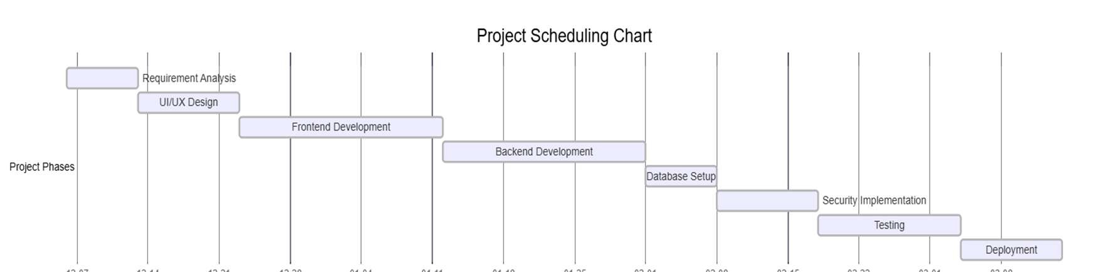
Figure 2.1 : Project Scheduling

CHAPTER 3: SYSTEM REQUIREMENTS STUDY

3.1 Study of Current System :

In the core ecosystem of many industrial sectors, the management of energy supplier profiles, fuel compliance certifications, and marketplace administration is historically handled manually or through disjointed, legacy desktop software. These current systems typically rely on physical paper trails, siloed email attachments, or static spreadsheets that demand extensive manual data entry. Evaluating this environment reveals that administrators must consolidate sustainability information from various suppliers by hand, making the process of generating accurate, verified reports on carbon offsets and fuel availability highly inefficient and prone to error.

3.2 Problems and Weaknesses of Current System :

The current manual or legacy digital systems in the energy sector suffer from several critical weaknesses that the GreenFuel Market architecture is designed to resolve:
- Data Fragmentation: Supplier records, fuel certifications, and carbon credit documents are scattered across isolated corporate hard drives or physical filing cabinets.
- Reporting Delays: Generating comprehensive market statistics (such as trade volumes or yearly carbon offset rates by region) takes days due to manual tallying processes rather than instantaneous cloud-based computations.
- Lack of Real-time Synchronization: Price updates or inventory changes made by individual suppliers are not instantly visible to corresponding buyers, leading to outdated market data across disparate spreadsheets.
- Approval Bottlenecks: Physical or email-based linear workflows frequently cause verification and compliance documents to be stalled, lost in transit, or difficult to audit for environmental standards.
- Accessibility Constraints: Legacy systems restrict access to on-premise desktop machines, preventing suppliers or buyers from updating listings or reviewing time-sensitive market fluctuations on the go via mobile-responsive web interfaces.

3.3 User Characteristics (Type of users who is dealing with the system)

The GreenFuel Market system caters directly to two distinct primary user groups, each with targeted operational behavior:
- Energy Suppliers:
  - Characteristics: Renewable energy providers, biofuel manufacturers, and carbon credit originators who require a straightforward, non-intrusive interface to log their fuel inventory, maintain their corporate profiles, and upload sustainability compliance documents.
  - Technical Proficiency: Moderate. They need intuitive web workflows (such as uploading verification files via MongoDB integrations) through a React-based interface without complex navigation or extensive training.
- Market Administrators / Auditors:
  - Characteristics: Environmental regulators or platform managers responsible for verifying fuel certifications, managing supplier onboarding access, and analyzing granular market productivity and carbon offset volumes.
  - Technical Proficiency: Moderate to High. They require potent analytical tools (such as real-time statistical progress bars and interactive charts powered by Node.js) and the ability to instantly generate and export aggregated PDF invoices and audit reports directly from the browser.

3.4 Hardware and Software Requirements (minimum requirements to run your system) :

For Web Client (End-Users):
- Operating System: Windows 10/11, macOS (Catalina or higher), Linux (Ubuntu/Debian), or mobile OS (Android 10+, iOS 14+).
- Web Browser: Modern evergreen browsers including Google Chrome (v90+), Mozilla Firefox (v88+), Microsoft Edge, or Safari (v14+) to ensure compatibility with React 18 and HTML5 Canvas for PDF generation.
- Network Permissions: Unrestricted internet access to connect securely to AWS (EC2/S3/RDS) and the Node.js API endpoints.
- Standard Storage: Sufficient local storage to download and view natively generated jsPDF invoices and compliance reports.
For Development & Maintenance Ecosystem:
- IDE: Visual Studio Code (VS Code) or IntelliJ IDEA (Ultimate Edition).
- Runtime & Package Managers: Node.js (LTS Version 20.x or higher) and npm or yarn for dependency management.
- Cloud Infrastructure: AWS Management Console active account (leveraging EC2 for hosting, RDS for MongoDB, and S3 for storage) and a Vercel account for frontend deployment.
- Core Languages: JavaScript (ES6+) or TypeScript, and SQL for database querying.

Minimum Hardware Requirements
For Web Client (End-Users):
- Device: Standard Desktop, Laptop, or Tablet with a minimum display resolution of 1024x768.
- Processor: 1.6 GHz Dual-Core processor or equivalent architecture.
- Memory (RAM): Minimum 4 GB RAM (8 GB recommended for smooth rendering of real-time Socket.io data streams and high-resolution chart dashboards).
- Network: Active High-Speed Broadband or Cellular Data (4G/5G/Wi-Fi) to handle real-time marketplace updates.
For Developers (Codebase Maintenance):
- Processor: Intel Core i5 / AMD Ryzen 5 class or higher (Quad-core minimum).
- Memory (RAM): 8 GB RAM minimum (16 GB recommended for running the Node.js backend, React development server, and local MongoDB instances simultaneously).
- Storage: Minimum 20 GB of free SSD space reserved for node_modules, project assets, and local development environments.

  - Constraints :

3.5.1 Regulatory Policies

The system must comply with institutional data privacy policies and regional data protection regulations (such as GDPR or institutional equivalent) since it handles seller/buyer personal information and potentially sensitive research publications. Data must be securely processed and encrypted via authorized Google Firebase services.

    - Hardware Limitations

The application heavily relies on Android native canvas drawing APIs for generating PDF statistical reports natively on the device. Because of this, very low-end devices with minimal memory (< 1GB RAM) may experience rendering delays when generating large multi-page reports. High-speed networking is also recommended to stream uncompressed media via Cloudinary seamlessly.

    - Interfaces to Other Applications

GreenFuel Market functions natively with Android APIs (targeting Level 36). It interfaces tightly with the external Firebase SDK (Firestore, Auth) and the Cloudinary REST SDK for automated media payloads. It does not intrinsically interface with legacy on-premise university SQL architectures; therefore, a transitional parsing step would be necessary to import historical faculty data.

3.5.4 Parallel Operations

The Firebase real-time NoSQL snapshot listeners continuously execute parallel network threads (addSnapshotListener). While highly efficient regarding concurrent multi-user synchronization, the application must carefully manage Android lifecycle states to prevent memory leaks if background snapshot listeners are not properly detached when an Activity (e.g., AdminReportsActivity) is destroyed.

    - Higher Order Language Requirements

Development enforces the use of modern Android architectural standards: Kotlin and Java 11 compilations. It also mandates technical familiarization with Jetpack components, ViewBinding, advanced XML UI manipulation, and Gradle KTS integrations.

    - Reliability Requirements

The backend database necessitates a strict 99.9% uptime (provided gracefully by Firebase and Cloudinary SLAs), given that faculty evaluations or administrative approval deadlines depend exclusively on uninterrupted, time-sensitive document access.

3.5.7 Criticality of the Application

The application is considered highly critical during designated academic evaluation and formal promotion seasons. While not a life-safety application, the data integrity, timestamp accuracy, and immutability of the uploaded publications and admin approval statuses are paramount to institutional credibility.

    - Safety and Security Consideration

Client-side software safety spans encrypted Firebase Authentication protocols overriding easily exploitable basic password arrays. Furthermore, rigid Firestore Security Rules are structurally necessary to prevent standard faculty from maliciously modifying Admin records or approving their own pending documents. Media logic uploaded to Cloudinary must be appropriately sanitized to restrict hazardous executable file extensions from breaching the server nodes.

3.6 Assumptions and Dependencies:

      - Assumptions: All intended users (faculty and administrators) have reliable access to Android smartphones running API 23 or above, possess continuous internet access, and retain the minimal technical literacy required to natively upload documents and traverse dashboards.
      - Dependencies: The continuous operational lifecycle of this mobile application is heavily dependent on the Google Play Services ecosystem, Firebase backend pricing/tier allowances, horizontal Cloudinary storage limits, and iterative updates to the core Android architecture libraries (e.g., OkHttp, AndroidX).

CHAPTER 4: SYSTEM ANALYSIS

4.1 Requirements of New System (SRS) :

4.1.1 User Requirements

For Sellers (Fuel Suppliers):
- Secure Access: The ability to securely register as a corporate entity, verify industrial credentials, and log in to a dedicated supply workspace.
- Inventory & Profile Management: An intuitive graphical interface allowing sellers to maintain up-to-date corporate profiles and list fuel types (Bio-CNG, Ethanol, etc.) with real-time stock availability.
- Listing & Certification Workflow: The capability to seamlessly submit new fuel listings via the web interface. This includes attaching sustainability certifications and compliance PDFs securely via Amazon S3 and tracking the "Available / Under Review / Sold" status in real-time.

For Buyers (Industrial Consumers):
- Marketplace Navigation: Access to a real-time "Green Hub" to browse available fuel listings, filter by fuel type or region, and view verified sustainability ratings.
- Procurement Workflow: The ability to initiate purchase requests, negotiate pricing via Socket.io real-time messaging, and securely track the lifecycle of their orders from "Payment Pending" to "Delivered."
- Digital Invoicing: A dedicated portal to view transaction history and download natively generated PDF invoices for corporate tax and carbon credit auditing.

For Transporters (Logistics Providers):
- Delivery Management: A specialized dashboard to view assigned fuel transport tasks, including pickup locations (Sellers) and drop-off points (Buyers).
- Real-time Status Updates: The capability to update the shipment state (Dispatched / In-Transit / Delivered) which reflects instantly across the Buyer and Seller dashboards using the Node.js backend.
- Compliance Documentation: The ability to upload digital Proof of Delivery (POD) and transit permits to ensure the supply chain remains transparent and auditable.

For Administrators (System Oversight):
- Holistic Verification Interface: A master dashboard to oversee the entire marketplace. Admins require the ability to verify seller certifications, approve new fuel listings, and moderate user access to maintain platform integrity.
- Real-time Market Analytics: Rapid visual aggregation of market data, such as total transaction volumes, carbon offset totals, and category-by-category trading arrays.
- Automated Audit Generation: The ability to instantly generate, compile, and download these aggregated marketplace statistics as offline PDF reports for environmental compliance and institutional reviews.

4.1.2 System Requirements

To fulfill the above user criteria, the underlying mobile architecture dictates strict technical requirements:
- Authentication Engine: The system must enforce strong routing that unequivocally separates Faculty interactions from Admin privileges using Firebase Authentication.
- Responsive Data Streams: The system requires a low-latency NoSQL paradigm mapping. To ensure a change made by an Admin is instantly reflected on a Faculty member's phone, the app demands Firestore addSnapshotListener realtime callbacks, removing the need for manual page refreshes.
- Media CDN: Institutional document attachments must offload to a dedicated Content Delivery Network (Cloudinary integration via OkHttp) to retain application speed while simultaneously handling complex media permutations.
- Native Rendering Module: The system requires an in-built drawing schema using the Android Canvas and PdfDocument libraries mapped specifically to format exported analytical data logically.

4.2 Features Of New System :

The GreenFuel Market application introduces several transformative features aimed at obliterating manual supply chain and trading bottlenecks:
- Multi-Role Navigation Paradigm: Separate, deeply customized UI workflows geared purely toward the contextual needs of Admins (AdminDashboard, MarketReports), Sellers (InventoryManager), Buyers (MarketplaceView), and Transporters (LogisticsHub).
- Real-Time Data Synchronization: Unlike legacy offline databases or static spreadsheets, GreenFuel Market leverages WebSockets and Node.js to automatically trigger layout refreshes across all connected devices within milliseconds of a state change (e.g., a fuel listing transitioning from Available to Sold).
- Dynamic Analytic Dashboards: Intelligent React algorithms dynamically calculate rendering metrics for progress bars and custom data visualizations (e.g., interactive energy distribution charts) based on live active market matrices.
- On-the-Fly Native PDF Export: Advanced use of the jsPDF framework translating complex active UI arrays directly into formatted, timestamped analytical invoices and audit reports stored instantly in local device directories.
- Off-Server Media Orchestration: Seamless Amazon S3 upload pipelines taking intense processing load (such as high-resolution fuel images and large compliance PDFs) natively off the primary MongoDB database, thereby accelerating transmission bandwidth and system responsiveness.

    - Navigation Chart Of system
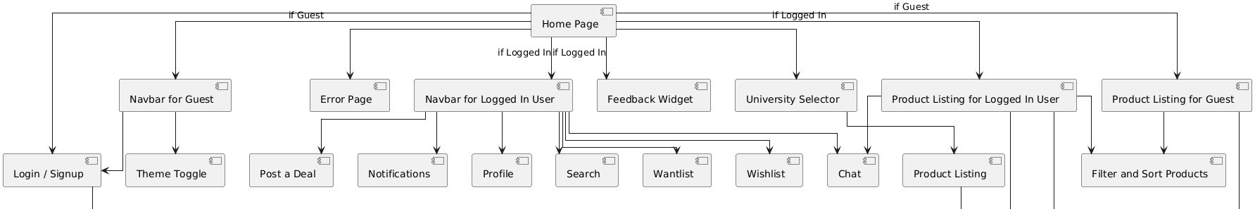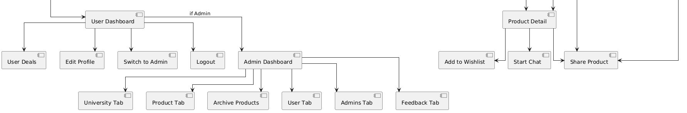

Figure 4.2 : Navigation Chart Of system

  - Activity Diagram :

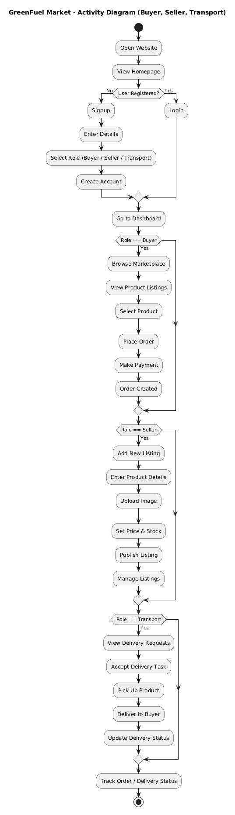
  - Class Diagram :

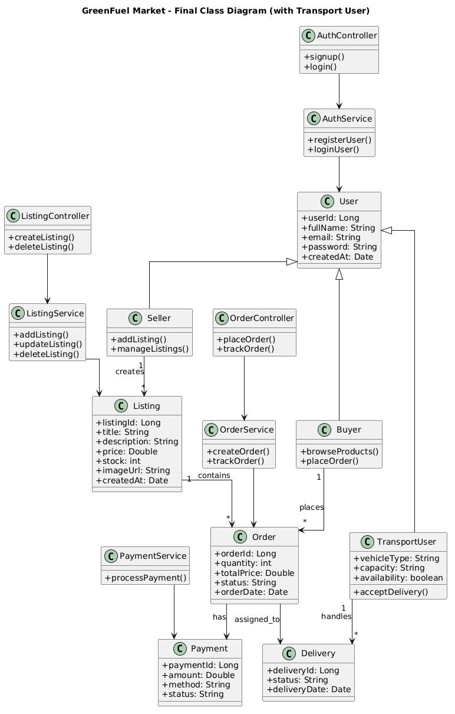
Figure 4.4 : Class Diagram
  - Data Modeling (ER Diagram) :

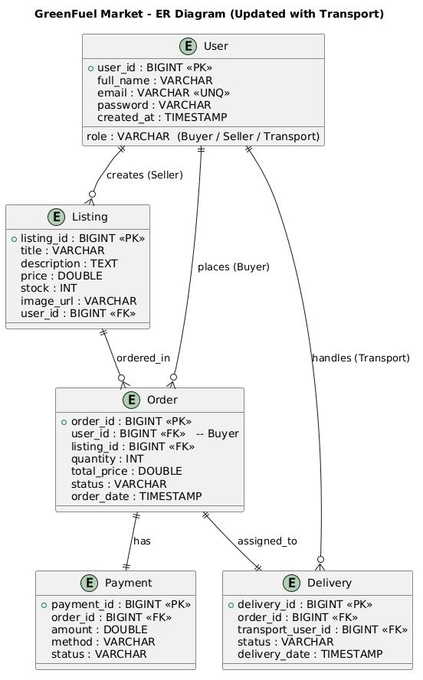

Figure 4.5 : Data Modelling (ER Diagram)

CHAPTER 5: SYSTEM DESIGN

5.1 System Architecture Design :

The system architecture of the GreenFuelMarket application is built upon a modern, cloudnative mobile framework. It utilizes a Client-Server Architecture specifically optimized for real-time mobile synchronization and off-server object storage. The architecture is logically divided into three primary tiers: the Client Tier (Android Application), the Cloud Services Tier (Backend), and the Local Storage Tier.

- Client Tier (Android Application):
      - Acts as the presentation and primary logic layer running strictly on the user's mobile device. It is sub-divided into four dedicated UI workflows: Admin View, buyer view, seller view and transport View.
      - It handles all view-binding, custom UI rendering (such as the SimpleBarChartView), and the native generation of digital PDF canvas reports.
- Cloud Services Tier (Firebase & Cloudinary):
      - Firebase Authentication: Operates as the secure gateway, verifying credentials before allowing traffic into the core application.
      - Firebase Firestore (NoSQL): Functions as the central nervous system. Using addSnapshotListener, it establishes a continuous real-time connection to the Android client, pushing instant updates (e.g., when a document goes from "Pending" to "Approved") without requiring manual page refreshes.
- Local Storage Tier:
• Utilized specifically by the Administrator module. After the core framework aggregates analytical data, the localized Android PdfDocument engine mathematically renders the visualization arrays and safely deposits the fully formatted offline PDF natively into the user's external device storage.

5.2 Sequence Diagram :

    - Login/Registration:
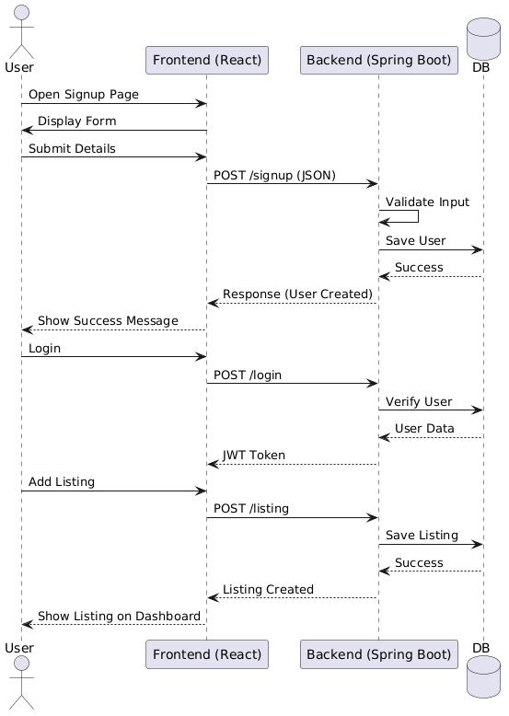

Figure 5.2 : Sequence Diagram ( Faculty Document Upload)

5.3 Logical Description of Data :

- Relational Hierarchy: Unlike flat NoSQL structures, the logical architecture utilizes a Relational Schema consisting of normalized tables. The primary entities, users, fuel_listings, and transactions, are linked via foreign keys to ensure referential integrity and support complex analytical joins.
- Security & Authorization Rules: Data integrity is strictly maintained through Node.js middleware and JWT (JSON Web Tokens). A Seller holds writing permissions exclusively for creating new entries within the fuel_listings table but is systematically blocked from modifying the logical status field. Only an Administrator’s verified role retains the requisite server-level authorization to overwrite the status (e.g., from Pending to Available) during the verification workflow.
- Access Patterns & Indexing: To render real-time UI components (like the interactive market charts) instantly, the MongoDB database is logically indexed by chronological created_at timestamps and categorical fuel_type parameters. This optimizes query execution speeds, allowing the Node.js backend to stream structural data changes via WebSockets (Socket.io) at millisecond latency.
- Media Decoupling: To preserve the relational database's read/write speed and prevent performance degradation, native binary files (compliance PDFs and fuel images) are never stored as BLOBs within the database. Logically, the database merely stores an encrypted s3_url string pointing to the external Amazon S3 bucket. This reduces overall application memory bloat, ensures high availability of documents, and drastically accelerates internal network routing.

CHAPTER 6: IMPLEMENTATION PLANNING

6.1 Implementation Environment ( Single vs Multiuser, GUI vs Non GUI ) :

The GreenFuel Market application is deployed in a Multiuser, GUI-based mobile environment.
- Multiuser Environment: The system actively supports concurrent user sessions securely separated by Firebase Authentication. Changes made by one user (such as an Admin approving a document) are synchronously pushed to the respective Faculty member in real-time via Firestore snapshot listeners without locking the database thread for the hundreds of other connected users.
- GUI (Graphical User Interface) Environment: The entire application is interacted via a mobile touchscreen interface. It relies wholly on XML-based Android Activity layouts and native custom Views (like the SimpleBarChartView) rather than command-line operations, ensuring perfect accessibility for non-technical academic staff.

6.2 Program/Modules Specification :

- Authentication & Authorization Module: Handles the Login.js and Register.js frontend components. It validates credentials securely via the Node.js backend, issues a JWT (JSON Web Token), and redirects the user stream to the correct dashboard (Admin, Seller, Buyer, or Transporter) based on their verified access tier.
- Supplier & Inventory Module: Encompasses the SupplierDashboard.js component, profile manipulations, and stock notification logic. It handles the local rendering of the seller's specific fuel listings and provides UI elements to track real-time inventory levels and sales statuses.
- Listing & Media Upload Module: Features the AddListing.js component, which directly orchestrates attaching compliance elements, securely uploading them via the Amazon S3 configuration, and pushing the pending reference link directly to the MongoDB fuel_listings table through the Node.js API.
- Marketplace & Transaction Module: Concentrated inside MarketplaceView.js and its secondary ListingCard components. It loops through globally queried available fuels and allows Buyers to securely initiate purchase requests, utilizing Socket.io to manage real-time bidding and negotiation states between parties.
- Administrative & Audit Module: Centered in AdminAnalytics.js and MarketReports.js. It visually plots dynamic dataset arrays onto React charts (using Recharts or Chart.js) and natively streams generated market statistics into timestamped, downloadable, offline PDF invoices and audit structures via the jsPDF engine.

6.3 Coding Standards :

• Component & File Naming Conventions: All React component files utilize PascalCase (e.g., AdminReports.jsx, SupplierDashboard.js). Internal functions, hooks, and variables utilize camelCase (e.g., uploadComplianceDocs, fuelStockCount). Global constants and environment variables natively use UPPER_SNAKE_CASE (e.g., BASE_URL, JWT_SECRET).
• Style & Layout Formatting: Component styling utilizes Tailwind CSS utility classes to ensure a clean, responsive UI without bloated external CSS files. CSS modules or global stylesheets use descriptive kebab-case (e.g., market-grid-container, invoice-modal.css) and group child components inside logically scoped Flexbox or Grid layouts to maximize cross-browser rendering performance.
• UI Separation & Internationalization: Hardcoded strings are rigorously avoided within the JSX; user-facing text is extracted into centralized JSON translation files (e.g., en.json), enabling incredibly efficient future localization and cleaner UI code maintenance. Dynamic data is fetched via Axios and managed through React State to keep the view layer decoupled from the data logic.
• Resource & Memory Management: Node.js event listeners and WebSocket connections (Socket.io) are tightly managed according to the React Lifecycle (using useEffect cleanup functions). This ensures that background socket threads are properly disconnected when a component unmounts, preventing server-side socket bloat, memory leaks, or unnecessary browser battery drain.

CHAPTER 7: TESTING

  - Testing Plan :

The testing plan for the GreenFuel Market involves a structured, multitier evaluation designed to ensure standard functional stability, precise real-time data synchronization between the users and Admin dashboards, and flawless native PDF generation. The plan begins with isolated testing of individual Firebase authentication flows, progressing to integrated UI component testing, and concluding with end-to-end device testing.

  - Testing Strategy :

The testing strategy is primarily driven by a "Black Box" operational testing approach combined with targeted "White Box" backend validations. Since the system relies heavily on external cloud infrastructure (Firebase and Cloudinary), the strategy mandates testing exact network connectivity edge cases. The strategy involves iterative manual testing using Android Virtual Devices (AVDs) of varying screen sizes, followed by physical hardware testing to validate the complex graphical rendering paths required by the Android PdfDocument library.

  - Testing Methods :

- Unit Testing: Evaluating standalone Java/Kotlin methods such as validating email string formats before Firebase submission, or ensuring the custom SimpleBarChartView mathematically calculates percentages correctly before drawing on the Canvas.
- Integration Testing: Verifying that uploading a document through the CloudinaryConfig class successfully returns a secure URL that is immediately appended to a new Firestore "publications" object.
- System Testing: Checking the entire dual-role environment. This ensures an Admin cannot access the buyer or seller portal, and a buyer/seller cannot spoof Admin approval privileges.
- User Acceptance Testing (UAT): Final testing conducted by stakeholders (academic staff) to ensure the UI workflows (like viewing real-time approval notifications) intuitively meet their daily institutional requirements.

7.4 Test Cases :

Test Case 1: Seller Registration & Role Segregation

- Purpose: To verify that a new Energy Supplier can securely create an account and is properly restricted from Admin or Buyer features.
- Required Input: A valid corporate email, a unique password, and selecting the "Seller" role from the registration dropdown.
- Expected Result: The Node.js backend hashes the password, creates a new entry in the MySQL users table with the role strictly set to seller, and issues a JWT. The React router then securely routes the user exclusively to the SupplierDashboard component.
Test Case 2: Amazon S3 Compliance Document Upload
- Purpose: To confirm that attaching a fuel certification PDF correctly offloads the heavy file payload to the external Amazon S3 bucket.
- Required Input: The user selects a local 2MB PDF certificate, inputs "Bio-Ethanol Grade A" into the fuel title field, and clicks "Submit" in the AddListing component.
- Expected Result: The application utilizes the S3 signed-URL configuration, receives a secure s3_url, attaches it to a MySQL fuel_listings record mapped to the Seller's ID with the status pending, and displays a React "Success" toast notification without a UI freeze or browser hang.

Test Case 3: Admin Real-Time Market Approval

- Purpose: To ensure state changes modified by an Administrator reflect instantly across the marketplace using WebSockets.
- Required Input: An Admin user clicks the "Approve" button next to a pending fuel listing inside the AdminVerification dashboard.
- Expected Result: The Node.js server updates the database and emits a Socket.io event. The Seller's dashboard and the public Marketplace view instantly change the listing badge from pending to available without requiring a manual page refresh.

Test Case 4: Browser-Based PDF Invoice Generation

- Purpose: To validate the jsPDF integration capable of generating complex transaction reports directly in the browser.
- Required Input: An Admin or Buyer navigates to the MarketReports view, sees the populated dynamic charts, and clicks the "Export PDF" icon.
- Expected Result: The jsPDF library mathematically draws all current onscreen data arrays directly onto a formatted digital canvas, triggers a browser download for the .pdf file, and allows the user to view the timestamped report immediately.

CHAPTER 8: USER MANUAL

8.1 Registration Page :

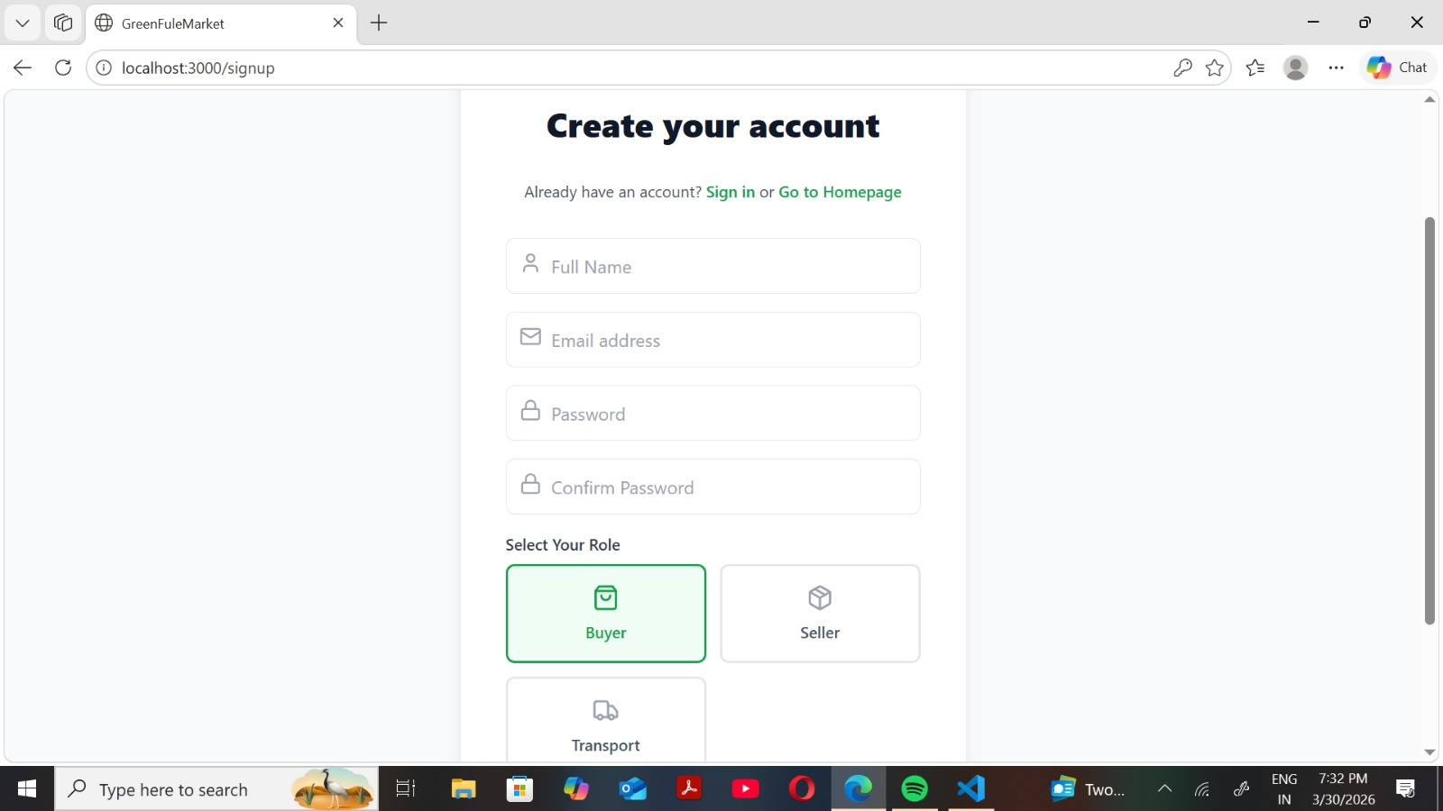

Figure 8.1: Registration Page

8.2 Login Page:

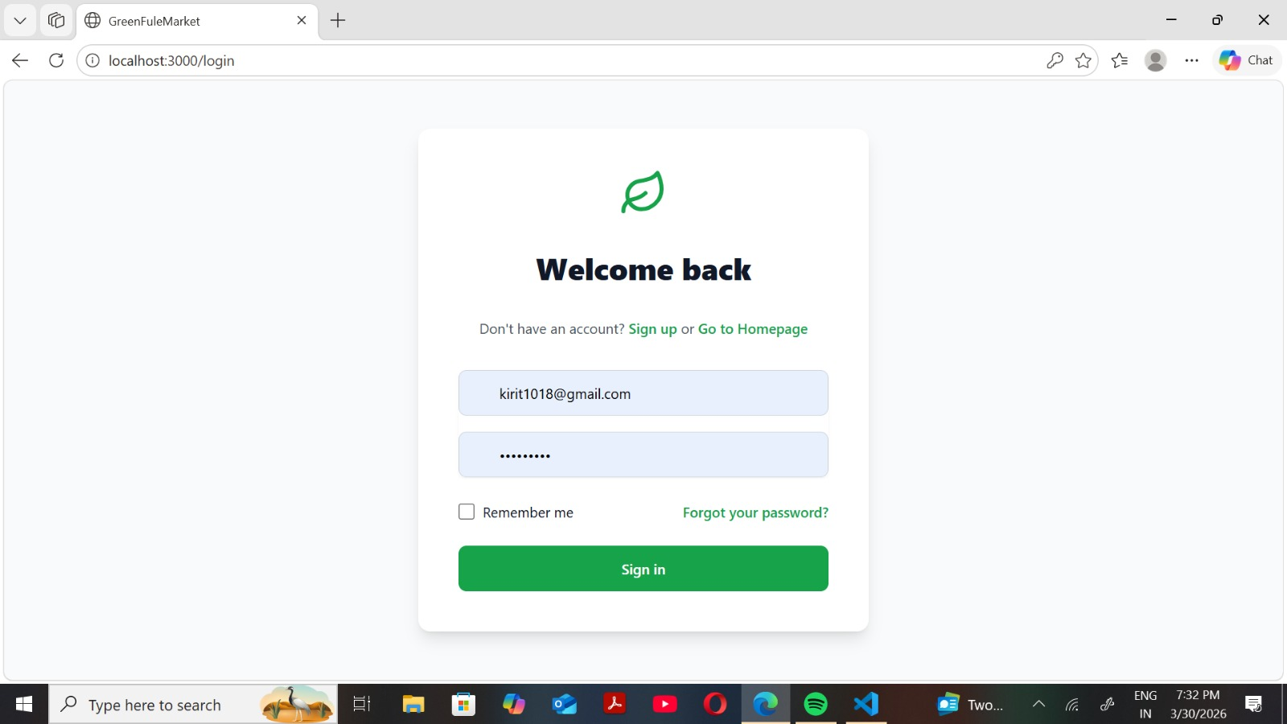

Figure 8.2: Login Page

8.3 Buyer Dashboard:

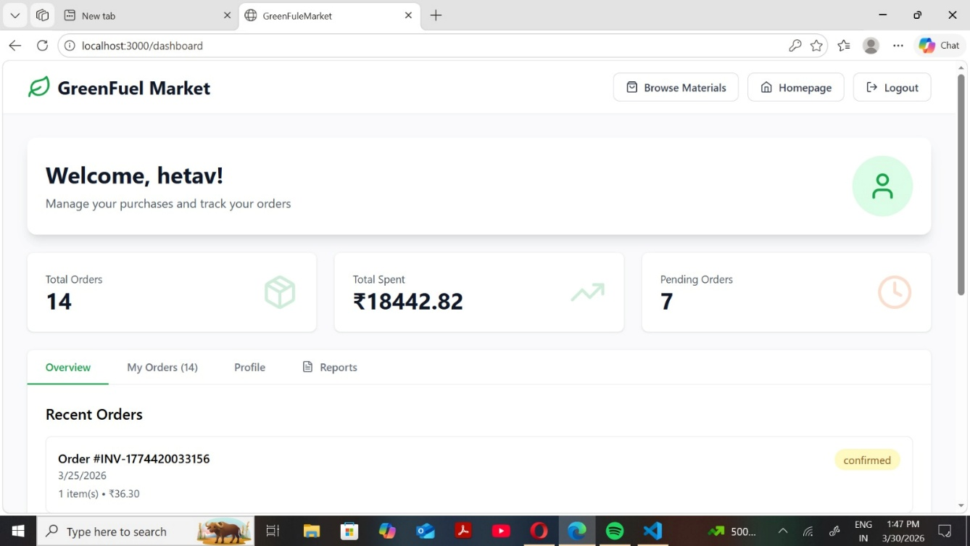

Figure 8.3 : Buyer Dashboard

8.4 Admin Portal :

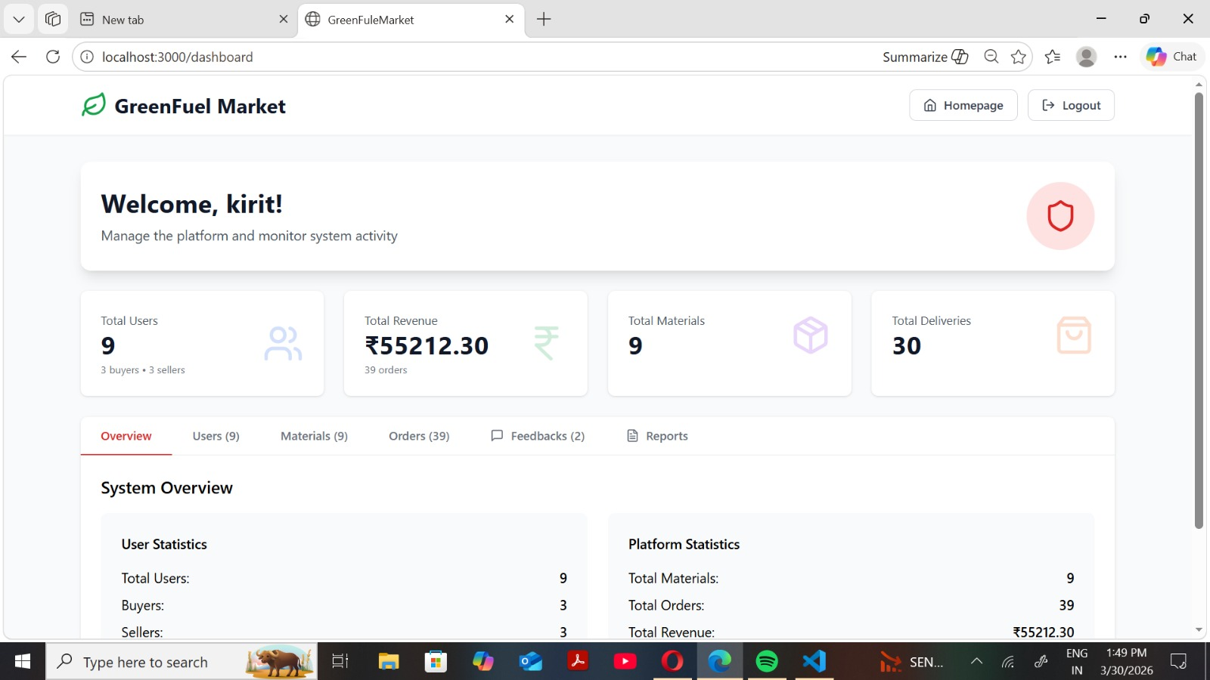

Figure 8.4 : Admin Portal

8.5 MarketPlace:

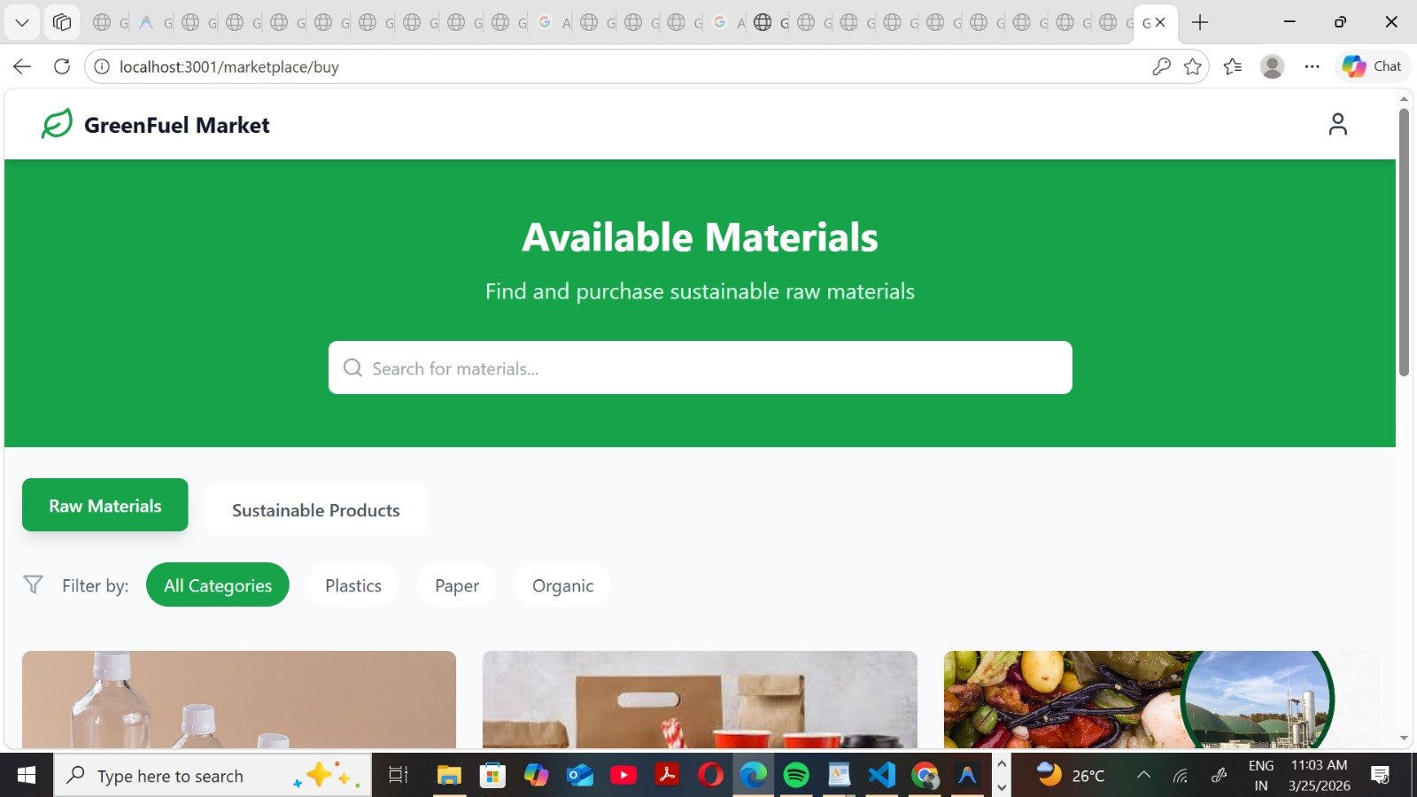
Figure 8.5 : MarketPlace

8.6 Cart panel:

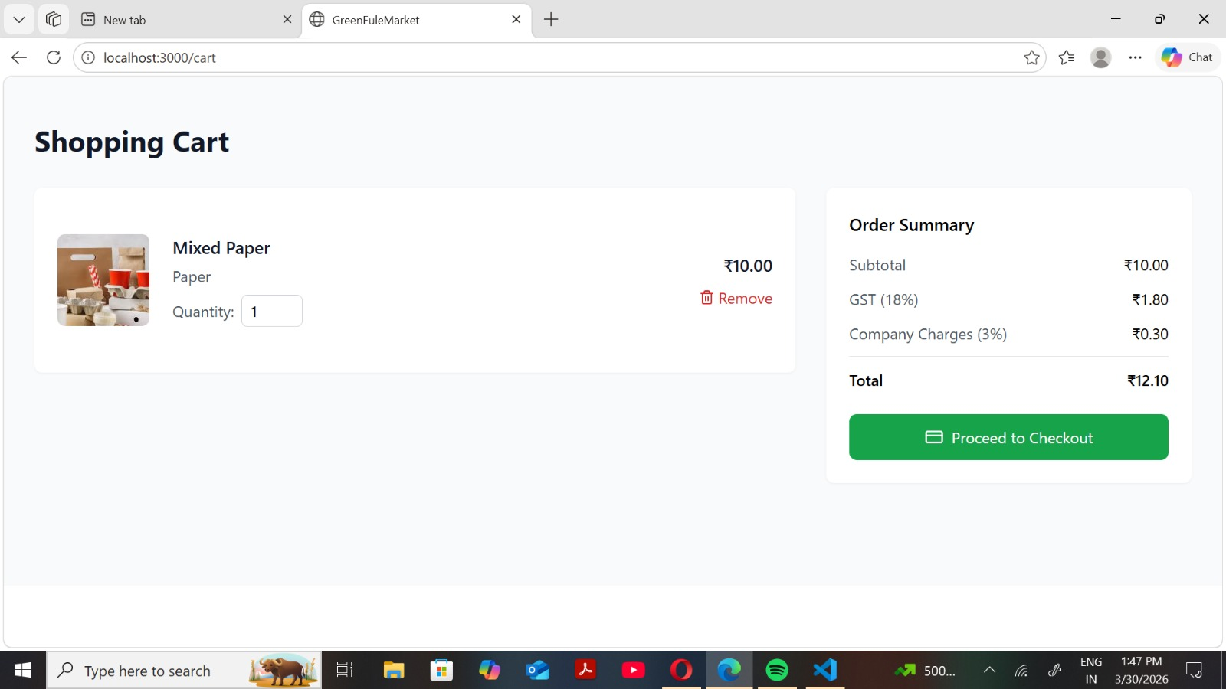

Figure 8.6 : cart panel

8.7 Seller Dashboard:

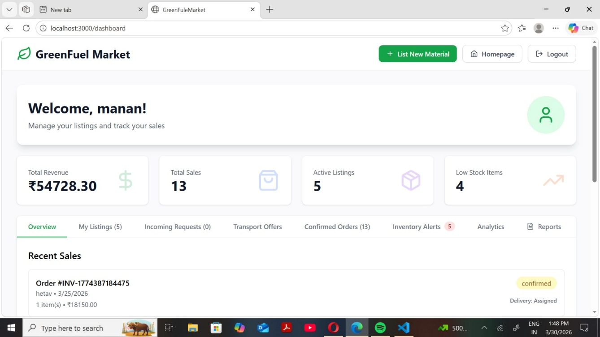

Figure 8.7: Seller Dashboard

8.8 About page:
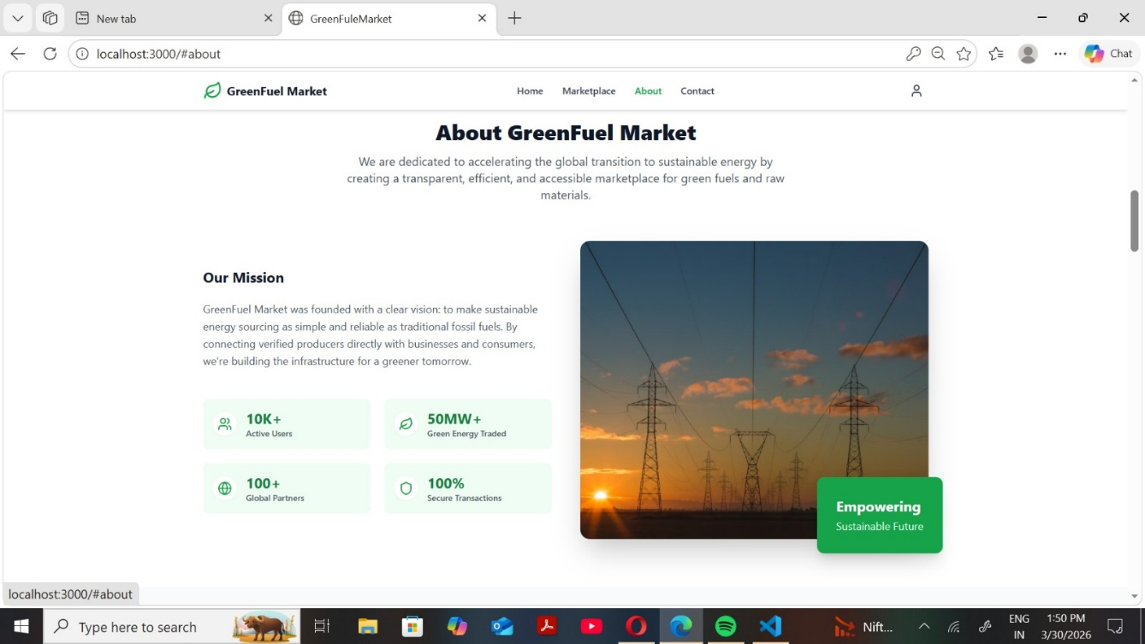
Figure 8.8: About Page

8.9 Contact page:
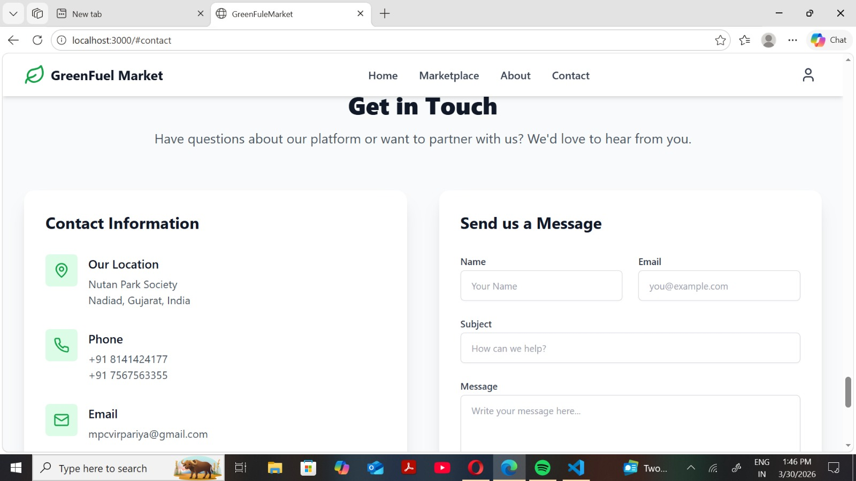
Figure 8.9: Contact Page

CHAPTER 9: LIMITATIONS AND FUTURE ENHANCEMENTS

9.1 Current System Limitations :

While the GreenFuel Market application successfully digitizes and streamlines academic tracking, it currently operates with a few architectural constraints:
- Native Android Exclusivity: The current codebase is explicitly programmed using Android XML and Java/Kotlin. There is presently no iOS equivalent or cross-platform web portal for faculty members lacking supported Android devices.
- Manual Validation Dependency: The system relies entirely on the Administrator to physically read and verify the legitimacy of the uploaded academic documents. There is no automated algorithmic plagiarism checker or AI-driven verification tool currently integrated into the upload pipeline.
- Legacy Data Migration: Faculty members are required to manually input their historical publications. There is no automated CSV or SQL bulk-import tool designed to ingest a university's pre-existing legacy database.
- Device Hardware Constraints: The native PDF export feature utilizes local Android canvas drawing, which relies heavily on device RAM. Extremely old or low-end smartphones may experience delayed rendering or memory constraints when generating excessively large multi-page analytical reports.

9.2 Future Enhancements :

To scale the GreenFuel Market application beyond its initial deployment phase, the following enhancements are proposed for future iterations:
- Cross-Platform Web Portal: Developing a synchronized React.js web dashboard linked to the same Firebase backend, allowing faculty to upload intensive documents directly from their desktop computers.
- Automated Plagiarism Integration: Implementing third-party educational API hooks that automatically scan uploaded Cloudinary PDFs, pre-flagging suspect documents securely before they reach the Admin's manual review queue.
- Advanced Push Notification Services: Upgrading the real-time Firebase addSnapshotListeners to include Firebase Cloud Messaging (FCM). This would trigger active system tray notifications to a user's phone the precise moment an Admin approves their publication, even when the application is completely closed.

CHAPTER 10: CONCLUSION AND DISCUSSION

10.1 Conclusions and Future Enhancement :

The GreenFuel Market application successfully demonstrates the viability of modernizing institutional academic tracking through mobile-first architecture. By integrating the Android SDK with Google Firebase and Cloudinary CDN, the project effectively eliminates the historic bottlenecks associated with manual, paper-based faculty evaluations. Looking forward, the infrastructure is robustly prepared to support advanced educational enhancements, such as cross-platform web synchronization and AI-driven automated plagiarism detection, which will further cement its utility in largescale academic environments.

10.2 Discussion :

10.2.1 Self Analysis of Project Viabilities

From a technical standpoint, the project proved highly viable. Relying on Firebase Firestore instead of building a custom SQL backend from scratch dramatically accelerated the development lifecycle, allowing the team to focus on the complex dualrole Android UI (Faculty vs. Admin). The application’s core functionality—uploading an academic document and having it instantly verifiable by a department head— operates with extremely low latency. The business viability is also strong, as universities actively seek integrated, low-cost digital management solutions that do not require massive on-premise hardware deployments.

10.2.2 Problem Encountered and Possible Solutions

- Problem 1: Android Canvas Memory Management: Generating multi-page PDF analytical reports directly on the device natively caused occasional "Out of Memory" (OOM) exceptions on older test devices when drawing large dynamic bar charts (e.g., SimpleBarChartView).
- Solution: Implemented strict Bitmap recycling and canvas layer scaling algorithms to ensure the PdfDocument class mathematically compressed visual components without overflowing the system heap.

- Problem 2: Media CDN Timeout: Direct uploads of heavy 5MB+ PDF files to Firebase Storage caused network timeouts on slower 3G cellular connections.

- Solution: Migrated the media handling pipeline to Cloudinary (using the "GreenFuel Market1" preset) which features aggressive CDN routing and optimized multi-part background thread uploads via OkHttp, effectively resolving the network timeout crashes.

- Problem 3: Fragmented State Updates: When an Admin approved a document, the buyer view did not immediately reflect the change unless the website was manually restarted.
- Solution: Replaced standard singular "get()" queries with Firebase's "addSnapshotListener" to establish constant WebSocket connections, forcing the UI to redraw instantly upon any remote database modification.

10.2.3 Summary of Project work :

In summary, the GreenFuel Market Android application achieves its core objective of digitizing academic publication oversight. Over the development lifecycle, the project successfully mapped detailed User and System Requirements directly into a functional, secure Android application. It employed an Agile implementation strategy, delivering critical authentication, cloud-storage pipelines, and native graphical reporting milestones sequentially. The systematic testing phases proved the architecture's stability, confirming that the dual-role mobile application is a powerful, ready-todeploy tool explicitly engineered to increase university administrative efficiency.

References

- React Documentation: https://react.dev/learn⁠�
(For frontend development using React.js)
- Node.js Documentation: https://nodejs.org/en/docs⁠�
- (For backend server and API development)
- Express.js Documentation: https://expressjs.com/⁠�
- (For building REST APIs in backend)
- MongoDB Documentation: https://www.mongodb.com/docs/⁠�
- (For database design and data storage)
- Material UI (MUI) Design System: https://mui.com/material-ui/getting-started/⁠�

List of Tables ............................................... vii
List of Figures ............................................. viii
ABSTRACT .................................................... ix

CHAPTER 1: INTRODUCTION ..................................... 1
1.1 Project Details ......................................... 1
1.2 Purpose ................................................. 1
1.3 Scope ................................................... 1
1.4 Objective ............................................... 2
1.5 Technology and Literature Review ........................ 3

CHAPTER 2: PROJECT MANAGEMENT .............................. 4
2.1 Feasibility Study ....................................... 4
2.1.1 Technical Feasibility ................................ 4
2.1.2 Time Schedule Feasibility ............................ 4
2.1.3 Operational Feasibility .............................. 4
2.1.4 Implementation Feasibility ........................... 4
2.2 Project Planning ........................................ 5
2.3 Project Scheduling ...................................... 6

CHAPTER 3: SYSTEM REQUIREMENTS STUDY ....................... 7
3.1 Study of Current System ................................ 7
3.2 Problems and Weaknesses ................................ 7
3.3 User Characteristics ................................... 8
3.4 Hardware and Software Requirements ..................... 8
3.5 Constraints ............................................ 9

CHAPTER 4: SYSTEM ANALYSIS ................................ 10
4.1 Requirements of New System ............................ 10
4.2 Features of New System ................................ 11
4.3 Use Case Diagram ...................................... 12
4.4 Class Diagram ......................................... 12
4.5 Data Modeling ......................................... 14

CHAPTER 5: SYSTEM DESIGN .................................. 16
5.1 System Architecture Design ............................. 16
5.2 Sequence Diagrams ...................................... 17

INDEX

1 Introduction ........................................ 1
1.1 Project Details ................................... 1
1.2 Purpose ........................................... 1
1.3 Scope ............................................. 1
1.4 Objective ......................................... 2
1.5 Technology and Literature Review .................. 3

2 Project Management ................................. 3
2.1 Feasibility Study ................................ 3
2.1.1 Technical Feasibility .......................... 3
2.1.2 Time Schedule Feasibility ...................... 3
2.1.3 Operational Feasibility ........................ 3
2.1.4 Implementation Feasibility ..................... 3
2.2 Project Planning .................................. 4
2.3 Project Scheduling ............................... 5

3 System Requirements Study .......................... 6
3.1 Study of Current System ........................... 6
3.2 Problems and Weaknesses .......................... 6
3.3 User Characteristics ............................. 7
3.4 Hardware and Software Requirements ............... 7
3.5 Constraints ...................................... 8

4 System Analysis .................................... 10
4.1 Requirements of New System ....................... 10
4.2 Features of New System ........................... 11
4.3 Navigation Chart ................................ 12
4.4 Use Case Diagram ................................ 12
4.5 Class Diagram .................................... 12
4.6 Data Modeling .................................... 14

5 System Design ...................................... 16
5.1 System Architecture Design ....................... 16
5.2 Sequence Diagram ................................ 17
5.3 Component and Deployment Diagram ................ 18
5.4 Input/Output Design ............................. 19
5.5 State Transition Diagram ........................ 19

6 Implementation Planning ............................ 20
6.1 Implementation Environment ...................... 20
6.2 Program Modules .................................. 21
6.3 Coding Standards ................................ 21

7 Testing ............................................ 23
7.1 Testing Plan ..................................... 23
7.2 Testing Strategy ................................ 23
7.3 Testing Methods .................................. 23
7.4 Test Cases ....................................... 24

8 User Manual ........................................ 25
9 Limitations and Future Enhancement ................. 32
10 Conclusion and Discussion ......................... 33

