**Credit Care**

**Group Members:**

Ajna Nushi

Ester Xhavara

Mishel Spaho

**Accepted by:** Igli Hakrama

CONTENTS

1. Requirements 
   1. Functional requirements
   2. Non-Functional Requirements
   3. Stakeholders Identification Table
   4. Onion Diagram
2. Software Design 
   1. Use Cases
   2. Use Case Diagram
   3. Activity Diagrams
   4. Sequence Diagram
   5. Collaboration Diagram
   6. BPMN Diagram
   7. State Diagram
   8. Class Diagram
3. **Requirements**
   1. **Functional requirements**

Functional Requirements describe the service that the banking management system must offer, they are subdivided into three access levels: Admin Mode, Teller Mode, and Customer Mode:

|  |  |  |  |
| --- | --- | --- | --- |
| Req# | Description | Access Level | Rate |
| FR_01 | User authentication through login and password. | Customer | High |
| FR_02 | Ability for customers to update personal information. | Customer | High |
| FR_03 | Capability for customers to change their password. | Customer | High |
| FR_04 | View account balance. | Customer | High |
| FR_05 | Access personal transaction history. | Customer | High |
| FR_06 | Transfer money between accounts. | Customer | High |
| FR_07 | Apply for and manage loans. | Customer | High |
| FR_08 | Deposit cash into their accounts. | Customer | High |
| FR_09 | User authentication via login and password. | Teller | High |
| FR_10 | Ability for tellers to change their password. | Teller | High |
| FR_11 | Register new bank customers. | Teller | High |
| FR_12 | View customer information and account details. | Teller | High |
| FR_13 | Manage customer accounts (create, update, close accounts, etc.) | Teller | High |
| FR_14 | User authentication via login and password. | Admin | High |
| FR_15 | View manager and customer details. | Admin | High |
| FR_16 | Add or update bank branch details | Admin | High |
| FR_17 | Add or update manager details | Admin | High |

* 1. **Non-Functional Requirements**

Non-functional requirements specify criteria that can be used to judge the operation of a system as a whole rather than specific behaviors. They describe emergent properties like security, performance, and availability and, unlike the functional requirements that can be worked around, are essential to fulfill for a usable system. The estimation of whether the product fulfills the non-functional requirement or not usually reduces to a boolean answer: yes or no.

For a bank management system, the most important non-functional requirements include security, performance, usability, and availability.

**Security**

Bank management systems are notorious for being subject to malicious attacks, so security is the major requirement for the system. Unauthorized access to the data is not permissible. The data must be backed up daily and stored in a secured location, at a distance from different facilities of the system.

Online transactions and stored digital files must be encrypted according to 128-bit or 256-bit AES encryption standards. The system also must employ firewall software as a defense against network attacks.

From the client-side, the system must provide an automatic log-out after an inactivity period, accept only secure passwords that have sufficient length and non-alphabetic characters, and block login attempts after several unsuccessful trials.

**Performance**

The bank management system is a multi-client system that must reach response time targets for each of the clients during simultaneous calls and must be able to run a target number of transactions per second without failure. The system must effectively utilize the hardware and energy resources to minimize operational costs.

**Usability**

The system must provide different graphical interfaces for customers, tellers, and admins. All system interfaces must be user-friendly and simple to learn, including helping hints and messages and intuitive workflow, especially in a client interface: the client must be able to fast learn and use the interface without prior knowledge of banking terminology or rules.

The interfaces must automatically adjust to devices with different screen sizes, and allow to change typeface size and color scheme to improve readability.

* 1. **Stakeholders Identification Table**

**1.4 Onion Diagram**

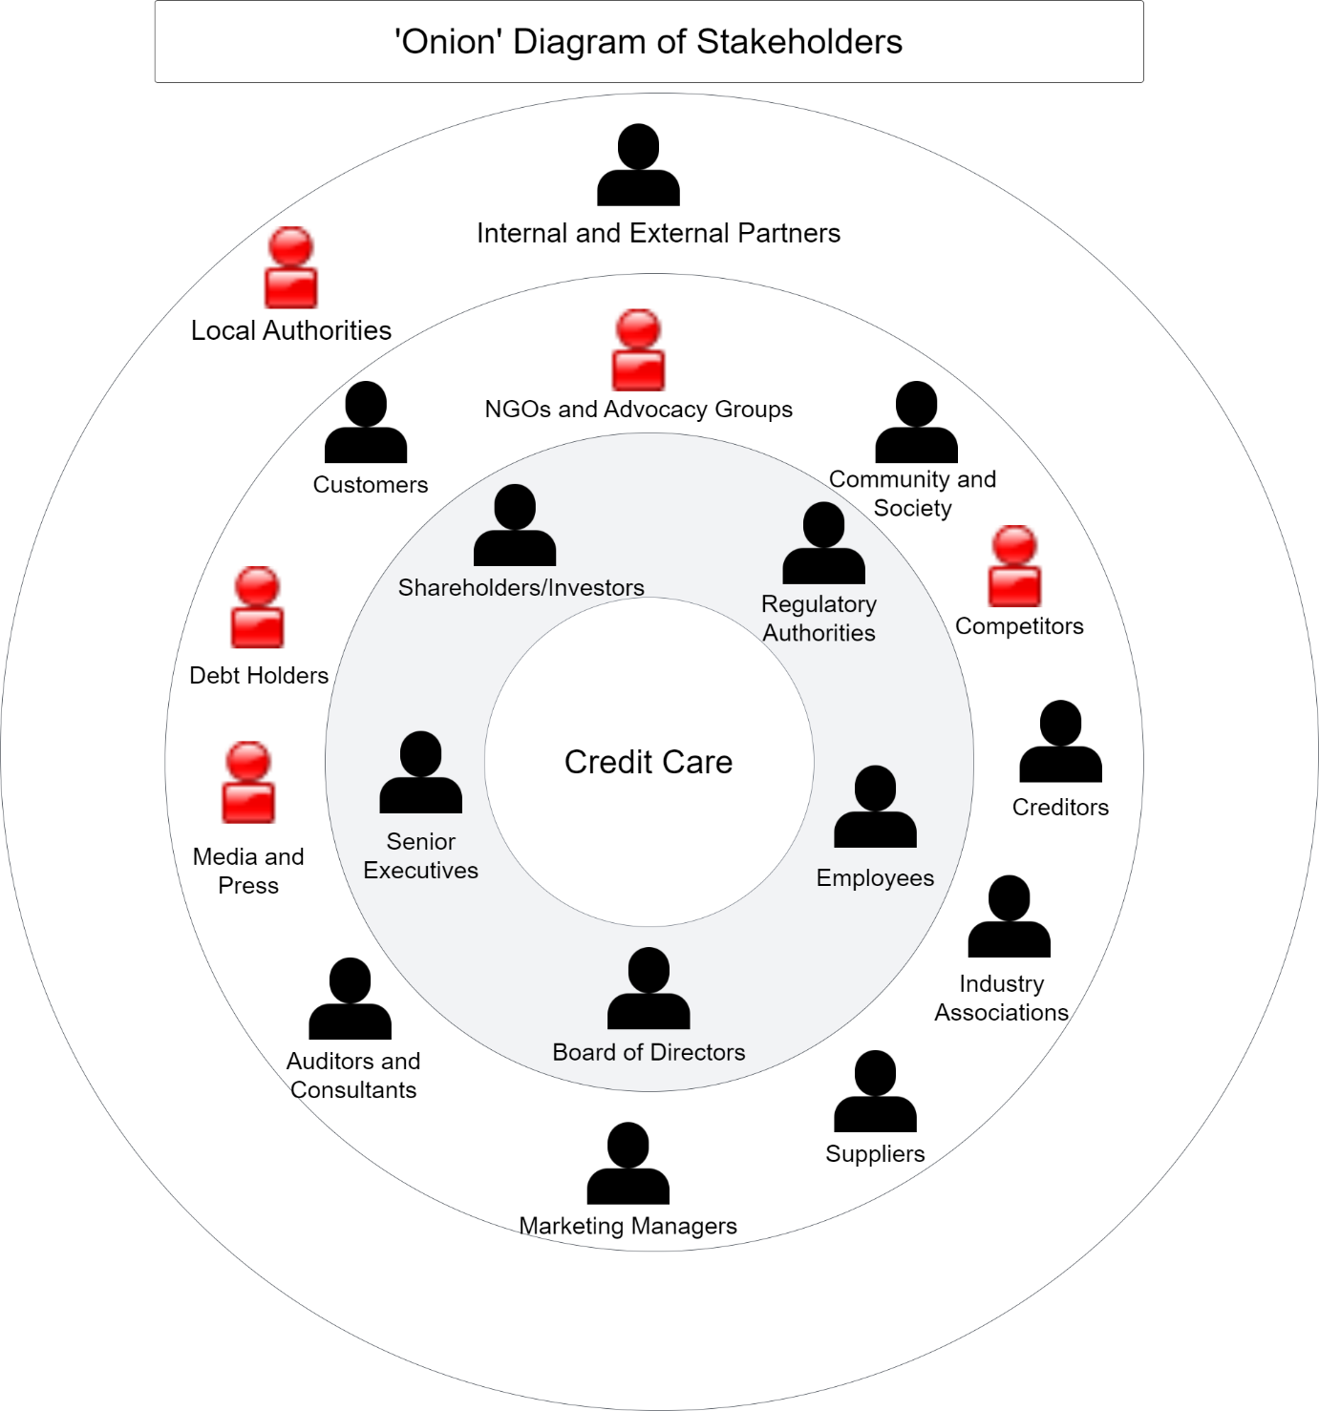

**2.Software Design**

**2.1 Use Cases**

Client Table:

|  |  |
| --- | --- |
| **Field** | **Description** |
| **Actor:** | Client |
| **Description:** | Represents an individual or business seeking financial services, including microloans. |
| **Pre-Condition:** | The client is interested in applying for a microfinance loan. |
| **Post-Condition:** | The client has successfully applied for a microfinance loan, and the loan approval process is initiated. |

TABLE 1 : LOAN OFFICER

|  |  |
| --- | --- |
| **Field** | **Description** |
| **Actor:** | Loan Officer |
| **Description:** | Evaluates loan applications submitted by clients. |
| **Pre-Condition:** | The loan officer receives a loan application to review. |
| **Post-Condition:** | The loan officer completes the evaluation, providing a recommendation for approval or rejection of the loan application. |

TABLE 2: LOAN OFFICER

|  |  |
| --- | --- |
| **Field** | **Description** |
| **Actor:** | Loan Officer |
| **Description:** | Conducts interviews with clients as part of the loan application process. |
| **Pre-Condition:** | The loan officer is assigned to interview a client based on a submitted loan application. |
| **Post-Condition:** | The loan officer completes the client interview, gathering additional information for the loan approval process. |

TABLE 3:LOAN OFFICER

|  |  |
| --- | --- |
| **Field** | **Description** |
| **Actor:** | Loan Officer |
| **Description:** | Manages the overall loan approval process, coordinating activities to ensure timely and accurate decision-making. |
| **Pre-Condition:** | The loan officer has completed the evaluation of a loan application and conducted client interviews. |
| **Post-Condition:** | The loan officer finalizes the loan approval process, communicating the decision to the client and initiating the next steps if approved. |

TABLE 1:MICROFINANCE SYSTEM

|  |  |
| --- | --- |
| **Field** | **Description** |
| **Actor:** | Microfinance System |
| **Description:** | Central software that manages overall microfinance operations. |
| **Pre-Condition:** | The microfinance system is operational and ready to receive requests. |
| **Post-Condition:** | The microfinance system successfully processes and manages microfinance operations, maintaining overall system integrity. |

TABLE 2: MICROFINANCE SYSTEM

|  |  |
| --- | --- |
| **Field** | **Description** |
| **Actor:** | Microfinance System |
| **Description:** | Facilitates the end-to-end processes of loan application, approval, and repayment. |
| **Pre-Condition:** | The microfinance system is actively receiving loan applications and is configured to handle approval and repayment processes. |
| **Post-Condition:** | The microfinance system successfully guides clients through the loan lifecycle, from application submission to approval and subsequent repayment. |

TABLE 3: MICROFINANCE SYSTEM

|  |  |
| --- | --- |
| **Field** | **Description** |
| **Actor:** | Microfinance System |
| **Description:** | Stores and processes client and transaction data securely and efficiently. |
| **Pre-Condition:** | The microfinance system has access to a reliable and secure database. |
| **Post-Condition:** | The microfinance system successfully stores and processes client and transaction data, ensuring accuracy and compliance with data protection standards. |

TABLE 1:DATABASE SERVER

|  |  |
| --- | --- |
| **Field** | **Description** |
| **Actor:** | Database Server |
| **Description:** | Stores and manages client information securely. |
| **Pre-Condition:** | The database server is operational and accessible to the microfinance system. |
| **Post-Condition:** | The database server successfully stores and manages client information, ensuring data integrity and security. |

TABLE 2: DATABASE SERVER

|  |  |
| --- | --- |
| **Field** | **Description** |
| **Actor:** | Database Server |
| **Description:** | Records transaction data generated by microfinance operations. |
| **Pre-Condition:** | The database server is ready to receive and record transaction data. |
| **Post-Condition:** | The database server successfully records transaction data, maintaining an accurate and up-to-date record of financial transactions. |

TABLE 3:DATABASE SERVER

|  |  |
| --- | --- |
| **Field** | **Description** |
| **Actor:** | Database Server |
| **Description:** | Supports the generation of reports and provides data for analysis purposes. |
| **Pre-Condition:** | The database server contains comprehensive and well-organized data. |
| **Post-Condition:** | The database server successfully supports reporting and analysis, allowing stakeholders to make informed decisions based on the stored data. |

TABLE 1:RELATIONSHIP MANAGER

|  |  |
| --- | --- |
| **Field** | **Description** |
| **Actor:** | Relationship Manager |
| **Description:** | Offers financial advice and support to clients based on their needs and circumstances. |
| **Pre-Condition:** | The relationship manager has access to relevant client information and financial tools. |
| **Pre-Condition:** | The relationship manager successfully provides valuable financial advice and support, addressing client concerns and contributing to their financial well-being. |

TABLE 1:SYSTEM ADMINISTRATOR

|  |  |
| --- | --- |
| **Field** | **Description** |
| **Actor:** | System Administrator |
| **Description:** | Manages and maintains the overall health and functionality of the microfinance system. |
| **Pre-Condition:** | The system administrator has access to necessary tools and documentation for system management. |
| **Post-Condition:** | The microfinance system is effectively managed and maintained, ensuring uninterrupted operations. |

TABLE 2: SYSTEM ADMINISTRATOR

|  |  |
| --- | --- |
| **Field** | **Description** |
| **Actor:** | System Administrator |
| **Description:** | Handles configuration tasks and ongoing maintenance to optimize the performance of the microfinance system. |
| **Pre-Condition:** | The system administrator has the required permissions and knowledge to configure and maintain the system. |
| **Post-Condition:** | System configuration changes are successfully implemented, and regular maintenance tasks are performed to enhance system performance. |

TABLE 1: IT SUPPORT

|  |  |
| --- | --- |
| **Field** | **Description** |
| **Actor:** | IT Support |
| **Description:** | Provides technical assistance and support for the microfinance system. |
| **Pre-Condition:** | The IT support personnel has access to relevant system documentation and tools. |
| **Post-Condition:** | Technical support is successfully provided, addressing the reported issues or inquiries related to the microfinance system. |

TABLE 2: IT SUPPORT

|  |  |
| --- | --- |
| **Field** | **Description** |
| **Actor:** | IT Support |
| **Description:** | Resolves technical issues to ensure the continuous functionality of the microfinance system. |
| **Pre-Condition:** | The IT support personnel has knowledge of the microfinance system architecture and common technical issues. |
| **Post-Condition:** | Technical issues are successfully resolved, and the microfinance system is functioning as expected. |

**2.2 Use Case Diagram**

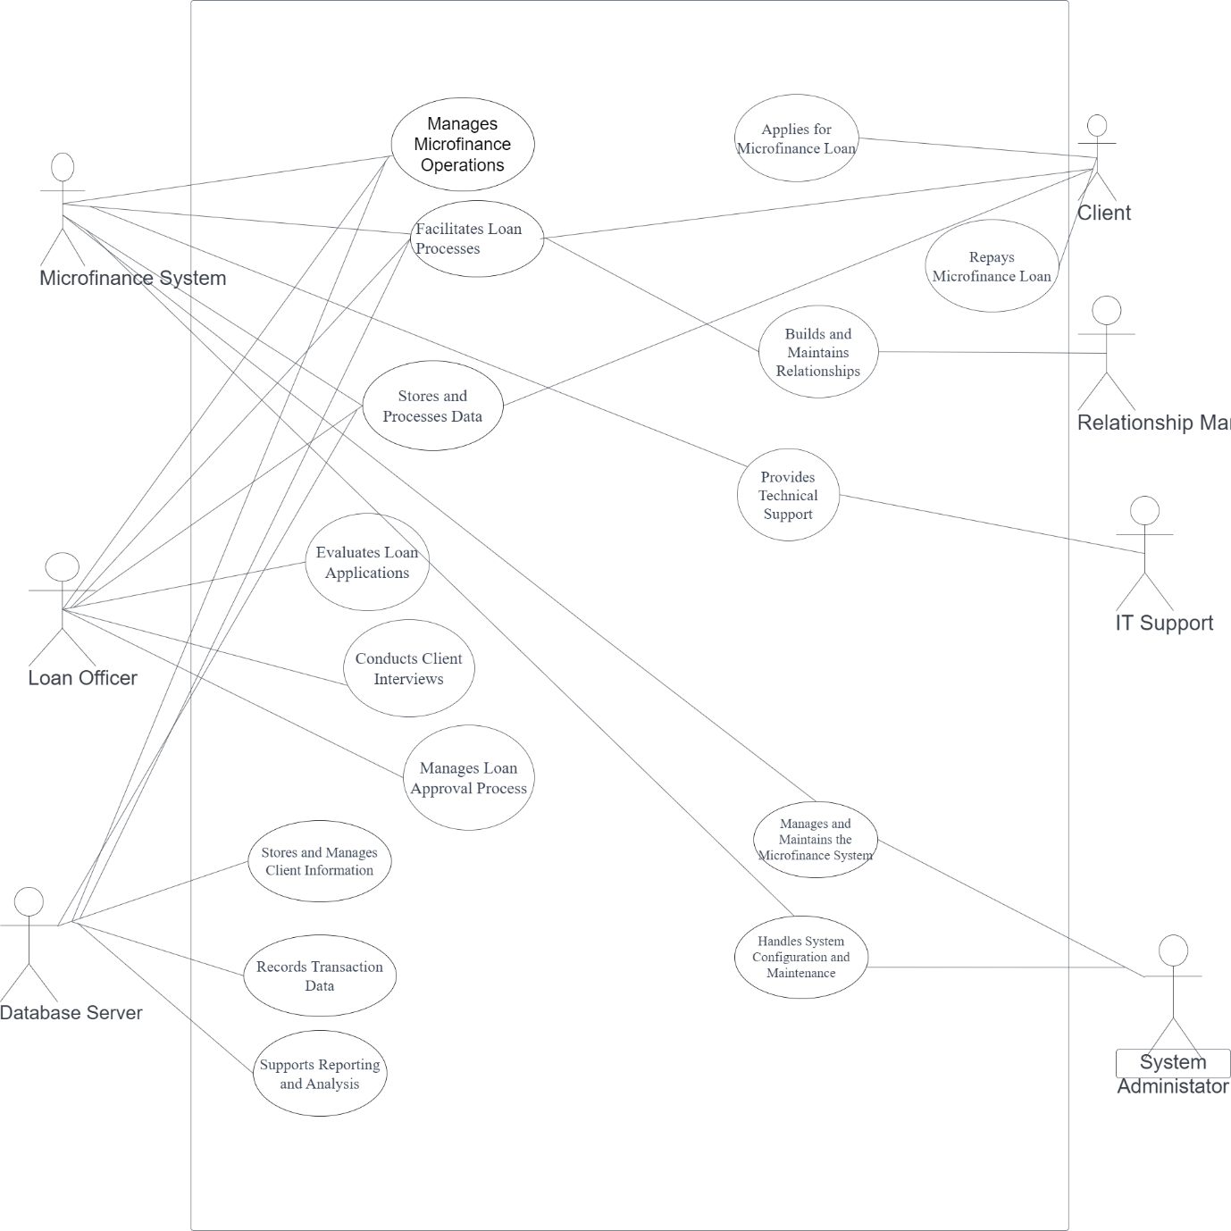

**2.3 Activity Diagrams**

Activity Diagram for login

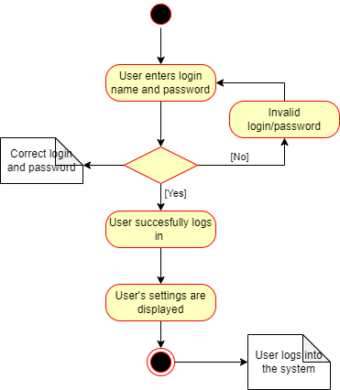

Swimlane Activity Diagram for applying for a loan

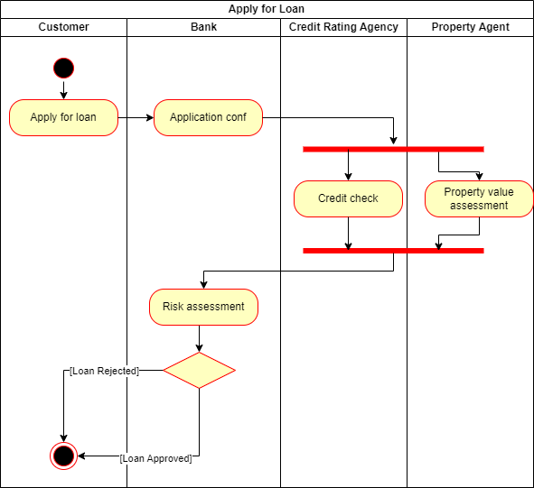

**2.4 Sequence Diagram**

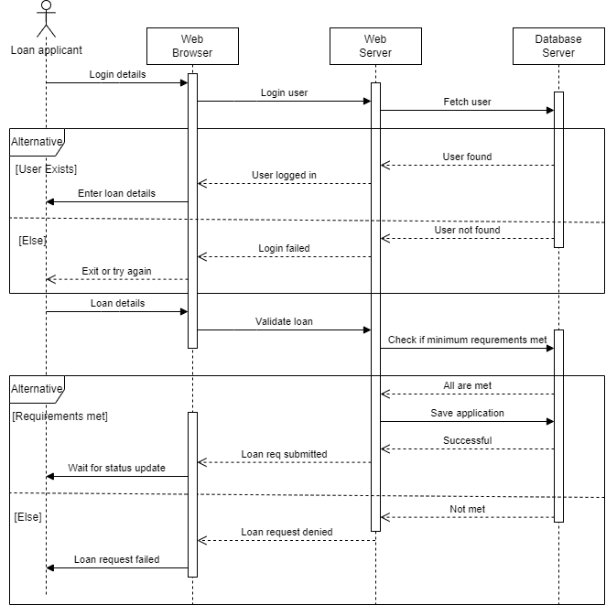

**2.5 Collaboration Diagram**

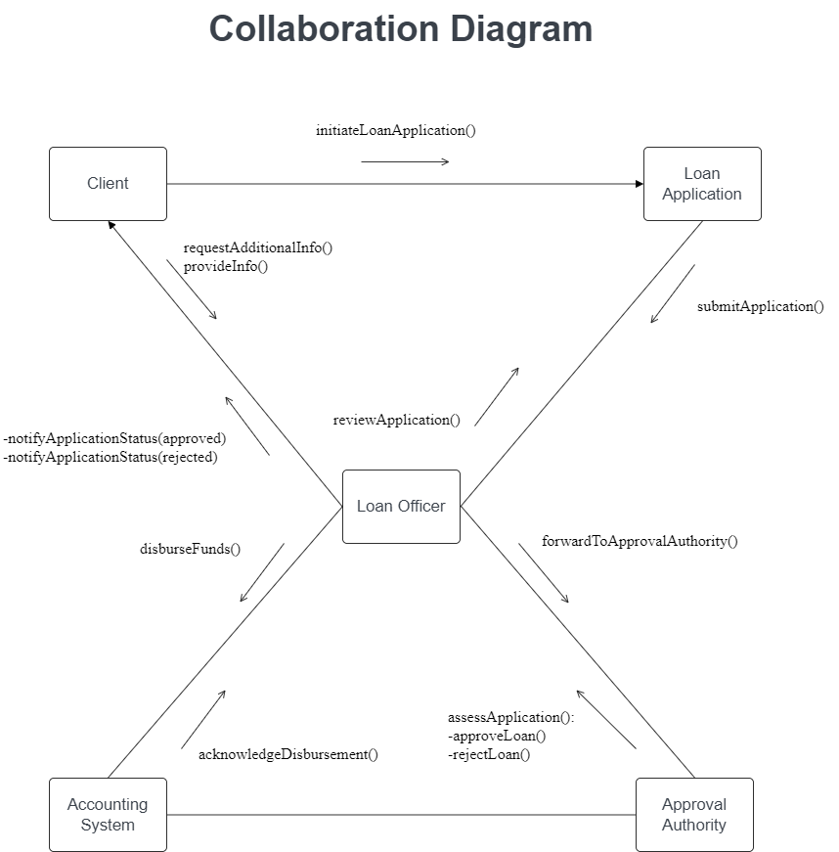

**2.6 BPMN Diagram**

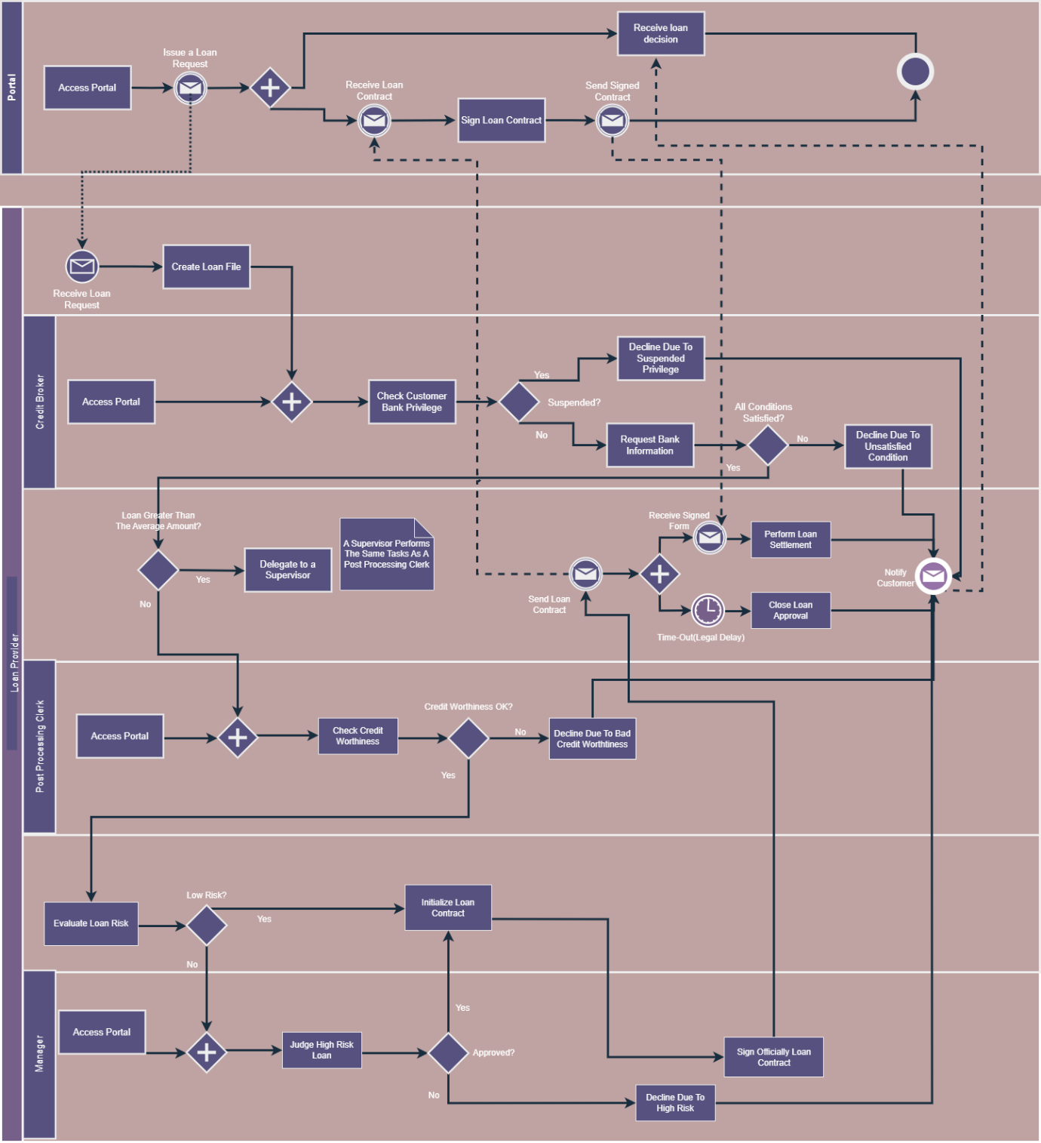

**2.7 State Diagram**

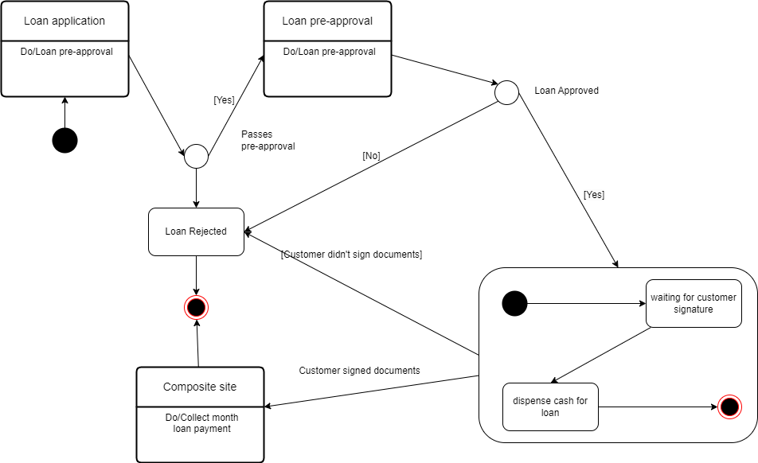

**2.8 Class Diagram**

Loan Application class diagram

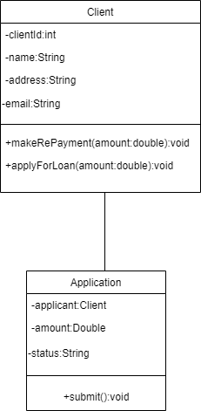

Loan Payment class diagram

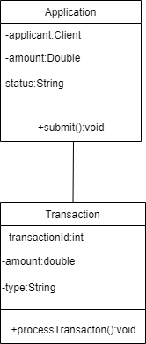

Financial Reports class diagram

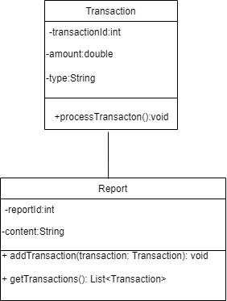

Expanded class diagram

