Nigeria’s 2026 Flood Crisis: Communities Submerged, Thousands Displaced as Flood Warnings Spread Across the Country
Rabi Elabor
ISRION INTERNATIONAL LTD
Published October 20, 2026
Recent flooding in Nasarawa and Kogi States, alongside widespread flood warnings across Nigeria, highlights growing concerns about community safety, agricultural losses, water contamination, and the urgent need for stronger flood monitoring and early warning systems.
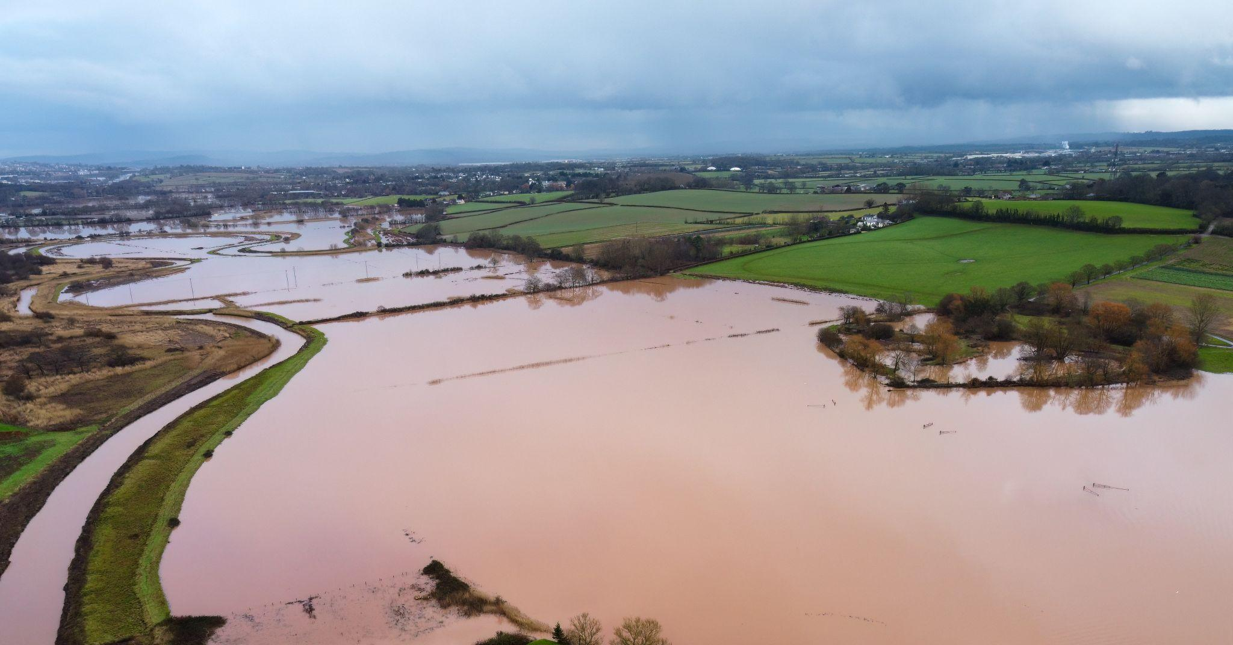

Nigeria Faces Widespread Flood Threats
Nigeria is confronting another challenging flood season as heavy rainfall, rising river levels, and flooding in vulnerable communities threaten lives, livelihoods, agricultural production, and critical infrastructure. Recent reports from Nasarawa and Kogi States have documented flooding affecting communities along major river systems. Meanwhile, federal authorities have issued flood-risk warnings covering numerous states, particularly communities situated along riverbanks, floodplains, and low-lying areas.
On October 20, 2026, Premium Times reported that flooding in Nasarawa State had claimed at least two lives, submerged more than 18 communities, and displaced thousands of residents. The situation follows a series of national flood advisories issued by the Nigeria Hydrological Services Agency (NIHSA), the National Emergency Management Agency (NEMA), and other federal authorities. Together, these developments demonstrate the need for improved flood forecasting, environmental monitoring, community preparedness, and coordinated emergency response.

Nasarawa State: Deadly Flooding Submerges More Than 18 Communities
Severe flooding has affected communities in Doma Local Government Area of Nasarawa State, particularly settlements located along the River Benue.
According to reports published by Voice of Nigeria on October 20, at least two people have died, while more than 18 communities have been submerged following heavy rainfall and the overflow of the river. The flooding has damaged residential buildings, agricultural lands, and roads, forcing thousands of residents to seek shelter in nearby communities on higher ground.
Earlier assessments by the Nasarawa State Emergency Management Agency estimated that between 4,000 and 5,000 people had been displaced across 11 communities. Subsequent assessments identified additional affected settlements. Communities including Agyema, Rukubi, and Akpanaja have experienced significant disruption. Floodwaters have also rendered important access roads impassable, complicating evacuation, emergency response, and the delivery of relief materials.
The Nasarawa State Government has directed emergency management officials to assess the damage and coordinate assistance for displaced households. The disaster highlights the vulnerability of communities living along the River Benue, where seasonal increases in water levels can threaten settlements, farmland, and transportation networks.

Kogi State: Flooding Triggers Emergency Rescue Operations
In Kogi State, the National Emergency Management Agency coordinated search-and-rescue operations in flood-affected communities in Bassa Local Government Area in October 2026. The affected communities reportedly included Edakabawa, Ehebechi, Ehuruma, Edagachi, Adimbeku, and Ogoh. Kogi remains particularly vulnerable to riverine flooding because of its location near the confluence of the Niger and Benue rivers. Communities situated along these major waterways may experience flooding when heavy rainfall and elevated upstream river flows combine to increase water levels.
Flooding in such areas can disrupt agricultural production, damage transportation routes, isolate settlements, and threaten access to essential services. The recent emergency operations reinforce the importance of monitoring river levels, maintaining evacuation routes, and improving communication between emergency agencies and vulnerable communities.

Anambra State: Flood Warnings Identify 87 Vulnerable Communities
In late September 2026, the Nigeria Hydrological Services Agency issued a high-risk flood advisory covering 87 communities across four Local Government Areas in Anambra State. The advisory covered Anambra East, Anambra West, Awka North, and Ayamelum.
According to NIHSA, water levels at the Igbagbada monitoring station on the Anambra River had exceeded warning thresholds. The assessment identified 45 schools, 16 health facilities, 10 markets, and 23 religious centers as potentially exposed infrastructure. Residents of vulnerable communities were advised to move to higher ground, protect livestock and essential belongings, and avoid crossing flooded roads and waterways. The advisory was valid from September 28 to October 4, 2026, and has since expired.
Although the warning identified significant potential exposure, it should not be interpreted as confirmation that all 87 communities experienced flooding. Nevertheless, the advisory demonstrates the importance of monitoring river systems and communicating flood-risk information before disasters occur.

Federal Government Issues Flood Warnings Across Multiple States
Nigeria's flood emergency extends beyond individual incidents. In September 2026, NIHSA warned of heightened riverine flood risk across 15 states, including Imo, Cross River, Ebonyi, Benue, Anambra, Akwa Ibom, Lagos, Rivers, Edo, Kogi, Taraba, Delta, Bayelsa, Enugu, and Abia.Following the warning, NEMA directed its zonal directorates and operational offices to activate emergency preparedness measures and coordinate with state and local authorities.
A separate federal flood prediction covering September 27 to October 10 identified communities across 24 states and the Federal Capital Territory as facing varying levels of flood risk. The warnings included parts of the North Central, North East, South East, South South, and South West geopolitical zones. Major urban centers identified in the advisory included Makurdi, Lokoja, Minna, Port Harcourt, Benin City, Asaba, Calabar, Uyo, Onitsha, Lagos, and Ibadan.
These warnings reflected the combined risks of heavy rainfall, rising river levels, saturated soils, surface runoff, and inadequate drainage. However, flood-risk warnings are forecasts rather than confirmation that every listed state or community experienced flooding.

More Than 14,000 Nigerian Communities Classified as High Flood Risk in 2026
The scale of Nigeria's flood vulnerability is reflected in the country's 2026 national flood outlook. According to the National Emergency Management Agency's 2026 flood assessment, NIHSA identified approximately 14,118 communities across 266 Local Government Areas in 33 states and the Federal Capital Territory as being at high risk of flooding. Thousands of additional communities were classified as facing moderate flood risk. These projections demonstrate the extensive exposure of Nigerian communities to riverine and urban flooding.
The recurring threat is influenced by several interconnected factors, including intense rainfall, river overflow, settlement expansion into floodplains, poor drainage infrastructure, blocked waterways, and changes in land use.
Although climate change may influence extreme rainfall patterns, its contribution to specific flood events requires dedicated scientific analysis. The challenge is therefore not only improving flood predictions but ensuring that warnings lead to timely action capable of protecting lives and property.

Environmental Consequences of Flooding Across Nigeria
Beyond immediate displacement and infrastructure damage, flooding can produce substantial environmental consequences.
Water contamination and public health: Floodwaters can transport sewage, household waste, agricultural chemicals, sediments, and other pollutants into rivers, wells, and surface-water sources.
Agricultural losses and food security: Flooding can destroy standing crops, erode fertile topsoil, damage irrigation infrastructure, and prevent farmers from accessing agricultural land. For communities dependent on farming, repeated flooding can reduce household income and threaten local food security.
Soil erosion and sediment transport: High-velocity floodwaters can accelerate riverbank erosion, remove topsoil, and transport substantial sediment loads into downstream water bodies. These processes may alter river channels, affect aquatic habitats, and increase sediment accumulation in drainage systems.
Damage to infrastructure and settlements: Flooding can damage roads, bridges, buildings, electricity infrastructure, and water-supply systems. Where access routes are submerged, emergency response and recovery operations become more difficult.


Infrastructure and Environmental Monitoring: Strengthening Nigeria's Flood Response
Strengthening Nigeria's resilience to flooding requires an integrated approach combining infrastructure planning, environmental monitoring, and advanced geospatial technologies. Drone aerial planning, remote sensing, and hydrological modeling can support flood-risk assessments, early warning systems, and evidence-based disaster management.
Drone-based aerial reconnaissance and mapping can strengthen Nigeria's flood response by providing high-resolution imagery of affected communities, damaged infrastructure, and inundated agricultural lands.
Comparing suitable pre-flood and post-flood satellite images can help estimate inundation extent. Satellite observations and drone surveys can help identify affected areas, monitor changes in surface-water extent, and assess the exposure of settlements, agricultural lands, transportation networks, and critical infrastructure.
For Nigeria's 2026 flood season, a national geospatial assessment could investigate:
- The spatial extent of confirmed flood events across affected states.
- Assess the exposure of roads, bridges, drainage systems, schools, hospitals, and other critical facilities to flooding.
- Communities repeatedly affected by riverine and urban flooding.
- The relationship between flood exposure, elevation, drainage networks, and land-use changes.
- Priority locations for flood mitigation, infrastructure improvements, environmental monitoring, flood-control interventions, and emergency response.
This approach can strengthen early warning capabilities, guide climate-resilient infrastructure development, protect vulnerable communities, and support sustainable environmental planning.

Recommendations for Strengthening Flood Resilience in Nigeria
Strengthen national flood monitoring. Federal and state authorities should integrate hydrological observations, rainfall forecasts, satellite imagery, drone survey and GIS-based flood mapping into coordinated monitoring systems.
Improve early warning communication. Flood alerts should reach vulnerable communities through accessible channels, including local radio, mobile messaging, community leaders, and emergency management networks.
Expand post-flood environmental assessments. Water-quality testing, sanitation inspections, and contamination assessments should be prioritized in communities affected by flooding.
Protect agricultural livelihoods. Flood exposure mapping should support the assessment of damaged farmland, agricultural recovery planning, and the identification of areas suitable for flood-resilient land management.
Promote risk-informed infrastructure development. Flood hazard information should guide road construction, drainage planning, housing development, and the siting of public facilities.
Improve access to environmental data. Flood forecasts, hydrological observations, hazard maps, and environmental monitoring results should be accessible to government agencies, researchers, private organizations, and communities.

Path way forward
These technologies can support flood monitoring, hazard mapping, environmental exposure assessment, infrastructure planning, agricultural risk evaluation, and sustainable land management. By combining their emerging technologies with reliable environmental information, Nigeria can strengthen disaster preparedness and support more resilient communities.
Effective flood management begins before the floodwaters arrive. Understanding where risks exist, identifying vulnerable communities, and translating scientific evidence into timely action are essential to protecting lives, livelihoods, and the environment.

ISRION INTERNATIONAL LTD — The Catalyst for Sustainable Change.
Editorial note: This article presents reported flood incidents, official warnings, and environmental risk analysis. It does not claim that ISRION INTERNATIONAL LTD conducted original field surveys, satellite flood mapping, or water-quality testing for the events discussed.

