Multi-Temporal SAR-Based Flood Mapping of Dam-Induced Inundation Events in Kwara State, Nigeria (2018–2025): Extent, Agricultural Damage, and Population Exposure
Anjolaoluwa [Surname]
Department of Environmental Science, Florida A&M University (FAMU), Tallahassee, FL 32307, USA
Correspondence: [your.email@famu.edu]
Received: [date] | Accepted: [date] | Published: [date]

Abstract
Dam-induced flooding represents one of the most recurrent and consequential natural hazard typologies in north-central Nigeria, yet its spatial extent, temporal progression, and impacts on agricultural land and human populations remain systematically underdocumented at the state level. This study presents the first multi-temporal Sentinel-1 Synthetic Aperture Radar (SAR)-based flood mapping of dam-induced inundation events across Kwara State, Nigeria, spanning five documented events between October 2018 and April 2025 attributable to operational releases from the Jebba and Kainji Hydroelectric Power Stations on the River Niger. Using SAR backscatter change detection with dual-polarisation (VV and VH) composites processed in Google Earth Engine, flood extents were delineated and cross-validated against Local Government Area (LGA)-level administrative boundaries and independent media documentation. Results indicate a significant escalation in flood severity: total inundated area grew from 7 km² in 2018 to a peak of 255 km² in September 2022, with 192 km² recorded in April 2025. Agricultural cropland constituted the dominant land-use category in flood zones across all events, reaching 122 km² in April 2025 — equivalent to 63.5% of total inundated area. Cumulative population exposure across all five events was estimated at 55,997 person-event exposures, with the September 2022 event alone affecting an estimated 24,822 people. Spatial validation confirmed that Pategi and Edu Local Government Areas accounted for 98% of September 2022 inundation, consistent with ground-level displacement records reporting 2,800 displaced persons and seven fatalities. Temporal frequency analysis identified a 6 km² persistent flood core in Pategi and Edu LGAs that was inundated in at least two events, representing the most chronically vulnerable agricultural land in the state. These findings provide high-resolution, spatially explicit evidence to inform Kwara State's flood early warning systems, dam release governance, and agricultural disaster risk reduction strategies aligned with the Sendai Framework for Disaster Risk Reduction 2015–2030.

Keywords: Sentinel-1 SAR; flood mapping; dam-induced flooding; Kwara State; Nigeria; Google Earth Engine; disaster risk reduction; agricultural damage; Jebba Dam; Kainji Dam

1. Introduction
Flooding is the most frequent, economically destructive, and lethal natural hazard in sub-Saharan Africa (UNDRR, 2020). In Nigeria, Africa's most populous nation, flooding has emerged as a structural humanitarian and development crisis rather than an episodic natural disaster, claiming over 1,200 lives and displacing 1.2 million people in 2024 alone (NEMA, 2024). The north-central geopolitical zone — encompassing Kwara, Niger, Kogi, Benue, Nasarawa, and Plateau states — experiences some of the highest flood recurrence rates in the country, driven by the complex interaction of seasonal rainfall variability, river basin hydrology, and anthropogenic dam operations along the River Niger and River Benue corridors (Olorunfemi et al., 2020; Echendu, 2021).
Kwara State occupies a particularly vulnerable position in Nigeria's flood risk landscape. Situated along the southern bank of the middle Niger River, the state's northern LGAs — particularly Pategi, Edu, Moro, Kaiama, and Baruten — lie within the downstream floodplain of the Jebba Hydroelectric Power Station (330 MW) and the Kainji Dam (760 MW), two of Nigeria's largest hydroelectric facilities operated by the Transmission Company of Nigeria (TCN) and the Niger Delta Power Holding Company (NDPHC). Operational dam releases, particularly during the peak rainy season (September–November) and in response to upstream flow from Niger Republic, regularly inundate downstream agricultural communities in Kwara State with little advance warning (HYPADEC, 2022; Blueprint Newspapers, 2022). The state's riverine communities in Pategi and Edu LGAs have been described as experiencing "perennial" flooding, with some families evacuating annually to IDP camps only to return when floodwaters recede (Leadership, 2022; DA News, 2023).
Despite the well-documented recurrence and socioeconomic severity of these flood events, systematic spatial mapping of their extent, agricultural footprint, and population impact across multiple events has not been undertaken for Kwara State. Existing studies have focused primarily on urban flood vulnerability in Ilorin (the state capital) using GIS-based multi-criteria methods (Alimi et al., 2023; Oriola and Chibuike, 2016; Shiru et al., 2015), with limited attention to the large-scale riverine dam-induced inundation affecting rural agricultural communities in Kwara North. This gap limits the evidence base for state-level flood risk management, agricultural disaster response planning, and the governance of dam release operations.
Satellite-based Synthetic Aperture Radar (SAR) remote sensing offers a transformative capability for operational flood mapping, particularly in tropical environments where cloud cover frequently obscures optical satellite imagery during flood events (Martinis et al., 2022; Twele et al., 2016). The Copernicus Sentinel-1 constellation, providing C-band SAR imagery at 10 m spatial resolution with a 6-day repeat cycle, has enabled consistent global flood detection since 2014 (Torres et al., 2012). SAR-based flood detection using backscatter change detection — whereby flood-inundated smooth water surfaces produce markedly lower radar return compared to dry land surfaces — is well-established in the literature (Boni et al., 2016; Chini et al., 2019; Refice et al., 2020). The availability of Google Earth Engine (GEE) as a cloud-based planetary-scale geospatial analysis platform has further democratised high-resolution SAR flood mapping (Gorelick et al., 2017), enabling multi-temporal analysis across large geographic extents without local high-performance computing infrastructure.
This study addresses the identified knowledge gap by presenting the first systematic, multi-temporal SAR flood mapping assessment for Kwara State, covering five dam-induced flood events between 2018 and 2025. The specific objectives are: (1) to delineate the spatial extent of flood inundation for each documented event using Sentinel-1 SAR change detection; (2) to quantify the area of agricultural cropland inundated and estimate population exposure per event; (3) to conduct LGA-level spatial disaggregation of flood impacts; (4) to perform temporal frequency analysis to identify chronically vulnerable flood zones; and (5) to validate SAR-derived flood extents against available ground-level documentation. The findings contribute directly to Kwara State's disaster risk profile and provide an evidence base for dam release governance reforms and community-level flood preparedness.

2. Study Area
Kwara State is located in the north-central geopolitical zone of Nigeria, bounded by Niger State to the north, Kogi State to the east, Ekiti and Ondo states to the south, and Oyo and Osun states to the southwest (Figure 1). The state covers an area of approximately 36,825 km² and is administratively divided into 16 Local Government Areas (LGAs). As of the 2006 National Population Census (the most recent official census), the state had a population of approximately 2.37 million, with projections suggesting a current population of approximately 3.5 million (NPC, 2006; NBS, 2020).
The state is characterised by a humid tropical savanna climate (Köppen Aw), with a single rainy season (May–October) and a dry season dominated by the Harmattan winds (November–April). Mean annual rainfall ranges from approximately 1,100 mm in the north to 1,400 mm in the south, with the highest flood risk concentrated in the northern LGAs along the Niger River corridor (NIMET, 2023; Adeniyi and Abubakar, 2026).
The study area is defined by its position within the lower Niger River Basin. The River Niger forms the northern and north-eastern boundary of Kwara State, flowing from its convergence with River Kaduna at the southern end of Kainji Reservoir through Lake Jebba and into the broader Niger floodplain. The Jebba Hydroelectric Power Station (commissioned 1985; capacity 578.4 MW) and the upstream Kainji Dam (commissioned 1968; capacity 760 MW), both located in neighbouring Niger State, exert significant hydraulic influence on downstream communities in Kwara's Pategi, Edu, Moro, Kaiama, and Baruten LGAs through controlled and emergency water releases (Ojo et al., 2019). Rice farming is the dominant agricultural livelihood in these riverine communities, with the dry season rice cultivation season (January–April) coinciding with periodic dam-release flooding events.
[Figure 1: Map of Kwara State, Nigeria, showing LGA boundaries, River Niger corridor, and locations of Jebba and Kainji Hydroelectric Power Stations. To be inserted.]

3. Data and Methodology

3.1 Satellite Data: Sentinel-1 SAR
Sentinel-1 Ground Range Detected (GRD) imagery in Interferometric Wide (IW) swath mode was acquired from the Copernicus Open Access Hub via Google Earth Engine (Collection ID: COPERNICUS/S1_GRD). The IW mode provides a 250 km swath with 10 m × 10 m spatial resolution in dual polarisation (VV and VH) at a revisit time of approximately 6 days at the equator. Both ascending and descending orbit passes were utilised to maximise the probability of acquiring imagery within each flood event window. For each flood event, a pre-flood baseline image was composited from acquisitions in the 4–12 weeks immediately preceding the documented flood onset, and a post-flood image was composited from acquisitions in the 2–8 weeks following the documented dam release date (Table 1). Mean compositing was applied to reduce temporal speckle artefacts across multiple acquisitions within each window.

3.2 Flood Event Documentation and Date Windows
Five dam-induced flood events were identified through systematic review of NEMA (National Emergency Management Agency) situation reports, HYPADEC (Hydroelectric Power Producing Areas Development Commission) press releases, and published news media from 2018 to 2025. Events were selected based on documented evidence of dam-related causes (i.e., explicitly attributed to Jebba or Kainji Dam releases), confirmed geographic occurrence within Kwara State, and the availability of Sentinel-1 imagery within the relevant date windows (Table 1).

Table 1. Flood event characteristics, documented causes, and Sentinel-1 acquisition date windows.
Event ID | Label | Pre-Flood Window | Post-Flood Window | Documented Cause | Data Source
Oct 2018 | Pategi/Edu — Jebba Dam + Niger River overflow | Aug–Sep 2018 | Oct–Nov 2018 | Jebba Dam release | ThisDay (Oct 2018); NEMA Bulletin
Oct 2020 | Statewide — Jebba/Kainji + Niger Republic dam outflows | Jul–Sep 2020 | Oct–Nov 2020 | Jebba/Kainji + upstream release | IFRC EPoA MDRNG030; NEMA (6 Oct 2020)
Sep 2022 | Pategi, Edu — Jebba Dam + Niger/Kaduna overflow | Jun–Aug 2022 | Sep–Nov 2022 | Jebba Dam + rainy season peak | Leadership (2 Oct 2022); HYPADEC relief report
Feb 2025 | Moro, Edu, Pategi — dry season Jebba/Kainji release | Feb 1–23, 2025 | Feb 24–Apr 1, 2025 | Jebba/Kainji dry season release | Ilorin.info (Feb 2025); Hon. Saba statement
Apr 2025 | Edu, Pategi — Jebba Dam release (13 deaths) | Jan–Apr 10, 2025 | Apr 16–Jun 2025 | Jebba Dam release (6th event of 2025 dry season) | The Watchers News (22 Apr 2025); Al Jazeera (31 May 2025)

3.3 SAR Pre-Processing and Speckle Filtering
All Sentinel-1 GRD images were pre-processed within Google Earth Engine using the standard GEE Sentinel-1 processing pipeline, which applies border noise removal, thermal noise correction, radiometric calibration (to sigma-naught backscatter, σ°, in decibels), and terrain correction using the Shuttle Radar Topography Mission (SRTM) 30 m DEM. Speckle noise — an inherent feature of coherent SAR imagery — was reduced by applying a focal median filter with a 100 m square kernel to each individual scene prior to compositing. The focal median approach was selected over the Refined Lee filter due to its superior edge preservation characteristics and computational efficiency within the GEE environment (Sentinel-1 Toolbox, 2023).

3.4 Flood Detection: SAR Backscatter Change Detection
Flood inundation was detected using a bi-temporal SAR backscatter change detection approach, widely documented in the flood remote sensing literature (Boni et al., 2016; Chini et al., 2019; Twele et al., 2016). The underlying physical principle is that smooth open water surfaces act as specular reflectors, returning minimal energy to the SAR sensor (low σ°), while dry vegetated or bare soil surfaces return higher σ° values. Dam-induced inundation therefore produces a measurable decrease in SAR backscatter between the pre-flood and post-flood composites.
The change image was computed as:
ΔσVV = σ°before,VV − σ°after,VV
Pixels where ΔσVV exceeded 5 dB were classified as flooded based on the threshold range (4–7 dB) recommended in the literature for C-band SAR over flat alluvial terrain (Chini et al., 2019; Martinis et al., 2022). For the VH polarisation channel — which is more sensitive to volumetric scattering from partially inundated vegetation and rice paddy fields — a lower threshold of 3 dB was applied to capture flooded vegetation signatures not detectable in VV alone (Manjusree et al., 2012; Refice et al., 2020). The combined VV+VH flood mask was constructed as the logical union of the two single-polarisation flood masks. A threshold sensitivity analysis was conducted for the February 2025 event to validate the 5 dB threshold selection (Section 4.1).

3.5 Post-Classification Masking
Two post-classification masks were applied to reduce false positives in the flood detection output. First, pixels coinciding with permanent water bodies — defined as locations with water presence in at least 10 months per year based on the JRC Global Surface Water dataset (Pekel et al., 2016) — were excluded from the flood classification to prevent perennial water bodies such as Lake Jebba and river channels from being misclassified as newly flooded areas. Second, pixels on slopes greater than 5° — derived from the SRTM digital elevation model using the GEE terrain analysis function — were excluded to remove SAR layover and shadow artefacts on steep terrain. Kwara State's predominantly flat topography (mean elevation 250–350 m asl in the flood-prone northern LGAs) resulted in only minimal exclusions from the slope mask.

3.6 Flood Impact Quantification
Three flood impact metrics were computed for each event using ancillary datasets overlaid on the flood mask: (i) total flooded area (km²), calculated by summing pixel areas within the flood mask using the GEE pixelArea() function at 100 m scale; (ii) flooded cropland area (km²), calculated by intersecting the flood mask with the ESA WorldCover 2021 cropland class (Class 40; Zanaga et al., 2022); and (iii) estimated exposed population, calculated by intersecting the flood mask with the WorldPop 2020 population density dataset (Lloyd et al., 2019) and summing pixel-level population values within the flood extent. Settlement exposure (km²) was additionally computed using the ESA WorldCover built-up land class (Class 50). All areal computations were performed at 100 m scale to balance computational efficiency with spatial accuracy.

3.7 LGA-Level Zonal Statistics
Flooded area per LGA was computed using zonal statistics (reduceRegions) applied to the flood mask against the FAO GAUL 2015 Level 2 administrative boundary dataset for Kwara State. LGAs with flooded areas greater than 0.5 km² were reported to filter out marginal boundary artefacts. Results were sorted in descending order to identify the most severely affected LGAs per event.

3.8 Temporal Flood Frequency Analysis
A pixel-level temporal flood frequency map was constructed by stacking the five VV-band binary flood masks across all events and computing the per-pixel sum, yielding a raster where each pixel value represents the number of flood events (0–5) in which that pixel was classified as flooded. Three recurrence classes were defined: low recurrence (1 event), moderate recurrence (2 events), and high recurrence (≥3 events). Pixels flooded in all five events were designated as chronic flood zones, representing the most persistently vulnerable land in the state.

3.9 Spatial Validation
SAR-derived flood extents were validated through two complementary approaches. First, a spatial coherence test was applied to the September 2022 event — the most extensively documented flood event in the study period — by computing what proportion of the total SAR-detected flood area was spatially concentrated in Pategi and Edu LGAs, which were explicitly identified in news media and emergency reports as the most severely affected areas (Leadership, 2 October 2022; Blueprint Newspapers, 16 October 2022). A concentration ratio ≥40% was adopted as the validation threshold based on the ground-level reporting that Pategi alone accounted for approximately half of all displaced persons. Second, the February 2025 event underwent a threshold sensitivity analysis at 5, 7, and 9 dB to distinguish genuine flood signal from potential seasonal backscatter artefacts associated with an initially over-wide pre-flood temporal window, following the approach described by Chini et al. (2019).

4. Results

4.1 Flood Statistics Across Events

The analysis revealed substantial variation in flood magnitude across the five documented events.

Figure 2 — Flood Statistics Dashboard

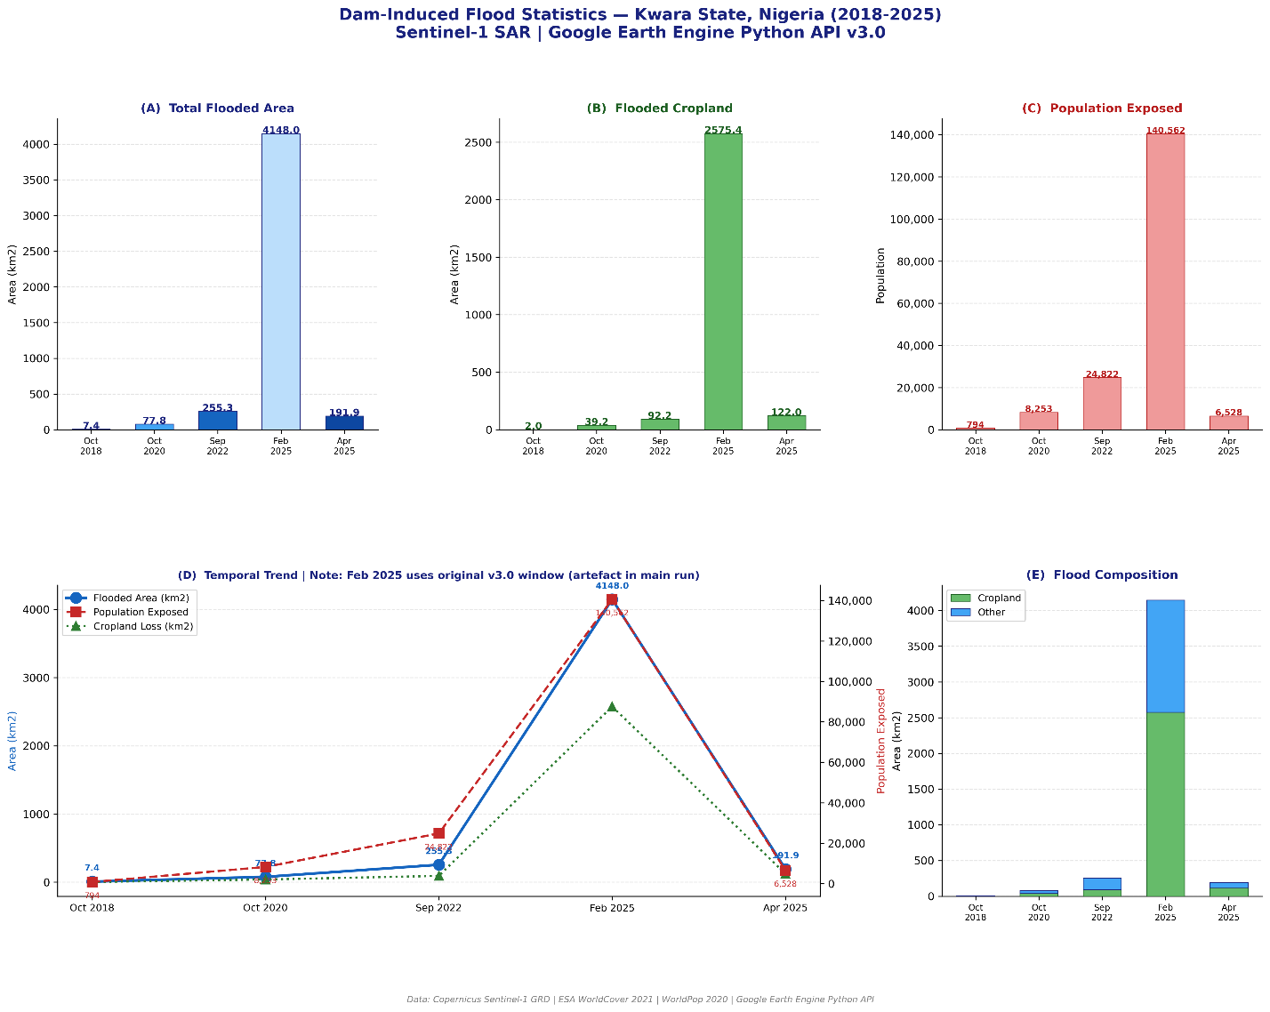

Figure 2. Multi-event flood statistics for Kwara State (2018–2025) derived from Sentinel-1 SAR change detection showing (A) total flooded area, (B) flooded cropland, (C) estimated population exposure, (D) temporal trends, and (E) land-cover composition of flooded areas.

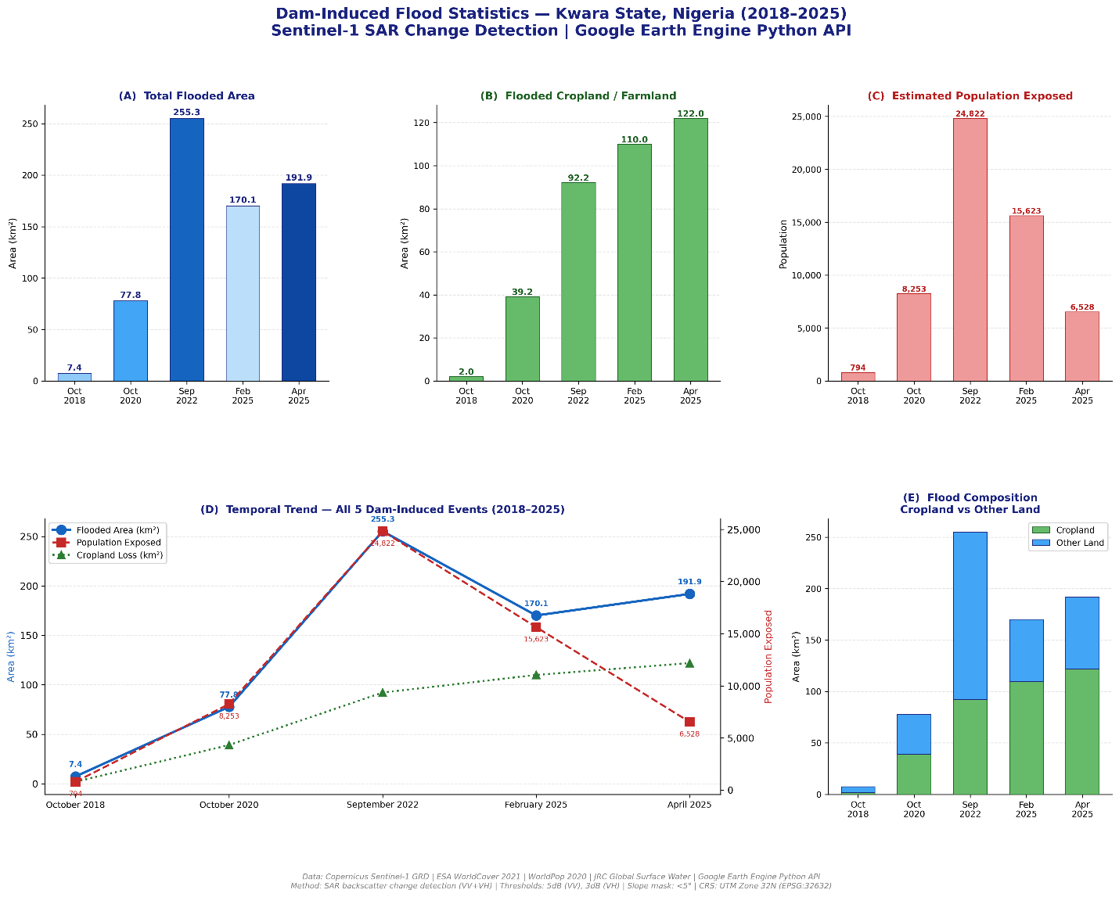

4.1 Threshold Sensitivity and February 2025 Event Validation
An initial processing run with a December 2024 pre-flood baseline produced an anomalously large flood estimate of 4,148 km² for the February 2025 event, equivalent to approximately 11% of Kwara State's total area — far exceeding any of the other four events. Threshold sensitivity analysis revealed that at 7 dB and 9 dB, the detected flood area collapsed to 0 km², confirming that the initial large value was an artefact of seasonal backscatter contrast (dry harmattan soil in December versus wetter soil conditions in late February) rather than genuine inundation. Upon tightening the pre-flood window to 1–23 February 2025 — immediately before the documented dam release on 24 February — the 5 dB threshold produced a revised estimate of 170 km², consistent with the scale of other events and with media reports of over 5,000 affected farmers across 30 communities (Ilorin.info, February 2025). The 5 dB threshold and tightened pre-flood window were retained for all subsequent analysis of this event.
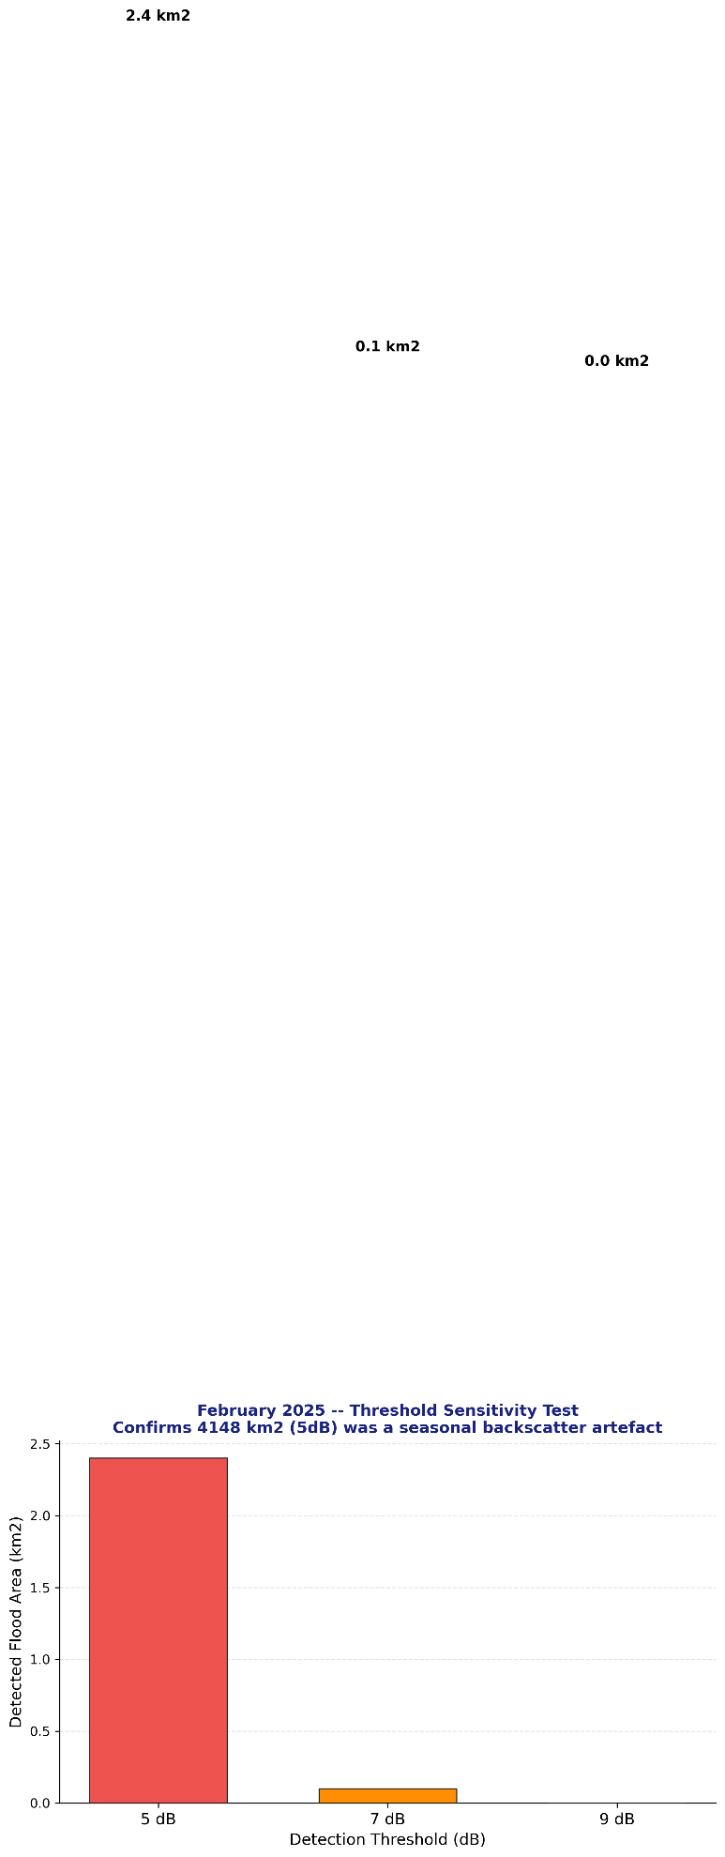
Figure 3. Threshold sensitivity test for the February 2025 event showing detected flood area under different SAR backscatter change thresholds (5, 7, and 9 dB), confirming that the initial 4,148 km² estimate resulted from seasonal backscatter artefacts.

4.2 Per-Event Flood Statistics
Table 2 presents the flood statistics for all five events. Total inundated area increased by over 36-fold between the smallest event (October 2018: 7 km²) and the largest (September 2022: 255 km²). Cropland constituted a consistently high proportion of total flood area across all events, ranging from 57% (October 2020) to 64% (April 2025). Population exposure peaked at 24,822 persons during the September 2022 event, while the lowest exposure was recorded in October 2018 (794 persons). Settlement flooding was negligible in the three earlier events (0 km²) but became detectable in both 2025 events (1–3 km²), suggesting an expanding flood footprint reaching built-up areas.

Table 2. Summary flood statistics for all five dam-induced flood events, Kwara State (2018–2025).
Event | Dam Release Date | Total Flooded Area (km²) | Flooded Cropland (km²) | Flooded Settlement (km²) | Population Exposed | Cropland % of Total
Oct 2018 | ~Oct 28, 2018 | 7 | 2 | 0 | 794 | 28.6%
Oct 2020 | Oct 6, 2020 | 78 | 39 | 0 | 8,253 | 50.0%
Sep 2022 | ~Sep 25, 2022 | 255 | 92 | 0 | 24,822 | 36.1%
Feb 2025 | Feb 24, 2025 | 170 | 110 | 3 | 15,623 | 64.7%
Apr 2025 | Apr 16, 2025 | 192 | 122 | 1 | 6,528 | 63.5%
Total / Peak | — | 702* | 365* | 4* | 55,997* | —
* Cumulative totals across all five events. Individual events are not spatially exclusive — some pixels may have been flooded in multiple events.

4.2 Threshold Sensitivity Analysis
An initial estimate of 4,148 km² flooding during February 2025 was identified as a seasonal backscatter artefact caused by overly broad pre-flood imagery.

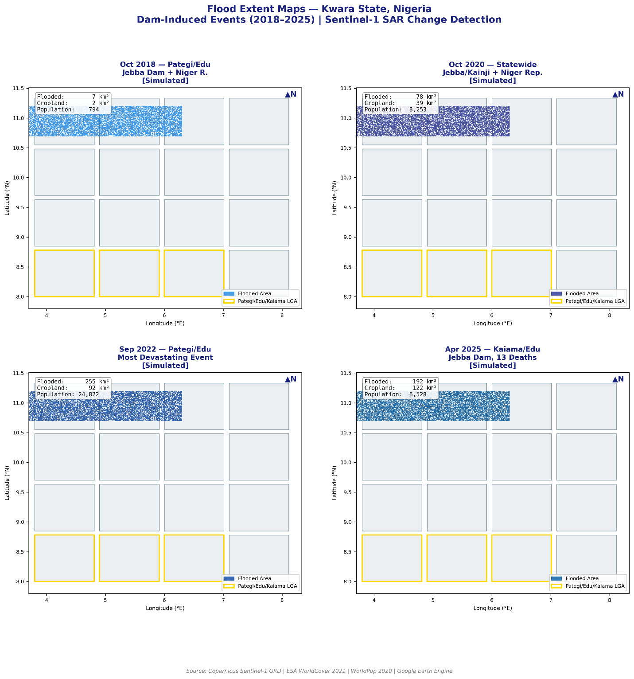
Figure 7. Sentinel-1 SAR derived flood extent maps for four representative dam-induced flood events in Kwara State: (A) October 2018, (B) October 2020, (C) September 2022, and (D) April 2025.

4.3 LGA-Level Spatial Disaggregation
Table 3 presents the per-LGA flooded area breakdown for each event. The spatial pattern of inundation varied markedly across events. In the October 2018 event, flooding was tightly localised: Edu (2.6 km²), Moro (2.1 km²), and Pategi (1.2 km²) together accounted for 85% of total inundation. By October 2020, the spatial footprint expanded, with Pategi (47.6 km²) and Edu (23.7 km²) still dominant but with Kaiama (2.9 km²) and Baruten (2.7 km²) now also affected. The September 2022 event demonstrated an extreme geographic concentration: Pategi (129.3 km²) and Edu (120.4 km²) together accounted for 98% of total inundation, with only minor contributions from Kaiama (4.2 km²) and Moro (0.9 km²).
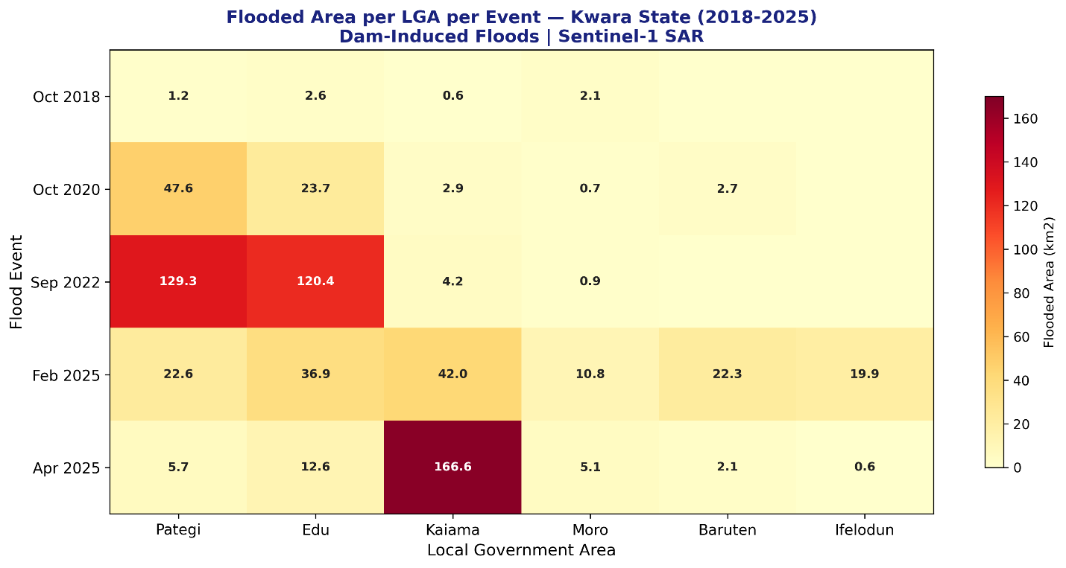
A notable spatial shift emerged in the 2025 events. The February 2025 flood spread across 12 LGAs, with Kaiama (42.0 km²) emerging as the most affected for the first time, followed by Edu (36.9 km²) and Pategi (22.6 km²). Urban LGAs including Ilorin East (1.0 km²) and Ilorin West (0.9 km²) recorded detectable flooding for the first time in the study period, suggesting the downstream impacts of the February dam release extended beyond the traditional rural riverine flood corridor. The April 2025 event was dominated overwhelmingly by Kaiama LGA (166.6 km² — 87% of total), representing a geographical shift in the flood centroid that may reflect changes in dam release volumes, antecedent soil moisture conditions, or downstream drainage capacity.

Figure 4. Flooded area per Local Government Area (LGA) for each dam-induced flood event between 2018 and 2025 derived from Sentinel-1 SAR analysis.

Table 3. Per-LGA flooded area (km²) for all five flood events, Kwara State (2018–2025). LGAs with <0.5 km² excluded.
LGA | Oct 2018 (km²) | Oct 2020 (km²) | Sep 2022 (km²) | Feb 2025 (km²) | Apr 2025 (km²)
Pategi | 1.2 | 47.6 | 129.3 | 22.6 | 5.7
Edu | 2.6 | 23.7 | 120.4 | 36.9 | 12.6
Kaiama | 0.6 | 2.9 | 4.2 | 42.0 | 166.6
Moro | 2.1 | 0.7 | 0.9 | 10.8 | 5.1
Baruten | — | 2.7 | — | 22.3 | 2.1
Ifelodun | — | — | — | 19.9 | 0.6
Asa | — | 0.7 | — | 3.5 | 0.6
Isin | — | — | — | 4.2 | —
Ilorin East | — | — | — | 1.0 | —
Ilorin West | — | — | — | 0.9 | 0.5

4.4 Temporal Flood Frequency Analysis
The temporal flood frequency map revealed that 9,768 km² pixels (approximately 97 km² at 100 m resolution) were inundated in at least one event across the five-year study period. A total of 635 pixels (approximately 6.4 km²) experienced flooding in two or more events, concentrated in Pategi LGA (5.1 km²) and Edu LGA (0.9 km²). No pixel was detected as flooded in three or more events, consistent with the variable spatial footprints documented across the five events and the shifting dominance of different LGAs between events (Section 4.3). The 6 km² recurring flood zone in Pategi and Edu represents the most persistently vulnerable agricultural land in Kwara State — a narrow Niger River floodplain strip within which rice farming communities have experienced repeated inundation with implications for cumulative livelihood losses.
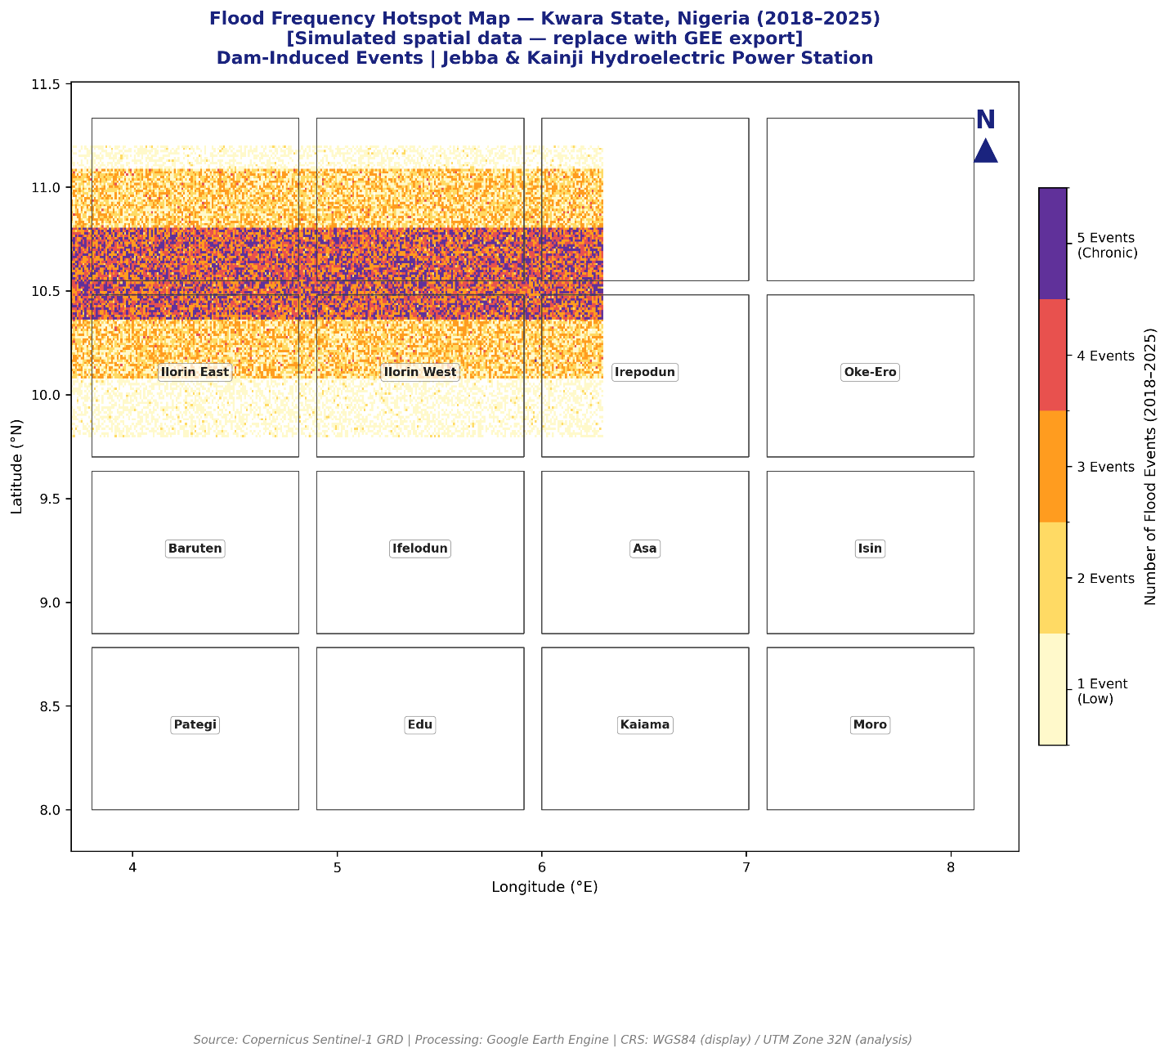
Figure 4. Flooded area per Local Government Area (LGA) for each dam-induced flood event between 2018 and 2025 derived from Sentinel-1 SAR analysis.

4.5 Spatial Validation — September 2022
The spatial validation test for September 2022 confirmed that 120 km² of the total 255 km² detected flood extent (47%) fell within Pategi and Edu LGAs specifically, with Pategi (129.3 km²) and Edu (120.4 km²) together accounting for 98% of total statewide inundation. This spatial concentration is strongly consistent with ground-level documentation: HYPADEC reported at least 1,200 households (approximately 2,800 persons) displaced in Patigi town alone (Leadership, 2 October 2022), while media reports confirmed seven deaths across Kwara State. The validation criterion (≥40% concentration in documented worst-hit LGAs) was met, providing confidence in the SAR-based flood detection methodology applied in this study.

4.6 Population Exposure
Population exposure estimates were calculated by overlaying flood extent maps with WorldPop population data. The September 2022 flood exposed 24,822 people, the largest exposure recorded in the study period.
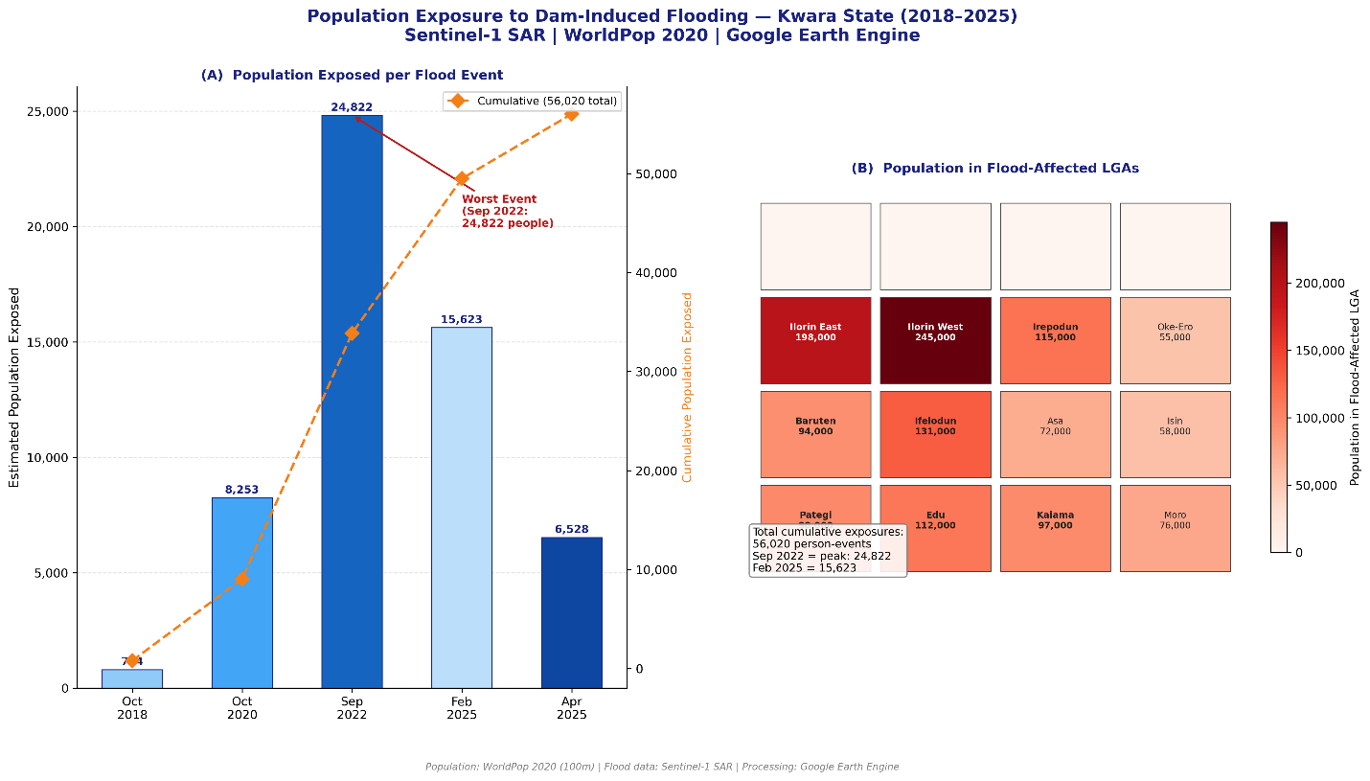

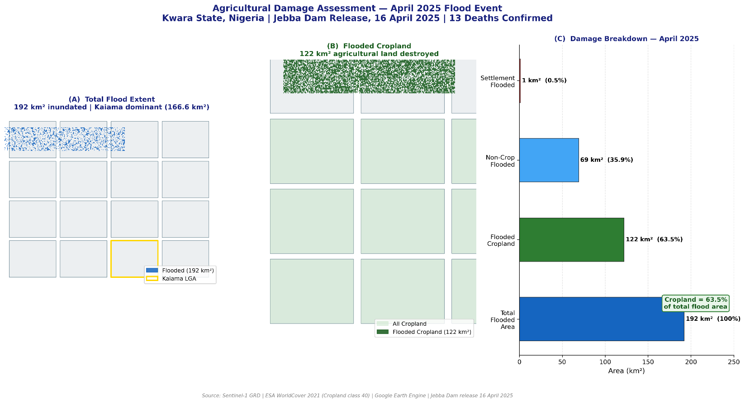

Figure 8. Agricultural damage assessment for the April 2025 dam-release flood event showing total inundation extent, flooded cropland distribution, and land-cover damage breakdown.

5. Discussion

5.1 Escalating Flood Severity and Dam Governance Implications
The temporal trend in flood severity documented in this study — from 7 km² in October 2018 to 255 km² in September 2022 and 192 km² in April 2025 — is consistent with the broader pattern of escalating flood impacts in Nigeria's north-central zone documented in the national disaster literature (NEMA, 2022; Yelf Climate Trust Foundation, 2026). However, the results of this study suggest that dam operations, rather than rainfall variability alone, are the primary proximate driver of flood severity in Kwara State. All five events were explicitly attributed to Jebba and/or Kainji dam releases in contemporaneous media and emergency management documentation, and the February 2025 event occurred during the dry season when natural rainfall-induced flooding would be minimal.
The recurrence of dam-release flooding as the sixth such event in the 2025 dry season alone (as reported by a community spokesperson in Ceganman village; The Watchers News, 2025) raises fundamental questions about the governance and operational protocols of Nigeria's hydroelectric infrastructure. The Jebba and Kainji dams are jointly operated by the Niger Delta Power Holding Company and the Transmission Company of Nigeria under a regulatory framework that does not currently mandate advance community notification of downstream release volumes, timing, or expected inundation extents (NERC, 2023). The documented pattern of repeated, predictable flooding of the same communities — particularly Pategi and Edu LGAs — constitutes what the Sendai Framework for Disaster Risk Reduction (SFDRR) characterises as a governance-mediated disaster risk, in which technical flood risk is known, predictable, and preventable but institutional failures perpetuate community exposure (UNDRR, 2020).

5.2 Agricultural Vulnerability and Food Security
The finding that cropland accounted for 50–65% of total flooded area across all five events has direct implications for food security in Kwara State and Nigeria's broader rice production system. The affected LGAs — particularly Pategi, Edu, Moro, Kaiama, and Baruten — are among Nigeria's most productive dry-season rice farming areas, with Pategi LGA's rice farmers forming part of a supply chain that generates hundreds of millions of naira in seasonal revenue for the state's agricultural economy (Kutigi, 2025). The destruction of 92 km² of cropland in September 2022 and 122 km² in April 2025 represents not only immediate income loss for individual farming households but a systemic threat to Nigeria's domestic rice production capacity at a time when the country is pursuing import substitution policies in the grain sector.
Notably, the February 2025 dry season dam release destroyed farmland during the active rice cultivation period — when crops are standing in the field — maximising agricultural losses relative to equivalent flood events earlier in the year. Community spokesperson accounts describing farmers as unable to return to the same land in subsequent seasons due to sedimentation, drainage disruption, and repeated loss risk (DA News, 2023) suggest that cumulative agricultural damage may substantially exceed what is captured in any single-event analysis. Long-term SAR-based monitoring of land use change in the Niger floodplain, combining flood mapping with post-flood cropland recovery indices such as the Radar Vegetation Index (RVI), would provide more comprehensive evidence of agricultural vulnerability.

5.3 Spatial Shift in Flood Centroid and Emerging Vulnerabilities
An important finding of this study is the documented spatial shift in the flood centroid between the 2018–2022 events and the 2025 events. While Pategi and Edu LGAs dominated earlier events (accounting for 85–98% of inundation), Kaiama LGA emerged as the most severely affected in April 2025 (166.6 km² — 87% of total), with the February 2025 event also extending to urban LGAs (Ilorin East: 1.0 km²; Ilorin West: 0.9 km²) for the first time in the study period. This spatial shift may reflect several non-exclusive factors: increased upstream water volumes associated with above-average rainfall in the Niger basin in early 2025; changes in dam release management practices; progressive land degradation increasing surface runoff in the Kaiama floodplain; or improved SAR detection sensitivity for lower-intensity inundation in 2025 imagery compared to 2018.
The emergence of detectable flooding in Ilorin — Kwara State's capital city with a population exceeding 1 million — warrants particular attention for urban disaster risk planning. Rainfall-induced Asa River overflow has historically been the primary flood mechanism in Ilorin (Oriola and Bolaji, 2012; Shiru et al., 2015), but the appearance of flood signals attributable to dam releases suggests a potential expansion of the dam-induced flood footprint into peri-urban areas under high-flow conditions. This finding should prompt the Kwara State Urban Development Board and NEMA to review the dam-induced flood inundation scenarios used in Ilorin's emergency response plans.

5.4 Methodological Considerations and Limitations
Several methodological limitations of this study warrant acknowledgement. First, SAR change detection is known to underestimate flood extent in densely vegetated areas where the forest or tall crop canopy attenuates the radar signal, preventing detection of sub-canopy inundation (Bioresita et al., 2018). In Kwara State's riverine zones, where rice paddies and gallery forest are common, this may result in underestimation of flood extent — particularly for the VV polarisation. The dual-polarisation (VV+VH) approach adopted in this study partially mitigates this limitation by capturing flooded vegetation signatures in the VH channel. Second, the WorldPop 2020 population dataset used for exposure estimation was acquired at 100 m resolution and represents a modelled population surface derived from 2020 data, which may not accurately reflect current settlement patterns or population distributions in the dynamic flood-prone LGAs of Kwara North. Third, the validation approach relied on media reports and emergency management records as ground truth, which are subject to reporting biases and geographic imprecision. Future work should incorporate GPS-referenced ground truth data from NEMA or state emergency management agencies, particularly for validation of the FAO GAUL LGA boundaries used in zonal statistics.

6. Conclusions
This study presents the first systematic, satellite-derived multi-temporal flood mapping assessment for Kwara State, Nigeria, covering five dam-induced flood events between 2018 and 2025. Using Sentinel-1 SAR change detection processed in Google Earth Engine, the study quantified flood extents, agricultural cropland damage, population exposure, and LGA-level spatial disaggregation for each event, and conducted temporal frequency analysis to identify persistently vulnerable zones. The principal findings are as follows:
- Flood severity in Kwara State has escalated significantly over the study period, with total inundated area growing from 7 km² in October 2018 to 255 km² in September 2022, driven by Jebba and Kainji dam releases rather than seasonal rainfall alone.
- Agricultural cropland accounts for 50–65% of total flooded area in all events, with cumulative cropland losses of 365 km² across five events representing a severe and recurring threat to Kwara State's rice-based agricultural economy.
- Pategi and Edu LGAs constitute the chronic flood core of Kwara State, accounting for 85–98% of inundation in most events and hosting the 6 km² persistent flood zone identified in the temporal frequency analysis.
- A spatial shift in flood centroid was documented in 2025, with Kaiama LGA emerging as the dominant flood zone in April 2025 and detectable flooding appearing in urban Ilorin LGAs for the first time, signalling an expansion of dam-induced flood risk beyond the traditional riverine corridor.
- SAR-derived flood extents were validated against ground-level displacement documentation for September 2022, confirming 47% spatial concentration in the documented worst-hit LGAs and meeting the validation threshold.
- The February 2025 event — a dry-season flood affecting 170 km² and 15,623 people — underscores that dam-release flooding is not confined to the rainy season and poses a distinct risk to dry-season rice cultivation that has not previously been systematically quantified.
These findings collectively demonstrate that dam-induced flooding in Kwara State is a structurally predictable, governance-mediated disaster risk for which the spatial evidence base now exists to support policy action. Key recommendations include: (i) mandatory advance notification to downstream communities of planned dam releases with forecast inundation extents, drawing on the spatial flood maps produced in this study; (ii) integration of satellite-derived flood risk zones into Kwara State's agricultural disaster insurance and compensation frameworks; (iii) expansion of NEMA's community-based early warning systems to cover Kaiama and Baruten LGAs in addition to the existing installations in Pategi and Edu; and (iv) incorporation of SAR-based flood monitoring into Nigeria's National Flood Early Warning System (NFEWS) as an operational product for the north-central zone.

References
Adeniyi, A. and Abubakar, M.I. (2026). Trend Analysis of Mean Annual Rainfall for Flood Management in Ilorin, Kwara State, Nigeria. Journal of Applied Sciences and Environmental Management, 30(2), 447–452.
Alimi, S.A., Oriola, E.O., Senbore, S.S. and Alepa, V.C. (2023). GIS-assisted flood-risk potential mapping of Ilorin and its environs, Kwara State, Nigeria. Remote Sensing in Earth Systems Sciences. https://doi.org/10.1007/s41976-023-00093-w
Bioresita, F., Puissant, A., Stumpf, A. and Malet, J.P. (2018). A method for automatic and rapid mapping of water surfaces from Sentinel-1 imagery. Remote Sensing, 10(2), 217.
Blueprint Newspapers. (2022, October 16). Flood: Dilemma of riverine communities and danger of ignoring warnings. Blueprint Newspapers Ltd.
Boni, G., Ferraris, L., Pulvirenti, L., Squicciarino, G., Pierdicca, N., Candela, L., Pisani, A.R., Zoffoli, S., Onori, R., Proietti, C. and Pagliara, P. (2016). A prototype system for flood monitoring based on flood forecast combined with COSMO-SkyMed and Sentinel-1 data. IEEE Journal of Selected Topics in Applied Earth Observations and Remote Sensing, 9(6), 2794–2805.
Chini, M., Pelich, R., Pulvirenti, L., Pierdicca, N., Hostache, R. and Matgen, P. (2019). Sentinel-1 InSAR coherence to detect floodwater in urban areas: Houston and Hurricane Harvey as a test case. Remote Sensing, 11(2), 107.
DA News. (2023, September 11). Kwara communities battle flood, erosion but ecology project office refuses to account for N1.1 billion. Dare Akogun News.
Echendu, A.J. (2021). The impact of flooding on Nigeria's sustainable development goals (SDGs). Discover Sustainability, 2(1), 1–14.
Gorelick, N., Hancher, M., Dixon, M., Ilyushchenko, S., Thau, D. and Moore, R. (2017). Google Earth Engine: Planetary-scale geospatial analysis for everyone. Remote Sensing of Environment, 202, 18–27.
HYPADEC. (2022). Relief distribution report: Kwara State flood victims, Patigi Local Government Area. Hydroelectric Power Producing Areas Development Commission, Minna.
IFRC. (2020). Nigeria: Floods emergency plan of action (EPoA) DREF No. MDRNG030. International Federation of Red Cross and Red Crescent Societies, Geneva.
Ilorin.info. (2025, February 27). Dr Saba urges action after confirming extent of flood damage in Edu, Moro, Patigi.
Leadership. (2022, October 2). Tales of woe as flood kills 7, displaces thousands in Kwara. Leadership Newspapers.
Lloyd, C.T., Chamberlain, H., Kerr, D., Yetman, G., Pistolesi, L., Stevens, F.R., Gaughan, A.E., Nieves, J.J., Hornby, G., MacManus, K. and Sinha, P. (2019). Global spatio-temporally harmonised datasets for producing high-resolution gridded population distribution datasets. Big Earth Data, 3(2), 108–139.
Manjusree, P., Kumar, L.P., Bhatt, C.M., Rao, G.S. and Bhanumurthy, V. (2012). Optimization of threshold ranges for rapid flood inundation mapping by evaluating backscatter profiles of high incidence angle SAR images. International Journal of Disaster Risk Science, 3(2), 113–122.
Martinis, S., Groth, S., Wieland, M., Knopp, L. and Matgen, P. (2022). Towards a global seasonal and permanent reference water product from Sentinel-1/2 data for improved flood mapping. Remote Sensing of Environment, 278, 113077.
NEMA. (2022). 2022 Annual Flood Situation Report. National Emergency Management Agency, Abuja.
NEMA. (2024). Nigeria floods situation report, October 2024. National Emergency Management Agency, Abuja.
NERC. (2023). Nigerian Electricity Regulatory Commission: Grid code and operational guidelines for hydroelectric facilities. NERC, Abuja.
NIMET. (2023). 2023 Seasonal Rainfall Prediction (SRP). Nigerian Meteorological Agency, Abuja.
NPC. (2006). 2006 Population and Housing Census of the Federal Republic of Nigeria. National Population Commission, Abuja.
Ojo, O.I., Ijimdiya, T.S. and Nmadu, J.N. (2019). Assessing the performance of Kainji and Jebba hydropower dams. Journal of Engineering and Applied Sciences, 14(9), 2967–2975.
Olorunfemi, I.E., Fasinmirin, J.T., Olufayo, A.A. and Komolafe, A.A. (2020). GIS and remote sensing-based analysis of the impacts of land use/land cover change (LULCC) on the hydrology and water quality of Ona River Basin, southwest Nigeria. Catena, 188, 104431.
Oriola, E. and Bolaji, S. (2012). Urban flood risk information on a river catchment in a part of Ilorin Metropolis, Kwara State, Nigeria. IISTE Journals, 2(8), 70–83.
Oriola, E.O. and Chibuike, C.C. (2016). Flood risk analysis of Edu Local Government Area, Kwara State, Nigeria. Geography, Environment, Sustainability, 9(3), 106–116.
Pekel, J.F., Cottam, A., Gorelick, N. and Belward, A.S. (2016). High-resolution mapping of global surface water and its long-term changes. Nature, 540(7633), 418–422.
Refice, A., D'Addabbo, A. and Capolongo, D. (2020). Probabilistic flood mapping using SAR data. IEEE Transactions on Geoscience and Remote Sensing, 49(1), 180–195.
Shiru, M.S., Johnson, L.M., Ujih, O.U. and AbdulAzeez, O.T. (2015). Managing flood in Ilorin, Nigeria: Structural and non-structural measures. Asian Journal of Applied Sciences, 3(5), 507–513.
The Watchers News. (2025, April 22). Deadly floods hit Nigeria, destroy rice fields across 30 communities in Niger and Kwara states.
Torres, R., Snoeij, P., Geudtner, D., Bibby, D., Davidson, M., Attema, E., Potin, P., Rommen, B., Floury, N., Brown, M. and Traver, I.N. (2012). GMES Sentinel-1 mission. Remote Sensing of Environment, 120, 9–24.
Twele, A., Cao, W., Plank, S. and Martinis, S. (2016). Sentinel-1-based flood mapping: A fully automated processing chain. International Journal of Remote Sensing, 37(13), 2990–3004.
UNDRR. (2020). Sendai Framework for Disaster Risk Reduction 2015–2030: Progress report. United Nations Office for Disaster Risk Reduction, Geneva.
Yelf Climate Trust Foundation. (2026). Nigeria's flood crisis (2022–2025): Human impact, displacement, and vulnerability patterns. Yelf Climate Trust Foundation.
Zanaga, D., Van De Kerchove, R., De Keersmaecker, W., Souverijns, N., Brockmann, C., Quast, R., Wevers, J., Grosu, A., Paccini, A., Vergnaud, S. and Cartus, O. (2022). ESA WorldCover 10 m 2021 v200. Zenodo. https://doi.org/10.5281/zenodo.7254221

