**Increasing Sales at a Nurse Staffing Agency**

Executive Summary

The aim of the following report was to gather actionable insights from nursing staff data to improve a Nurse Staffing Agency’s (NSA) sales, address nursing talent shortages in care facilities, and facilitate flexible, contract work for healthcare professionals. Below are the findings from the data analyses as well as their accompanying recommendation(s).

* Result: Texas had the largest number of understaffed facilities with no contract nurses, including Five Points Nursing and Rehabilitation and Legend Oaks Healthcare and Rehabilitation.
  + Recommendation: Target Texas care facilities, including Five Points Nursing and Rehabilitation and Legend Oaks Healthcare and Rehabilitation, for addition to the NSA’s platform.
* Result: Care facilities were highly understaffed on weekends, especially Sundays, as well as at the start and middle of the month, compared to the weekdays and the end of the month.
  + Recommendation: Devote resources to advertising weekend shifts to healthcare professionals on the NSA’s platform and approach care facilities for addition to the platform at the start and middle of the month.
* Result: Illinois and Texas had the largest numbers of understaffed, low-quality facilities, and Missouri had facilities such as The Estates of Perryville, LLC and Four Seasons Living Center that were both low-quality and on average, significantly below the legal requirement of 3.48 nursing hours per resident per day.
  + Recommendation: Target care facilities in Illinois, Texas, and Missouri for addition to NSA’s platform (e.g., The Estates of Perryville, LLC, Four Seasons Living Center).

Full Report

The Nursing Staffing Agency’s (NSA) goals include addressing talent shortages in care facilities, helping healthcare professionals find flexible, contract work at these facilities, and increasing sales of NSA’s product/service to help accomplish the prior two goals.

This report sought to answer the following questions based on the above-mentioned goals:

1. **Where are the largest numbers of understaffed facilities located?** This will reveal where the NSA’s product/service is most needed and promote the efficient allocation of resources (e.g., advertising).
2. **Which facilities are understaffed and need contract nurses?** This will elucidate where to which facilities to approach about the NSA’s product/service to help address talent shortage.
3. **When are facilities most likely to be understaffed?** This will help to target periods during which facilities may need – and therefore buy – the NSA’s product/service. It will also help target periods/shifts to advertise to healthcare professionals on the NSA’s platform.
4. **Where are the largest numbers of understaffed, low-quality facilities located?** This will show where the high-quality healthcare professionals on the NSA’s platform are needed and promote the efficient allocation of resources to increase sales, improve the healthcare quality, and address talent shortages.
5. **Which understaffed facilities have the lowest quality ratings?** This will reveal facilities the NSA should target to promote the high-quality healthcare professionals on the NSA’s platform. It will also help address talent shortage and increase healthcare quality at the facilities.

To answer these questions, the following datasets were used:

* Q1 2024 Payroll Based Journal Daily Nurse Staffing Dataset (PBJ)
* October 2024 Center for Medicare & Medicaid Services (CMS) Nursing Homes Provider Information Dataset (CMS Provider)
* October 2024 CMS Nursing Homes State US Averages Dataset (CMS Averages)

**Assumptions**

As I cleaned the data and conducted analyses, I made three primary assumptions. I assumed that the NSA’s customers are care facilities and healthcare professionals and that all nursing staff in the PBJ dataset are eligible to be on the NSA’s platform. I also assumed that the legal requirement for nursing hours per resident per day was 3.48, based on information from the CMS website.

**Data Cleaning and Exploration**

* The data were loaded into a Jupyter Notebook and cleaned, which included dropping from all three datasets any columns that were irrelevant for my analyses.
* In the PJB dataset, nursing hours were summed regardless of role (e.g., RN vs. CNA) but total, employee, and contract hours were kept separate because the NSA employs only contractors. I also created a new variable in the dataset to capture total nursing hours per resident per day.
* In the CMS Provider dataset, I calculated correlations between nursing hours per resident per day and facility ratings. These correlations were moderate and positive.
* In the CMS Averages dataset, the first row included data for the U.S. (instead of a single state), so it was removed from the dataset, but its values were stored for later use in data analyses.
* Missing data:
  + PJB: All days on which there were no residents in a facility were removed to avoid division by zero, and to include in my analyses only days on which facilities had residents, which is consistent with the goals of this project.
  + CMS Provider: The presence of missing values in this dataset did not have a negative influence on my analyses or project goals, so no rows were deleted for missing data.
* The PJB and CMS Averages datasets were merged, so the former dataset could include state averages for important variables. The CMS Provider and CMS Averages datasets were also merged for the same reason. Data analyses of these two merged datasets were completed in PostgreSQL.

**Data Analyses**

**(1) Where are the largest numbers of understaffed facilities located?**

To answer this question, I wrote a SQL query probing the PBJ dataset to produce U.S. states in order of how many days facilities in the states did not meet the legal requirement of 3.48 nursing hours per resident per day and did not have any contract nursing hours. I found that Texas had the most days (53,382) on which facilities did not meet these criteria, followed by Ohio (27,238). ***Thus, Texas is a valuable state in which the NSA can target understaffed facilities who have the capacity to address their talent shortages via contract nursing staff.***

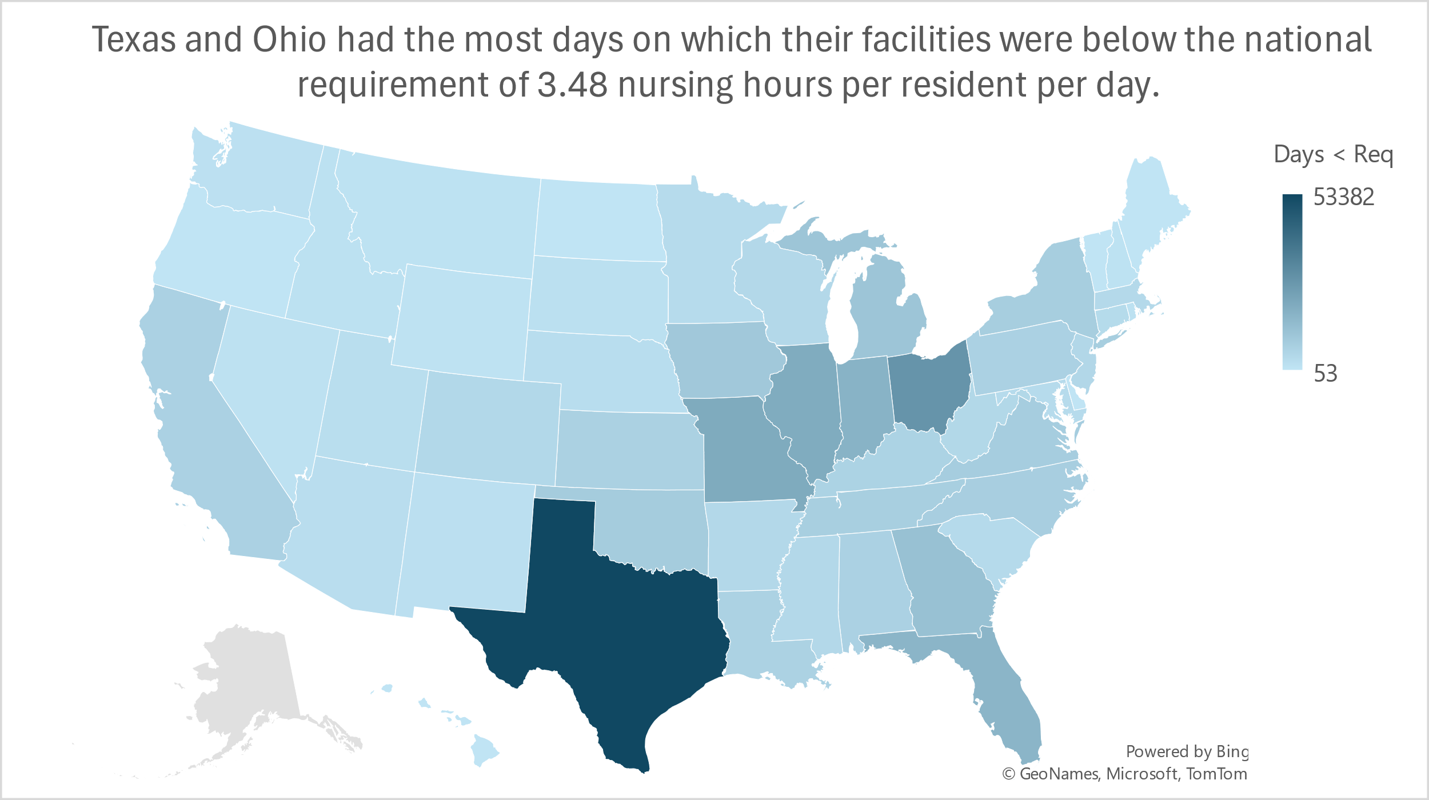

I wrote another SQL query probing the CMS dataset to produce U.S. states in order of how many facilities in those states had average nursing hours per resident per day that did not meet the legal requirement. The result also showed that Texas had the most understaffed facilities with 822, followed by Ohio and Illinois with 411.

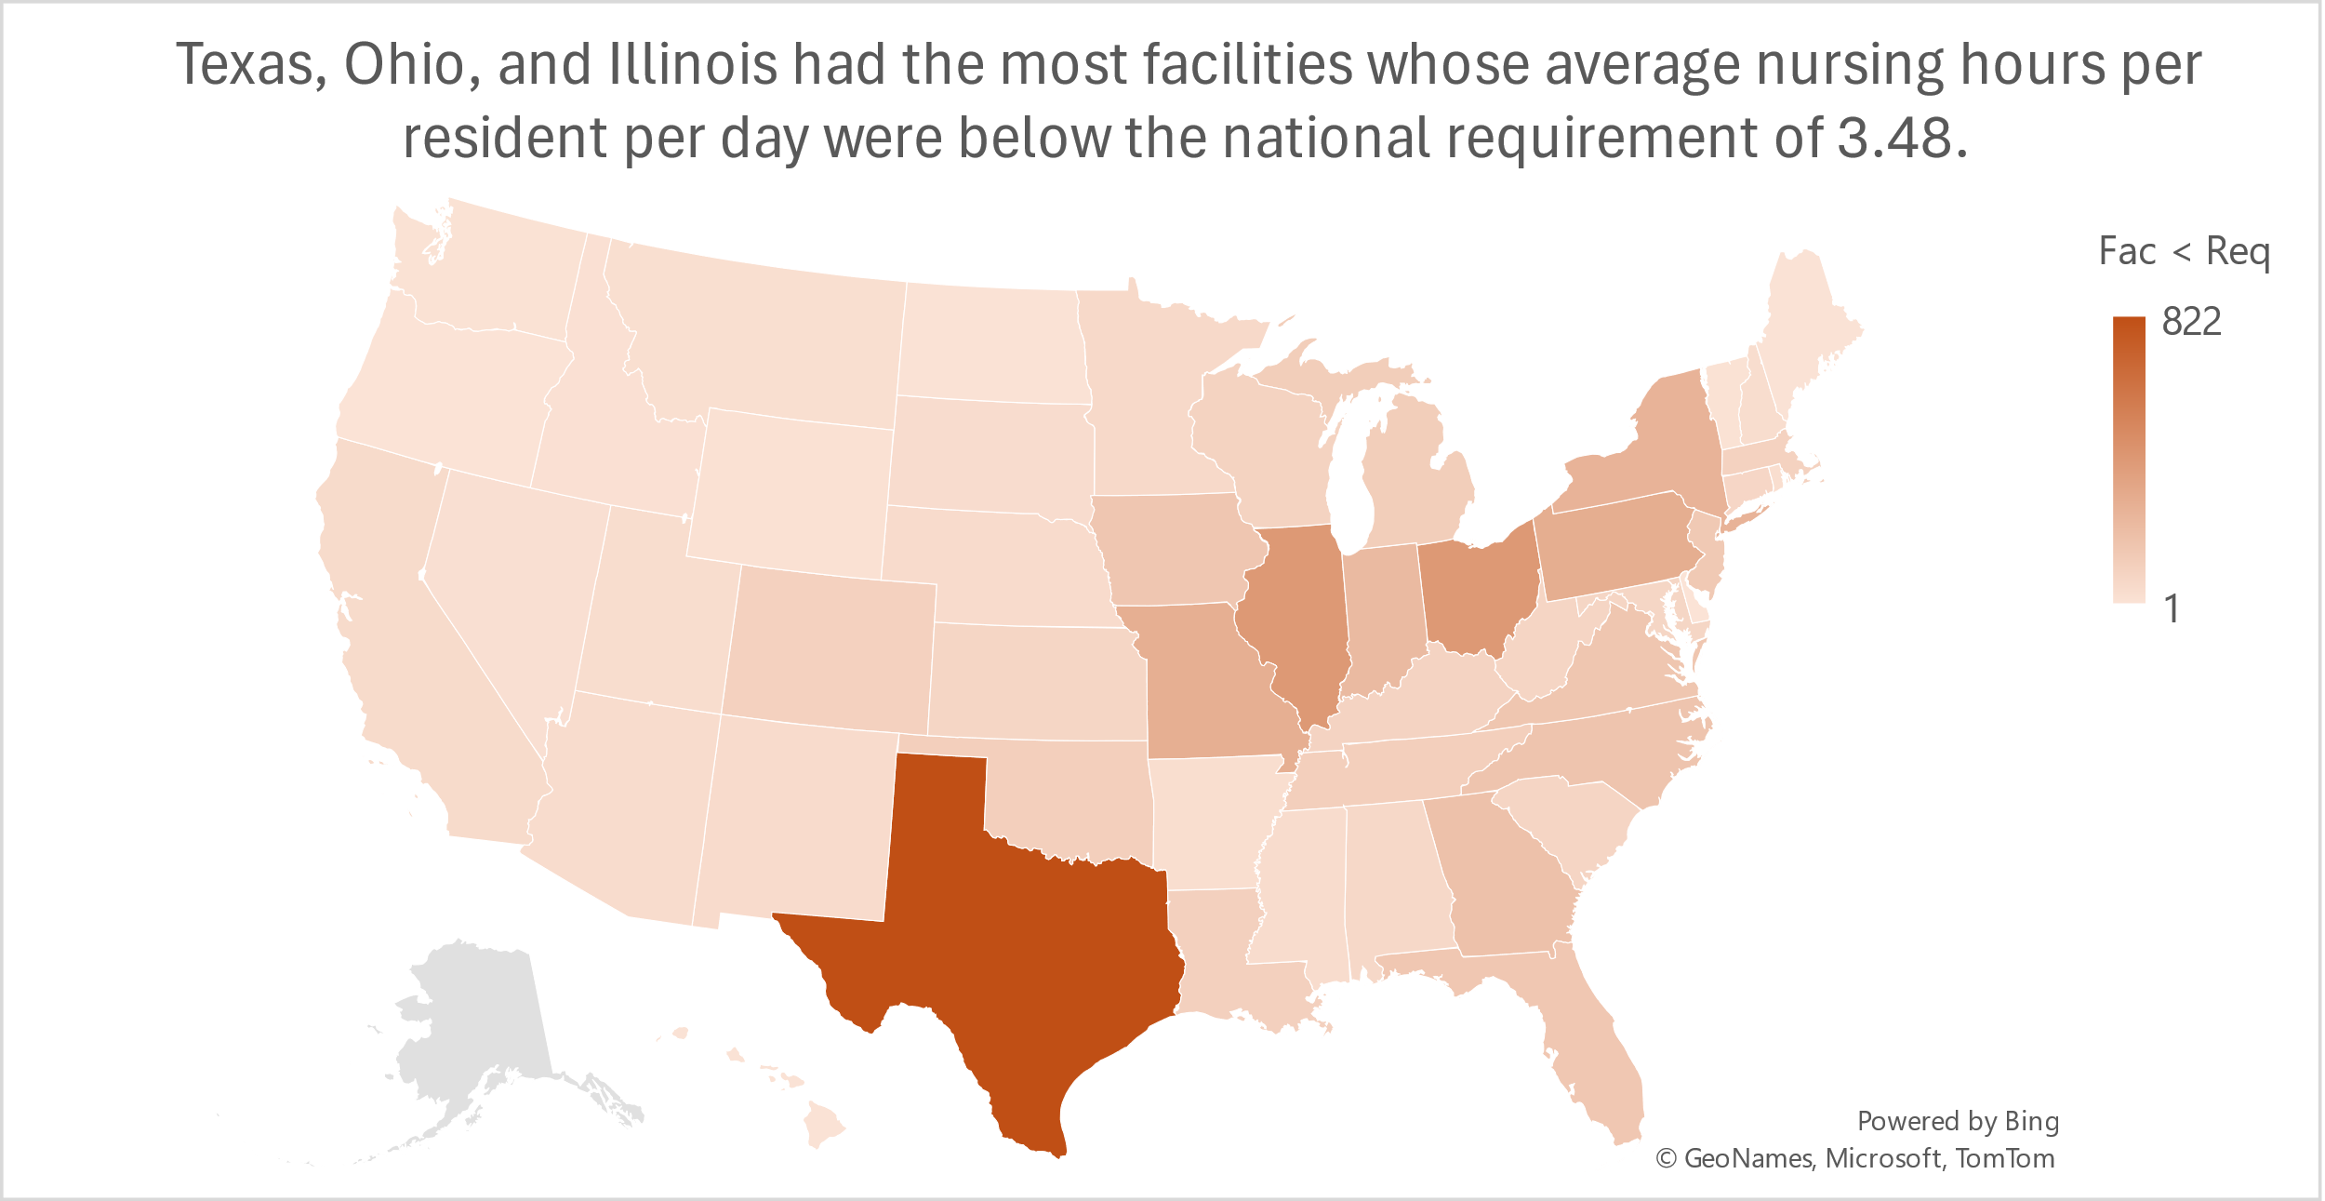

**(2) Which facilities are understaffed and could use contract nurses?**

To answer this question, I wrote a SQL query probing the PBJ dataset to produce 10 care facilities (and their states) in order of how many days they did not meet the legal requirement of 3.48 nursing hours per resident per day and did not have any contract nursing hours. This list included multiple Texas facilities, including ***Five Points Nursing and Rehabilitation and Legend Oaks Healthcare and Rehabilitation***. These two facilities along with ***Miller’s Merry Manor*** in Indiana may be valuable facilities for the NSA to target due to their talent shortage and capacity to take on nursing contractors.

|  |  |  |
| --- | --- | --- |
| Facility Name | State | Days Nursing Hours Below 3.48 Requirement |
| FIVE POINTS NURSING AND REHABILITATION | Texas | 164 |
| MILLER'S MERRY MANOR | Indiana | 149 |
| LEGEND OAKS HEALTHCARE AND REHABILITATION CENTER - | Texas | 135 |
| COMMUNITY CARE CENTER | California | 92 |
| BURFORD MANOR | Oklahoma | 91 |
| HILLCREST CARE CENTER INC | Missouri | 91 |
| CLARENDON NURSING HOME | Texas | 91 |
| SIENNA NURSING AND REHABILITATION | Texas | 91 |
| WESTWOOD VLGE NRSG AND RHB CTR | Illinois | 91 |
| ORCHARD GARDENS | Kansas | 91 |

I also wrote a SQL query probing the CMS dataset to produce the top 10 care facilities (and their states) by how many hours on average they were below the legal requirement of nursing hours per resident per day. The results are shown in the table below. I would recommend targeting ***Seville Care Center and Sylvia G Thompson Resident Center, Inc*** because Missouri is in the top 5 states for both days during which their facilities did not meet the legal requirement of nursing hours per resident per day (in the PBJ dataset) and number of facilities that (on average) did not meet the requirement (in the CMS dataset).

|  |  |  |
| --- | --- | --- |
| Facility Name | State | Average Hours Below 3.48 Requirement |
| BEAR MOUNTAIN AT WORCESTER | Massachusetts | 3.4765 |
| LINCOLN HEALTH CARE CENTER | Colorado | 3.44583 |
| ST CATHERINE OF SIENA | New Jersey | 3.43058 |
| THE MASSACHUSETTS VETERANS HOME AT CHELSEA | Massachusetts | 3.39307 |
| IRON RIVER CARE CENTER | Michigan | 3.39279 |
| AVOYELLES MANOR NURSING HOME | Louisiana | 3.33603 |
| SEVILLE CARE CENTER | Missouri | 3.33355 |
| SYLVIA G THOMPSON RESIDENCE CENTER, INC | Missouri | 3.33216 |
| COUNTRYSIDE ESTATES | Oklahoma | 3.30506 |
| MORRISON NURSING HOME | New Hampshire | 3.22408 |

**3) When are facilities most likely to be understaffed?**

To answer this question, I wrote four SQL queries probing the PBJ dataset. The first query produced the number of facilities that did not meet the legal requirement of 3.48 nursing hours per resident per day and did not have any contract nursing hours on those days. The second query supplied the number of facilities that did not meet these criteria in January, February, and March of 2024. The third query provided the number of facilities that did not meet the above-mentioned criteria on each day of the month, collapsing across all three months. And the final query generated the number of facilities that did not meet the aforementioned criteria on each day of the week, collapsing across all three months.

Altogether, my findings showed that there was a weekly pattern in each month such that many facilities were understaffed and had capacity for contract nurses on Sunday but recovered by Wednesday. In addition, care facilities were more likely to be understaffed and to need contract nurses at the weekend compared to weekdays as well as at the start and the middle of the month compared to the end of the month. Furthermore, I found that more facilities were understaffed and could have used contract nurses in March compared to January and February.

I recommend that the NSA ***devote most of its resources to advertising weekend – especially Sunday – shifts to healthcare professionals on the NSA’s platform*** and allocate the fewest resources to advertising shifts on Wednesday. I also recommend that ***the NSA should approach care facilities about joining the NSA’s platform toward the start and middle of the month***.

**4) Where are the largest numbers of understaffed, low-quality facilities located?**

To answer this question, I wrote a SQL query probing the CMS dataset to produce U.S. states in order of how many facilities in those states had average nursing hours per resident per day below the legal requirement of 3.48 and had scores of 1 (out of 5) on overall rating, health rating, quality rating, and staff rating. I found that Illinois had the most understaffed, low-quality facilities with 18, followed by Texas with 16. Thus, ***Illinois and Texas are valuable states in which the NSA can target understaffed, low-quality care facilities*** to help them address their talent shortages and improve the quality of their care via the high-quality health professionals on the NSA’s platform.

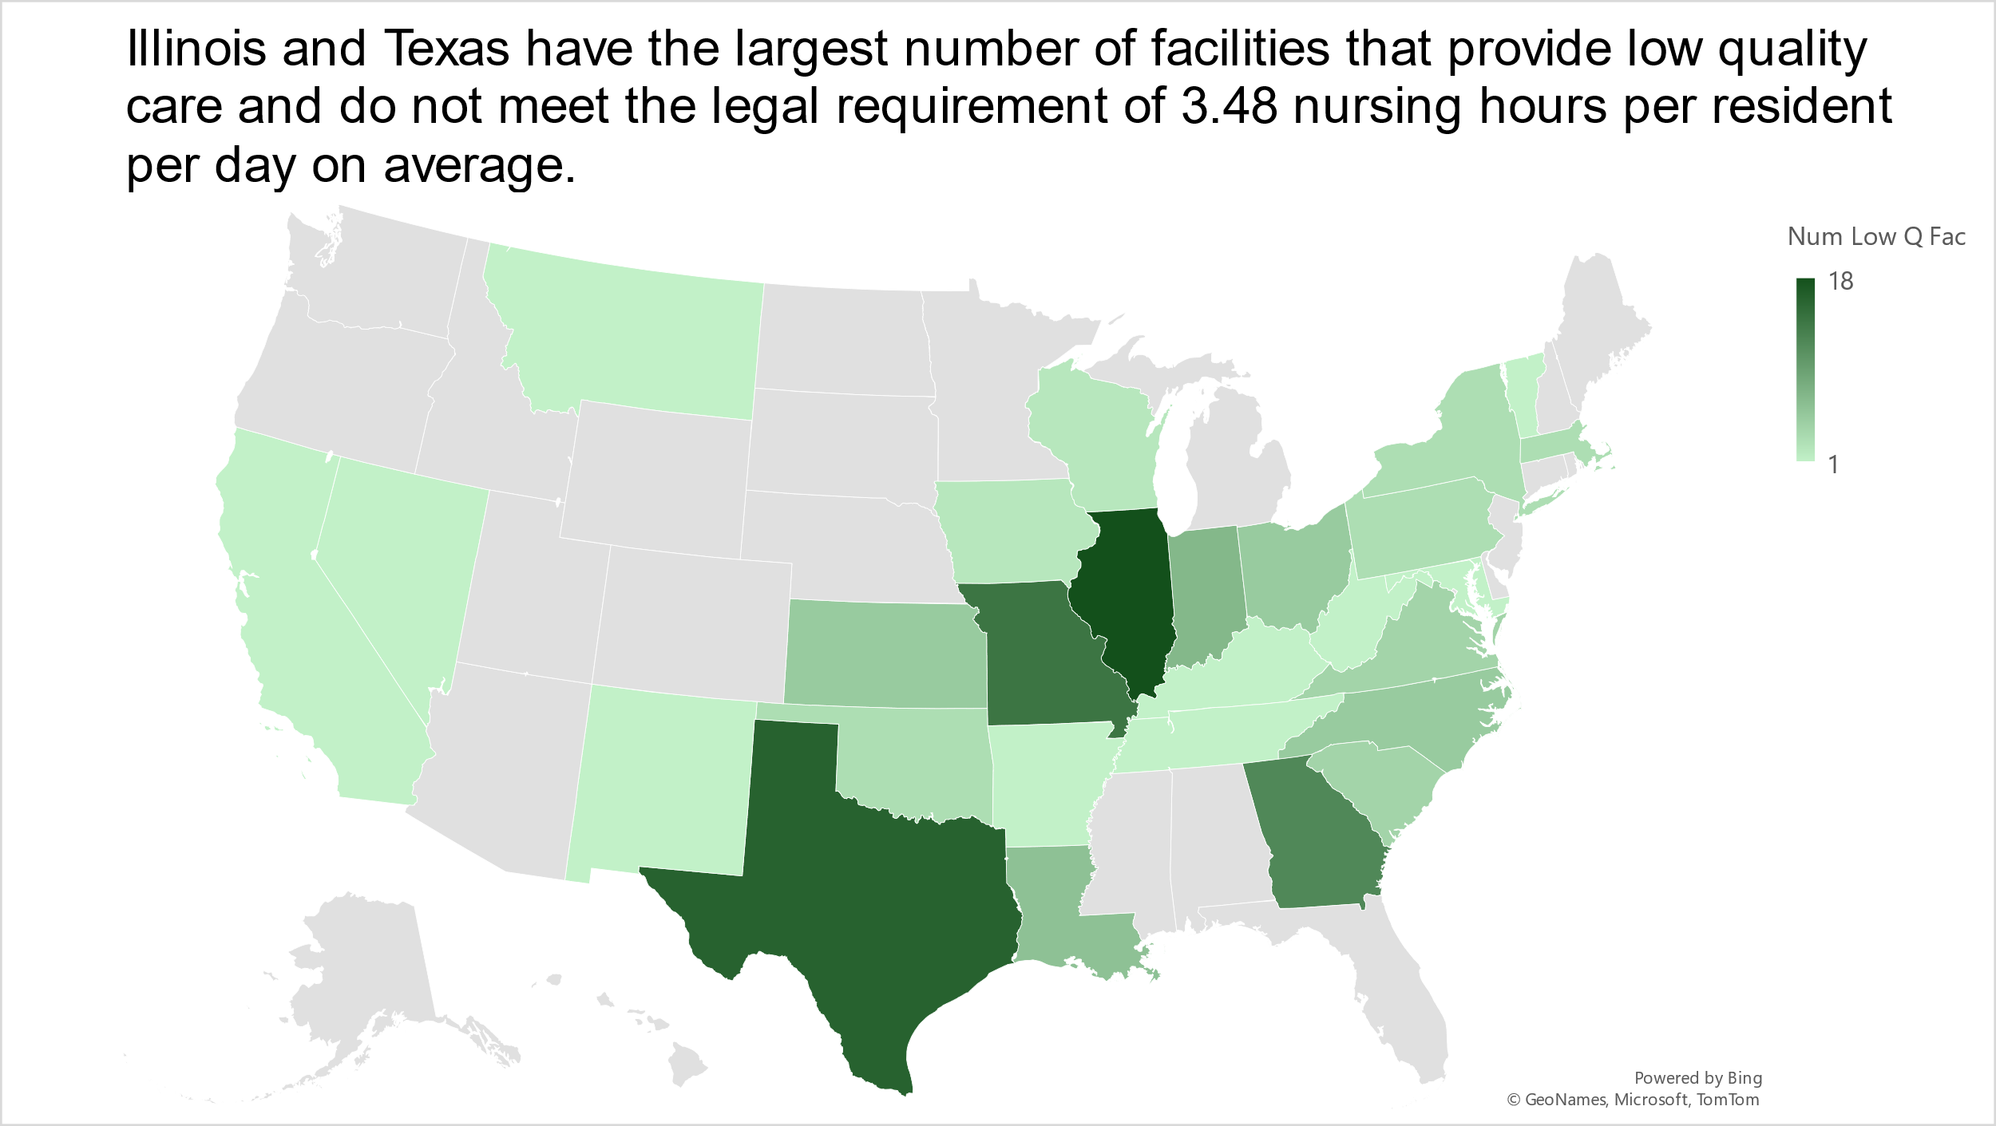

**5) Which understaffed facilities have the lowest quality ratings?**

To answer this question, I wrote a SQL query probing the CMS dataset to produce 10 care facilities (and their states) that had average nursing hours per resident per day below the legal requirement of 3.48 and had scores of 1 (out of 5) on overall rating, health rating, quality rating, and staff rating in order of how many hours on average they were below the legal requirement. The results are shown in the table below. I would recommend targeting ***The Estates of Perryville, LLC and Four Seasons Living Center*** because Missouri is in the top 3 states, along with Illinois and Texas, for the number of facilities that are both understaffed and provide low-quality care.

|  |  |  |
| --- | --- | --- |
| Facility Name | State | Average Hours Below 3.48 Requirement |
| ESTATES OF PERRYVILLE, LLC, THE | Missouri | 2.40105 |
| UNIVERSAL HEALTH CARE/FUQUAY-VARINA | North Carolina | 2.00377 |
| FOUR SEASONS LIVING CENTER | Missouri | 1.98394 |
| HELLENIC NURSING & REHABILITATION CENTER | Massachusetts | 1.93094 |
| SENATH SOUTH HEALTH CARE CENTER | Missouri | 1.83193 |
| CRESTWOOD HEALTH CARE CENTER, LLC | Missouri | 1.82995 |
| TRANQUILITY NURSING AND REHAB | Indiana | 1.75394 |
| CHICAGO RIDGE SNF | Illinois | 1.64943 |
| PRAIRIE RIDGE HEALTH & REHABILITATION | Kansas | 1.59041 |
| ASTORIA PLACE OF SILVERTON | Ohio | 1.51339 |

**Recommendations and Conclusions**

1. Target facilities in **Texas** for addition to the NSA’s platform due to its large number of understaffed facilities that have the capacity for contract nursing staff.
2. Add **Five Points Nursing and Rehabilitation and Legend Oaks Healthcare and Rehabilitation in Texas, Miller’s Merry Manor in Indiana, and Seville Care Center and Sylvia G Thompson Resident Center in Missouri** to the NSA’s platform as they are highly understaffed and can remedy this via contract nurses.
3. Devote resources to advertising **weekend shifts** to healthcare professionals on the NSA’s platform and approach care facilities for addition to the platform toward the **start and middle of the month** as these are the periods during which facilities have greater talent shortages and do not have contract nursing staff.
4. Contact care facilities in **Illinois and Texas** for addition to the NSA’s platform due to their large numbers of **understaffed, low-quality facilities** that will be improved by the platform’s high-quality contract nursing staff.
5. Add **The Estates of Perryville, LLC and Four Seasons Living Center in Missouri** to the NSA’s list of customers because they are **highly understaffed and provide low-quality care** that will be remedied by using the NSA’s platform.

In summary, this report highlights opportunities for a Nursing Staff Agency (NSA) to market its product/service in key states such as Texas, Illinois, and Missouri as well as at specific understaffed and/or low-quality facilities that likely have the capacity for contract nursing staff. The report also shows the optimal time periods during which to market the NSA’s product/service to both healthcare professionals and care facilities. Implementing these actionable, data-driven recommendations will not only increase sales for the NSA, but it will help accomplish the NSA’s goals of decreasing talent shortage in nursing care facilities and helping healthcare professionals find flexible, contract work.