**УО «Белорусский государственный университет информатики и**

**радиоэлектроники»**

**Кафедра ПОИТ**

**Отчет по лабораторной работе №3.1**

**по предмету**

**Основы Алгоритмизации и Программирования**

**Вариант 1**

**Выполнил**

**Андросов И.С.**

**Проверила**

**Данилова Г.В.**

Группа:

**8**51001

**Минск 2018**

**Задание**

Даны две строки st1 и st2. Разработать процедуру, которая по значению первого параметра выполняет следующие операции над данными строками: находит символы, встречающиеся в обеих строках, находит символы, встречающиеся только в первой строке, только во второй строке.

**Код программы**

**(Delphi)**

**program** laba_3_1;

{$APPTYPE CONSOLE}

**uses**

SysUtils;

**function** GetYesNoChoice(): Char;

**var**

Answer: Char;

IsCorrect: Boolean;

**begin**

**repeat**

ReadLn(Answer);

Answer := UpCase(Answer);

**if** (Answer = 'Y') **or** (Answer = 'N') **then**

IsCorrect := true

**else**

**begin**

IsCorrect := false;

WriteLn('Incorrect input. Enter Y(Yes) or N(No):');

**end**;

**until** IsCorrect;

GetYesNoChoice := Answer;

**end**;

**procedure** GetOutputToFile(CommonСharacters, MyUniqueString, ThatUniqueString: String);

**var**

IsCorrect: Boolean;

NewFile: TextFile;

NameOfFile: String;

**begin**

WriteLn('Enter the name of file Name.txt:');

IsCorrect := false;

**repeat**

ReadLn(NameOfFile);

**if** (**not** FileExists(NameOfFile)) **then**

WriteLn('File does not exist. Try again:')

**else**

**begin**

Assign(NewFile, NameOfFile);

Writeln('Would you like to rewrite the file? Press Y(Yes) or N(No):');

**if** GetYesNoChoice = 'Y' **then**

**try**

Rewrite(NewFile);

WriteLn(NewFile, 'Common characters: ', CommonСharacters);

WriteLn(NewFile, 'Unique characters of first string: ',

MyUniqueString);

WriteLn(NewFile, 'Unique characters of second string:',

ThatUniqueString);

IsCorrect := true;

**except**

WriteLn('Access is not allowed. Try again:');

**end**

**else**

**try**

Append(NewFile);

WriteLn(NewFile, 'Common characters: ', CommonСharacters);

WriteLn(NewFile, 'Unique characters of first string: ',

MyUniqueString);

WriteLn(NewFile, 'Unique characters of second string:',

ThatUniqueString);

IsCorrect := true;

**except**

WriteLn('Access is not allowed. Try again:');

**end**;

**end**;

**until** IsCorrect;

Close(NewFile);

**end**;

**procedure** CompareStrings(MyString, ThatString: String; **var** CommonСharacters,

MyUniqueString, ThatUniqueString: String);

**var**

i, j, k: ShortInt;

**begin**

j := 1;

k := 1;

**for** i := 1 **to** Length(MyString) **do**

**if** (pos(MyString[i], ThatString) <> 0) **and** (pos(MyString[i], CommonСharacters)

= 0) **then**

**begin**

Insert(MyString[i], CommonСharacters,j);

Inc(j);

**end**

**else**

**if** (pos(MyString[i], MyUniqueString) = 0) **and** (pos(MyString[i],

CommonСharacters) = 0) **then**

**begin**

Insert(MyString[i], MyUniqueString, k);

Inc(k)

**end**;

j := 1;

**for** i := 1 **to** Length(ThatString) **do**

**if** (pos(ThatString[i], CommonСharacters) = 0) **and** (pos(ThatString[i],

ThatUniqueString) = 0) **then**

**begin**

Insert(ThatString[i], ThatUniqueString, j);

Inc(j);

**end**;

**end**;

**function** CheckFile(**var** MyFile: TextFile): Boolean;

**var**

IsCorrect: Boolean;

**begin**

IsCorrect := false;

**if** Eof(MyFile) **then**

IsCorrect := true

**else**

Write('There sould be only two strings. Try again. ');

CheckFile := IsCorrect;

**end**;

**procedure** GetFile(**var** Myfile: TextFile);

**var**

IsCorrect: Boolean;

NameOfFile: String;

**begin**

WriteLn('Enter file name(Name.txt):');

IsCorrect := false;

**repeat**

ReadLn(NameOfFile);

**if** (**not** FileExists(NameOfFile)) **then**

WriteLn('File does not exist. Try again:')

**else**

**begin**

AssignFile(MyFile, NameOfFile);

reset(MyFile);

**if** SeekEof(MyFile) **then**

WriteLn('File is empty. Try again:')

**else**

IsCorrect := true;

**end**;

**until** IsCorrect;

**end**;

**procedure** Main();

**var**

IsCorrect: Boolean;

MyString, ThatString, CommonСharacters, MyUniqueString, ThatUniqueString : String;

MyFile : TextFile;

**begin**

WriteLn('This program finds characters occurring in both strings, finds characters

found only in the first string, only in the second string.', #10, 'Would

you like to open the file or work in console? Press Y(Yes) or N(No):');

**if** GetYesNoChoice() = 'Y' **then**

**begin**

**repeat**

GetFile(MyFile);

ReadLn(MyFile, MyString);

**if not**(Eof(MyFile)) **then**

**begin**

Read(MyFile, ThatString);

IsCorrect := CheckFile(MyFile);

**end**

**else**

Write('There sould be two strings. Try again. ');

**until** IsCorrect;

WriteLn('The first string: ', MyString, #10, 'The second string: ',

ThatString);

**end**

**else**

**begin**

Write('Enter the first string:');

ReadLn(MyString);

Write('Enter the second string:');

ReadLn(ThatString);

**end**;

CompareStrings(MyString, ThatString, CommonСharacters, MyUniqueString,

ThatUniqueString);

WriteLn('Would you like to write down the answer to file? Press Y(Yes) or N(No):');

**if** GetYesNoChoice = 'Y' **then**

GetOutputToFile(CommonСharacters, MyUniqueString, ThatUniqueString);

WriteLn('Common characters: ', CommonСharacters, #10, 'Unique characters of the

first string: ', MyUniqueString, #10, 'Unique characters of the second

string: ', ThatUniqueString, #10, 'Press "Enter" to exit the console.');

ReadLn;

**end**;

**begin**

Main();

**end**.

**Скриншоты**

**(Delphi)**

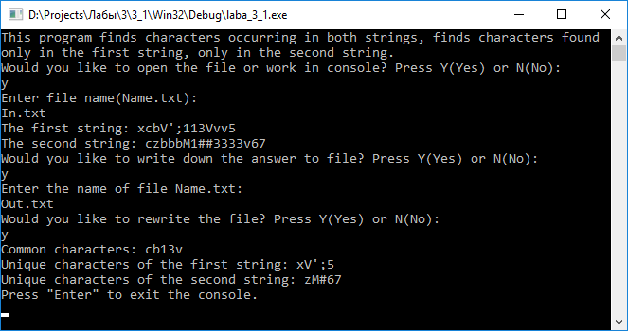

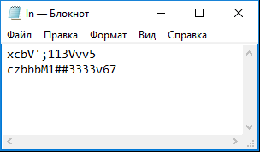

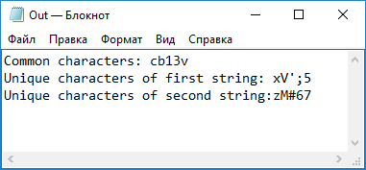

**Схема алгоритма**





