**УО «Белорусский государственный университет информатики и**

**радиоэлектроники»**

**Кафедра ПОИТ**

**Отчет по лабораторной работе №3.2**

**по предмету**

**Основы Алгоритмизации и Программирования**

**Вариант 1**

**Выполнил**

**Андросов И.С.**

**Проверила**

**Данилова Г.В.**

Группа:

**8**51001

**Минск 2018**

**Задание**

Дана непустая последовательность символов, требуется построить и напечатать множество, элементами которого являются встречающиеся в последовательности знаки арифметических операций, знаки препинания и цифры.

Разработать алгоритм методом пошаговой детализации и программу, реализующую этот алгоритм.

**Код программы**

**(Delphi)**

**program** laba_3_2;

{$APPTYPE CONSOLE}

**uses**

SysUtils;

**const**

ThatSet = ['+', '-', '*', '/','.',',',':',';','!','?','0'..'9'];

**type**

TMySet = **set of** Char;

**procedure** GetMySetConsole(MyString: String);

**var**

MySet: TMySet;

i, j: Byte;

**begin**

MySet := [];

**for** i := 1 **to** Length(MyString) **do**

**if** (MyString[i] **in** ThatSet) **then**

**begin**

MySet := MySet + [MyString[i]];

Write('The element ', MyString[i], ' was added to the set: ');

**for** j := 0 **to** 255 **do**

**if** chr(j) **in** MySet **then**

Write(chr(j));

WriteLn;

**end**;

**if** MySet = [] **then**

WriteLn('There are no such signs in that sequence.')

**else**

WriteLn('The needed set was found.');

**end**;

**function** GetYesNoChoice(): Char;

**var**

Answer: Char;

IsCorrect: Boolean;

**begin**

**repeat**

ReadLn(Answer);

Answer := UpCase(Answer);

**if** (Answer = 'Y') **or** (Answer = 'N') **then**

IsCorrect := true

**else**

**begin**

IsCorrect := false;

WriteLn('Incorrect input. Enter Y(Yes) or N(No):');

**end**;

**until** IsCorrect;

GetYesNoChoice := Answer;

**end**;

**procedure** GetFile(**var** Myfile: TextFile);

**var**

IsCorrect: Boolean;

NameOfFile: String;

**begin**

WriteLn('Enter file name(Name.txt):');

IsCorrect := false;

**repeat**

ReadLn(NameOfFile);

**if** (**not** FileExists(NameOfFile)) **then**

WriteLn('File does not exist. Try again: ')

**else**

**begin**

**try**

AssignFile(MyFile, NameOfFile);

reset(MyFile);

**if** SeekEof(MyFile) **then**

**begin**

WriteLn('File is empty. Try again: ');

CloseFile(MyFile);

**end**

**else**

IsCorrect := true;

**except**

WriteLn('Access is not alowed. Try Again: ');

**end**;

**end**;

**until** IsCorrect;

**end**;

**procedure** GetOutPutFile(**var** NewFile: TextFile);

**var**

IsCorrect: Boolean;

**begin**

IsCorrect := false;

**repeat**

GetFile(NewFile);

WriteLn('Would you like to rewrite the file? Press Y(Yes) or N(No):');

**try**

**if** GetYesNoChoice = 'Y' **then**

Rewrite(NewFile)

**else**

**begin**

Append(NewFile);

WriteLn(NewFile);

**end**;

IsCorrect := true;

**except**

Write('This file can not be edited. Try again. ');

**end**;

**until** IsCorrect;

**end**;

**procedure** GetMySetFile(MyString: String);

**var**

NewFile: TextFile;

MySet: TMySet;

i, j: Byte;

**begin**

GetOutputFile(NewFile);

MySet := [];

**for** i := 1 **to** Length(MyString) **do**

**if** (MyString[i] **in** ThatSet) **then**

**begin**

MySet := MySet + [MyString[i]];

Write(NewFile, 'The element ', MyString[i], ' was added to the set: ');

**for** j:= 0 **to** 255 **do**

**if** chr(j) **in** MySet **then**

Write(NewFile, chr(j));

WriteLn(NewFile);

**end**;

**if** MySet = [] **then**

WriteLn(NewFile, 'There are no such signs in that sequence.')

**else**

WriteLn(NewFile, 'The needed set was found.');

CloseFile(NewFile);

**end**;

**function** CheckString(MyString: String): Boolean;

**var**

IsCorrect: Boolean;

i: Integer;

**begin**

IsCorrect := false;

**if not**(MyString = '') **and not**(MyString = ' ') **then**

**begin**

i := 0;

**repeat**

inc(i);

**if not**(MyString[i] = ' ') **then**

IsCorrect := true;

**until** IsCorrect **or** (i = Length(MyString));

**end**;

**if not** IsCorrect **then**

WriteLn('The sequence must not be empty. Try Again.');

CheckString := IsCorrect;

**end**;

**function** GetMyStringConsole(): String;

**var**

MyString: String;

**begin**

**repeat**

Write('Enter the sequence:');

ReadLn(MyString);

**until** CheckString(MyString);

GetMyStringConsole := MyString;

**end**;

**function** GetMyStringFile(**var** MyFile: TextFile): String;

**var**

MyString: String;

**begin**

**repeat**

GetFile(MyFile);

ReadLn(MyFile, MyString);

**if not**(Eof(MyFile)) **then**

WriteLn('There sould be only one sequence. Try again. ');

**until** Eof(MyFile);

WriteLn('The sequence is: ', MyString);

GetMyStringFile := MyString;

**end**;

**procedure** Main();

**var**

MyString: String;

MyFile: TextFile;

**begin**

WriteLn('This program makes up a set which elements are occurring in the sequence in a row

of arithmetic operations, punctuation signs and numbers.', #10, 'Would you like to

open the file or work in console? Press Y(Yes) or N(No):');

**if** GetYesNoChoice() = 'Y' **then**

MyString := GetMyStringFile(MyFile)

**else**

MyString := GetMyStringConsole();

WriteLn('Would you like to write down the answer to file? Press Y(Yes) or N(No):');

**if** GetYesNoChoice = 'Y' **then**

GetMySetFile(MyString)

**else**

GetMySetConsole(MyString);

WriteLn('Press "Enter" to exit the console.');

ReadLn;

**end**;

**begin**

Main();

**end**.

**Скриншоты**

**(Delphi)**

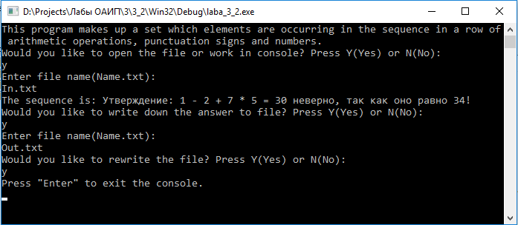

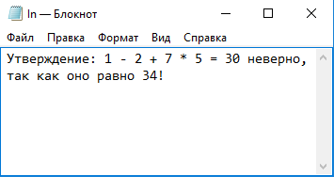

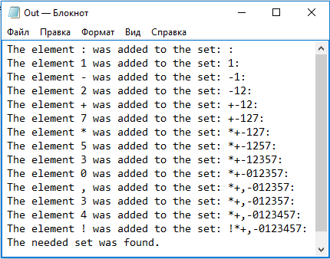

**Схема алгоритма**





