The Hypertext Transfer Protocol (HTTP) is an application protocol for distributed, collaborative, and hypermedia information systems. HTTP is the foundation of data communication for the World Wide Web.

Hypertext is structured text that uses logical links (hyperlinks) between nodes containing text. HTTP is the protocol to exchange or transfer hypertext.

GET requests a representation of the specified resource. Note that GET should not be used for operations that cause side-effects, such as using it for taking actions in web applications. One reason for this is that GET may be used arbitrarily by robots or crawlers, which should not need to consider the side effects that a request should cause.

**and**

POST submits data to be processed (e.g., from an HTML form) to the identified resource. The data is included in the body of the request. This may result in the creation of a new resource or the updates of existing resources or both.

**So essentially GET is used to retrieve remote data, and POST is used to insert/update remote data**

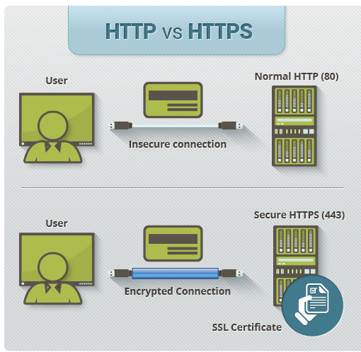 

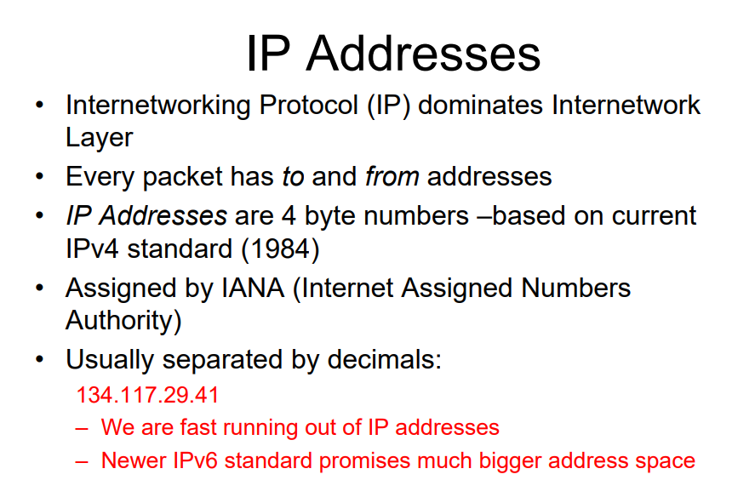 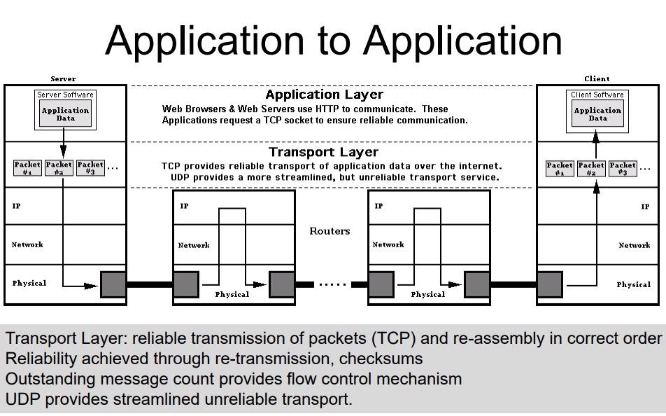 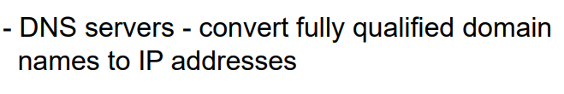 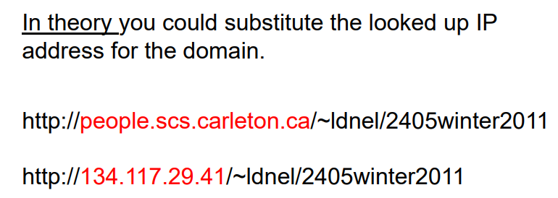

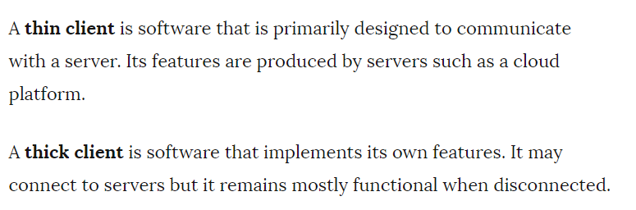

When you execute something synchronously, you wait for it to finish before moving on to another task. When you execute something asynchronously, you can move on to another task before it finishes.

That being said, in the context of computers this translates into executing a process or task on another "thread." A thread is a series of commands (a block of code) that exists as a unit of work. The operating system can manage multiple threads and assign a thread a piece ("slice") of processor time before switching to another thread to give it a turn to do some work. At its core (pardon the pun), a processor can simply execute a command, it has no concept of doing two things at one time. The operating system simulates this by allocating slices of time to different threads.

Now, if you introduce multiple cores/processors into the mix, then things CAN actually happen at the same time. The operating system can allocate time to one thread on the first processor, then allocate the same block of time to another thread on a different processor. All of this is about allowing the operating system to manage the completion of your task while you can go on in your code and do other things.

Asynchronous programming is a complicated topic because of the semantics of how things tie together when you can do them at the same time. There are numerous articles and books on the subject; have a look!

A **callback function**, also known as a higher-order **function**, is a **function** that is passed to another **function** (let's call this other **function** “otherFunction”) as a parameter, and the**callback function** is called (or executed) inside the otherFunction. 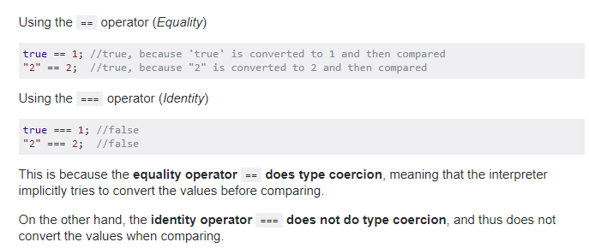 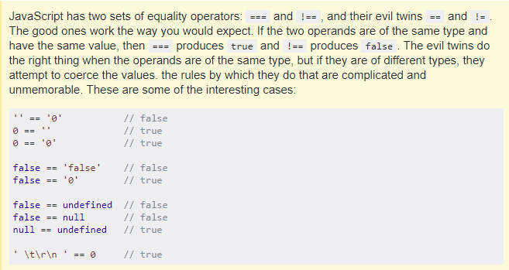

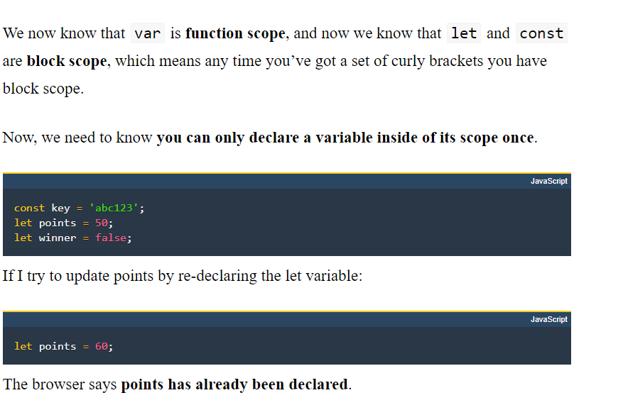 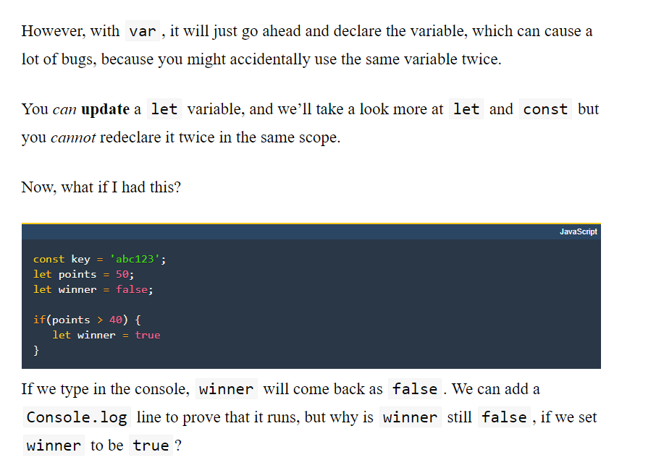 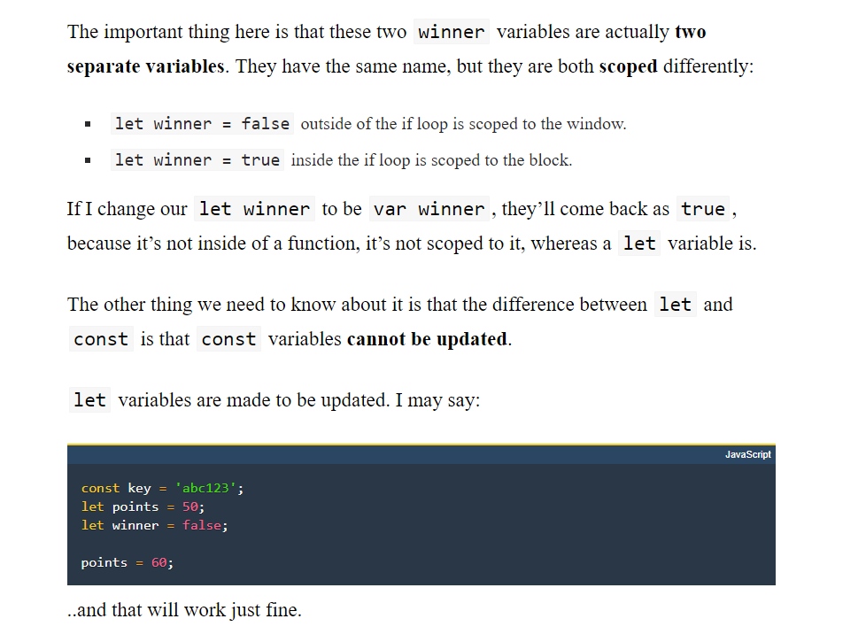 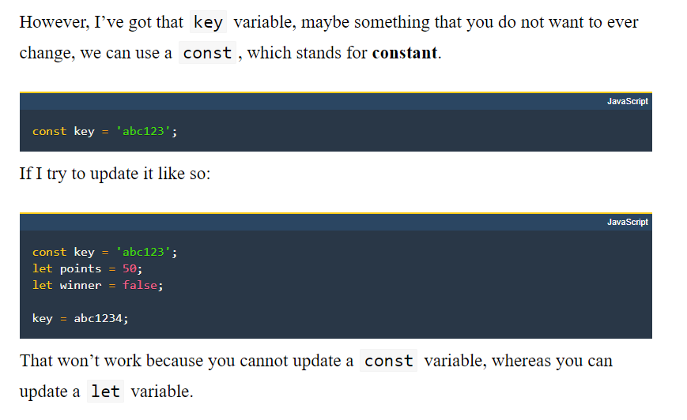

<https://www.w3schools.com/js/js_arrays.asp>

<https://www.w3schools.com/jsref/jsref_obj_string.asp>

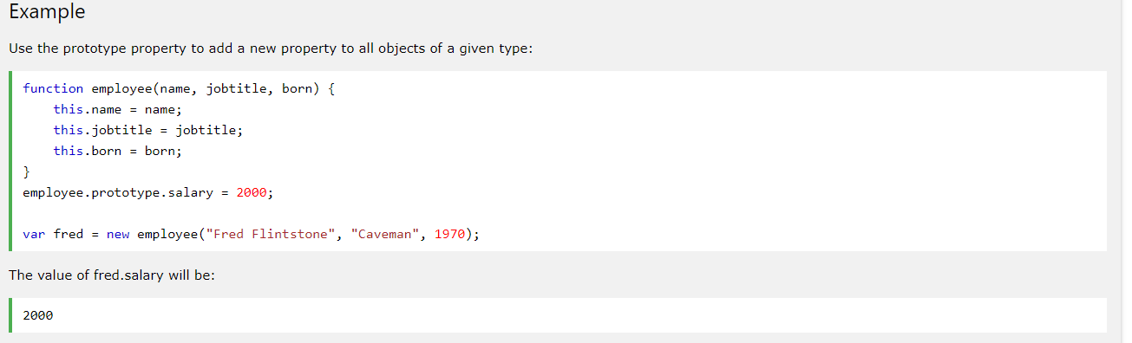

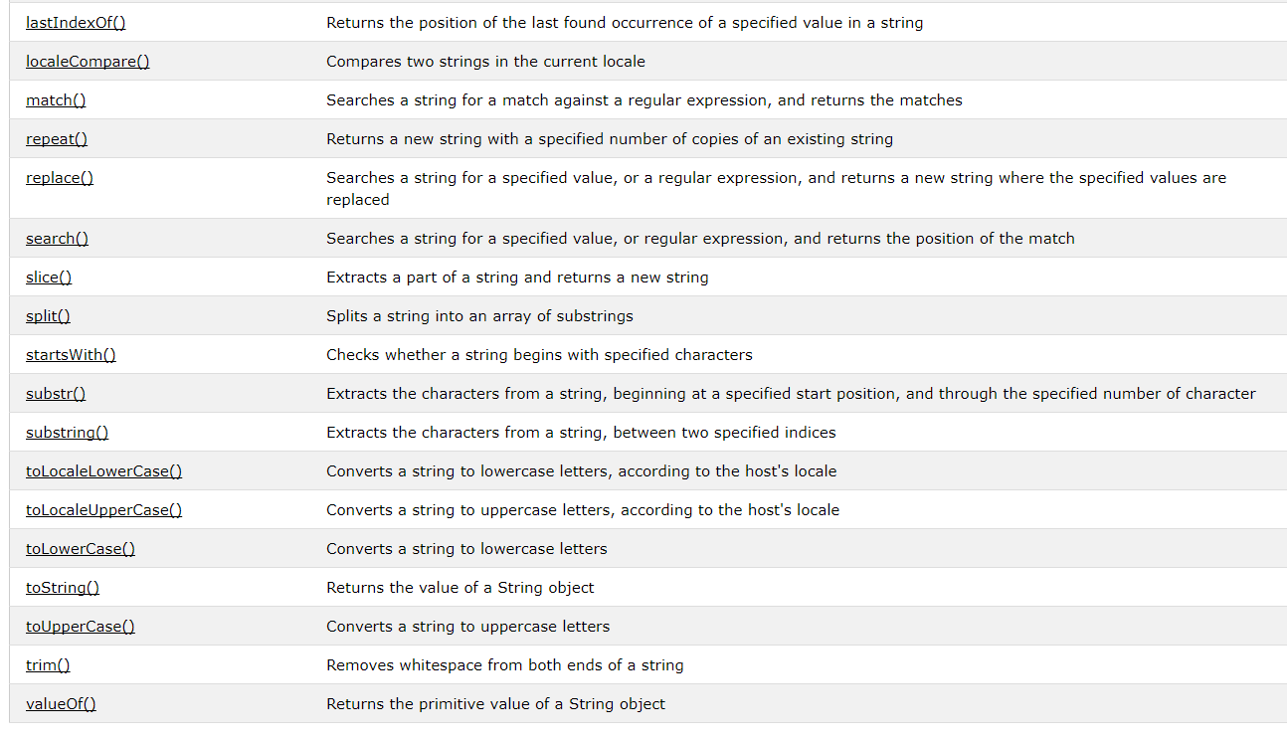

export

<https://developer.mozilla.org/en-US/docs/web/javascript/reference/statements/export>

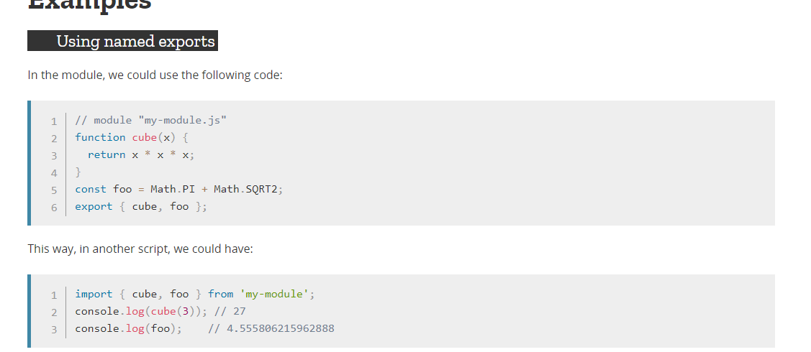 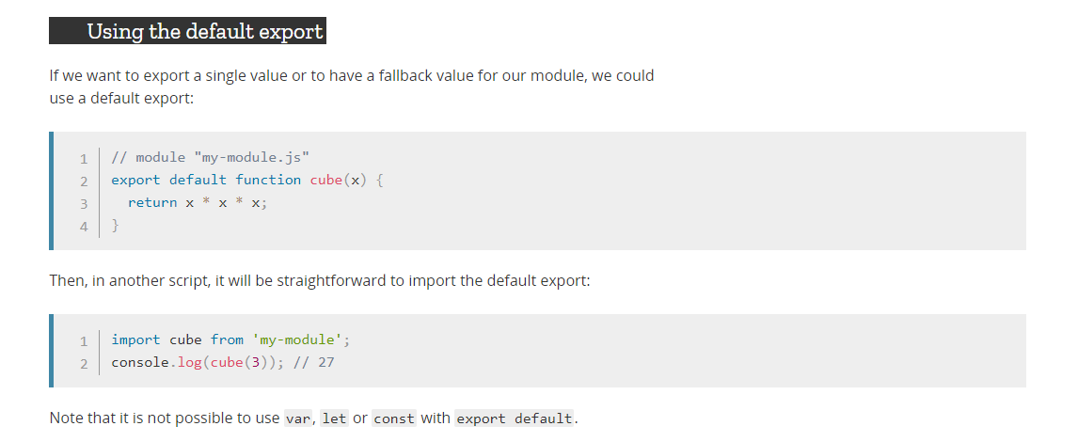

<https://developer.mozilla.org/en-US/docs/Web/JavaScript/Reference/Statements/import>

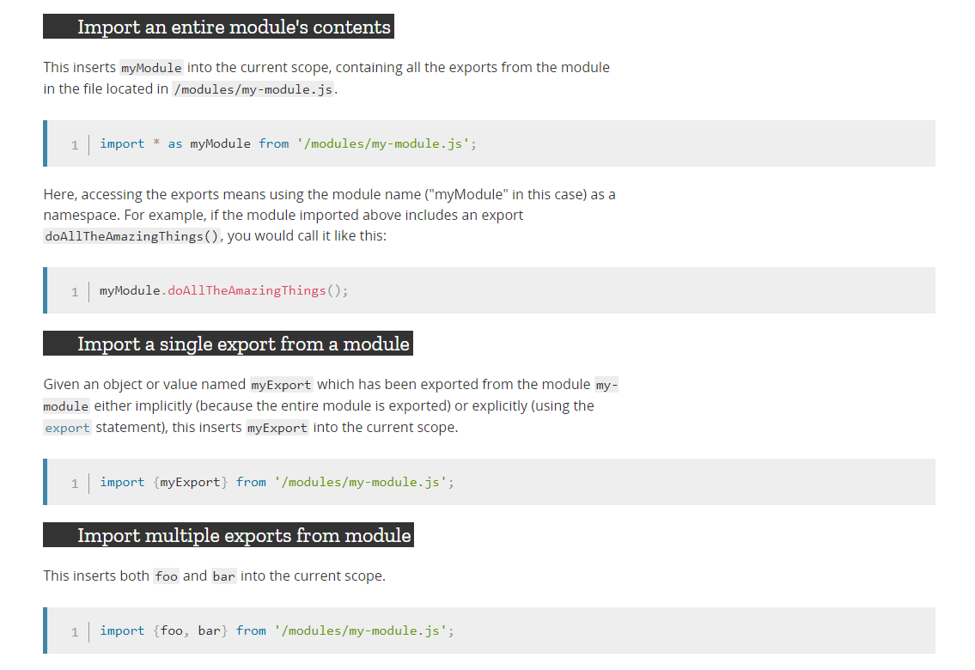 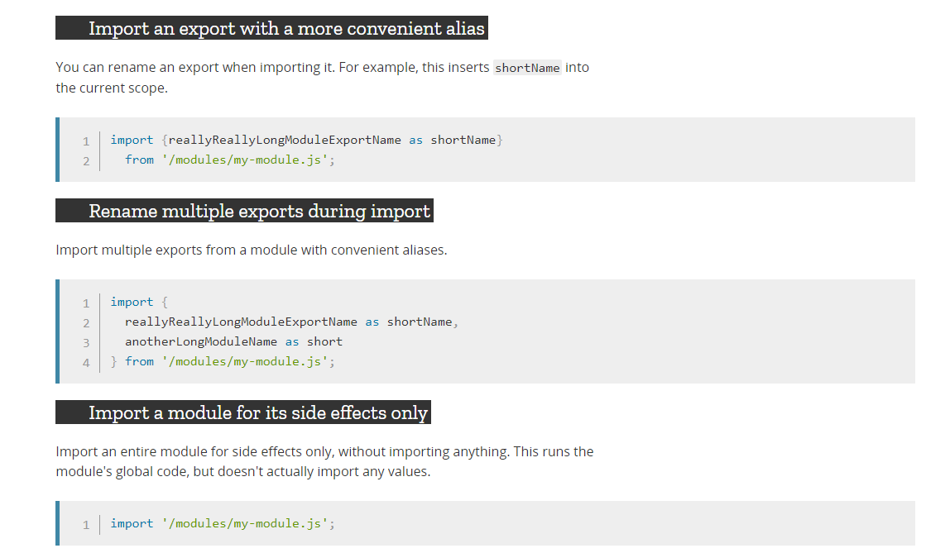

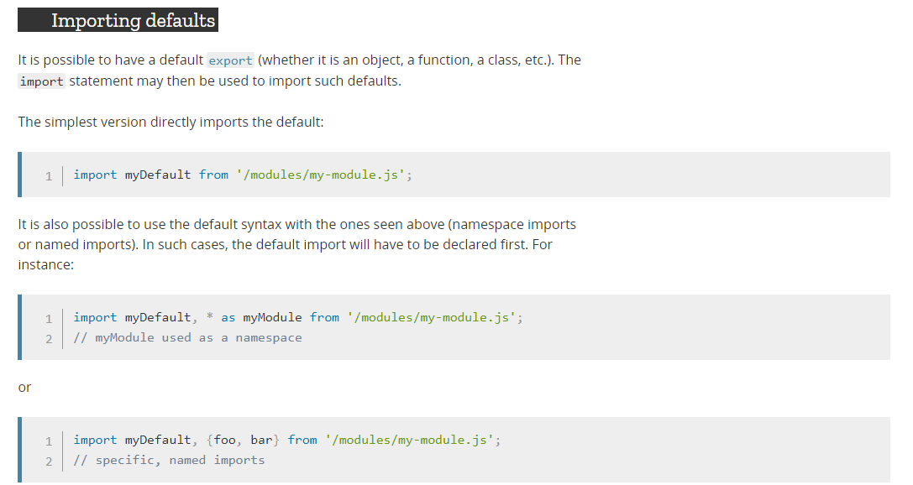 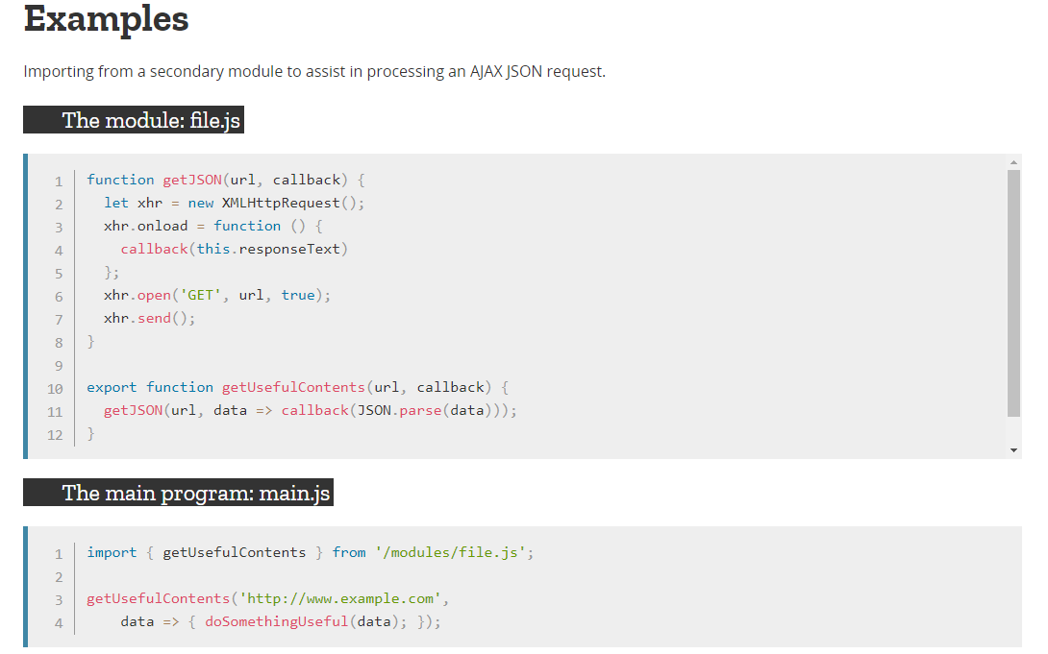

<https://www.w3schools.com/js/js_function_closures.asp>

A **closure** is an inner function that has access to the outer (enclosing) function's variables—scope chain. The **closure** has three scope chains: it has access to its own scope (variables **defined** between its curly brackets), it has access to the outer function's variables, and it has access to the global variables.

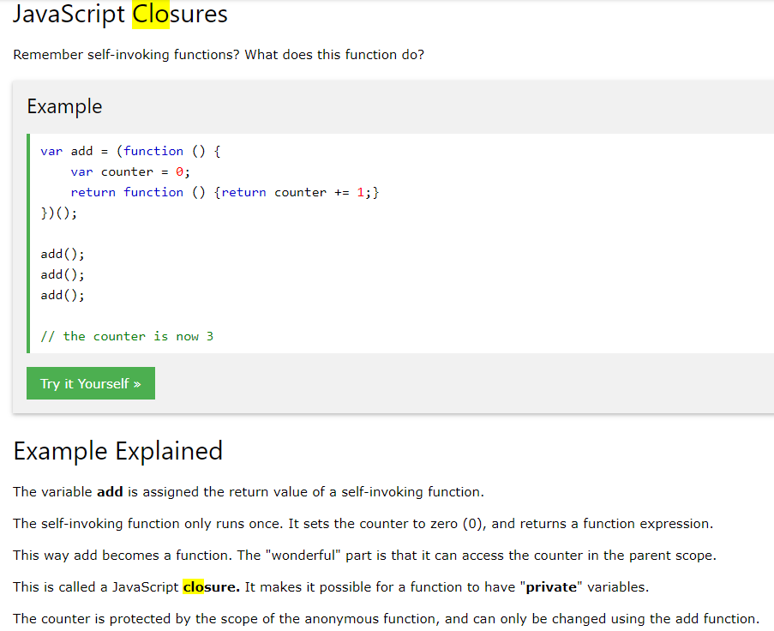

<http://people.scs.carleton.ca/~comp2406/notes/07%20Basic%20Static%20Server/01basic_static_server.js>

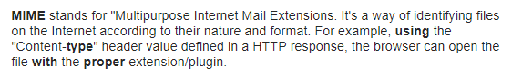

A **package**.**json file** contains meta data about your app or module. Most importantly, it includes the list of dependencies to install from npm when running npm install

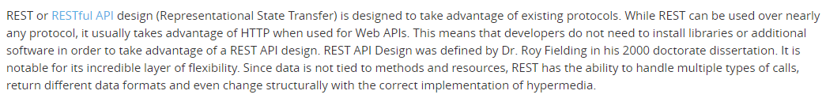

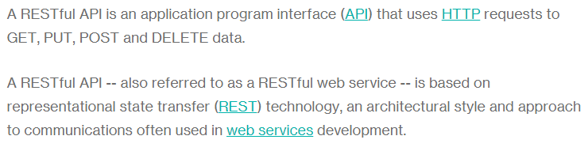

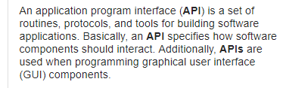

Javascript templates are rendered and cached client-side without sending an HTTP request to the server — in other words, they’re lightning fast.

One of the distinguishing features of Jade is its clean syntax. Elements are created with CSS selector syntax which makes the template consistent with your style sheet and JavaScript element selector library.

HANDLE BARS FEATURES:

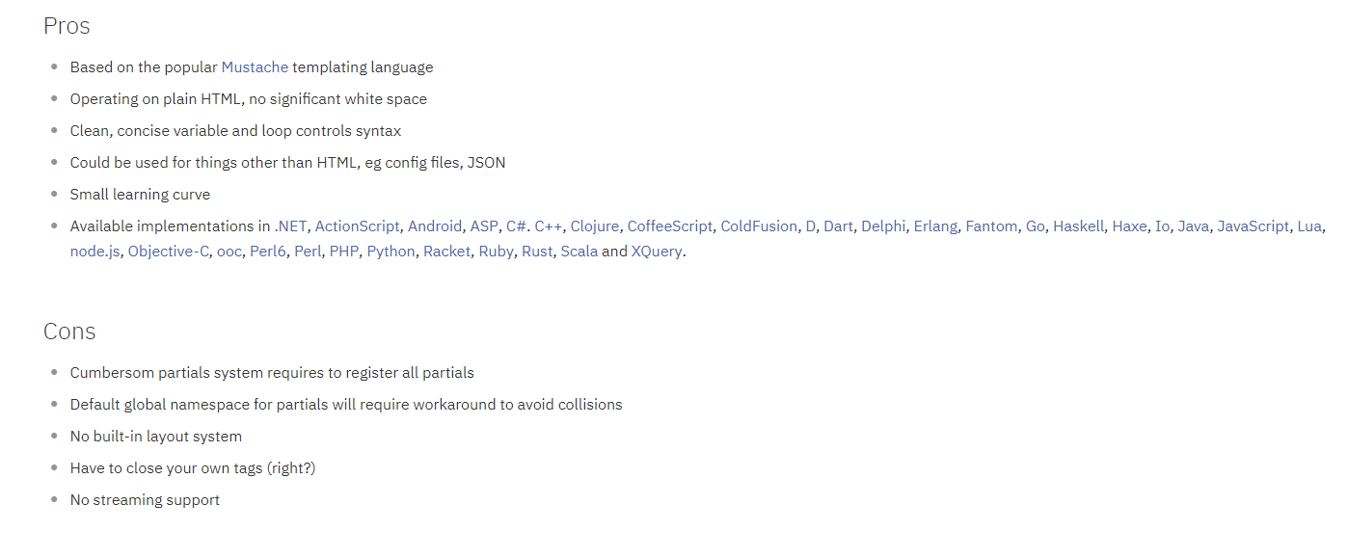

<https://www.w3schools.com/js/js_json_stringify.asp>

<https://www.w3schools.com/js/js_json_parse.asp>

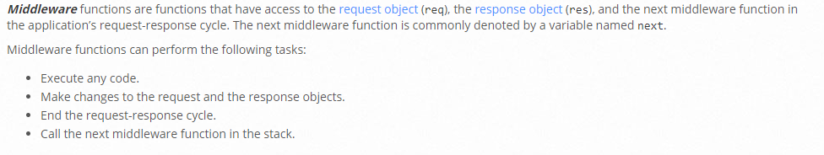

EXPRESS ROUTES:

<https://expressjs.com/en/guide/routing.html>

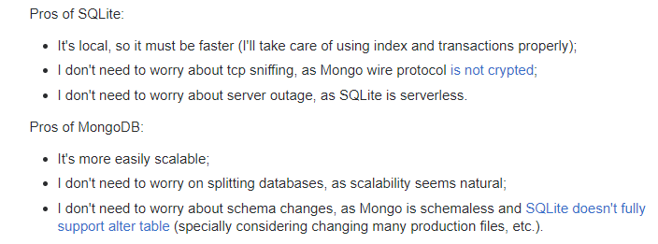

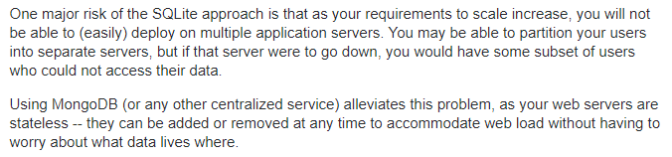

JSON VS RELATIONAL DATABASE:

**Relational databases** like MySQL, PostgreSQL and SQLite3 represent and store data in tables and rows. ... Meanwhile, non-**relational databases** like MongoDB represent data in collections of **JSON** documents.

JSON VS XML:

<https://www.w3schools.com/js/js_json_xml.asp>

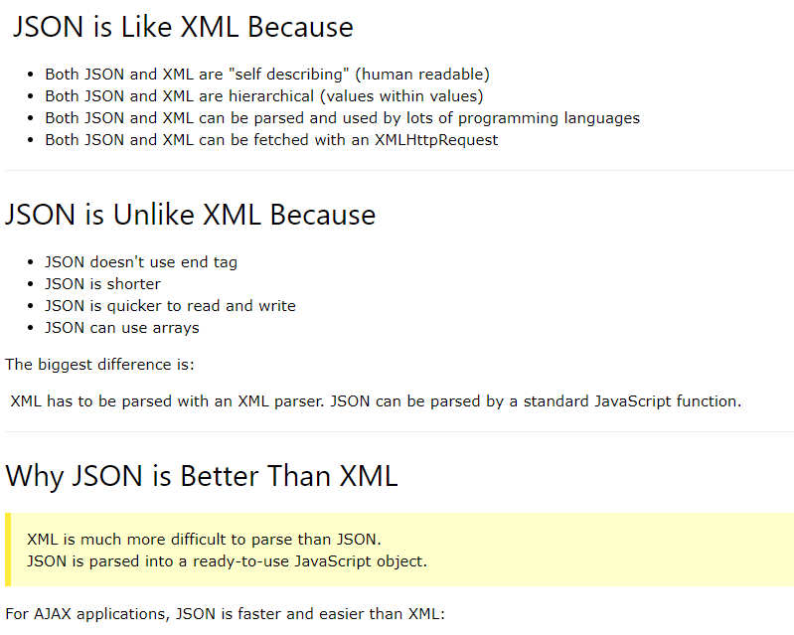

**Database normalization**, or simply **normalization**, is the process of organizing the columns (attributes) and tables (relations) of a relational **database** to reduce data redundancy and improve data integrity. ... Informally, a relational **database** relation is often described as "**normalized**" if it meets third normal form

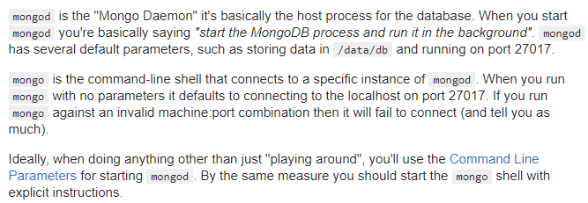

PART 5:

Look at tutorial 9 again or redo it.

The basic node static server can be looked at on his websites and was linked previously in the document. Get a good feel for it.

Please leave a response here:

<http://www.strawpoll.me/14587692>