BE 1

<https://course-offering.com/home>

IP: 76.76.21.21:443

16 HTTP requests

Some images and some js files

8.5 Kb

Total took 889 ms

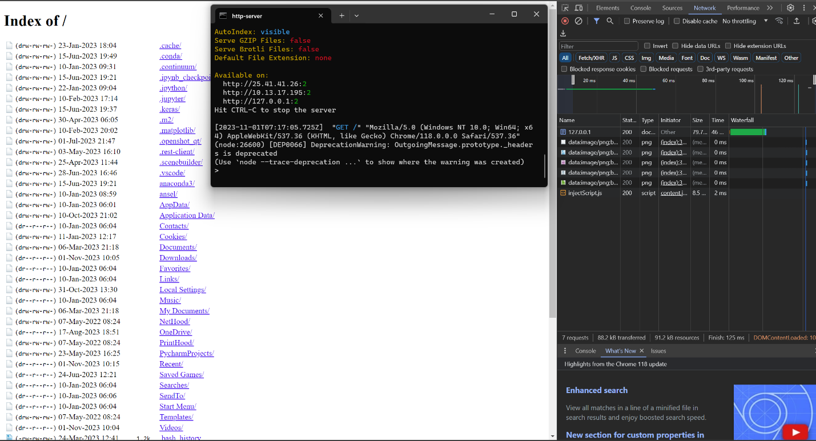

Domain name: <http://classicgames.world/>