

GLOBAL STRATEGIC MARKETING

The new commercial structure will continue to serve our Medical, Electronics, Transportation, Consumer and Industrial markets through the Global Business Unit structure. Marketing plays a key role in building an externally focused and customer centric business model. The function will sit across Business Units on a global level. The Strategic Marketing Team will set and execute marketing strategies in alignment with the Global Business Unit strategic plans.


Katie Gotzen will head up the Global Strategic Marketing Team. Each team member will act as a contact person for the different Business Units, according to the organisational chart below: Dorota Aladyn will be the contact person for Global Industrial, Andrew Booker for Global Medical, Katie Gotzen and Julia Shylo for Global Electronics, Jo Mohan for Consumer US and Corine Blouquy for Global Transportation. Marc Fournier will continue to manage Consumer Europe. Julia Shylo will also be responsible for Marketing Intelligence for all markets. Marketing will report to Heejae Chae, until the Director of Global Sales is in place.

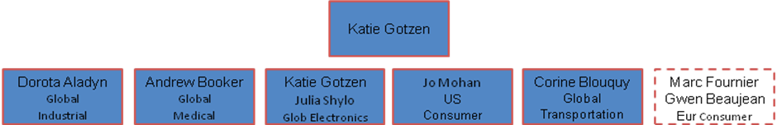

Katie Gotzen
Global Strategic Marketing Manager

