Outlook Web Access Quick Start

Scapa Group Plc

Version: 1.0

Contents
1.0 Preface 3
1.1 Prepared By 3
1.2 Customer Distribution List 3
1.3 Change History 3
2.0 Overview 4
3.0 Connecting to Outlook Web Access from outside Scapa sites 4
4.0 Connecting to Outlook Web Access from inside Scapa sites. 7
5.0 Viewing Outlook Web Access for the very first time 7
5.1 Navigation Pane 7
5.2 Messages Pane 8
5.3 Preview Pane 9
6.0 Outlook Web Access Toolbar Explained 11
6.1 New Button 11
6.2 Move/Copy Button 11
6.3 Delete Button 12
6.4 Reply Button 12
6.5 Reply to All Button 12
6.6 Forward Button 12
6.7 Preview Pane Configuration Button 12
6.8 Check For New Messages Button 13
6.9 Search Button 13
6.10 Find Names Button 14
6.11 Help Button 15
7.0 Composing and Addressing Messages 16
7.1 Message Toolbar Explained 16
7.2 Addressing Messages in Outlook Web Access. 18
7.3 Adding Attachments to your message 22
7.4 Typing Your Message 23
7.5 Sending Your Message 24
8.0 Receiving Mail in Outlook Web Access 24

Preface

Prepared By
Name | Function
Mark Brookes | European IT Development Manager

Customer Distribution List
Name | Function
James Hennessey | European IT Manager

Change History
Version | Date | Revision Description
1.0 | 25/05/06 | Initial revision

Overview
This document gives information on how to use Outlook Web Access to access Scapa Email from outside the organisation, whether on a home PC or Internet Café.

This document will detail how to logon to Outlook Web Access, send and receive mail, manage calendaring functions, manage contacts and other useful Outlook Web Access functions.

Connecting to Outlook Web Access from outside Scapa sites

If you want to view your mail from home (without having to use a VPN), Internet Café, or someone else’s computer follow the instructions below

Open Internet Explorer, in the address bar type https://owa.scapa.com or https://owa.scapana.com

The following warning should be presented:

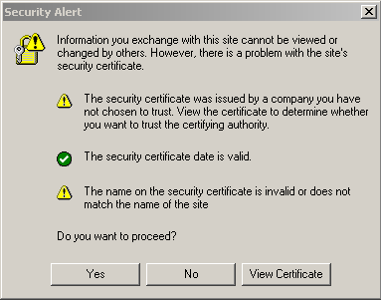

Click Yes (You can view the certificate if want to! – It should read as follows)
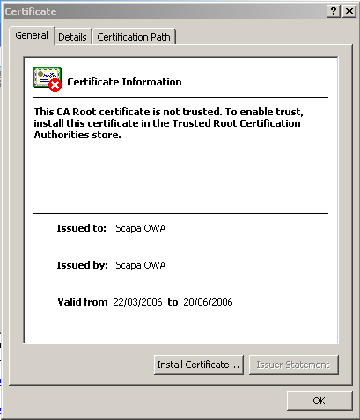

The following page will be displayed:

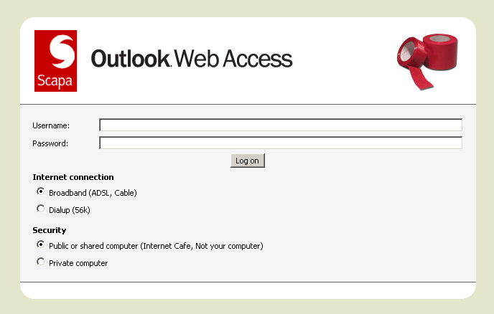

In the username and password section of the log on box, your username can be entered in the following two ways:

Domain\Username e.g. SCAPA\jsmith

Email Address e.g. john.smith@scapa.com

The password is the password that you log on to the network with.

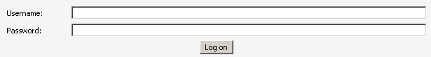

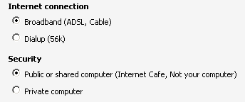

Select the relevant options for your connection.

Connecting to Outlook Web Access from inside Scapa sites.

If you want to look at your mail while on another Scapa site and you don’t have access to your desktop/laptop you can without logging off your colleagues computer:

Open Internet Explorer and type https://owa.scapa.com or https://owa.scapana.com

The procedure for logging on to Outlook Web Access is exactly the same as described in the section above.

Viewing Outlook Web Access for the very first time

Once you have logged on, your E-mail inbox will be rendered as a web page. Outlook Web Access on Exchange 2003 closely resembles Outlook 2003.

The initial page is rendered as follows:

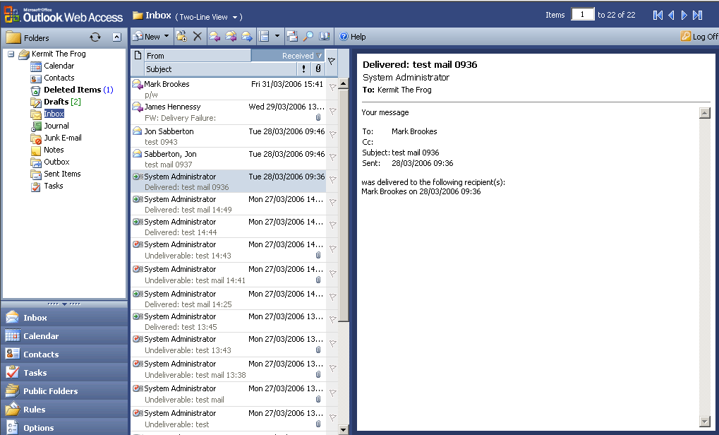

The main page is split into three panes:

Navigation Pane

This pane allows you to navigate your inbox, calendar, contacts, tasks, Public Folders, Inbox rules and Outlook Web Access Options

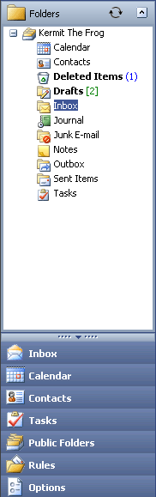

Messages Pane

This pane lists your messages that are in your inbox or the folder within your inbox that you are currently viewing. This looks as follows:

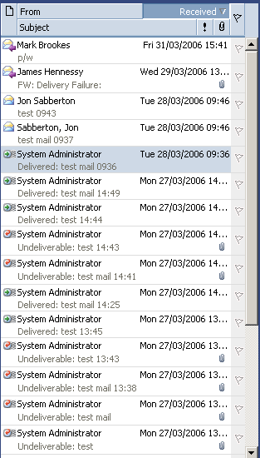

Preview Pane

The preview pane displays the contents of the currently selected e-mail without opening the mail. This is displayed as follows:
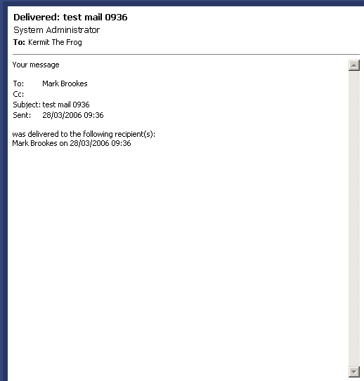

Outlook Web Access Toolbar Explained

The Outlook Web Access Toolbar has the following icons located above the messages pane

New Button

The “new button” when clicked on will open a new internet explorer window for you to compose your mail in:

The “drop down” button when clicked will present other options for you to select as shown below:

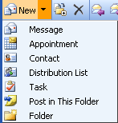

Move/Copy Button

The “Move/copy” button will open an Internet Explorer dialog box asking you what you would like to move or copy as shown below:

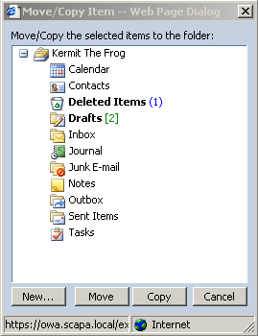

The new button creates a new folder.

Delete Button

Deletes the currently selected message.

Reply Button

Replies to the currently selected message.

Reply to All Button

Replies to all recipients listed in the selected message.

Forward Button

Forwards the selected message.

Preview Pane Configuration Button

Changes the location of the preview pane. The following options for the preview are selectable as follows:

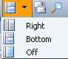

Check For New Messages Button

Checks for New Messages.

Search Button

Launches the Search tool as shown on the following page:

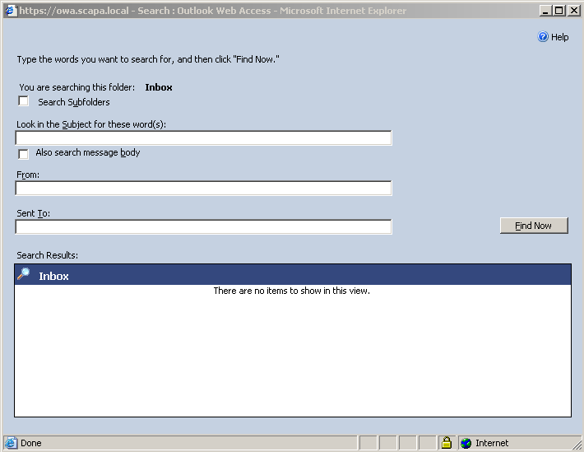

Find Names Button

Launches the Find Names dialog box (shown on the following page). You can search for users in the Global Address List as well as in your Outlook Contacts.

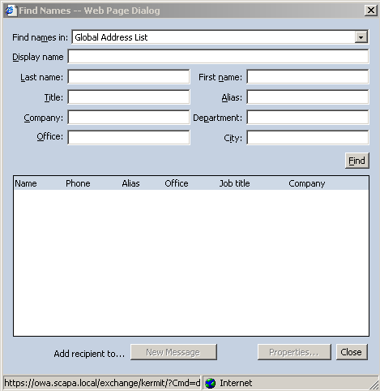

Help Button

Launches a comprehensive Outlook Web Access help dialog box.

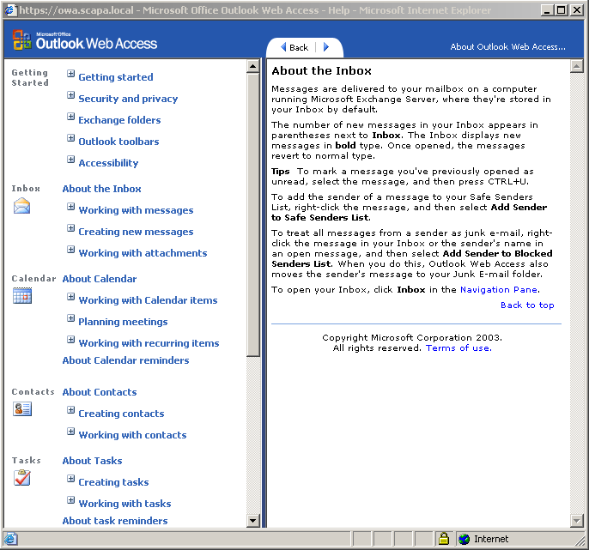

Composing and Addressing Messages

Click the new button to launch a new Internet Explorer page to compose your mail in.

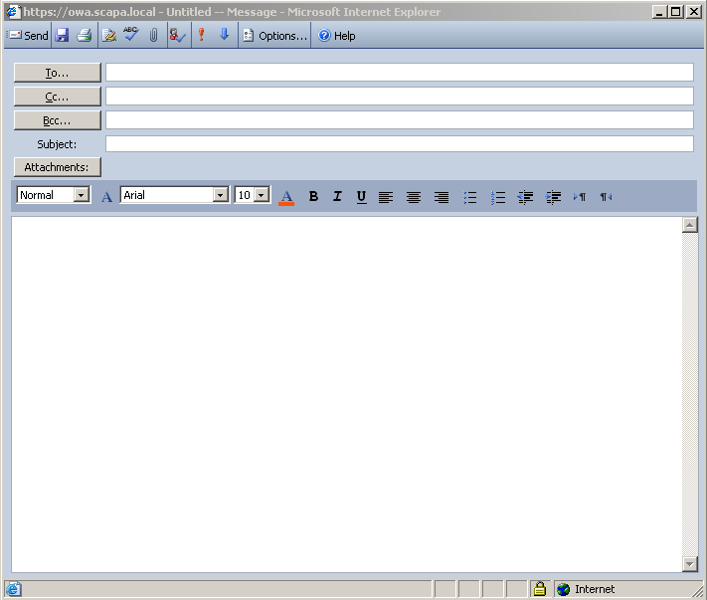

Message Toolbar Explained

The message toolbar is shown below. The following sections explain each button.

Send Button

Sends the message

Save Button

Saves the message to the drafts folder

Print Button

Prints the displayed message.

Insert Signature Button

Inserts a pre-created signature

Spellcheck Button

Spellchecks the mail before sending it

Attachment Button

Attaches a file to a mail

Check Names Button

Verfies the names you’ve typed into the To: and cc: fields against the Global Address List and Contacts

Priority Buttons

Assigns a priority to the message: Urgent: Low:

Options Button

The Options Button allows the following options to be applied to the message:

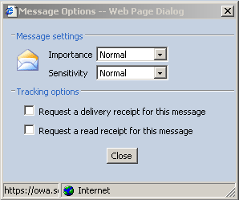

Help Button

Provides Help on Outlook Web Access

Addressing Messages in Outlook Web Access.

There are several ways of addressing messages in Outlook Web Access, this section will outline one of those ways.

If the users you are addressing mail to are defined in the Global Address list you can type part of their name and click the check name button . Names must be separated By the “;” symbol. Names not listed in the global address list must be either selected from contacts (method 2) or their full e-mail address typed out e.g. mark.brookes@scapa.com

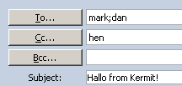

When the “check name button” is checked Outlook Web Access queries the Global Address List for all names beginning with Mark, Dan and that have the word hen in them. These are prompted by using separate dialog boxes as shown below:

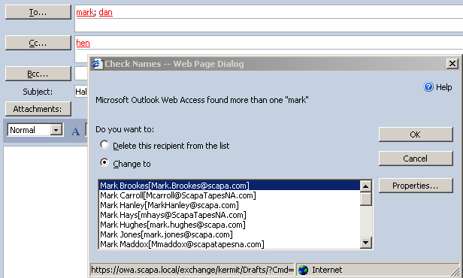

Choose the correct recipient (in this case Mark Brookes) and click OK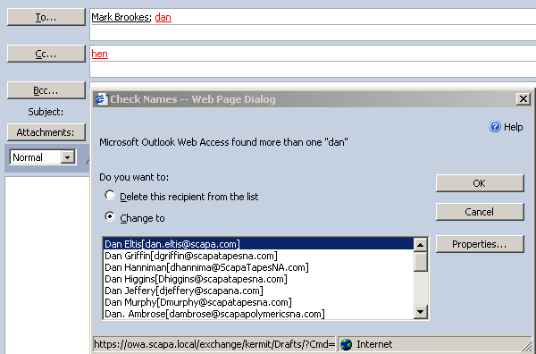

Repeat for the other recipients
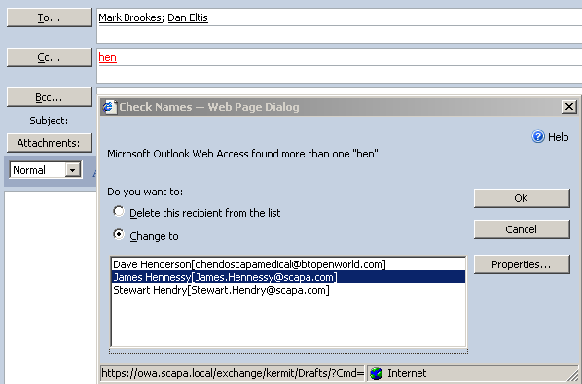

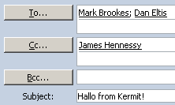

The addressed (internal) mail should look similar to that shown above.

To add entries from your Outlook Contacts click the relevant button (To, CC, BCC), the following screenshots will give an example of adding a contact into the To field.

Click the “To” button and from the Find Names dialog box you can choose Global Address list or Contacts. You cannot click the find button without entering some information to search for. Outlook Web Access requires some information to search against.

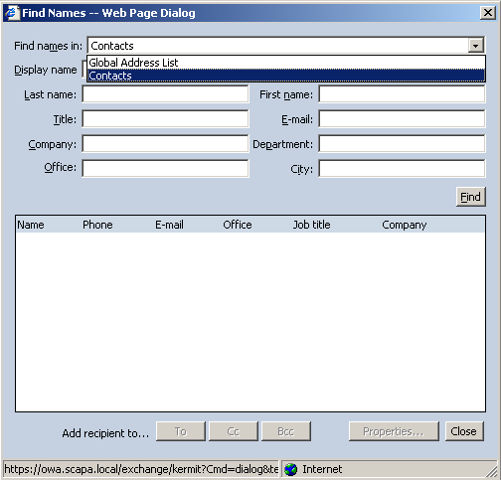

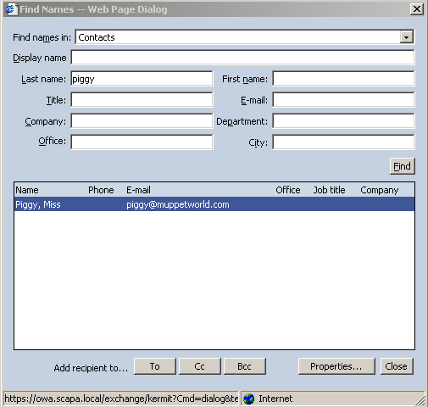

Select the relevant field you want to add the contact to (To, CC, BCC), then click close.

The address will look as shown below.

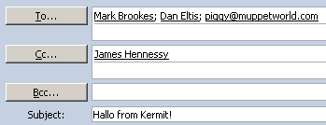

Adding Attachments to your message

To add an attachment to your message click the attachment button

Once clicked the attachment button will display the following dialog box:

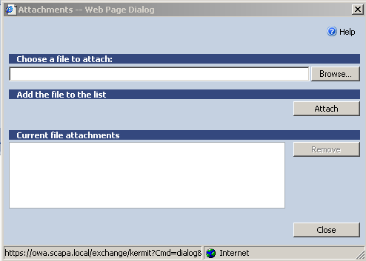

Click the browse button to choose the file you want to attach.

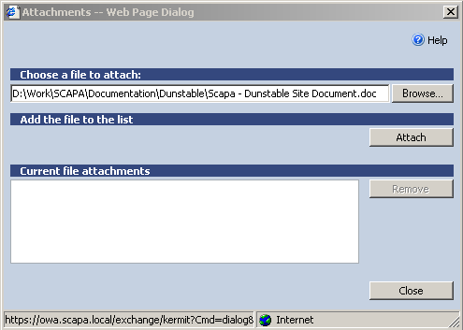

Click the attach button

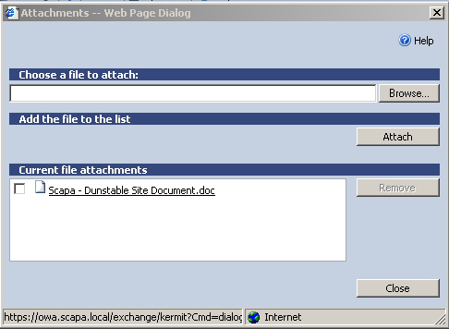

Click Close. The Attachment will then appear attached to the message.

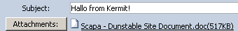

Typing Your Message

There are different fonts, colours and formatting that can be used within you message these are chosen from the following toolbar:

Sending Your Message

Once your message has been typed click the send button.

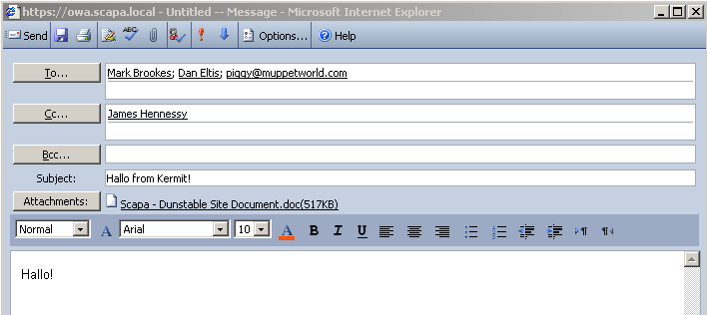

The message should appear in you Sent Items folders.

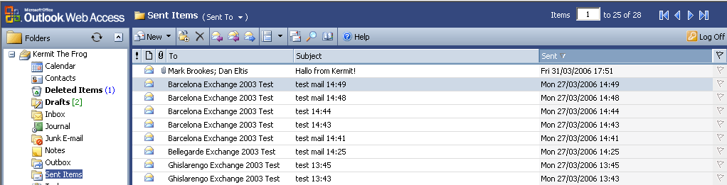

Receiving Mail in Outlook Web Access

When new mail has been received, Outlook Web Access will pop up a notification at the bottom of the screen to notify you. If you click the pop up the web page will update automatically. You can also press the refresh button on Internet Explorer to refresh the page

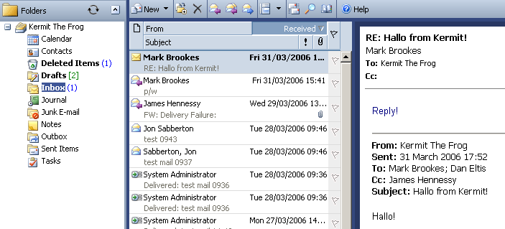

The new mails will appear in bold with an unread number displayed in your navigation pane. Once you have read your mail either in the preview pane or by double clicking the mail the page should refresh. If it doesn’t just click the refresh button.

