8D (8 Disciplines of Problem Solving)

Problem Definition and Root Cause Analysis.
It is a common mistake of problem solving teams to jump to conclusions and make decisions based on feelings and non verified observations. The team must stay focused on the facts and what solutions can be linked to these facts.
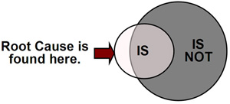
8D is a formal and meticulous approach to solving complex problems. The 8D process uses a combination of effective techniques and tools to focus a cross functional team through a very detailed analysis of the problem that has brought them together. When followed diligently, 8D will lead to the discovery of the root causes and possible solutions with consideration of cost, timing, effect on customers, and the impact on the organization.

The Basic Premise of the 8D Process
Problems cannot be solved without definition of the root causes. This process for defining the root causes takes several steps:

Steps
D1: Assemble a cross-functional team of experts
D2: Define the Problem fully
D3: Implement and verify Interim Containment Actions (ICAs) as needed. Also
known as Temporary Fixes.
D4: Identify and Verify Root Cause
D5: Choose and verify Permanent Corrective Actions (PCAs). Preventive Actions
are also chosen.
D6: Implement and validate PCAs
D7: Prevent recurrence of the Problem/Root Cause
D8: Recognize the efforts of the Team
Tools and techniques utilized in 8D to define root causes and their possible solutions are as follows:
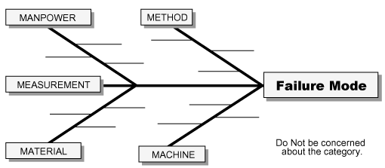
- Problem Statement (What is wrong with what?)
- 5 Why technique
- Is and Is Not
- Difference and Change Analysis
- Fishbone/Cause and Effects
- Active and Passive Verification

The 8D process originally arose out of Ford Motor Company, where it went through several iterations over several decades, including "TOPS" or "Team Oriented Problem Solving". In the late 1990's, Ford developed a revised version of the 8D process, officially titled "Global 8D" (G8D) which is the current global standard for Ford and many other companies in the automotive supply chain. The major revisions to the process are as follows:
- Addition of a D0 (D-Zero) step as a gateway to the process. At D0, the team documents the symptoms that initiated the effort along with any Emergency Response Actions (ERAs) that were taken before formal initiation of the G8D. D0 also incorporates standard assessing questions meant to determine whether a full G8D is required. The assessing questions are meant to ensure that in a world of limited problem-solving resources, the efforts required for a full team-based problem-solving effort are limited to those problems that warrant these resources.
- Addition of Escape Point to D4 through D6. The idea here is to consider not only the Root Cause of a problem, but equally importantly, what went wrong with the control system in allowing this problem to escape. Global 8D requires the team to identify and verify this Escape Point (defined as the earliest control point in the control system following the Root Cause that should have detected the problem but failed to do so) at D4. Then, through D5 and D6, the process requires the team to choose, verify, implement, and validate Permanent Corrective Actions to address the Escape Point.

