Task 1: Retrieve Webpage Title (5 marks)
● Objective: Verify the page title of the Registration page.
● Steps:
1. Open the provided URL: https://practice.qabrains.com/registration
2. WAIT until the page loads using ExpectedConditions.urlContains("registration")
3. Retrieve the webpage title using driver.getTitle().
4. Validate the page title using Java conditional logic and return the title as String
● Expected Output:
Page Title = "QA Practice Site" (verify exact title text)
Answer

Ensure the application navigates to the correct Registration page & verify that the Registration page loads successfully and that the webpage title is exactly "QA Practice Site".

Our first aim is to open the webpage https://practice.qabrains.com/registration using webdriver. Using WebDriverWait we give some time for browsers to load the page. We check the title of the page using get title using driver.getTitle , if the requirements meet then we get the value and print output.

Program
package Examtest;
import java.time.Duration;
import org.openqa.selenium.WebDriver;
import org.openqa.selenium.chrome.ChromeDriver;
import org.openqa.selenium.support.ui.ExpectedConditions;
import org.openqa.selenium.support.ui.WebDriverWait;
public class Exam1 {
public static void main(String[] args)
{
WebDriver driver;
driver = new ChromeDriver();
driver.manage().window().maximize();
driver.get("https://practice.qabrains.com/registration");
WebDriverWait wait = new WebDriverWait(driver, Duration.ofSeconds(10));
wait.until(ExpectedConditions.urlContains("registration"));
String actualTitle = driver.getTitle();
System.out.println("Page Title = \"" + actualTitle + "\"");
String expectedTitle = "QA Practice Site";
if (actualTitle.equals(expectedTitle)) {
System.out.println("Title Validation Sucessfully Passed");
} else {
System.out.println("Sorry, Title Validation Failed");
}
}

}

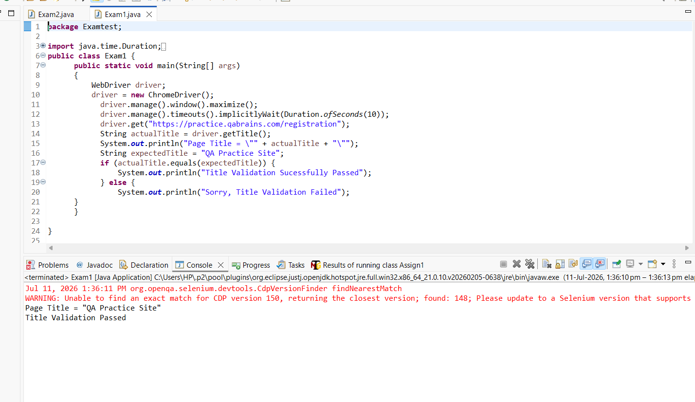

Task 2: Verify Registration Form Elements(10 marks)
● Objective: Validate the presence of Form fields and sign up button on the registration form.
● Steps:
1. Open the URL: https://practice.qabrains.com/registration
2. Wait for all form elements to load using ExpectedConditions.visibilityOfAllElementsLocatedBy()
3. Create a HashMap to store the result
Syntax: Map<String, Boolean> mapName = new HashMap<>();
4. Verify visibility of each required element: Name, Country, Account Type, Email, Password, Confirm Password, Sign Up button. Each check returns a boolean value
5. Store visibility of elements in the Map: key = element name, value = boolean variable
6. Return the Map with all element visibility details(Boolean values indicating element presence.)
● Expected Output:
{EmailField=true, nameField=true, Country=true, ConfirmPasswordField=true, PasswordField=true, AccountType=true, SignUpBotton=true}

Answer
Our first aim is to open the webpage https://practice.qabrains.com/registration using webdriver. After locating the required elements present in the website , list the items into a HashMap list, with help boolean we check the presence and store values into Map.
After that print the values in the required format

package Examtest;
import java.time.Duration;
import java.util.LinkedHashMap;
import java.util.Map;
import org.openqa.selenium.By;
import org.openqa.selenium.WebDriver;
import org.openqa.selenium.chrome.ChromeDriver;
import org.openqa.selenium.support.ui.ExpectedConditions;
import org.openqa.selenium.support.ui.WebDriverWait;
public class Exam2 {

public static void main(String[] args) {

WebDriver driver = new ChromeDriver();
driver.manage().window().maximize();
driver.get("https://practice.qabrains.com/registration");
WebDriverWait wait = new WebDriverWait(driver, Duration.ofSeconds(10));

wait.until(ExpectedConditions.visibilityOfElementLocated(By.xpath("//input")));
Map<String, Boolean> formElements = new LinkedHashMap<>();

boolean nameField = driver.findElement(By.id("name")).isDisplayed();
boolean country = driver.findElement(By.id("country")).isDisplayed();
boolean accountType = driver.findElement(By.id("account")).isDisplayed();
boolean emailField = driver.findElement(By.id("email")).isDisplayed();
boolean passwordField = driver.findElement(By.id("password")).isDisplayed();
boolean confirmPasswordField = driver.findElement(By.id("confirm_password")).isDisplayed();
boolean signUpButton = driver.findElement(By.xpath("//button[@type='submit']")).isDisplayed();

formElements.put("\n Email Field", emailField);
formElements.put("\n Name Field", nameField);
formElements.put("\n Country", country);
formElements.put("\n Confirm Password Field", confirmPasswordField);
formElements.put("\n Password Field", passwordField);
formElements.put("\n AccountType", accountType);
formElements.put("\n SignUp Button", signUpButton);
System.out.println(formElements);
}
}

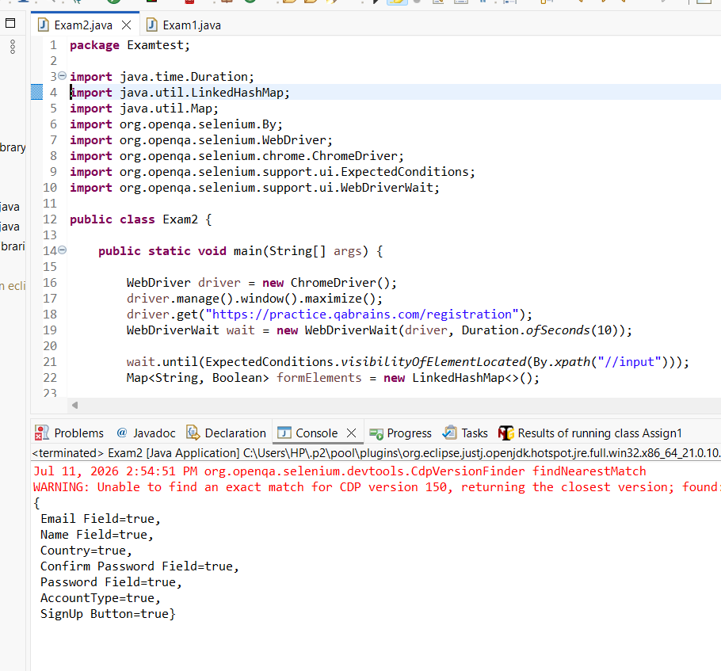

Task 3: Perform Sample Registration and return URL after successful Signup(10 marks)
● Objective: Automate the registration form submission.
● Steps:
1. Open the Registration page: https://practice.qabrains.com/registration
2. Initialize explicit wait to handle dynamic elements
3. Wait until all form elements are visible on the page using ExpectedConditions.visibilityOfAllElementsLocatedBy()
4. Enter the Name in the Name field
5. Select Country from the Country dropdown. Choose "India" from the available options
6. Select Account Type from the Account dropdown. Choose "Engineer" from the available options
7. Enter Email in the Email field
8. Enter Password in the Password field
9. Enter the same Password in the Confirm Password field
10. Click on the Sign Up button to submit the form
11. Wait until the URL contains "registered=true" using ExpectedConditions.urlContains() to confirm successful registration
12. Capture the current URL after registration
13. Return the URL to indicate successful registration
Expected Output:
Redirected URL: https://practice.qabrains.com/registration?registered=true
Answer
Our first aim is to open the webpage https://practice.qabrains.com/registration using webdriver. After locating the required elements present in the website , enter the values into specified fields then press the specified button, after that we have to check the URL value. If the value is changed to the registration then print the value .

package Examtest;
import java.time.Duration;
import org.openqa.selenium.By;
import org.openqa.selenium.WebDriver;
import org.openqa.selenium.chrome.ChromeDriver;
import org.openqa.selenium.support.ui.ExpectedConditions;
import org.openqa.selenium.support.ui.Select;
import org.openqa.selenium.support.ui.WebDriverWait;
public class Exam3 {
public static void main(String[] args) {
WebDriver driver = new ChromeDriver();
driver.manage().window().maximize();
driver.get("https://practice.qabrains.com/registration");
WebDriverWait wait = new WebDriverWait(driver, Duration.ofSeconds(10));
wait.until(ExpectedConditions.visibilityOfElementLocated(By.xpath("//input")));
driver.findElement(By.id("name")).sendKeys("Aju");
Select country = new Select(driver.findElement(By.id("country")));
country.selectByVisibleText("India");
Select accountType = new Select(driver.findElement(By.id("account")));
accountType.selectByVisibleText("Engineer");
driver.findElement(By.id("email")).sendKeys("aju123@example.com");
driver.findElement(By.id("password")) .sendKeys("Test@123");
driver.findElement(By.id("confirm_password")).sendKeys("Test@123");
driver.findElement(By.xpath("//button[text()='Signup']")).submit();

wait.until(ExpectedConditions.urlContains("registered=true"));
String currentURL = driver.getCurrentUrl();
System.out.println("Current URL: " + currentURL);

}
}

