1. **Select Your Operating System (OS): Choose an operating system that best suits your preferences and project requirements. Download and Install Windows 11.**[**https://www.microsoft.com/software-download/windows11**](https://www.microsoft.com/software-download/windows11)

Objective: Install Windows 11 on a designated computer using a bootable USB drive created with Rufus, a third-party utility.

Materials:

* Target computer meeting Windows 11 system requirements
* Bootable USB drive with 8GB of storage space
* Download copy of Rufus from the official website (<https://rufus.ie/>)

Procedure:

1. Media Preparation with Rufus:
   * Downloaded a valid Windows 11 ISO file from the Microsoft website (<https://www.microsoft.com/software-download/windows11>).
   * Launched the downloaded Rufus application.
   * Identified the target USB drive by selecting it from the "Device" dropdown menu.
   * Clicked the "SELECT" button next to "Boot selection" and chose the downloaded Windows 11 ISO file.
   * Verified that the "Partition scheme" and "Target system" options were set to appropriate values but I chose GPT for UEFI systems based on the target computer's configuration.
   * Left other settings at their default values.
   * Clicked "Start" to initiate the process of creating the bootable USB drive. Confirmed the prompt to erase all data on the chosen drive. Then I waited for the installation to complete and ejected my bootable USB drive from the computer on which I had downloaded the Windows 11 ISO file.
2. BIOS/UEFI Configuration:
   * Restarted the target computer.
   * During the boot process, pressed the Esc key to enter the BIOS/UEFI settings menu .
   * Located the boot order settings within the BIOS/UEFI menu.
   * Modified the boot order to prioritize the newly created bootable USB drive.
   * Saved the changes and exited the BIOS/UEFI menu.
3. Windows 11 Installation:
   * The target computer booted from the USB drive and commenced the Windows 11 installation process.
   * Followed the on-screen instructions, selecting the desired language, keyboard layout, and time zone.
   * A product key was prompted, but I chose to skip for now since I did not have a product key.
   * Selected the Custom installation type.
   * Chose C drive for Windows 11 installation.
   * The installation process began and took some time.
4. Post-Installation:
   * Once the installation was complete, the computer restarted automatically.
   * Completed the initial setup screens for language, region, and user account creation.
   * The Windows 11 desktop loaded, indicating a successful installation.

Conclusion: Successfully installing Windows 11 on the target computer was achieved by utilizing Rufus to create a bootable USB drive.

1. **Install a Text Editor or Integrated Development Environment (IDE): Select and install a text editor or IDE suitable for your programming languages and workflow. Download and Install Visual Studio Code.**[**https://code.visualstudio.com/Download**](https://code.visualstudio.com/Download)

Visual Studio Code (VS Code) is a powerful code editor that works great for various programming languages, including Python. This guide will walk you through downloading and installing VS Code on Windows 11, along with setting up Python extension for enhanced development experience.

Prerequisites:

* Internet connection (recommended for download and updates)
* Windows 11 operating system

Downloading VS Code:

1. Open your web browser and visit the official Visual Studio Code download page: <https://code.visualstudio.com/download>
2. You'll see the download options for various operating systems. Under the "Windows" section, click the download button (usually labeled "Download for Windows").

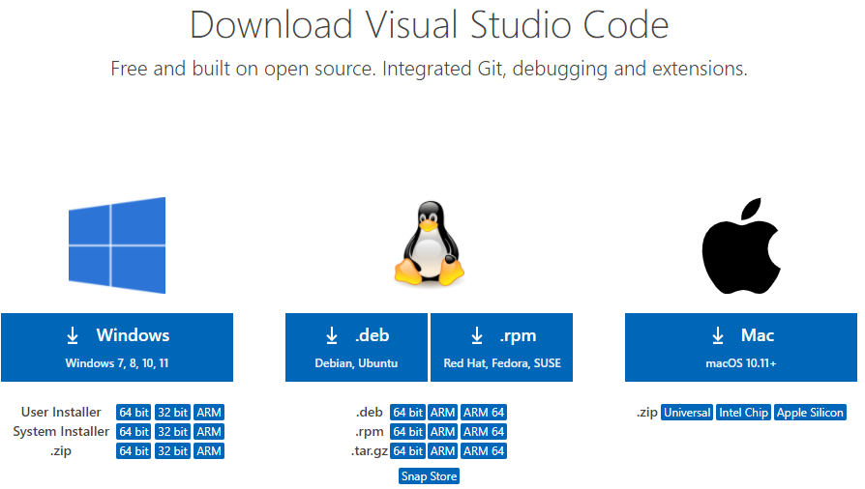

Visual Studio Code Download Page

Running the Installer: Once the download finishes, locate the downloaded file. It will typically be named "VSCodeUserSetup-{version}.exe". Double-click the downloaded installer file to begin the setup process.

Installation Options:

1. The VS Code installer will open with a welcome message. Click "Next" to proceed.

VS Code Installer Welcome Screen

1. The next screen allows you to choose the installation location for VS Code. The default location is typically C:\Users\{Username}\AppData\Local\Programs\Microsoft VS Code. You can keep the default or choose a different location if desired. Click "Browse" to select a different location.
2. You can also choose whether to create a desktop shortcut for VS Code. This is recommended for easy access. Leave the checkbox ticked if you want a shortcut.
3. Review the license terms. If you agree, click the checkbox and then click "Install" to begin the installation process.

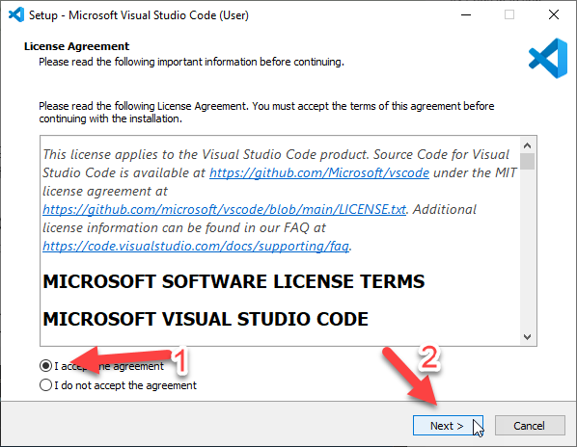

VS Code Installer License Terms and Installation Options

Next

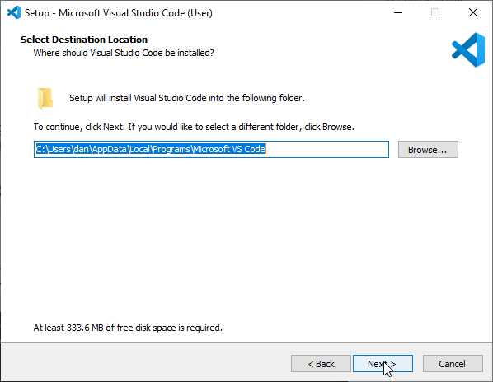

Next

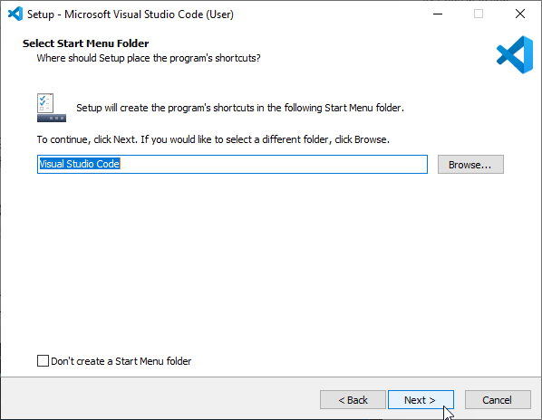

Next



Next

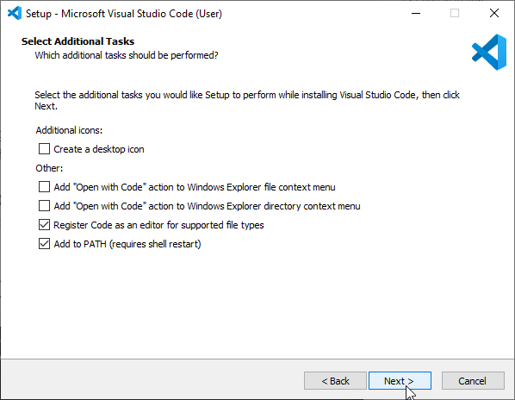

Next

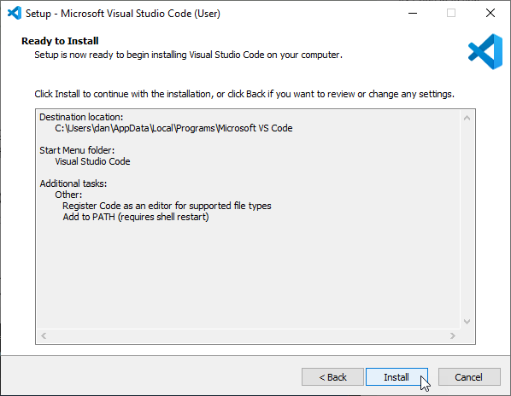

Next

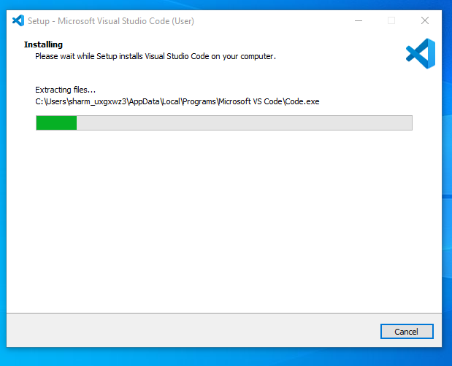

Installation Progress:The installation process will take a few minutes depending on your internet speed and system configuration. You'll see a progress bar indicating the installation status.

VS Code Installer Installation Progress

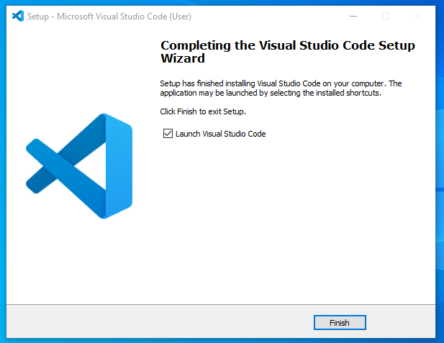

Launch VS Code: Once the installation is complete, you'll see a completion message. You can click the "Finish" button to close the installer. You can now launch VS Code by clicking on the shortcut (if created) on your desktop or by searching for it in the Start menu.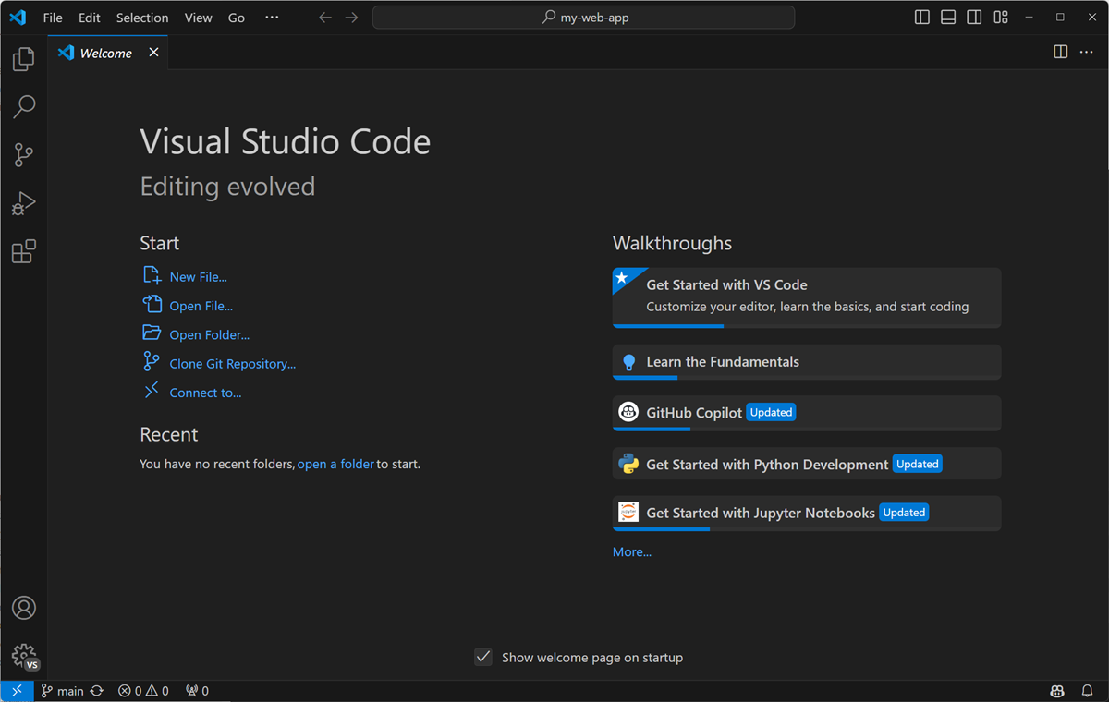

VS Code Installer Installation Complete and you have successfully downloaded and installed Visual Studio Code on your Windows 11 system.

After installing VS Code, you can personalize it to create an optimal coding environment that suits your preferences and workflow. Here are some initial configurations and settings to consider:

Themes and Fonts:

* Theme: VS Code offers a variety of built-in themes (light and dark) that can affect the overall look and feel of the editor. You can explore them under the "File" -> "Preferences" -> "Settings" menu and search for "Theme". Choose one that you find aesthetically pleasing and easy on your eyes. Popular themes include Dark+, Monokai, and One Dark Pro.
* Font: Setting a comfortable font size and type can significantly improve your coding experience. You can adjust these preferences under "Settings" by searching for "Font Size" and "Font Family". Consider fonts like Fira Code, Consolas, or Cascadia Mono, designed for code readability.

Extensions:

VS Code offers a vast library of extensions that extend its functionality and cater to specific programming languages or development tasks. Here are some highly recommended extensions for an enhanced coding experience:

* Python (by Microsoft): This essential extension provides IntelliSense, code completion, linting, debugging, and other functionalities specifically for Python development. (Already installed as described in the previous steps)
* Code Runner: Allows you to directly run code snippets or entire files within VS Code, streamlining your development workflow.
* Pylint: A popular Python linter that helps identify potential errors and code style issues in your Python projects.
* GitLens: Supercharges your Git integration within VS Code, allowing you to visualize code history, blame commits, and navigate branches effortlessly.
* Bracket Pair Colorizer: Highlights matching brackets and parentheses in different colors, making your code easier to read and navigate.
* Settings Sync: Synchronizes your VS Code settings and extensions across multiple machines, ensuring a consistent coding environment wherever you work.

Installing Python extension:

1. Open VS Code.
2. Click on the Extensions icon (looks like a box with four smaller squares inside) in the Activity bar on the left side of the window.
3. 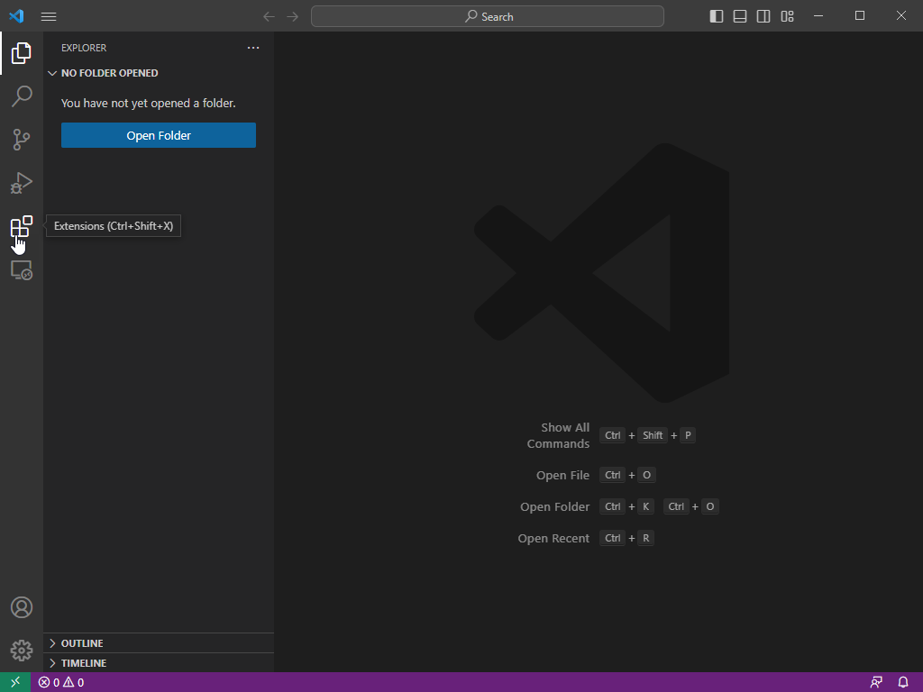

VS Code Extensions Icon Highlighted

1. In the Extensions search bar, type "python" and press Enter. This will display a list of extensions related to Python development.
2. Look for the extension named "Python" by Microsoft. Click the "Install" button next to it.

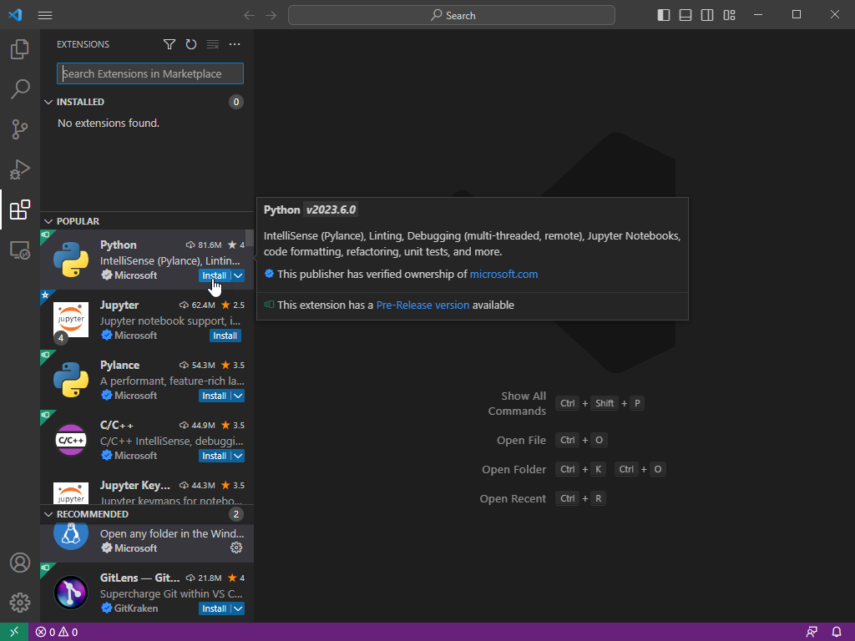

Settings:

* Auto Save: Enabling "Auto Save" under "Settings" -> "Files" ensures your code is automatically saved at regular intervals, preventing data loss in case of unexpected crashes.
* Keyboard Shortcuts: VS Code offers many default keyboard shortcuts for various actions. You can customize these shortcuts under "Settings" -> "Keyboard Shortcuts" to align with your preferences or leverage existing shortcut sets from other code editors you're familiar with.
* Terminal: Consider configuring your preferred terminal within VS Code for seamless integration with your command line tools. You can adjust these under "Settings" -> "Terminal".

These are just some general recommendations. The best configuration for your VS Code environment depends on your specific needs and coding style. Explore the vast array of extensions and settings available to personalize your experience and create an optimal coding environment that boosts your productivity and enjoyment.

1. **Set Up Version Control System: Install Git and configure it on your local machine. Create a GitHub account for hosting your repositories. Initialize a Git repository for your project and make your first commit.**[**https://github.com**](https://github.com/)

The objective of this assignment is to set up a version control system using Git on a Windows 11 machine, configure it, create a GitHub account for hosting repositories, initialize a Git repository for a project, and make the first commit.

Step 1: Install Git

* + I visited the official Git website at [git-scm.com](https://git-scm.com/).
  + I clicked on the "Download" button to obtain the Git installer for Windows.
  + I located the downloaded installer (Git-2.45.2-64-bit.exe) and double-clicked to execute it.
  + I followed the installation wizard, using the default settings unless specific preferences were required:
    - I selected my preferred text editor when prompted which was vscode for my case.
    - I chose the option to "Use Git from the command line and also from 3rd-party software."
    - For line ending conversions, I selected "Checkout Windows-style, commit Unix-style line endings."
  + I completed the installation process.

Step 2: Configure Git

* + Git Bash is included with the Git for Windows installation. I opened Git Bash by searching for it in the Start menu.
  + In Git Bash, I configured my user information with the following commands:

git config --global user.name "Ajuleta"

git config --global user.email "gavinopio256@gmail.com"

* + To verify the configuration, I ran:

git config –list

* + This command displayed my Git settings, including username and email.

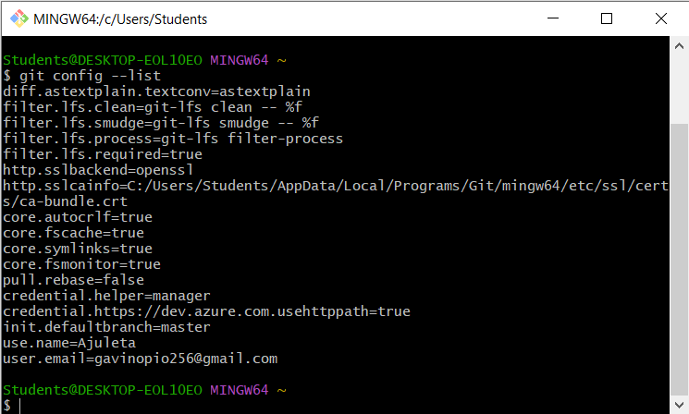

### Step 3: Create a GitHub Account

* + I navigated to [GitHub](https://github.com/) and clicked on the "Sign up" button in the upper right corner.
  + I followed the instructions to create my GitHub account.

Step 4: Initialize a Git Repository

* + I opened Git Bash and navigated to my project folder using the following command:

cd C:\Users\Students\Desktop\PLP\GIT\NewEcommerceApp

* + I initialized a new Git repository in my project folder by executing:

git init

Step 5: Make Your First Commit

* + To stage all changes in my project folder, I ran:

git add .

* + I committed the staged changes with an appropriate message:

git commit -m "Initial commit"

Step 6: Push to GitHub

* + I logged in to my GitHub account and clicked the + icon in the upper right corner.
  + I selected “New repository” and filled in the repository details such as name and description.
  + I clicked Create repository.
  + I copied the URL of my new GitHub repository.
  + In Git Bash, I linked my local repository to the GitHub repository using:

git remote add origin https://github.com/Ajuleta/NewEcommerceApp.git

* + I pushed my initial commit to the remote repository on GitHub:

git push -u origin master

I had an error report “src refspec master does not match any” in trying to push my commits to the repository but I later got a solution from <https://www.freecodecamp.org/news/error-src-refspec-master-does-not-match-any-how-to-fix-in-git/> on how to resolve the error.

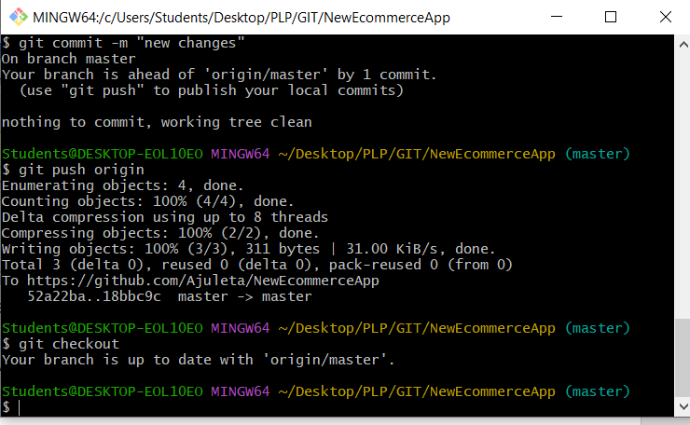

1. **Install Necessary Programming Languages and Runtimes: Install Python from**[**http://wwww.python.org**](http://wwww.python.org/)**programming language required for your project and install their respective compilers, interpreters, or runtimes. Ensure you have the necessary tools to build and execute your code.**

The goal of this assignment is to install Python on my Windows 11 machine and ensure I have the necessary tools to build and execute code for my project.

Step 1: Download Python

* + I navigated to [python.org](https://www.python.org/) using my web browser.
  + On the homepage, I located the download section and chose the latest stable release for Windows.

Step 2: Install Python

* + I clicked on the download link for the desired Python version. This downloaded the installer to my computer.
  + I located the downloaded installer file (python-3.12.4.exe) and double-clicked to run it.
  + During the installation process, I could customize the installation if needed. However, I decided to use the default settings.
  + I ensured that the "Add Python to PATH" option was checked. This allowed me to run Python from the command line.
  + I followed the prompts to complete the installation.

Step 3: Verify the Installation

* + I opened Command Prompt by searching for it in the Start menu.
  + I typed the following command and pressed Enter:

python –version

* + This displayed the version of Python that I installed.

Python 3.12.4

* + Pip is the package installer for Python. I verified its installation by typing:

pip --version

* + This displayed the version of Pip installed.

pip 24.0 from C:\Program Files\Python312\Lib\site-packages\pip (python 3.12)

Step 4: Install Necessary Packages and Tools

* + It is good practice to upgrade Pip to the latest version. I ran:

pip install --upgrade pip

* + For project-specific dependencies, it is recommended to use a virtual environment. I installed the virtual environment module which was not installed:

python -m pip install virtualenv

1. **Create a Virtual Environment**:
   * I navigated to my project directory and created a virtual environment:

cd C:\Users\Students\Desktop\PLP\my_project

python -m venv venv

1. **Activate the Virtual Environment**:
   * I activated the virtual environment:

.\venv\Scripts\activate

1. **Install Project Dependencies**:
   * With the virtual environment activated, I installed necessary packages specified by my project in this case Django

Python -m pip install Django

But since I had initially installed it just gave me this screen

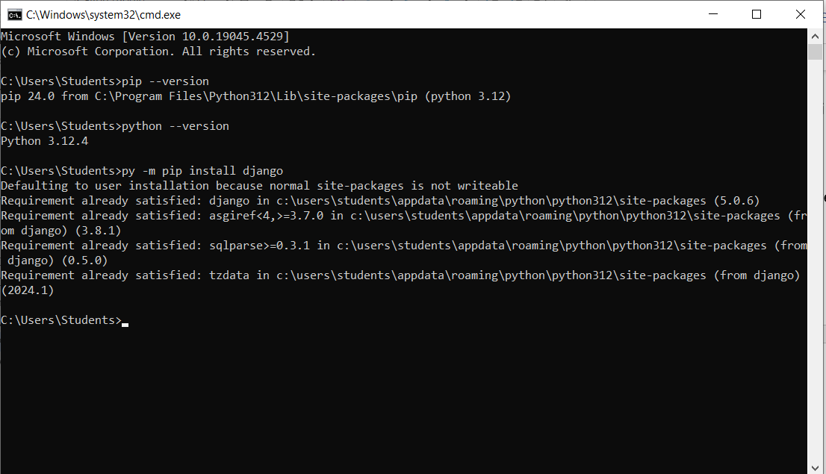

Step 5: Verify the Setup

* + I created a simple Python script to verify the setup. I created a file named test.py with the following content:

print("Hello, Python!")

* + I ran the script from the command line:

python test.py

* + The script ran and output Hello, Python!, confirming that Python was installed and working correctly.

1. **Install Package Managers: If applicable, install package managers like pip (Python).**

Here's how to install pip, the package manager for Python, on a Windows machine:

Method 1: Using the Official Python Installer.

1. Download the latest Python installer from the official website: <https://www.python.org/downloads/>
2. During installation, make sure to check the box for "Add Python to PATH". This ensures you can run pip commands from anywhere in your command prompt.
3. Open a Command Prompt window (search for "cmd" in the Start menu).
4. Type pip --version and press Enter.

If pip is installed correctly, you should see the version number displayed.

Method 2: Using get-pip.py (For users who already have Python installed)

1. Download the get-pip.py script from the Python Packaging Authority: <https://pip.pypa.io/en/stable/installation/>
2. Save get-pip.py to a convenient location on your computer (e.g., your Desktop).
3. Open a Command Prompt window (search for "cmd" in the Start menu).
4. Use the cd command to navigate to the directory where you saved get-pip.py. For example, if you saved it on your Desktop, type:

cd Desktop

1. Run the following command to install pip using Python:

python get-pip.py

1. Follow the on-screen instructions during the installation process.

Once you've completed either method, open a new Command Prompt window and type pip --version again. You should see the pip version displayed, confirming successful installation.

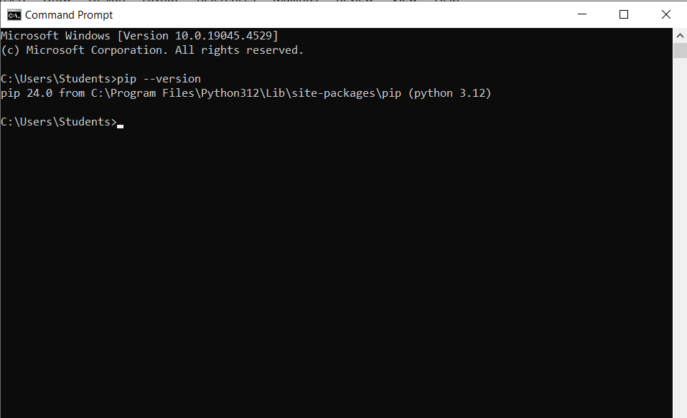

1. Configure a Database (MySQL): Download and install MySQL database. <https://dev.mysql.com/downloads/windows/installer/5.7.html>

Here's a guide on downloading and installing MySQL database on Windows, including screenshots for each step. We'll be using the recommended MSI Installer method.

**1. Download MySQL Installer:**

* Visit the MySQL downloads page for Windows: <https://dev.mysql.com/downloads/mysql/>

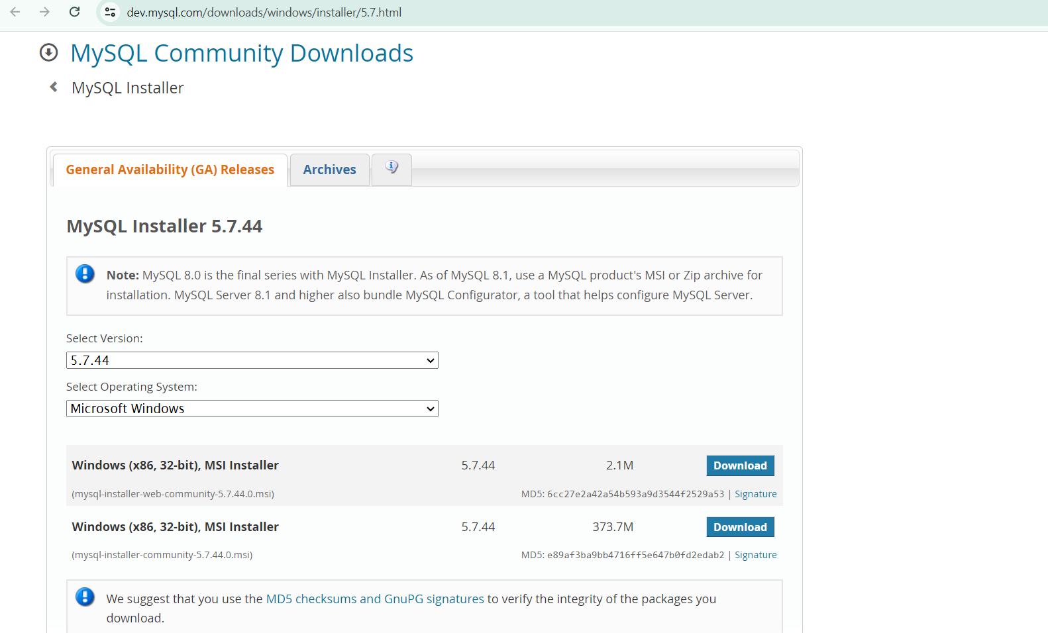

* Under "MySQL Community Server", select the version you want to install (e.g., 8.0.30). Click the "no thanks, just start my download" link.

**2. Run the Installer:**

* Double-click the downloaded .msi file (e.g., mysql-installer-community-8.0.30.msi).

**3. Choose Setup Type:**

* In the installer window, select "Custom" setup type (unless you have specific reasons to choose another option). Click "Next".

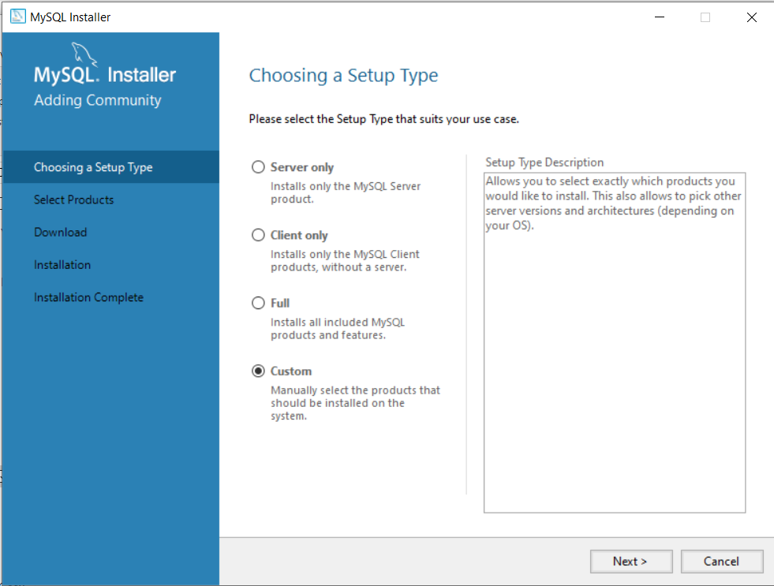

Next

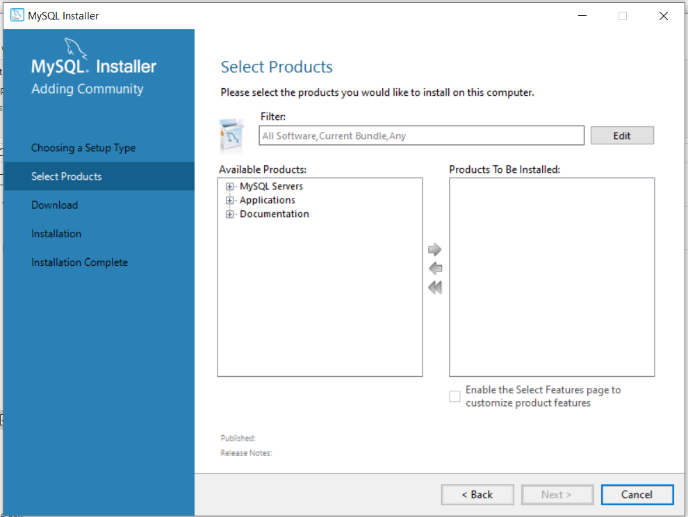

Next

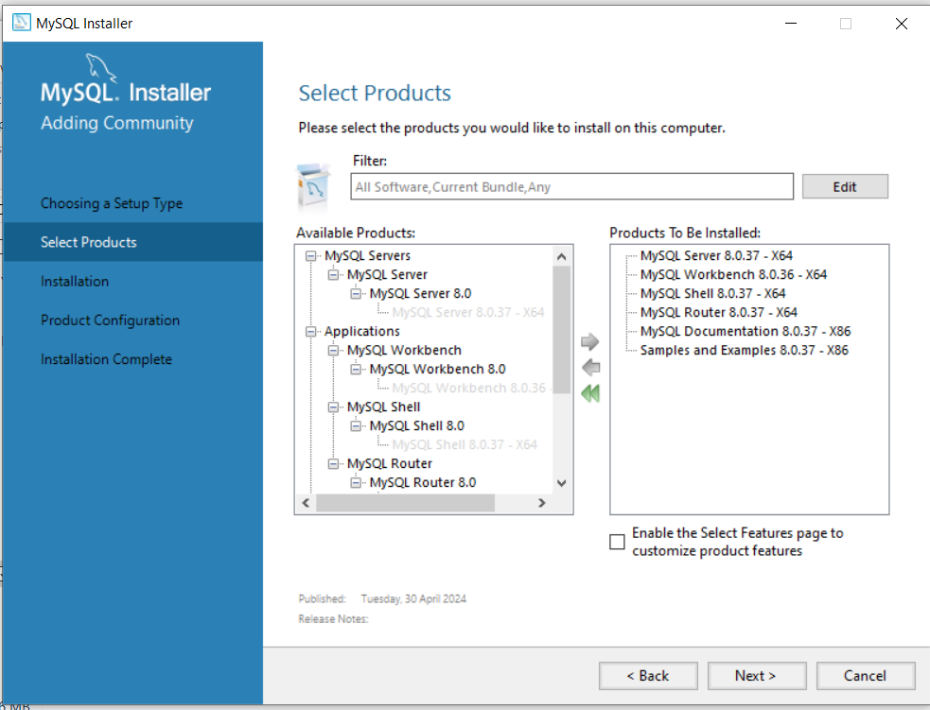

Next

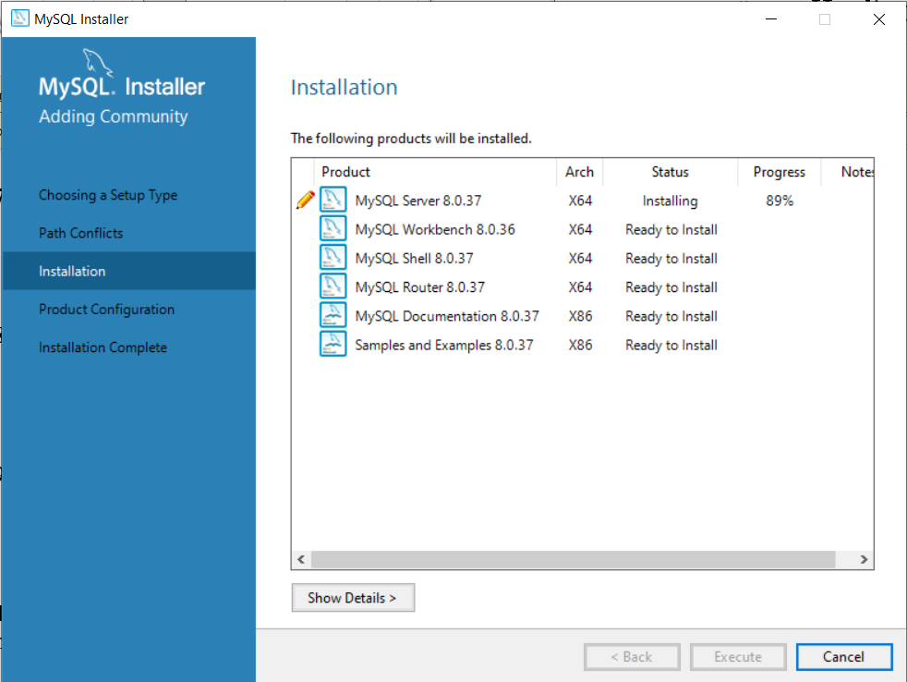

Next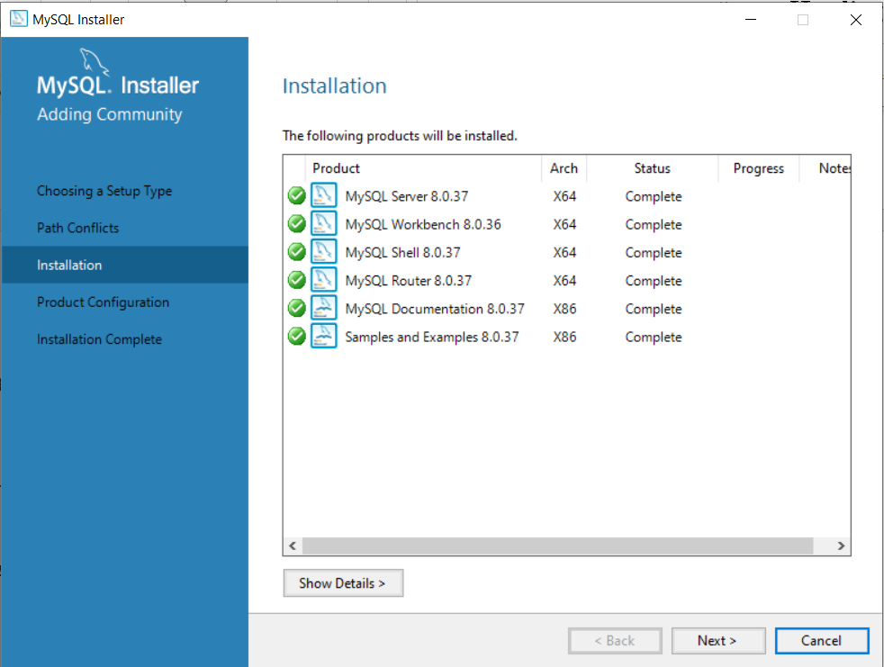

Next

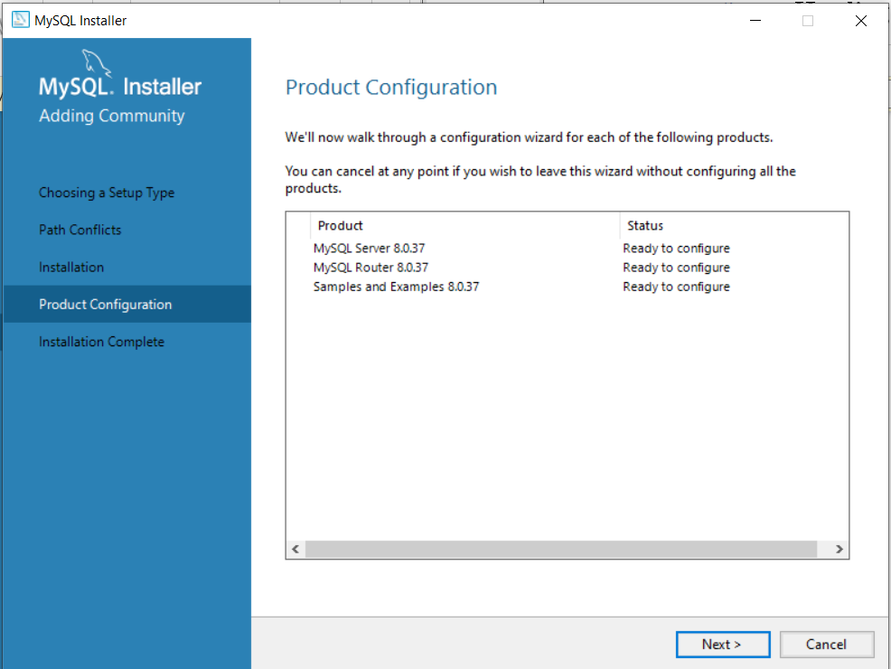

**4. Product Selection:**

* By default, all products are selected. You can choose to deselect some components if you don't need them. Click "Next".

**5. Configuration:**

* Here, we'll use the MySQL Configurator tool for configuration. Leave the "Standard Configuration" option selected and click "Next".

**6. Security Configuration:**

* This is a crucial step. Set a strong password for the root user (the main administrative account). Enter and confirm the password. Optionally, you can enable "Check for updates" and choose the update method. Click "Next".

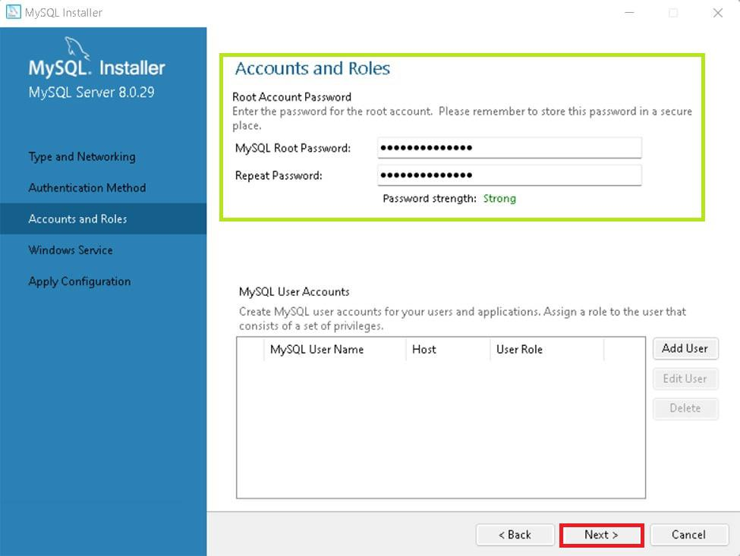

**7. Port Configuration:**

* The default port for MySQL is 3306. You can keep it or change it if needed (not recommended for beginners). Click "Next".

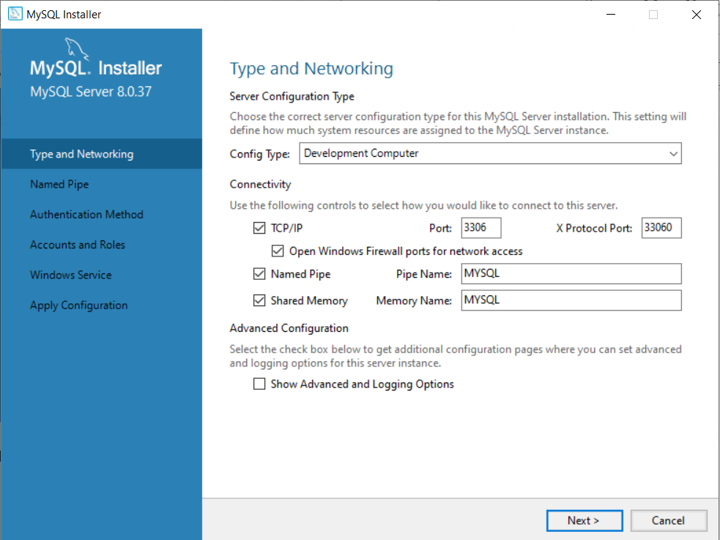

**8. Advanced Options:**

* This step is for experienced users. Leave the defaults unless you have specific requirements. Click "Next".

**9. Installation:**

* Review the summary of your configuration choices. Click "Execute" to begin the installation.

The installation process will take a few minutes. Once completed, you'll see a success message. Click "Finish" to close the installer.

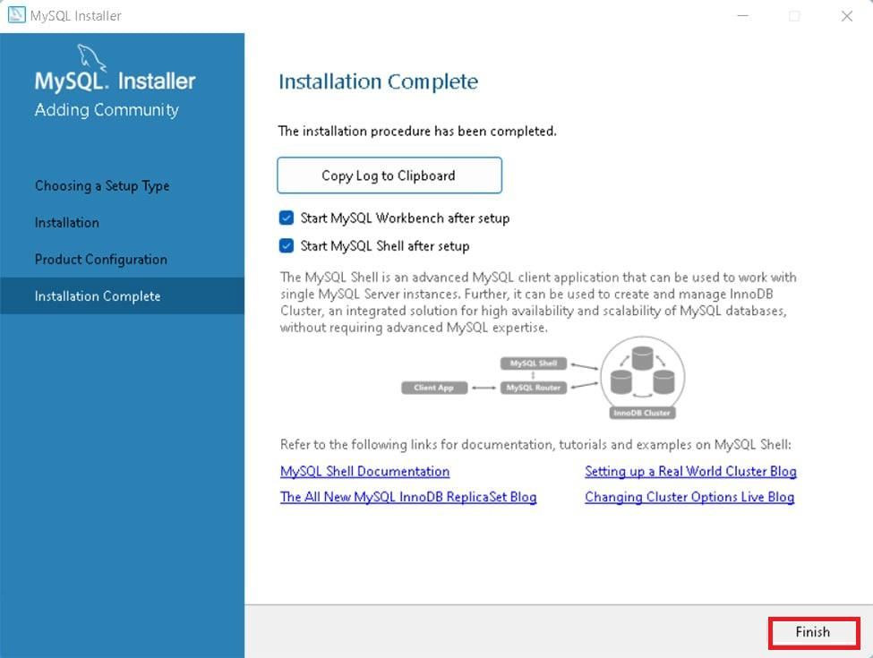

**Additional Notes:**

* After installation, you can start the MySQL service from the Windows Services window (search for "services.msc" in the Start menu).
* To connect to the MySQL server, you can use the MySQL command-line client or a graphical tool like MySQL Workbench.

By following these steps and referring to the screenshots, you should be able to successfully download and install MySQL database on your Windows machine

MySQL for Windows is a user-friendly database system that helps manage and organize data efficiently. With a simple installation process, it provides a reliable platform for storing and retrieving information. Its compatibility makes it a Preferred option for businesses and developers looking for a strong Windows database solution.

1. **Explore Extensions and Plugins: Explore available extensions, plugins, and add-ons for your chosen text editor or IDE to enhance functionality, such as syntax highlighting, linting, code formatting, and version control integration.**

The objective of this assignment is to explore available extensions, plugins, and add-ons for Visual Studio Code (VS Code) to enhance its functionality. This includes finding and installing extensions for syntax highlighting, linting, code formatting, and version control integration.

* + I launched Visual Studio Code from the Start menu.
  + I opened the Extensions view by clicking on the Extensions icon in the Activity Bar on the side of the window or by using the keyboard shortcut Ctrl+Shift+X.
  + **Python**: I searched for the "Python" extension by Microsoft and installed it. This extension provides rich support for Python, including syntax highlighting.

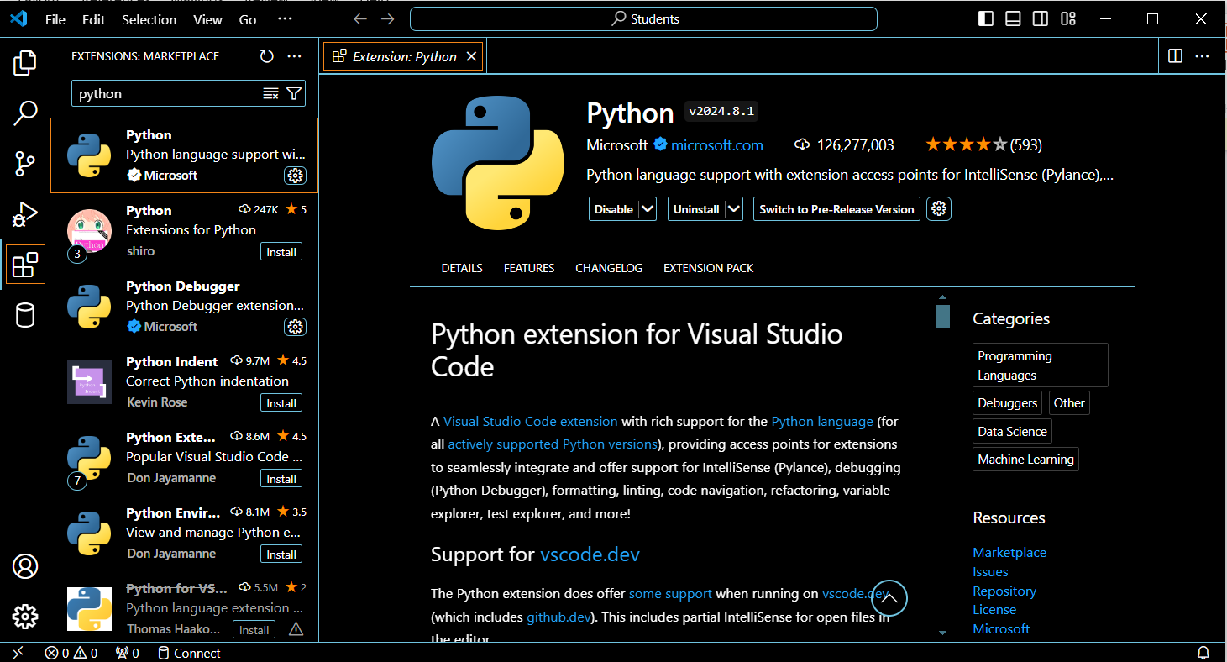

* + **JavaScript/TypeScript**: I searched for the "ESLint" extension for linting JavaScript and TypeScript and installed it.

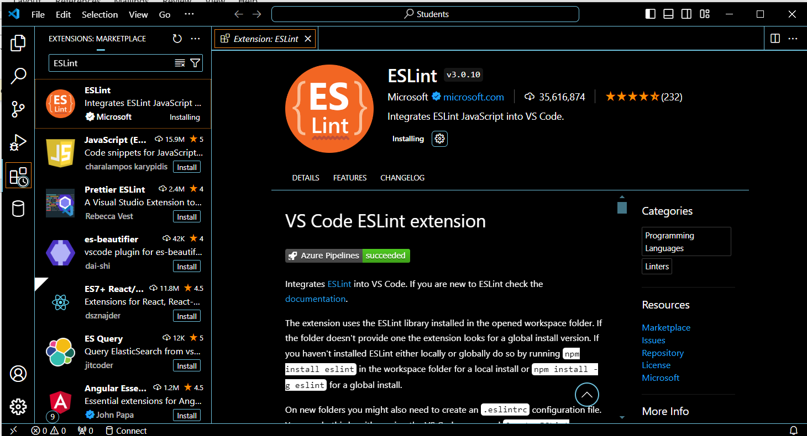

* + **HTML/CSS**: I searched for the "HTML CSS Support" extension to enhance HTML and CSS syntax highlighting and installed it.

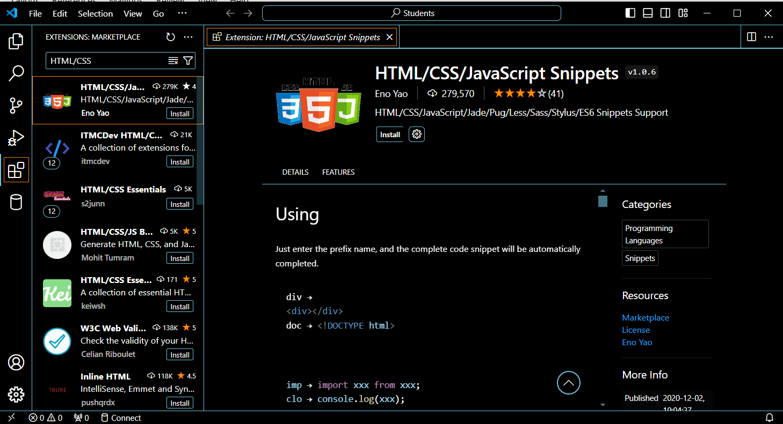

* + **Prettier**: I installed the "Prettier - Code formatter" extension for consistent code formatting across various languages.

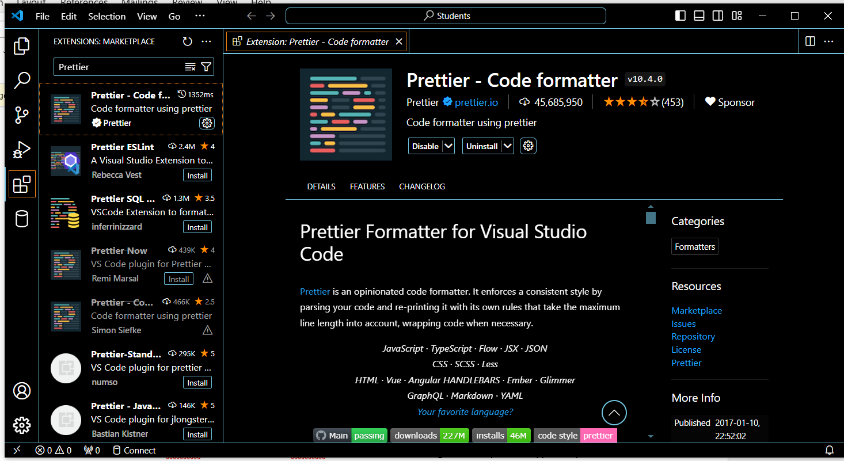

* + **Pylint**: For Python, I installed the "Python" extension which includes Pylint for linting Python code.

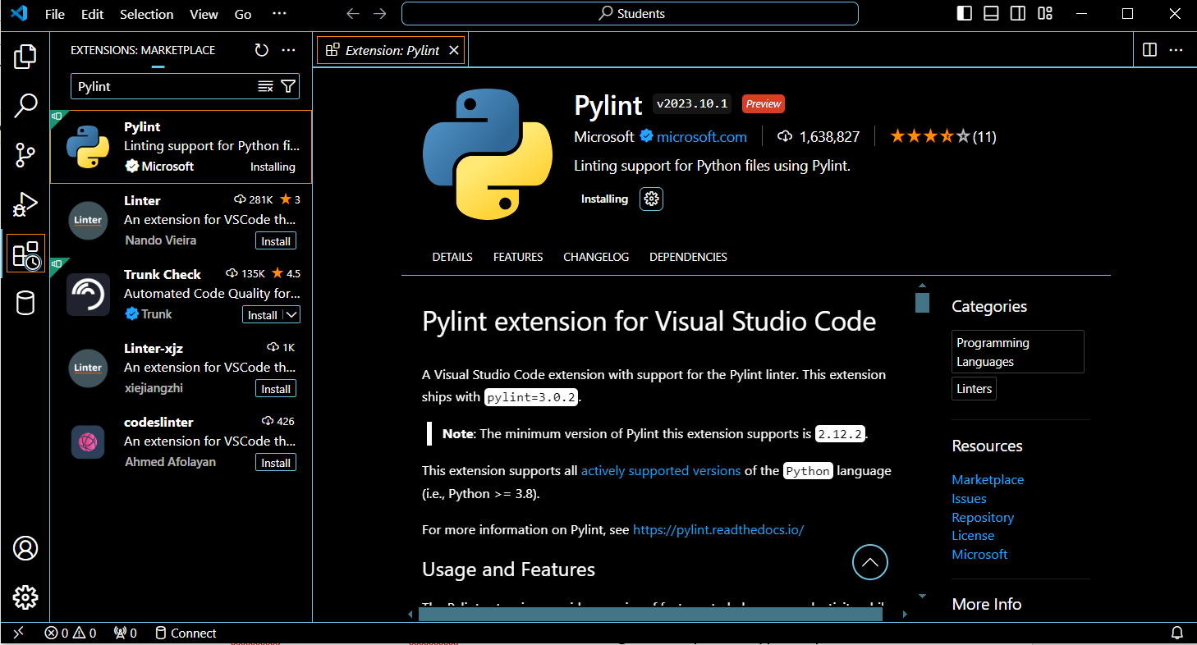

* + **GitLens**: I installed the "GitLens" extension to enhance Git capabilities in VS Code, including viewing detailed Git history and changes.

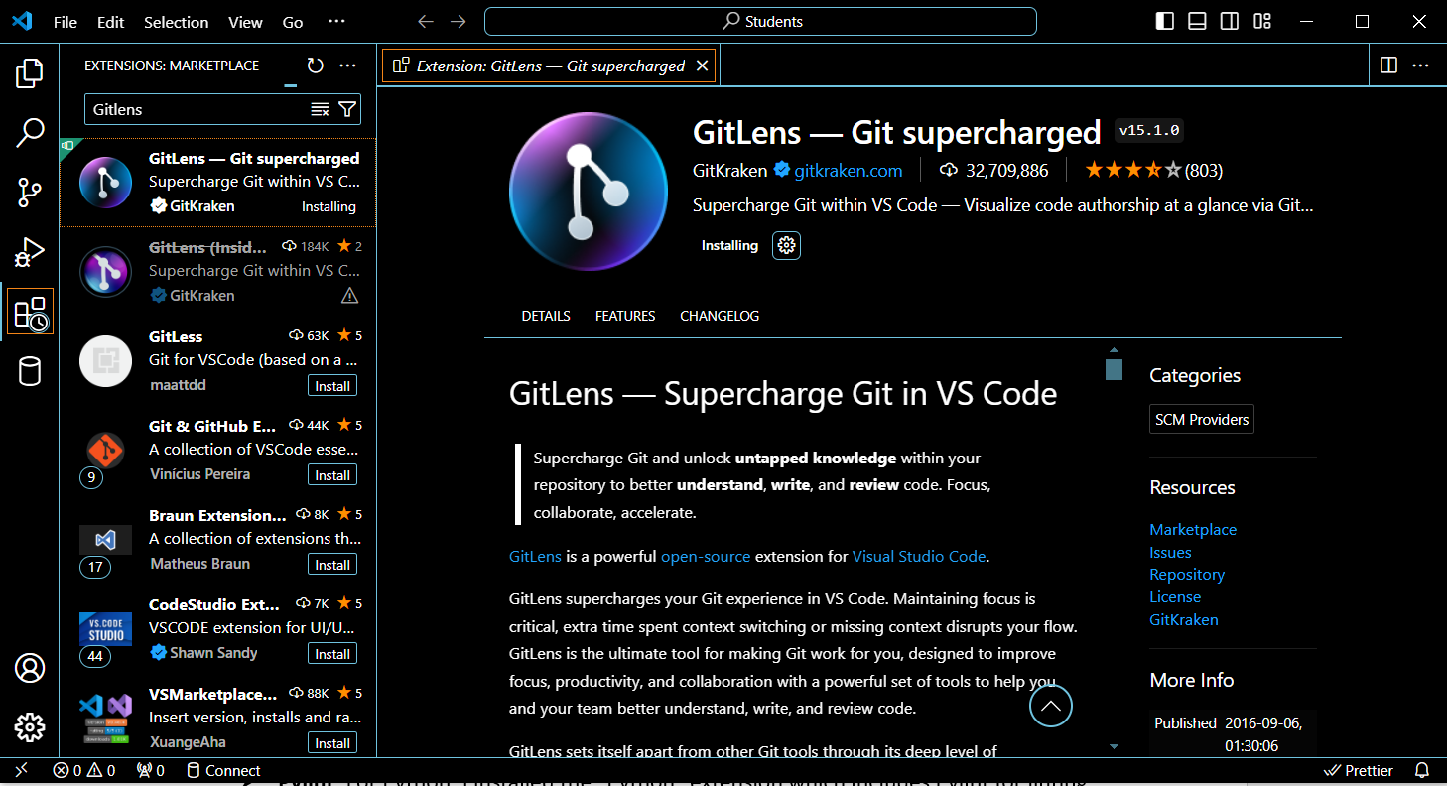

* + **GitHub**: I installed the "GitHub Pull Requests and Issues" extension to manage GitHub pull requests and issues directly from VS Code.

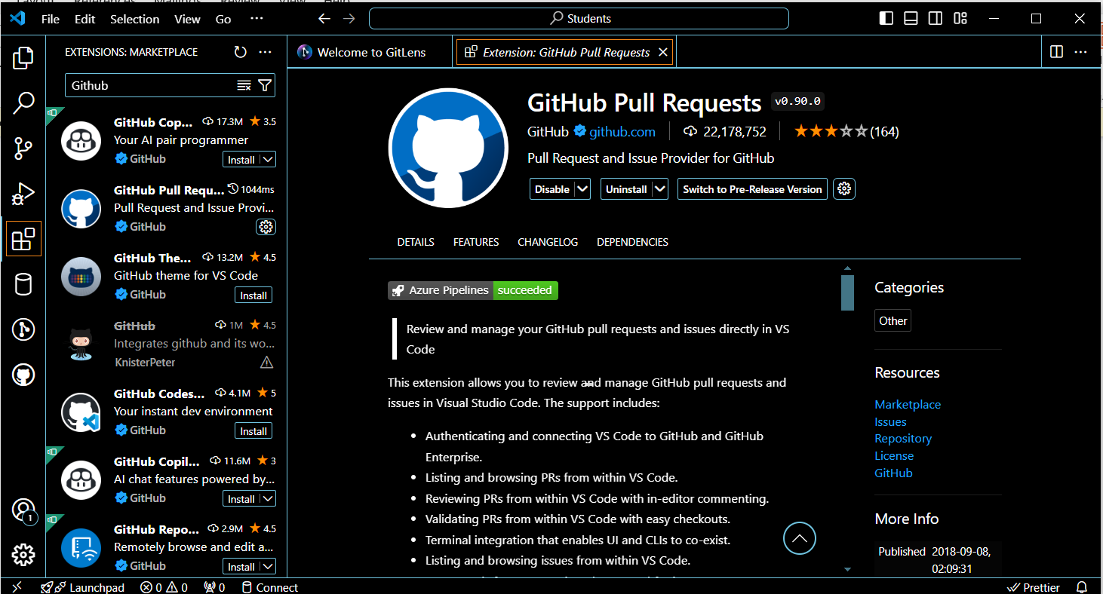

References:

<https://www.geeksforgeeks.org/>

<https://www.freecodecamp.org/>

<https://github.com/>

<https://gemini.google.com/>

<https://chatgpt.com/>

<https://www.mysql.com/>

<https://www.youtube.com/>