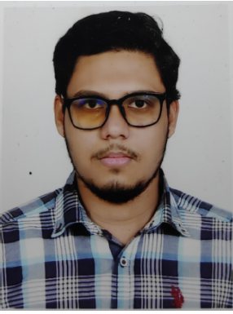**Name**: Ajwad Abid Mahi

Father’s Name: Md. Yamin Kabir

Mother’s Name: Masuda Begum

Present Address: 9 Central Basaboo, Dhaka-1214.

Phone: 01912240168, Email: [ajwadmahi@gmail.com](mailto:ajwadmahi@gmail.com).

Permanent Address: Mulatol, kotowali, Rangpur.

Date of birth: July 4, 1996

Religion: Islam (Sunni)

Marital Status: Single

Nationality : Bangladeshi by birth

Education

* Passed S.S.C from Ideal School and College in the year of 2013 with GPA 5.00.
* Passed H.S.C from National Ideal College in the year of 2015 with golden GPA 5.00.
* Got Admitted in Notre Dame University Bangladesh in the year of 2015.
* Member of Notre Dame University Bangladesh Computer Club.
* Doing thesis in “Underwater Image Enhancement using various attempts and filters.”
* Awarded as 2nd runner up in project showing.

Continuing education in Computer Science and Engineering.

**Carrier Objective**

I always want to do my best in my carrier using my educational knowledge and experience. Want to implement my learning in as much as I can using my knowledge.

**Professional Summary**

I passed my S.S.C exam in 2013 from Ideal School and College. Then passed the H.S.C exam in 2015 from National Ideal College. After that I started my Bachelor of Science program in Computer Science Engineering in Notre Dame University Bangladesh which will end at the end of 2019. I completed all 123 credits out of 150 credit without remaining any repeat or supplementary.

Signature