**An application that uses GUI components, Fonts, Colours**

**Expt 1 Date: 18/08/2022**

**Aim:**

To create a mobile application that uses GUI components, fonts, and colours.

**Code:**

**main.dart**

**import 'package:flutter/material.dart';  
  
void main() {  
 runApp(MaterialApp(  
 home: Home(),  
 ));  
}  
  
class Home extends StatelessWidget {  
 const Home({Key? key}) : super(key: key);  
  
 @override  
 Widget build(BuildContext context) {  
 return Scaffold(  
 appBar: AppBar(  
 title: Text("Hello World"),  
 centerTitle: true,  
 backgroundColor: Colors.deepOrange,  
 ),  
 body: Center(  
 child: Text(  
 "Hello World",  
 style: TextStyle(  
 fontSize: 45.0,  
 fontWeight: FontWeight.bold,  
 letterSpacing: 2.0,  
 color: Colors.blueGrey[600],  
 fontFamily: 'Raleway',  
 ),  
 ),  
 ),  
 floatingActionButton: FloatingActionButton(  
 onPressed: () {},  
 child: Text("+"),  
 backgroundColor: Colors.deepOrange,  
 ),  
 );  
 }  
}**

**Output:**

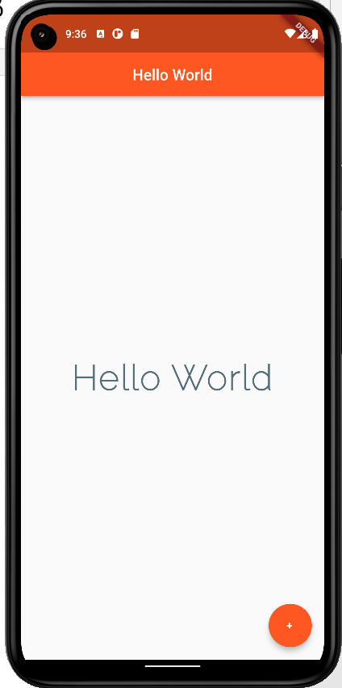

**Result:**

A mobile application which uses GUI components, fonts, and colours has been implemented successfully

**An application that uses Layout Managers and Event Listeners**

**Expt 2 Date: 25/08/2022**

**Aim:**

To create a mobile application that uses Layout Managers and Event Listeners

**Code:**

**import 'package:flutter/material.dart';  
  
void main() {  
 runApp(const MaterialApp(  
 home: Home(),  
 ));  
}  
  
class Home extends StatefulWidget {  
 const Home({Key? key}) : super(key: key);  
  
 @override  
 State<Home> createState() => _HomeState();  
}  
  
class _HomeState extends State<Home> {  
 int projects=0;  
 @override  
 Widget build(BuildContext context) {  
 return Scaffold(  
 backgroundColor: Colors.*black54*,  
 appBar: AppBar(  
 title: Text(  
 "Profile"  
 ),  
 backgroundColor: Colors.*black12*,  
 centerTitle: true,  
 elevation: 0.0,  
 ),  
 body: Padding(  
 padding: EdgeInsets.fromLTRB(30.0, 40.0, 30.0, 0.0),  
 child: Column(  
 crossAxisAlignment: CrossAxisAlignment.start,  
 children: <Widget>[  
 Center(  
 child: CircleAvatar(  
 backgroundImage: AssetImage('assets/formal_photo-min.jpg'),  
 radius: 50.0,  
 ),  
 ),  
 SizedBox(  
 height: 20.0,  
 ),  
 Text(  
 "NAME",  
 style: TextStyle(  
 color: Colors.*grey*,  
 letterSpacing: 2.0,  
 ),  
 ),  
 SizedBox(  
 height: 10.0,  
 ),  
 Text(  
 "B Dinesh",  
 style: TextStyle(  
 color: Colors.*limeAccent*,  
 letterSpacing: 2.0,  
 fontSize: 28.0,  
 fontWeight: FontWeight.*bold*,  
 ),  
 ),  
 SizedBox(  
 height: 20.0,  
 ),  
 Text(  
 "PROJECTS",  
 style: TextStyle(  
 color: Colors.*grey*,  
 letterSpacing: 2.0,  
 ),  
 ),  
 SizedBox(  
 height: 10.0,  
 ),  
 Text(  
 "$projects",  
 style: TextStyle(  
 color: Colors.*limeAccent*,  
 letterSpacing: 2.0,  
 fontSize: 28.0,  
 fontWeight: FontWeight.*bold*,  
 ),  
 ),  
 SizedBox(  
 height: 20.0,  
 ),  
 ElevatedButton(  
 onPressed: () {  
 setState(() {  
 projects++;  
 });  
 },  
 onLongPress: () {  
 setState(() {  
 projects*=2;  
 });  
 },  
 child: Icon(  
 Icons.*add*,  
 ),  
 style: ElevatedButton.*styleFrom*(  
 primary: Colors.*green*,  
 ),  
 ),  
 SizedBox(  
 height: 20.0,  
 ),  
 ElevatedButton(  
 onPressed: () {  
 setState(() {  
 if(projects>0)  
 projects--;  
 });  
 },  
 onLongPress: () {  
 setState(() {  
 if(projects>0)  
 projects~/=2;  
 });  
 },  
 child: Icon(  
 Icons.*remove*,  
 ),  
 style: ElevatedButton.*styleFrom*(  
 primary: Colors.*deepOrange*,  
 ),  
 ),  
 SizedBox(  
 height: 20.0,  
 ),  
 Row(  
 children: [  
 Icon(  
 Icons.*mail*,  
 color: Colors.*grey*,  
 ),  
 SizedBox(  
 width: 20.0,  
 ),  
 Text(  
 "dinesh.b.2k1@gmail.com",  
 style: TextStyle(  
 color: Colors.*grey*,  
 fontWeight: FontWeight.*bold*,  
 fontSize: 15.0,  
 ),  
 )  
 ],  
 )  
 ],  
 ),  
 ),  
 );  
 }  
}**

**Output:**

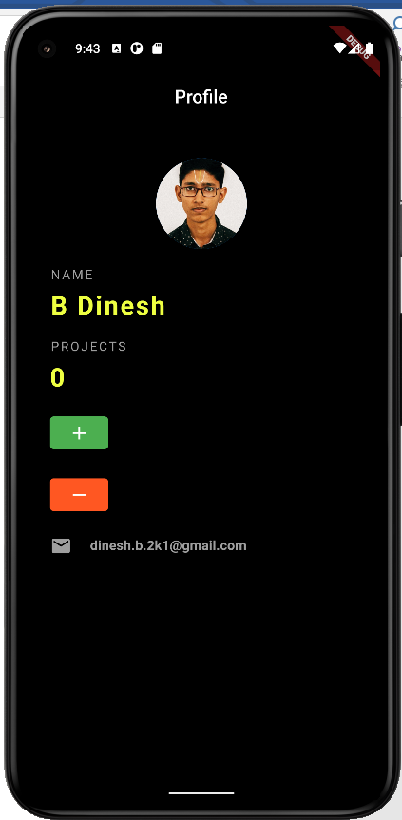

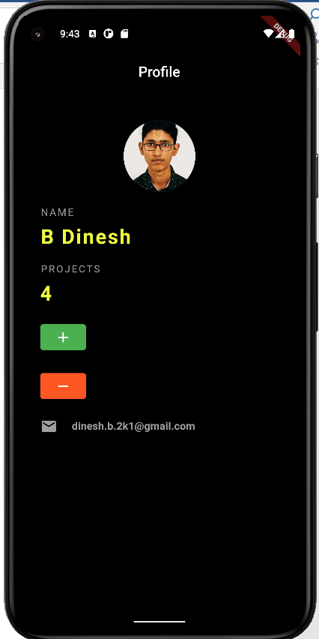

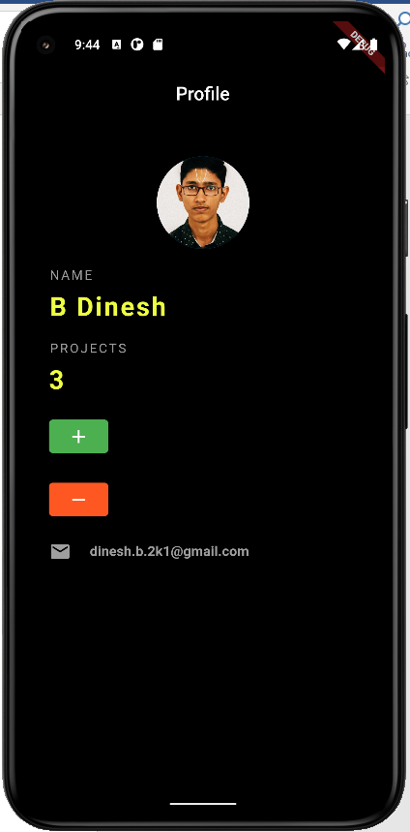

**Result:**

An application that uses layout managers and event listeners has been implemented successfully.

**Creation of Calculator Application**

**Expt 3 Date: 01/09/2022**

**Aim:**

To create a mobile calculator application

**Code:**

**import 'package:flutter/material.dart';  
import 'package:font_awesome_flutter/font_awesome_flutter.dart';  
import 'package:math_expressions/math_expressions.dart';  
  
void main() {  
 runApp(MaterialApp(  
 home: const Home(),  
 theme: ThemeData.dark(),  
 ));  
}  
  
class Home extends StatefulWidget {  
 const Home({Key? key}) : super(key: key);  
  
 @override  
 State<Home> createState() => _HomeState();  
}  
  
class _HomeState extends State<Home> {  
 @override  
 Widget build(BuildContext context) {  
 return Scaffold(  
 appBar: AppBar(  
 title: const Text("Calculator"),  
 backgroundColor: Colors.*lightBlue*,  
 ),  
 body: const Padding(  
 padding: EdgeInsets.fromLTRB(20.0, 30.0, 20.0, 40.0),  
 child: CalcBody(),  
 ),  
 );  
 }  
}  
  
class CalcBody extends StatefulWidget {  
 const CalcBody({Key? key}) : super(key: key);  
  
 @override  
 State<CalcBody> createState() => _CalcBodyState();  
}  
  
class _CalcBodyState extends State<CalcBody> {  
 var tController = TextEditingController();  
 bool dec=false;  
 bool isOperator(String s){  
 if(s[s.length-1]=="\u00F7"||s[s.length-1]=="\u00D7"||s[s.length-1]=="-"||s[s.length-1]=="\u002B"||s[s.length-1]=="."||s[s.length-1]=="%"){  
 return true;  
 }  
 return false;  
 }  
 @override  
 Widget build(BuildContext context) {  
 return Column(  
 children: [  
 const SizedBox(  
 height: 120.0,  
 ),  
 Container(  
 padding: const EdgeInsets.all(22.0),  
 child: TextField(  
 textAlign: TextAlign.right,  
 decoration: const InputDecoration(  
 hintText: "0",  
 ),  
 style: const TextStyle(  
 fontSize: 45.0,  
 ),  
 controller: tController,  
 readOnly: true,  
 ),  
 ),  
 const SizedBox(  
 height: 10.0,  
 ),  
 Expanded(  
 child: GridView.count(  
 crossAxisSpacing: 10,  
 crossAxisCount: 4,  
 children: [  
 InkWell(  
 child: const Center(  
 child: Text(  
 "AC",  
 style: TextStyle(  
 fontSize: 20.0,  
 fontWeight: FontWeight.*bold*,  
 color: Colors.*lightBlue*,  
 ),  
 ),  
 ),  
 onTap: () {  
 setState(() {  
 tController.text="";  
 dec=false;  
 });  
 },  
 ),  
 InkWell(  
 child: const Icon(  
 Icons.*backspace*,  
 color: Colors.*lightBlue*,  
 ),  
 onTap: () {  
 setState(() {  
 if(tController.text.isNotEmpty) {  
 tController.text=tController.text.substring(0,tController.text.length-1);  
 }  
 });  
 },  
 ),  
 InkWell(  
 child: const Icon(  
 Icons.*percent*,  
 color: Colors.*lightBlue*,  
 ),  
 onTap: () {  
 setState(() {  
 if(!isOperator(tController.text)) {  
 tController.text+="%";  
 dec=false;  
 }  
 });  
 },  
 ),  
 InkWell(  
 child: const Center(  
 child: FaIcon(  
 FontAwesomeIcons.*divide*,  
 color: Colors.*lightBlue*,  
 ),  
 ),  
 onTap: () {  
 setState(() {  
 if(!isOperator(tController.text)) {  
 tController.text+="\u00F7";  
 dec=false;  
 }  
 });  
 },  
 ),  
 InkWell(  
 child: const Center(  
 child: Text(  
 "7",  
 style: TextStyle(  
 fontSize: 30.0,  
 fontWeight: FontWeight.*normal*,  
 color: Colors.*white*,  
 ),  
 ),  
 ),  
 onTap: () {  
 setState(() {  
 tController.text+="7";  
 });  
 },  
 ),  
 InkWell(  
 child: const Center(  
 child: Text(  
 "8",  
 style: TextStyle(  
 fontSize: 30.0,  
 fontWeight: FontWeight.*normal*,  
 color: Colors.*white*,  
 ),  
 ),  
 ),  
 onTap: () {  
 setState(() {  
 tController.text+="8";  
 });  
 },  
 ),  
 InkWell(  
 child: const Center(  
 child: Text(  
 "9",  
 style: TextStyle(  
 fontSize: 30.0,  
 fontWeight: FontWeight.*normal*,  
 color: Colors.*white*,  
 ),  
 ),  
 ),  
 onTap: () {  
 setState(() {  
 tController.text+="9";  
 });  
 },  
 ),  
 InkWell(  
 child: const Center(  
 child: FaIcon(  
 FontAwesomeIcons.*xmark*,  
 color: Colors.*lightBlue*,  
 ),  
 ),  
 onTap: () {  
 setState(() {  
 if(!isOperator(tController.text)) {  
 tController.text+="\u00D7";  
 dec=false;  
 }  
 });  
 },  
 ),  
 InkWell(  
 child: const Center(  
 child: Text(  
 "4",  
 style: TextStyle(  
 fontSize: 30.0,  
 fontWeight: FontWeight.*normal*,  
 color: Colors.*white*,  
 ),  
 ),  
 ),  
 onTap: () {  
 setState(() {  
 tController.text+="4";  
 });  
 },  
 ),  
 InkWell(  
 child: const Center(  
 child: Text(  
 "5",  
 style: TextStyle(  
 fontSize: 30.0,  
 fontWeight: FontWeight.*normal*,  
 color: Colors.*white*,  
 ),  
 ),  
 ),  
 onTap: () {  
 setState(() {  
 tController.text+="5";  
 });  
 },  
 ),  
 InkWell(  
 child: const Center(  
 child: Text(  
 "6",  
 style: TextStyle(  
 fontSize: 30.0,  
 fontWeight: FontWeight.*normal*,  
 color: Colors.*white*,  
 ),  
 ),  
 ),  
 onTap: () {  
 setState(() {  
 tController.text+="6";  
 });  
 },  
 ),  
 InkWell(  
 child: const Center(  
 child: FaIcon(  
 FontAwesomeIcons.*minus*,  
 color: Colors.*lightBlue*,  
 ),  
 ),  
 onTap: () {  
 setState(() {  
 if(!isOperator(tController.text)) {  
 tController.text+="-";  
 dec=false;  
 }  
 });  
 },  
 ),  
 InkWell(  
 highlightColor: Colors.*grey*,  
 splashColor: Theme.*of*(context).canvasColor,  
 child: Container(  
 decoration: BoxDecoration(  
 color: Theme.*of*(context).canvasColor,  
 shape: BoxShape.circle,  
 ),  
 child: const Center(  
 child: Text(  
 "1",  
 style: TextStyle(  
 fontSize: 30.0,  
 fontWeight: FontWeight.*normal*,  
 color: Colors.*white*,  
 ),  
 ),  
 ),  
 ),  
 onTap: () {  
 setState(() {  
 tController.text+="1";  
 });  
 },  
 ),  
 InkWell(  
 child: const Center(  
 child: Text(  
 "2",  
 style: TextStyle(  
 fontSize: 30.0,  
 fontWeight: FontWeight.*normal*,  
 color: Colors.*white*,  
 ),  
 ),  
 ),  
 onTap: () {  
 setState(() {  
 tController.text+="2";  
 });  
 },  
 ),  
 InkWell(  
 child: const Center(  
 child: Text(  
 "3",  
 style: TextStyle(  
 fontSize: 30.0,  
 fontWeight: FontWeight.*normal*,  
 color: Colors.*white*,  
 ),  
 ),  
 ),  
 onTap: () {  
 setState(() {  
 tController.text+="3";  
 });  
 },  
 ),  
 InkWell(  
 child: const Center(  
 child: FaIcon(  
 FontAwesomeIcons.*plus*,  
 color: Colors.*lightBlue*,  
 ),  
 ),  
 onTap: () {  
 setState(() {  
 if(!isOperator(tController.text)) {  
 tController.text+="\u002B";  
 dec=false;  
 }  
 });  
 },  
 ),  
 const InkWell(  
  
 ),  
 InkWell(  
 child: const Center(  
 child: Text(  
 "0",  
 style: TextStyle(  
 fontSize: 30.0,  
 fontWeight: FontWeight.*normal*,  
 color: Colors.*white*,  
 ),  
 ),  
 ),  
 onTap: () {  
 setState(() {  
 tController.text+="0";  
 });  
 },  
 ),  
 InkWell(  
 child: const Center(  
 child: Text(  
 ".",  
 style: TextStyle(  
 fontSize: 30.0,  
 fontWeight: FontWeight.*normal*,  
 color: Colors.*white*,  
 ),  
 ),  
 ),  
 onTap: () {  
 setState(() {  
 if(!dec&&!isOperator(tController.text)) {  
 tController.text+=".";  
 dec=true;  
 }  
 });  
 },  
 ),  
 InkWell(  
 child: Container(  
 decoration: const BoxDecoration(  
 color: Colors.*lightBlue*,  
 shape: BoxShape.circle,  
 ),  
 child: const Center(  
 child: FaIcon(  
 FontAwesomeIcons.*equals*,  
 color: Colors.*white*,  
 ),  
 ),  
 ),  
 onTap: () {  
 String expression='';  
 for(int i=0;i<tController.text.length;i++){  
 if(tController.text[i]=='×'){  
 expression+='*';  
 }  
 else if(tController.text[i]=='÷'){  
 expression+='/';  
 }  
 else{  
 expression+=tController.text[i];  
 }  
 }**  
  **try {  
 Parser p = Parser();  
 Expression exp = p.parse(expression);  
 ContextModel cm = ContextModel();  
 double eval = exp.evaluate(EvaluationType.REAL, cm);  
 setState(() {  
 tController.text = '$eval';  
 });  
 } catch (e) {  
 setState(() {  
 tController.text = 'ERR';  
 });  
 }  
 },  
 ),  
 ],  
 ),  
 ),  
 ],  
 );  
 }  
}**

**Output:**

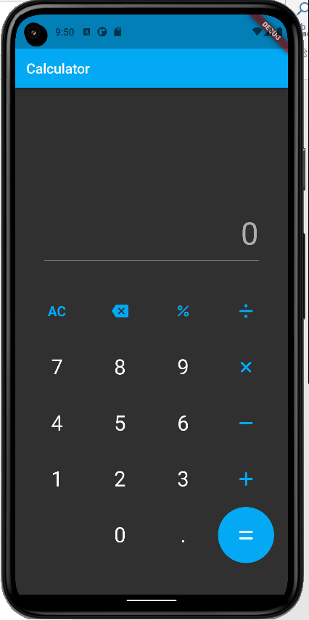

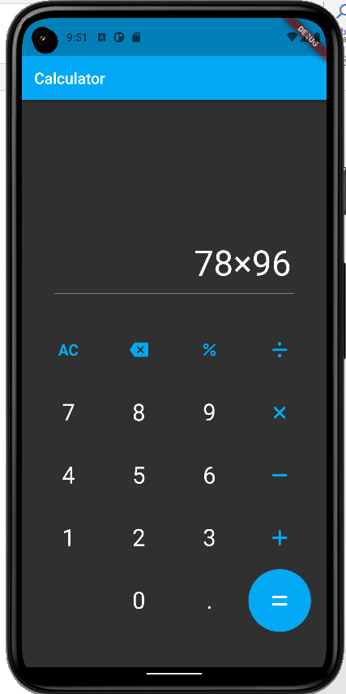

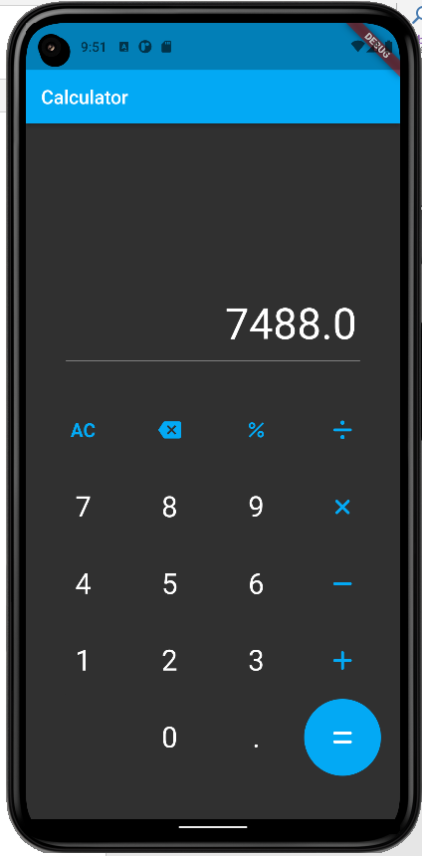

**Result:**

A calculator application for mobiles has been implemented successfully.

**An application that draws basic graphical primitives on screen**

**Expt 4 Date: 08/09/2022**

**Aim:**

To create a mobile application that draws basic graphical primitives on screen.

**Code:**

**import 'package:flutter/material.dart';  
  
void main() {  
 runApp(const MyApp());  
}  
  
class MyApp extends StatelessWidget {  
 const MyApp({Key? key}) : super(key: key);  
  
 @override  
 Widget build(BuildContext context) {  
 return MaterialApp(  
 title: 'Flutter Demo',  
 theme: ThemeData(  
 primarySwatch: Colors.blue,  
 ),  
 home: Scaffold(  
 appBar: AppBar(  
 title: const Text("Basic Shapes"),  
 centerTitle: true,  
 ),  
 body: SingleChildScrollView(  
 child: const Shapes()  
 ),  
 )  
 );  
 }  
}  
  
class Shapes extends StatelessWidget {  
 const Shapes({Key? key}) : super(key: key);  
  
 @override  
 Widget build(BuildContext context) {  
 return GridView.count(  
 crossAxisCount: 2,  
 padding: const EdgeInsets.all(20),  
 mainAxisSpacing: 10,  
 crossAxisSpacing: 10,  
 children: <Widget>[  
 Container(  
 padding: const EdgeInsets.all(20),  
 decoration: BoxDecoration (  
 border: Border.all(  
 width: 1,  
 )  
 ),  
 child: Column(  
 children: <Widget>[  
 const Padding(  
 padding: EdgeInsets.all(15),  
 child: Text("Line"),  
 ),  
 CustomPaint(  
 size: const Size(300, 300),  
 painter: LinePainter(),  
 ),  
 ],  
 ),  
 ),  
 Container(  
 padding: const EdgeInsets.all(20),  
 decoration: BoxDecoration (  
 border: Border.all(  
 width: 1,  
 )  
 ),  
 child: Column(  
 children: <Widget>[  
 const Padding(  
 padding: EdgeInsets.all(15),  
 child: Text("Rectangle"),  
 ),  
 CustomPaint(  
 size: const Size(200, 300),  
 painter: RectanglePainter(),  
 )  
 ],  
 ),  
 ),  
 Container(  
 padding: const EdgeInsets.all(20),  
 decoration: BoxDecoration (  
 border: Border.all(  
 width: 1,  
 )  
 ),  
 child: Column(  
 children: <Widget>[  
 const Padding(  
 padding: EdgeInsets.all(15),  
 child: Text("Circle"),  
 ),  
 CustomPaint(  
 size: const Size(300, 300),  
 painter: CirclePainter(),  
 )  
 ],  
 ),  
 ),  
 Container(  
 padding: const EdgeInsets.all(15),  
 decoration: BoxDecoration (  
 border: Border.all(  
 width: 1,  
 )  
 ),  
 child: Column(  
 children: <Widget>[  
 const Padding(  
 padding: EdgeInsets.all(15),  
 child: Text("Ellipse"),  
 ),  
 CustomPaint(  
 size: const Size(200, 300),  
 painter: OvalPainter(),  
 )  
 ],  
 ),  
 ),  
 ],  
 );  
 }  
}  
  
class LinePainter extends CustomPainter {  
 @override  
 void paint(Canvas canvas, Size size) {  
 var paint = Paint()  
 ..color = Colors.teal  
 ..strokeWidth = 10;  
  
 Offset start = Offset(0, size.height / 2);  
 Offset end = Offset(size.width, size.height / 2);  
  
 canvas.drawLine(start, end, paint);  
 }  
  
 @override  
 bool shouldRepaint(CustomPainter oldDelegate) {  
 return false;  
 }  
}  
  
class RectanglePainter extends CustomPainter {  
 @override  
 void paint(Canvas canvas, Size size) {  
 var paint = Paint()  
 ..color = Colors.deepOrange  
 ..strokeWidth = 10;  
  
 Rect rect = const Offset(0,0) & size;  
 canvas.drawRect(rect, paint);  
 }  
  
 @override  
 bool shouldRepaint(CustomPainter oldDelegate) {  
 return false;  
 }  
}  
  
class CirclePainter extends CustomPainter {  
 @override  
 void paint(Canvas canvas, Size size) {  
 var paint = Paint()  
 ..color = Colors.lightGreenAccent  
 ..strokeWidth = 10;  
  
 canvas.drawCircle(Offset(size.width / 2, size.height / 2),  
 size.height / 2,  
 paint  
 );  
 }  
  
 @override  
 bool shouldRepaint(CustomPainter oldDelegate) {  
 return false;  
 }  
}  
  
class OvalPainter extends CustomPainter {  
 @override  
 void paint(Canvas canvas, Size size) {  
 var paint = Paint()  
 ..color = Colors.deepPurpleAccent  
 ..strokeWidth = 10;  
  
 var rect = const Offset(0, 0) & size;  
 canvas.drawOval(rect, paint);  
 }  
  
 @override  
 bool shouldRepaint(CustomPainter oldDelegate) {  
 return false;  
 }  
}**

**Output:**

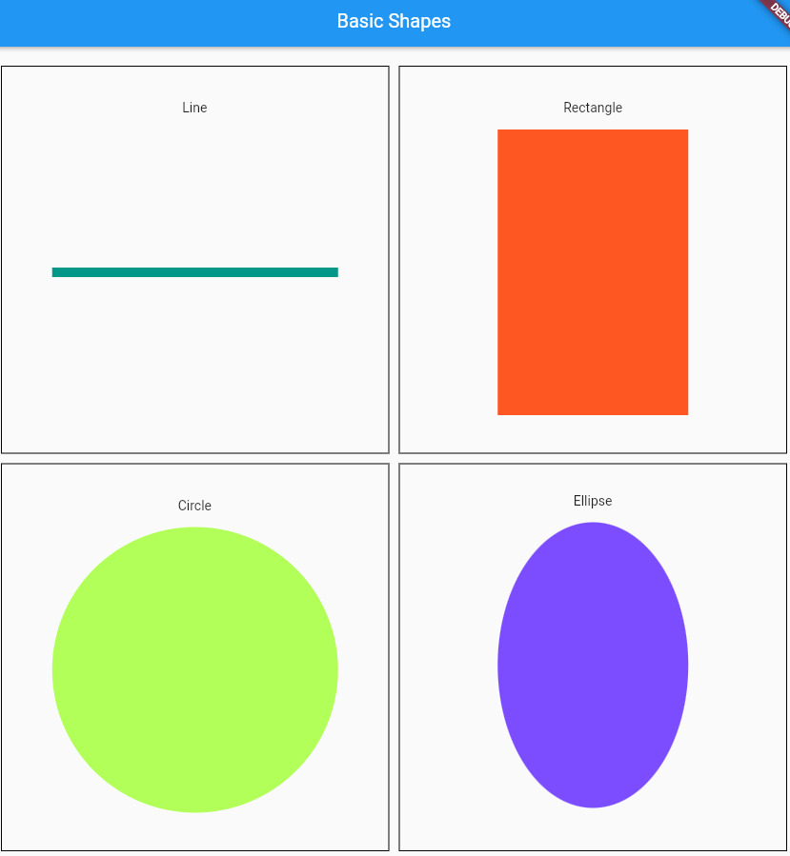

**Result:**

A mobile application that draws basic graphical primitives on screen has been implemented successfully.

**An application that makes use of a database**

**Expt 5 Date: / /2022**

**Aim:**

To create a mobile application that connects to a database and performs CRUD operations.

**Code:**

**Main.dart**

**import 'package:flutter/material.dart';  
import 'package:font_awesome_flutter/font_awesome_flutter.dart';  
import 'pages/home.dart';  
  
void main() {  
 runApp(const MaterialApp(  
 home: Home(),  
 ));  
}**

**Home.dart**

**import 'dart:convert';  
  
import 'package:flutter/material.dart';  
import 'package:font_awesome_flutter/font_awesome_flutter.dart';  
import 'package:http/http.dart';  
import '../schema.dart';  
  
class Home extends StatefulWidget {  
 const Home({Key? key}) : super(key: key);  
  
 @override  
 State<Home> createState() => _HomeState();  
}  
  
class _HomeState extends State<Home> {  
 var tController1 = TextEditingController();  
 var tController2 = TextEditingController();  
 var tController3 = TextEditingController();  
 var url="http://10.106.206.0:5000";  
  
 static const *_iconTypes* = <IconData>[  
 Icons.*add*,  
 FontAwesomeIcons.*rotate*,  
 Icons.*delete*,  
 FontAwesomeIcons.*eye*,  
 FontAwesomeIcons.*solidEye*,  
 ];  
 // Map<IconData,Function> iconMap={  
 // Icons.add:  
 // }  
 int curIcon=0;  
 int decider=1;  
 final GlobalKey<FormState> _formKey = GlobalKey<FormState>();  
 @override  
 Widget build(BuildContext context) {  
 return Scaffold(  
 appBar: AppBar(  
 title: const Text(  
 'Student Profile',  
 style: TextStyle(  
 fontSize: 20.0,  
 ),  
 ),  
 centerTitle: true,  
 backgroundColor: Colors.*indigo*,  
 ),  
 body: SingleChildScrollView(  
 child: Form(  
 key: _formKey,  
 child: Column(  
 crossAxisAlignment: CrossAxisAlignment.center,  
 children: <Widget>[  
 Container(  
 padding: const EdgeInsets.fromLTRB(32.0,32.0,32.0,0.0),  
 child: TextFormField(  
 decoration: const InputDecoration(  
 hintText: "Reg No.",  
 ),  
 keyboardType: TextInputType.*number*,  
 controller: tController1,  
 validator: (String? value) {  
 if ( (value == null || value.isEmpty) &&curIcon%5!=4) {  
 return 'Please enter some text';  
 }  
 return null;  
 },  
 ),  
 ),  
 const SizedBox(  
 height: 10.0,  
 ),  
 Container(  
 padding: const EdgeInsets.fromLTRB(32.0,32.0,32.0,0.0),  
 child: TextFormField(  
 decoration: const InputDecoration(  
 hintText: "Name",  
 ),  
 controller: tController2,  
 validator: (String? value) {  
 if ( (value == null || value.isEmpty) &&(curIcon%5!=4&&curIcon%5!=3&&curIcon%5!=2)) {  
 return 'Please enter some text';  
 }  
 return null;  
 },  
 ),  
 ),  
 const SizedBox(  
 height: 10.0,  
 ),  
 Container(  
 padding: const EdgeInsets.all(32.0),  
 child: TextFormField(  
 decoration: const InputDecoration(  
 hintText: "Marks",  
 ),  
 keyboardType: TextInputType.*number*,  
 controller: tController3,  
 validator: (String? value) {  
 if ( (value == null || value.isEmpty) &&(curIcon%5!=4&&curIcon%5!=3&&curIcon%5!=2)){  
 return 'Please enter some text';  
 }  
 return null;  
 },  
 ),  
 ),  
 const SizedBox(  
 height: 10.0,  
 ),  
 GestureDetector(  
 child: FloatingActionButton(  
 backgroundColor: Colors.*indigo*,  
 child: AnimatedSwitcher(  
 duration: const Duration(seconds: 2),  
 transitionBuilder: (Widget child, Animation<double> animation) {  
 return ScaleTransition(scale: animation, child: child);  
 },  
 child: Icon(  
 *_iconTypes*[curIcon%5],  
 )  
 ),  
 onPressed: () {  
 if (_formKey.currentState!.validate()) {  
 // Process data.  
 int opt=curIcon%5;  
 switch(opt){  
 case 0: {  
 addData();  
 showDialog(  
 context: context,  
 builder: (context) => AlertDialog(  
 title: const Text(  
 "Insertion Done"  
 ),  
 content: const Text(  
 "The record has been inserted"  
 ),  
 actions: [  
 TextButton(  
 onPressed: () => Navigator.*pop*(context, 'OK'),  
 child: const Text('OK'),  
 ),  
 ],  
 )  
 );  
 }  
 break;  
 case 1: {  
 updateData();  
 showDialog(  
 context: context,  
 builder: (context) => AlertDialog(  
 title: const Text(  
 "Updating Done"  
 ),  
 content: const Text(  
 "The record has been updated"  
 ),  
 actions: [  
 TextButton(  
 onPressed: () => Navigator.*pop*(context, 'OK'),  
 child: const Text('OK'),  
 ),  
 ],  
 ),  
 );  
 }  
 break;  
 case 2: {  
 deleteData();  
 showDialog(  
 context: context,  
 builder: (context) => AlertDialog(  
 title: const Text(  
 "Record Deleted"  
 ),  
 content: const Text(  
 "The record has been deleted"  
 ),  
 actions: [  
 TextButton(  
 onPressed: () => Navigator.*pop*(context, 'OK'),  
 child: const Text('OK'),  
 ),  
 ],  
 ),  
 );  
 }  
 break;  
 case 3: {  
 //viewOne();  
 showDialog(  
 context: context,  
 builder: (context) => AlertDialog(  
 title: const Text(  
 "All the records in the DB"  
 ),  
 content: FutureBuilder<Map<dynamic,dynamic>?>(  
 future: viewData(),  
 builder: (context,snapshot){  
 if(snapshot.hasError){  
 print("COD GOD!");  
 }  
 else if(snapshot.connectionState==ConnectionState.waiting){  
 return const CircularProgressIndicator();  
 }  
 else if(snapshot.hasData){  
 final Map<dynamic,dynamic>? viewOne = snapshot.data;  
 return Container(  
 height: 300.0,  
 width: 300.0,  
 child: Text("Reg No.: ${viewOne?["reg_no"]} Name: ${viewOne?["name"]} Marks: ${viewOne?["marks"]}"),  
 );  
 }  
 return Container();  
 },  
 ),  
 actions: [  
 TextButton(  
 onPressed: () => Navigator.*pop*(context, 'OK'),  
 child: const Text('OK'),  
 ),  
 ],  
 ),  
  
 );  
 }  
 break;  
 case 4: {  
 showDialog(  
 context: context,  
 builder: (context) => AlertDialog(  
 title: const Text(  
 "All the records in the DB"  
 ),  
 content: FutureBuilder<List<dynamic>?>(  
 future: viewAllData(),  
 builder: (context,snapshot){  
 if(snapshot.hasError){  
 print("Mangathada Mariyatha");  
 }  
 else if(snapshot.connectionState==ConnectionState.waiting){  
 return const CircularProgressIndicator();  
 }  
 else if(snapshot.hasData){  
 final List<dynamic>? ViewData=snapshot.data;  
 return Container(  
 height: 300.0,  
 width: 300.0,  
 child: ListView.builder(  
 itemCount: ViewData?.length,  
 itemBuilder: (BuildContext context,int index){  
 return Text("Reg No.: ${ViewData?[index]["reg_no"]} Name: ${ViewData?[index]["name"]} Marks: ${ViewData?[index]["marks"]}");  
 },  
 ),  
 );  
 }  
 return Container();  
 },  
 ),  
 actions: [  
 TextButton(  
 onPressed: () => Navigator.*pop*(context, 'OK'),  
 child: const Text('OK'),  
 ),  
 ],  
 ),  
 );  
 }  
 break;  
 }  
 setState(() {});  
 }  
 },  
 ),  
 onHorizontalDragStart: (d){},  
 onHorizontalDragUpdate: (d){  
 setState(() {  
 int matter= (d.primaryDelta!).toInt();  
 decider=(matter>=0)?(1):(-1);  
 });  
  
 },  
 onHorizontalDragEnd: (details){  
 setState(() {  
 curIcon+=decider;  
 });  
 },  
 ),  
 ],  
 ),  
 ),  
 ),  
 floatingActionButtonLocation: FloatingActionButtonLocation.*centerFloat*,  
 );  
 }  
 Future<List> viewAllData() async {  
 Response response = await get(Uri.*parse*("${url}/view_all"));  
 Map data=json.decode(response.body);  
 List datal=data['result'];  
 return datal;  
 }  
 Future<void> addData() async{  
 Student s1=Student(regno: tController1.text,name: tController2.text,marks: tController3.text);  
 final response = await post(  
 Uri.*parse*('${url}/add'),  
 headers: <String, String>{  
 'Content-Type': 'application/json; charset=UTF-8',  
 'reg_no': s1.regno,  
 'name': s1.name,  
 'marks': s1.marks,  
 });  
 }  
 Future<Map<dynamic,dynamic>> viewData() async{  
 Response response = await get(  
 Uri.*parse*("${url}/view"),  
 headers: <String,String>{  
 'Content-Type': 'application/json; charset=UTF-8',  
 'reg_no': tController1.text,  
 });  
 Map data=json.decode(response.body);  
 Map datal=data['result'];  
 return datal;  
 }  
 Future<void> updateData() async{  
 Student s1=Student(regno: tController1.text,name: tController2.text,marks: tController3.text);  
 Response response= await patch(  
 Uri.*parse*("${url}/update"),  
 headers: <String,String>{  
 'Content-Type': 'application/json; charset=UTF-8',  
 'reg_no': s1.regno,  
 'name': s1.name,  
 'marks': s1.marks,  
 });  
 }  
 Future<void> deleteData() async{  
 Student s1=Student(regno: tController1.text,name: tController2.text,marks: tController3.text);  
 Response response= await delete(  
 Uri.*parse*("${url}/delete"),  
 headers: <String,String>{  
 'Content-Type': 'application/json; charset=UTF-8',  
 'reg_no': s1.regno,  
 });  
 }  
  
}**

**schema.dart**

**import 'package:flutter/material.dart';  
  
class Student{  
 String regno="-1";  
 String name="Unknown";  
 String marks="-1";  
 Student({required this.regno,required this.name,required this.marks});  
}**

**app.py**

*from* flask *import* Flask, request, Response

*import* sqlite3, json

app *=* Flask(__name__)

db_locale*=*"class.db"

*@app.route*("/view",methods*=*['GET'])

*def* *view_rec*():

*if* request.method*==*'GET':

        con*=*sqlite3.connect(db_locale)

        rno*=*request.headers["reg_no"]

        print(rno)

        c*=*con.cursor()

        sql_exec_str*=*"SELECT * FROM student WHERE reg_no = ?"

        student_info*=*c.execute(sql_exec_str,[rno]).fetchall()

        con.commit()

        con.close()

        resp*=*{}

        resp["reg_no"]*=*student_info[0][0]

        resp["name"]*=*student_info[0][1]

        resp["marks"]*=*student_info[0][2]

        fin_resp*=*{}

        fin_resp["result"]*=*resp

*return* json.dumps(fin_resp)

*@app.route*("/view_all",methods*=*['GET'])

*def* *view_all_rec*():

*if* request.method*==*"GET":

        con*=*sqlite3.connect(db_locale)

        c*=*con.cursor()

        c.execute("""

            SELECT * FROM student

        """)

        students*=*c.fetchall()

        con.commit()

        con.close()

        res*=*[]

        final_res*=*{}

*for* student *in* students:

            resp*=*{}

            resp["reg_no"]*=*student[0]

            resp["name"]*=*student[1]

            resp["marks"]*=*student[2]

            res.append(resp)

        final_res['result']*=*res

*return* json.dumps(final_res)

*@app.route*("/add",methods*=*['POST'])

*def* *add_rec*():

*if* request.method*==*'POST':

        con*=*sqlite3.connect(db_locale)

        c*=*con.cursor()

        c.execute("""

            INSERT INTO student(reg_no,name,marks)

            VALUES(?,?,?)

        """,(request.headers["reg_no"],request.headers["name"],request.headers["marks"])

        )

        con.commit()

        con.close()

        resp*=*{}

*return* Response(status*=*200)

*@app.route*("/delete",methods*=*['DELETE'])

*def* *delete_rec*():

*if* request.method*==*'DELETE':

        con*=*sqlite3.connect(db_locale)

        c*=*con.cursor()

        c.execute("""

            DELETE FROM student

            WHERE reg_no = ?

        """,([request.headers["reg_no"]])

        )

        con.commit()

        con.close()

*return* Response(status*=*200)

*@app.route*("/update",methods*=*['PATCH'])

*def* *update*():

*if* request.method*==*'PATCH':

        con*=*sqlite3.connect(db_locale)

        c*=*con.cursor()

        sql_exec_str*=*"UPDATE student SET name = ?, marks=? WHERE reg_no =?"

        c.execute(sql_exec_str,(request.headers['name'],request.headers['marks'],request.headers['reg_no']))

        con.commit()

        con.close()

*return* Response(status*=*200)

*if* __name__ *==* '__main__':

    app.run(host*=*"0.0.0.0",port*=*5000)

**Output:**

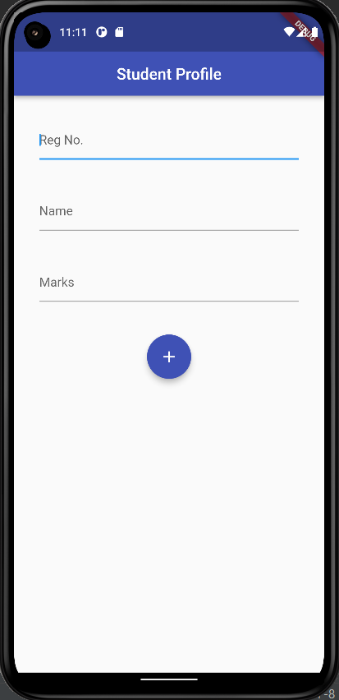

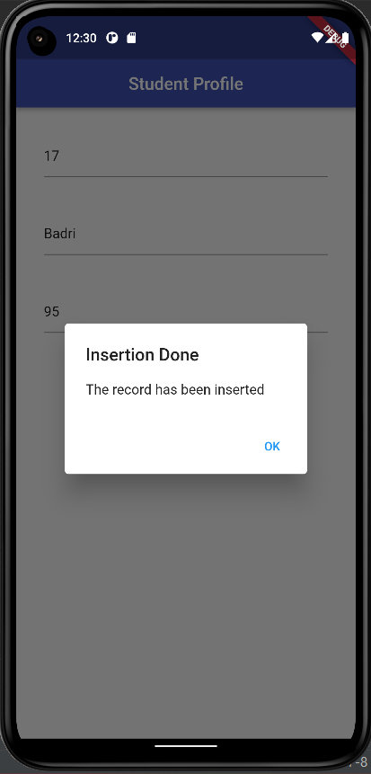 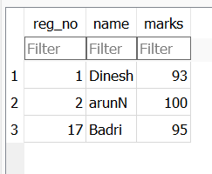

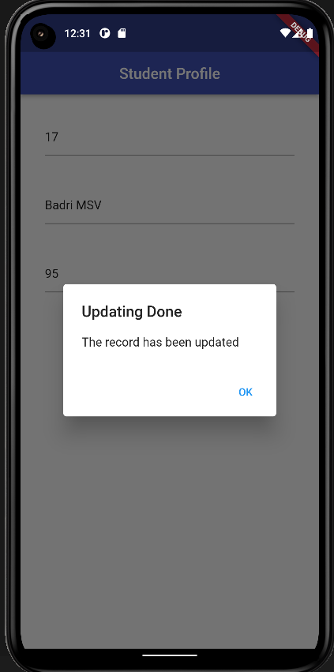 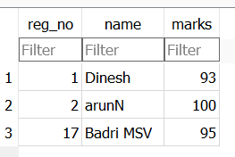

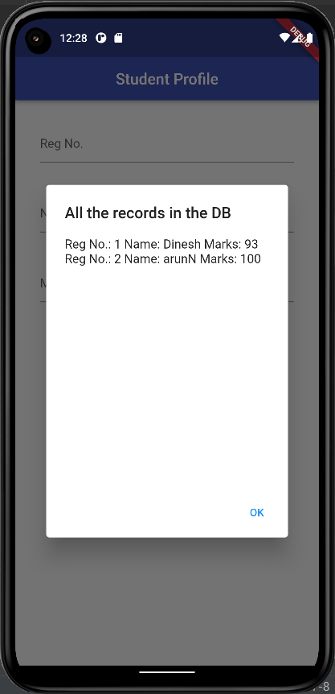

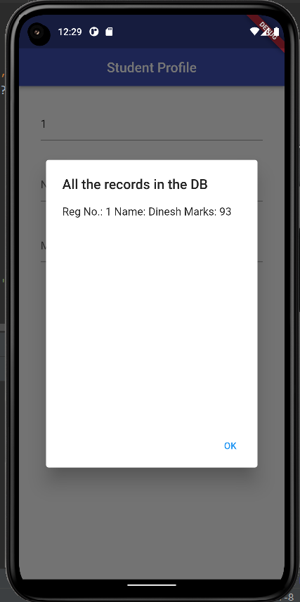

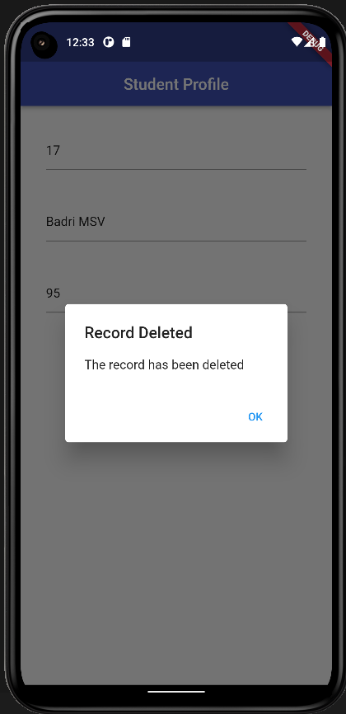 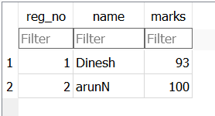

**Result:**

CRUDoperations are performed successfully upon connecting the mobile app to the database by using python Flask as the backend.

**An application that makes use of RSS feed**

**Expt 6 Date: / /2022**

**Aim:**

To create a mobile application that uses RSS feed.

**Code:**

**Main.dart**

**import 'package:flutter/foundation.dart';  
import 'package:flutter/material.dart';  
import 'package:webfeed/webfeed.dart';  
import 'package:http/http.dart' as http;  
import 'package:url_launcher/url_launcher.dart';  
void main() {  
 runApp(const RSSDemo());  
}  
  
class RSSDemo extends StatelessWidget {  
 const RSSDemo({Key? key}) : super(key: key);  
  
 @override  
 Widget build(BuildContext context) {  
 return const MaterialApp(title: "RSS Feed", home: RSSMainPicture());  
 }  
}  
  
class RSSMainPicture extends StatefulWidget {  
 const RSSMainPicture({Key? key}) : super(key: key);  
  
 @override  
 State<RSSMainPicture> createState() => _RSSMainPictureState();  
}  
  
class _RSSMainPictureState extends State<RSSMainPicture> {  
 late Future<RssFeed> result;  
 Future<RssFeed> giver() async {  
 var response =  
 await http.get(Uri.*parse*("https://www.espncricinfo.com/rss/content/story/feeds/0.xml"));  
 var channel = RssFeed.parse(response.body);  
 return channel;  
 }  
  
 @override  
 void initState() {  
 super.initState();  
 result = giver();  
 }  
  
 @override  
 Widget build(BuildContext context) {  
 return Scaffold(  
 appBar: AppBar(  
 title: const Text("News"),  
 actions: [  
 IconButton(onPressed: ()=>result=giver(), icon: const Icon(Icons.*refresh_rounded*)),  
 ],  
 ),  
 body: FutureBuilder<RssFeed?>(  
 future: result,  
 builder: (context,snapshot){  
 if(snapshot.hasError){  
 if(kDebugMode){  
 print("Error");  
 }  
 return Container();  
 }  
 else if(snapshot.connectionState==ConnectionState.waiting){  
 return const Center(  
 child: CircularProgressIndicator(),  
 );  
 }  
 else if(snapshot.hasData){  
 var feed=snapshot.data!;  
 var items=feed.items;  
 return ListView.builder(  
 itemCount: items?.length,  
 itemBuilder: (context,index){  
 var item=items![index];  
 return GestureDetector(  
 onTap: () async{  
 if (!await launchUrl(Uri.*parse*(item.link!))) {  
 throw 'Could not launch ${item.link}';  
 }  
 },  
 child: ListTile(  
 // leading: CachedNetworkImage(  
 // imageUrl: mediaImage!,  
 // progressIndicatorBuilder: (context, url, downloadProgress) =>  
 // CircularProgressIndicator(value: downloadProgress.progress),  
 // errorWidget: (context, url, error) => const Icon(Icons.error),  
 // ),  
 title: Text(item.title!),  
 subtitle: Text("${item.pubDate!}"),  
 ),  
 );  
 },  
 );  
 }  
 return Container();  
 },  
 ),  
 );  
 }  
}**

**Output:**

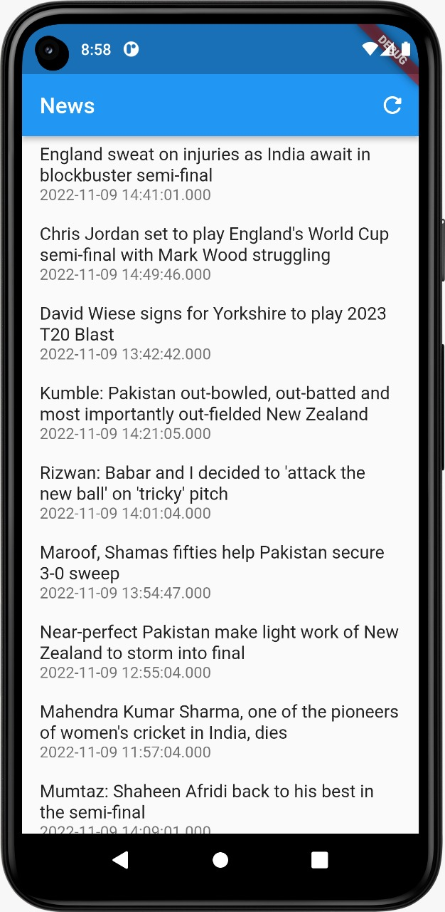

**Result:**

RSS feed has been successfully integrated with the mobile app.

**An application that implements multithreading**

**Expt 7 Date: / /2022**

**Aim:**

To create a mobile application that implements multithreading.

**Code:**

**main.dart**

**import 'package:expt7/pages/home.dart';  
import 'package:flutter/material.dart';  
  
void main() {  
 runApp(const MyApp());  
}  
  
class MyApp extends StatelessWidget {  
 const MyApp({super.key});  
  
 // This widget is the root of your application.  
 @override  
 Widget build(BuildContext context) {  
 return MaterialApp(  
 title: 'Flutter Demo',  
 theme: ThemeData(  
 primarySwatch: Colors.*blue*,  
 brightness: Brightness.dark,  
 ),  
 home: const Home(),  
 );  
 }  
}**

**home.dart**

**import 'dart:async';  
import 'dart:math';  
  
import 'package:flutter/foundation.dart';  
import 'package:flutter/material.dart';  
  
class Home extends StatefulWidget {  
 const Home({Key? key}) : super(key: key);  
  
 @override  
 State<Home> createState() => _HomeState();  
}  
  
class _HomeState extends State<Home> {  
 int randint=99;  
 static FutureOr<int> *randGen*(int cal){  
 var rng = Random();  
 return rng.nextInt(100);  
 }  
 @override  
 Widget build(BuildContext context) {  
 return Scaffold(  
 appBar: AppBar(  
 title: Text(  
 "Multithreading App",  
 ),  
 centerTitle: true,  
 ),  
 body: Column(  
 mainAxisAlignment: MainAxisAlignment.spaceEvenly,  
 children: <Widget>[  
 Row(  
 mainAxisAlignment: MainAxisAlignment.spaceAround,  
 children: [  
 Text(  
 "Random Number: ",  
 style: TextStyle(  
 fontSize: 20.0,  
 ),  
 ),  
 Text(  
 "${randint}",  
 style: TextStyle(  
 fontSize: 20.0,  
 ),  
 ),  
 ],  
 ),  
 SizedBox(  
 height: 20.0,  
 ),  
 TextButton(  
 onPressed: () async{  
 int result = await compute(*randGen*,randint);  
 setState(() {  
 randint = result;  
 });  
 },  
 child: Text(  
 "Press Me!",  
 style: TextStyle(  
 fontSize: 20.0,  
 ),  
 ),  
 ),  
 ],  
 ),  
 );  
 }  
}**

**Output:**

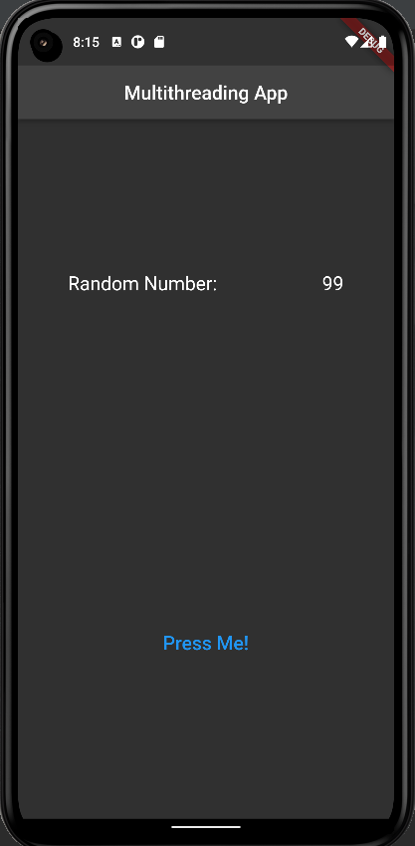 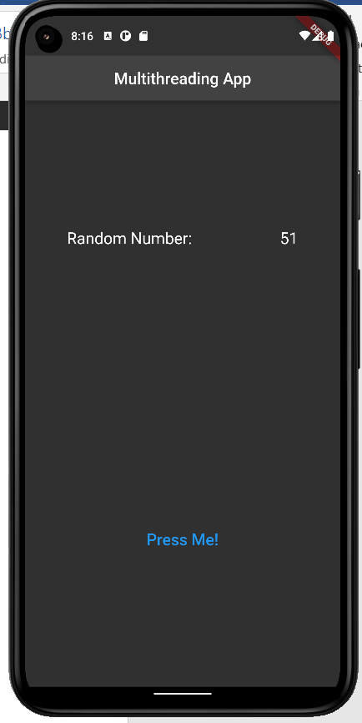

**Result:**

An android application that implements multithreading has been developed and executed successfully.

**An application that uses GPS location information**

**Expt 8 Date: / /2022**

**Aim:**

To create a mobile application that uses GPS location information.

**Code:**

**import 'package:flutter/material.dart';  
import 'package:location/location.dart';  
  
void main() {  
 runApp(const MyApp());  
}  
  
class MyApp extends StatelessWidget {  
 const MyApp({Key? key}) : super(key: key);  
  
 // This widget is the root of your application.  
 @override  
 Widget build(BuildContext context) {  
 return MaterialApp(  
 title: 'Flutter Demo',  
 theme: ThemeData(  
 primarySwatch: Colors.*pink*,  
 ),  
 home: const Home(),  
 );  
 }  
}  
class Home extends StatelessWidget {  
 const Home({Key? key}) : super(key: key);  
  
 @override  
 Widget build(BuildContext context) {  
 return Scaffold(  
 appBar: AppBar(  
 title: const Text(  
 "My Location"  
 ),  
 centerTitle: true,  
 ),  
 body: const LocationInfo(  
   
 ),  
 floatingActionButtonLocation: FloatingActionButtonLocation.*centerDocked*,  
 );  
 }  
}  
  
class LocationInfo extends StatefulWidget {  
 const LocationInfo({Key? key}) : super(key: key);  
  
 @override  
 State<LocationInfo> createState() => _LocationInfoState();  
}  
  
class _LocationInfoState extends State<LocationInfo> {  
 String _myLoc ="My Location";  
 Location location=new Location();  
 late bool _serviceEnabled;  
 late PermissionStatus _permissionGranted;  
 late LocationData _locationData;  
 bool _isListenLocation =false, _isGetLocation = false;  
  
 @override  
 Widget build(BuildContext context) {  
 return Column(  
 crossAxisAlignment: CrossAxisAlignment.stretch,  
 children: <Widget>[  
 const SizedBox(  
 height: 20.0,  
 ),  
 const Icon(  
 Icons.*location_pin*,  
 ),  
 const SizedBox(  
 height: 20.0,  
 ),  
 Center(  
 child: Text(  
 "$_myLoc",  
 style: TextStyle(  
 fontSize: 20.0,  
 ),  
 ),  
 ),  
 const SizedBox(  
 height: 20.0,  
 ),  
 FloatingActionButton(  
 child: Icon(  
 Icons.*location_on_sharp*,  
 ),  
 onPressed: updateLoc,  
 ),  
 ],  
 );  
 }  
 void updateLoc() async{  
 _serviceEnabled = await location.serviceEnabled();  
 if(!_serviceEnabled){  
 _serviceEnabled = await location.requestService();  
 if(_serviceEnabled)  
 return;  
 }  
 _permissionGranted = await location.hasPermission();  
 if(_permissionGranted == PermissionStatus.denied){  
 _permissionGranted = await location.requestPermission();  
 if(_permissionGranted != PermissionStatus.granted)  
 return;  
 }  
 _locationData = await location.getLocation();  
 setState(() {  
 _isGetLocation = true;  
 });  
 if(_isGetLocation){  
 _myLoc="${_locationData.latitude} / ${_locationData.longitude}";  
 }  
 }  
}**

**Output:**

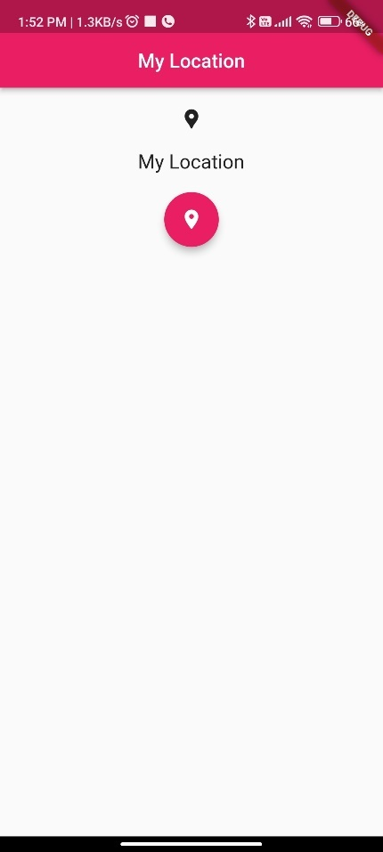 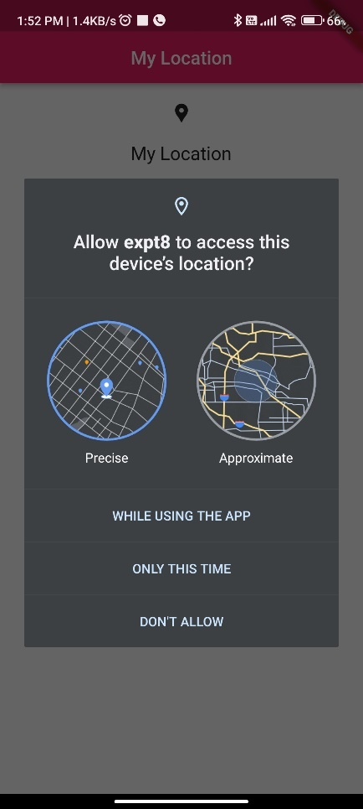 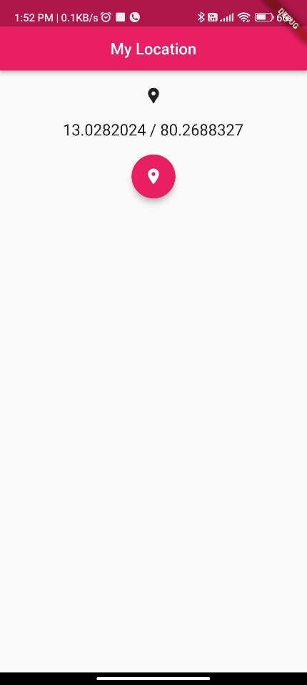

**Result:**

A native application that uses GPS location has been developed and executed successfully.

**An application that takes advantage of rich gesture-based UI handling**

**Expt 9 Date: / /2022**

**Aim:**

To create a mobile application that will take advantage of underlying phone functionality including rich gesture-based UI handling

**Code:**

**import 'dart:math';  
import 'package:flutter/material.dart';  
import 'package:sensors_plus/sensors_plus.dart';  
  
void main() {  
 runApp(const MyApp());  
}  
  
class MyApp extends StatelessWidget {  
 const MyApp({super.key});  
  
 // This widget is the root of your application.  
 @override  
 Widget build(BuildContext context) {  
 return MaterialApp(  
 title: 'Flutter Demo',  
 theme: ThemeData(  
 // This is the theme of your application.  
 //  
 // Try running your application with "flutter run". You'll see the  
 // application has a blue toolbar. Then, without quitting the app, try  
 // changing the primarySwatch below to Colors.green and then invoke  
 // "hot reload" (press "r" in the console where you ran "flutter run",  
 // or simply save your changes to "hot reload" in a Flutter IDE).  
 // Notice that the counter didn't reset back to zero; the application  
 // is not restarted.  
 primarySwatch: Colors.*blue*,  
 ),  
 home: const MyHomePage(title: 'Gyroscope and ui'),  
 );  
 }  
}  
  
class MyHomePage extends StatefulWidget {  
 const MyHomePage({super.key, required this.title});  
  
 // This widget is the home page of your application. It is stateful, meaning  
 // that it has a State object (defined below) that contains fields that affect  
 // how it looks.  
  
 // This class is the configuration for the state. It holds the values (in this  
 // case the title) provided by the parent (in this case the App widget) and  
 // used by the build method of the State. Fields in a Widget subclass are  
 // always marked "final".  
  
 final String title;  
  
 @override  
 State<MyHomePage> createState() => _MyHomePageState();  
}  
  
class _MyHomePageState extends State<MyHomePage> {  
 double _dx = 0,  
 _dy = 0;  
  
 @override  
 Widget build(BuildContext context) {  
 return Scaffold(  
 appBar: AppBar(  
 title: Text(widget.title),  
 ),  
 body: StreamBuilder<GyroscopeEvent>(  
 stream: SensorsPlatform.*instance*.gyroscopeEvents,  
 builder: (context, snapshot) {  
 if (snapshot.hasData) {  
 _dy = _dy + snapshot.data!.y * 10;  
 _dx = _dx + snapshot.data!.x * 10;  
 }  
 return Stack(  
 children: [  
 Positioned(  
 top: _dy,  
 left: _dx,  
 child: GestureDetector(  
 onPanUpdate: (details) {  
 setState(() {  
 _dy = max(0, _dy + details.delta.dy);  
 _dx = max(0, _dx + details.delta.dx);  
 });  
 },  
 child: const CircleAvatar(),  
 ),  
 )  
 ],  
 );  
 },  
 ),  
 );  
 }  
}**

**Output:**

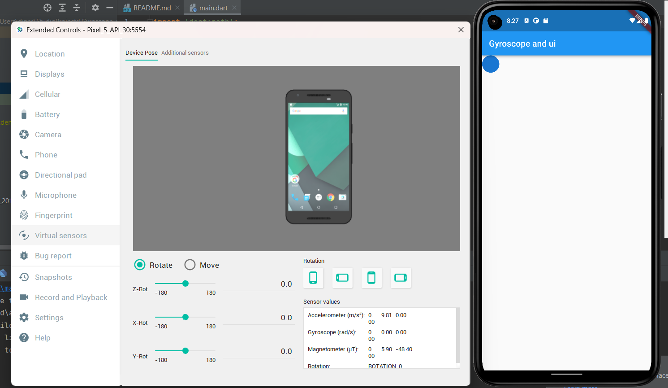

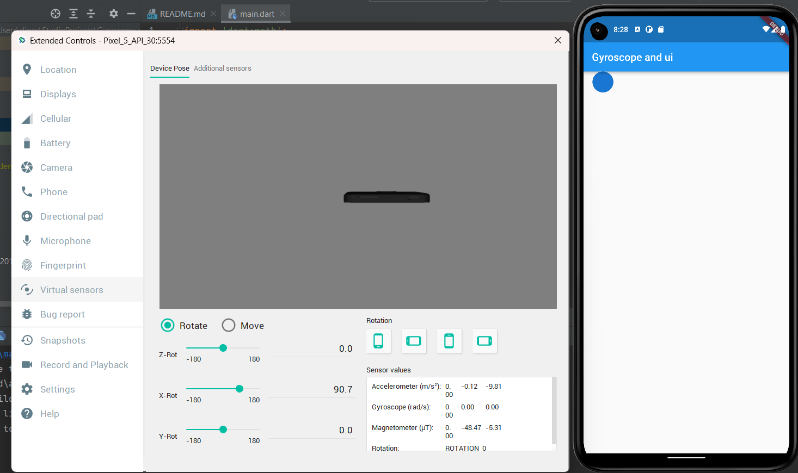

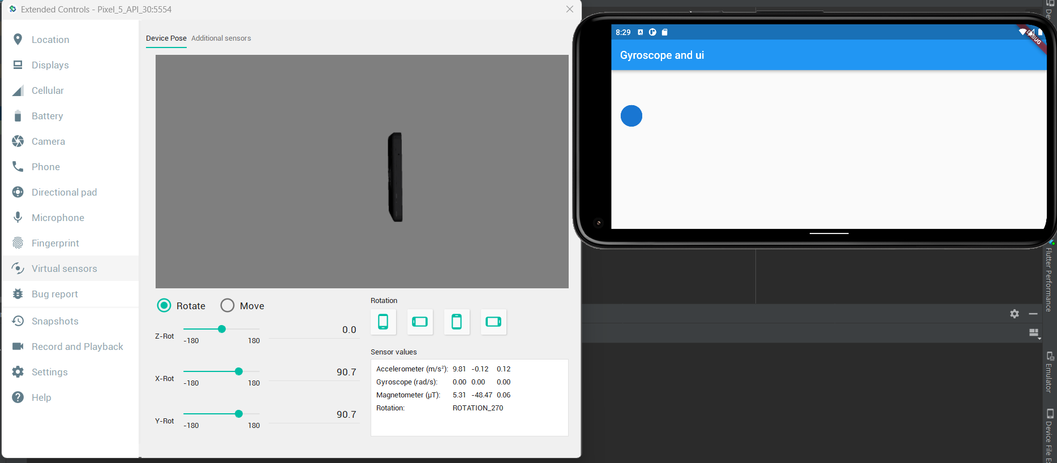

**Result:**

A mobile application that uses rich gestures to handle UI was developed and executed successfully.

**An application that creates an alert upon user action**

**Expt 10 Date: / /2022**

**Aim:**

To create an application that sends an alert upon user action.

**Code:**

**main.dart**

**import 'package:expt10/pages/home.dart';  
import 'package:flutter/material.dart';  
  
void main() {  
 runApp(const MyApp());  
}  
  
class MyApp extends StatelessWidget {  
 const MyApp({Key? key}) : super(key: key);  
  
 // This widget is the root of your application.  
 @override  
 Widget build(BuildContext context) {  
 return MaterialApp(  
 title: 'Experiment 10',  
 theme: ThemeData.dark(),  
 home: const Home(),  
 );  
 }  
}**

**home.dart**

**import 'package:expt10/services/local_notification_service.dart';  
import 'package:flutter/material.dart';  
  
class Home extends StatefulWidget {  
 const Home({Key? key}) : super(key: key);  
  
 @override  
 State<Home> createState() => _HomeState();  
}  
  
class _HomeState extends State<Home> {  
 late final LocalNotificationService service;  
 @override  
 void initState(){  
 service = LocalNotificationService();  
 service.initialize();  
 super.initState();  
 }  
 @override  
 Widget build(BuildContext context) {  
 return Scaffold(  
 appBar: AppBar(  
 title: const Text(  
 "Local Notifications Expt"  
 ),  
 backgroundColor: const Color(0xff006473),  
 centerTitle: true,  
 ),  
 body: Padding(  
 padding: EdgeInsets.all(MediaQuery.*of*(context).size.width*0.25),  
 child: Column(  
 children: <Widget>[  
 TextButton(  
 onPressed: () async {  
 await service.showNotification(  
 id: 0,  
 title: "Sample Notification",  
 body: "Sample Body"  
 );  
 },  
 child: const Text(  
 "Get an instant Notification"  
 ),  
 ),  
 TextButton(  
 onPressed: () async {  
 await service.showScheduledNotification(  
 id: 0,  
 title: "Sample Notification",  
 body: "Sample Body",  
 seconds: 4,  
 );  
 },  
 child: const Text(  
 "Get a delayed Notification"  
 ),  
 ),  
 ],  
 ),  
 ),  
 );  
 }  
}**

**local_notification_service.dart**

**import 'package:flutter_local_notifications/flutter_local_notifications.dart';  
import 'package:timezone/timezone.dart' as tz;  
import 'package:timezone/data/latest.dart' as tz;  
  
class LocalNotificationService {  
 LocalNotificationService();  
  
 final _localNotificationService = FlutterLocalNotificationsPlugin();  
  
 Future<void> initialize() async{  
 tz.initializeTimeZones();  
 const AndroidInitializationSettings androidInitializationSettings =  
 AndroidInitializationSettings('ic_stat_assistant_navigation');  
  
 const DarwinInitializationSettings iosInitializationSettings =  
 DarwinInitializationSettings(  
 requestAlertPermission: true,  
 requestBadgePermission: true,  
 requestSoundPermission: true,  
 );  
 const InitializationSettings settings = InitializationSettings(  
 android: androidInitializationSettings,  
 iOS: iosInitializationSettings  
 );  
  
 await _localNotificationService.initialize(settings);  
 }  
 Future<NotificationDetails> _notificationDetails() async{  
 const AndroidNotificationDetails androidNotificationDetails = AndroidNotificationDetails(  
 "channel_id", "channel_name",  
 channelDescription: "Description",  
 importance: Importance.*max*,  
 priority: Priority.*max*,  
 playSound: true,  
 );  
 const DarwinNotificationDetails darwinNotificationDetails = DarwinNotificationDetails();  
 return const NotificationDetails(android: androidNotificationDetails,iOS: darwinNotificationDetails);  
 }  
 Future<void> showNotification({  
 required int id,  
 required String title,  
 required String body}) async{  
 final details = await _notificationDetails();  
 await _localNotificationService.show(id, title, body, details);  
 }  
 Future<void> showScheduledNotification({  
 required int id,  
 required String title,  
 required String body,  
 required int seconds  
 }) async{  
 final details = await _notificationDetails();  
 await _localNotificationService.zonedSchedule(  
 id,  
 title,  
 body,  
 tz.TZDateTime.from(DateTime.now().add(Duration(seconds: seconds)), tz.local,),  
 details,  
 androidAllowWhileIdle: true,  
 uiLocalNotificationDateInterpretation: UILocalNotificationDateInterpretation.absoluteTime  
 );  
 }  
}**

**Output:**

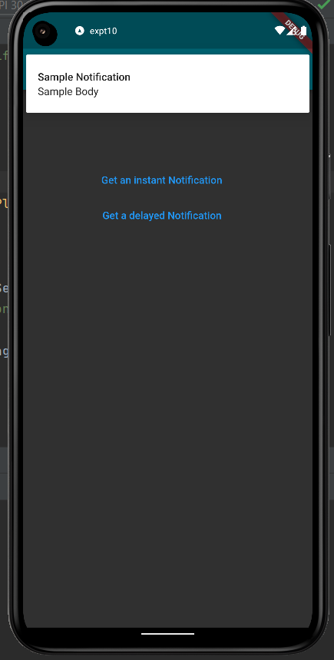 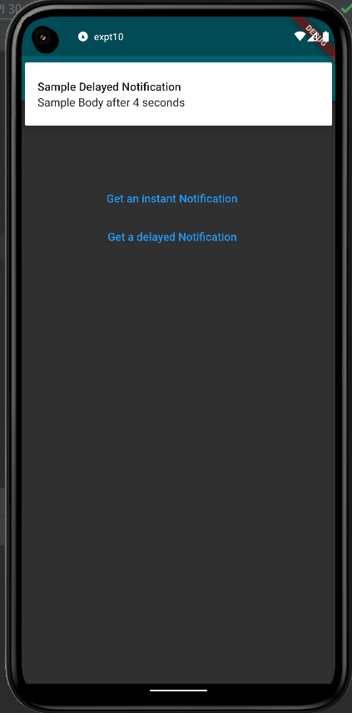

**Result:**

An application that sends an alert upon user action was developed and executed successfully.

**An application that creates an alarm clock**

**Expt 11 Date: / /2022**

**Aim:**

To create an application that creates an alarm clock.

**Code:**

**main.dart**

**import 'package:flutter/material.dart';  
import 'pages/home.dart';  
void main() {  
 runApp(const MyApp());  
}  
  
class MyApp extends StatelessWidget {  
 const MyApp({super.key});  
  
 // This widget is the root of your application.  
 @override  
 Widget build(BuildContext context) {  
 return MaterialApp(  
 title: 'Flutter Demo',  
 theme: ThemeData(  
 primarySwatch: Colors.*cyan*,  
 brightness: Brightness.dark,  
 ),  
 home: const Home(),  
 );  
 }  
}**

**home.dart**

**import 'package:flutter/material.dart';  
import 'package:flutter_alarm_clock/flutter_alarm_clock.dart';  
  
class Home extends StatefulWidget {  
 const Home({Key? key}) : super(key: key);  
  
 @override  
 State<Home> createState() => _HomeState();  
}  
  
class _HomeState extends State<Home> {  
 TimeOfDay time= TimeOfDay(hour: 23, minute: 59);  
 @override  
 Widget build(BuildContext context) {  
 return Scaffold(  
 appBar: AppBar(  
 title: Text(  
 "Alarm Clock",  
 ),  
 centerTitle: true,  
 elevation: 0.0,  
 backgroundColor: Colors.cyan,  
 ),  
 body: Padding(  
 padding: EdgeInsets.all(20),  
 child: Center(  
 child: Column(  
 mainAxisAlignment: MainAxisAlignment.center,  
 children: [  
 Row(  
 mainAxisAlignment: MainAxisAlignment.spaceEvenly,  
 children: [  
 Text(  
 "Time set: ",  
 style: TextStyle(  
 fontSize: 30.0,  
 ),  
 ),  
 Text(  
 "${time.hour.toString().padLeft(2,'0')}:${time.minute.toString().padLeft(2,'0')}",  
 style: TextStyle(  
 fontSize: 30.0,  
 color: Colors.cyan,  
 ),  
 )  
 ],  
 ),  
 SizedBox(  
 height: 30.0,  
 ),  
 Row(  
 mainAxisAlignment: MainAxisAlignment.spaceAround,  
 children: [  
 TextButton(  
 onPressed: () async{  
 TimeOfDay? newTime = await showTimePicker(  
 context: context,  
 initialTime: time,  
 );  
 if(newTime == null) return;  
 setState(() {  
 time = newTime;  
 });  
 },  
 child: Text(  
 "Edit Time",  
 style: TextStyle(  
 fontSize: 17.0,  
 ),  
 ),  
 ),  
 TextButton(  
 onPressed: () {  
 FlutterAlarmClock.createAlarm(time.hour,time.minute);  
 },  
 child: Text(  
 "Set Alarm",  
 style: TextStyle(  
 fontSize: 17.0,  
 ),  
 ),  
 ),  
 ],  
 ),  
 ],  
 ),  
 ),  
 ),  
 );  
 }  
}**

**Output:**

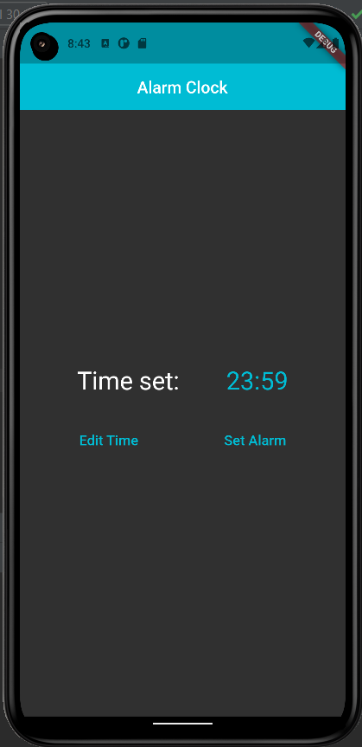 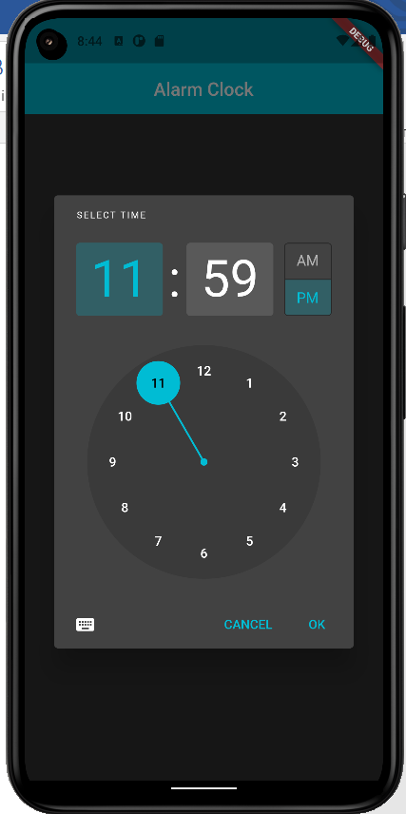

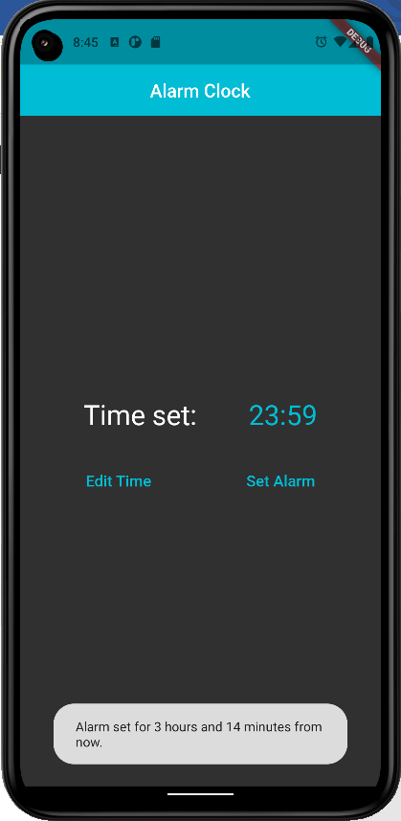 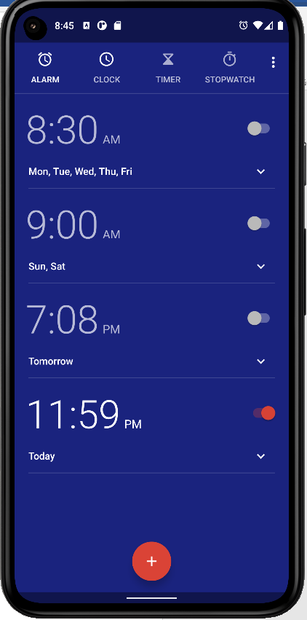

**Result:**

An application that creates an alarm clock is developed and tested successfully.

**An application that performs REST-based API calls**

**Expt 12 Date: / /2022**

**Aim:**

To create an application that performs REST-based API calls.

**Code:**

**main.dart**

**import 'dart:convert';  
  
import 'package:flutter/material.dart';  
import 'package:http/http.dart' as http;  
  
void main() {  
 runApp(const MyApp());  
}  
  
class MyApp extends StatelessWidget {  
 const MyApp({super.key});  
  
 // This widget is the root of your application.  
 @override  
 Widget build(BuildContext context) {  
 return MaterialApp(  
 title: 'Api Calls',  
 theme: ThemeData(  
 // This is the theme of your application.  
 //  
 // Try running your application with "flutter run". You'll see the  
 // application has a blue toolbar. Then, without quitting the app, try  
 // changing the primarySwatch below to Colors.green and then invoke  
 // "hot reload" (press "r" in the console where you ran "flutter run",  
 // or simply save your changes to "hot reload" in a Flutter IDE).  
 // Notice that the counter didn't reset back to zero; the application  
 // is not restarted.  
 primarySwatch: Colors.*blue*,  
 ),  
 home: const MyHomePage(title: 'Codeforces Problem Set'),  
 );  
 }  
}  
  
class MyHomePage extends StatefulWidget {  
 const MyHomePage({super.key, required this.title});  
  
 // This widget is the home page of your application. It is stateful, meaning  
 // that it has a State object (defined below) that contains fields that affect  
 // how it looks.  
  
 // This class is the configuration for the state. It holds the values (in this  
 // case the title) provided by the parent (in this case the App widget) and  
 // used by the build method of the State. Fields in a Widget subclass are  
 // always marked "final".  
  
 final String title;  
  
 @override  
 State<MyHomePage> createState() => _MyHomePageState();  
}  
  
class _MyHomePageState extends State<MyHomePage> {  
 late Future<Map<String,dynamic>> info;  
 @override  
 void initState(){  
 info=giver();  
 super.initState();  
 }  
   
 Future<Map<String,dynamic>> giver() async{  
 var response = await http.get(Uri.*parse*("https://www.boredapi.com/api/activity"));  
 Map<String,dynamic> result=json.decode(response.body);  
 //print(result);  
 return result;  
 }  
 @override  
 Widget build(BuildContext context){  
 return Scaffold(  
 appBar: AppBar(  
 title: const Text("Bored API"),  
 actions: [  
 IconButton(onPressed: ()=>setState(() {  
 info=giver();  
 }), icon: const Icon(Icons.*refresh_rounded*))  
 ],  
 ),  
 body: FutureBuilder<Map<String,dynamic>>(  
 future: info,  
 builder: (context,snapshot){  
 if(snapshot.connectionState==ConnectionState.waiting){  
 return const Center(child: CircularProgressIndicator());  
 }  
 Map<String,dynamic> data={};  
 if(snapshot.hasData){  
 data=snapshot.data!;  
 return Center(  
 child: Column(  
 mainAxisAlignment: MainAxisAlignment.center,  
 children: [  
 Text("Activity: ${data["activity"]}"),  
 Text("Type: ${data["type"]}"),  
 Text("Participants: ${data["participants"]}"),  
 Text("Price: \$${data["price"]}"),  
 ],  
 ),  
 );  
 }  
 return Container();  
 },  
 ),  
 );  
 }  
}**

**Output:**

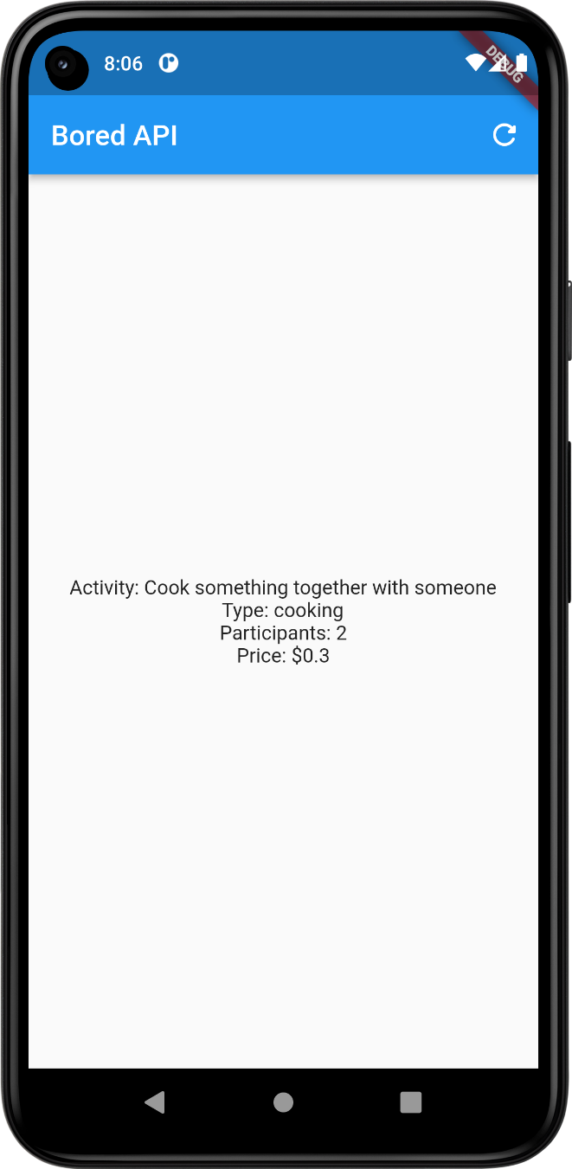

**Result:**

An application that performs REST-based API calls is developed and tested successfully.