Training Data Exploration and Linear Model Specification Assessment
Robust Detection of Anomalous Taxi Fares Using Least Trimmed Squares Regression
Stage Report
Aditya Kumar
IED/10007/23
3 November 2026
Scope limited to the 40,000 training records. Test outcomes were not examined.

Executive Summary
The 40,000-record training sample supports a strong fare relationship, but it does not satisfy the conditions needed for unqualified classical OLS interpretation. Distance has the clearest association with fare. Extreme duration records create substantial leverage, residual variance rises with fitted fare, and residual means follow systematic curves across distance and duration. These findings justify the planned OLS and LTS comparison while requiring HC3 uncertainty for OLS and explicit influence reporting.
- The diagnostic OLS model explains 92.7% of training-fare variation, with MAE $2.07 and RMSE $3.28. These are in-sample diagnostics, not test performance.
- Fare and distance have Pearson correlation 0.953. Fare and duration have Pearson correlation 0.494 but Spearman correlation 0.967, showing strong tail distortion.
- There are 2,038 observations above the 2p/n leverage threshold, 1,663 above Cook's 4/n screening threshold, and 575 with absolute internally studentized residual above 3.
- The primary additive linear specification should remain the common, interpretable basis for OLS and LTS. If LTS residual diagnostics retain the same curvature, nonlinear distance and duration terms should be added as a prespecified sensitivity model rather than selected from test results.

Scope and Data Protection
The fixed modelling dataset contains 50,000 eligible January 2026 standard-rate Yellow Taxi trips. This report uses only the 40,000 observations labelled train. The training source-ID fingerprint is 199b0d9697584054d47e44638848bc40fb1b2467dbf07902991466df097eb384. The 10,000 test outcomes were not summarized, plotted, transformed, or used to choose the model form.
The preparation rules require a January pickup, standard rate code 1, positive fare and distance, duration of at least one minute, and passenger count of at least one. No upper fare, distance, duration, or passenger-count limit was imposed. Visual windows stop at the 99.5th percentile only to keep dense plots readable; every tail observation remains in the calculations.

Statistical Examination
The analysis combines distribution summaries, Pearson and Spearman correlations, variance inflation factors, a training-only OLS diagnostic fit, HC3 standard errors, Breusch-Pagan and Ramsey RESET tests, residual-shape checks, leverage, Cook's distance, and binned residual means. Large-sample test statistics are interpreted together with graphical patterns and effect sizes.

Training Distributions
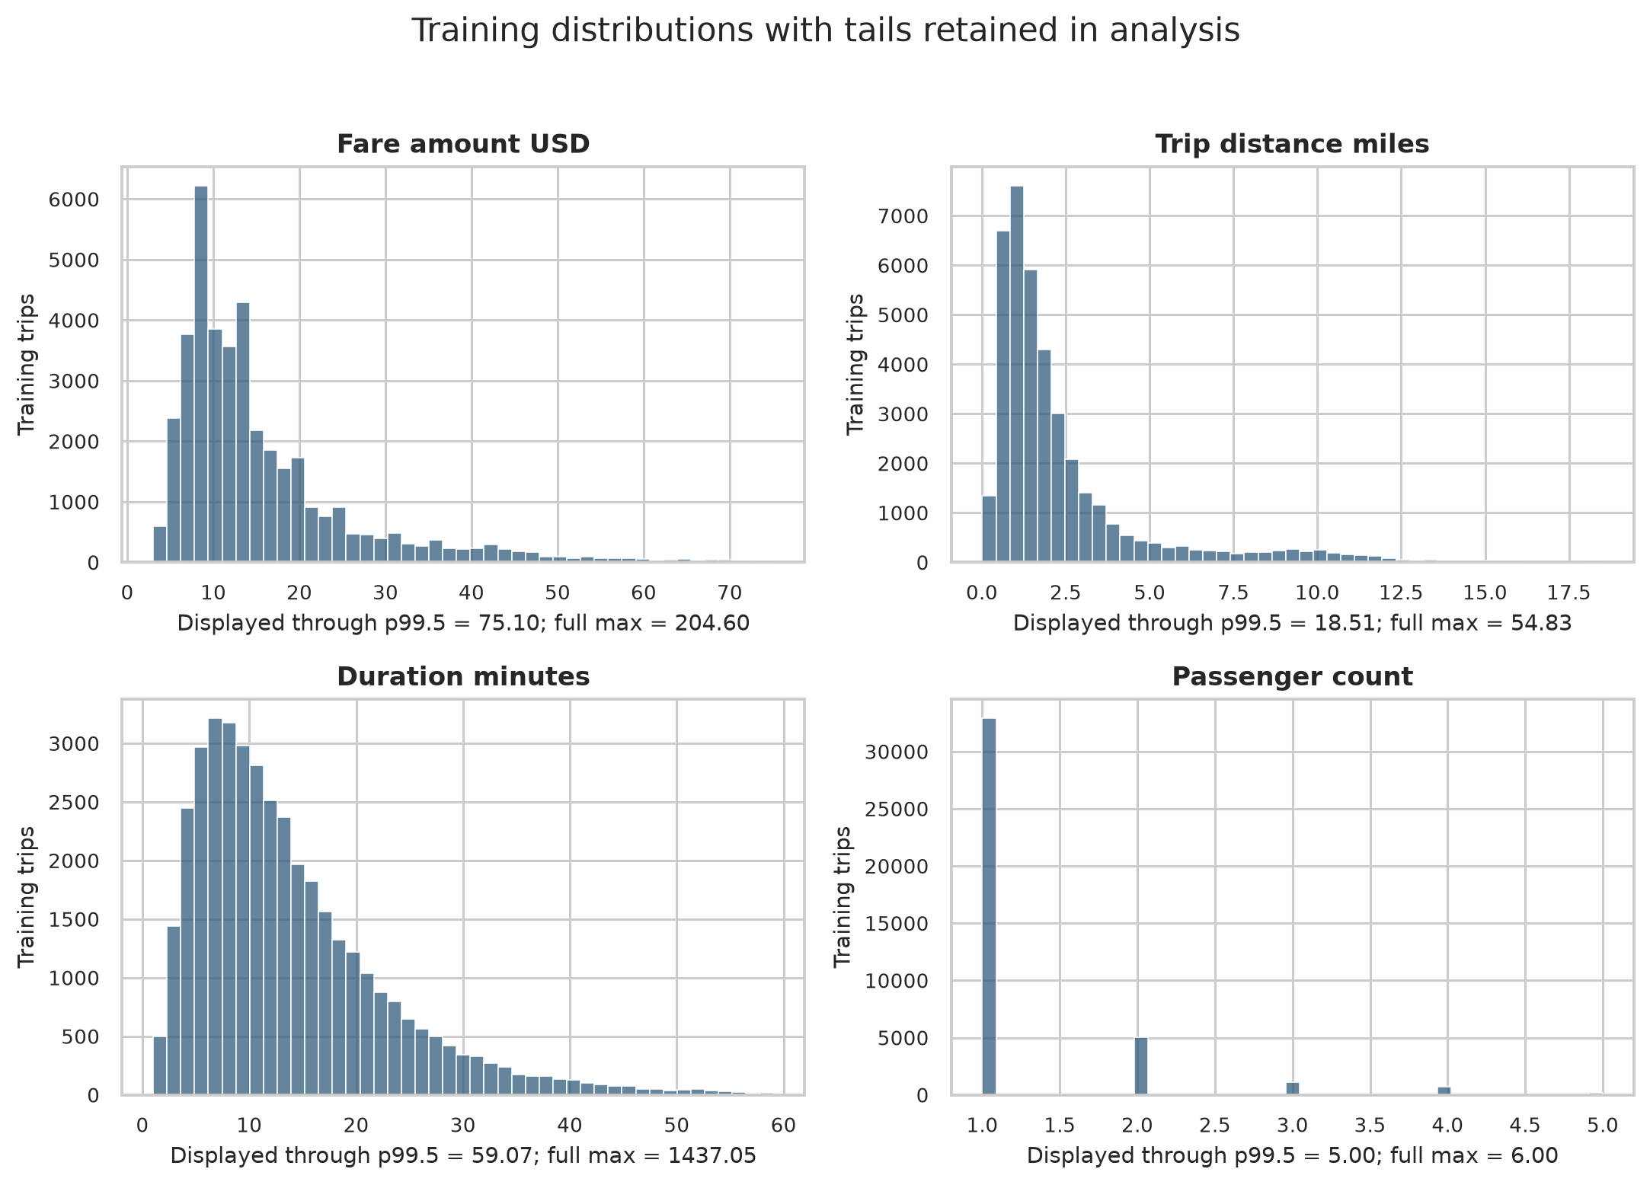
Figure 1 Central training distributions shown through the 99.5th percentile with full maxima reported
Variable | Median | P95 | P99 | Maximum | Skewness
Fare amount USD | 12.10 | 40.80 | 65.30 | 204.60 | 2.75
Trip distance miles | 1.53 | 9.30 | 15.50 | 54.83 | 3.40
Duration minutes | 11.58 | 32.77 | 50.38 | 1,437.05 | 51.75
Passenger count | 1.00 | 3.00 | 4.00 | 6.00 | 3.32

Fare, distance, and duration are strongly right-skewed. Duration is the most extreme: its median is 11.58 minutes and its 99th percentile is 50.38, but the maximum is 1437.05 minutes. Such records can be valid, erroneous, or interrupted trips; the current policy keeps them so that LTS can assess their compatibility with the dominant fare relationship.

Fare Relationships
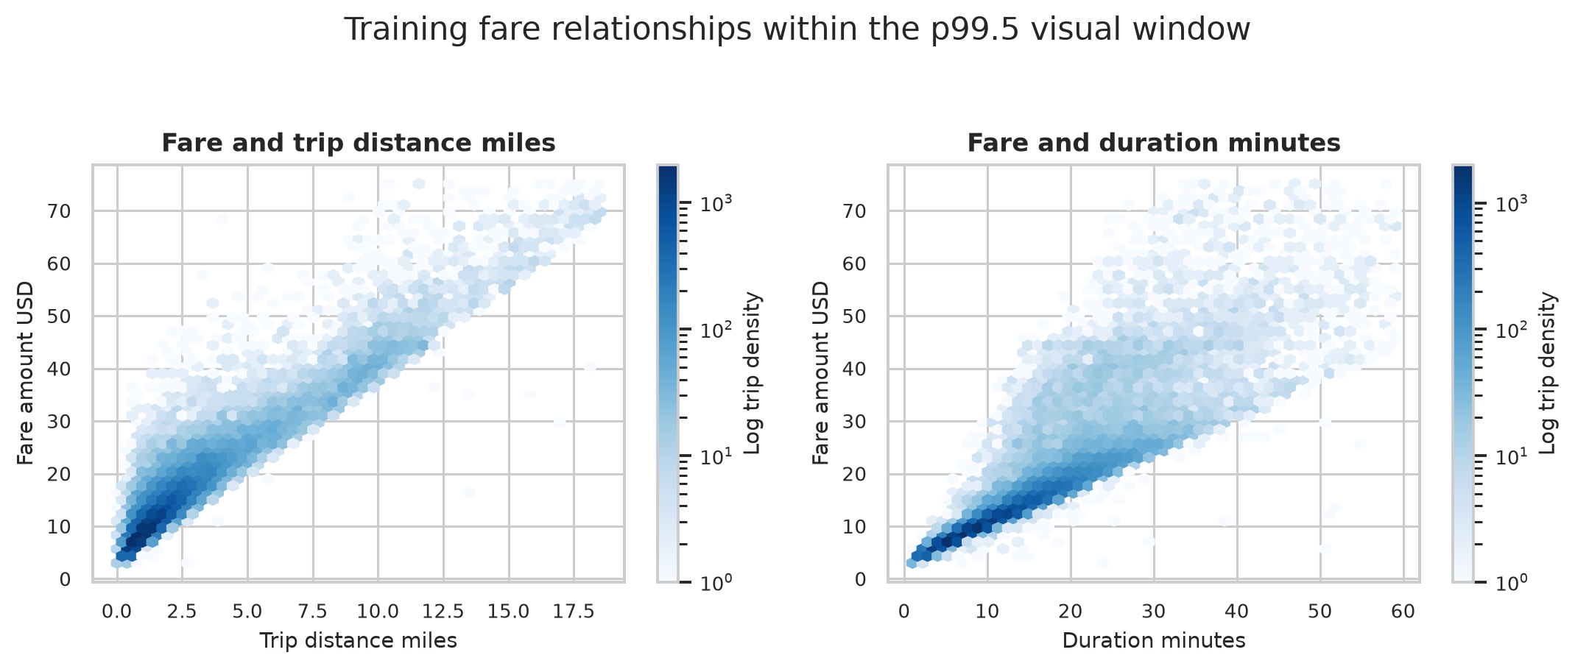
Figure 2 Fare relationships in a 99.5th percentile visual window using log-density hexagons
Fare rises strongly with both distance and ordinary-duration trips. Distance shows a narrower relationship with fare, while the duration plot widens as trips become longer. The widening vertical spread signals heteroskedasticity and may also reflect congestion, route differences, surcharges not represented by the predictors, and unusual records.
The plots show several parallel fare bands rather than one perfectly homogeneous cloud. A single additive regression line can summarize the dominant relationship, but it cannot reproduce every tariff or operational detail. This is a model limitation rather than a reason to delete observations.

Association and Collinearity
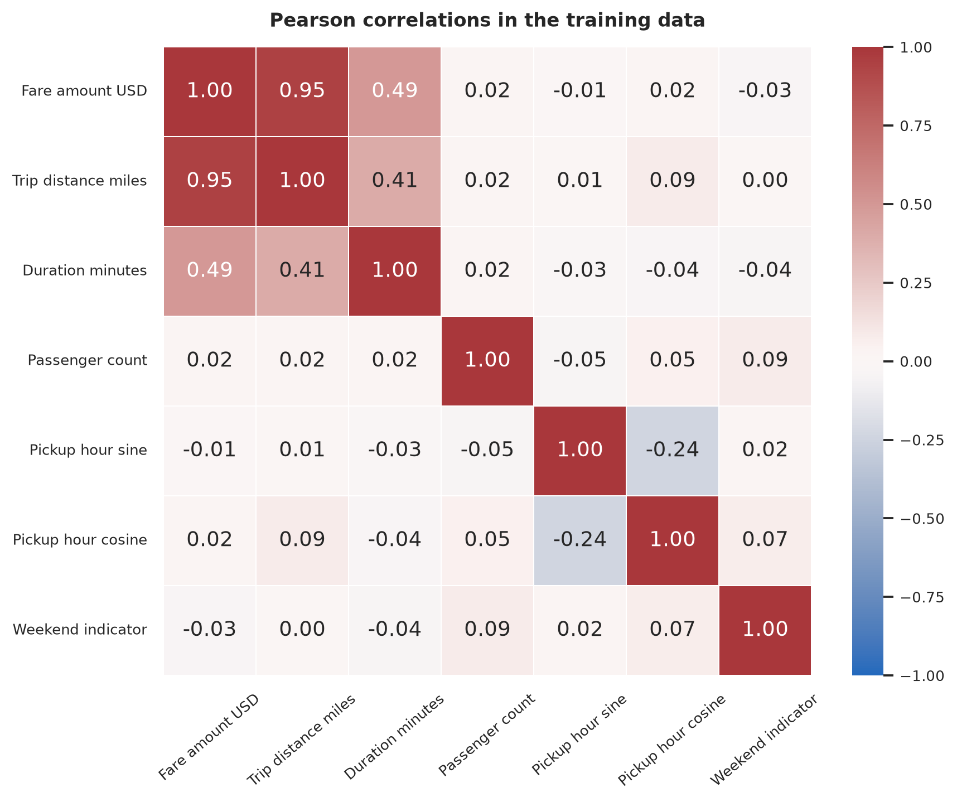
Figure 3 Pearson correlations among the response and proposed predictors
Variable pair | Pearson | Spearman
Fare and distance | 0.953 | 0.909
Fare and duration | 0.494 | 0.967
Distance and duration | 0.405 | 0.816

The rank correlations show that ordinary trips follow a strong monotonic distance-duration-fare structure. Pearson correlation is much lower for duration because a few exceptionally long recorded durations do not carry proportionally large fares. This discrepancy is direct evidence that tail observations can dominate covariance-based OLS quantities.

Variance Inflation Factors
Predictor | VIF
Trip Distance | 1.21
Duration Min | 1.21
Passenger Count | 1.01
Pickup Hour Sin | 1.07
Pickup Hour Cos | 1.09
Is Weekend | 1.01

All predictor VIF values are between 1.01 and 1.21, so conventional linear collinearity is low. This result does not contradict the high Spearman association between distance and duration: VIF measures linear dependence and is itself affected by extreme tail geometry.

Training Only OLS Diagnostic Model
The additive diagnostic model has training R squared 0.9269, adjusted R squared 0.9269, MAE $2.07, RMSE $3.28, and median absolute error $1.58. These values describe fit to the training records and must not be presented as out-of-sample performance.
Term | Coefficient | OLS SE | HC3 SE | HC3 95 percent CI
Const | 5.241 | 0.041 | 0.285 | 4.681 to 5.800
Trip Distance | 3.622 | 0.006 | 0.096 | 3.434 to 3.810
Duration Min | 0.082 | 0.001 | 0.039 | 0.005 to 0.159
Passenger Count | 0.138 | 0.025 | 0.036 | 0.067 to 0.209
Pickup Hour Sin | -0.578 | 0.027 | 0.061 | -0.698 to -0.458
Pickup Hour Cos | -1.089 | 0.025 | 0.088 | -1.261 to -0.917
Is Weekend | -0.745 | 0.038 | 0.065 | -0.873 to -0.617

Holding the other predictors fixed, the diagnostic OLS slope is $3.62 per mile and $0.08 per minute. These slopes are associations within the specified model. They are not causal effects, and the duration slope is especially vulnerable to the extreme-duration leverage documented below.
HC3 standard errors are materially larger than conventional OLS standard errors. For distance, HC3 is about 16 times the conventional value; for duration, it is about 39 times larger. This difference shows why conventional homoskedastic standard errors would give misleading precision.

Residual Assumptions
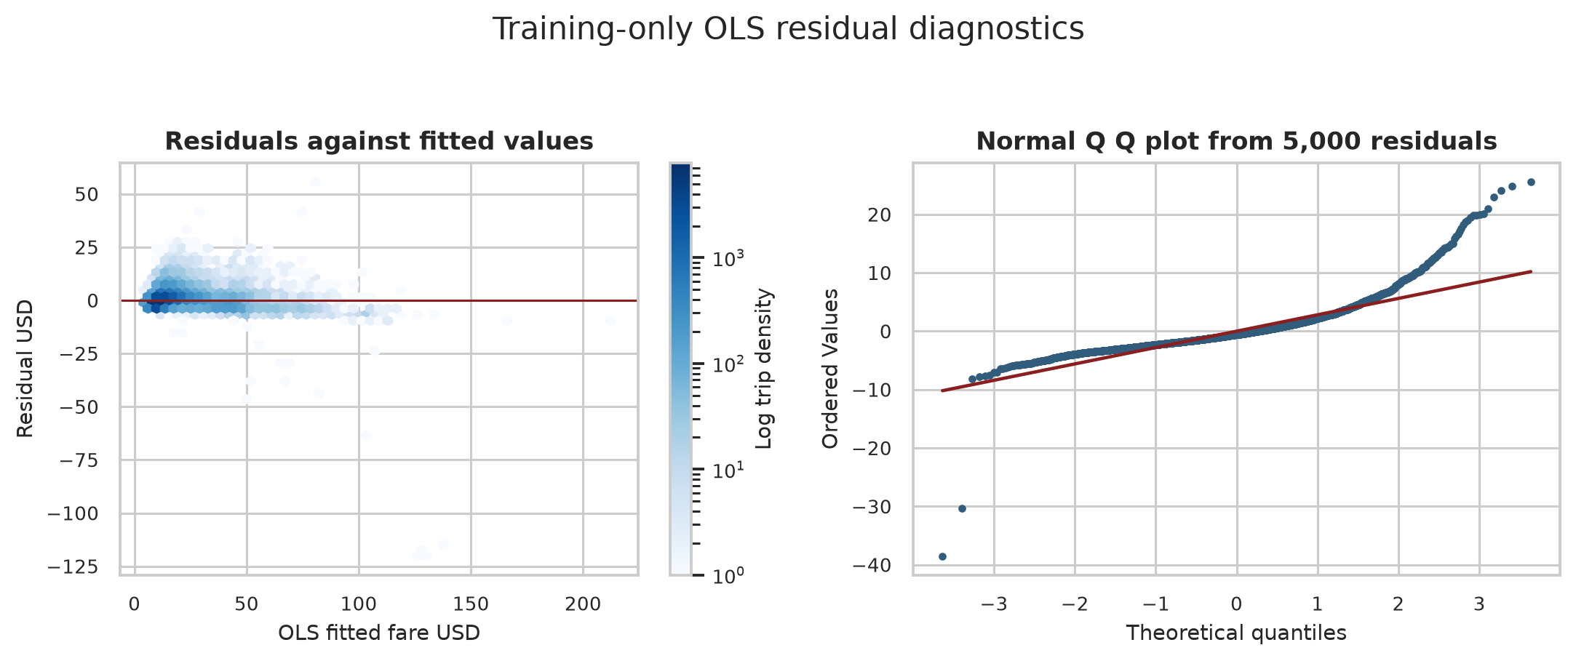
Figure 4 Training-only OLS residual spread and normal quantile comparison
Diagnostic | Statistic | Reported probability
Breusch-Pagan heteroskedasticity | 33,831.5 | Less than 1e-16
Ramsey RESET functional form | 3,692.6 | Less than 1e-16
Jarque-Bera normality | 56,739,341.0 | Less than 1e-16
Durbin-Watson | 2.013 | Not a p value

Residuals have skewness -3.21 and kurtosis 187.4. The Q Q plot confirms heavy tails and asymmetry. With 40,000 observations, formal tests are extremely sensitive, but the visual departures and large effect sizes are also substantial. Normal-theory OLS inference should therefore not be used without qualification.
Durbin-Watson is 2.013, close to 2 in the stored random sample order. This does not prove temporal independence because the ordering is not a continuous trip sequence and multiple trips may share operational conditions.

Functional Form and Residual Scale
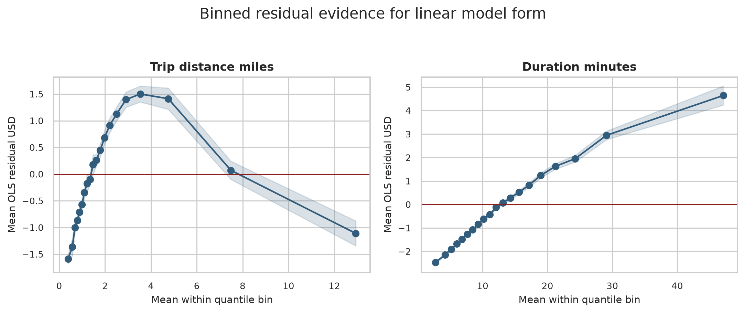
Figure 5 Mean OLS residuals within twenty predictor quantile bins with 95 percent mean confidence bands
Mean residuals should remain near zero across predictor values when the conditional mean is well represented. Instead, distance residuals move from negative to positive and back to negative, while duration residuals rise steadily from approximately -$2.48 to $4.64. Ramsey RESET reaches the same conclusion: the proposed linear mean is an approximation, not a complete fare function.
Fitted fare decile | Mean fitted fare | Mean absolute residual | Residual RMSE
1 | 7.47 | 1.64 | 1.91
5 | 11.69 | 1.63 | 2.28
10 | 45.13 | 3.49 | 6.22

Residual RMSE rises from $1.91 in the lowest fitted-fare decile to $6.22 in the highest. This more than threefold increase is a practical measure of heteroskedasticity, not merely a significant p value.

Leverage and Influence
Screening condition | Training records | Fraction
High leverage above 2p/n | 2,038 | 5.10%
Cook's distance above 4/n | 1,663 | 4.16%
Absolute studentized residual above 3 | 575 | 1.44%

The maximum leverage is 0.192, compared with the 2p/n screening threshold 0.00035. Maximum Cook's distance is 56.62. These are screening statistics, not automatic deletion rules.

Highest Cook Distance Records
Source row | Fare | Miles | Minutes | Residual | Cook distance
2429744 | 7.90 | 1.23 | 1,437.05 | -120.33 | 56.622
660951 | 7.20 | 0.52 | 1,436.37 | -119.34 | 55.633
251108 | 8.60 | 1.41 | 1,412.12 | -119.16 | 52.728
433589 | 24.00 | 4.40 | 1,413.85 | -114.25 | 47.772
1419099 | 42.20 | 10.70 | 737.38 | -62.86 | 2.720
1349531 | 4.40 | 0.19 | 511.67 | -45.02 | 0.672

The four most influential records report durations near 1,412 to 1,437 minutes with fares from $7.90 to $24.00. OLS predicts fares above $126 for these records, producing residuals near -$114 to -$120 and Cook's distances from 47.77 to 56.62. Their influence explains why the OLS duration coefficient and its uncertainty are unstable. They remain in the dataset for robust modelling and later audit review.

Model Specification Decision
The primary comparison will retain the same additive linear predictors for OLS and LTS: distance, duration, passenger count, pickup-hour sine and cosine, and weekend status. This common specification isolates the effect of the estimator. It also preserves direct coefficient interpretation and matches the assignment's focus on resistance to anomalous fares.
- Fit all scaling parameters on the 40,000 training records and apply them unchanged to the test set.
- Use HC3 uncertainty for OLS and report conventional standard errors only as a diagnostic comparison.
- Fit raw and explicitly reweighted FAST-LTS at alpha 0.75, with alpha 0.50 and 0.90 sensitivity checks.
- Retain all extreme predictor and fare observations; classify LTS residual flags as audit candidates rather than proven errors or fraud.
- After the robust fit, repeat the binned residual check. If meaningful curvature remains under LTS, add a training-prespecified nonlinear sensitivity model using distance and duration terms without consulting test outcomes.

Limitations
This phase does not estimate out-of-sample performance and does not establish causal fare effects. TLC records are provider-submitted, passenger counts are driver-reported, and the predictors omit location, congestion-fee detail, tolls, and route information. Formal test p values are affected by the large sample, and the diagnostic OLS fit is itself sensitive to the influential observations it is intended to reveal.

Next Statistical Phase
The next phase will freeze training-only scaling, fit clean OLS and reweighted FAST-LTS, perform alpha sensitivity, and evaluate both models once on the untouched 10,000-record test set. Controlled $100 response contamination will follow only after clean-model results are recorded.

Data and Reproducibility
Data source: New York City Taxi and Limousine Commission, January 2026 Yellow Taxi Trip Records. Preparation, split assignment, diagnostics, figures, and tables are generated by repository commands with seed 42. The machine-readable tables in outputs/tables are the source of the values reported here.

