1. Problem + Algorithm
Experiment No.: 10
Title: Particle Swarm Optimization for the Rosenbrock Function
Aim: Implement PSO to minimize the Rosenbrock function and analyze parameter effects.
Problem Statement:
Minimize f(x,y) = (1 − x)² + 100(y − x²)² over −3 ≤ x ≤ 3 and −2 ≤ y ≤ 5. The known minimum is f(1,1) = 0. The narrow curved valley tests search and convergence.
Algorithm:
1. Initialize random particle positions and small velocities within the bounds.
2. Evaluate fitness and initialize each personal best and the global best.
3. Update velocity using inertia, cognitive attraction and social attraction.
4. Clip velocities, move particles and project out-of-bounds coordinates onto the boundary.
5. Set clipped velocity coordinates to zero, then update personal and global bests.
6. Repeat for the iteration budget; report the best position and compare parameter changes.
Velocity: v(new) = wv + c1r1(pbest − position) + c2r2(gbest − position). Position(new) = position + v(new). Random values are independent per particle and coordinate.

2. Program
Executable Python code including function definitions, core algorithm, baseline settings and parameter modifications. The companion notebook contains the step-by-step cells, plots and full result tables.
import numpy as np
bounds = np.array([[-3., 3.], [-2., 5.]])
lower, upper = bounds[:,0], bounds[:,1]
span = upper - lower
success_tolerance = 1e-3

def rosenbrock(points):
points = np.asarray(points, dtype=float)
x, y = points[..., 0], points[..., 1]
return (1-x)**2 + 100*(y-x**2)**2

def run_pso(w=0.7, c1=1.5, c2=1.5, n_particles=30,
n_iterations=200, velocity_fraction=0.2, seed=42):
rng = np.random.default_rng(seed)
limit = velocity_fraction * span
position = rng.uniform(lower, upper, size=(n_particles, 2))
velocity = rng.uniform(-0.1 * span, 0.1 * span, size=(n_particles, 2))
velocity = np.clip(velocity, -limit, limit)
pbest = position.copy()
pbest_value = rosenbrock(position)
index = np.argmin(pbest_value)
gbest, best_value = pbest[index].copy(), float(pbest_value[index])
history, best_path = [best_value], [gbest.copy()]
snapshots = [position.copy()]
first_hit = 0 if best_value <= success_tolerance else np.nan

for iteration in range(1, n_iterations + 1):
r1, r2 = rng.random(position.shape), rng.random(position.shape)
velocity = w * velocity + c1 * r1 * (pbest - position) + c2 * r2 * (gbest - position)
velocity = np.clip(velocity, -limit, limit)
proposed = position + velocity
outside = (proposed < lower) | (proposed > upper)
position = np.clip(proposed, lower, upper)
velocity[outside] = 0
values = rosenbrock(position)
improved = values < pbest_value
pbest[improved], pbest_value[improved] = position[improved], values[improved]
index = np.argmin(pbest_value)
gbest, best_value = pbest[index].copy(), float(pbest_value[index])
history.append(best_value)
best_path.append(gbest.copy())
snapshots.append(position.copy())
if np.isnan(first_hit) and best_value <= success_tolerance:
first_hit = iteration

return dict(position=gbest, fitness=best_value, history=np.array(history),
best_path=np.array(best_path), snapshots=np.array(snapshots),
coordinate_error=float(np.linalg.norm(gbest - [1, 1])),
first_hit=first_hit, evaluations=n_particles * (n_iterations + 1),

Program continued
first_hit_evaluations=n_particles * (first_hit + 1) if np.isfinite(first_hit) else np.nan)

baseline = dict(w=0.7, c1=1.5, c2=1.5, n_particles=30,
n_iterations=200, velocity_fraction=0.2)
result = run_pso(**baseline, seed=42)
print("Best position:", result["position"])
print("Best fitness:", result["fitness"])

changes = {"w":[0,0.4,0.9,1.2], "c1":[0,0.5,3], "c2":[0,0.5,3],
"n_particles":[10,60], "n_iterations":[30,500],
"velocity_fraction":[0.02,0.8]}
for parameter, values in changes.items():
for value in values:
settings = {**baseline, parameter:value}
runs = [run_pso(**settings, seed=s) for s in range(30)]
fitness = np.array([r["fitness"] for r in runs])
success = 100 * np.mean(fitness <= success_tolerance)
print(parameter, value, "mean=", fitness.mean(), "success%=", success)

3. Output + Analysis
Objective Function: Minimize f(x,y) = (1 − x)² + 100(y − x²)².
Search Interval: −3 ≤ x ≤ 3; −2 ≤ y ≤ 5.
Initial Solution: 30 positions sampled uniformly inside the search box; seed 42.
Initial Velocity: Uniform in ±10% of each coordinate range, then clipped.
Key Parameters: w = 0.7, c1 = 1.5, c2 = 1.5; velocity fraction = 0.2.
Maximum Iterations: 200; 30 particles; 6,030 objective evaluations.
Program Execution
Final Optimal Solution: x = 1.00001762; y = 1.00003425
Minimum Function Value: 4.080698872e-10
Execution Status: Successfully Executed
Execution checkpoint | Best objective value
Iteration 0 | 6.9634131
Iteration 50 | 0.00011994235
Iteration 100 | 6.8652313e-06
Iteration 200 | 4.0806989e-10
Both objective terms are nonnegative and vanish at (1,1). The measured result is close to this known optimum. Success in the experiments means f ≤ 0.001; it does not mean exact coordinate equality.

Convergence Graph
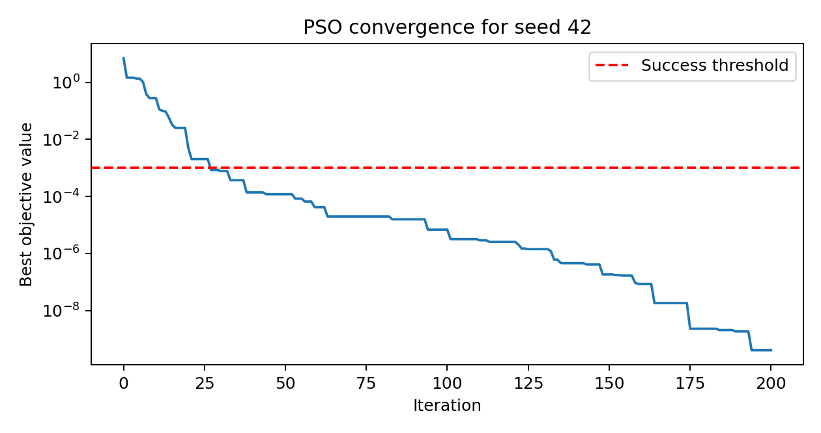
Figure: Convergence of Particle Swarm Optimization
X-axis → Iteration. Y-axis → Best objective-function value on a logarithmic scale.
The stored best can only improve or remain unchanged. Individual tours or particle positions may become worse. A fixed seed makes this illustrated run reproducible.
The baseline reaches the success threshold in all 30 runs, with mean final fitness 1.067071 × 10⁻⁸. A good single trajectory is therefore supported by repeated-run evidence for this particular problem.

Parameter Modification
Change one parameter at a time and keep all other baseline settings fixed. Each setting uses seeds 0–29. Original and modified results report mean final objective and success rate across 30 runs. Smaller objective values and higher success rates are better.
S. No. | Parameter | Original Value | Modified Value | Original Result | Modified Result | Observation
1 | w | 0.7 | 0 | 1.07e-08; 100.0% | 5.65e-02; 50.0% | Mean higher; success -50.0 pp.
2 | w | 0.7 | 0.4 | 1.07e-08; 100.0% | 1.27e-08; 100.0% | Mean higher; success +0.0 pp.
3 | w | 0.7 | 0.9 | 1.07e-08; 100.0% | 1.76e-04; 96.7% | Mean higher; success -3.3 pp.
4 | w | 0.7 | 1.2 | 1.07e-08; 100.0% | 5.65e-03; 16.7% | Mean higher; success -83.3 pp.
5 | c1 | 1.5 | 0 | 1.07e-08; 100.0% | 3.62e-15; 100.0% | Mean lower; success +0.0 pp.
6 | c1 | 1.5 | 0.5 | 1.07e-08; 100.0% | 7.65e-15; 100.0% | Mean lower; success +0.0 pp.
7 | c1 | 1.5 | 3 | 1.07e-08; 100.0% | 8.23e-05; 100.0% | Mean higher; success +0.0 pp.
8 | c2 | 1.5 | 0 | 1.07e-08; 100.0% | 7.20e-02; 23.3% | Mean higher; success -76.7 pp.
9 | c2 | 1.5 | 0.5 | 1.07e-08; 100.0% | 6.90e-09; 100.0% | Mean lower; success +0.0 pp.
10 | c2 | 1.5 | 3 | 1.07e-08; 100.0% | 5.30e-05; 100.0% | Mean higher; success +0.0 pp.
11 | n_particles | 30 | 10 | 1.07e-08; 100.0% | 5.10e-04; 93.3% | Mean higher; success -6.7 pp.
12 | n_particles | 30 | 60 | 1.07e-08; 100.0% | 5.41e-11; 100.0% | Mean lower; success +0.0 pp.
13 | n_iterations | 200 | 30 | 1.07e-08; 100.0% | 5.56e-03; 43.3% | Mean higher; success -56.7 pp.
14 | n_iterations | 200 | 500 | 1.07e-08; 100.0% | 1.32e-18; 100.0% | Mean lower; success +0.0 pp.
15 | velocity_fraction | 0.2 | 0.02 | 1.07e-08; 100.0% | 1.86e-08; 100.0% | Mean higher; success +0.0 pp.
16 | velocity_fraction | 0.2 | 0.8 | 1.07e-08; 100.0% | 3.44e-09; 100.0% | Mean lower; success +0.0 pp.
pp = percentage points. A mean difference below 10⁻¹² is labeled unchanged in the observation column; the result columns retain scientific notation for PSO. The complete notebook also reports variation, worst results and first-hit effort.
Interpretation
Inertia w: w = 0 gives 50% success, while w = 1.2 gives 16.7%. Moderate inertia balances movement and refinement better in this experiment; clipping bounds motion but does not ensure useful convergence.
Cognitive coefficient c1: c1 = 0 performs very well on this two-dimensional example. This is an observed problem-specific result, not evidence that personal memory should always be removed.
Social coefficient c2: Removing social attraction gives 23.3% success. Sharing the swarm best is useful here. Stronger social attraction may also reduce diversity too early.
Swarm size and iteration count: Ten particles give 93.3% success; 30 iterations give 43.3%. Sixty particles or 500 iterations improve objective accuracy while costing more evaluations. The notebook includes a separate 6,000-evaluation comparison.
Velocity fraction: Both 0.02 and 0.8 reach 100% success. Smaller caps restrict travel; larger caps permit overshoot. Tied success rates can conceal differences in convergence speed and precision.
These comparisons are descriptive results for one small optimization problem and 30 random seeds. Parameters interact, and a better mean under a larger budget does not by itself establish better computational efficiency.

